DS 1 Template

My Screenshots/Photos
- Please add 4–6 screenshots or photos of your digital life.
- You can use your phone or laptop.
- For each screenshot, write one or two sentences explaining what it shows.

Screenshot/Photo 1
[Insert Photo/Screenshot below]
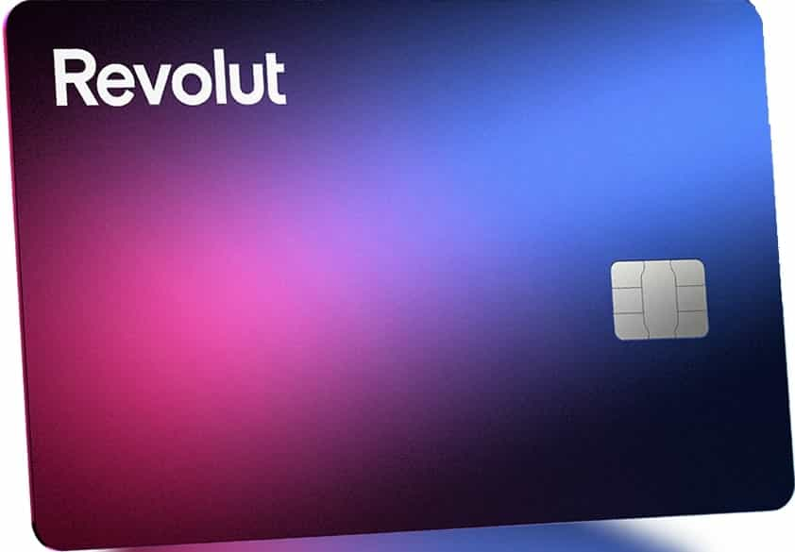
[I have recently opened a Revolut bank account I am pretty happy with for its convenience of use and lots options to better manage money . ]

Screenshot/Photo 2
[Insert Photo/Screenshot below]
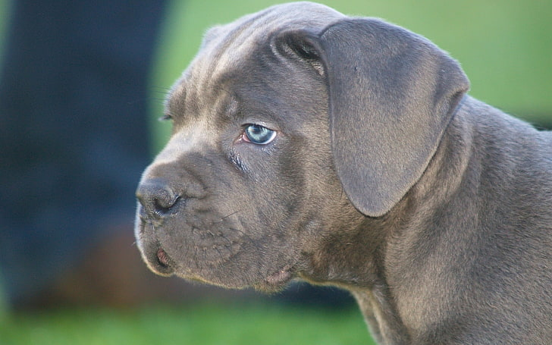
[ This is my Kane Corsa puppy I bought recently . She is an adorable dog I have named her Roxy .]

Screenshot/Photo 3
[Insert Photo/Screenshot below]
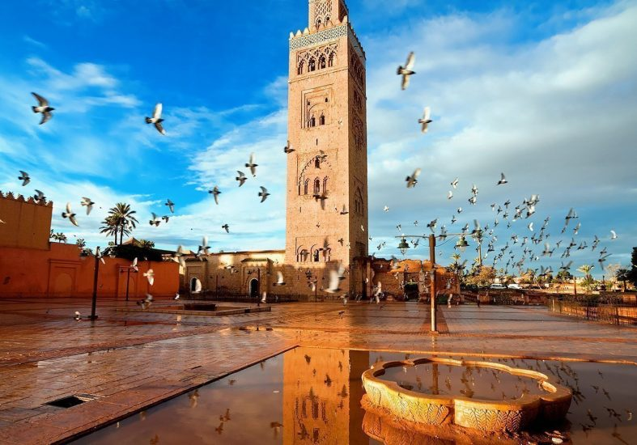
[ I went on holiday to Morrocco . We did a tour of Marrakesh it was fabulous I enjoyed it so much . The photo above is a Mosque I visited very historic building .]

Screenshot/Photo 4
[Insert Photo/Screenshot below]
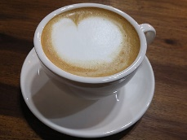
[I have a daily coffee fix twice a day , if I miss it im not in the best of moods . ]

Screenshot/Photo 5
[Insert Photo/Screenshot below]
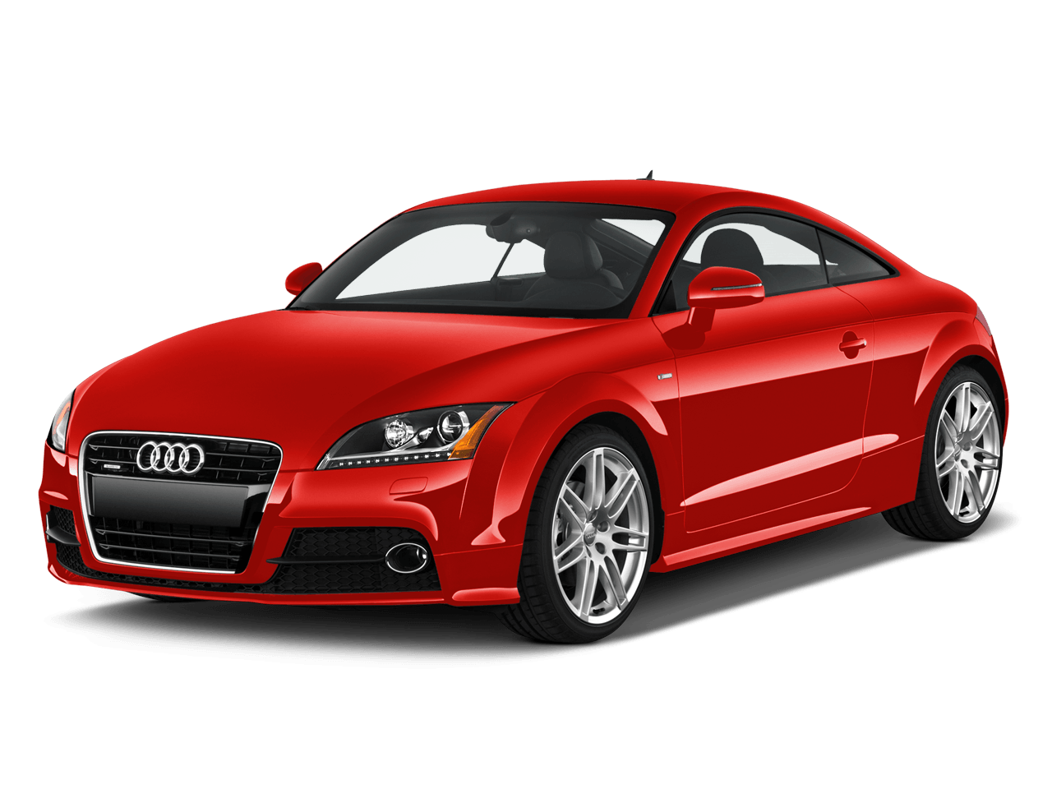
This is my Audi TT which I recently sold . I had a lot of fun with it the time I had it .

Screenshot/Photo 6
[Insert Photo/Screenshot below]
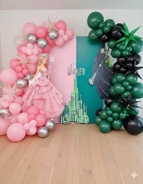
[ My daughter was 25 a few days ago so we celebrated with lots food and noise .]

My Short Reflection
- Write 5–8 simple sentences about your digital life.
- You can use the sentence starters below if helpful.
I use digital tools like banking apps to manage money better to pay bills and send money or receive from people.
It is so convenient when you don’t have to ever go to a physical bank again , those days are long gone .
Digital skills have become a very important part of our lives , it is a skill that you cannot escape from using in every day life .

Sentence starters
- I use digital tools to …
- I feel confident when I …
- I want to improve …
- I often use these tools: …
- I sometimes feel nervous about …
- I hope this module will help me …
- Digital skills are important for me because …
You can write more if you want.

Submission Checklist
Before you submit, please check:
​​​ ☒ I added 4–6 screenshots
☒ I wrote short sentences for each screenshot
☒ I wrote my short reflection
☒ My work is my own
☒ My file opens correctly
​​☒ My file opens correctly

