Programme: Master of Business Administration
Module: Marketing Management
Module Code: LCMB7024
Topic: Marketing Environment Analysis and Strategic Growth for Codelco's Lower-Carbon Transition
Student name: Chocha Neha Ramshibhai
Student id: 2542712
Lecturer: Laila Maazouz

Table of Contents
Task 1: Marketing Environment Analysis 3
1.1 Company Selection and Context 3
1.2 External Marketing Environment Actor 1: Natural Environment 4
1.3 External Marketing Environment Actor 2: Technological Environment 6
Task 2: Strategic Growth and Competitive Positioning 8
2.1 Strategic Growth Recommendation Using the Ansoff Matrix 8
2.2 Competitive Advantage Through a Lower-Carbon Business Model 10
Task 3: Critical Reflection on AI Usage 12
3.1 Tool Disclosure 12
3.2 Critical Evaluation of AI Output 13
3.3 Contribution Analysis 13
3.4 Ethical and Professional Reflection 13
References 14
Appendix 1: Drought and energy transforming production cost 19

Task 1: Marketing Environment Analysis

1.1 Company Selection and Context
1.1.1 Company Overview
Codelco is Chile’s state-owned copper producer and the largest copper mining company in the world, which supplies around one quarter of the country’s export revenues through its operations incorporating Chuquicamata, El Teniente and Andina. As global demand for copper accelerated because of renewable energy systems, electric vehicles and power infrastructures, Codelco occupies a strategically important position in the energy transition. As a result, the company is increasingly aligning its mining operations as well as product portfolio with lower carbon production, responsible resource management and ultimately sustainability-driven market expectations.
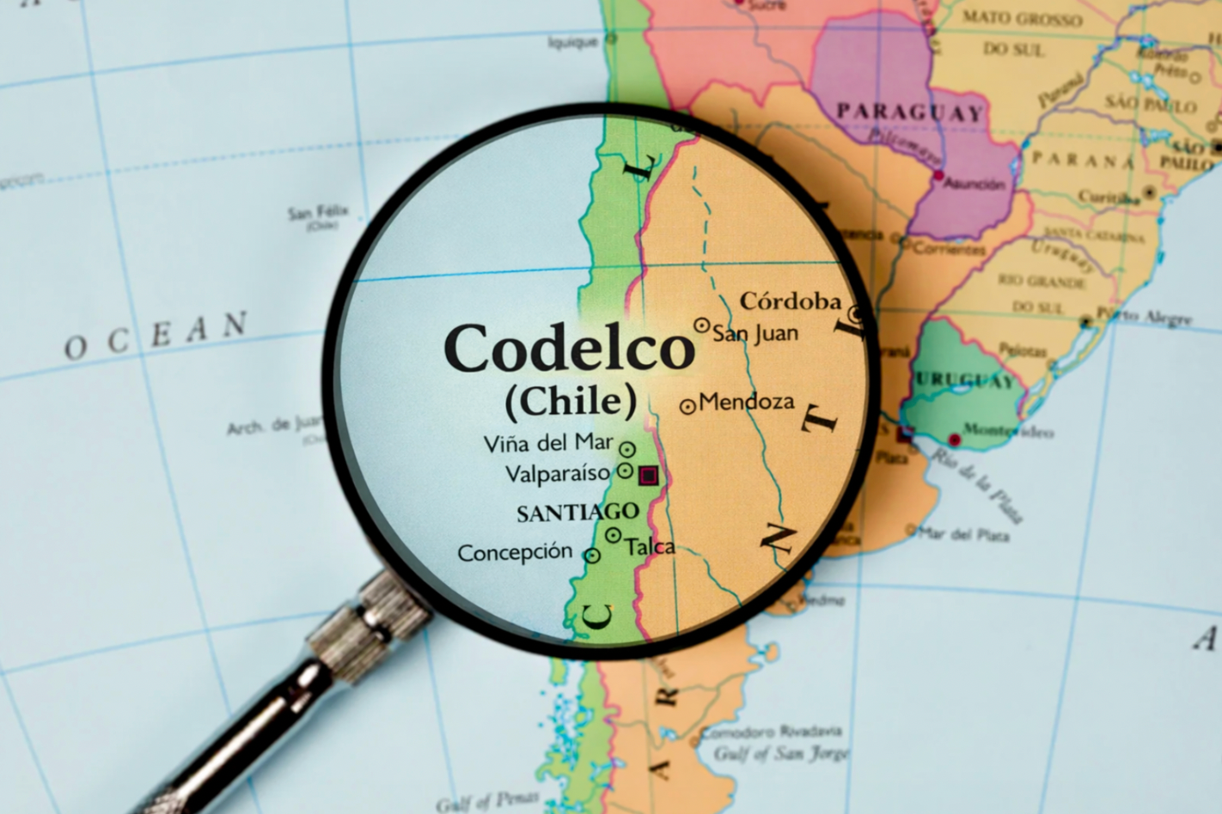

Figure 1: Codelco
(Source: Rivera, 2026)
1.1.2 Sustainability Context
Codelco has successfully embedded sustainability into its long-term strategy through its Sustainable Development Commitments 2030, targeting a 70% reduction across greenhouse gas emissions by 2030 (from a 2019 baseline) and finally attaining 100% renewable electricity within its Chilean operations, a milestone reached in the year 2023 (Codelco, 2026). The company is also investing in desalinated water infrastructure as well as advanced tailings management to address the water scarcity and environmental risks in Chile. These initiatives not only strengthen the business positioning of Codelco as a supplier of lower-carbon copper but also assist in meeting the growing sustainability expectations of electric vehicles, renewable energy and industrial customers.

1.2 External Marketing Environment Actor 1: Natural Environment
1.2.1 Natural Environment as a Key Marketing Environment Actor
Natural environment pressures are intensifying the transition of Codelco towards lower-carbon copper production through transforming the operational priorities as well as customer expectations. Resource scarcity is a crucial challenge because the average copper ore grades in Chile have steadily declined while the mining operations within the Atacama Desert are exposed to severe water stress (Ramirez and Holden, 2026).
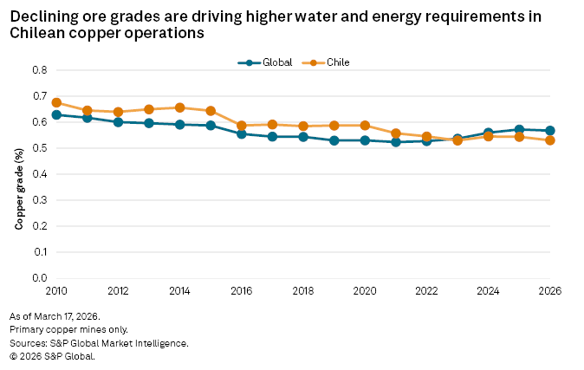

Figure 2: Declining grades of ore are driving higher water and energy requirements
(Source: Ramirez and Holden, 2026)
Besides that, to lower the reliance on freshwater, Codelco is heavily investing in the Northern District Desalination Plant, expected to supply desalinated water to copper mining operations across Chuquicamata, Radomiro Tomic and Ministro Hales and thus enhance the resource resilience while supporting the sustainable production (Codelco, 2025)
Simultaneously, climate change has intensified the prolonged droughts and extreme weather, which are increasing the operational risks while motivating greater dependence on renewable energy. In response, Codelco aims to attained 85% renewable electricity within its Chilean business operations in the financial year 2026, while diminishing approximately 2,780,000 tons of CO2 emissions per annum compared with the traditional electricity sources. Environmental regulations further reinforce this transition (Codelco, 2025).
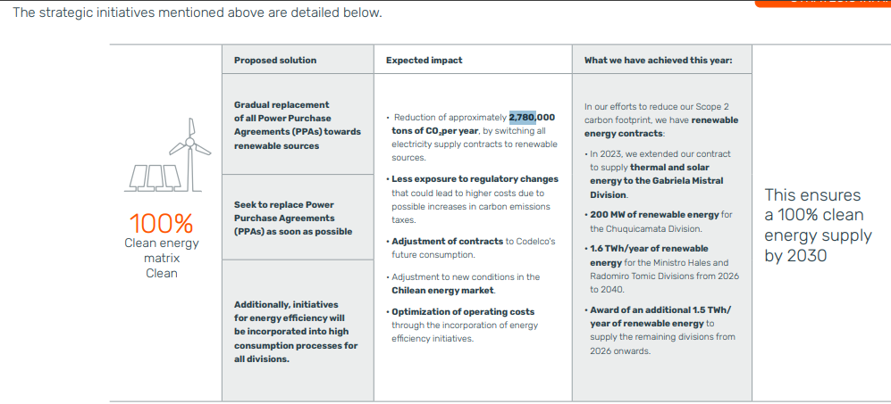

Figure 3: Strategic initiatives of Codelco
(Source: Codelco, 2025)
Chile’s Framework Law on Climate Change (Law 21.455) commits to country to carbon neutrality by the end of 2050, while global customers are increasingly demanded low-carbon raw materials to comply with policies such as the Carbon Border Adjustment Mechanism of the European Union (IKI, 2026). In addition, biodiversity concerns, along with stricter environmental permitting, require responsible tailings management in combination with ecosystem protection to manage the social licence of Codelco to operate. In essence, it can be asserted that concurrently, all of these natural environmental pressures compel Codelco to closely integrate renewable energy, water efficiency, and environmentally responsible mining into its lower-carbon business model, which fortifies its long-term market competitiveness.
1.2.2 Opportunities and Threats
Opportunities
The ongoing demand for low-carbon copper offers significant market opportunities, with the International Energy Agency through projecting that clean energy technologies could double the global copper demand by 2040 under net-zero scenarios (Mani et al., 2024).
The achievement of 100% renewable electricity of Codelco across its Chilean operations improves its competitiveness among customers who seek sustainably sourced copper.
Threats
Prolonged droughts across northern Chile alongside declining grades of ore maximise the costs of production, which require substantial investment in desalination and resource efficiency [Refer to Appendix 1].
Stricter environmental regulations as well as biodiversity protection measures can delay the mining approvals, increase adherence costs and ultimately constrain the future production expansion.

1.3 External Marketing Environment Actor 2: Technological Environment
1.3.1 Influence of the Technological Environment
The technological environment is a critical external actor because the production of low-carbon copper increasingly relies on a sense of innovation instead of resource availability alone. As per the International Energy Agency, digital technologies, electrification, and finally automation can notably enhance the effectiveness of energy while lowering emissions across mining operations and thus making technology central to the decarbonisation strategy of the sector (IEA, 2026). In contrast, research work by Chipangamate et al., (2023) showed that technological adoption alone cannot ensure sustainable mining unless it is accompanied by both effective environmental governance and stakeholder engagement as well.
This perspective is clearly evident in Codelco’s business strategy. Beyond attaining the 85% renewable electricity within its Chilean business operations in the finance year 2026, the company is also investing over US$1.3 billion within the Northern District Desalination Project along with autonomous haulage, digital mine management as well as predictive maintenance systems to enhance the operational effectiveness while lowering the freshwater reliance (Codelco, 2025). In comparison to the dominant players like BHP, which has prioritised autonomous mining initially to boost the level of productivity, Codelco closely aligns technological innovation with resource effectiveness and emission reductions, thus fortifying its sustainability transitions and strengthening its sustainability transitions while reinforcing its competitive positioning within the global low-carbon copper markets (Llancan, 2019).
1.3.3 Opportunities and Threats
Opportunities
Codelco’s strong investment approximately US$ 102 million in areas like automation, renewable energy as well as digital mining technologies strengthens its unique capabilities to supply lower-carbon copper (Codelco, 2025). These the company has created a sense of differentiation in response to growing demand from both the electric vehicles and renewable energy manufacturers as well.
Threats
High capital investment requirements, technology implementation risks and ultimately the growing cybersecurity threats might lower the short-term profitability. If technological adoption lags behind the key rivals like BHP and Rio Tinto, Codelco could weaken its competitive positioning and also lose market share across the rapidly expanding low-carbon copper market.

Task 2: Strategic Growth and Competitive Positioning

2.1 Strategic Growth Recommendation Using the Ansoff Matrix
2.1.1 Ansoff Matrix Analysis
The Ansoff Matrix reveals four strategic growth options; however, their suitability varies significantly for the low-carbon transition of Codelco. As per this framework, market penetration presents the lowest-risk growth through maximising the sales of the existing products within the existing markets (Zugay and Zakaria, 2023). However, this option is constrained for Codelco because copper is a globally traded commodity whose demand is largely driven by both electrification as well as industrial consumption rather than any promotional activities.
In a similar way, market development offers limited strategic value as Codelco already exports extensively to countries like Asia, Europe, and North America (Kruschel and Lafranchise, 2023). Though diversification could diminish the high reliance on copper, it will require a significant amount of investment beyond the firm’s core mining capabilities and thus it will maximise both the strategic and operational risks.
On the contrary, product development represents the most suitable strategy for Codelco as it allows the form to develop lower-carbon, responsibly produced copper for its existing industrial customers.

Figure 4: Ansoff Matrix
(Source: Self-developed)
This closely aligns with the 2030 sustainability commitments of the company incorporating a 70% reduction across its greenhouse gas emissions and 60% reduction across its continental water use and finally the investment within the electrification, green hydrogen and desalination technologies in order to boost the sustainability of its copper products (International Copper, 2026). In comparison with the alternative Ansoff strategies, product development most profoundly aligns Codelco’s sustainability objectives with the changing expectations of both customers and the regulatory body, thus supporting long-term competitive growth.
2.1.2 Recommended Strategy: Product Development
Research work by Ahmed (2025) shows that product development is an effective growth strategy when organisations innovate for the existing markets to respond to the changing needs of the potential customers. However, research work by Tojiri (2023) argues that product innovation only develops innovation only when it delivers meaningful differentiation from the key rivals. Through applying these perspectives, Codelco needs to prioritise developing the certified lower-carbon as well as traceable copper products instead of expanding into the new markets or unrelated business. This strategy develops greater value for existing industrial customers who seek sustainable raw materials while fortifying the long-term supply relationships. Compared with market penetration, which provides limited growth within the commodity markets, and diversification, which carries higher strategic risk, product development offers Codelco with a more competitive yet commercially viable pathway to capture the growing demand for responsibly sourced copper (Razak, 2022).
2.1.3 Response to Environmental Pressures
The product development strategy allows Codelco to respond proactively to the environmental pressures identified in Task 1 through producing the lower-carbon, responsibly sourced copper which caters the increasingly stringent sustainability requirements (Ushie et al., 2025). Compared with market development, this strategy directly addresses the rising customer demand for the low-emission materials instead of simply expanding the geographical reach. However, Mesut (2026) attaining this transition requires substantial investment across renewable energy, electrification and finally water efficient technologies and thus maximise the short-term cost. Nevertheless, through aligning the product innovation with both natural and technological pressures, Codelco needs to strengthen its long-term competitive edge in combination with a sense of resilience within the global copper market.

2.2 Competitive Advantage Through a Lower-Carbon Business Model
2.2.1 Lower-Carbon Business Model
A lower-carbon business model has become a strategic necessity instead of a voluntary sustainable initiative for Codelco, as the global buyers increasingly prioritise responsibly sourced copper. Research work by Bari et al., (2022) argues that environmental capabilities can become a key source of sustained competitive advantages. On the flip side Posen et al., (2023) argues that competitive advantages of firms heavily rely on the creation of a superior value which the competitors cannot easily replicate. Codelco effectively discloses this through aligning the decarbonisations with its core business operations rather than treating it as an adherence exercise. Besides that, the company also aims to attain 100% renewable electricity within Chilean operations in the year 2030, whereas its US$1.3 billion Northern District Desalination Project assisted in diminishing the high reliance on scarce freshwater resources. However, these investments remarkably maximise the capital expenditure, and it might also weaken short-term financial performance. Compared with the dominant players concentrating initially on the effectiveness of production, the lower-carbon business model of Codelco to improve its adaptability against the tightening environmental regulations while fortifying its appeal to global manufacturers seeking low-carbon copper and thus build a more sustainable basis for the long-term competitive advantages.
2.2.2 Competitive Positioning Using Porter’s Generic Strategies

Figure 5: Porter's Generic Strategies
(Source: Self-developed)
With respect to Codelco, differentiation is the more appropriate strategy because sustainability has become a prior criterion for purchasing for the potential manufacturers of electric vehicles, renewable energy equipment and finally the low-carbon infrastructures. Compared with cost leadership, which is very complicated across a capital-intensive mining industry currently experiencing environmental compliance costs, differentiation allows this mining company to compete through responsibly sourced, lower-carbon copper. However, Juneja (2025) argues that differentiation is only considered as a sustainable approach when supported through both valuable as well as difficult-to-imitate resources. Codelco’s investments across renewable-driven mining, water-efficient business operations and ultimately the certified sustainable productions fortify this exclusiveness and thus allow the firm to develop long-term trust of the customers while profoundly managing the competitive edge despite the increasing competition from the global producers of copper.
2.2.3 Sustaining Competitive Advantage
For attaining sustainable competitive advantages, Codelco needs to consistently fortify its lower-carbon capabilities instead of relying on the existing sustainability achievements. Sustainability will boost customer value through allowing Codelco to supply lower-carbon, responsibly sourced copper, which closely aligns with the procurement requirements of electric vehicle, renewable energy and infrastructure manufacturers. This will also strengthen the corporate reputation through showcasing measurable commitments, incorporating 100% renewable electricity within its business operations by 2030, along with the ambitious emission reduction targets. As a consequence, strong ESG performances maximise the confidence levels of the investors, because the sustainable mining organisations are better positioned in order to attract long-term capital while managing the regulatory threats. However, compared with organisations which completely depend on the effectiveness of production, Codelco's sustainability investment of Codelco creates a sense of stronger differentiation and thus supports the long-term competitiveness despite requiring no substantial capital expenditure.

Task 3: Critical Reflection on AI Usage

3.1 Tool Disclosure
AI tools specifically ChatGPT has been utilised to guide the development of this report through developing a primary report structure, refining the academic languages and suggesting relevant theoretical frameworks, incorporating the Ansoff Matrix and Porter’s Generic strategies. The tool also assisted me across finding the potential discussion points while enhancing the logical flow between each section (Khalifa and Albadawy, 2024). However, AI is not relied upon the factual evidence or any kind of final arguments. Company-specific information, sustainability data and ultimately the industry evidence closely associating to Codelco has been independently obtained from official company sustainability reports along with academic journal articles and finally the reputable industry publications to ensure that the report reflected accurate, relevant as well as up-to date information.

3.2 Critical Evaluation of AI Output
AI-developed content has been profoundly examined before being included into the research work. Information which is relevant to Codelco’s sustainability initiates, emission targets as well as operational developments has been cross-verified through leveraging the official sustainability reports and recognised industry sources while the theoretical concepts has been confirmed through academic literature. Besides that, statistics and factual claims were checked properly against several sources to minimise both the inaccuracies and outdated information. AI-powered arguments have been also refined where they lack any company-specific evidence or any kind of critical evaluation. This verification procedure helped to assured that the final report has highlighted the reliable information, managed an academic credibility.

3.3 Contribution Analysis
AI supported the primary structure of this report, language refinement and ultimately organise the raw ideas while also suggesting different relevant strategic frameworks. However, the selection of Codelco, interpretation of its sustainability initiatives and finally the application of the both Ansoff Matrix and Porter's Generic Strategies has been completed independently. Moreover, the critical comparison of the academic perspectives, analysis of the environmental pressures or competitive positioning in amalgamation with the close alignment of the company specific evidence represented my original contribution.

3.4 Ethical and Professional Reflection
The ethical utilisation of the AI requires a sense of transparency, academic integrity and ultimately professional judgement (Nnorom, 2025). Though AI enhances effectiveness within the research and writing, high dependence might lower critical thinking while introducing any kind of inaccurate or biased information. Therefore, all AI-driven content has been verified through leveraging credible academic as well as industry sources. From a marketing standpoint, it can be asserted that AI needs to support the evidence-based analysis instead of replacing the human judgement and thus ensure strategic decisions remain accurate as well as ethical.

References
Ahmed, A. (2025) ‘Product development and innovation’. Copyright© 2025 Eurasian Research Institute, p. 104. Available at: https://www.gbppublications.com/_files/ugd/5e526c_d512b35bd3f04b9eac3a95ed47ef78ea.pdf#page=117
Bari, N., Chimhundu, R. and Chan, K.C. (2022) ‘Dynamic capabilities to achieve corporate sustainability: A roadmap to sustained competitive advantage’, Sustainability, 14(3), p. 1531. Available at: https://www.mdpi.com/2071-1050/14/3/1531
Chipangamate, N.S., Nwaila, G.T., Bourdeau, J.E. and Zhang, S.E. (2023) ‘Integration of stakeholder engagement practices in pursuit of social licence to operate in a modernising mining industry’, Resources Policy, 85, p. 103851. Available at: https://www.sciencedirect.com/science/article/pii/S0301420723005627
Codelco (2025) Climate Change Report 2025. Available at: https://www.codelco.com/prontus_codelco/site/docs/20251002/20251002120038/climate_change_report.pdf (Accessed: 11 July 2026).
Codelco (2025) First Quarter 2025 Results. Available at: https://www.codelco.com/sites/site/docs/20250428/20250428185356/operational_and_financial_report_march_31__2025.pdf (Accessed: 11 July 2026).
Codelco (2025) Innovation and Technology. Available at: https://www.codelco.com/memoria2014/site/artic/20150406/asocfile/20150406151445/innovation_and_technology.pdf (Accessed: 11 July 2026).
Codelco (2026) Sustainability Commitments by 2030. Available at: https://www.codelco.com/sustainability-commitments-by-2030 (Accessed: 11 July 2026).
IEA (2026) Digitalisation and Energy. Available at: https://www.iea.org/reports/digitalisation-and-energy (Accessed: 11 July 2026).
IKI (2026) Chile Energy Transition. Available at: https://www.international-climate-initiative.com/en/iki-media/video/chile_energy_transition/ (Accessed: 11 July 2026).
International Copper (2026) Codelco Commits to Reaching Net-Zero Emissions by 2050 with its “100 Percent Clean Energy Matrix”. Available at: https://internationalcopper.org/resource/codelco-commits-to-reaching-net-zero-emissions-by-2050-with-its-100-percent-clean-energy-matrix/ (Accessed: 11 July 2026).
Juneja, A. (2025) ‘A comprehensive study of the generic competitive strategies’, Organizational Development, p. 138. Available at: https://alexispress.us/wp-content/uploads/2022/07/Organizational-Development.pdf#page=145
Khalifa, M. and Albadawy, M. (2024) ‘Using artificial intelligence in academic writing and research: An essential productivity tool’, Computer Methods and Programs in Biomedicine Update, 5, p. 100145. Available at: https://www.sciencedirect.com/science/article/pii/S2666990024000120
Kruschel, L.B. and Lafranchise, J.F. (n.d.) White Gold Rush–Codelco’s Lithium Ambitions in Chile. Available at: https://research.cbs.dk/files/98727500/1567855_29068_Master_Thesis.pdf
Llancan, F.H.S. (2019) ‘Innovation in the mining industry: a review of recent technological developments and current trends’. Available at: https://www.academia.edu/download/82004772/AC15412450n01.pdf
Mani, A., Budd, T. and Maine, E. (2024) ‘Emissions-intensive and trade-exposed industries: Technological innovation and climate policy solutions to achieve net-zero emissions by 2050’, RSC Sustainability, 2(4), pp. 903–927. Available at: https://pubs.rsc.org/zh-hans/content/articlepdf/2024/su/d3su00335c
Mesut, C. (2026) Competitive Advantage Through Strategic: Bridging Traditional Theory and Emerging Corporate Strategies. p. 111. Available at: https://books.google.com/books?hl=en&lr=&id=X1PBEQAAQBAJ&oi=fnd&pg=PA111&dq=market+penetration,+which+provides+limited+growth+within+the+commodity+markets,+and+diversification,+which+carries+higher+strategic+risk,+product+development+offers++capture+the+growing+demand&ots=HBMRsuiuCa&sig=gjUiyBop_bxzgUwHKTkPqA24fBM
Nnorom, I.C. (2025) ‘Ethical considerations in artificial intelligence and academic integrity: Balancing technology and human values’, AI and Ethics, Academic Integrity and the Future of Quality Assurance in Higher Education, p. 15. Available at: https://www.researchgate.net/profile/Mamman-Muazu-2/publication/384969429_AI_and_EthicsAcademic_integrity_and_the_future_of_Quality_Assurance_in_Higher_Education_Hand_Book_on_AI_and_Quality_Higher_Education_in_Honour_of_Prof_Abubakar_Adamu_Rasheed_Volume_3/links/67655cb9e74ca64e1f20db0b/AI-and-Ethics-Academic-integrity-and-the-future-of-Quality-Assurance-in-Higher-Education-Hand-Book-on-AI-and-Quality-Higher-Education-in-Honour-of-Prof-Abubakar-Adamu-Rasheed-Volume-3.pdf#page=100
Posen, H.E., Ross, J.M., Wu, B., Benigni, S. and Cao, Z. (2023) ‘Reconceptualizing imitation: Implications for dynamic capabilities, innovation, and competitive advantage’, Academy of Management Annals, 17(1), pp. 74–112. Available at: https://papers.ssrn.com/sol3/Delivery.cfm?abstractid=4197355
Ramirez, M. and Holden, J. (2026) Water, energy pressures are driving up Chile's mining costs. Available at: https://www.spglobal.com/market-intelligence/en/news-insights/research/2026/04/water-energy-pressures-are-driving-up-chiles-mining-costs (Accessed: 11 July 2026).
Razak, I. (2022) ‘Product diversification: Marketing management strategy for business growth’, Jurnal Ekonomi, 11(03), pp. 2162–2167. Available at: https://ejournal.seaninstitute.or.id/index.php/Ekonomi/article/download/3995/3173
Rivera, M. (2026) Codelco: A State Operator Under Pressure in the Age of Geopolitical Mining. Available at: https://geopoliticalmining.com/codelco-chile-a-state-operator-under-pressure-in-the-age-of-geopolitical-mining/ (Accessed: 11 July 2026).
Tojiri, Y. (2023) ‘Product differentiation strategy for organizational financial profitability: Enhancing market share and profitability – a comprehensive literature review’, Atestasi: Jurnal Ilmiah Akuntansi, 6(2), pp. 856–876. Available at: https://jurnal.feb-umi.id/index.php/ATESTASI/article/download/821/638
Ushie, O.J., Nwokolo, S.C., Ohiero, P.O., Iwuji, P.C., Eyime, E.E. and Ogbulezie, J.C. (2025) ‘Resilient strategies to mitigate the volatility of copper and aluminium critical mineral demand for net-zero electricity network production’, Sustainable Energy Research, 12(1), p. 56. Available at: https://link.springer.com/content/pdf/10.1186/s40807-025-00178-8.pdf
Zugay, B. and Zakaria, R. (2023) ‘Ansoff matrix’. SAGE Publications. Available at: https://sk.sagepub.com/foundations/ansoff-matrix?tab=Theory+In+Practice

Appendix 1: Drought and energy transforming production cost
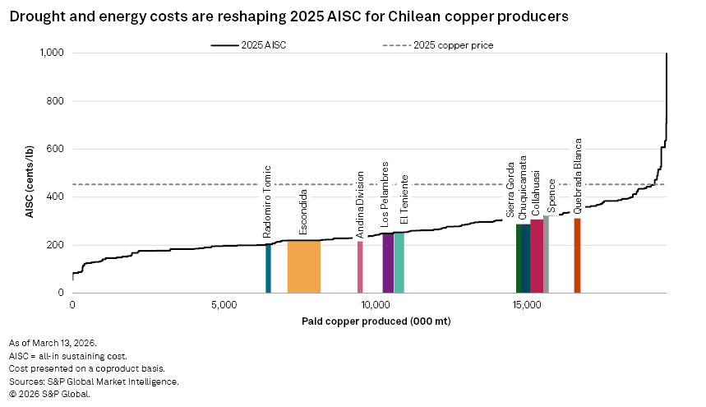
(Source: https://www.spglobal.com/market-intelligence/en/news-insights/research/2026/04/water-energy-pressures-are-driving-up-chiles-mining-costs.)

