ISSUES AND CHALLENGES OF CYBERSECURITY AND MITIGATION STRATEGIES USING AI


Name- Harsimran Kaur Hira
Student ID - 2218345
Course - MBA Banking and Finance
Module Name - Dissertation
Module Code -LCMB7020_LON
Lecturer Name – Jia Miao



Master’s Degrees by Examination and Dissertation
Declaration Form.

I, Harsimran Kaur Hira, declare that this dissertation has been composed by myself, that the work contained herein is entirely my own except where explicitly stated otherwise in the text, and that this work has not been submitted for any other degree or qualification, in whole or in part, except as specified.

Signature: …………Harsimran Kaur Hira……………………............................

Date: …………15/06/2024……………………............................

Abstract
Cybersecurity is a key trait of modern society, which empowers data safety and personal information. Businesses can implement AI-based solutions by being aware of the drawbacks of traditional cybersecurity. Mitigation strategies based on artificial intelligence can improve cybersecurity and reduce the likelihood of cyberattacks. Furthermore, this research will advance our understanding of AI cybersecurity. The research has addressed a significant digital challenge, regarding cybersecurity. The study has also demonstrated AI's potential for cybersecurity. Through the identification of problems and remedies, the research has presented the challenges prevalent in cybersecurity and the role of AI in mitigating issues. Businesses may better plan and purchase data and infrastructure protection technology by being aware of the cybersecurity landscape. For conducting the study, mixed method has been utilised, and for collecting primary data, a survey has been conducted. Moreover, the data has been critically analysed to procure different insights, and based on the conclusion of the study, a set of recommendations has been presented.

Acknowledgement
Firstly, I am thankful to my guide and professors for helping me in data collection and understanding the value of the research. Secondly, I am also thankful to my classmates and friends for helping me to understand data from different perspectives.

Table of Contents
Table of Contents 4
Chapter One: Introduction 6
1.1 Background 6
1.2 Research Aims and Objectives 7
1.3 Research Questions 7
1.4 Rationale of the Study 7
1.5 Significance of the Study 8
1.6 Problem Statement 9
1.7 Organization of the Dissertation 10
2. Literature review 10
2.1 Overview of cybersecurity 10
2.2 Cybersecurity in different perspectives 13
2.2.1 Identity threat 13
2.2.2 Social media 14
2.2.3 Personal devices, virus, etc 16
2.2.4 Banking 19
2.2.5 Other fraud and other consideration 20
2.3 Recent development 23
2.3 Recent development 23
3.0 Research Methodology 26
3.1 Introduction 26
3.2 Research Onion 26
3.3 Research Approach 27
3.4 Research Philosophy 28
3.5 Research Design 29
3.6 Research Strategy 29
3.7 Data Collection Method 30
3.8 Data Analysis 30
3.9 Ethical Consideration 31
3.10 Summary 32
Chapter 4: Findings and Discussion 33
4.1 Introduction 33
4.2 Findings 33
4.3 Discussion 48
Chapter 5: Conclusion and Recommendations 51
5.1 Conclusion 51
5.2 Recommendations 52
5.3 Research Limitations 53
5.4 Future Research Opportunities 53
Reference list 54
Appendices 61

Chapter One: Introduction

1.1 Background
Cyberattacks are more likely due to rapid technology advancement and dependency. Cybersecurity concerns grow as cyber threats become more sophisticated. Cybersecurity Ventures predicts $6 trillion in 2021 cybercrime costs. To protect sensitive data, strong cybersecurity is essential. The digital age has advanced society in numerous ways. Cyberattacks and security issues increase with such developments, providing a serious risk to organisations and individuals. Cybersecurity is become a social and economic problem (Camacho, 2024). Identity thieves and organised cybercriminals exploit critical infrastructure security holes as cybersecurity threats.
Due of cyberattack volume and complexity, traditional cybersecurity solutions are insufficient. Innovative and advanced methods are needed to address this threat. AI cybersecurity is one option. Artificial intelligence can detect and stop assaults in real time, enhancing cybersecurity. It can detect and respond to threats faster as an automated and proactive cybersecurity solution. The rapid development of technology has benefitted society yet facilitated cyberattacks. The rise of technology and digital platforms exposes people, companies, and governments to cyberattacks. In the digital age, cybersecurity protects individuals, businesses, and governments from unwanted data and system access, interruption, and misuse.
Cybersecurity protects computers, networks, and data from hackers. Information systems and networks are protected from digital attacks, theft, and damage by many technologies, methods, and practices. New and effective security mechanisms are needed to prevent sophisticated cyberattacks. Traditional firewalls and encryption are insufficient to tackle new cyber threats. A promising cybersecurity solution is AI. Threat detection and incident response are automated and improved by AI. Technology has enhanced many businesses and simplified life. Cybercrime and security breaches increase with technology use. Cyberattacks have become more frequent and severe, costing trillions and injuring millions. Cyberattacks were the top worldwide risk in likelihood and impact in the World Economic Forum's worldwide Risk Report 2020, highlighting the need to address cybersecurity (Sontan, and Samuel, 2024).
As technology progresses, cyberattacks and threats have increased. The digital age requires cybersecurity for individuals, corporations, and governments. Due to increased internet and gadget use, cybercrime has damaged individuals and companies financially and reputationally. Cyberattacks occur every 39 seconds, making cybersecurity important. Cybersecurity concerns governments, businesses, and individuals in the digital age. Due to the rise in cyberattacks and data breaches, stronger data protection is essential. Cybercriminals use new methods as technology evolves, making cybersecurity difficult. AI solutions to cybersecurity challenges are examined in this dissertation. Recently, technology has made occupations easier, faster, and more efficient for individuals and businesses. Cybersecurity challenges arise with new technologies. Cybersecurity safeguards computers, networks, software, and data from cyberattacks. The exponential surge in cyber-attacks over the past decade has revealed that traditional cybersecurity methods can longer protect people and businesses. The need for effective cyber threat solutions is growing (Bécue, Praça, and Gama, 2021).

1.2 Research Aims and Objectives
This dissertation investigates cybersecurity vulnerabilities and provides AI-based mitigation. This dissertation examines cybersecurity and AI solutions. The objectives will be explained within the following discussion.
1. To identify the current challenges and threats in the field of cybersecurity.
2. To examine the role of artificial intelligence in addressing cybersecurity challenges.
3. To provide recommendations for the integration of AI in cybersecurity strategies.
4. To understand the capabilities of AI in cybersecurity.

1.3 Research Questions
The research questions which will guide the dissertation are as follow.
1. What are the current issues and challenges in cybersecurity?
2. How can AI be used to enhance cybersecurity?
3. What are the strengths and limitations of AI-based cybersecurity solutions?
4. How can AI be effectively utilized to mitigate cybersecurity threats?

1.4 Rationale of the Study
Research is vital for many reasons. First, it discusses cybersecurity and data protection challenges for businesses and individuals. Understanding concerns helps design effective mitigation solutions. Second, this research will improve AI cybersecurity knowledge. This industry's AI capabilities will be examined to boost cybersecurity. This research will assist businesses and policymakers on leveraging AI to combat cybersecurity threats. Cybersecurity threatens consumers and businesses. Traditional cybersecurity methods cannot guard against new and sophisticated cyber threats in the ever-changing digital economy. Therefore, cyberthreats require complicated and imaginative answers. AI has shown potential in cybersecurity and other fields (Kumar et al., 2023). This study examines how AI can tackle cybersecurity issues that hampered prior solutions.
Emerging cybersecurity AI is understudied. Artificial intelligence may lessen cybersecurity risks. This study's recommendations can benefit cybersecurity researchers and practitioners. The number and complexity of cyberattacks require new and improved solutions, making this research relevant. Due to rapid technological advancement and increased cyber threats, AI's cybersecurity potential must be examined. Cybersecurity experts may benefit from AI's cyberattack detection and prevention. AI for cybersecurity has perks and cons, as this article shows.
Cyberattacks affect individuals, companies, and governments worldwide. Protecting critical data and infrastructure from cyberattacks is essential as technology and data grow. Firewalls and antivirus can longer defend against sophisticated cyberattacks. AI and other current technologies are needed to boost cybersecurity. Digitization and technology have explosively escalated cyberattacks. Firewalls and antivirus software cannot keep up with cybercriminals' sophisticated methods. Thus, sensitive data protection requires more complicated and flexible solutions. AI can automate tasks, discover abnormalities, and find patterns that traditional methods miss, revolutionising cybersecurity. This study explains how AI improves cybersecurity. This work advances cybersecurity and AI's potential to solve problems. Corporate and government bodies can apply AI in cybersecurity with its realistic guidance. Research on cybersecurity and AI's ability to address current issues will assist policymakers and academia (Ahsan et al., 2022).

1.5 Significance of the Study
Cybersecurity will benefit from these dissertation findings. Understanding traditional cybersecurity's shortcomings helps companies adopt AI-based solutions (Patil, 2016). Artificial intelligence-based mitigation methods can boost cybersecurity and lower cyberattack risk. Additionally, this research will improve AI cybersecurity knowledge. A major digital issue is addressed, making this research important. Data breaches and cyberattacks are driving cybersecurity demand. The study will improve cybersecurity and provide AI-based cyber threat mitigation recommendations to companies and individuals. This study will show AI's cybersecurity potential. This study matters for several reasons. It begins with the current cybersecurity landscape and its effects on individuals, organisations, and governments. Second, AI's cybersecurity capabilities are analysed. Thirdly, stakeholders should employ AI to boost cybersecurity. This study will explain cybersecurity and AI's role in cyber defence to individuals, companies, and governments. This dissertation will describe cybersecurity and AI's challenges and solutions. The findings will assist governments, businesses, and individuals understand AI's cybersecurity potential. This report provides cybersecurity AI implementation suggestions.
This study can improve cybersecurity and AI by identifying concerns and solutions. Knowing the cybersecurity landscape helps companies plan and buy data and infrastructure protection equipment. This research can also assist lawmakers draft cybercrime laws. Additionally, this study will add to the growing AI and applications literature. It will influence cybersecurity research and policies. The findings of study will assist businesses and people improve cybersecurity. Organisations may deploy AI cybersecurity wisely by knowing its possibilities (Guembe et al., 2022). The findings will inform future study and add to the literature. Increases threat landscape understanding by revealing cybersecurity threats and issues. Aids AI cybersecurity research with evidence. To assist policymakers and organisations, evaluates AI dangers and ethics. Suggests employing AI in cybersecurity to reduce threats.

1.6 Problem Statement
Cybersecurity threats are too complicated for traditional solutions. AI is used to solve classic cybersecurity challenges in this research. Despite increased cybersecurity expertise and spending, cyberattacks are growing more frequent and sophisticated. This highlights the need for innovative cybersecurity solutions. Traditional security methods are inadequate, and AI is improving cybersecurity. The usefulness and practicality of AI in this environment are unknown. The work addresses this gap and reveals AI's cybersecurity potential. Cybersecurity is threatened by more frequent and sophisticated cyberattacks. Traditional cybersecurity solutions fail, exposing people and organisations (Mughal, 2018). AI-based cybersecurity solutions are proposed in this research.
Cyberattacks are becoming more regular and complex, alarming individuals, organisations, and governments (Geluvaraj, Satwik, and Ashok Kumar, 2019). Traditional cybersecurity no longer defends against these attacks. AI should be explored to solve challenges and improve cybersecurity. As cyberattacks become more frequent and complex, traditional cybersecurity measures are failing. Novel and improved methods are needed to overcome these difficulties. This article discusses AI's cybersecurity benefits and implementation guidance.
Digital data security is threatened by more frequent and sophisticated cyberattacks. Modern, proactive cybersecurity is essential to reduce these dangers. AI can boost cybersecurity, according to this study. Cyberattacks are increasing, and old cybersecurity methods no longer protect businesses and individuals. Modern and new technologies like AI are needed to mitigate cybersecurity risk. AI raises ethical and practical challenges (Mylrea, and Gourisetti, 2017). Many efforts address the diverse types of issues.

1.7 Organization of the Dissertation
The dissertation is divided into important chapters. I will include detail review about relevant literature on cybersecurity and AI. There will be proper level of explanation about the research methodology utilized within the study. The findings of the research will be presented and evaluated within the dissertation. There will be also a chapter which will be explained within the named as conclusions and recommendations that rely on the diverse research findings.

2. Literature review

2.1 Overview of cybersecurity
According to Familoni, (2024) cybersecurity safeguards digital systems, networks, and data from unauthorised access, attacks, and breaches. This comprehensive overview covers cybersecurity's importance, key ideas, common threats, and vital mitigation methods. In today's interconnected world, where digital technologies power personal communication and critical infrastructure, cybersecurity is essential. Cybersecurity breaches can cost money, reputation, and data. Making sensitive data accessible only to permitted users or systems. Data is encrypted during transmission or storage. Keeping data accurate, complete, and secure. Data integrity is validated via hash functions and digital signatures.
Camacho, (2024) has stated that maintaining systems and resources. DoS attacks must be prevented and mitigated. Verifying users or systems ensures approved resource access. Biometrics, passwords, and multi-factor authentication are authentication mechanisms. User and system authentication and role-based permissions. Avoiding digital transaction rejections. Digital signatures and auditors provide non-repudiation. Malware that steals or harms data. Viruses, worms, Trojans, ransomware. Cheating to get passwords or financial data. Phishing attacks spoof actual companies via emails, SMS, or fake websites. Intercepting unlawful communication. MitM attacks intercept, modify, or inject data.
Jimmy, (2021) included and referred that web application vulnerabilities allow backend database SQL command execution. Database tampering or illegal access to sensitive data may occur. Disrupting a system, network, or service with traffic. DoS and DDoS attacks can block genuine users from websites and services. Internal wrongdoing by employees or contractors who misuse their power or access to hurt the company. Security-based firewalls monitor and control network traffic. Firewalls separate trustworthy internal and external networks.
Identification and response to real-time threats and policy violations using IDPS systems. IDPS blocks malware and illegal access. Protecting sensitive data in transit and at rest with encryption. Strong encryption methods and protocols safeguard data. Update software, OS, and firmware frequently to fix security holes. Patch management reduces bad actor abuse. Sharing cybersecurity ideas like phishing detection and prevention. Security awareness training is crucial for human cybersecurity. Limiting user privileges and sensitive resource access with least privilege and granular controls. Access restrictions prevent unauthorised entry and insider threats (Shah, 2021).
Multifaceted cybersecurity needs a proactive, holistic approach to secure digital assets and prevent threats (Rodrigues, 2020). This study covers fundamental principles, common risks, and critical mitigation measures to help businesses and individuals secure, confidential, integrity, and availability of their digital systems and data. Modern cybersecurity threats include malware and nation-state cyberattacks. The problem is massive. Cybersecurity Ventures forecasts global cybercrime costs will top $6 trillion by 2021. IoT and cloud computing have expanded the threat surface, providing attackers new ways to attack. Thakur, (2024) has stated that cybersecurity is a serious concern in the digital age due to the frequency and sophistication of cyber threats. Traditional defences are failing these threats and therefore AI is improving cybersecurity. Individuals, businesses, and governments are threatened by increasingly sophisticated and broad cyberattacks. The CISA says malware, ransomware, phishing, and insider threats are evolving. Technology's rapid growth has brought many benefits, but it has also raised cybersecurity problems. As organisations, governments, and individuals store, analyse, and transfer sensitive data on digital systems and networks, strong cybersecurity is needed more than ever. Traditional cybersecurity strategies sometimes fail to address new cyberthreats. These hazards endanger critical infrastructure, data, and national security. Digital cybersecurity worries individuals, companies, and governments globally. As digital technology advances, cyber threats have become more sophisticated, compromising data security and privacy. These hazards are increasingly handled by AI. AI can help cybersecurity, according to this literature study (Bertino et al., 2021).
Cyberattacks harm individuals, organisations, and governments online. Ali et al., (2022) have stated that cybersecurity Ventures predicts cybercrime losses would top $6 trillion by 2021, underlining the necessity to address cybersecurity. Digital asset protection is harder due to networked devices, improved attack pathways, and hacking tool commoditization. Cyber threats like malware, phishing, cyber-espionage, and ransomware are evolving. Cyberattacks on government organisations, healthcare organisations, financial institutions, and key infrastructure have escalated, according to CISA. Cybersecurity Ventures estimates that cybercrime will cost $6 trillion worldwide by 2021 as straining businesses and governments. According to Ghelani, (2022) several problems impair traditional cybersecurity. Cyberthreats are growing rapidly. Signature-based detection cannot keep up with emerging malware strains' volume and complexity, leaving businesses vulnerable to zero-day attacks. The global cybersecurity skills gap, estimated at millions, deepens the issue. Another issue: more sophisticated cyberattacks. Social engineering, zero-day exploits, and polymorphic malware help APTs hide in networks. Contemporary IT ecosystems are interdependent, so a breach in one company can influence supply chains, amplifying intrusions.
Sakhnini, and Karimipour, (2020) have stated that cybersecurity changes with new threats and technology. The Cybersecurity and Infrastructure Security Agency reports rising ransomware, phishing, data breaches, and supply chain risks. These accidents weaken digital system trust and cost money. The rise of networked devices and the IoT has enlarged the attack surface, offering cybercriminals more opportunities to exploit weaknesses and launch assaults. Cybersecurity professionals struggle to secure sophisticated networks in interconnected digital ecosystems. Multiple issues hamper cybersecurity. Large and diverse cyberthreats are an issue. Traditional security methods cannot keep up with new attacks. The cybersecurity skills gap exposes companies to attackers. Recent large-scale breaches illustrate that interconnected digital systems increase cyberattack vulnerability.
Based on the above analysis it can be stated that cyber security plays the most important role in protecting the network, databases and digital systems from cyber-attacks, data breaches and unauthorised access. In that case, the increasing demand for digital technologies for critical infrastructure and personal communication has enhanced the need for ensuring cybersecurity. Data breaches and other vulnerable activities might lead to a reduction of brand reputation and financial losses. The key factors of cybersecurity include availability, encryption strategies, data confidentiality and authentication procedures. It might include the common threats like phishing, MitM attacks, malware and DDoS attacks. In order to mitigate the challenges organisations might use firewalls, IDPS systems and strong access controls. On the other hand, IoT and cloud computing systems might be easier to access and enhance the risks of data breaches. Enhancement of awareness about security and improving the technological mechanism will ensure the safety of databases and prevent the risks associated with cybersecurity.

2.2 Cybersecurity in different perspectives

2.2.1 Identity threat
Identity theft leadings to stealing PII to impersonate someone or commit fraud is a widespread criminal. Cybersecurity prevents and detects identity theft. Social security numbers, bank account information, and passwords must be protected to prevent identity theft. Access limitations, encryption, and authentication protect PII from cybercriminals. By understanding phishing methods and questionable emails, websites, and texts, users may protect their credentials. Monitoring and detection help organisations spot suspicious behaviour and unlawful access promptly. IDS, anomaly detection, and user behaviour analytics identify identity fraud. Sontan, and Samuel, (2024) explained that cybercriminals steal login credentials with phishing emails and viruses. These credentials can be used to steal identities and access email and online banking. Large-scale data breaches that compromise PII from company databases raise identity theft risk. The 2017 Equifax data breach exposed approximately 147 million people's personal information, increasing identity theft. Scammers use stolen identities to open accounts, apply for loans and credit cards, and buy. Identity theft causes financial losses, bad credit, and lengthy recovery. MFA secures accounts and sensitive data by requiring a password and a mobile device-sent one-time code. Biometric and knowledge-based authentication questions help businesses prevent account takeovers. Credit monitoring services can detect anomalous account openings and credit queries and send real-time notifications to prevent identity theft risks.
AI offers cybersecurity benefits and disadvantages. Adversarial attacks, when threat actors manipulate AI systems to escape detection or generate false positives, are serious. AI systems need training data, hence insufficient or biassed data can lead to errors. There is requirement to consider ethics and privacy while employing AI in cybersecurity. AI-powered surveillance can infringe privacy rights if misused. AI threat hunting and attribution increase cybersecurity and transparency issues. Organisations can ensure to address AI-driven cybersecurity issues within different types of ways. Crafting machine learning models that can withstand attacks via adversarial training and model diversification. Explainable AI helps security analysts understand alerts and decisions from AI systems (Bharadiya, 2023). Combining AI and human analysts' cybersecurity skills. Many companies have improved cybersecurity with AI. Cybersecurity firm Darktrace employs AI algorithms to detect and respond to cyber threats in real time, helping organisations manage risks. BlackBerry-owned Cylance prevents malware and zero-day attacks with AI-based endpoint protection.
Threat intelligence, vulnerability management, incident response, and security operations use AI. AI algorithms assist threat intelligence platforms uncover new threats and patterns by correlating threat data from several sources. AI-driven risk assessment systems can prioritise vulnerabilities by severity and security impact, helping security teams repair high-risk vulnerabilities first. Security incident containment and remediation are accelerated by AI-powered SOAR platforms, which automate repetitive tasks and orchestrate response actions across security technologies. To combat sophisticated threats, several companies have incorporated AI-driven cybersecurity solutions. Famous cybersecurity startup Darktrace employs AI algorithms inspired by the human immune system to detect and respond to cyber threats in real-time across digital settings. Security company Palo Alto Networks offers Cortex XDR, an AI-driven extended detection and response platform that correlates security telemetry from many sources to detect and respond to threats.
This review can be concluded by stating that cybersecurity plays the most important role in detecting identify and removing the identity threats. It protects the personally identifiable information through encryption, limiting access and authentication. In that case, it is required to understand the phishing procedures and monitoring the unauthorised activities to protect the credentials. Also, a strong focus on protecting confidential databases will help to prevent adversarial attacks and meet privacy concerns.

2.2.2 Social media
Communication, networking, and sharing personal experiences are now daily social media activities. Privacy breaches, data breaches, and online harassment result from social media use. Social media data including location, photos, and contacts must be protected from attackers. Privacy and security settings on social media help users control material visibility and risk. Social networking sites must secure user data to avoid breaches and unauthorised access. Security audits, encryption, and access limits protect important data (Gupta et al., 2020).
Vegesna, (2023) stated that social media cyberbullying and harassment must be aggressively addressed to promote online safety and respect. Users are protected by content filtering, reporting, and community norms. Cybercriminals steal data, spread viruses, and mimic authentic social network members. Social engineering, phishing, and weak passwords threaten accounts. Social media networks collect vast user data for targeted ads and analytics. However, data breaches or inadequate data protection may allow illegal access or use of personal data, compromising users' privacy rights. On social media, fake news, misinformation, and disinformation can encourage violence and weaken democracy. Content control, fact-checking, and algorithmic transparency can halt this (Aslam, 2024).
Promote complex passwords and 2FA for social media accounts. Privacy settings education and encouraging users to routinely review and change their privacy preferences help users control data visibility and protect privacy. Cybersecurity awareness training helps social media users notice and report strange activity, making them more resistant to phishing scams and account hijackings. Identity theft and social media risks are reduced by cybersecurity. Preventing cyberattacks, boosting awareness of prevalent threats, and encouraging cybersecurity can protect digital identities and online privacy (Ambalavanan, 2020).
AI and cybersecurity will merge due to technology and threat environment changes. Organisations should combine AI-powered cybersecurity solutions with human experience and best practices to maximise advantages and minimise risks. Additionally, policymakers and industry stakeholders must agree on AI cybersecurity standards. Cybersecurity is complicated and requires constant innovation and threat response. Cybercrime detection, risk management, and response improve with AI (Rehan, 2024). AI-driven cybersecurity can improve security and reduce cyberattack risk. Without management and experience, AI cannot solve cybersecurity problems. AI-driven cybersecurity solutions need more research and funding to tackle new threats and secure critical assets and infrastructure.
Singh et al. (2020) said AI and ML are cyber defence powerhouses. AI analyses enormous network data, user behaviour, and security logs to detect anomalies and hazards in real time. These systems can prevent suspicious behaviour, quarantine infected devices, and initiate incident response, saving time. Companies can mitigate cyber threats with AI-powered predictive analytics. AI models can identify trends, anticipate attack pathways, and assess cyber threat likelihood and impact using historical data, threat intelligence, and contextual information. This improves cybersecurity by managing resources, deploying targeted security measures, and creating effective incident response strategies. AI-powered security adapts to threats. These systems can improve detection, defence, and autonomous threat response with new data and feedback. Adaptive and autonomous cybersecurity can help organisations avoid complicated cyber threats (Jeong, 2020).
Dasgupta, Akhtar, and Sen, (2022) explained that AI prioritises patches and controls vulnerabilities. AI-based solutions identify critical vulnerabilities from vulnerability, system, and threat data. Organisations prioritise security issues with limited resources to reduce hackers' window of opportunity. Many companies use AI-driven mitigation to tackle challenges. AI-powered threat hunting systems can detect IOC and suspicious activity on networks. Many companies use AI-driven mitigation to tackle challenges. AI-powered threat hunting systems can detect IOC and suspicious activity on networks. Honeypots and decoy networks using AI distract attackers, providing security teams time. Immutable ledgers and decentralised consensus in AI and blockchain may defend vital infrastructure from hackers. Companies can detect and avoid hidden insider risks with AI-driven user behaviour analytics. These systems can detect insider risks including data exfiltration, unauthorised access, and hostile behaviour by analysing user behaviour, access patterns, and irregularities. Proactive insider threat identification helps secure organisations.
The above-reviewed literature has highlighted the risks of using social media platforms including, data theft, cyberbullying and privacy breaches. In that case, it is required to protect the databases of customers through complex password combinations, two-factor authentication and data encryption. Artificial intelligence can enhance the security of information by detecting threats and frauds.

2.2.3 Personal devices, virus, etc
AL-Dosari, Fetais, and Kucukvar, (2024) explained that there is importance of access, interact, and complete all things online level with computers, phones, and tablets. Viruses, malware, and unauthorised access can also harm these devices. Cybersecurity is essential for device protection and cyberattack prevention. Images, financial data, and login credentials are stored on personal devices. This data must be protected to prevent identity theft, financial fraud, and privacy breaches. Malware like viruses, ransomware, and spyware can compromise device and data security. Antivirus, firewalls, and security improvements prevent malware. Social media, email, and messaging apps are used on personal devices. Communications must be secure to prevent hostile eavesdropping, interception, and manipulation Kseniia, and Minbaleev, (2020).
Using network connections or removable storage, viruses and worms infect and spread on personal devices. WannaCry spread rapidly across thousands of PCs in 2017 to encrypt files and demand payment. Phishing attacks steal login credentials or financial information from personal devices via fake emails, messages, or websites. Phishing scams impersonate trusted companies or persons to deceive victims into clicking on malicious links or installing malware. Personal devices are at risk when cybercriminals intercept and eavesdrop on public Wi-Fi networks. Man-in-the-middle attacks intercept and manipulate device-network connections in insecure Wi-Fi networks (Shaukat et al., 2020).
Installing trustworthy antivirus software on personal devices removes viruses, Trojans, and malware. Cyberattacks can be prevented by updating antivirus and malware scanners. Updates to security, operating system, and software help address vulnerabilities thieves may exploit. Automatic updates install critical security fixes fast. Passwords, fingerprints, and 2FA secure devices and accounts. No shared or default passwords and complex passwords boost device security (Kumar et al., 2023).
AI-automate malware analysis and incident response. Unsal et al., (2021) referred that AI-based systems can swiftly analyse, categorise, identify, and build malware countermeasures, helping security teams respond faster. Prioritising security risks using AI helps firms manage resources and respond. AI aids software security and supply chain risk management. Software developers can reduce system risks by using AI-powered code analysis and vulnerability detection to uncover and patch security flaws early. AI can audit and monitor supply chain partners' security, helping companies identify and resolve third-party vendor and dependency issues. Examples can prove AI-driven cybersecurity solutions' viability. Darktrace, a significant cybersecurity startup, employs immune system-inspired AI algorithms to detect and respond to new threats in real time. BlackBerry-owned Cylance prevents malware and ransomware attacks via machine learning (Raimundo, and Rosário, 2022). These case studies show how AI improves cyber defenses and reduces new threats.
Many real-world examples demonstrate AI's cybersecurity. Darktrace, a significant AI cybersecurity business, uses unsupervised machine learning algorithms to detect and respond to cyber assaults in real time. Darktrace's AI-powered software can detect breaches in network traffic and user behaviour and decrease risks. Cybersecurity company AI and machine learning help Cylance secure endpoints predictively. Alazab et al., (2021) explained that Cylance’s AI-driven software analyses billions of file attributes and uses complex mathematical models to detect and prevent malware before it causes harm. The AI-powered technology finds new cyber dangers by analysing unstructured data from security publications, blogs, forums, and research papers. IBM Watson boosts cybersecurity experts with AI-driven insights.
Darktrace AI uses unsupervised machine learning techniques to detect and respond to cyber-attacks in real time. Darktrace AI learns network and endpoint behaviour to detect fraud and correct them automatically. Machine learning-based AI-driven endpoint protection stops malware and fileless attacks. Cylance PROTECT analyses file attributes and behaviour to prevent known and undiscovered endpoint threats. Deep Instinct uses deep learning algorithms to predict and prevent endpoint, network, and mobile device cyberattacks. By training on a diverse dataset, Deep Instinct can identify and mitigate emerging cyber hazards with few false positives. Vectra AI detects and responds to cyber assaults in real time using machine learning techniques. Vectra AI analyses network traffic and user behaviour to prioritise security investigations and fixes (Schmitt, 2023).
AI-powered cybersecurity systems examine enormous data sets to find cyber threat patterns. These systems detect odd behaviour, malware signatures, and compromise signs in real time to mitigate threats. In predictive analytics, AI employs historical data, threat intelligence feeds, and machine learning models to predict cyber assaults. Organisations can avoid cyberattacks by identifying vulnerabilities and attack pathways. AI-driven cybersecurity systems automate incident response, detecting, containing, and remediating cyber threats quickly. Automating security operations speeds incident detection and mitigation (Gunduz, and Das, 2020). AI-based behavioural biometrics authenticates users and detects illegal access attempts by studying user behaviour and interaction patterns. These solutions continuously monitor user activity to detect insider threats and credential misuse. AI-based adaptive security controls change security rules and configurations based on threat and risk levels. Security breaches are reduced and cyber defenses strengthened by adaptive security controls. AI may aid cybersecurity experts. Machine learning helps AI systems spot cyber-attack patterns in massive data sets. Data breaches and system invasions are reduced via real-time threat detection and response Bharadiya (2023).
The analysis can be concluded by highlighting it's key findings which indicate that, cybersecurity plays the most important role in protecting personal data and devices from malware attacks. Antivirus software, enhanced authentication, threat detection and antivirus software can help to prevent the challenges by using artificial intelligence. Integration of artificial intelligence with human excellence organisations can successfully protect its confidential databases from cyber threats and ensure confidentiality of the information.

2.2.4 Banking
Banking and financial industries are prime targets for cyberattacks due to their significant assets and sensitive data. For customer data, financial transactions, and system integrity, banks need cybersecurity. Cybersecurity must reduce banking cyber risks. Banking institutions store sensitive consumer account, transaction, and financial data. This information must be kept private to prevent data breaches, financial fraud, and unauthorised access. Online banking, mobile apps, and ATMs must be protected to prevent fraudsters from accessing, intercepting, or manipulating financial transactions. Transactions are protected by encryption, authentication, and fraud detection. Banks are required to obey tight data, cybersecurity, and financial privacy laws. GDPR and PCI DSS compliance decrease legal and regulatory risks and ensure cybersecurity accountability (Rangaraju, 2023).
Bank data breaches might reveal account, SSN, and financial information. The 2014 JPMorgan Chase breach exposed over 83 million client accounts, demonstrating banking data breach vulnerabilities. Credit and debit card fraud worry banks and customers. Cybercriminals steal cardholder data and make unauthorised transactions using skimming, card cloning, and CNP fraud. DDoS, malware, and insider threats can attack core banking, payment processing, and ATM networks. Bank infrastructure failure can disrupt services, cost money, and damage reputation. Real-time transaction monitoring, anomaly detection, and machine learning algorithms help prevent fraud, suspicious behaviour, and unauthorised transactions.
Authenticating online banking, smartphone apps, and ATM transactions improves security. MFA, biometric authentication, and dynamic security tokens verify user identities and secure critical transactions. Cybersecurity awareness training informs bankers and customers about cyber threats, phishing schemes, and security best practices. Education helps consumers fight social engineering and online fraud. Personal gadgets and banks need cybersecurity to avoid malware, data breaches, and financial fraud. By strengthening cybersecurity, boosting awareness of common threats, and encouraging security and resilience, individuals, companies, and banks can reduce cyber risks and protect their assets, data, and reputation (Naseer, 2021).
Security detects and prevents assaults via AI. Machine learning algorithms can detect cyberattacks in network traffic, endpoint records, and user behaviour. New data may help AI systems adapt to dangers and enhance detection. Darktrace and Cylance prevent malware from infiltrating enterprise networks via AI. Shoetan et al., (2024) stated that through automating repetitive tasks and expediting decision-making, AI can improve incident response. AI systems can quarantine suspect files, isolate hijacked devices, and block hostile IP addresses during security crises. This minimises cyber-attack detection and containment time, avoiding business disruptions and losses. Actionable AI insights and recommendations can also help cybersecurity experts. By assessing vast security data, AI systems may identify vulnerabilities, rank risks, and recommend fixes depending on the organization's threat landscape. This helps cybersecurity teams prioritise threats and allocate resources.
AI can improve security by observing and adapting. AI systems can anticipate dangers and weaknesses to help businesses avert cyberattacks. IBM Radar and Splunk utilise AI-driven analytics to detect and respond to security issues in real time, strengthening defences and reducing cyber threats. AI-powered machine learning and behavioural analytics enhance danger detection. AI systems can detect cyberattacks by examining enormous data sets in real time. Preventive security intervention is possible with anomaly detection algorithms that detect abnormal network traffic or user behaviour. AI automates incident response and decreases cyber harm. Incident response systems can automatically triage security warnings, prioritise risk severity, and remediate. AI-enabled automation lowers manual errors and speeds response times, helping organisations manage cyber threats and recover faster.
The above analysis has highlighted that for the banking and financial industries it is required to protect the sensitive databases, system integrity and financial transactions. Focusing on the regulations including PCI DSS and GDPR it will be possible to ensure financial integrity and improve cyber security practice.

2.2.5 Other fraud and other consideration
Cybersecurity transcends social media, devices, banking, and identity theft. Also significant are e-commerce fraud, IP protection, supply chain security, and technology development. Understanding these views helps create a cybersecurity plan and reduce risks. Online shopping, payments, and digital transactions are possible on e-commerce platforms and fraud is conceivable. Online fraud—unauthorized transactions, payment disputes, account takeovers, and counterfeit goods—threatens businesses and customers. Online transactions must be secure to avoid fraud, credit card theft, and unauthorised charges. Encryption, payment gateways, and fraud detection systems protect financial data (Al-Hawawreh, Aljuhani, and Jararweh, 2023).
To prevent e-commerce fraud, machine learning algorithms, behavioural analytics, and transaction monitoring are needed. Real-time fraud detection mitigates risk by spotting suspicious patterns, irregularities, and indicators. Cybercriminals steal e-commerce accounts by phishing, credential stuffing, and brute force. Accounts can be hacked to make purchases, change settings, or steal data. Online CNP fraud involves cybercriminals using stolen payment cards to buy goods. Since e-commerce allows cardless purchases, CNP fraud targets them. Secure authentication and fraud detection prevent CNP fraud and save businesses and customers money. Ideas, patents, trademarks, copyrights, and trade secrets are intellectual property. IP protection drives innovation, growth, and competitiveness. IP theft and piracy are reduced by cybersecurity. Encrypt proprietary software code, design blueprints, and trade secrets to prevent theft. Strong encryption and keys secure IP data. Granular access controls and user permissions restrict IP asset access using least privilege. User restriction decreases insider threats, data breaches, and IP theft (Viganò, Loi, and Yaghmaei, 2020).
Business rivals, foreign governments, and hostile insiders can steal trade secrets, proprietary technologies, and R&D data. Hacking, data breaches, and insider threats are common ways to profit from IP theft. Businesses, manufacturers, and content creators confront major counterfeiting and piracy concerns. Cybercriminals make fake items, pirated software, and brand replicas to harm real businesses. Suppliers, manufacturers, distributors, and logistics providers create complex supply chains to generate and deliver goods and services. The integrity, stability, and resilience of global business depend on supply chain security against cyber threats, vulnerabilities, and disruptions. Assessing and managing supply chain cybersecurity risks requires vendor risk management. Supplier security assessments, third-party vendor due diligence, and cybersecurity contracts mitigate supply chain risks and ensure compliance. Threat feeds, industry research, and security advisories assist companies identify and mitigate supply chain cyber threats. Sharing threat intelligence helps partners and stakeholders defend against common risks (Humayun et al., 2021).
Cybercriminals penetrate companies through trusted supply chain partners and vendors. Software and hardware supply chain attacks, third-party breaches, and unauthorised access use supplier network flaws to steal data or transfer malware payloads to target businesses. Hardware implants, malicious firmware updates, and counterfeit goods endanger critical infrastructure, industrial systems, and consumer electronics. Inspection, validation, and traceability are needed to detect and mitigate physical supply chain attacks. AI, IoT, blockchain, and quantum computing present new cybersecurity challenges. Understanding how new technologies affect cybersecurity is essential for adapting security strategies, handling new risks, and responsibly employing innovation. To be dependable, fair, and transparent, AI and machine learning systems must be secured from adversarial attacks, data poisoning, and model shortcomings. Strong security measures, bias reduction, and explainability reduce AI risks and build confidence Jimmy, (2024).
Smart home devices, industrial sensors, and connected autos complicate cybersecurity by increasing network attack surfaces. Secure devices, segment networks, and enforce robust authentication to protect IoT ecosystems from botnets, DDoS attacks, and data breaches. AI algorithms may discriminate based on race, gender, or other sensitive traits, inflicting social harm. Equitable and inclusive AI systems require ethical concerns, diverse training data, and algorithmic transparency. Mirai and Reaper launch large DDoS, spam, and crypto jacking attacks using compromised IoT devices. Security hygiene and risk mitigation are needed to protect IoT devices with default passwords, unpatched vulnerabilities, and poor security controls from botnet operators. Cybersecurity includes e-commerce fraud, intellectual property protection, supply chain security, and new technology, each providing unique challenges for businesses and individuals. Through awareness of these viewpoints' cybersecurity implications and proactive risk mitigation, stakeholders can protect corporate assets, data, and operations from cyber threats and establish a secure and resilient digital environment (Yaacoub et al., 2022).
AI-powered adaptive security controls use contextual awareness and adaptive learning to adapt security policies and controls to changing threat intelligence and risk profiles. Adaptive controls optimise access rights, network segmentation, and encryption to prevent hazards and unauthorised access to critical assets. AI-driven predictive analytics help companies prepare for cyberattacks. AI-driven platforms can improve cybersecurity training and education by personalising learning to skill levels and preferences. These platforms use adaptive learning algorithms to identify knowledge gaps and give tailored cybersecurity training to employees. AI-based simulations and gamification can recreate real-world cyber-attack scenarios, letting students practise reaction strategies safely (Nishant, Kennedy, and Corbett, 2020).
AI improves cybersecurity defences and reduces risks. AI-driven threat intelligence systems can uncover new threats and vulnerabilities by analysing threat data from several sources. Natural language processing and machine learning parse and contextualise threat data to assist firms make security decisions. Another mitigation method is AI-powered endpoint security. Antivirus signatures miss polymorphic malware. Even without warning, AI-driven endpoint security solutions' ML algorithms detect and block harmful activities in real time. Identifying new threats helps companies avert breaches. Cybersecurity is complicated and changing quickly. AI offers new ways to improve security and reduce risks. Machine learning algorithms and advanced analytics help organisations detect and respond to cyber-attacks faster, more accurately, more efficiently. AI will increasingly assist organisations keep ahead of attackers in the digital security war as it matures (Ahmad et al., 2021).
Cybersecurity and AI offer opportunities and problems for digital asset protection. AI can improve threat detection and response, but its downsides must be addressed. In a linked world, AI-driven mitigation and data scientist-cybersecurity collaboration can improve cyber resilience. Academic research, corporate insights, and real-world applications underscore AI's importance in cyber defence by providing a comprehensive understanding of cybersecurity risks, challenges, and mitigation methods. The growing threat landscape, insider dangers, IT complexity, and cybersecurity skills shortage make cybersecurity difficult for organisations. However, AI can enhance threat detection, vulnerability management, user behaviour analytics, and incident response automation. AI-driven cybersecurity can improve security and reduce threats.
In conclusion the cybersecurity is a disciplinary system which protects different risk factors associated with digital life. Artificial intelligence, machine learning and blockchain technologies might help to detect the threats and protect the intellectual properties.

2.3 Recent development

2.3 Recent development
Recently emerging AI and machine learning methods have changed cybersecurity threat detection and response. AI-driven security systems can analyse enormous data sets, discover trends, anomalies, and compromise signs, and respond to security threats in real time. AI-based IDSs can detect and neutralise APTs, zero-day attacks, and insider threats better than signature-based ones. Companies evaluate and mitigate cybersecurity threats with AI-enabled predictive analytics. Predictive analytics models analyse historical data, contextual information, and threat intelligence feeds to predict cyber threats, vulnerabilities, and attack vectors, enabling businesses prioritise security, allocate resources, and mitigate risks. AI and automation-powered SOCs have transformed cybersecurity. Autonomous SOCs leverage AI-driven orchestration and response to expedite issue triage, investigation, and resolution. By automating routine tasks and decision-making, autonomous SOCs help security teams focus on strategic goals and high-priority threats (Benzaïd, and Taleb, 2020).
Zero Trust Architecture, which focuses least privilege, continuous authentication, and micro-segmentation to restrict insider threats and attacker lateral movement, is growing in popularity. AI-driven IAM solutions implement Zero Trust by dynamically adjusting access constraints depending on user behaviour, device posture, and risk indicators. Threat Intelligence and Analysis: AI-powered threat intelligence tools identify cybercriminal threats, tactics, and techniques by correlating OSINT, dark web forums, and security feeds. These solutions leverage NLP and machine learning algorithms to prioritise warnings, extract actionable insights, and provide security analysts with contextualised threat data for decision-making (Zhang et al., 2022).
AI-driven behavioural analytics technologies uncover compromise by detecting anomalous user and entity activity across networks, endpoints, and clouds. Behavioural analytics systems build baselines of expected conduct and detect aberrant activity in real time to detect insider threats, credential misuse, and sophisticated cyberattacks that bypass standard security protections. User authentication and authorization requests are evaluated by AI-powered adaptive access control solutions based on location, device, network, and behavioural biometrics. Changing access privileges and imposing granular limits in real time lowers unauthorised access, privilege escalation, and credential-based attacks, enhancing security.
AI-driven threat hunting solutions detect malicious activity, hidden threats, and IT infrastructure security vulnerabilities using machine learning and advanced analytics. Threat hunting solutions automate workflows, correlate security data sources, and provide actionable insights to assist security teams locate and fix problems faster, decreasing dwell time and cyber-attack damage. Cybersecurity company using AI Deep Instinct endpoint security software uses deep learning to prevent known and novel cyber threats in real time. Deep Instinct uses deep learning models trained on vast datasets of harmful and benign files to detect and stop malware, ransomware, and zero-day attacks on PCs, mobile devices, and IoT devices (Thakur, 2024).
Darktrace detects and responds to threats autonomously using AI. Darktrace's Enterprise Immune System uses real-time unsupervised machine learning algorithms to detect abnormal activity and insider threats in cloud, email, and industrial control systems. Darktrace's AI-powered method detects and mitigates cyber threats without human interaction. BlackBerry-owned Cylance pioneered AI-driven endpoint protection that blocks malware and fileless attacks using machine learning. Cylance's Predictive Advantage approach classifies and stops endpoint threats before execution using AI algorithms trained on millions of harmful and benign files, reducing attack surface and breach risk. AI has improved cyber defence, helping companies to detect, respond to, and mitigate cyber threats. In today's dynamic threat landscape, AI-driven threat detection, predictive analytics, autonomous security operations, and adaptive access controls increase cybersecurity, reduce risks, and protect against emerging threats. However, cyber attackers change their tactics and strategies, so companies must stay alert, adapt, and invest in advanced cybersecurity solutions that leverage AI for proactive threat mitigation and resilience.
The digital age presents more complicated cyber dangers to organisations. AI can increase cyber security as traditional methods fall behind threats. AI-driven security solutions and mitigation can improve cybersecurity and combat emerging threats. Cybersecurity and AI offer opportunities and problems for digital asset protection. AI can improve threat detection and response, but its downsides must be addressed. In a linked world, AI-driven mitigation and data scientist-cybersecurity collaboration can improve cyber resilience. Academic research, corporate insights, and real-world applications underscore AI's importance in cyber defence by providing a comprehensive understanding of cybersecurity risks, challenges, and mitigation methods.
Modern companies must prioritise cybersecurity due to sophisticated cyber threats. AI can enhance threat identification, vulnerability management, and incident response. AI in cybersecurity raises ethical, privacy, and regulatory issues. AI, human skills, and best practices can improve cybersecurity and prevent new threats. Business cybersecurity challenges are complex and changing. The fast development of cyber dangers, a shortage of qualified staff, and legal limits make cybersecurity difficult. But AI-driven mitigation offers hope. AI and ML can automate security, identify, respond to, and predict cyberattacks. AI-powered threat detection, predictive analytics, and adaptive protection are changing cybersecurity. As AI-driven cybersecurity grows, businesses must stay attentive, monitor security, and adapt to changing threats. AI and cybersecurity knowledge and resilience can assist digital organisations protect their assets, reputation, and long-term operations.
In conclusion, artificial intelligence has offered different opportunities for protecting the databases from the frauds and data breaches. In that case, it is required to implement data-driven systems like Zero Trust Architecture, AI-POWERED IDs and enhance security controls to prevent the challenges.

3.0 Research Methodology

3.1 Introduction
A research methodology includes the entire research procedures and planning for collecting and analysing the needed evidence. In that case, researchers need to focus on applying the appropriate research methodology to support the research and effectively answer
the research questions. This section will mention the methodology which has been used to measure the Issues and Challenges of Cybersecurity and Mitigation Strategies using AI. In order to develop this section will mention the entire research procedure including, the research onion, approach, philosophy, design and strategies. Also, it will mention the data collection method, method for analysing the stored evidence, time horizon and ethical considerations for better understanding.

3.2 Research Onion
As the structure of the research onion, it argues that the research strategies might involve experimental research, surveys, action research, interviews systematic literature review and case studies (Mardiana, 2020). It helps to identify the main purpose of the research by measuring the appropriate methods for each of the steps associated with the research.
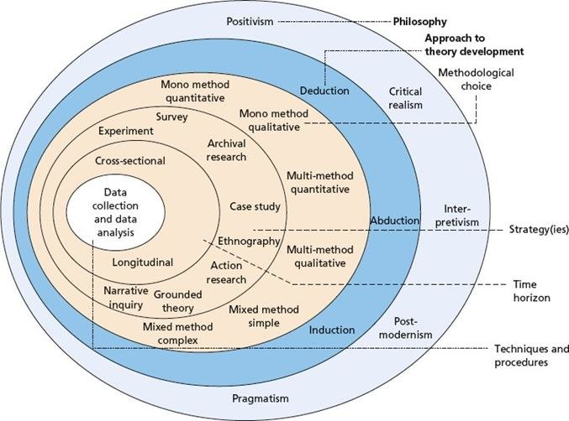
Figure 1: Research Onion
(Source: Saunders et al., 2019)

3.3 Research Approach
A proper research approach can help the researchers meet the objectives effectively and introduce the expected results of the research. For effective research it is important to outline the research approaches effectively so that it can be easy for the researchers to outline to required activities effectively. In that case, a research approach generally focuses on two types of procedures data collection and data analysis. Based on the characteristics there are three types of data collection and two types of data analysis methods present. The data collection processes are the primary, secondary and mixed methodology and the data analysis has two divisions inductive and deductive. Following its characteristics, this research has focused on a mixed methodology which influences everyone to adopt the primary and secondary research methods at the same time (Dawadi et al., 2021). Using a mixed methodology it has conducted an online survey to get a clear idea about the cybersecurity-related issues. On the other side, it has also reviewed the literature to identify the theoretical contexts related to the topic Issues and Challenges of Cybersecurity and Mitigation Strategies using AI. The research questions have been constructed by depending on the usage of artificial intelligence to prevent cyber security challenges. It will help the researchers discover a wide range of resources and analyse the perspectives to place a common statement to facilitate the conclusion.
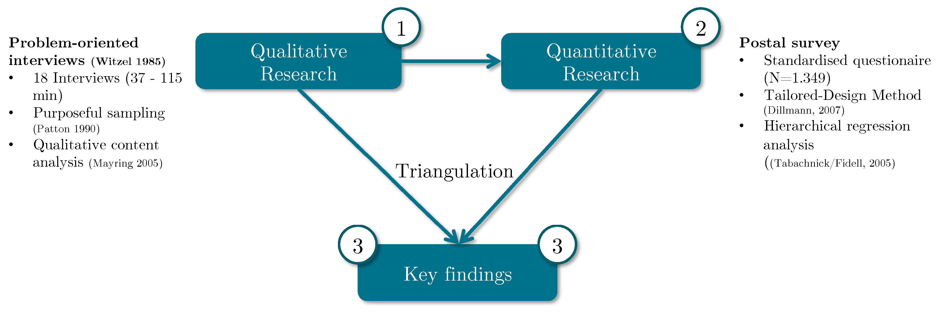
Figure 2: Framework for mixed methodology
(Source: März et al., 2020)

3.4 Research Philosophy
The beliefs related to data collection patterns and analysis patterns have been undertaken by research philosophy. Research philosophy is meant to reflect on the beliefs of the researchers about the sequence and pattern for data collection and analysis. Realistic, pragmatic, positivism and interpretivism are the variations of a research philosophy which indicate different types of beliefs (Saliya, 2023). These philosophies influence the researchers to measure the most effective way and sequence to collect the intellectual databases which may meet the outcome. A realistic research philosophy depends on the independent ideas which have been derived from human excellence. It is supported by the assumptions of the scientific research approach which prioritises the development process of knowledge. In the context of the present research on the Issues and Challenges of Cybersecurity and Mitigation Strategies using AI, it will use realistic research as it has implemented both the resources primary and secondary. Also, following the characteristics it has developed some questionaries to get a practical and real finding related to the research topic.

3.5 Research Design
A research design reflects on the entire research strategy which has been used to find the answers to the research questions. It influences the researchers to perfectly outline the underlying theories and models associated with the research topic. The primary strategy of a research design is collecting and storing the resources by maintaining integrity and ensuring effective usage of the resources for producing the results. Descriptive, Quasi-experimental, experiment and correlational designs are major variations of research design which impact the findings (Gopalan et al., 2020). The application of a proper research design helps the researchers to organise the research questions effectively so that it can be easy to identify the most efficient resources. An experimental research design has been undertaken to complete this dissertation. Following the guidelines of this design researchers has collected a wide range of information both primary and secondary and analyse them to measure the AI-powered solutions to mitigate the cybersecurity challenges.

3.6 Research Strategy
In order to meet the expected conclusion of a research topic it is important to to develop a proper research strategy to impact the objectives. A research strategy impacts the research activities including, the identification and organising of authentic resources, and measurement of the research questions and objectives to discover a proper research statement (Tracy, 2019). It has influenced the researchers to communicate the findings effectively by organising the resources and measuring the effective research questions to get the appropriate resources. This research has particularly focused on the usage of secondary resources by considering an experimental research design. Considering these factors, it became easy for the researchers to measure the AI-powered solutions in response to the cybersecurity challenges. Also, using a relevant research strategy, researchers can open the scope for further research to explore the topic more.

3.7 Data Collection Method
The data collection method is another major part of research which guides the researchers to collect the resources in the correct mode. A data collection method involves the primary mode, secondary mode and mixed mode (Lau et al., 2019). As it has chosen a mixed methodology it has collected both primary and secondary resources. For the primary resources, it has developed 30 survey questions to understand the participants' opinions. These survey questions have helped the researchers to get the expected answers from the participants. In the context of collecting the secondary resources, it has used Google Scholar to collect the authentic literature and articles which may facilitate the entire research. Focusing on different perspectives associated with artificial intelligence solutions for cybersecurity it has collected a wide range of resources.

3.8 Data Analysis
Along with the data collection method, data analysis is another major part of a research which helps the researchers to analyse the collected resources by maintaining the research ethics. As per the concept of the research approach, the data analysis has two variables including induction and deductive. The inductive data analysis process influences the researchers to focus on some particular patterns and observations to discover new theories (Pearse, 2019). A deductive data analysis process starts with the hypothesis and tests the entire theory by observing its characteristics. For developing this research, it has applied an inductive data analysis process to analyse different resources effectively and discover a new theoretical concept by observing the pattern of the resources. It has supported the research by offering a deep insight into the theoretical patterns of the resources so that the researchers can analyse the perspectives effectively. Also, it has observed the information which has been obtained from the survey to identify the opinions of people in AI-powered solutions to mitigate the cybersecurity challenges.

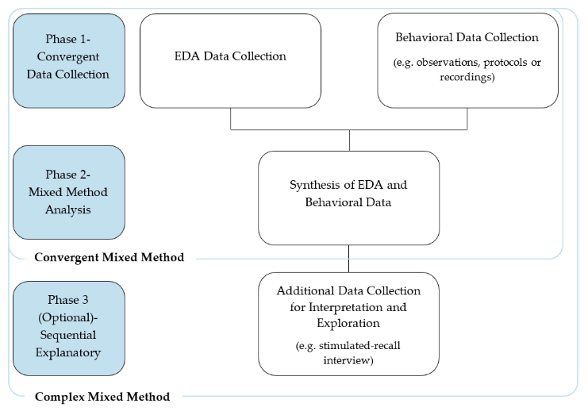
Figure 3: Data Collection method for Mixed methodology
(Source: Reid et al., 2020)

3.9 Ethical Consideration
Ethics works as the key component of research which validates the findings by measuring their authenticity. For the researchers, it is important to follow the research ethics for conducting the entire process. Following research ethics, the researchers collected all the databases and practical evidence by obtaining consent from the participants (Wolfenden et al., 2021). Also, it has maintained the ethics related to informed consent by obtaining permission from the authors. It has also acknowledged the contributions of the previous researchers and authors through referencing and citation. In the context of the surveys, it has ensured everyone is placing their opinions with their consent and the researchers have maintained transparency while conducting the survey. All the resources have been stored in the archives, hard disks and the cloud computing system to maintain their confidentiality and protect them from vulnerability. None of the perspectives of this research are meant to hurt any region or person, all the decisions have been placed by analysing the collected resources. Lastly, it has maintained integrity and transparency throughout the file so that it is possible to establish its authenticity. Another major ethical consideration is the usage of the available and reliable resources, all the used resources are available online and they are peer-reviewed articles (Mncube and Mthethwa, 2022). Maintaining different factors of ethical considerations, the researchers have ensured the efficiency of the findings.

3.10 Summary
The above analysis has explained the brief introduction about the used methodologies for the research on artificial intelligence solutions in mitigating the cybersecurity challenges. Using a mixed methodology it has used the primary and secondary resources at the same time and ensures it uses the most efficient resources. Also, it has focused on online surveys to get a practical idea about the perceptions of the people. Depending on this methodology it has used an experimental research design to discover new ideas by observing the existing ideologies. Focusing on different factors of the mixed methodology it has successfully answered the research questions and established the perspectives. The usage of a proper research methodology will significantly impact the conclusion of the research and justify the significance of the study.

Chapter 4: Findings and Discussion

4.1 Introduction
The chapter will present data, based on the survey conducted regarding the issues and challenges regarding cybersecurity, and data will be analysed, as well. In this regard, several pie-charts will be presented and data will be critically analysed to procure different insights.

4.2 Findings
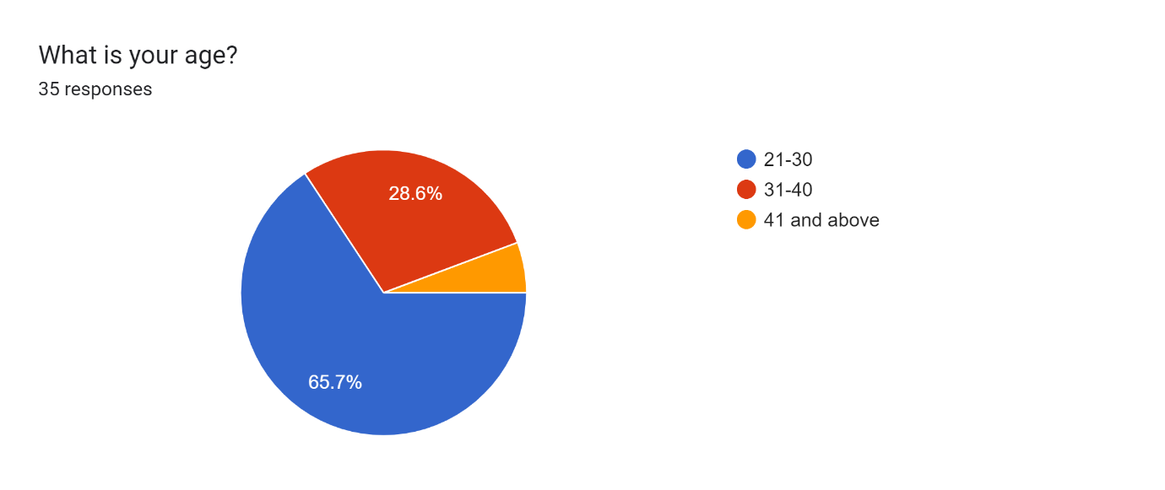
Figure 3: What is your age?
(Source: Self-created)
Figure 3 refers to participants' age, and it is observed that 65.7% were from the group of 21 to 30, while 28.6% were from the group of 31 to 40.
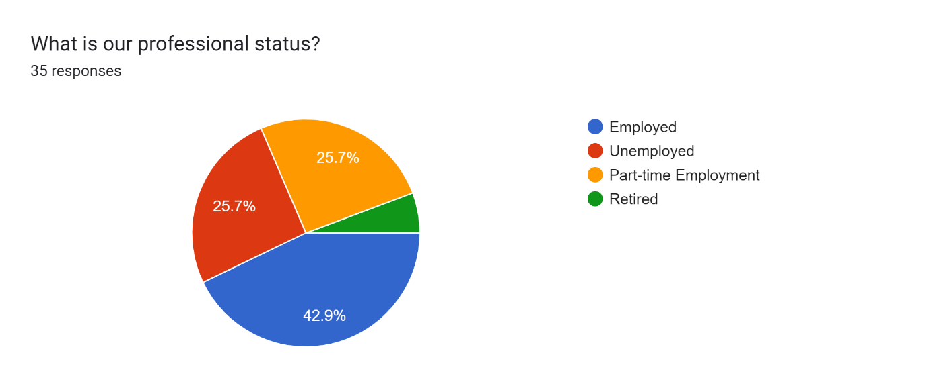
Figure 4: What is your professional status?
(Source: Self-created)
Figure 4 refers to the professional status of participants, and it is observed that 42.9% were employed, while 25.7% were unemployed. On the other hand, it is also observed that the rest of the 25.7% of participants were part-time employees.

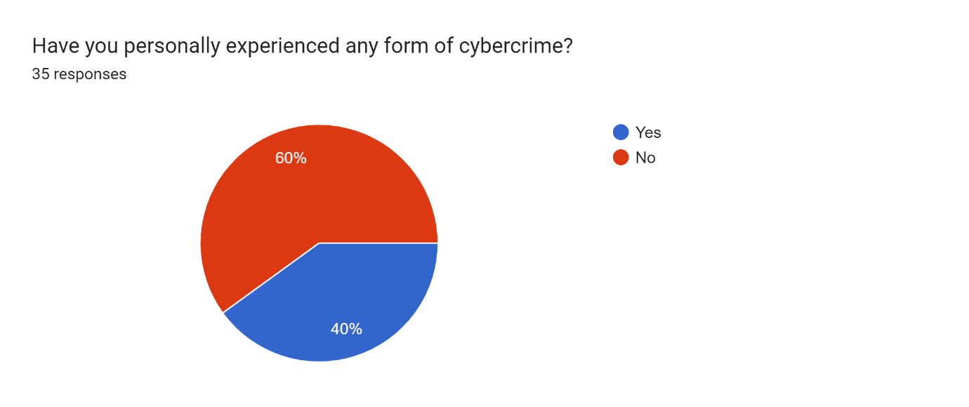
Figure 5: Have you personally experienced any form of cybercrime?
(Source: Self-created)
Figure 5 refers to the survey results, based on whether participants have experienced any form of cybercrime. According to the findings, 60% of participants responded that they did not face any form of cybercrime, while the rest of the 40% faced cybercrime issues.
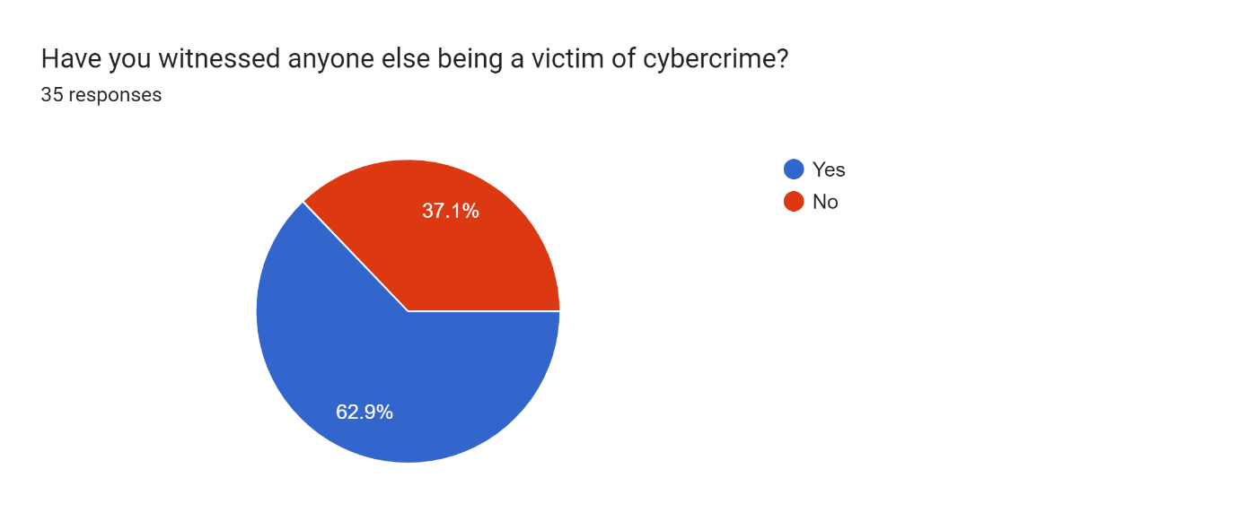
Figure 6: Have you witnessed anyone else being a victim of cybercrime?
(Source: Self-created)
Figure 6 refers to data regarding participants’ experiences, based on witnessing anyone else being a victim of cybercrime. According to the data found from the survey, 62.9% of participants responded positively, while the rest 37.1% opined that they did not witness anyone being threatened by cybercrime.
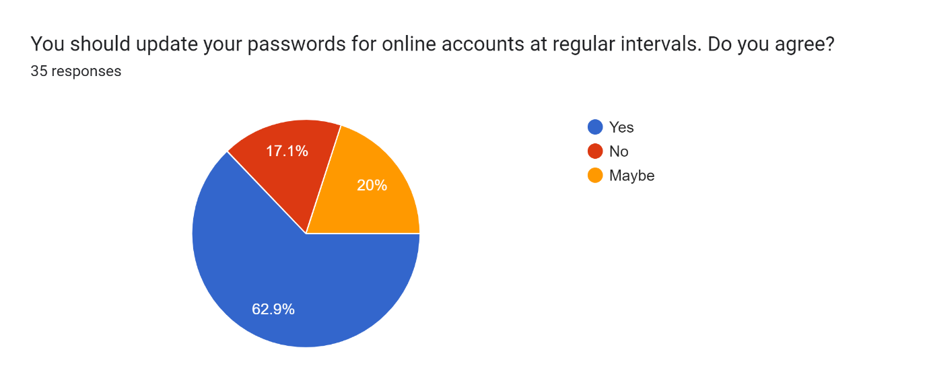
Figure 7: You should update your passwords for online accounts at regular intervals. Do you agree?
(Source: Self-created)
Figure 7 mentions that 62.9% of participants agreed that they should update their passwords for online accounts at regular intervals, while 17.1% did not agree. On the other hand, it is observed from the findings that 20% of the participants were not sure about their decision on updating passwords for online accounts at regular intervals.
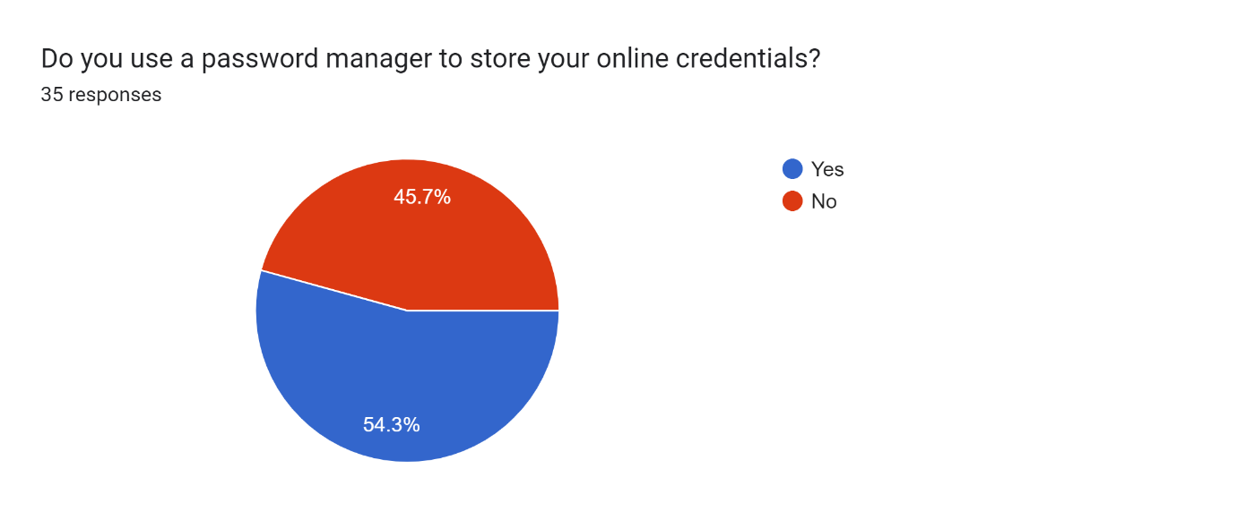
Figure 8: Do you use a password manager to store your online credentials?
(Source: Self-created)
Figure 8 refers to the result, based on the survey on whether participants use a password manager to store their online credentials. According to the findings, 54.3% of the participants opined that they use a password manager to store their online credentials, while the rest 45.7% of participants do not use a password manager to store their online credentials.
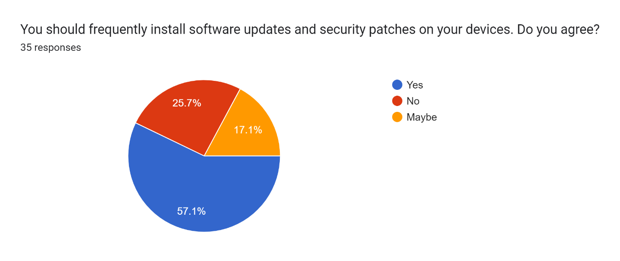
Figure 9: You should frequently install software updates and security patches on your devices. Do you agree?
(Source: Self-created)
Figure 9 presents that 57.1% of participants opined that participants should frequently install software updates and security patches on their devices, while 25.7% of participants did not agree that they should frequently install software updates and security patches on their devices.
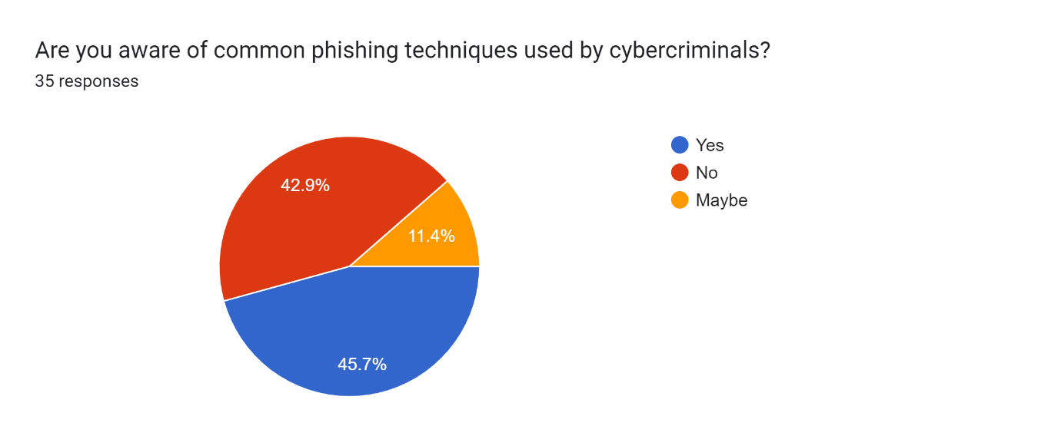
Figure 10: Are you aware of common phishing techniques used by cybercriminals?
(Source: Self-created)
According to the chart, 45.7% of participants were aware of common phishing techniques used by cybercriminals, while it is further observed from the chart that 42.9% of participants were not aware of common phishing techniques used by cybercriminals. It is further observed from the chart that 11.4% of participants were not sure about phishing techniques used by cybercriminals.
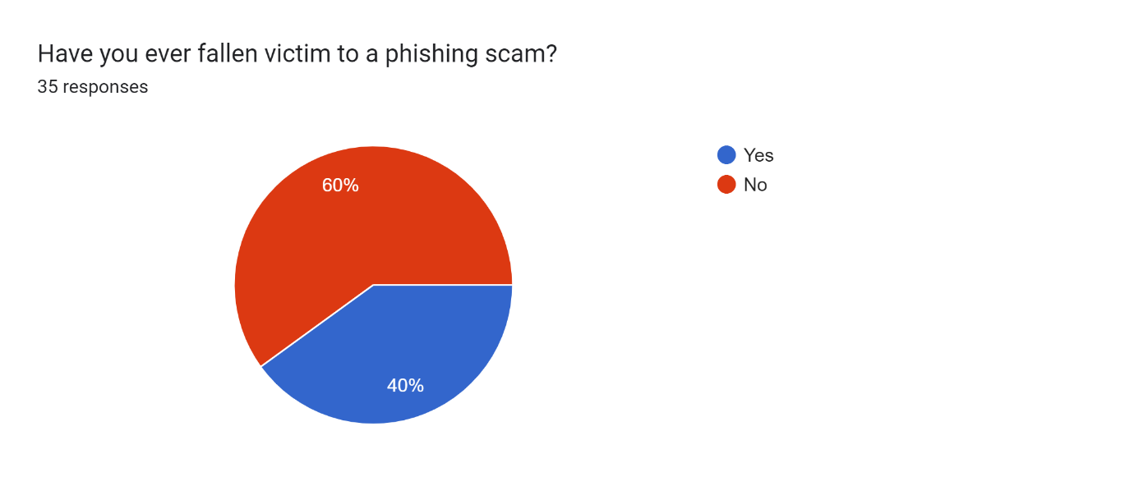
Figure 11: Have you ever fallen victim to a phishing scam?
(Source: Self-created)
Figure 11 shows that 40% of participants fell victim to a phishing scam, while 60% did not. The lack of awareness regarding phishing and scams can be a key reason behind it.
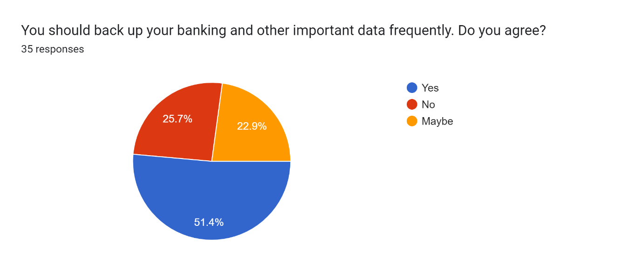
Figure 12: You should frequently back up your banking and other important data. Do you agree?
(Source: Self-created)
Figure 12 highlights the survey result, based on participants’ views on backing up banking and data frequently. As per the result, 51.4% of participants agreed that they should frequently back up their banking and other important data, while 25.7%, did not.

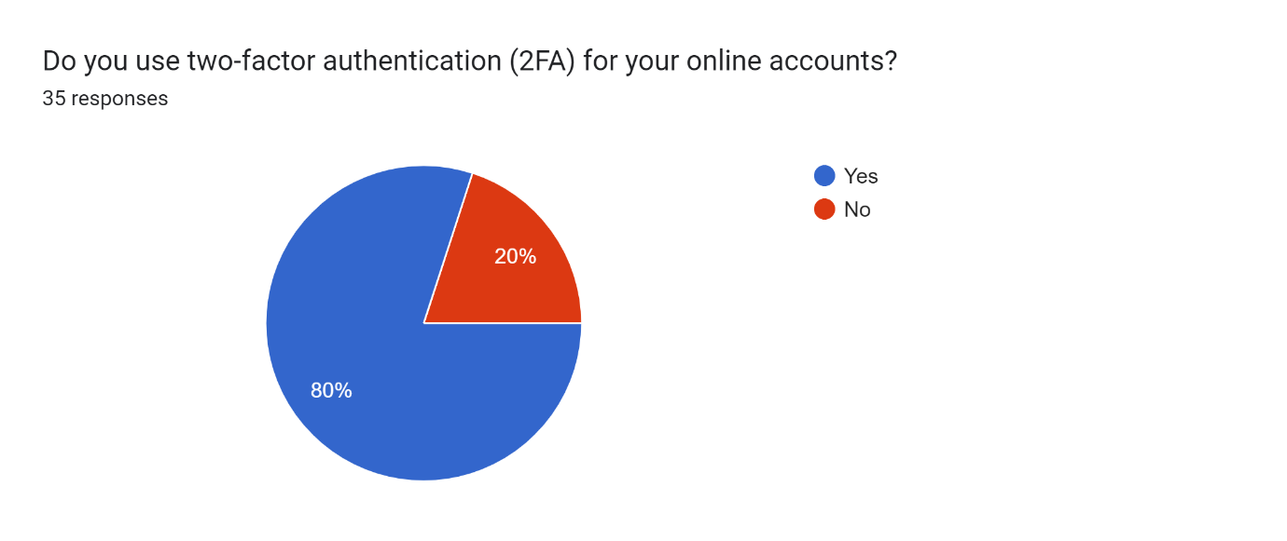
Figure 13: Do you use two-factor authentication (2FA) for your online accounts?
(Source: Self-created)
Figure 13 portrays that 80% of participants use two-factor authentication (2FA) and 20% do not. It refers to people’s knowledge and concern about cybersecurity.
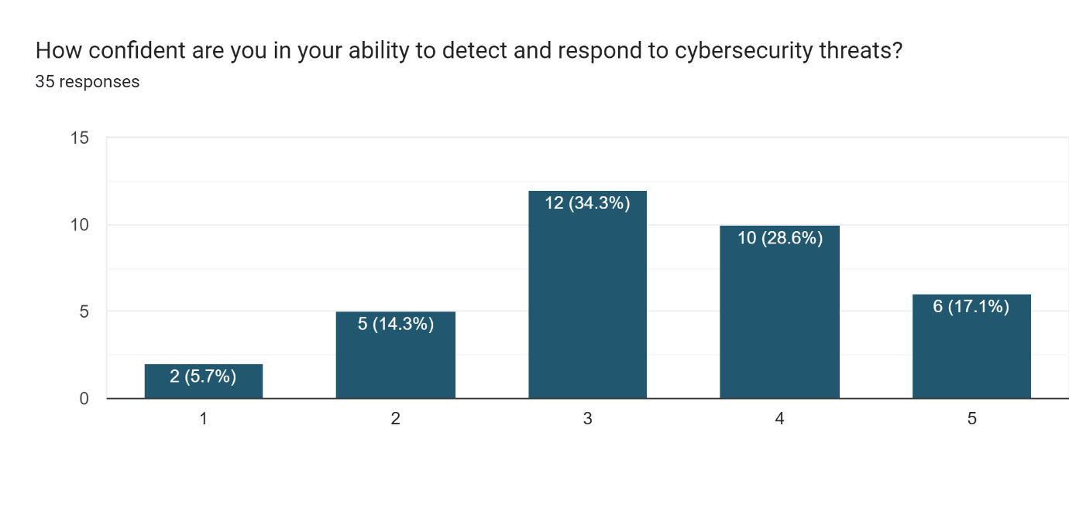
Figure 14: How confident are you in your ability to detect and respond to cybersecurity threats?
(Source: Self-created)
Figure 14 presents the result of the survey based on participants’ confidence in their ability to detect and respond to cybersecurity threats. According to the survey results, 34.3% of people rated their confidence as 3 and 28.6% of the rest rated it as 4. On the other hand, according to the survey result, 17.1% of participants rated it as 5. However, it is observed from the survey results that 14.3% of participants rated their confidence as 2 and 5.7% of the rest rated it as 1.
Figure 15 portrays the results of participants’ cybersecurity awareness campaigns or initiatives. According to the survey result, 45.7% of participants responded that they participated in the cybersecurity awareness campaigns, while the rest of 54.3% of participants did not participate.
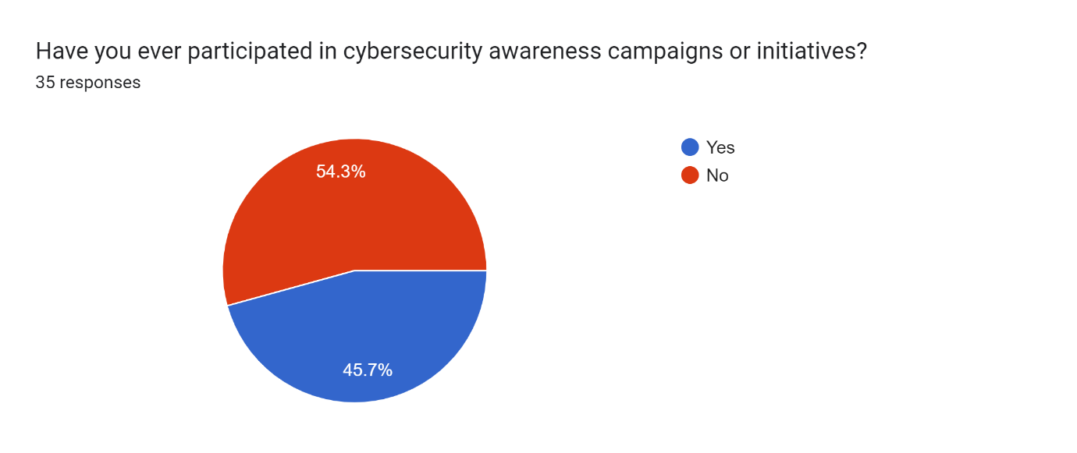
Figure 15: Have you ever participated in cybersecurity awareness campaigns or initiatives?
(Source: Self-created)
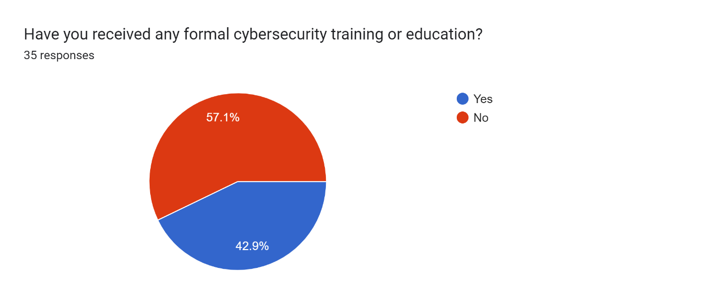
Figure 17: Have you received any formal cybersecurity training or education?
(Source: Self-created)
Figure 17 refers to the survey results regarding people’s formal training or education in cybersecurity. According to the survey result, 57.1% of participants received formal cybersecurity training or education, while 42.9% did not receive any such training.
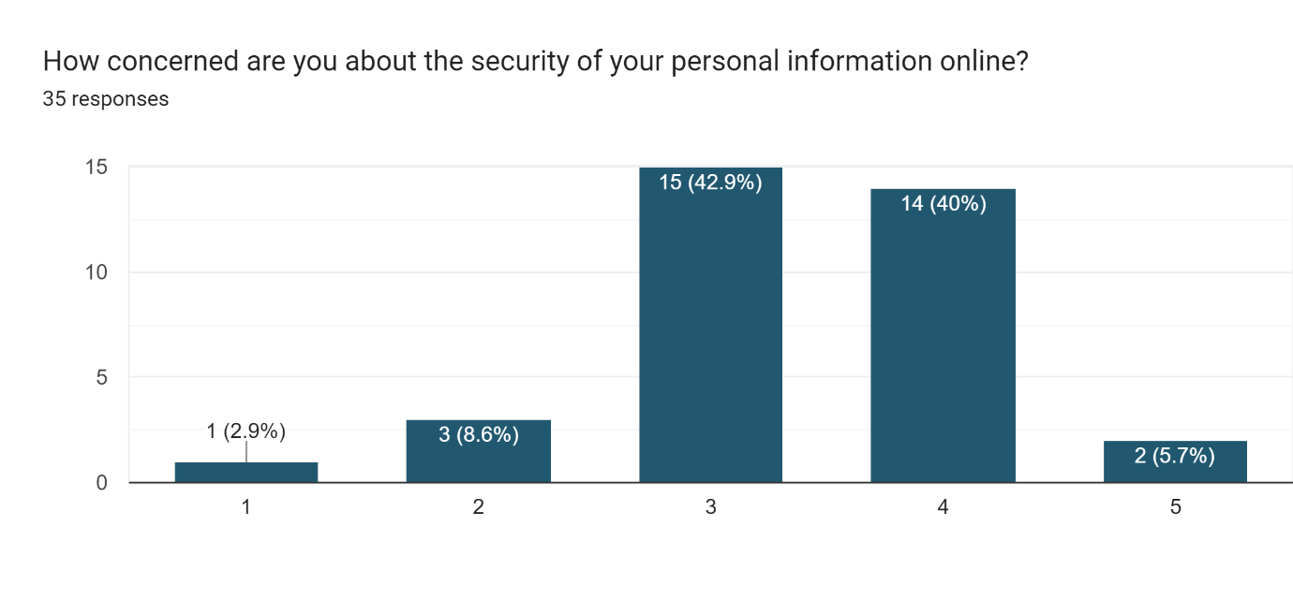
Figure 18: How concerned are you about the security of your personal information online?
(Source: Self-created)
Figure 18 refers to people’s concerns about the online security of personal information. According to the chart, 42.9% of participants rated their concern about the security of their online personal information as 3, while 40% of the rest of the participants rated it as 4. On the other hand, the survey result mentions that 5.7% of participants rated it as 5, while 8.6% and 2.9% of participants rated it as 2 and 1, respectively.
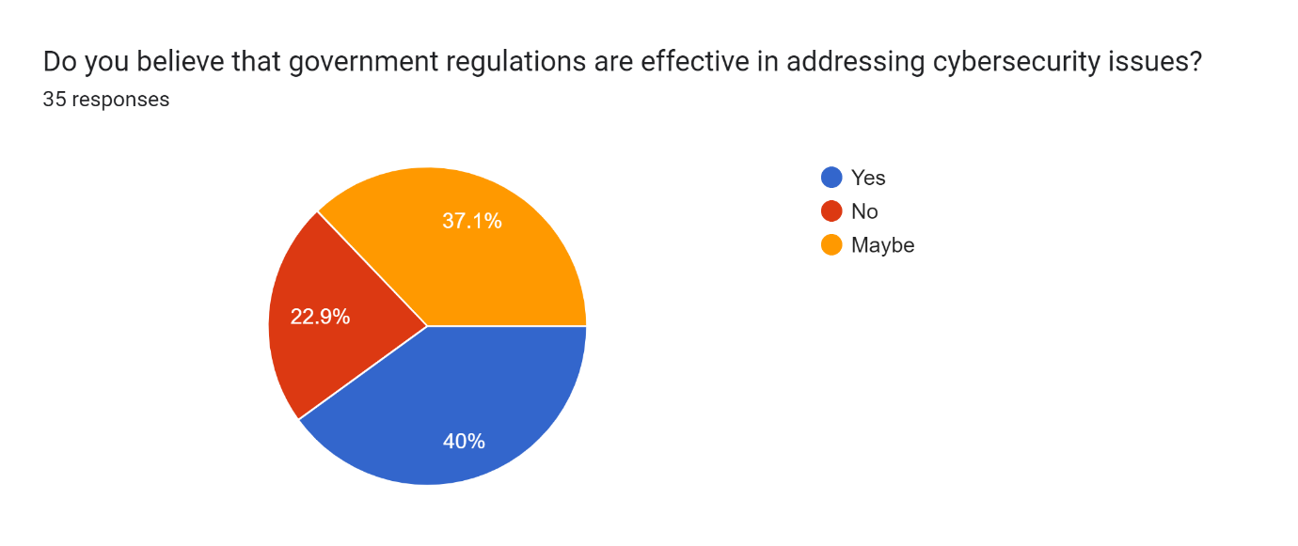
Figure 19: Do you believe that government regulations are effective in addressing cybersecurity issues?
(Source: Self-created)
Figure 19 presents participants’ views on the government regulations that are effective in addressing cybersecurity issues. According to the chart, 22.9% of participants did not believe that government regulations were effective in addressing cybersecurity issues, while 40% of participants opted for the effectiveness of government regulations in addressing cybersecurity issues. On the other hand, 37.1% of participants were not sure about the impact of government regulations in addressing cybersecurity issues.
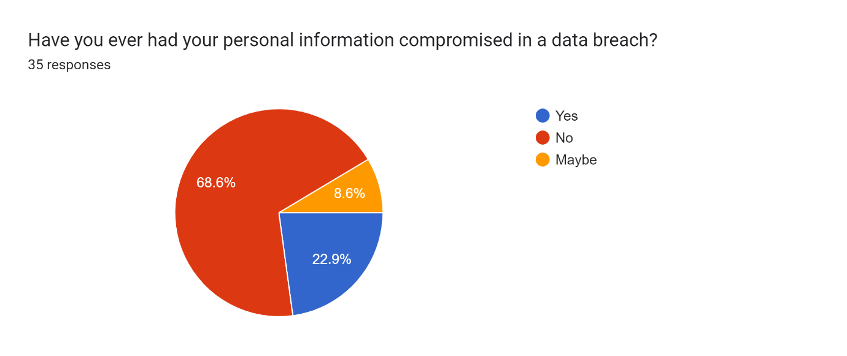
Figure 20: Have you ever had your personal information compromised in a data breach?
(Source: Self-created)
Figure 20 presents data on the issues regarding data breaching. According to the finding, 68.6% of participants responded that they never had to compromise personal information in a data breach. On the other hand, 8.6% of participants were not sure about being the victim of data breaching.
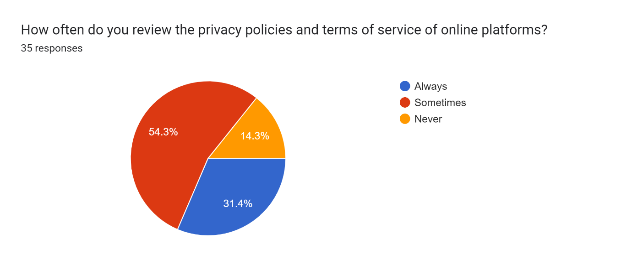
Figure 21: How often do you review the privacy policies and terms of service of online platforms?
(Source: Self-created)
Figure 21 refers to the results based on participants’ review of privacy policies and terms of service of online platforms. According to the results, 54.3% of participants opined that they sometimes review the privacy policies and terms of service of online platforms. On the other hand, it is further observed from the chart that 14.3% of participants have never reviewed the privacy policies and terms of service of online platforms, while 31.4% of participants review them regularly.
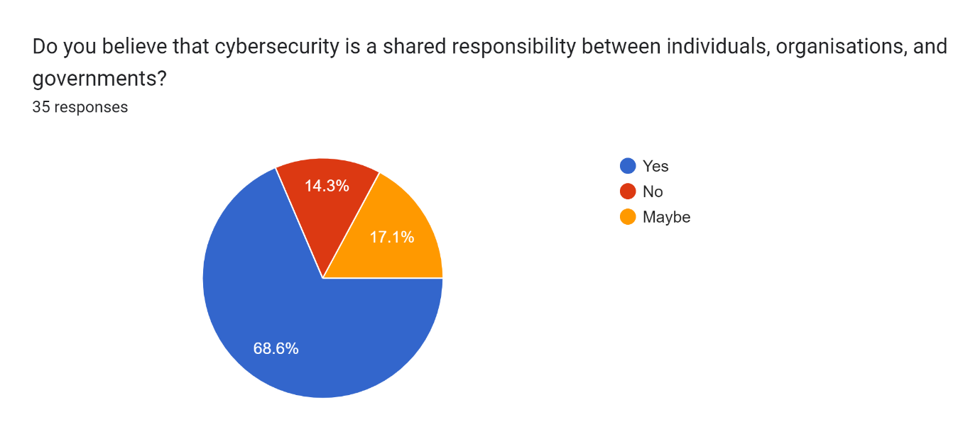
Figure 22: Do you believe that cybersecurity is a shared responsibility between individuals, organisations and governments?
(Source: Self-created)
Figure 22, presents data, based on participants’ belief in the shared responsibility between individuals, organisations and governments. According to the chart, 68.6% of participants strongly believe that cybersecurity is a shared responsibility between individuals, organisations and governments. On the other hand, it is observed from the chart that 14.3% of participants do not believe that cybersecurity is a shared responsibility between individuals, organisations and government, while 17.1% of participants were not sure about the interconnectedness between individuals, organisations and government.
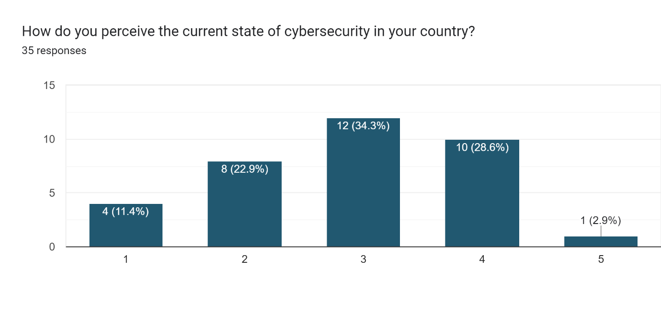
Figure 23: How do you perceive the current state of cybersecurity in your country?
(Source: Self-created)
Figure 23 presents results, based on participants’ perceptions regarding the current state of cybersecurity in their country. According to the chart, 34.3% of participants rated it as 3, while 28.6% of participants rated it as 4. On the other hand, as per the chart, 11.4% of participants rated it as 1, while 2.9% and 22.9% of participants rated it as 5 and 2, respectively.
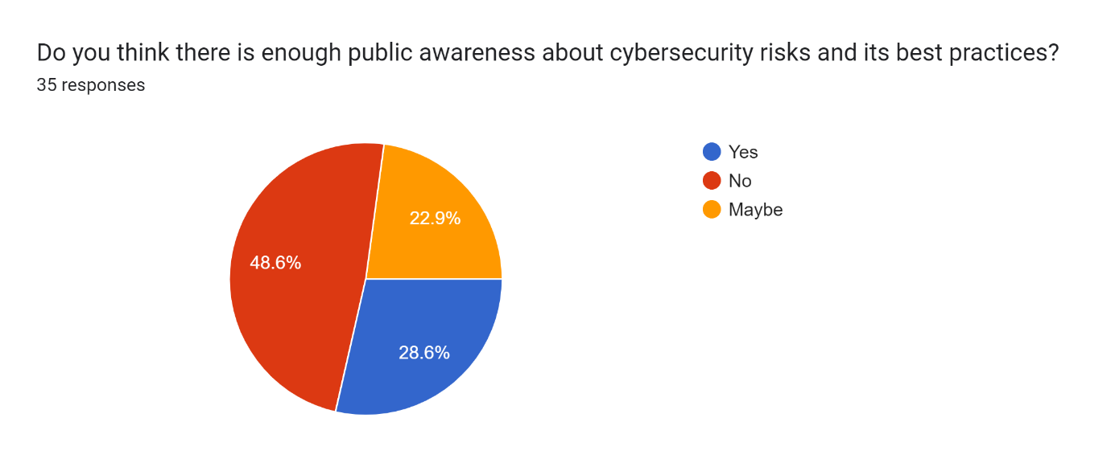Figure 24: Do you think there is enough public awareness about cybersecurity risks and its best practices?
(Source: Self-created)
Figure 24 refers to people’s opinions about public awareness of cybersecurity risks and its best practices. According to the chart, 28.6% of participants opted for the availability of public awareness of cybersecurity risks and their best practices. On the other hand, 48.6% of participants opted for the lack of public awareness of cybersecurity risks and its best practices, while 22.9% of participants did not have any concrete idea about it.

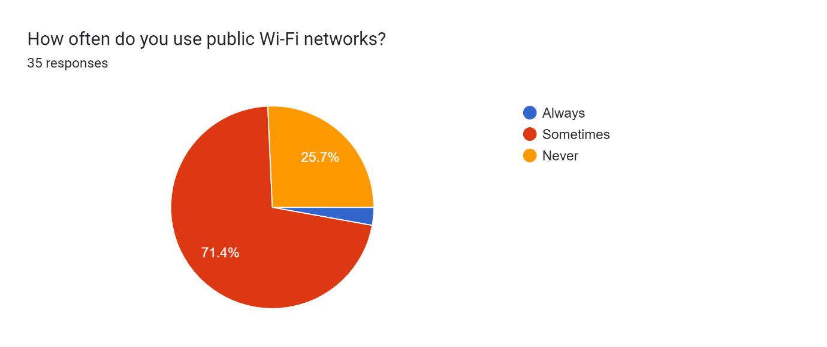
Figure 25: How often do you use public Wi-Fi networks?
(Source: Self-created)
According to Figure 25, 71.4% of participants sometimes use Wi-Fi for cybersecurity, while 26.7% of participants do not use Wi-Fi for cybersecurity purposes. The lack of knowledge and awareness about the value of Wi-Fi in cybersecurity can be a key reason behind their responses.
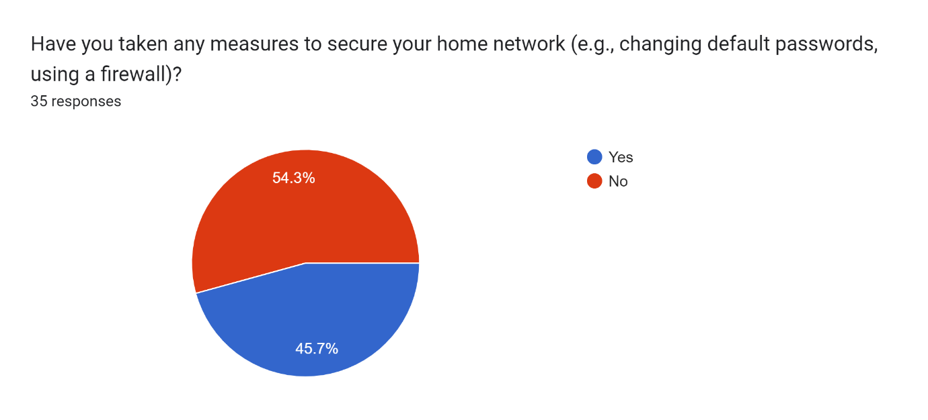
Figure 26: Have you taken any measures to secure your home network (e.g. changing default passwords using a firewall)?
(Source: Self-created)
The awareness regarding cybersecurity can be observed from the responses, and it is observed that 45.7% of participants have taken measures to secure home networks. On the other hand, due to the lack of awareness and knowledge, 54.3% of participants did not opt for using measures to protect their home networks.
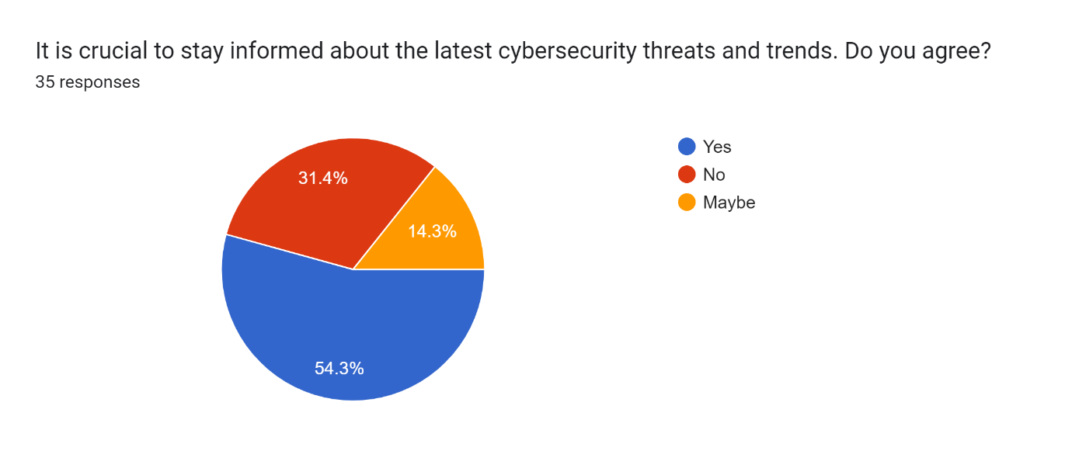
Figure 27: It is crucial to stay informed about the latest cybersecurity threats and trends. Do you agree?
(Source: Self-created)
According to Figure 27, 54.3% of participants opted for awareness regarding the latest cybersecurity threats and trends, so that they can take measures to protect their financial acts and activities. On the other hand, 31.4% of participants did not show any interest in staying informed about the latest cybersecurity threats and trends.
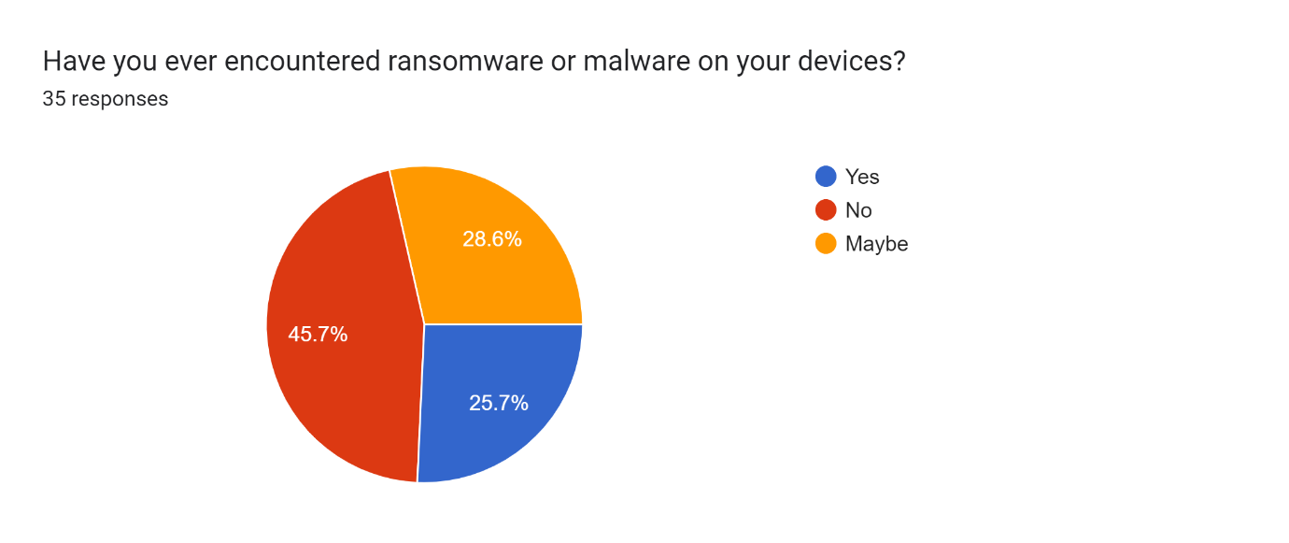
Figure 28: Have you ever encountered ransomware or malware on your device?
(Source: Self-created)
Figure 28 presents the data regarding participants’ experience in encountering ransomware or malware on their devices. According to the chart, 25.7% of participants responded about their first-hand experience regarding ransomware or malware, while 45.7% did not encounter any ransomware or malware. Moreover, 28.6% of participants were not assured about the attack.
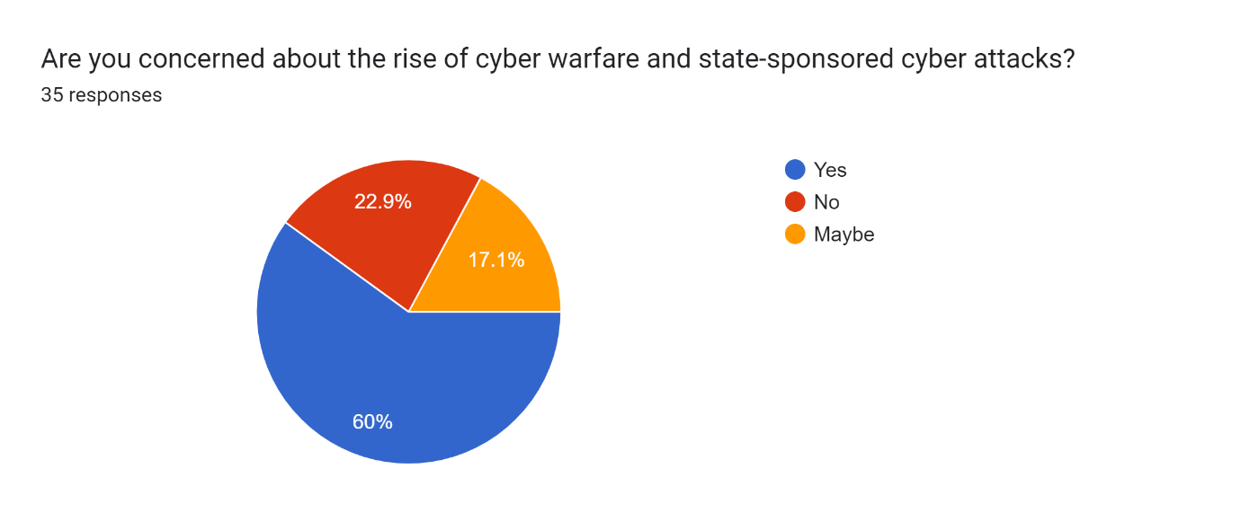
Figure 29: Are you concerned about the rise of cyber warfare and stage-sponsored cyber-attacks?
(Source: Self-created)
Figure 29 refers to people’s knowledge about the rise of cyber warfare and stage-sponsored cyber-attacks, and it is observed that 60% of participants were concerned about the rise of cyber warfare and stage-sponsored cyber-attacks, and 22.9% of participants were not open to the knowledge of cyber warfare. On the other hand, 17.1% of participants were not sure about their concerns or knowledge.
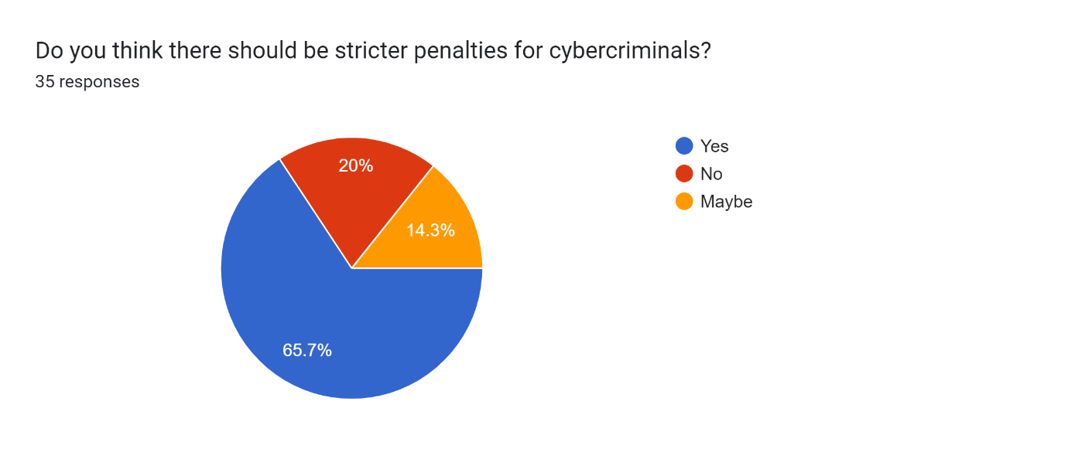
Figure 30: Do you think there should be stricter penalties for cybercriminals?
(Source: Self-created)
Figure 30 refers to the participants’ overview, based on stricter penalties for cybercriminals. According to the chart, 65.7% of participants opted for stricter penalties, while 20% of participants did not opt for it. On the other hand, 14.3% of participants were not sure about their knowledge and perceptions.

4.3 Discussion
Cybersecurity protects digital networks, systems, and data from breaches, attacks, and unauthorised access. Cybersecurity is crucial in today's interconnected world, as digital technologies power both critical infrastructure and intimate communication. Money, reputation, and data can all be lost due to cybersecurity breaches. restricting access to sensitive data to authorised people or systems only and encrypting data before it is transferred or stored. They are maintaining complete, accurate, and safe data. Digital signatures and hash functions are used to verify data integrity. Sustaining resources and systems is important. DoS attacks need to be avoided and lessened. Approved resource access is ensured by user or system verification. Authentication systems include multi-factor authentication, passwords, and biometrics. Role-based permissions and authentication of users and the system. preventing rejections of digital transactions. Non-repudiation is provided by auditors and digital signatures. malware capable of data theft or damage. Trojans, worms, viruses, and ransomware. stealing money or credentials through deception (Camacho (2024). Phishing attacks use phoney websites, emails, or SMS to impersonate real businesses. intercepting communications that are not authorised.

SQL commands can be executed in a backend database through web application vulnerabilities. There may be instances of sensitive data theft or manipulation of databases. causing traffic to interfere with a system, network, or service. Real users may be prevented from accessing websites and services by DoS and DDoS attacks. internal misconduct committed by workers or outside contractors who abuse their authority or access to harm the business (Jimmy, (2021). Firewalls with a security focus keep an eye on and manage network traffic. Reliable internal and external networks are kept apart by firewalls. Using IDPS technologies to identify and respond to threats and policy violations in real-time. IDPS prevents unauthorised access and malware. using encryption to secure sensitive data both in transit and at rest. Robust encryption techniques and protocols provide data security and patch management lessens misuse by malicious actors. exchanging cybersecurity concepts, such as phishing detection and avoidance. Training in security awareness is essential for human cybersecurity. granular controls and least privilege policies that restrict user privileges and access to critical resources. Restrictions on access prevent internal threats and unauthorised entry.
To secure digital assets and stop threats, multifaceted cybersecurity requires a proactive, all-encompassing approach (Rodrigues, 2020). To assist individuals and organisations in ensuring the security, confidentiality, integrity, and availability of their digital systems and data, this research addresses essential concepts, typical hazards, and crucial mitigation strategies. Malware and nation-state cyberattacks are examples of contemporary cybersecurity risks. The risk of the attack surface has grown as a result of IoT and cloud computing, giving attackers additional avenues for assault. The frequency and sophistication of cyber threats in the digital era make cybersecurity a critical problem. Artificial Intelligence is enhancing cybersecurity since traditional defences are not upholding modern threats. Cyberattacks that are becoming more complex and widespread pose a threat to people, companies, and governments (Thakur, 2024). Malware, ransomware, phishing, and insider threats are all changing, according to the CISA. The quick development of technology offers numerous advantages, but it has also created new cybersecurity issues. Strong cybersecurity is more important than ever since sensitive data is stored, analysed, and transferred on digital systems and networks by businesses, governments, and private citizens. Sometimes, emerging cyber threats are not adequately addressed by conventional cybersecurity techniques. Critical data, infrastructure, and national security are at risk from these threats. Governments, businesses, and citizens worldwide are concerned about digital cybersecurity. Data security and privacy are at risk due to the increasing sophistication of cyber threats that accompany the advancement of digital technologies. The use of technological acts and activities has been valuable in ensuring the use of cybersecurity in personal and professional life.
Accessing, interacting with, and finishing everything on the internet via PCs, phones, and tablets is crucial. These devices can also be harmed by malware, viruses, and unauthorised access. Protecting devices and preventing cyberattacks require cybersecurity. Personal devices save images, financial data, and login credentials. To stop financial fraud, identity theft, and privacy violations, this data needs to be protected. Data and device security can be jeopardised by malware such as viruses, ransomware, and spyware. Malware is prevented via firewalls, antivirus software, and security upgrades. On personal devices, they use chat apps, email, and social networking. To avoid hostile eavesdropping, interception, and manipulation, communications must be secure. The banking and financial sectors are particularly vulnerable to cyberattacks because of their substantial assets and private information (AlDaajeh et al. 2022). Banks require cybersecurity for client data, financial operations, and system integrity. Cybersecurity needs to lower the hazards of cyberbanking. Sensitive financial, transaction, and account information is stored by banking institutions. To avoid financial fraud, unauthorised access, and data breaches, this information must be kept confidential. Protecting ATMs, smartphone apps, and online banking is necessary to stop criminals from accessing, monitoring, or altering financial activities. Authentication, fraud detection, and encryption safeguard transactions (Moustafa et al. 2022). People’s awareness regarding 2FA can be valuable for ensuring cybersecurity, using AI. Tight data, cybersecurity, and financial privacy regulations must be followed by banks. GDPR and PCI DSS compliance guarantee cybersecurity responsibility while reducing legal and regulatory concerns.

Chapter 5: Conclusion and Recommendations

5.1 Conclusion
Stealing personal information to carry out fraud or impersonation through identity theft is a common criminal activity. Identity theft is prevented and detected by cybersecurity. Passwords, bank account details, and social security numbers need to be secured to stop identity theft. Authentication, encryption, and access restrictions keep PII safe from hackers. Through knowledge of phishing techniques and dubious emails, websites, and messages, users can safeguard their login credentials. Organisations can quickly identify illegal access and suspicious conduct with the aid of monitoring and detection. Identity fraud is detected using IDS, anomaly detection, and user behaviour analytics.
It can be concluded that cybercriminals use viruses and phishing emails to obtain login credentials. Email and online banking can be accessed with these credentials, and identities can be stolen. ID theft risk is increased by large-scale data breaches that expose personally identifiable information from business databases. A stolen identity is used by scammers to open accounts, apply for credit cards and loans, and make purchases. Identity theft results in long-term recovery, financial losses, and damaged credit. MFA uses a password and a one-time code issued to your mobile device to secure accounts and sensitive data. Businesses can prevent account takeovers by using knowledge-based authentication questions and biometric authentication. To reduce the danger of identity theft, credit monitoring services can identify unusual account openings and credit inquiries and provide real-time alerts.
AI has both advantages and disadvantages for cybersecurity. Threat actors that use AI systems to evade detection or produce false positives are engaging in major adversarial attacks. Because AI systems require training data, biased or inadequate data may result in mistakes. When using AI in cybersecurity, ethics and privacy must be considered. Misuse of AI-powered surveillance has the potential to violate privacy rights. Concerns about cybersecurity and transparency are exacerbated by AI threat hunting and attribution. Businesses may make sure to handle cybersecurity risks driven by AI in a variety of methods. Using adversarial training and model diversification to create machine learning models that are resistant to attacks.
AI is used in security operations, incident response, threat intelligence, and vulnerability management. It can be concluded that through the correlation of threat data from several sources, AI algorithms help threat intelligence platforms identify new threats and patterns. Security teams can address high-risk vulnerabilities first by using AI-driven risk assessment tools to prioritise vulnerabilities based on their severity and security effect. Artificial intelligence (AI)-driven SOAR platforms expedite security incident containment and remediation by automating repetitive processes and coordinating response actions across security technologies. It can also be concluded that numerous businesses have implemented AI-driven cybersecurity solutions to counter complex threats.
AI examines vast amounts of network data, user activity, and security logs to quickly identify abnormalities and threats. It can be concluded from the research that these time-saving tools can stop suspicious conduct, quarantine infected devices, and start incident response. Businesses can reduce cyber vulnerabilities by using predictive analytics driven by AI. It can be concluded that with the use of threat intelligence, contextual data, and historical data, AI models can recognise patterns, predict attack vectors, and evaluate the impact and likelihood of cyber threats. By managing resources, implementing focused security measures, and developing efficient incident response plans, this enhances cybersecurity. It information and input, these systems can enhance autonomous threat response, defence, and detection. Organisations can prevent complex cyber threats by implementing autonomous and adaptive cybersecurity.

5.2 Recommendations
Man-in-the-middle (MiTM) attack are archaic cyberattacks that involve intercepting data being delivered over a communication connection between two parties that are acting as authorised communicators. A variant of this assault should utilise IP address spoofing, in which a malevolent actor deceives trustworthy systems into granting them access, so gaining system access (AlDaajeh et al. 2022). A message replay attack occurs when a malevolent actor uses the communication connection to send a previously stored, stale message again.
Phishing should be executed by creating phoney emails and sending them to phoney systems in an attempt to trick unsuspecting end users into clicking a link and disclosing private information. These kinds of assaults capitalise on social engineering techniques, in which emails are crafted to look authentic to entice recipients to believe them. Spear phishing is characterised as a well-planned operation in which the malicious actor thoroughly investigates potential victims to create emails that seem extremely authentic and frequently have reliable email addresses in the "from" field (Hubbard and Seiersen, 2023). Malicious actors who browse the web and look for vulnerable websites to insert malware scripts into the web servers should be considered drive-by assaults. Eventually, end users who visit the website become infected with the malware, which compromises the system and exposes sensitive data among other things (Reeves, 2021). However, to carry out a password attack, shoulder surfing user keyboard activity should be considered, as brute force entry into a system using popular passwords, and create complex passwords by applying artificial intelligence algorithms.

5.3 Research Limitations
Despite providing a thorough analysis of the issues and problems regarding cybersecurity and the impact of AI on mitigating it, the study encountered several problems because of insufficient data. The primary data used to support the research in a mixed-method approach is the main source of the study's restriction. Due to the short research period, the data collecting process was hindered and insufficient data could not be gathered by the researcher. The research's spontaneity was hampered by the lack of primary and secondary data, and the study’s efficacy was hampered by the absence of critical analysis. The collective values of the research were impacted by the lack of critical analysis brought on by the inadequate data.

5.4 Future Research Opportunities
The research not only presents a detailed analysis of the issues and challenges regarding cybersecurity, but it also paved a pathway for future research. A study, based on the extensive use of AI to combat the issues of cybersecurity can be conducted. On the other hand, different studies, based on industries and the threat of cybersecurity, as well as, the use of AI, can be conducted to procure insights.

Reference list
Ahsan, M., Nygard, K.E., Gomes, R., Chowdhury, M.M., Rifat, N. and Connolly, J.F., (2022). Cybersecurity threats and their mitigation approaches using Machine Learning—A Review. Journal of Cybersecurity and Privacy, 2(3), pp.527-555.
Ahmad, T., Zhang, D., Huang, C., Zhang, H., Dai, N., Song, Y. and Chen, H., 2021. Artificial intelligence in sustainable energy industry: Status Quo, challenges and opportunities. Journal of Cleaner Production, 289, p.125834.
Alazab, M., RM, S.P., Parimala, M., Maddikunta, P.K.R., Gadekallu, T.R. and Pham, Q.V., 2021. Federated learning for cybersecurity: Concepts, challenges, and future directions. IEEE Transactions on Industrial Informatics, 18(5), pp.3501-3509.
AL-Dosari, K., Fetais, N. and Kucukvar, M., 2024. Artificial intelligence and cyber defense system for banking industry: A qualitative study of AI applications and challenges. Cybernetics and systems, 55(2), pp.302-330.
Al-Hawawreh, M., Aljuhani, A. and Jararweh, Y., 2023. Chatgpt for cybersecurity: practical applications, challenges, and future directions. Cluster Computing, 26(6), pp.3421-3436.
Ali, A., Septyanto, A.W., Chaudhary, I., Al Hamadi, H., Alzoubi, H.M. and Khan, Z.F., 2022. Applied artificial intelligence as event horizon of cyber security. In 2022 International Conference on Business Analytics for Technology and Security (ICBATS) (pp. 1-7). IEEE.
Ambalavanan, V., 2020. Cyber threats detection and mitigation using machine learning. In Handbook of research on machine and deep learning applications for cyber security (pp. 132-149). IGI Global.
Aslam, M., 2024. AI and cybersecurity: an ever-evolving landscape. International Journal of Advanced Engineering Technologies and Innovations, 1(1), pp.52-71.
Bécue, A., Praça, I. and Gama, J., (2021). Artificial intelligence, cyber-threats and Industry 4.0: Challenges and opportunities. Artificial Intelligence Review, 54(5), pp.3849-3886.
Benzaïd, C. and Taleb, T., 2020. AI for beyond 5G networks: A cyber-security defense or offense enabler?. IEEE network, 34(6), pp.140-147.
Bertino, E., Kantarcioglu, M., Akcora, C.G., Samtani, S., Mittal, S. and Gupta, M., 2021. AI for Security and Security for AI. In Proceedings of the Eleventh ACM Conference on Data and Application Security and Privacy (pp. 333-334).
Bharadiya, J., 2023. Machine learning in cybersecurity: Techniques and challenges. European Journal of Technology, 7(2), pp.1-14.
Bharadiya, J.P., 2023. Ai-driven security: How machine learning will shape the future of cybersecurity and web 3.0. American Journal of Neural Networks and Applications, 9(1), pp.1-7.
Camacho, N.G., (2024). The Role of AI in Cybersecurity: Addressing Threats in the Digital Age. Journal of Artificial Intelligence General science (JAIGS) ISSN: 3006-4023, 3(1), pp.143-154.
Dasgupta, D., Akhtar, Z. and Sen, S., 2022. Machine learning in cybersecurity: a comprehensive survey. The Journal of Defense Modeling and Simulation, 19(1), pp.57-106.
Dawadi, S., Shrestha, S. and Giri, R.A., (2021). Mixed-methods research: A discussion on its types, challenges, and criticisms. Journal of Practical Studies in Education, 2(2), pp.25-36.https://oro.open.ac.uk/75449/1/Dawadi%2C%20Shreshta%20and%20Giri%202021.pdf
Familoni, B.T., 2024. Cybersecurity challenges in the age of AI: theoretical approaches and practical solutions. Computer Science & IT Research Journal, 5(3), pp.703-724.
Guembe, B., Azeta, A., Misra, S., Osamor, V.C., Fernandez-Sanz, L. and Pospelova, V., (2022). The emerging threat of ai-driven cyber-attacks: A review. Applied Artificial Intelligence, 36(1), p.2037254.
Geluvaraj, B., Satwik, P.M. and Ashok Kumar, T.A., (2019). The future of cybersecurity: Major role of artificial intelligence, machine learning, and deep learning in cyberspace. In International Conference on Computer Networks and Communication Technologies: ICCNCT 2018 (pp. 739-747). Springer Singapore.
Ghelani, D., 2022. Cyber security, cyber threats, implications and future perspectives: A Review. Authorea Preprints.
Gopalan, M., Rosinger, K. and Ahn, J.B., (2020). Use of quasi-experimental research designs in education research: Growth, promise, and challenges. Review of Research in Education, 44(1), pp.218-243.https://journals.sagepub.com/doi/pdf/10.3102/0091732X20903302
Gunduz, M.Z. and Das, R., 2020. Cyber-security on smart grid: Threats and potential solutions. Computer networks, 169, p.107094.
Gupta, R., Tanwar, S., Al-Turjman, F., Italiya, P., Nauman, A. and Kim, S.W., 2020. Smart contract privacy protection using AI in cyber-physical systems: tools, techniques and challenges. IEEE access, 8, pp.24746-24772.
Hubbard, D.W. and Seiersen, R., 2023. How to measure anything in cybersecurity risk. John Wiley & Sons.
Humayun, M., Jhanjhi, N.Z., Talib, M.N., Shah, M.H. and Suseendran, G., 2021. Cybersecurity for data science: issues, opportunities, and challenges. Intelligent Computing and Innovation on Data Science: Proceedings of ICTIDS 2021, pp.435-444.
Jakka, G., Yathiraju, N. and Ansari, M.F., 2022. Artificial Intelligence in Terms of Spotting Malware and Delivering Cyber Risk Management. Journal of Positive School Psychology, 6(3), pp.6156-6165.
Jeong, D., 2020. Artificial intelligence security threat, crime, and forensics: Taxonomy and open issues. IEEE Access, 8, pp.184560-184574.
Jimmy, F., 2021. Emerging Threats: The Latest Cybersecurity Risks and the Role of Artificial Intelligence in Enhancing Cybersecurity Defenses. Valley International Journal Digital Library, pp.564-574.
Jimmy, F.N.U., 2024. Cyber security Vulnerabilities and Remediation Through Cloud Security Tools. Journal of Artificial Intelligence General science (JAIGS) ISSN: 3006-4023, 2(1), pp.196-233.
Kseniia, N. and Minbaleev, A., 2020. Legal support of cybersecurity in the field of application of artificial intelligence technology. In 2020 International Conference Quality Management, Transport and Information Security, Information Technologies (IT&QM&IS) (pp. 59-62). IEEE.
Kumar, S., Gupta, U., Singh, A.K. and Singh, A.K., (2023). Artificial intelligence: revolutionizing cyber security in the digital era. Journal of Computers, Mechanical and Management, 2(3), pp.31-42.
Lau, C.Q., Cronberg, A., Marks, L. and Amaya, A., (2019), December. In search of the optimal mode for mobile phone surveys in developing countries. A comparison of IVR, SMS, and CATI in Nigeria. In Survey Research Methods (Vol. 13, No. 3, pp. 305-318).https://ojs.ub.uni-konstanz.de/srm/article/download/7375/6821
Mardiana, S., (2020). Modifying research onion for information systems research. Solid State Technology, 63(4), pp.5304-5313.https://www.researchgate.net/profile/Siti-Mardiana/publication/359542575_Modifying_Research_Onion_for_Information_Systems_Research/links/62432dc07931cc7ccf033406/Modifying-Research-Onion-for-Information-Systems-Research.pdf
März, S., Bierwirth, A. and Schüle, R., (2020). Mixed-method research to foster energy efficiency investments by small private landlords in Germany. Sustainability, 12(5), p.1702.https://www.mdpi.com/2071-1050/12/5/1702
Mncube, L.S. and Mthethwa, L.C., (2022). Potential ethical problems in the creation of open educational resources through virtual spaces in academia. Heliyon, 8(6).https://www.cell.com/heliyon/pdf/S2405-8440(22)00911-2.pdf
Moustafa, A.A., Bello, A. and Maurushat, A., 2021. The role of user behaviour in improving cyber security management. Frontiers in Psychology, 12, p.561011.
Mughal, A.A., (2018). Artificial Intelligence in Information Security: Exploring the Advantages, Challenges, and Future Directions. Journal of Artificial Intelligence and Machine Learning in Management, 2(1), pp.22-34.
Mylrea, M. and Gourisetti, S.N.G., (2017). Cybersecurity and optimization in smart “autonomous” buildings. Autonomy and Artificial Intelligence: A Threat or Savior? pp.263-294.
Naseer, I., 2021. The efficacy of Deep Learning and Artificial Intelligence Framework in Enhancing Cybersecurity, Challenges and Future Prospects. Innovative Computer Sciences Journal, 7(1).
Nishant, R., Kennedy, M. and Corbett, J., 2020. Artificial intelligence for sustainability: Challenges, opportunities, and a research agenda. International Journal of Information Management, 53, p.102104.
Patil, P., (2016). Artificial intelligence in cybersecurity. International journal of research in computer applications and robotics, 4(5), pp.1-5.
Pearse, N., (2019). An illustration of a deductive pattern matching procedure in qualitative leadership research. Electronic Journal of Business Research Methods, 17(3), pp.pp143-154.https://academic-publishing.org/index.php/ejbrm/article/download/1398/1361
Raimundo, R.J. and Rosário, A.T., 2022. Cybersecurity in the internet of things in industrial management. Applied Sciences, 12(3), p.1598.
Rangaraju, S., 2023. Ai sentry: Reinventing cybersecurity through intelligent threat detection. EPH-International Journal of Science And Engineering, 9(3), pp.30-35.
Reeves, A., Delfabbro, P. and Calic, D., 2021. Encouraging employee engagement with cybersecurity: How to tackle cyber fatigue. SAGE open, 11(1), p.21582440211000049.
Rehan, H., 2024. AI-Driven Cloud Security: The Future of Safeguarding Sensitive Data in the Digital Age. Journal of Artificial Intelligence General science (JAIGS) ISSN: 3006-4023, 1(1), pp.47-66.
Rodrigues, R., 2020. Legal and human rights issues of AI: Gaps, challenges and vulnerabilities. Journal of Responsible Technology, 4, p.100005.
Sakhnini, J. and Karimipour, H., 2020. AI and security of cyber physical systems: Opportunities and challenges. Security of Cyber-Physical Systems: Vulnerability and Impact, pp.1-4.
Saunders et al., (2019), Saunders et al.'s Research Onion Available at: https://www.researchgate.net/figure/Saunders-et-als-Research-Onion-30_fig2_349316382 [Accessed: 16.05.2024]
Saliya, C.A., (2023). Research Philosophy: Paradigms, world views, perspectives, and theories. In Social Research Methodology and Publishing Results: A Guide to Non-Native English Speakers (pp. 35-51). IGI Global.https://www.researchgate.net/profile/Candauada-A-Saliya/publication/369152900_Research_Philosophy_Paradigms_World_Views_Perspectives_and_Theories/links/6460a744434e26474fe4c100/Research-Philosophy-Paradigms-World-Views-Perspectives-and-Theories.pdf
Schmitt, M., 2023. Securing the Digital World: Protecting smart infrastructures and digital industries with Artificial Intelligence (AI)-enabled malware and intrusion detection. Journal of Industrial Information Integration, 36, p.100520.
Shah, V., 2021. Machine Learning Algorithms for Cybersecurity: Detecting and Preventing Threats. Revista Espanola de Documentacion Cientifica, 15(4), pp.42-66.
Shaukat, K., Luo, S., Varadharajan, V., Hameed, I.A., Chen, S., Liu, D. and Li, J., 2020. Performance comparison and current challenges of using machine learning techniques in cybersecurity. Energies, 13(10), p.2509.
Shoetan, P.O., Amoo, O.O., Okafor, E.S. and Olorunfemi, O.L., 2024. Synthesizing AI'S impact on cybersecurity in telecommunications: a conceptual framework. Computer Science & IT Research Journal, 5(3), pp.594-605.
Singh, S., Karimipour, H., HaddadPajouh, H. and Dehghantanha, A., 2020. Artificial intelligence and security of industrial control systems. Handbook of Big Data Privacy, pp.121-164.
Sontan, A.D. and Samuel, S.V., (2024). The intersection of Artificial Intelligence and cybersecurity: Challenges and opportunities. World Journal of Advanced Research and Reviews, 21(2), pp.1720-1736.
Thakur, M., 2024. Cyber security threats and countermeasures in digital age. Journal of Applied Science and Education (JASE), pp.1-20.
Tracy, S.J., (2019). Qualitative research methods: Collecting evidence, crafting analysis, communicating impact. John Wiley & Sons. http://voicebucketvoitto.s3.amazonaws.com/pdf/ingles/The%20power%20of%20Self-Confidence%20-%20Brian%20Tracy.pdf
Unsal, D.B., Ustun, T.S., Hussain, S.S. and Onen, A., 2021. Enhancing cybersecurity in smart grids: false data injection and its mitigation. Energies, 14(9), p.2657.
Vegesna, V.V., 2023. Enhancing cyber resilience by integrating AI-Driven threat detection and mitigation strategies. Transactions on Latest Trends in Artificial Intelligence, 4(4).
Ventre, D., 2020. Artificial intelligence, cybersecurity and cyber defence. John Wiley & Sons.
Viganò, E., Loi, M. and Yaghmaei, E., 2020. Cybersecurity of critical infrastructure. The Ethics of Cybersecurity, pp.157-177.
Wolfenden, L., Foy, R., Presseau, J., Grimshaw, J.M., Ivers, N.M., Powell, B.J., Taljaard, M., Wiggers, J., Sutherland, R., Nathan, N. and Williams, C.M., (2021). Designing and undertaking randomised implementation trials: guide for researchers. Bmj, 372.https://www.bmj.com/content/bmj/372/bmj.m3721.full.pdf
Yaacoub, J.P.A., Noura, H.N., Salman, O. and Chehab, A., 2022. Robotics cyber security: Vulnerabilities, attacks, countermeasures, and recommendations. International Journal of Information Security, 21(1), pp.115-158.
Zhang, Z., Al Hamadi, H., Damiani, E., Yeun, C.Y. and Taher, F., 2022. Explainable artificial intelligence applications in cyber security: State-of-the-art in research. IEEE Access, 10, pp.93104-93139.

Appendices
1. Do you believe that cybersecurity threats are increasing in complexity and frequency?
Strongly Agree
Agree
Neutral
Disagree
Strongly Disagree
2. Please tell me your viewpoint on the effectiveness of current cybersecurity measures in addressing emerging threats.
Strongly Agree
Agree
Neutral
Disagree
Strongly Disagree
3. From your perspective, is human error a significant factor contributing to cybersecurity breaches?
Strongly Agree
Agree
Neutral
Disagree
Strongly Disagree
4. Do you think artificial intelligence (AI) can play a vital role in enhancing cybersecurity defenses?
Strongly Agree
Agree
Neutral
Disagree
Strongly Disagree
5. Please share your opinion on the potential risks associated with relying on AI for cybersecurity.
Strongly Agree
Agree
Neutral
Disagree
Strongly Disagree
6. From your point of view, do you believe AI can effectively adapt to evolving cyber threats?
Strongly Agree
Agree
Neutral
Disagree
Strongly Disagree
7. Do you agree that proactive threat intelligence is essential for effective cybersecurity?
Strongly Agree
Agree
Neutral
Disagree
Strongly Disagree
8. Please express your views on the importance of encryption in mitigating cybersecurity risks.
Strongly Agree
Agree
Neutral
Disagree
Strongly Disagree
9. From your perspective, are regulations and compliance frameworks effective in addressing cybersecurity challenges?
Strongly Agree
Agree
Neutral
Disagree
Strongly Disagree
10. Do you believe that user education and awareness are crucial components of a comprehensive cybersecurity strategy?
Strongly Agree
Agree
Neutral
Disagree
Strongly Disagree
11. Please share your thoughts on the role of multi-factor authentication in bolstering cybersecurity defenses.
Strongly Agree
Agree
Neutral
Disagree
Strongly Disagree
12. From your point of view, is regular software patching an effective measure in mitigating cybersecurity vulnerabilities?
Strongly Agree
Agree
Neutral
Disagree
Strongly Disagree
13. Do you agree that the Internet of Things (IoT) poses significant cybersecurity challenges?
Strongly Agree
Agree
Neutral
Disagree
Strongly Disagree
14. Please express your opinion on the potential impact of quantum computing on cybersecurity.
Strongly Agree
Agree
Neutral
Disagree
Strongly Disagree
15. From your perspective, do you believe that biometric authentication will become a prevalent cybersecurity measure in the future?
Strongly Agree
Agree
Neutral
Disagree
Strongly Disagree
16. Do you agree that there are ethical concerns surrounding the use of AI in cybersecurity?
Strongly Agree
Agree
Neutral
Disagree
Strongly Disagree
17. Please share your opinion on the legal frameworks needed to govern the use of AI in cybersecurity.
Strongly Agree
Agree
Neutral
Disagree
Strongly Disagree
18. From your point of view, do you believe that transparency in AI algorithms is essential for ethical cybersecurity practices?
Strongly Agree
Agree
Neutral
Disagree
Strongly Disagree
19. Do you agree that collaboration between public and private sectors is necessary to combat cybersecurity threats effectively?
Strongly Agree
Agree
Neutral
Disagree
Strongly Disagree
20. Please express your views on international cooperation in addressing global cybersecurity challenges.
Strongly Agree
Agree
Neutral
Disagree
Strongly Disagree
21. From your perspective, is information sharing among organizations crucial for improving cybersecurity resilience?
Strongly Agree
Agree
Neutral
Disagree
Strongly Disagree
22. Do you believe that allocating adequate financial resources is essential for implementing robust cybersecurity measures?
Strongly Agree
Agree
Neutral
Disagree
Strongly Disagree
23. Please share your opinion on the cost-effectiveness of AI-driven cybersecurity solutions.
Strongly Agree
Agree
Neutral
Disagree
Strongly Disagree
24. From your point of view, do you think organizations prioritize cybersecurity investments sufficiently?
Strongly Agree
Agree
Neutral
Disagree
Strongly Disagree
25. Do you agree that there is a need for specialized cybersecurity education and training programs?
Strongly Agree
Agree
Neutral
Disagree
Strongly Disagree
26. Please express your opinion on the role of continuous learning in staying ahead of cybersecurity threats.
Strongly Agree
Agree
Neutral
Disagree
Strongly Disagree
27. From your perspective, is there sufficient emphasis on cybersecurity awareness in educational curricula?
Strongly Agree
Agree
Neutral
Disagree
Strongly Disagree
28. Do you feel confident in the cybersecurity measures implemented by your organization or the organizations you are associated with?
Strongly Agree
Agree
Neutral
Disagree
Strongly Disagree
29. Please share your level of trust in the ability of AI-driven cybersecurity solutions to protect sensitive data and systems.
Strongly Agree
Agree
Neutral
Disagree
Strongly Disagree
30. From your point of view, do you believe that the current state of cybersecurity is adequate to safeguard against evolving threats?
Strongly Agree
Agree
Neutral
Disagree
Strongly Disagree

