University of Wales Trinity Saint David
Portfolio
Module: Emergent Leadership Skills in the Workplace BMSW6101
Student: Mariana Codreanu 2118364
Lecturer: Samuel Ofori

Contents
Introduction 2
1. Theory X, Y & Z of leadership 3
2. Similarities and differences of Theory X, Y & Z approaches 5
3. Advantages and disadvantages of Theory X, Y & Z 7
4. Theoretical evaluation of Theory X, Y & Z approaches 9
5. Situational or Contingency leadership 10
6. Cost of living in UK 12
Conclusion and Recommendations 14
References 15

Part 1. Academic Report

Introduction
Leadership is, most fundamentally, about changes. What leaders do is create the systems and organizations that managers need, and, eventually, elevate them up to a whole new level or ... change in some basic ways to take advantage of new opportunities.
—John P. Kotter
Although the terms management and leadership are sometimes used synonymously, they are two distinct ideas. According to a well-known definition by Peter Drucker, "leadership is doing the right things; management is doing things right" (Drucker, 2004, p. 98)."The process of influencing an organised group towards accomplishing its goals" is one definition of leadership (Chemers, 2014, p. 1). Building relationships with staff members is a key component of interpersonal leadership to encourage cooperation and teamwork (Northouse, 2018). Conceptual leadership necessitates having a broad viewpoint and the capacity to plan strategically for an organization's future (Kotter, 2013). According to Northouse (2021), behavioural theorists identified two primary leadership styles: "task-oriented" and "relationship-oriented." Situational theory suggests that the effectiveness of a leader depends on the situational factors at play. Fiedler (1967) proposed that leaders have a dominant leadership style but that different situations call for different leadership styles. This theory emphasizes the importance of adapting leadership style to fit the situation at hand.
This paper discusses two theorists' perspectives on employees' roles inside the company: McGregor, with his "Theory X" and "Theory Y," and Ouchi, with his idea of a "Theory Z." Within these theories, the different writers talk on how each one is crucial to management's comprehension of their employees. This paper aims to compare the perspectives of these two thinkers on different aspects of the interaction between workers and management, including motivation, leadership, power, authority, and conflict. In addition, an introduction about contingency approach will be discussed, and how a crisis, like cost-of-living in UK, may determine the leadership style.

Theory X, Y & Z of leadership

Douglas MacGregor first presented the theories of X and Y management in 1960 (Rice University, N.D.). In essence, they are two different management philosophies. According to the XY Theory of Management, employees can be classified into one of two separate and diametrically opposed groups based on the motivational needs they possess.

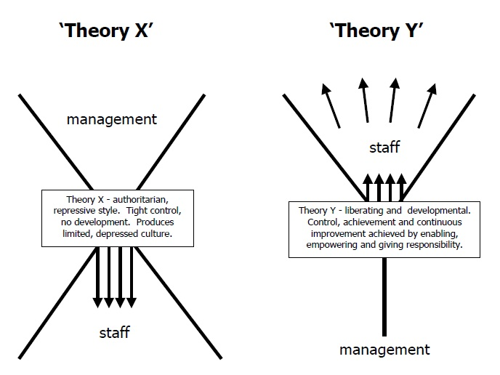
Figure 1. MacGregor theories X and Y diagrams

1. Theory X: presupposes that workers are innately lazy and will take any opportunity to avoid labour. According to this hypothesis, managers that want to stimulate their staff are prone to utilise severe control and punishment. Theory X, a management theory developed by Douglas McGregor, is based on the idea that workers are naturally unmotivated, slow, and in need of authoritarian management. This theory represents a pessimistic view of human nature, according to which employees must be strictly supervised and disciplined to be productive. Workers are viewed as lazy and docile.
Examples of Theory X management practices include micromanagement, strict accountability, and authoritarian management. McGregor believed that Theory X management practices were not only ineffective but also compounded the problem of low employee motivation. He argued that by treating employees as passive and disinterested, managers failed to tap into their potential and creativity. Instead, McGregor advocated for a more democratic and participative management style that recognized the value of employee input and collaboration.

2. McGregor's Theory Y: is a management theory that assumes employees are self-motivated, responsible, and want to contribute to the success of their organization. This theory reflects a positive view of human nature, in which workers are seen as creative and proactive and require supportive work environments to achieve their full potential.
Examples of Theory Y management practices include open communication, empowerment, and a focus on team collaboration. Managers who subscribe to this theory create a positive work culture that encourages employee engagement, creativity, and career development. McGregor believed that Theory Y management practices were more effective in promoting employee motivation and organizational success than Theory X practices. He argued that by treating employees as creative and proactive, managers could create a work environment that encouraged innovation and productivity.
3. Ouchi's Theory Z: is a management theory that evolved from McGregor's Theory Y and originated in Japan in the 1970s and 1980s. The theory emphasizes employee involvement in decision-making, job security, and long-term employment to improve productivity and create a positive work culture. "Theory Z management seeks to develop a strong corporate culture wherein employees feel a strong sense of loyalty and identification with the company."
This approach is often contrasted with more traditional Western management models, which tend to emphasize short-term goals and a focus on individual performance.
Examples of Theory Z management practices include a focus on team collaboration and consensus-based decision-making, job security, promotion from within the organization, and a commitment to employee training and development.
Ouchi believed that Theory Z management practices were more adapted to the changing demands of modern business environments. He argued that as organizations became more global and more complex, the traditional Western management practices became less effective. For example, he noted that Japanese companies used a Theory Z approach to compete successfully against larger, more established Western companies in the automotive industry.
These theories have impacted management practices in many industries and have been extensively employed in management literature.

Similarities and differences of Theory X, Y & Z approaches

Different management theorists have put forth three distinct theories of leadership: X, Y, and Z. There are some commonalities and contrasts across the theories, even though the basic presumptions of each one regarding employee behaviour vary.
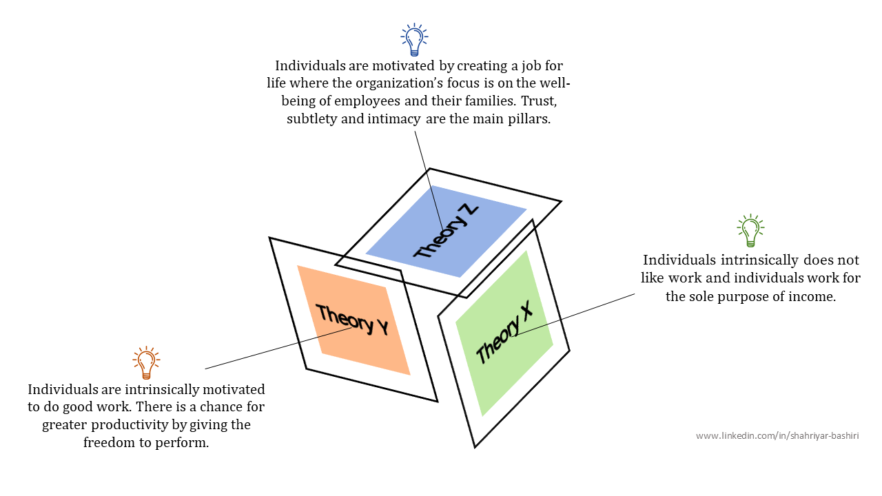
Figure 2. Theory X, theory Y and theory Z. (source: https://www.linkedin.com/pulse/theory-x-y-z-shahriyar-bashiri/)
Similarities
Theory X, Y, and Z are management theories that describe different beliefs about how employees are motivated and controlled in the workplace. While each theory has its unique characteristics, there are some similarities between them.

Employee motivation: All three theories are concerned with understanding how to motivate employees to perform better in the workplace. Theory X suggests that employees are inherently lazy and need to be closely monitored and controlled to ensure productivity. Theory Y argues that employees are self-motivated and will excel when given the opportunity to contribute and develop their skills. Theory Z emphasizes the importance of creating a supportive work environment that values employee involvement and commitment.

Employee involvement: Another commonality among the three theories is the focus on involving employees in decision-making processes. Theory X may not explicitly advocate for employee involvement, but it acknowledges the importance of clear communication and supervision. Theory Y and Z both emphasize the benefits of empowering employees to participate in decision-making and problem-solving, leading to higher employee engagement and job satisfaction.

Leadership style: While Theory X, Y, and Z have different assumptions about employee behaviour, they all recognize the importance of effective leadership in managing and motivating employees. Leaders in a Theory X environment may adopt a more authoritarian style to ensure productivity, while leaders in a Theory Y or Z environment may focus on building relationships and supporting employee development.

In conclusion, while Theory X, Y, and Z have distinct differences in their underlying assumptions about employee motivation and behaviour, there are some common themes that emerge in terms of the importance of employee involvement, motivation, and leadership in the workplace. By understanding and leveraging these similarities, managers can create a more effective and engaging work environment for their employees.

Differences:
Their basic presumptions on employee behaviour are where these theories diverge most. Whereas Theory Y bases its assumptions on the idea that workers are inherently motivated and capable of working freely, Theory X bases its assumptions on the idea that workers are inherently lazy and need continual supervision. In contrast, Theory Z assumes that workers have a natural attachment to their companies and that good corporate cultures and collaborative decision-making can strengthen this loyalty.

 | Theory X | Theory Y | Theory Z
View of work | Employees dislike work and will try to avoid it | Employees view work as a natural part of life | Employee involvement is the key to increase productivity
Attitude toward responsibility | Employees seek security not responsibility | Employees will seek responsibility under proper work conditions | Employees prefer to share responsibility and decision making
Attitude toward innovation | Security valued over ambition | Individuals capable of innovation | Whole is better than sum of parts
Ability to control | Coerces, controlled, threatened | Self-direction, self-control | Implicit control by loyalty to team
Motivation | Employees are motivated by financial rewards | Employees are motivated by many different needs | Employees need guaranteed employment and will accept slow evaluation
Table 1. Differences between Theories X, Y and Z
Leaders from Theory X would be more autocratic, whereas leaders from Theory Y would be more collaborative. However, it appears that the managers would continue to have a lot of authority in both situations. Leaders under Theory Z would need to have a tremendous level of faith in their employees' ability to make wise judgements. Thus, this kind of leader is more likely to take on the role of "coach" and delegate most decision-making authority to the employees.

Advantages and disadvantages of Theory X, Y & Z

Theory X, Theory Y, and Theory Z pertain to theories of human work management and motivation that propose two facets of employee conduct. Theory X is a negative theory that emphasises monitoring, and Theory Y is a positive theory that emphasises incentives and acknowledgment. In contrast, Theory Z combines the two of them.

Theory X Advantages:
One of the Theory X advantages is strict control, which can be useful in situations where employees require close supervision to ensure they meet performance standards. Another advantage is clarity and structure, which can be beneficial in high-pressure or time-sensitive environments. Also, in Theory X organizations, decision-making is typically centralized, allowing for rapid responses to challenges or changes in the business environment.
Theory X Disadvantages:
One of the biggest disadvantages of this theory is the lack of employee empowerment. Theory X can lead to disengagement and lower morale among employees who feel micromanaged and undervalued. In the same way employee’s creativity and innovation can be limited by restricting autonomy and decision-making authority. Also, due to the focus on control and supervision, Theory X management practices can result in high turnover rates as employees seek more fulfilling and empowering work environments.
Theory Y Advantages:
One important advantage of this theory is employee empowerment, Theory Y encourages employees to take ownership of their work and contribute to decision-making, leading to higher levels of engagement and job satisfaction. At the same time, by valuing employee input and ideas, Theory Y organizations are more likely to foster a culture of innovation, leading to new products, services, and processes. Theory Y management practices promote a positive work environment where employees feel valued and respected, reducing turnover rates and increasing employee loyalty and better retention.
Theory Y Disadvantages:
In some cases, Theory Y managers may delegate too much authority to employees, leading to inefficiency or quality issues if employees are not adequately trained or supervised. Also, they can create resistance to change, because employees who are used to a Theory X management style may struggle to adapt to a Theory Y approach, leading to resistance and conflicts within the organization. Theory Y can present a lack of structure, organizations may prioritize employee empowerment and collaboration to the extent that they overlook the need for clear guidelines and accountability, potentially leading to confusion or inefficiency.
Theory Z Advantages:
Theory Z emphasizes building strong relationships and investing in employee development, leading to a more sustainable and resilient organizational culture. In addition, Theory Z promotes a collaborative and team-based approach to problem-solving, enhancing communication and cooperation among different departments. Employee loyalty is one of the best advantages, by fostering a supportive and inclusive work environment, Theory Z organizations are likely to experience higher levels of employee loyalty and commitment, reducing turnover rates and increasing productivity.
Disadvantages:
Theory Z organizations may struggle to adapt to rapidly changing market conditions or technological advancements due to their emphasis on traditional values and long-term planning. Also, the consensus-driven nature of Theory Z decision-making processes can result in slower response times to urgent issues or opportunities in the marketplace.
In conclusion, each theory — X, Y, and Z — has its own set of advantages and disadvantages that should be carefully considered in the context of the specific organizational goals, culture, and industry. By understanding the strengths and weaknesses of each approach, managers can tailor their management practices to best support the needs and motivations of their employees while achieving business objectives.

Theoretical evaluation of Theory X, Y & Z approaches
Theory X, Y, and Z are management theories proposed to explain different perspectives on employee motivation and behaviour in the workplace. The theoretical evaluation of these approaches involves assessing their relevance, applicability, and implications for organizational management.
Theory X, proposed by Douglas McGregor in the 1960s, suggests that employees are inherently lazy, resistant to change, and need to be closely controlled and monitored to ensure productivity. This theory is based on a traditional, command-and-control management approach. However, critics argue that Theory X can lead to disengagement, low morale, and reduced creativity among employees (McGregor, 1960). While Theory X may be suitable in certain contexts where tight supervision is necessary, it may not be the most effective approach in modern organizations that value empowerment, collaboration, and innovation.
Theory Y, also proposed by McGregor, presents a contrasting view that employees are self-motivated, capable of taking initiative, and seek opportunities to contribute and develop their skills. This theory emphasizes trust, empowerment, and participative decision-making as key drivers of employee engagement and organizational effectiveness. Theory Y has been associated with higher levels of employee satisfaction, creativity, and performance (McGregor, 1960). However, some critics argue that Theory Y may be overly optimistic and unrealistic in certain situations where employees may not possess the intrinsic motivation and skills required to excel without clear direction and guidance.
Theory Z, introduced by William Ouchi in the 1980s, integrates elements of Japanese management practices, such as long-term employment, consensus decision-making, and employee involvement in decision-making. While Theory Z has been associated with improved employee morale, job satisfaction, and organizational commitment, some scholars have questioned its adaptability to different cultural and organizational contexts (Ouchi, 1981). Additionally, the consensus-driven decision-making process in Theory Z may result in slower decision-making and difficulty in responding to rapid changes in the business environment.
In conclusion, the theoretical evaluation of Theory X, Y, and Z suggests that each approach has its strengths and weaknesses, and the effectiveness of these theories may depend on the specific organizational context, industry, and cultural factors. Organizations should critically assess the relevance and applicability of these theories to determine the most suitable management approach for their workforce and strategic objectives.
When considering the role of culture and personal differences in the workplace, Theory Y would be the most useful theoretical approach. Theory Y, proposed by Douglas McGregor, suggests that employees are self-motivated, capable of taking initiative, and seek opportunities to contribute and develop their skills. This approach values trust, empowerment, and participative decision-making, which are essential considerations when navigating diverse cultural backgrounds, personal differences, and generational characteristics in the workforce. For example, in politics and religion: Theory Y is conducive to fostering a work environment that respects individuals' political beliefs and religious affiliations. By emphasizing trust, open communication, and mutual respect, organizations can create a culture that accommodates diverse perspectives and values diversity of thought. Employees are more likely to feel empowered and engaged when they can openly express their political and religious views without fear of discrimination or bias.
By adopting Theory Y principles, organizations can create a more inclusive, supportive, and engaging work environment that celebrates diversity, values individual contributions, and empowers employees to reach their full potential, regardless of generational, gender, political, religious, or familial differences. This approach aligns with the values of respect, fairness, and collaboration that are essential for navigating cultural diversity and promoting a positive and inclusive workplace culture.

Situational or Contingency leadership

Contingency approaches to leadership refer to theories that suggest the most effective leadership style or behaviour depends on specific situational factors, such as the characteristics of the followers, the nature of the task, and the organizational context. These approaches emphasize that there is no one-size-fits-all leadership style and that leaders should adapt their behaviour to meet the needs of different situations. Contingency theories help leaders understand that what works in one situation may not work in another and encourage flexibility and customization in leadership practices.
One of the prominent contingency theories of leadership is the Situational Leadership Theory (SLT) developed by Paul Hersey and Ken Blanchard (1969). According to SLT, effective leadership is contingent on the readiness level of followers, which is determined by their competence and motivation to perform a specific task. Based on the readiness level of followers, leaders should adjust their leadership style, ranging from directing to coaching, supporting, and delegating.
Another notable contingency theory is the Path-Goal Theory developed by Robert House (1971), which suggests that leaders should adapt their behaviour to align with the needs and characteristics of their followers and the task at hand.
The LPC approach emphasizes the importance of matching the leader's style with the situation and the preferences of the followers. The approach proposes that leaders' effectiveness depends on their LPC scores, which reflect their underlying motivating factors and the situational contexts in which they operate (Fiedler, 1964).
Transformational leadership theory suggests that leaders can transform their followers' values, beliefs, and behaviours by inspiring them to achieve higher levels of performance and personal growth. This type of leadership involves four key elements: idealized influence, inspirational motivation, intellectual stimulation, and individualized consideration (Bass, 1985).
These contingency theories of leadership highlight the importance of considering the specific demands of each situation and adjusting leadership behaviour accordingly to maximize effectiveness. By understanding and applying the principles of contingency approaches to leadership, leaders can enhance their ability to navigate diverse challenges, inspire and motivate their followers, and achieve organizational goals in a dynamic and ever-changing environment.

Cost of living in UK

One of the significant recent issues that have impacted UK businesses is the rising cost of living. The average cost of living in the UK climbed by more than 20% between 2011 and 2018, but average salaries increased by little more than 10%, according to research from the Resolution Foundation (2019). The cost of living in the UK has been on the rise due to various factors, including inflation, stagnant wage growth, increasing housing costs, and higher energy prices. This has put pressure on both individual consumers and businesses, impacting purchasing power, consumer confidence, and overall economic stability.
The cost-of-living crisis has had several implications for UK businesses:
- Consumer Spending: As the cost-of-living increases, households' disposable income decreases, leading to reduced consumer spending on non-essential goods and services. This has a direct impact on businesses, particularly those in the retail and hospitality sectors, as demand for their products and services may decline.
- Wage Pressure: Businesses may face challenges in attracting and retaining talent due to the mismatch between the rising cost of living and stagnant wage growth. To remain competitive and retain skilled workers, businesses may need to adjust their compensation packages, which can increase operating costs.
- Supply Chain Disruptions: The cost-of-living crisis has also exacerbated supply chain disruptions, leading to shortages of raw materials, delays in production, and increased transportation costs. This can impact the operational efficiency and profitability of businesses across various industries.
- Inflationary Pressures: Rising costs of goods and services, driven by inflation, can squeeze profit margins for businesses. Rising energy costs have affected businesses in the UK in addition to wages. The Federation of Small Businesses (2019) reports that during the last ten years, energy bills for small businesses in the UK have increased by an average of 35%. This can have a substantial effect on the profitability of these enterprises.
In general, businesses have been greatly impacted by the cost-of-living problem in the UK. As a result, they have had to modify their workforce management, operations, and strategy to mitigate the consequences of growing expenses and remain resilient in an economically challenging environment.

A specific example that can be relevant to a UK small business is the impact of rising energy costs on a local independent restaurant. As the cost of energy, including electricity and gas, has been increasing due to various factors such as global energy prices, supply chain disruptions, and government policies, small businesses like restaurants have faced challenges in managing their operational costs and maintaining profitability.
In this scenario, will be considered a local independent restaurant in the UK that has been impacted by rising energy costs:

- Effectively Implemented Actions:
Energy Efficiency Measures: The restaurant installed energy-saving appliances, lighting fixtures, and HVAC systems to reduce energy consumption and lower utility bills.

- Negotiated Contracts: The restaurant proactively renegotiated its energy contracts with suppliers to secure better rates and terms.

- Menu Adjustments: The restaurant made strategic menu adjustments, such as incorporating more seasonal and locally sourced ingredients, to offset rising food costs influenced by energy prices.

Ineffectively Implemented Actions:

- Delayed Response: The restaurant delayed implementing energy-saving measures and cost-saving strategies in response to rising energy costs, resulting in higher operational expenses and reduced profitability.
- Reactive Approach: Instead of proactively managing energy costs, the restaurant took a reactive approach by only responding to sudden increases in utility bills or external factors.
- Limited Monitoring: The restaurant lacked regular monitoring and analysis of its energy consumption patterns and costs, missing opportunities to identify inefficiencies and implement targeted solutions for reducing energy expenses.

Finally, the example of a local independent restaurant in the UK highlights the importance of proactive energy management and cost-saving strategies for small businesses to navigate challenges posed by rising energy costs. By effectively implementing energy efficiency measures, negotiating supplier contracts, and adapting business practices to mitigate cost pressures, small businesses can enhance their financial resilience and sustainability in a competitive market environment.

Conclusion and Recommendations
In conclusion, the cost-of-living has a complicated effect on UK businesses, influencing pay, energy prices, and the availability of competent labour, among other facets of the business environment. To ensure a sustainable and competitive business environment, lawmakers must consider measures that address the underlying reasons of growing living costs, even as firms must negotiate these obstacles. A potentially useful leadership approach to combat the cost-of-living problem and its effects on small enterprises in the UK is transformational leadership. This approach places a strong emphasis on encouraging and motivating staff members to reach higher performance standards and pursue personal development, all of which can boost output and enhance the company's overall success. Furthermore, transformational leadership places a major emphasis on developing relationships with staff members, which can support employee loyalty and retention as well as lower turnover and related expenses. Leadership plays a crucial role in shaping the success, resilience, and sustainability of any business operating in the UK within the current social-economic context. In today's rapidly evolving business landscape characterized by complex challenges, disruptive changes, and dynamic market conditions, effective leadership is more important than ever in guiding organizations towards growth, innovation, and competitiveness.

References
- Bass, B. M. (1985). Leadership and performance beyond expectations. Free Press.
- Bui, T. T. (2019). The impact of McGregor's Theory X, Theory Y, and Theory Z on employee motivation and job satisfaction: A literature review. The International Journal of Business and Management, 7(4), 48-58.
- Chemers, M. M. (2014). An integrative theory of leadership (2nd ed.). Routledge.
- De Visser, M., & Woolley, L. (2006). Douglas McGregor: Revisiting Theory Y. Journal of Management History, 12(3), 219-234.
- Drucker, P. (2004). The Essential Drucker: The Best of Sixty Years of Peter Drucker's Essential Writings on Management. HarperCollins.
- EY, (2022). "Rising cost of living: EY ITEM Club revises down UK GDP forecast as inflation hits 5.2%" -. [https://www.ey.com/en_uk/news/2022/03/rising-cost-of-living-ey-item-club-revises-down-uk-gdp-forecast-as-inflation-hits-52].
- Federation of Small Businesses. (2019). Rising energy costs: The impact on small businesses. Retrieved from https://www.fsb.org.uk/media-centre/latest-news/2019/08/01/rising-energy-costs-the-impact-on-small-businesses
- Fiedler, F. E. (1964). A contingency model of leadership effectiveness. Advances in Experimental Social Psychology, 1, 149-190.
- Hersey, P., & Blanchard, K. H. (1969). Management of organizational behaviour: Utilizing human resources. Englewood Cliffs, NJ: Prentice-Hall.
- House, R. J. (1971). A path-goal theory of leader effectiveness. Administrative Science Quarterly, 16(3), 321-339
- https://www.linkedin.com/pulse/theory-x-y-z-shahriyar-bashiri/
- Kotter, J. P. (2013). Management is (still) not leadership. Harvard Business Review, 91(1/2), 62-77.
- McGregor, D. (1960). The human side of enterprise. New York: McGraw-Hill.
- Northouse, P. G. (2018). Leadership: Theory and practice (8th ed.). Sage Publications.
- Ouchi, W. G. (1981). Theory Z: How American business can meet the Japanese challenge. Reading, MA: Addison-Wesley.
- People 1st International. (2017). State of the nation: UK hospitality and tourism workforce report, 2017. Retrieved from https://people1st.co.uk/wp-content/uploads/2018/11/State-of-the-nation-2017.pdf
- Perry, J. L., Mesch, D., & Paarlberg, L. (2006). Motivating employees in a new governance era: The performance paradigm revisited. Public Administration Review, 66(s1), 4-14.
- Resolution Foundation. (2019). Living standards, poverty, and inequality in the UK: 2019. Retrieved from https://www.resolutionfoundation.org/app/uploads/2019/01/Living-Standards-Poverty-and-Inequality-in-the-UK-2019.pdf
- Robbins, S. P., Coulter, M., & DeCenzo, D. A. (2017). Fundamentals of management.
- Shafritz, J. M., Ott, J. S., & Jang, Y. S. (2015). Classics of organization theory. Cengage Learning.
- Sohail, M. S., & Sarfraz, M. (2018). Simulation based comparative study of Theory X, Theory Y and Theory Z of organizational management. Journal of Business and Retail Management Research, 12(4), 113-121.
- The Guardian, (2022). "Cost of living crisis leaves UK households £9bn worse off, says thinktank" -. [https://www.theguardian.com/business/2022/mar/08/cost-of-living-crisis-leaves-uk-households-9bn-worse-off-says-thinktank].

Student: Mariana Codreanu 2118364
University of Wales Trinity Saint David Samuel Ofori
Portfolio
Module: Emergent Leadership Skills in the Workplace BMSW6101

Contents
Introduction 19
Driscoll Model of Reflection 19
Experience (What?) 20
Reflection (So What?) 21
Action (Now What?) 23
Conclusion 24
References 25

Part 2. Reflective Essay

Introduction
According to Finlay (2008), reflective practice is "learning through and from experience towards gaining new insights of self and practice." Making connections between experiences is made possible through the methodical review process known as reflection. A fundamental component of both teaching and learning is reflection. Through "challenging assumptions of everyday practice and critically evaluating practitioners' own responses to practice situations," it seeks to increase your awareness of your own professional knowledge and behaviour (Finlay, 2008).
The Driscoll model of reflection is a structured framework that guides individuals through the reflective process by prompting them to explore and analyse their experiences, emotions, and actions. In the context of completing the module on Emergent leadership skills for the workplace, I will use the Driscoll model of reflection to reflect on my learnings and insights regarding leadership theories, traits, skills, and ethics. In this reflection, I will be sharing my insights and takeaways from the leadership module. Through this module, I gained a deeper understanding of what it takes to be an effective leader. I learned that leadership is not just about having a position or title, but rather it involves a set of skills and behaviours that can be developed and honed over time.

Driscoll Model of Reflection
Driscoll’s model of reflection incorporates the “what”, “so what”, and “now what” of the experience into your reflection (Driscoll, 1994). Based on your experience, you are analysing its key takeaways and deciding on your next course of action. To stimulate thought during the reflection, the model incorporates trigger questions and is linked with Kolb's learning cycle. Through these two processes, self-directed learning can be experienced in inspecting, analysing, challenging, transforming, and applying behaviours towards desired results.
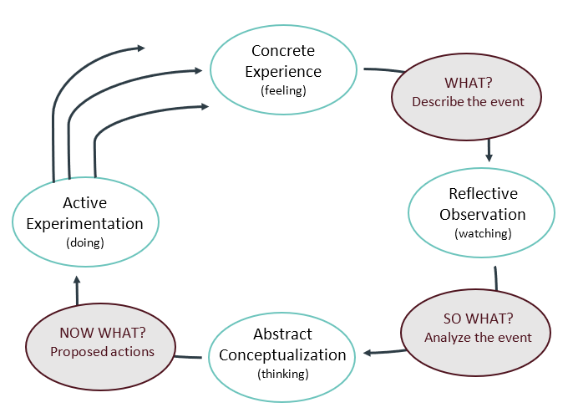
Figure 1. Driscoll's "What?", "So what?" and "Now what?" model of reflection.
The first step in Driscoll's reflection model is concrete experience (feeling), or "WHAT?" describe the event. The next step is reflective observation (watching), or "SO WHAT?" the incident, to abstract conceptualization (thinking), to suggested activities for "NOW WHAT?" and finally to active experimentation (doing).
Next step I will reflect on my learning based on the Driscoll model of reflection after completing the module on Emergent leadership skills for the workplace.

Experience (What?)
During the module on Emergent leadership skills for the workplace, I engaged with various concepts and theories related to leadership, including the nature of leadership, recognizing leadership traits, developing leadership skills, and addressing ethics in leadership. I gained a thorough understanding of a wide range of leadership-related topics from this module, including identifying personal qualities, comprehending leadership philosophies and styles, honing leadership abilities, overcoming situational leadership obstacles, leading in unpredictable times, and handling ethics in leadership. Every subject improved my knowledge and leadership skills and gave me the resources I need to flourish in a changing and diverse workplace. I learned about the essential qualities of effective leaders, as well as the nature of leadership itself and how it helps teams and organisations achieve their objectives. I also learned more about the various theories, techniques, and leadership philosophies that underpin good leadership practices. I've also gained knowledge on self-awareness and how to identify character attributes that support good leadership. How to use self-evaluation activities to pinpoint own values, preferences, strengths, and shortcomings as a leader so that we can take advantage of their special abilities and characteristics in leadership positions. The course explores many leadership theories and approaches, such as Theory X, Theory Y, and Theory Z, these management theories are put up to explain different perspectives on employee motivation and behaviour at work (McGregor, 1960). The underlying presumptions, methods, and consequences of each philosophy will be covered, as well as how these philosophies influence leadership practices and behaviours. I looked at the Path-Goal theory, House (1971), which suggests that leaders should adapt their behaviour to align with the needs and characteristics of their followers and the task at hand, the LPC (Least Preferred Co-Worker) method, and transformational leadership as examples of situational leadership models, and discovered how to modify the leadership approach to suit the requirements of various followers, circumstances, and organisational settings (P. Hersey and K. Blanchard,1969). In addition, I learned about leadership in uncertain situations, this section addresses leading during times of change, uncertainty, and crisis. I looked at methods for leading teams and organisations through uncertainty, handling complexity, coming to wise decisions, and building resilience. I now have a better grasp of the nature of leadership and how vital flexibility and adaptability are to becoming a successful leader thanks to the lectures, materials, and many other things that have been made available.

Reflection (So What?)
When learning new concepts about leadership, I experienced a range of emotions and reactions that influenced my engagement with the material and my understanding of the topic. Initially, I felt excited and curious to explore new ideas, theories, and perspectives on leadership. The prospect of delving into different leadership styles, skills, and philosophies sparked my interest and motivated me to deepen my knowledge in this area. As I progressed through the learning process, I also felt challenged and sometimes overwhelmed by the complexity and depth of the concepts being presented. Some theories and models of leadership required deeper reflection and critical analysis, pushing me to think beyond my existing beliefs and assumptions about leadership practices.

At times, I felt inspired and invigorated by the potential for personal and professional growth that comes with learning new concepts about leadership. Discovering new ways to enhance my leadership skills, adapt my style to different situations, and lead with integrity and ethics filled me with a sense of purpose and determination to become a more effective leader. However, I also went through phases of self-doubt and uncertainty as I struggled to apply these novel ideas to my own style of leadership. Confronting my shortcomings, dealing with prejudices and presumptions, and changing my conduct to conform to good leadership techniques were difficult.
During my study I have enjoyed learning about transformational leadership, which emphasizes inspiring and motivating followers to achieve higher levels of performance. This theory has resonated with me somehow because I like building strong relationships, fostering growth and development, and creating a shared vision within a team or organization. However, situational leadership theory has piqued my interest since it examines how leaders can modify their approach to suit the demands of various contexts and followers. This idea provides a useful and adaptable method of leadership that can be used in a variety of settings, enabling me to modify my style of leadership in response to situations. In addition, I have found fulfilment in studying ethical leadership since it emphasises the significance of honesty, integrity, and moral judgement when leading others.
On the other hand, I have experienced anxiety or worry when it comes to learning how to be a leader in times of crisis, change, or uncertainty. It can be difficult for leaders to navigate unstable and volatile situations since they call for resilience, adaptability, and strategic thinking, all of which can be frightening or difficult. Additionally, Theory X and Theory Y, which examine opposing presumptions about motivation and behaviour in the workplace, have made me uneasy or uncomfortable. Additionally, I have feared applying leadership skills in real-world scenarios or practice, as it can involve taking risks, making difficult decisions, and facing potential failures.
After learning about these leadership theories, styles, and skills, I identified moments of success from my previous work experience and found my leadership style which helped me and my team successfully achieve our goals, unconsciously applying principles of transformational leadership.
Reflecting on my learning journey, I realized the importance of self-awareness and continuous growth in developing effective leadership skills. The module also highlighted the significance of ethical leadership in fostering a positive work environment and driving organizational success. By delving into leadership traits and skills development, I understood the diverse qualities that contribute to effective leadership and how they can be applied in real-world scenarios to achieve workplace objectives.

Action (Now What?)
Moving forward, I am committed to applying the knowledge and insights gained from the module to enhance my leadership capabilities. I plan to actively work on developing key leadership traits such as empathy, communication, and adaptability, while also prioritizing ethical decision-making in leadership roles. I aim to integrate the leadership theories and skills learned into my day-to-day practices, seeking opportunities for growth and self-improvement as a leader in the workplace. I can also, continue the practice of self-awareness and identifying my leadership qualities to gain a better understanding of my leadership strengths and areas that require improvement. Apply the concept of situational leadership by customising my approach to each situation's unique requirements. For example, to guarantee timely completion during a project with a tight deadline, I might need to be more directive and give precise directions. On the other hand, I could take a more active stance during a group brainstorming session, encouraging team members to exchange ideas and participate in the decision-making process. In addition, I would embrace ethical leadership principles in my decision-making to maintain my team's integrity and trust. When faced with a choice between competing interests, I will think about how I may prioritise the interests of all parties involved while adhering to moral principles. If I find out, for instance, that there may have been an ethical transgression on my team, I will try to handle the matter fairly, transparently, and in accordance with ethical standards. Also, I could employ transformational leadership strategies to encourage and inspire my group to work towards a common goal. Lastly, improve my conflict resolution and communication techniques to encourage constructive conflict resolution and beneficial interactions. When team members disagree on how to approach a project, engage in active listening to comprehend their points of view, encourage open discussion to resolve worries, and cooperate to find a win-win solution. Productivity can be increased, and team cohesion strengthened through effective communication and conflict resolution.
Incorporating these elements of leadership learning into my interactions with coworkers can, in general, result in more favourable work environments, greater team dynamics, and increased effectiveness as a leader. I may become a more ethical, flexible, and motivating leader in my professional setting by thinking back on these important lessons and putting them to use in practical settings.

Conclusion
In conclusion, I was able to gain important insights and perspectives that will guide my future leadership growth and practice by applying the Driscoll model of reflection to methodically analyse and reflect on my learning journey through the leadership skills module.
Emergent leadership skills for the workplace module have proven to be a valuable and enriching learning experience, offering a comprehensive exploration of essential leadership concepts, theories, and practices. Through engaging with diverse topics such as understanding leadership, recognizing personal traits, exploring different leadership philosophies and styles, developing crucial leadership skills, navigating situational challenges, leading in uncertain times, and addressing ethics in leadership, I have gained valuable insights and practical knowledge to enhance my leadership capabilities. Furthermore, this module has given me a comprehensive grasp of leadership methods and concepts, enabling me to lead with assurance, morality, and influence in my various roles and organisations. With the knowledge and abilities, I've acquired from this module, I'm ready to start a journey of leadership excellence, ongoing development, and positive impact both at work and outside of it.

References

- Covey, S.R. (2004). The 7 Habits of Highly Effective People: Powerful Lessons in Personal Change. Free Press.
- Fiedler, F. E. (1964). A contingency model of leadership effectiveness. Advances in Experimental Social Psychology, 1, 149-190.
- Finlay, L. (2008). Reflecting on Reflective Practice. Practice-Based Professional Learning Paper 52, The Open University.
- Hersey, P., & Blanchard, K. H. (1969). Management of organizational behaviour: Utilizing human resources. Englewood Cliffs, NJ: Prentice-Hall.
- House, R. J. (1971). A path-goal theory of leader effectiveness. Administrative Science Quarterly, 16(3), 321-339
- Kotter, J. P. (2013). Management is (still) not leadership. Harvard Business Review, 91(1/2), 62-77.
- McGregor, D. (1960). The human side of enterprise. New York: McGraw-Hill.
- Northouse, P. G. (2021). Leadership: Theory and practice. Sage Publications.
- Robbins, S.P., Judge, T.A. (2018). Organizational Behaviour. Pearson.
- Yukl, G. (2019). Leadership in organizations. Pearson.

