Reliabilty Lecture 05 April 2021

As Stephanie Glen (2021) says outside the study of statistics many people use the words reliability and validity interchangably. They are releated but are different.

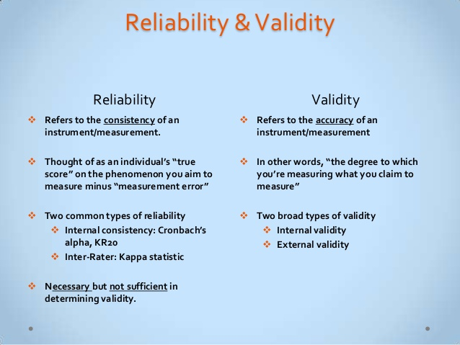

Figure 1. Some basic definitions. Source: Glen (2021) (A website, so I am not sure of the date of its writing. SG.)

Reliability implies consistency: if you take IQ Test five times, you should get roughly the same results every time. A test is valid if it measures what it is supposed to.

Tests that are valid are also reliable. The IQ test is valid (and reliable) because it measures what a person’s intelligence is.

However, tests that are reliable are not always valid.

For example. If your thermometer was a degree off. It would be reliable (giving you the same results each time) but not valid (because the thermometer was not recording the correct temperature).

There is also some controversy about the validity of IQ tests. Some do not believe that they are valid or reliable. That the “intelligence” they test is culturally biased.
From this perspective theoretically your intelligence is inborn. Therefore you should get approximately the same result whenever and however many times you take the test. Nevertheless there are many books, training courses and tutors who coach students and claim they can improve your IQ, SATS or ACT test scores. Maybe intelligence is also influenced by social conditions, education, training, background environmental factors as much as inborn skill and aptitude.

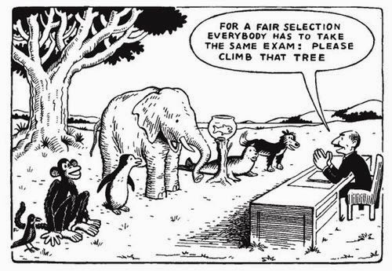

Figure 2. Equality in tree climbing. A fair test of abilty?



Figure 3. The three wise monkeys. They are often refered to in popular culture. See no evil, speak no evil, hear no evil! Just like us in research?

https://myozonelayer.com/2016/11/22/the-4th-monkey-do-no-evil/





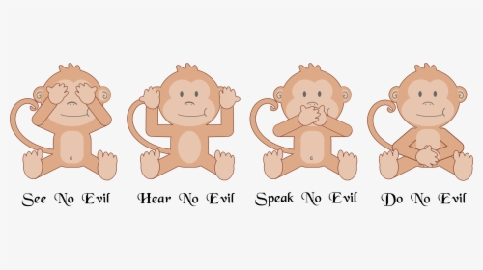



Figure 3. Manipulation of the data collection process?



Figure 4. General scepticism of the research process and funding pressures?



Figure 5. Using political catoons to integret the attitudes to the USA and beef exports in Taiwan. Source: Lin and Chang (2015) This is their Fig. 10.

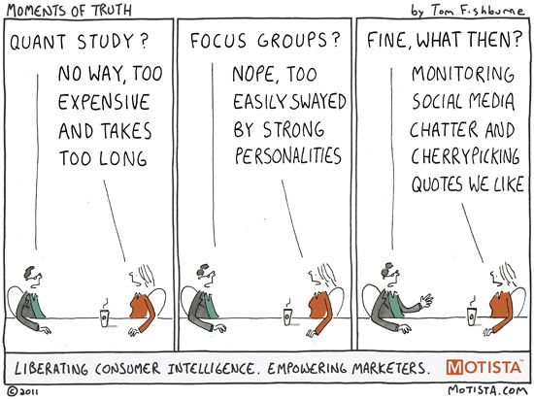

Figure 6. Let’s just do whatever we want…..too much pressure!

Research Reliability

Reliability refers to whether you get the same answer by using your research and data collected to measure something more than once. Does your research method produce stable and consistent results?
A specific measure is reliable if its application on the same object of research several times produces the same results. In other words a test or research findings to be repeatable.
For example, a medical thermometer is a reliable tool that would measure the correct temperature each time it is used. In the same way, a reliable math test will accurately measure mathematical knowledge for every student who takes it and reliable research findings can be replicated over and over.
For those doing quantitative methods Glenn (2021) states:
“Of course, it’s not quite as simple as saying you think a test is reliable. There are many statistical tools you can use to measure reliability.

For example:

- Kuder-Richardson 20: a measure of internal reliability for a binary test (i.e. one with right or wrong answers).
- Cronbach’s alpha: measures internal reliability for tests with multiple possible answers.

The Reliability Coefficient
A reliability coefficient is a measure of how well a test measures achievement. It is the proportion of variance in observed scores (i.e. scores on the test) attributable to true scores (the theoretical “real” score that a person would get if a perfect test existed).”

Much of this relates to quantitative methods but should also be applied to qualitative.
Research reliability can be divided into several categories:
- Test-retest reliability relates to the measure of reliability that has been obtained by conducting the same test/data collection exercise more than one time over time with the same sample group or object of research.

Test-retest reliability measures the consistency of results when you repeat the same test on the same sample at a different point in time. You use it when you are measuring something that you expect to stay constant in your sample.
Example: A test for colour blindness for pilots being admitted for training, should have a high reliability because colour blindness is a factor that does not change over time.
Test-retest reliability can be used to assess how well a method resists independent variables/ factors over time. The smaller the difference between the two sets of results, the higher the test-retest reliability. Conduct the same test on the same group of people at two different points in time. Then you calculate the correlation between the two sets of results.
If there is a variance over time, it needs to be explained. Either your model/theory is incorrect (not valid) or variables are not constant and this changing environment must be built into the model.
Example: The same student group was asked to complete the same questionnaire about their willingness to recycle their waste on campus, twice with an interval of one week, so that test results can be compared to assess stability of scores.
- Can you challenge if they find different willingness to recycle in the two periods?
Example: You collect website information on the same organisation investigating their commitment to CSR. You look for CSR statements and where they are located. You look for policy statements, with action plans and ways to measure impact.
- What if the organisation has updated its website and adopted new policies?
In the above IQ test example if you administer the test two months apart to the same group of people, but the results are significantly different, the test-retest reliability of the IQ questionnaire is low.

It might be a challenge to the quality of the test you used, the conditions under which it was administered or the way the data was analysed.

Example: Mood, concentration of respondents, atmosphere of the location and other factors could cause different results for the same respondents doing the same test.

This is a problem for interview data collection since it is often impossible to create identical environments in which to ask the interview questions. The interviewer can also be subject to changing feelings, levels of attention and enthusiasm. If nothing else try to reduce the impact of these environmental influences and challenge your own interview data once it is collected, building in a self-critical element which could create flaws in the quality of the data (its reliability).

- Steve Griffiths suffers from “White coat syndrome”. How should we test him to check his blood pressure, heart rate and oxygen levels?

https://www.healthline.com/health/white-coat-syndrome#:~:text=What%20is%20white%20coat%20syndrome,coats%20in%20a%20professional%20setting.
In fact he wore a blood pressure gauge for 24 hours which recorded the data. The medics could then read the time series and create an average score which said he was on the edge of needing drugs, which he chose not to take but he did alter his diet as a result.
2. Parallel forms reliability relates to a measure that is obtained by conducting assessment of the same phenomena with the participation of the same sample group via more than one assessment method. Measuring the correlation between two equivalent versions of a test, another option, when you have two different assessment tools or sets of questions to measure the same thing can evaluate reliability.
Example: The levels of employee satisfaction of UWTSD may be assessed with questionnaires, in-depth interviews and focus groups and results can be compared. This is one of the demands if you use case study or mixed methods, to enable triangulation.
- Can you think of ways in which some of these methods may find “the truth” more effectively than others?
See the discussion by Eva Codó (2008) where she analyses how she uses interviews and questionnaires to seek the truth, but each discovers method different things.
All methods have weaknesses as well as strengths. See Randall and Pheonix, (2009) on the problems of interviews. See problems using statistics even in the medical field, Indrayan (2007).
Maybe mixed methods can allow you to have the best of various methods…..the danger is that you get the worst of the methods used and may not do any one method at a high quality.
Maybe it depends on what you have set as your objectives for the research? Figure 7 restates past lecture notes.
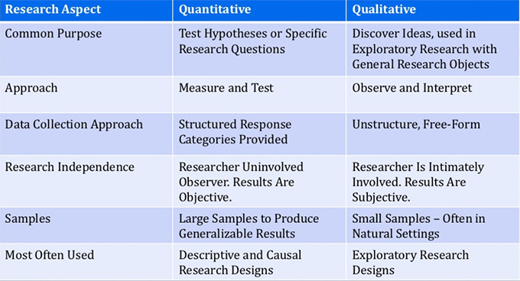
Figure 7. Different methods for different types of research. Source: Quoted in Ayat Shukairy (2002).
Perhaps it depends on your resources, including your own ability, time, access etc. See Figure 8, related to Marketing Research.
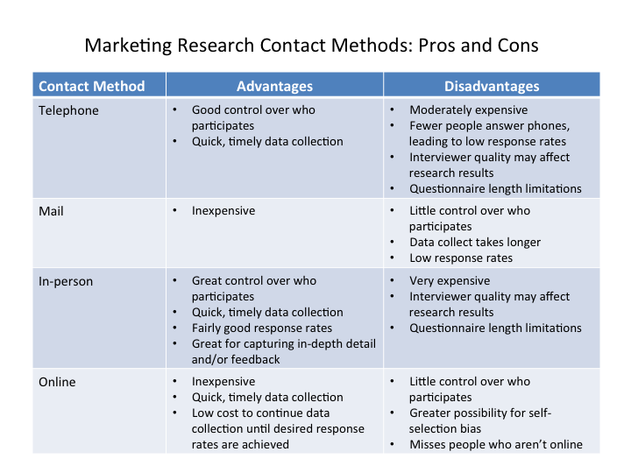
Figure 8. Marketing research Contact Methods. Source: Lumen Learning (2020).

- Also what sample should be used for each method?

- What if there IS ONLY one test? Can you think of an example?

- Inter-rater reliability/Interobserver reliability relates to the measure of sets of results obtained by different assessors using same methods.
Benefits and importance of assessing inter-rater reliability can be explained by referring to subjectivity of assessments. It measures the degree of agreement between different people observing or assessing the same thing. Data is collected by researchers assigning ratings, scores or categories to one or more variables. All researchers should agree on how to categorize or rate different types of behaviour.

Example: Levels of student recycling activity can be assessed at UWTSD using observation method by two different assessors. Inter-rater reliability relates to the extent of difference between the two assessments.
- Can two different researchers produce identical results looking at the same event, even if they are trained together and agree the criteria for collecting observation data?


Figure 9. A strange hat.

Remember Caroline ‘liked’ my book hat…..was she lying? Did you listen to her answer? Did you look at her body language? Did you interpret the relationship that she has with me? Do you believe that friends would not want to hurt each other’s feelings? Therefore she was always going to say she liked it!!!

- Can two sets of observations ever be identical?

A company sacks workers in a Western country location to move to an Asian location where workers are cheaper to employ…..good or bad CSR? Ask these two above!
Let alone these guys!


- What if they are taking place at identical times observing in the same location?

Maybe it depends on who is the actioner and who is the observer. The predicted stories of the different car owners were discussed in the lecture.
Who is correct? Who has most to gain? What outside actors may impact on what they say? Police? Insurance companies? Other drivers now in a car jam?
Can I be sure I am funny? See Figure 10.

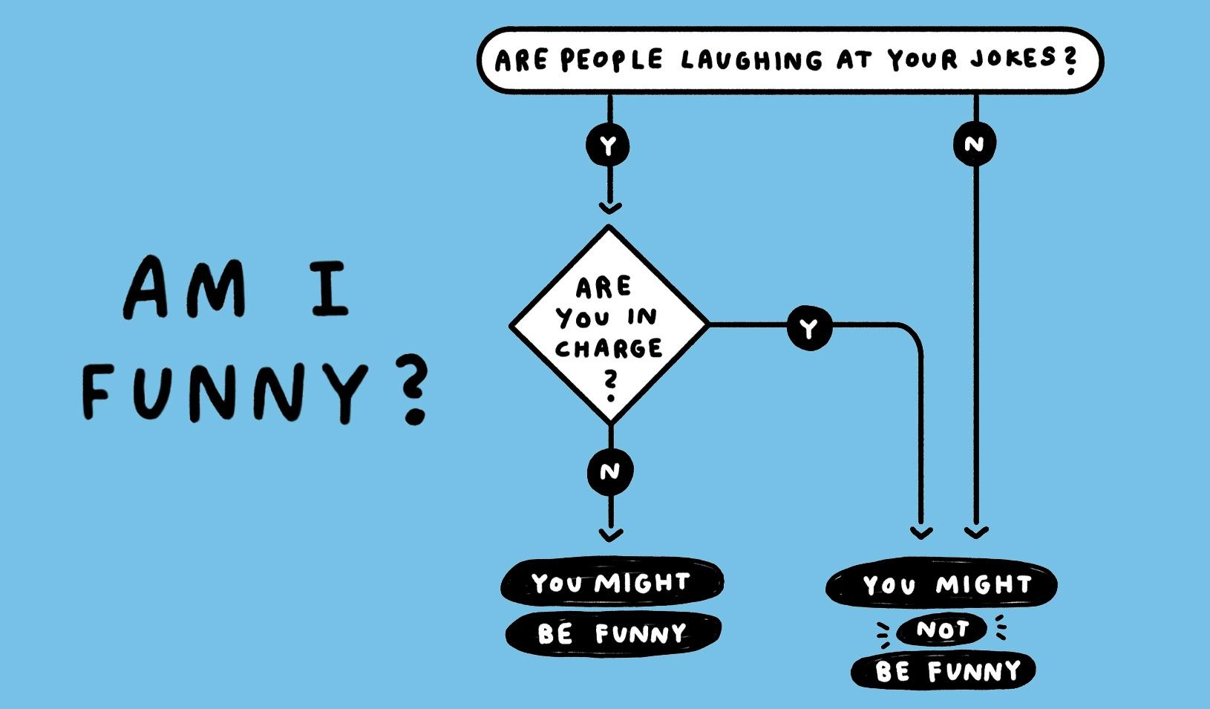
Figure 10. Process of me assessing my “funniness”. Source: Joel Stein (2021).
In the lecture I related the impact of this question varied with the power relations, objective of joke telling and the motivations of the actors involved…. Or just read Stein.
Challenges
People are subjective, so different observers’ perceptions of situations and phenomena naturally differ. Reliable research aims to minimize subjectivity as much as possible so that a different researcher could replicate the same results.
When designing the scale and criteria for data collection, it is important to make sure that different people will rate the same variable consistently with minimal bias. To measure interrater reliability, different researchers conduct the same measurement or observation on the same sample. Then you calculate the correlation between their different sets of results. If all the researchers give similar ratings, the test has high interrater reliability.
Example: A team of researchers observes new students entering the campus. They record the willingness to ask questions, listen to information, view video presentations and their reading of material sent to them for pre reading. To record stages of interaction, body language, signs of discomfort, lack of or over confidence, would need clearly defined variables, measurements, objective criteria and much training to familiarise themselves with the accurate recording of these behaviours.

4. Internal consistency reliability is applied to assess the extent of differences within the test items that explore the same construct produce similar results. Internal reliability, or internal consistency, is a measure of how well your test is measuring what you want it to measure.
Internal consistency assesses the correlation between multiple items in a test that are intended to measure the same construct.
Calculate internal consistency without repeating the test or involving other researchers. It is a good way of assessing reliability when you only have one data set.

It can be represented in two main formats:
a) average inter-item correlation is a specific form of internal consistency that is obtained by applying the same construct on each item of the test. For a set of measures designed to assess the same construct, you calculate the correlation between the results of all possible pairs of items and then calculate the average.
b) split-half reliability as another type of internal consistency reliability involves all items of a test or data set to be split in half. You randomly split a set of measures into two sets. After testing the entire set on the respondents, you calculate the correlation between the two sets of responses.

Example: To measure customer satisfaction with an online store, you could create a questionnaire with a set of statements that respondents must agree or disagree with. Internal consistency tells you whether the statements are all reliable indicators of customer satisfaction. This might check their consistency in replying to you.

Question 1: What factors attracted you to buying the ‘Bright red Jawad-Griff Fashion Trainers’? (Please number in order of importance, 1 the most important).



- The way my friends recommend it. | 2.
- The way they make me run faster. | 3.
- The lovely colour red. | 1.

Question 10: What is your favourite colour? (Mark one box).
- Blue | x
- Red
- Pink
- Yellow

This might indicate a contradiction in their evaluation or simply inconsistency.

A similar action can be used in interviewing or focus groups……with different questions which offer the opportunity to give contradictory answers if the respondent is not consistent or logical.

If responses to different items contradict one another, the test might be unreliable.
Maybe the language/vocabulary was not clear or the number of options in question 1 did not cover the reality of why they chose the product.
Perhaps they liked the feel of the shoes or appreciated that the company has good CSR policies and does not use low waged workers in developing countries. My closed question does not allow them to express this. An advantage of open-ended questions would allow them to tell me the ‘truth’? These are more difficult to code and anticipate answers.
However this apparent inconsistency might also be explained if the respondents are allowed to explain themselves, a strength of qualitative methods.
Example: A group of respondents are presented with a set of statements designed to measure optimistic and pessimistic mindsets. They must rate their agreement with each statement on a scale from 1 to 5. If the test is internally consistent, an optimistic respondent should generally give high ratings to optimism indicators and low ratings to pessimism indicators. The correlation is calculated between all the responses to the “optimistic” statements, but the correlation is very weak. This suggests that the test has low internal consistency.

I used a similar format when asking SMEs about their happiness to adopt Internet Marketing. After getting them to say if they had or had not adopted, I gave a list of good and bad things (mixed up) about internet marketing adoption. Those who had adopted should have ticked the advantages list and rated the disadvantages lower and vice versa.

Although this lends itself to numerical survey methods it can be used in qualitative work e.g. splitting two focus groups with the same characteristics and comparing the data for these separated sources, which should be identical.
5. External reliability means that your test or measure can be generalized beyond your study/research.
For example, the argument I made above that tutoring improves test scores should apply to more than one subject (e.g. to English as well as Maths). A test for depression should be able to detect depression in different age groups, for people in different socio-economic status or introverts.
One specific type is parallel forms reliability, where two equivalent tests are given to students a short time apart. If the forms are parallel, then the tests produce the same observed results.

Which type of reliability applies to my research?
It is important to consider reliability when planning your research design, collecting and analysing your data, and writing up your research. The type of reliability you should calculate depends on the type of research and your methodology.
What is my methodology? | Which form of reliability is relevant?
Measuring a property that you expect to stay the same over time. | Test-retest
Multiple researchers making observations or ratings about the same topic. | Interrater
Using two different tests to measure the same thing. | Parallel forms


You often get the feedback images above when going through passport control or immigration, to give your verdict on how the immigration officer treated you. Would you ever give them a frowny face? I have never done it!

How is reliability and validity realized in qualitative research?

Reliability in qualitative research refers to the stability of responses to multiple coders of data sets. It can be enhanced by detailed field notes by using recording devices and by transcribing the digital files.
However, validity in qualitative research might have different terms than in quantitative research. Lincoln and Guba (1985) used “trustworthiness” of a study as the naturalist’s equivalent for internal validation, external validation, reliability, and objectivity. Trustworthiness is achieved by credibility, authenticity, transferability, dependability, and confirmability in qualitative research.
To operationalize these terms, long engagement in the field and the triangulation of data sources, methods, and investigators to establish credibility. To confirm that the results are transferable between the researcher and those being studied, deep description is needed. In qualitative research, researchers look for dependability that the results will be subject to change and instability rather than looking for reliability.
Notice how many of the sources are derived from different subject disciples and different sector applications. Medical priorities may be different to business, requiring different levels of proof and validity to make operational sense. They all may start with the same definitions and objectives, but their operational parameters could be different.
In qualitative research, instead of using the word validation, Eisner (1991) constructed standards such as structural corroboration, consensual validation, and referential adequacy as evidence for asserting the credibility of qualitative research. In structural corroboration, the scientist uses several sources of data to support or deny the interpretation. According to Lather (1991) he identified four types of validation (triangulation, construct validation, face validation, and catalytic validation) as a “reconceptualization of validation.”
Varga-Dobai (2012) reviews from the feminist research perspectives interaction of researcher and subject, its constructionist impact on defining reality and contribution to wider qualitative studies. Refer to past discussions on the Halo effect etc. Rosenzweig (2007) looks at the impact on poor business decision making based on imperfect research and interpretation, seeing what they want in the data not what is really there.
Whittemore, Chase, and Mandle (2001), analyzed 13 writings about validation and came up with key validation criteria from these studies. They classified these criteria into primary and secondary criteria. They found 4 primary criteria which are:
- Credibility (Are the results an accurate interpretation of the participants’ meaning?)
- Authenticity (Are different voices heard?)
- Criticality (Is there a critical appraisal of all aspects of the research?)
- Integrity (Are the investigators self-critical?)
The secondary criteria are related to explicitness, vividness, creativity, thoroughness, congruence, and sensitivity.
These could be workable criteria for your research perspective.
According to Creswell & Poth (2013) they consider “validation” in qualitative research as it is trying to assess the “accuracy” of the results, as best described by the researcher, the participants, and the readers. This indicate that any report of research is a representation by the author. They believe that validation is used to emphasize a process, instead of verification made by extensive time spent in the field, detailed description, and a close relationship between the researcher and the participants.
Empathising the process rather than interrogating the results for generalisability and repeatability, seems to be the fallback for most qualitative researchers.

Are we back to debating Constructivism Research Philosophy?
So it seems we are back discussing phenomenological approaches and deconstructing existing structures and reconstructing meaning with multiple ways to interpret and relate different truths from different actors.
Constructivism accepts reality as a construct of human mind; therefore reality is perceived to be subjective. Moreover, this philosophical approach is closely associated with pragmatism and relativism. Constructivism philosophy is based on cognitive psychology and its background relates to Socratic method, ancient Greece. Nevertheless, popularity of constructivism as a perspective in epistemology increased in recent years.
The main distinction between constructivism philosophy and positivism relates to the fact that while positivism argues that knowledge is generated in a scientific method, constructivism maintains that knowledge is constructed by scientists and it opposes the idea that there is a single methodology to generate knowledge.
There are various types of constructivism such as phenomenological constructivism, biological constructivism, cognitive constructivism and radical constructivism. However, in business dissertations you are not normally expected to discuss each of these types in great lengths.
Figure 11. Illustrates the major differences between constructivism, positivism and pragmatism philosophies:
Philosophy | Constructivism |  | Positivism | Pragmatism
Type of research |  | Qualitative | Quantitative | Mixed
Methods |  | Open-ended questions, emerging approaches, text and/or image data | Closed-ended questions, pre-determined approaches, numeric data. | Both, open and closed-ended  questions.  Emerging and predetermined  approaches, and both, qualitative  and quantitative data analysis
Research practices |  | Positions researcher  within the context  Collects participant-generate meanings.  Focuses on a single concept or phenomenon.  Brings personal values into the study.  Studies the context or setting of participants.  Validates the accuracy of findings.  Interprets the data.  Creates an agenda for change or reform.  Involves researcher in collaborating with participants | Tests or verifies.  theories or explanations  Identifies variables of interest.  Relates variables in questions or hypotheses.  Uses standards of reliability and validity.  Observes and then measures information numerically.  Uses unbiased approaches.  Employs statistical procedures. | Collects both, qualitative and  quantitative data  Develops a rationale for mixing  methods  Integrates the data at various  stages of inquiry  Presents visual pictures of the  procedures in the study. Employs  practices of both qualitative and  quantitative research

Figure 11. Constructivism and other philosophical approaches. Source: Andrew et al. (2020)
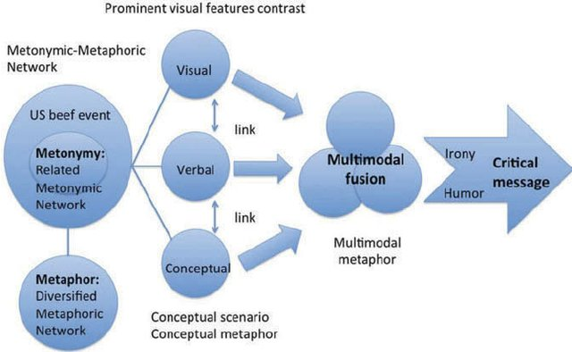
Figure 12. Multimodal fusion in political cartoon. Source: Source: Lin and Chang (2015).
In Figure 12 the scope for very different interpretations can be seen at vitually every stage, in the analysis of political cartoons. Achieving a traditonal version of reliabilty is going to be very difficult.
Humour, irony, interpretation is in the eye of the beholder. Was the intention to be funny? Was it to have a political impact? Is it a form of criticism which is diffivult using other means?
The objective might be relevant to how you intepret what they wrote.
What about bias, overt and unconscious in the researcher?
Bias can undermine all methods, particularly those where interpretation and several perspectives are the main idea.

An interesting article from Robson (2021). He reports the work of:

- Prof Edward Chang, Harvard Business School, Harvard University.

- Dr Doyin Atewologun, co-author of the EHRC Report, Founder of the British Psychological Society Diversity and Inclusion Group.

- Prof. Alex Lindsey, University of Memphis.

Interestingly they all seem to largely agree. If I wanted to research this, I would follow these authors/researchers, who are respected academics, raising the quality of this media source. (Making it more reliable?).

Implicit bias is being recognised. Companies are trying people to try to get rid of this. However such training and the diagnostic tests used are being challenged as being ineffective.

Training often starts with the

Implicit Association Test (IAT) see https://implicit.harvard.edu/implicit/

This should be objective and neutral, but it is being challenged as not producing reliable results. Why?

The training courses themselves are often too short, not followed up and do not reflect organisational culture. Hence the impacts are small or temporary.

As with many HRM topics, the conclusion is as usual…. genuine adoption of the concept by organisations, changing culture, organisation systems, rewards systems and valuing diversity will be needed to really make a change.

I wonder would more qualitative research be more appropriate?

Prince Harry having married a woman of colour, has acknoledged his recognition of bias in his background and upbringing. The person concerned needs to be empathetic to those whose expereince was not formally recognised. Not all are empathetic or can be trained to be so. What do we do with those who lack empathy or see not point in changing?

The critics of the Woke campaigns say we have gone too far in this process. The Guardian says this critique has been weaponised by right wing commentators (Rose, 2020). There are similar comments from some women and members of ethnic minoroties, but not many. I wonder why?

Conclusion

Some good questions to finish on.

Indicators of good research.
Adapted from O’Leary (2004) Table Page 58 and Chapter 4. See Moodle tile on research books.
- Have subjectives been managed?
For postivists being neutral and observing facts. For phenomenologists neutrality may be impossible, but should be acknowldged, negotiated and transparent to avoid bias.
- Are methods approached with consistency?
Postivists look for repeat testing and internal consistency. Phenomenolgists acknowledge that reliablity may not be possible, but methods should be systematic, well-documented and acccountable.
- Has ‘true essence‘ been captured?
Positivism-Truth value, validity, conclusions are correct and relate to what is being explored. Phenomenology looks for authenticity in its truth value and acknowledges that several truths may exist.
- Are findings applicable outside the main frame of reference?
Positivism looks for generalisabilty from the conclusions to the general population. Phenomenology looks for the possible transferabilty from a particular set of conditions to other groups, larger populations or settings.
- Can the research be verified?
Positivism wants Reproducibility – that results be supported if the same method was used in a different example. Phenomenology is concerned with Auditability. It accepts the importance of the research context. research context and therefore seeks full explication of methods to allow others to see how and why the researchers arrived at their conclusions.
Quantitative and qualitative are good for doing various things, sometimes different things. You need to make decisions and plan. It is too late once you launch your questionnaire or organise your focus groups to think of the problems that you might encounter.
Bibliography.
Andrew, P.S., Pedersen, P.M. & McEvoy, C.D. (2020) Research Methods and Designs in Sport Management, New York, Human Kinetics, Inc.
Codó, E. (2008) Interviews and Questionnaires, in Li, W. and Moyer, M.G. (eds). The Blackwell Guide to Research Methods in Bilingualism and Multilingualism, Oxford, Blackwell.
Creswell, J., & Poth, C. (2013). Qualitative inquiry and research design: Choosing among five approaches (Fourth ed.). Los Angeles: SAGE Publications.

Dudovskiy, J. (2018) The Ultimate Guide to Writing a Dissertation in Business Studies: A Step-by-Step Assistance, https://research-methodology.net/about-us/ebook/, (Accessed 04-04-21).
Eisner, E. W. (1991). The enlightened eye: Qualitative inquiry and the enhancement of educational practice. New York, NY: Macmillan. https://www.scirp.org/(S(lz5mqp453edsnp55rrgjct55))/reference/ReferencesPapers.aspx?ReferenceID=248789 (Accessed 21-04-21).

Everitt, B. S. and Skrondal, A. (2010), The Cambridge Dictionary of Statistics, Cambridge University Press.

Glen, S. (2021). Reliability and Validity in Research: Definitions, Examples. From Statistics HowTo.com: Elementary Statistics for the rest of us! https://www.statisticshowto.com/reliability-validity-definitions-examples/ (Accessed 21-04-21).

Gonick, L. (1993). The Cartoon Guide to Statistics. London, Harper Perennial.

Golafshani, N. (2003). Understanding reliability and validity in qualitative research. The Qualitative Report, 8(4), 597-606. (Accessed 21-04-21). http://www.nova.edu/ssss/QR/QR8-4/golafshani.pdf

Indrayan, A. (2007). Statistical fallacies in orthopaedic research, Indian Journal of Orthopaedics, 41(1):37-46, DOI: 10.4103/0019-5413.30524
Lather, P. (1991). Deconstructing/deconstructive inquiry: The politics of knowing and being known. Educational Theory, 41(2), 153-170.
Tiffany Ying-Yu Lin & Wen-yu Chiang (2015). Multimodal Fusion in Analyzing Political Cartoons: Debates on U.S. Beef Imports Into Taiwan, Metaphor and Symbol, 30:2, 137-161, DOI: 10.1080/10926488.2015.1016859 To link to this article: http://dx.doi.org/10.1080/10926488.2015.1016859
Lincoln, YS. & Guba, EG. (1985). Naturalistic Inquiry. Newbury Park, CA: Sage Publications. http://www.qualres.org/HomeLinc-3684.html (Accessed 21-04-21).

Lumen Learning. (2020). Primary Marketing Research Methods, https://courses.lumenlearning.com/vccs-mkt100-17fa/chapter/reading-primary-marketing-research-methods/, Accessed 21-10-20.
O’Leary (2004). The Essential Guide to Doing Research, London, Sage.

Randall, W. and Phoenix, C. (2009). The problem with truth in qualitative interviews: reflections from a narrative perspective, Qualitative Research in Sport and Exercise 1(2):125-140.

Robson, D. (2021). What unconscious bias training gets wrong… and how to fix it. 25 April, The Observer, https://www.theguardian.com/science/2021/apr/25/what-unconscious-bias-training-gets-wrong-and-how-to-fix-it, (Accessed 25-04-21).

Rose, S. (2020). How the word ‘woke’ was weaponised by the right, 21 January, The Guardian, https://www.theguardian.com/society/shortcuts/2020/jan/21/how-the-word-woke-was-weaponised-by-the-right (Accessed 21-01-21).

Rosenzweig, P. (2007). The Halo Effect: ... and the Eight Other Business Delusions That Deceive Managers. Cambridge Mass., The Free Press.

Stein, J. (2021). This Is Not a Joke: The Cost of Being Humorless, Stanford Business School Insights, https://www.gsb.stanford.edu/insights/not-joke-cost-being-humorless, (Accessed 05-05-21). He quotes Jennifer Aaker and Naomi Bagdonas (2020) Humor, Seriously: Why humor is a secret weapon in business and life, hello@humorseriously.com

Shukairy, A. (2002). 9 Tips to Conducting Accurate Qualitative Research, https://www.invespcro.com/blog/9-tips-to-conducting-accurate-qualitative-research/ (Accessed 21-04-21)

Varga-Dobai, K. (2012). The Relationship of Researcher and Participant in Qualitative Inquiry: From “Self and Other” Binaries to the Poststructural Feminist Perspective of Subjectivity, The Qualitative Report. Volume 17, Article 93, 1-1717. http://www.nova.edu/ssss/QR/QR17/varga-dobai.pdf

White, G.E. (2017). The Dissertation Warrior: The Ultimate Guide to Being the Kind of Person Who Finishes a Doctoral Dissertation or Thesis. New York, Triumphant Heart International, Inc.

Whittemore, R., Chase, S. K., & Mandle, C. L. (2001). Validity in qualitative research. Qualitative Health Research, 11, 522–537. 10.1177/104973201129119299

Articles:
Golafshani, N. (2003). Understanding Reliability and Validity in Qualitative Research. The Qualitative Report, 8(4), 597-606. http://nsuworks.nova.edu/tqr/vol8/iss4/6

The use of reliability and validity are common in quantitative research and now it is reconsidered in the qualitative research paradigm. Since reliability and validity are rooted in positivist perspective then they should be redefined for their use in a naturalistic approach. Like reliability and validity as used in quantitative research are providing springboard to examine what these two terms mean in the qualitative research paradigm, triangulation as used in quantitative research to test the reliability and validity can also illuminate some ways to test or maximize the validity and reliability of a qualitative study. Therefore, reliability, validity and triangulation, if they are relevant research concepts, particularly from a qualitative point of view, have to be redefined in order to reflect the multiple ways of establishing truth.

Reliability analysis for a proposed critical appraisal tool demonstrated value for diverse research designs.

MichaelCroweªLorraineSheppard^{ab}AlistairCampbell^{c}
https://doi.org/10.1016/j.jclinepi.2011.08.006

Abstract

Objective
To examine the reliability of scores obtained from a proposed critical appraisal tool (CAT).

Study Design and Setting
Based on a random sample of 24 health-related research papers, the scores from the proposed CAT were examined using intraclass correlation coefficients (ICCs), generalizability theory, and participants’ feedback.

Results
The ICC for all research papers was 0.83 (consistency) and 0.74 (absolute agreement) for four participants. For individual research designs, the highest ICC (consistency) was for qualitative research (0.91) and the lowest was for descriptive, exploratory and observational research (0.64). The G study showed a moderate research design effect (32%) for scores averaged across all papers. The research design effect was mainly in the Sampling, Results, and Discussion categories (44%, 36%, and 34%, respectively). The scores for research designs showed a majority paper effect for each (53–70%), with small to moderate rater or paper × rater interaction effects (0–27%).

Conclusions
Possible reasons for the research design effect were that the participants were unfamiliar with some of the research designs and that papers were not matched to participants’ expertise. Even so, the proposed CAT showed great promise as a tool that can be used across a wide range of research designs.

