SJIE5001
A Critical Analysis of Modern Numeracy Pedagogy, Policy and Social Perspectives.
This essay will take a critical approach to evaluating why good numeracy is important and how current initiatives support the development of numeracy across the curriculum within one’s own setting as well as from a global perspective. One will make comparisons with current policy and established good practice as well as examining how societal and economic values have influenced mathematical pedagogy. This essay will examine one’s own experiences as a practitioner working in a small, rural school in Wales (School A). Following a less than desirable inspection it is now in transition with the appointment of a new Headmaster. This has resulted in a clash of cultures as the school starts to move away from its former traditional values towards a more progressive pedagogy and the new Curriculum for Wales (Welsh Government, 2019). One will also examine past pedagogy styles which have been replaced by newly implemented numeracy strategies such as White Rose Maths (White Rose Maths, 2019) and how both past and present strategies compare with renowned global numeracy practice such as Singapore maths (Singapore Maths Inc, 2019) as well as how they relate to the National Literacy and Numeracy Framework (LNF) (Welsh Government, 2019).
To be able to critically analyse the significance of good numeracy skills within education, society and from a political perspective, it is important to define what exactly is meant by ‘numeracy’ and how it differs from our understanding of mathematics. Numeracy is a relatively new term derived from the contraction of numerical-literacy and has recently been adopted throughout Welsh primary schools. Professor Dianna Coben defines numeracy as:
“to be numerate means to be competent, confident, and comfortable within one’s judgements on whether to use mathematics in a particular situation and if so, what mathematics to use, how to do it, what degree of accuracy is appropriate, and what the answer means in relation to the context”. (Coben, 2000, p28, cited on Ackland, 2014, p9).
To clarify further, the use of numeracy in education refers to the use of mathematics as a portable skill, applicable to new situations across the curriculum and within our everyday lives (Compton, 2007). “Having a clear understanding of mathematics is socially empowering so that we are not at the mercy of those who are more mathematically astute” (IBID, 2007. p. 2). An example of this would be when doing the grocery shopping one needs to be able to calculate which deals are saving you money or if you can afford to buy them at all. Along with literacy and digital competence, numeracy will have to be considered within all future curriculum design to adhere to the new Curriculum for Wales guidelines (Welsh Government, 2019). In contrast with this is our understanding of the word mathematics and its connotations within the field of education. Mathematics is defined by the Merriam-Webster Dictionary as:
“the science of numbers and their operations, interactions, combinations, generalisations, and abstractions and of space configurations and their structure, measurement, transformations, and generalisations. Algebra, arithmetic, calculus, geometry, and trigonometry are branches of mathematics”.
There still exists in society today an attitude that one is either good or bad at mathematics which can be accompanied by maths anxiety (Wilson, 2014). Views on mathematics can be influenced by remembered experiences of outdated sexist and behaviourist teaching methods such as “teachers who are hostile, hold gender biases, are indifferent, or who embarrass students in front of peers” (Wilson, 2014). Also, there can be an established style of summative assessment that accompanies mathematics with correct or in-correct answers, thus children learn to fear producing an in-correct answer. They can develop the belief that they do not possess the skills needed to become a good mathematician and when they hit “obstacles, setbacks or criticism, (this) is just more proof that they (don’t) have the abilities that they cherished” (Dweck, 2016. Cited in Gross-Loh, 2016). This belief can have a profound effect and can lead to a fixed mind set which it can alienate a child from mathematics for the whole of their life. Teachers and parents can inadvertently convey their maths anxiety to children (IBID, 2014). Therefore, it is of great importance that children encounter positive role models who teach them not to be afraid of failing, failing is how one learns, acquires new skills and becomes more astute (Dweck, 2017). It is important to develop a growth mind set in children; Dweck (2017) describes growth mind set as the confidence that your basic abilities are things you can foster through your hard work, your stratagems and support from others.
There is a socio-cultural perspective of mathematics within education which promotes mathematics above other literacies and results in mathematically able students being labelled as more intelligent than others (Ackland, 2014.p.8, 14). It can also “give students advanced power through enhanced life chances in study, the world of work and societal affairs (Ackland, 2014. p.14).
Our concept of mathematics is influenced by a historical as well as political context (IBID, 2014. P. 10). This referrs to the neo-liberal hegemony that developed as a response to the Second World War (Davies, 2014. p.311) which has been the main driver behind behaviouristic pedagogy that exists to this day within our education systems. Neoliberalism promotes policies and discourses of the free-market, of competition, choice and privatisation (Hurch, 2007. As quoted by Darragh et al, 2019). The agenda of neoliberalism has been set by past and current governments “to encourage particular types of entrepreneurial, competitive and commercial behaviour in its citizens with the market as the regulatory mechanism” (Carter, 2016. P.33). This has historically denied the promotion of mathematics as a rewarding endeavour, removed from economic advantage (IBID, 2016).
Within the foundation phase in one’s own setting there has been a re-structuring and a new direction regarding the way numeracy is taught. Previously, there had been a focus on traditional mathematics lessons delivered daily in a time tabled slot. The teacher would stand at the front of the class and introduce a mathematical concept, then the children would sit in their groups which were chosen for ability. Practitioners would then help them work through a maths book. This was achieved using New Heinemann Mathematics work books from S.P.M,G. (School A. ,2019. p2). The work books were designed to require a correct answer to each sum, with no praise given for nearly correct answers, or even the right formula used. This summative assessment style can lead to children becoming alienated from mathematics and the adoption of a fixed mind set (Dweck, 2017).
This pedagogy which is delivered using the automatic transmission-led approach can deny learners involvement in their own learning experience (Watkins, 2003. p.11), it is linked to behaviourist didactic teaching which is now considered out dated and lacking by the New Curriculum principles based on pupil centred learning. As early as 1982, the Cockcroft Report was published, which had been commissioned by Callaghan’s Labour government to consider the effectiveness of mathematics teaching and the curriculum in primary settings (Gillard, 2007). Cockroft states that there is a ‘back to basics’ movement in some schools caused by public concerns over standards which has “encouraged some primary teachers to restrict their teaching largely to the attainment of computational skills” (Cockroft, 1982. p.80). He clarifies further that:
“However, mathematics of employment and of everyday life is always mathematics in context, the ability to carry out a particular numerical operation and the ability to know when to make use of it are not the same; both are needed” (IBID, 1982. p.8).
Cockroft (1982) writes that the primary curriculum should enhance children’s aesthetic and linguistic experience and be empowered to explore their environment to develop logical thought and develop “numerical skills which will be powerful tools for later work” (Cockroft, 1982. P. 84). This emulates Vygotskian teaching on social constructivism (Bates, 2019) which has informed the New Curriculum for Wales, the Foundation Phase and Successful Futures Curriculum Framework where it states:
“Children learn through first-hand experiential activities with ‘play’ providing the vehicle. Through play, children practise and consolidate their learning, play with ideas, experiment, take risks, solve problems, and make decisions individually, in small and in large groups” (Welsh Government, 2015, p. 5).
To provide guidance for teachers implementing the New Curriculum for Wales the Welsh Government have published the National Literacy and Numeracy Framework (LNF): draft Curriculum for Wales 2022 (Welsh Government, 2019) to provide guidance and targets for teachers to adhere to when planning numeracy lessons. This draft version differs from the previous NLF in that it refers to “targeted skills as progression steps rather than year groups” (Welsh Government, 2019). This change to the NLF is in accordance with Vygotskian thinking that that children go through stages of learning at differing timescales (Mooney, 2000). Vygotsky was opposed to the analysis of children’s abilities through intelligence tests, he thought careful observation of children was just as valid as test results (IBID, 2000) which corresponds with the New Curriculum for Wales. The Welsh Government New School Curriculum Overview (2019) states that:
“Assessment is a continuous process and takes place on a daily basis in schools. Progression reference points help learners, teachers, parents and carers to understand if appropriate progress is being made” (Welsh Government, 2019).
Teachers expectations for achievement will correspond approximately to skills that are usually acquired by the ages of 5, 8, 11 and 14 (Welsh Government, 2019). School A undertakes a baseline assessment when children start in reception then no structured testing takes place until the end of year 1. Instead the Teacher uses data collected through observations which informs if a child is ready to progress within the LNF or if more support is needed. Moving forwards, there is now a perspective of formative assessment structures within all areas of the New Curriculum for Wales, this will include a shift in the purpose of assessment towards supporting individual learner progression (Welsh Government 2019). Assessment will no longer be the existing ‘best fit’ use of levels. In the guidance, it highlights that assessment should inform a rounded picture of the pupil – highlighting their strengths, areas for progress and next steps in education (IBID, 2019). Feedback will take the form of E-portfolios with home, school links, as well as formal reports and engaging with parents will be seen as a two-way experience (IBID, 2019).
Following a restructuring in one’s own setting, Nursery and Reception have been combined and a new teacher appointed. There is new direction in numeracy practice with the adoption of White Rose Maths numeracy scheme of learning (White Rose Maths, 2019). The newly implemented scheme is in keeping with modern pedagogy trends towards Vygotskyan thinking regarding the way children pass through different stages in their learning and that they have to progress through these stages in a set order to develop a deep understanding. The White Rose Maths scheme have adopted Jerome Bruner’s concrete, pictorial and abstract’ (CPA) approach to teaching numeracy which is also embedded in Singapore Maths approach (MNP, 2019).
Children often find maths problematic because it is abstract. The CPA approach builds on children’s existing knowledge by demonstrating abstract ideas in a concrete and physical mode. It encompasses “moving from concrete materials, to pictorial representations, to abstract symbols and problems” (MNP, 2019). Concrete is the “doing” stage. During this stage, students use concrete objects to model problems. Unlike traditional maths teaching methods such as New Heinemann Mathematics work books, where teachers demonstrate how to solve a problem, the CPA approach “brings concepts to life by allowing children to experience and handle physical (concrete) objects” (MNP, 2019). The White Rose Maths scheme follows this dictate and introduces each intellectual concept first using physical objects to model problems and build connections (Singapore Maths Inc, 2019). The White Rose Maths website for Reception Guidance (2019, p.10) states that children should start by counting real life objects to enable the development of number sense. Then, once a concrete understanding of maths has been developed, the children can advance to pictorial representations of mathematical sums (White Rose Maths, 2019). The new class curriculum mirrors Bruner’s teaching on providing a structure on which learners can build schemas of mathematical understanding, children are scaffolded in their learning and new concepts are introduced and then re- visited to imbed learning in a spiral curriculum (Bates, 2019).
A good example of a strategy which is common to both White Rose Maths and Singapore maths is ‘Part Whole’ (see appendix D). This is an excellent tool to facilitate the learning of number bonds, a term which has been in use since the 1920s and describes the development of number sense in children as they learn the connections between numbers and how they fit together to create other numbers. Pupils are introduced to number bonds firstly through the CPA technique through play; they may sort and count 5 cup cakes onto two plates in the home corner, this is the concrete stage. From there they progress towards using counters and then the ‘part whole’ template can be introduced allowing children to progress to the pictorial stage as numbers reflect the counters originally used (see appendix E). As children become more confident, the ‘part whole’ template can be used in work books to represent number bonds up to 5, 10, then 20 and continue into 100s as they progress at their own pace. This strategy helps to support the development of many numeracy skills required by the LNF, for instance, in progression step 1, in the using number skills strand, one of the elements states that children should be able to “calculate using writing and mental methods” (Welsh Government, 2019). They clarify that children should “combine two groups of objects to find how many altogether?” (Welsh Government, 2019). With further development children progress to progression step 2 which states in the using number skills strand, included in the element “use number facts and relationships” (IBID, 2019) that children should be able to “use number facts within 10, i.e. - bonds within 10, e.g. 6 + 4” (IBID, 2019).
White Rose Maths shares methodology with Singapore Maths which is a very influential style of teaching mathematics. “Hundreds of head teachers across England and Wales are turning to Singapore maths to help pupils cope with the new, tougher national curriculum” (Mesure, 2015) and as noted by WISERD, the Singapore method has been a great influence on pioneer schools involved in the development of the New Curriculum for Wales (Newton, 2019). One of the reasons why Singapore maths is so influential is that Singapore achieves a consistently high rating in the Programme for International Student Assessment (PISA) Test, the triennial assessment published by the Organisation for Economic Co-operation and Development (OECD) which “measures 15-year-olds’ ability to use their reading, mathematics and science knowledge and skills to meet real-life challenges” (OECD, 2018). It provides a comprehensive and rigorous international assessment of student learning outcomes (IBID, 2018).
In the recently released PISA test results for 2018, Singapore are second from the top of the world ranking for mathematics, scoring a mean score of 569. This compares very well to the United Kingdom (UK) whose mean result is 502 and whose ranking is 17th (See Appendix A and appendix C) (BBC, 2019). However, the UK’s results do demonstrate a trend of improvement, up ten places from 27th ranking in 2016 (The Sunday Times, 2019) when they had a mean score of 492 (See Appendix B) (OECD, 2019).
The reason why the PISA report is relevant is that it provides governments with insight into how effective different countries education systems are which enables comparison. This, in turn, allows governments to “compete in the (global) ‘knowledge economy’ and to assure the economic wellbeing of their citizens” (Baird J. et al, 2011. p. 1). The creation of the New Curriculum for Wales has in part been a response to the PISA results for Wales over the last decade, which has seen Wales score significantly lower than England. In 2015, Wales PISA results for Mathematics was 478, which was lower than many EU countries and significantly lower than England’s score of 493 (see appendix F) (Jerrim and Shure, 2016). Also, in 2015 Singapore topped the PISA test with a test result for mathematics of 564 (see appendix F) (IBID).
Numeracy and mathematics education can be seen in a global context of social theory and change, sensitive to social and political trends (Wilson, 2014). Quality mathematics education is a human rights subject. The United Nations Convention on the Rights of the Child ratified by the UK in 1991 sets out the right of every child to education (UNICEF, 2020). But would further add that every child has a right to a quality education. In one’s own setting, following the implementing of the White Rose Maths scheme and the new directive of teaching numeracy from a cross-curriculum perspective, a more constructivist pedagogy is evolving. However, there is a danger that in moving away from the previous regimented, teaching regime, the focus on high quality mathematics teaching could be lost. Systems that were in place to support children who were struggling have been discontinued in favour of a more relaxed learning through play atmosphere. Although this can be an excellent technique for children to develop number mastery, it is only as effective as the planning and support that accompany it. In one’s own setting numeracy lessons at reception and nursery level take second place to literacy and other priorities, often replaced by singing number rhymes or a free play session with no input from educators. If continued, this trend could have a significant effect on future attainment levels as “mathematical competencies at kindergarten are highly relevant for learning outcomes at school. Number recognition, number sequence, counting, ordinality, relative size, addition and subtraction (are) found to be the strongest predictors for later school achievement” (Vougt et al, 2018). Free play is a “powerful vehicle for learning” (Hauser,2005. Cited in Vougt et al, 2018) but one would suggest that without the support of an educator directing children to build on what they already know, to introduce mathematical vocabulary and concepts, act as a role model or encourage the use of appropriate strategies then important learning opportunities may be lost (Burnham, 2018).
It is also pertinent to note that not all schools in the UK are completely embracing the new constructivist teachings within the modern pedagogy. Andrew Schleicher, the OECD’s education director and one of the most respected education experts in Europe, recently praised Michaela Community School in Wembley which has been vilified for being the strictest in England (Griffiths and Henry, 2019). He states that “positive discipline and direct instruction, the traditional form of teaching where the teacher stands at the front of the class and the children listen – was creating happy and confident pupils with outstanding outcomes” (Griffiths and Henry, 2019).
It could be insightful to consider Singapore maths in a more holistic context where it becomes plain that it is not just the content of their text book or the strategies applied that make it so successful. “Singapore’s academic strength lies in its national commitment to high-quality education and the overall coherence of its education” (Wang-Iverson et al, 2010). At its heart Singapore’s educational system has flexibility to accommodate the needs of individuals enabling children to learn at different rates and in different styles (Wang-Iverson et al, 2010). This requires considerable dedication from teachers which is catered for and nurtured with ongoing training and encouragement (IBID). Extra student support is available from year 1 when struggling students are put into small groups and tutored to ensure they achieve the same attainment level when beginning year 4 as their peers (IBID). In this way a firm foundation of mathematical concepts is imbedded.
In conclusion. I would suggest that School A has an opportunity to reinvent its self as a school of excellence. It should continue with the modernisation of the curriculum and with its progress towards delivering the New Curriculum for Wales through the implementation of White Rose Maths and cross-curriculum teaching. When considering numeracy and modern pedagogy I would caution against completely disregarding behaviouralist teaching strategies of the past. Often the right balance can be found by taking the best strategies from differing ethoses. There is still a place for good quality teacher led lessons if interwoven within the dictates of the CPA approach. Furthermore, I feel that much can be learnt from the dedication to success that is represented in Singapore maths. Not only within the strategies used, but also in the supportive, nurturing and creative processes that are part of its educational ethos.

References
Ackland, A. (2014). More… or less? Towards a critical pedagogy of Adult Numeracy. 9(2), pp7-21. Available at: https://files.eric.ed.gov/fulltext/EJ1057429.pdf. (Accessed on 25th November 2019).
Baird, J. et al (2011). Policy Effects of PISA, Oxford University Centre for Educational Assessment. Available at: http://oucea.education.ox.ac.uk/wordpress/wp-content/uploads/2011/10/Policy-Effects-of-PISA-OUCEA.pdf. (Accessed on 29th December 2019).
Bates, B. (2019). In: D. Alves, ed. Learning Theories Simplified. 2nd ed. Glasgow: Clark, James
Coughlan, S. (2019). Pisa tests: UK rises in international school rankings. BBC, 3rd December. Available at: https://www.bbc.co.uk/news/education-50563833. (Accessed on 7th December 2019).
Burnham, L. (2018). Supporting Teachng and Learning. London: Hodder Education, p. 140.
Coughlan, S. (2019) ‘Pisa tests: UK rises in international school rankings’. British Broadcasting Corporation. Available at: https://www.bbc.co.uk/news/education-50563833. (Accessed on 30th December 2019).
Carter, L. (2016). ‘Neoliberalism and STEM Education’. Journal for Activist Science and Technology Education. Volume 7/ Issue 1.
Compton, A. et al (2007). Supporting Numeracy: A Guide for Support Staff. Gateshead: Athenaeum Press.
Darragh et al (2019). NEOLIBERALISM: A CRISIS FOR MATHEMATICS EDUCATION? Available at: http://mes9.ece.uth./portal/images/paperslist/mes9apl/55.pdf. (Accessed on 26th November 2019).
Davies, W (2014). Neoliberalism bibliographic review. Theory culture and society. [On Line]. Available at: https://journals.sagepub.com/doi/pdf/10.1177/0263276414546383. (Accessed on: 26th November 2019).
Dweck, C. (2017). Mindset - Updated Edition: Changing The Way You think To Fulfil Your Potential.6th Ed. New York: Robinson.
Eddie, S. (2010). Making Psychology simple for everyone. Theories of cognitive development: Jean Piaget. [Online]
Available at: https://psychohawks.wordpress.com/2010/09/05/theories-of-cognitive-development-jean-piaget/
[Accessed 15th December 2019].
Gillard, D. (2007). Education in England, the history of our schools. The Cockroft Report(1982) Mathematics Counts. Available at: www.educationengland.org.uk/documents/cockroft/index.html. (Accessed on 14th December 2019).
Griffiths, F. and Henry, J. (2019). ‘England to storm up league tables for reading’. The Sunday Times, 1st December, p. 3.

Gross-Loh, C. (2016). How Praise Became a Consolation Prize. Helping children confront challenges requires a more nuanced understanding of the “growth mindset”.Available at: https://www.theatlantic.com/education/archive/2016/12/how-praise-became-a-consolation-prize/510845/. (Accessed on 19th December 2019).
Jerrim, J and Shure, N. (2016). Achievement of 15-YearOlds in Wales: PISA 2015 National Report. Available at: https://dera.ioe.ac.uk/27969/1/161206-pisa-2015-en.pdf. (Accessed on 4th January 2019).
Maths No Problem (2019). CPA Approach. Available at: https://mathsnoproblem.com/en/mastery/concrete-pictorial-abstract/. (Accessed on 30th December 2019).
Maths No Problem (2019). Number Bonds. (image). Available at: https://mathsnoproblem.com/en/mastery/number-bonds/. (Accessed on 31st December 2019).
Merriam-Webster incorporated (2019). Merriam-Webster Dictionary since 1866. Available at: https://www.merriam-webster.com/dictionary/mathematics. (Accessed on 25th November 2019).
Measure, S. (2015). Singapore maths: How a radical new way of teaching equips UK pupils to tackle a tougher curriculum. The Independent. Available at: https://www.independent.co.uk/news/education/education-news/singapore-maths-how-a-radical-new-way-of-teaching-equips-uk-pupils-to-tackle-a-tougher-curriculum-a6769421.html. (Accessed on 30th December 2019).
Mooney, C. (2000). In: Theories of Childhood. An introduction to Dewey, Montessori, Erikson, Piaget & Vygotsky. St. Paul: Redleaf Press.
Newton, N. (2019). Hopes and fears: The development of a new curriculum in Wales Wales Institute of Social & Economic Research, Data & Methods. W.I.S.E.R.D. Available at: https://wiserd.ac.uk/news/hopes-and-fears-development-new-curriculum-wales. (Accessed on 30th December 2019).
OECD (2019). PISA Programme for International Student Assessment. Available at: https://www.oecd.org/pisa/publications/pisa-2018-resultshtm.htm. (Accessed on 7th December 2019).
OECD (2019). PISA 2018 Results. WHAT STUDENTS KNOW AND CAN DO. VOLUME 1. Available at: https://www.oecd-ilibrary.org/docserver/5f07c754-en.pdf?expires=1577790540&id=id&accname=guest&checksum=D4ADD4A174B33954D9EA0FAA024F4493. (Accessed on 31st December 2019).
School A. (2019). A POLICY DOCUMENT FOR MATHEMATICS.
Singapore Maths Inc (2019). What Is Singapore Maths. Available at: https://www.singaporemath.com/Singapore_Math_s/331.htm. (Accessed on 30th December 2019).
UNICEF (2020). HOW WE PROTECT CHILDREN'S RIGHTS WITH THE UN CONVENTION ON THE RIGHTS OF THE CHILD. Available at: https://www.unicef.org.uk/what-we-do/un-convention-child-rights/. (Accessed on 4th January 2019).
Vogt, F, et al (2018). ‘Learning through play – pedagogy and learning outcomes in early childhood mathematics’. European Early Education Research Journal. 26(4). pp. 589-603. Available at: https://www.tandfonline.com/doi/full/10.1080/1350293X.2018.1487160. (Accessed on 4th January 2020).
Wang-Iverson, P. et al (2010). Beyond Singapore’s Mathematics Textbooks. Focussed and Flexible Support for Teachers and Learning. Available at: https://www.aft.org/sites/default/files/periodicals/wang-iverson.pdf. (Accessed on 4th January 2020).
Watkins, C. (2003). Learning, a sense maker’s-guide, London: The Education Union.
Welsh Government(2019). Assessment within Curriculum for Wales – Supporting Learner Progression. Available at: https://curriculumforwales.gov.wales/2019/12/14/assessment-within-curriculum-for-wales-supporting-learner-progression/. (Accessed on 31st December 2019).
Welsh Government (2015). Curriculum for Wales. Foundatin Phase Framework. Revised 2015. [Online]
Available at: https://gov.wales/sites/default/files/publications/2018-02/foundation-phase-framework-revised-2015.pdf
(Accessed 14th December 2019).
Welsh Government (2019). Draft curriculum for wales 2022. Mathematics and Numeracy. Get to know Mathematics and Numeracy. Available at: https://hwb.gov.wales/draft-curriculum-for-wales-2022/mathematics-and-numeracy/. (Accessed on 27th December 2019).
Welsh Government (2019). National Literacy and Numeracy Framework: draft Curriculum for Wales 2022 version, part of the Curriculum for Wales 2022. Available at: https://hwb.gov.wales/draft-curriculum-for-wales-2022/national-literacy-and-numeracy-framework-draft-curriculum-for-wales-2022-version. (Accessed on 29th November 2019).
Welsh Government (2019). New School Curriculum: overview. Available at: https://gov.wales/new-school-curriculum-overview . (Accessed on 22nd December 2019).
Welsh Government (2019). National Literacy and Numeracy Framework: Numeracy. Available at: https://hwb.gov.wales/storage/5286b8da-337d-4a0b-87b8-6facb7121120/national-literacy-and-numeracy-framework-numeracy-curriculum-2022.pdf. (Accessed on 31st December 2019).
White Rose Maths (2019). Premium Resources Centre. Available at: https://whiterosemaths.com/. (Accessed on 27th December 2019).
White Rose Maths (2019). Reception Guidance. #Maths Everyone Can. Available at: https://whiterosemaths.com/wp-content/uploads/2019/SoLs/RECEPTION/Reception-Autumn.pdf. (Accessed on 27th December 2019).
Wilson, S. (2014). ‘” Fail at maths and you fail at life”: Learned barriers to equal opportunities’. International Public Health Journal, suppl. Special issue: Quality of life and intellectual disability. Vol. 6. Issue 2. pp 147 – 160. Available at: https://search-proquest-com.ezproxy.uwtsd.ac.uk/docview/1625960586?accountid=130472&rfr_id=info%3Axri%2Fsid%3Aprimo. Accessed on 22nd December 2019.

Appendix.A.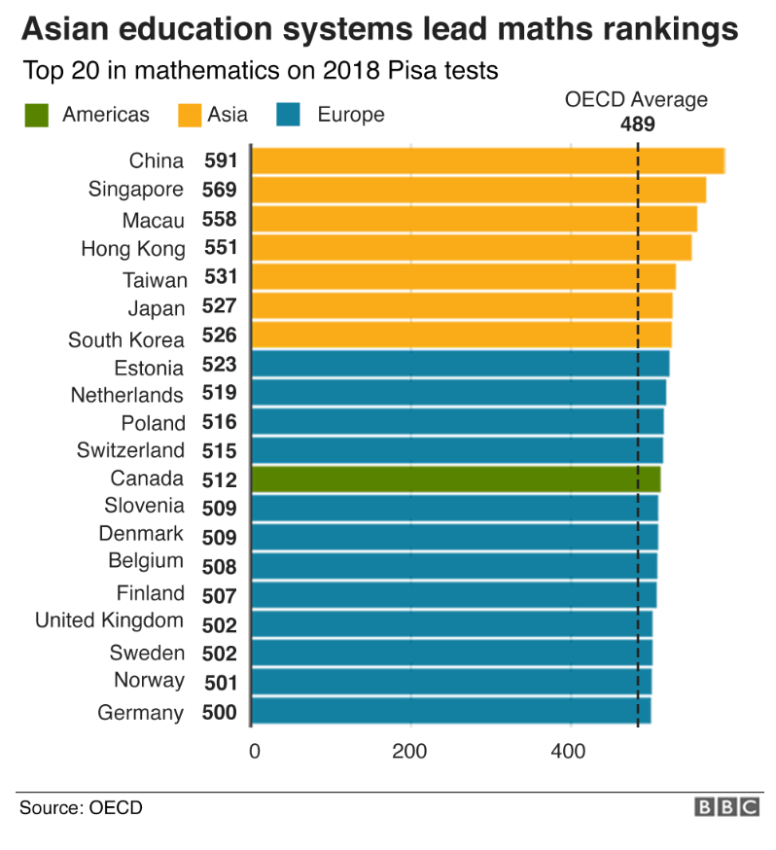
(BBC, 2019)

Appendix B
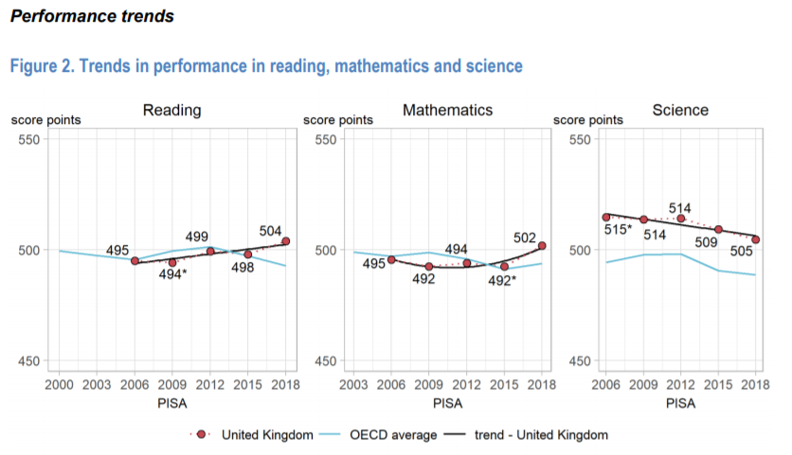
Appendix C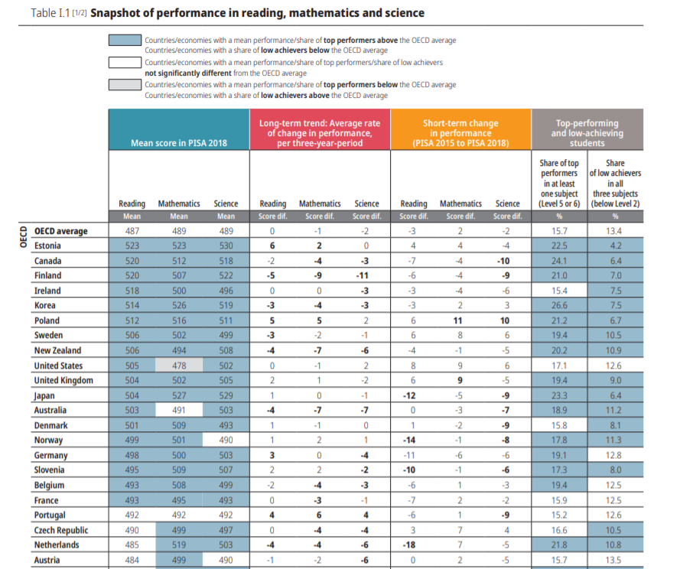

Appendix C continued

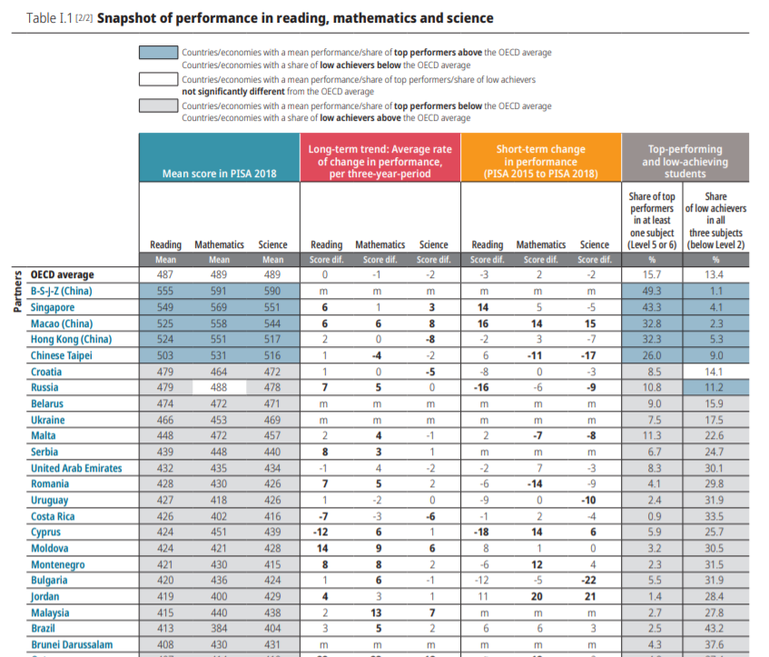

Appendix D
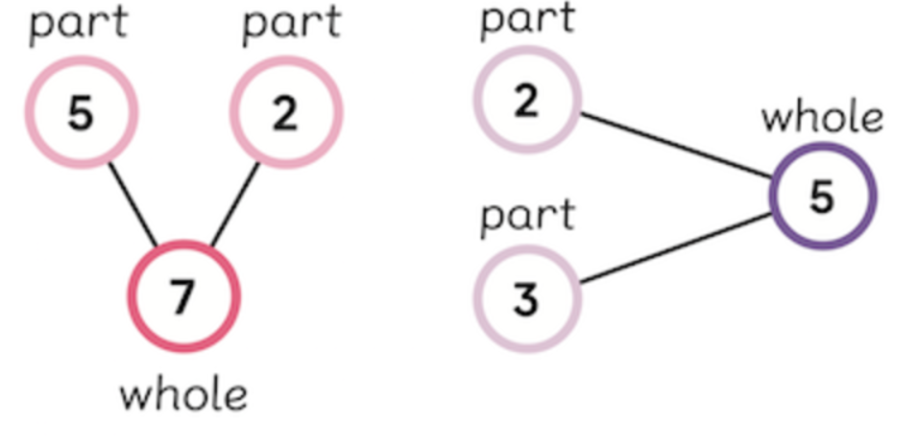
(MNP, 2019)
Appendix E
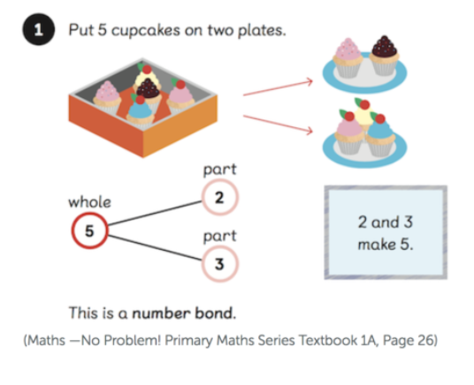
(MNP, 2019)
Appendix F
PISA Test Outcomes for Mathematics for 2015

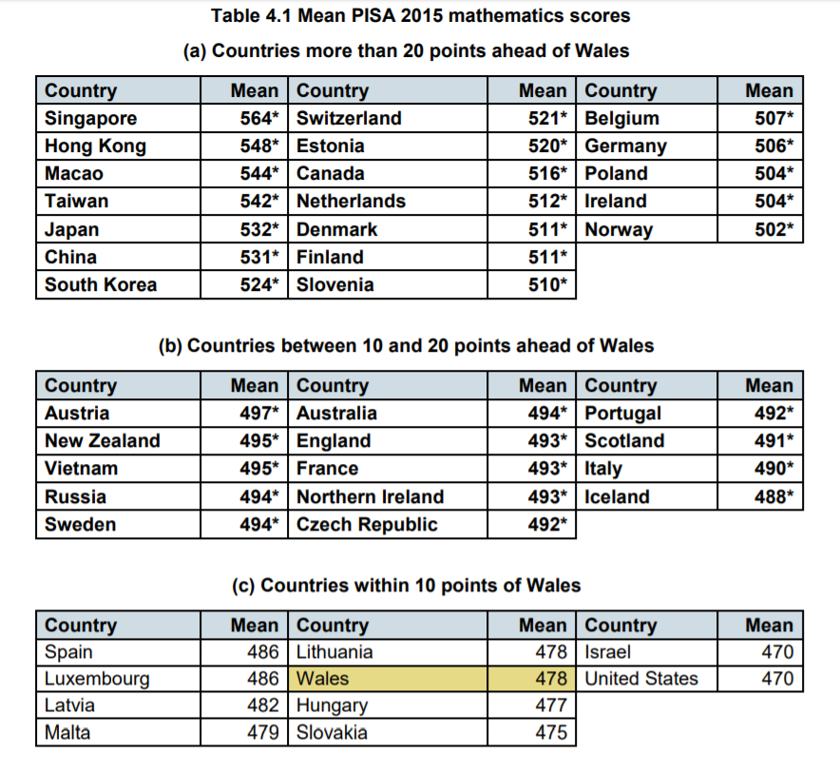
(Jerrim & Shure, 2016)

