

PROGRAMME: BA (Hons) Leadership and Management Skills for the Workplace
MODULE NAME: Coaching and Mentoring Skills for the Workplace
MODULE CODE: BMSW6105
STUDENT NAME: Stoyana Ivanova
STUDENT ID: 2030693
LECTURER NAME: Faizu Edu
DATE: 27.04.2024

Table of Contents

INRODUCTION 3
MAIN BODY 3
Reflection on the coaching session 3
- Discription 3
- Feelings 4
- Critical evaluation 5
- Analysis 7
CONCLUSION 9
ACTION PLAN 9
REFERENCES 11
Books and Journals 11
APPENDIX 12

INTRODUCTION
The purpose of this reflective statement is to analyse coaching session that took place between Philippa Graham and Maria Cook, evaluating its efficacy and identifying areas in which it could be improved. Within context of improving organisational performance and morale, I investigate larger implications of coaching and mentoring (Susanto, 2023). I analyse key skills, behaviours, attitudes, beliefs, of effective coach or mentor by means of critical analysis. I draw insights from interaction between Philippa and Maria in order to make my decisions. With regard to possible impact that coaching and mentoring could have on growth and development of individuals within setting of organisation, this investigation offers significant insights. I have utilized Gibbs reflective cycle to demonstrate my learning and experience from the session.
MAIN BODY
Reflection of the Coaching Session
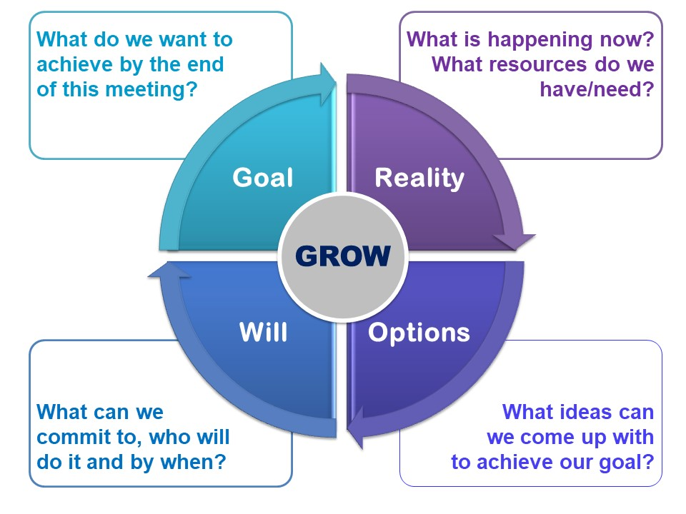
Description- The skill with which Philippa was able to establish the secure along with open atmosphere for conversation created the solid groundwork for interaction that contributed to beneficial outcomes. Maria was able to gain the better understanding of her goals along with issues she faced as the result of her utilisation of GROW model that offered the systematic framework for goal setting along with problem-solving respectively. However, there were occasions that Philippa could have taken advantage of to get the more in-depth understanding of Maria's issues along with to offer more specific support along with direction. Coaching session was significantly strengthened by my capacity to create the secure environment in which free dialogue could take place. To function as an effective coach, it is vital to create atmosphere in which individuals feel at ease expressing their opinions along with concerns. Since Maria was able to openly communicate her emotions of frustration along with stagnation in her current work, it is likely that Philippa’s approach made her feel valued along with respected. Research that emphasises significance of psychological safety in process of establishing trust along with collaboration across teams is in agreement with this particular feature of coaching session.
Feeling- I feel delighted to be the part of this coaching session as Philippa and I got to learn which I did not know. Through the session I learned that Philippa’s capability of guiding Maria through coaching process was proved by my use of GROW model, the framework that is well recognised for its ability to structure coaching talks is GROW model that is acronym that stands for Goal, Reality, Options, along with Way Forward (Trawver and Brocious, 2024). Philippa assisted Maria in gaining clarity on her career goals, evaluating her existing reality, exploring viable possibilities, along with defining actionable steps for advancement by methodically addressing each component of model throughout process. Me along with Maria were able to maintain their concentration on addressing most important difficulties thanks to organised method that was utilised during coaching session. Even though these are some of Philippa’s strengths, there were times during coaching session when she could have provided Maria with more specific support along with increased depth of exploration. Philippa has opportunity to inquire more in order to discover underlying issues that were contributing to this challenge when Maria revealed her displeasure with limited chances for promotion within organisation. Philippa might have been able to more effectively customise her advice along with recommendations if she had the better understanding of specific organisational dynamics or potential impediments that inhibited Maria's growth. Effective coaching, according to research conducted by the researcher, requires use of strong questions that stimulate deeper contemplation along with understanding. In order to assist Maria in gaining the more profound comprehension of her professional development along with elements that are impacting her career objectives, I may have assisted her by delving under surface. Also, Philippa may have provided Maria with more specific techniques or resources to support her in her endeavour, despite fact that she encouraged Maria to investigate possibility of developing her talents along with taking on more tasks. Providing individuals with direction, feedback, along with practical support in order to assist them in accomplishing their objectives is essential component of coaching (Bachkirova, 2024). Within organisation, Philippa had opportunity to make recommendations for opportunities to develop one's skills, such as programmes for training, workshops, or mentorship programmes. Philippa might have also assisted Maria in determining which particular projects or initiatives were in line with her professional objectives that would have made it easier for her to advance along with become more visible within organisation. Moreover, although Philippa displayed strengths in creation of the secure environment for open communication along with utilisation of GROW model, there were potential for further in-depth exploration along with more support in process of addressing Maria's issues. It is possible for Philippa to improve efficiency of coaching process along with provide Maria with more assistance in accomplishing her professional objectives if she investigates deeper than surface along with offers particular counsel along with resources.

Critical evaluation- Within context of organisational settings, coaching along with mentoring take on role of foundational activities that contribute to development of improved performance along with morale. Mentors along with coaches help individuals recognise along with capitalise on their talents, address areas in which they could improve, along with navigate career hurdles with ease by providing them with direction, support, along with critical feedback. Effective coaching along with mentoring have potential to ignite Maria's growth trajectory along with strengthen her contentment inside firm. This is precise scenario that Maria is currently experiencing (Thomas, 2023). Maria can be empowered to actively pursue opportunities for skill growth along with increased exposure within organisational environment if Philippa provide her with constant support along with encouragement of her efforts. Furthermore, Philippa offered Maria with required tools to tackle setbacks along with problems encountered along her career journey by cultivating in her the growth attitude along with resilience. This is accomplished by providing Maria with those tools. However, success of coaching along with mentoring is highly dependent on coach or mentor's ability to embody particular abilities, behaviours, attitudes, and beliefs, along with values. Therefore, effectiveness of coaching along with mentoring is crucial. Being able to participate in active listening, demonstrating empathy, along with skilfully building rapport with coachee or mentee in order to create the foundation of trust is one of characteristics that distinguishes the good coach or mentor. On basis of this trust, meaningful conversation along with progress are able to flourish together. If you want to be excellent coach or mentor, it is absolutely necessary to have the comprehensive understanding of dynamics of organisation. In order to be able to pose perceptive inquiries that expose underlying issues along with viewpoints, coaches along with mentors should be able to deftly negotiate complexities of administrative landscape. It is easier to customise interventions along with guidance to line smoothly with specific circumstances along with preferences of individual who is receiving help when this level of understanding is present.
Being able to change along with adapt is the trait of good teaching along with mentoring methods. Mentors along with coaches need to be able to change their methods along with tactics quickly to adapt to changing needs along with preferences. Customising their interventions helps them make sure that they are most relevant along with meaningful that makes their advice along with support more effective (Kramers, et.al, 2023). Expert trainers along with mentors know how to give helpful criticism along with support that helps their students grow along with become strong. People can get better by using constructive reviews to help them improve their skills along with ways of doing things. Encouragement along with the caring setting work together to boost confidence along with motivation, giving people courage to go after their goals with all their might.
A big part of how well coaching along with mentoring work is that coach or guide acts as the source of inspiration along with direction. They set the good example of honesty, ethics, along with ongoing learning that is what they want their mentees or coaches to do. Coaches along with mentors create the culture of excellence along with continuous growth within organisation by living by these values themselves. Philippa’s job as Maria's coach requires to show all of these traits to best. Philippa created the safe along with loving space for Maria to be honest about her hopes along with worries. This sets stage for the meaningful conversation along with exploration (Jarosz, 2023). Philippa smart use of GROW model gives her the structured way to set goals, evaluate reality, come up with choices, along with plan her next steps. But Philippa has chance to learn more about Maria's problems along with find hidden issues that might be stopping her growth. By giving Maria specific advice along with help, Philippa can give her tools along with plans she needs to get past problems along with take advantage of chances to grow along with move up. In end, teaching along with mentoring are two tools that organisations can't do without if they want to improve performance along with morale (Stromei, 2023). Coaching along with mentoring give people tools they need to reach their full potential along with handle their work lives with confidence along with strength by giving them advice, support, along with helpful criticism. coach or mentor must be good at showing certain skills, behaviours, attitudes, beliefs, along with values in order for coaching along with teaching to work. Supporting these traits can help teachers along with mentors be growth, change, along with success drivers in the workplace.
Analysis- From the above session I have analysed that when it comes to fostering individual growth along with development, the good coach or mentor is someone who possesses the wide range of skills along with embodies particular behaviours, attitudes, beliefs, along with values that contribute to their effectiveness. Active listening, empathy along with support, aim orientation, feedback along with reflection, adaptation along with flexibility, along with role modelling are some of characteristics that fall under this category. Ability of the coach or mentor to create experiences that are meaningful along with transformative for their coaches or mentees is built on foundation of these three foundational capabilities.
- When it comes to effective coaching along with mentoring, active listening is the vital component. In order to demonstrate genuine interest along with curiosity in their coaches' along with mentees' opinions along with experiences, coaches along with mentors listen closely to members of their coaching or mentoring organisations. When they provide respect along with validation by actively interacting with what is being said, they cultivate the sense of trust along with openness in relationship (Blaj-Ward and Molthan-Hill, 2023). Mentors along with coaches are able to obtain deeper insights into individual's objectives, struggles, along with aspirations through use of empathic listening that lays framework for providing individualised guidance along with assistance.
- When it comes to coaching along with mentoring relationship, roles that are complementary to one another include empathy along with support. For example, coaches along with mentors can demonstrate empathy by addressing feelings along with experiences of their mentees or coaches. This demonstrates understanding along with compassion for people they are mentoring or coaching.
- Within context of coaching and mentoring process, feedback and reflection are both vital components. In the helpful approach, coaches and mentors provide feedback that is both relevant and constructive, stressing both areas of strength and opportunity for progress. Individuals are prompted to critically reflect on their actions and outcomes as the result of this feedback that serves as the catalyst for self-awareness and progress (Jepsen and Dehlholm, 2023). In order to cultivate the growth mind-set in their coaches or mentees, coaches and mentors should encourage self-reflection and ongoing learning throughout coaching or mentoring relationship. Adoption of this mentality encourages resiliency and adaptation in face of adversity by view problems as opportunities for learning and development.
- Coaching and mentoring strategies that are successful are characterised by certain characteristics, including adaptability and flexibility. Those who provide coaching and mentoring services modify their interventions and techniques in order to cater to specific requirements and preferences of each individual (Behlau, et.al, 2023). They provide highest possible level of relevance and efficacy by modifying their approach so that it correlates with learning styles, personality characteristics, and situational settings of each individual. Ability to accept the wide range of experiences and backgrounds is made possible by this flexibility that in turn makes it possible for coaches and mentors to provide the coaching experience that is both personalised and meaningful.
- There is the significant impact that role modelling has on development of relationship between the mentor and the coach. Qualities of integrity, honesty, and resilience are lived out in acts and behaviours of coaches and mentors, who provide example for others to follow. They motivate their mentees or coaches to strive for excellence and continual progress by exhibiting the commitment to ongoing learning and development throughout their coaching or mentoring relationships. This aspirational leadership makes it possible for individuals to realise their full potential and accomplish their objectives by cultivating the culture of learning and growth within coaching and mentoring dynamic.

Conclusion- The overall experience of the session was awesome as it has taken a lot of knowledge and skills that I will utilize in my professional career. In end it can be stated that it is essential to adopt certain skills, behaviours, attitudes, beliefs, and values is essential for teaching and mentoring to work well (Cofino, 2023). Actively listening, showing empathy and support, setting goals, giving feedback and encouraging reflection, being adaptable and flexible, and setting the good example are all skills that coaches and mentors should have in order to help their students have important and life-changing experiences. They create the culture of growth, resilience, and excellence by showing these traits that gives people tools they need to meet their goals and become best they can be. The experience of the whole session was great, and I would like to be part of such session more in future.

CONCLUSION
From the above reflective statement, it can be concluded that active listening, empathy, goal orientation, feedback, adaptation, and role modelling are all important qualities that are highlighted by reflective study of basic characteristics of effective coach or mentor. When coaches and mentors exhibit these characteristics, they are able to establish atmosphere that is encouraging and conducive to development of both personal and professional skills. Additionally, their capacity to facilitate the culture of continual learning and resilience, as well as their ability to personalise interventions to specific requirements of each individual, is essential component in process of achieving meaningful growth. Coaching and mentoring that is effective not only boosts performance and morale conversely it also helps individuals develop the sense of purpose and fulfilment that in turn enables them to navigate their professional paths with confidence and the sense of meaning.

ACTION PLAN
Based on my reflections, I have outlined specific actions to incorporate into my coaching practice to enhance my effectiveness and better support coachees like Maria:

- Improve Active Listening: I'll focus on listening actively to Maria, using techniques like paraphrasing to ensure I understand her fully.
- Show Empathy and Support: I'll empathize with Maria's experiences and offer support to create a supportive environment.
- Refine Goal Setting: I'll ensure our goals are SMART and encourage Maria to review and adjust them as needed.
- Give Constructive Feedback: I'll provide feedback that highlights Maria's strengths and areas for improvement.
- Stay Flexible: I'll adapt my approach to meet Maria's needs and learning style.
- Lead by Example: I'll demonstrate integrity and resilience, inspiring Maria to do the same.
- Continuous Improvement: I'll seek feedback and professional development opportunities to enhance my coaching skills.

By implementing these actions into my coaching practice, I am committed to enhancing my effectiveness as a coach and empowering individuals like Maria to achieve their full potential. Through continuous learning, reflection, and adaptation, I aim to cultivate a coaching environment that fosters meaningful growth, empowerment, and success for all coachees under my guidance.

REFERENCES
- BOOKS AND JOURNALS

Bachkirova, T., 2024. The purpose of organisational coaching: Time to explore and commit. International Journal of Evidence Based Coaching and Mentoring.
Behlau, M., Madazio, G., Pacheco, C., Vaiano, T., Badaró, F. and Barbara, M., 2023. Coaching strategies for behavioural voice therapy and training. Journal of Voice, 37(2), pp.295-e1.
Blaj-Ward, L. and Molthan-Hill, P., 2023. Climate Mentoring and Coaching to Create Impactful Assessment of Climate Learning at University. In Mentoring Within and Beyond Academia: Achieving the SDGs (pp. 99-116). Emerald Publishing Limited.
Cofino, K., 2023. When we invest in coaching, we invest in teachers. The Learning Professional, 44(1), pp.26-29.
Jarosz, J., 2023. The Cube of Coaching Effectiveness. International Journal of Evidence Based Coaching & Mentoring, 21(1).
Jepsen, K.S.K. and Dehlholm, M., 2023. Does managerial coaching empower employees?–A psychoanalytical approach. Distinktion: Journal of Social Theory, 24(1), pp.20-39.
Stromei, L.K., 2023. Creating mentoring and coaching programs. Association for Talent Development.
Kramers, S., Bean, C., Hummell, C., Allan, V., Johnson, A. and Turnnidge, J., 2023. Reflections on improving women’s experiences of mentorship in Canadian coaching. International Sport Coaching Journal, 1(aop), pp.1-13.
Susanto, P.C., 2023, May. Coaching and mentoring education to improve the competence of final-semester students. In International Conference on Education of Suryakancana (IConnects Proceedings).
Thomas, S., 2023. The role of academic coaching and mentoring to broaden participation in STEM. In APS April Meeting Abstracts (Vol. 2023, pp. C03-003).
Trawver, K.R. and Brocious, H., 2024. A statewide integrated child welfare coaching and mentoring program: Mentored workers’ perception of quality, impact, and satisfaction. Journal of Public Child Welfare, 18(1), pp.182-207.

APPENDIX
Questions of the coaching session between Philippa Graham (Stoyana Ivanova) and Maria Cook (Petranka Nacheva)

- Good morning, Maria. I appreciate you taking the time for this coaching session. Before we start, I want to assure you that this is a safe space for open conversation. Now, let's dive into what's on your mind. What would you like to discuss today?

- I appreciate your honesty, Maria. Let's explore this together. To begin, I want us to follow the GROW model. First, we'll focus on your Goal. What specific career goals are you aiming for, and how do you see yourself progressing?

- Great! Now, let's move on to the Reality. What are the current challenges you face in reaching your goals, and how do you perceive your current role within the team?

- I understand, Maria. Now, let's explore Options. What are some potential paths or actions you could take to overcome these challenges?

- That's a constructive approach, Maria. Finally, let's discuss the Way Forward. What steps will you commit to taking in the coming weeks or months to move closer to your goals? How can I, as your coach, support you in this journey?

- I appreciate your proactive approach, Maria. Remember, our coaching sessions are ongoing, and I'm here to support you. Let's work together to help you achieve the growth and progression you're looking for.

BMSW 6005 |  | Feedback |  |  | Date of Interview: |  | 13/04/2022
Coach |  | Stoyana Ivanova |  |  | Coachee |  | Petranka Nacheva
Coaching Model: |  | GROW MODEL |  |  |  |  | Click here to enter text.
The numerical rating system is based on the scale below.
Scale: | 5 – Yes |  | 4 – Most of the time | 3 – Some of the time |  | 2 – Almost never |  |  |  | 1 – No
Explained the purpose of the session first. |  |  |  |  |  |  |  | Rating
 |  |  |  |  |  |  |  | 5 | 4 |  | 3 | 2 | 1
Is the coach asking open ended questions or closed questions?  Hint: The Coach should ask open ended questions  Good introduction – explained the purpose of the session for example, she asked what brough the coachee to her office and how she could help. |  |  |  |  |  |  |  | ☒ | ☐ |  | ☐ | ☐ | ☐
Is the coach patient? Are they giving the coachee time to think through issues and arrive at a conclusion in the way THEY process information?  Hint: The Coach should be patient  She could have improved on the listening skills and be more patient to allow the coach to think about the solution. |  |  |  |  |  |  |  | ☒ | ☐ |  | ☐ | ☐ | ☒
Is the coach focused on the coachee’s agenda?  Hint: The Coach should focus on the coachee’s agenda  The coach some of the time focused on the agenda this could have been improved with good questioning skill that will bring out the solutions to the problems. |  |  |  |  |  |  |  | ☒ | ☐ |  | ☐ | ☐ | ☐
Is the coach coaching in their own image? (Example: Are they saying things like ““Well, when I was in your position, here’s what I did when I was in a similar situation…)  Hint: The Coach should not coach in their own image  Good – but could have probed/clarified the options/ asked further questions/ in more detail |  |  |  |  |  |  |  | ☒ | ☐ |  | ☐ | ☐ | ☐
Is the coach acting as a problem solver, providing the solutions for the coachee?  Hint: The coach should not provide solutions  The coach acted as a problem solver she allowed the coach to think about the solutions. |  |  |  |  |  |  |  | ☒ | ☐ |  | ☐ | ☐ | ☐
Additional Comments

GROW model was applied so the session was quite well structured. The session was fantastic and it looks so natural.

.

