
STUDENT NAME:
STUDENT ID:2414562 , Rodica Ion
MODULE CODE: LCLM5002
LECTURE NAME: Mudassar Hasan
COMPONENT 2 – INDIVIDUAL REPORT

Table of Contents
Introduction 3
Digital Technology Trends, and Flexible Working Arrangements Business Transformation at Jaguar Land Rover 3
Digital Technology Trends 4
Flexible Working Arrangements 5
A Critical Evaluation of How Departmental Managers Can Ensure Effective Implementation of HR Practices 5
Conclusion and Future Recommendations 7
Future Recommendations 7
Conclusion 8
References (Harvard Style) 8

HR Department in Birmingham, Jaguar Land Rover (JLR)

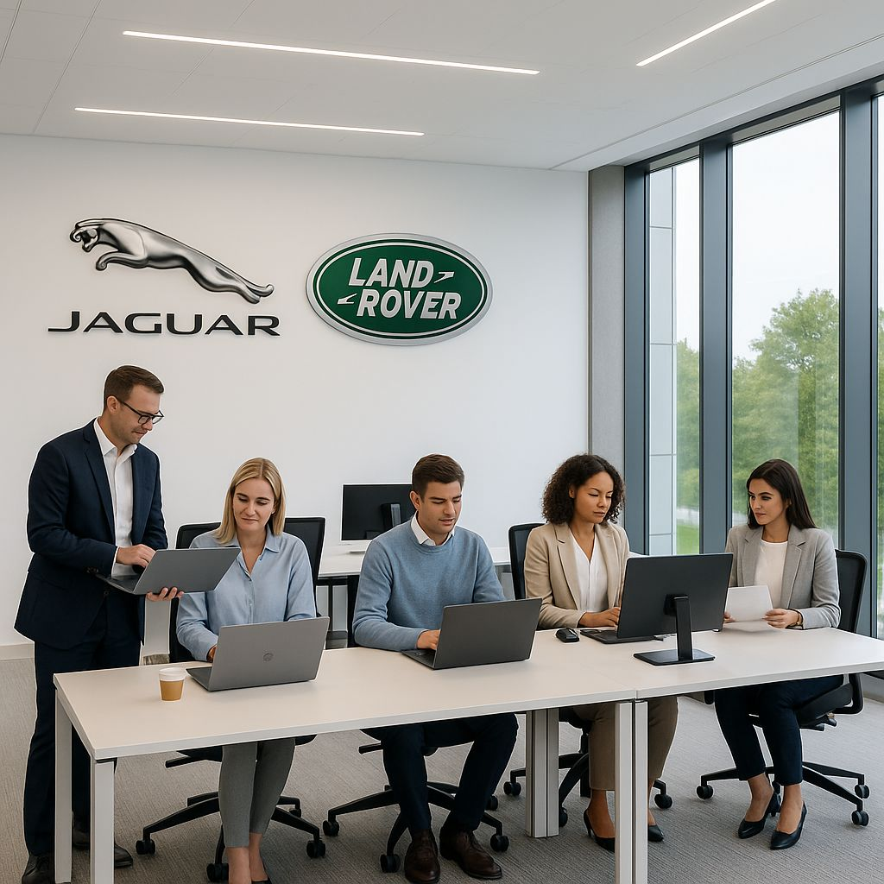

Introduction

As a newly appointed Human Resources (HR) officer at Jaguar Land Rover (JLR) in Birmingham, I have joined the organisation at a time of significant transformation and change. JLR, a global leader in the automotive industry, is currently undergoing a large-scale business transformation as part of its Reimagine Strategy, focusing on electrification, sustainability, and digital innovation (Jaguar Land Rover, 2023). This period of change has placed new demands on the workforce and management, leading to an increase in employee grievances relating to workload, communication, and the adaptation to digital systems.

The rapid spread of technology and the need for organisations to become more flexible with regards to their working patterns has resulted in increasing complexity for organisi1ing work in today’s business context (CIPD, 2023). The shift to hybrid work, digital collaboration tools and automation has altered the nature of how employees worked together and how leaders tracked productivity. We in JLR must make sure that we move our HR practices on as the business moves – and finding ways to ensure staff feel the support, value and competence they bring when embracing new technologies & approaches is just one of them. Now it’s a case of being able to connect workers and look after one another striking the right balance between digital innovation, staff wellbeing at home and effective communication across all parts of the business is what will make or break companies moving forwards.

Digital Technology Trends, and Flexible Working Arrangements Business Transformation at Jaguar Land Rover

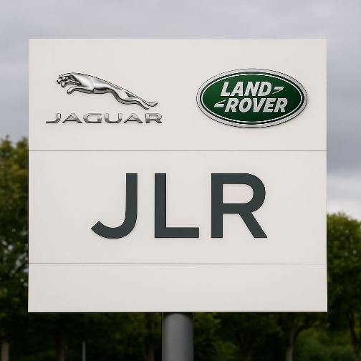
Reimagine Strategy Jaguar Land Rover (JLR) is presently embarking upon one of the most ambitious revitalization initiatives in its history, as part of efforts to transform itself into a world leading sustainable luxury business (Jaguar Land Rover, 2023). That transformation will be both about the new tools and a profound change in culture and organisation. The business transmutation of JLR is motivated by a variety of reasons, such as the global competition, environmental targets and fast automotive industry development. The shift from the traditional internal combustion engines to electric vehicles (EVs) is a response to changing consumer demands for travel and local pollution reduction, as well as to government regulation of carbon emissions (SMMT, 2023).
Burnes (2017) suggests that successful business reform must connect with an organisation’s strategy and its approach to people management and leadership. For JLR, this translates into the need to acquire new skills, development of digital literacy and creating a culture of agility and innovation among employees. Yet, change of this magnitude does not come without a cost – resistance from employees towards it, lack of communication and fear about job security (Kotter, 1996). Because as much as new technologies and processes are about a better customer experience, it’s also about greater efficiency, effectiveness for staff so that they’re engaged, motivated and skilled to use the latest tech.

Digital Technology Trends

Digitalisation has become a core part of JLR’s business, impacting production and human resources management. The organization is making substantial investments in Industry 4.0 technologies such as automation, AI, data analytics and digital twins to improve efficiency and decision-making around manufacturing (Deloitte, 2021). In HR, these technologies are disrupting traditional methods. The implementation of the digital Human Resource Information Systems (HRIS) allows JLR to facilitate recruitment, onboarding, and performance management (Bondar Ouk and Brewster, 2016).
AI-enabled analytics helps HR forecast talent shortages, anticipate turnover victims, develop specific training stimuli (Marler and Boudreau, 2017). This empirical approach facilitates making decisions based on evidence and aligns workforce development with the organization's strategic intentions. Additional, digital workplace tools like Microsoft Teams and SAP SuccessFactors are now critical communication Swiss Army knives in hybrid work environments, where businesses operate a mix of onsite and remote employees.
But greater dependence on digital systems can create problems with security, privacy and the so-called digital divide. However, workers with lower levels of digital skills may find new platforms harder to use, so ongoing digital training and support will be necessary (CIPD, 2023b). Additionally, automation in production may induce employees to fear losing their job (Krzywdzinski and Scholz 2017), fuelling an HR’s role that must balance technical efficiency with employee well-being through transparent communication and innovative upskilling programmes (Meijerink et al., 2021).

Flexible Working Arrangements
Work on wheels Works on wheels has become a dominant dynamic for modern working at Jaguar Land Rover, particularly post-Covid, as the company rips up old work-place-style norms in its global revolution to become even more agile and efficient. The organization’s implementation of hybrid work patterns for numerous corporate and technical positions is a concerted effort in driving a more agile and people-focused culture (Jaguar Land Rover, 2023). "Having these policies, employees can now split their time between home and the office so they (can) better handle all of those stressors of both work-related things as well as personal things."
This move reflects a wider change in the UK jobs market, with flexible working moving from being a nice-to-have ‘perk’ to something that’s considered an essential part of any modern work package. As the Chartered Institute of Personnel and Development (CIPD 2022) indicate, flexible working (such as remote working, part-time hours and a compressed week) are increasingly crucial in shaping how employees are attracted to and retained at organizations. More workers consider flexibility a critical element to be healthier, happier, and less stressed at work.
At JLR, the effects of remote working have been largely positive. There are reports that show people who have been given the freedom to define their work environment, they are happier and more engaged and more productive. This is in line with Bloom and colleagues (2015) who suggest that flexible working arrangements may also lower turnover rates by leading employees to feel more trusted, empowered and able to manage their personal responsibilities well. This then leads to higher levels of organizational commitment and performance.
Furthermore, the hybrid working models have played an important role in building a culture of inclusivity and diversity in JLR. By adjusting for staff with caring responsibilities, a disability or other personal needs – its founder reckons the company has built a more level workplace field where people can perform at their best. It’s not just about love triangles, either – this inclusivity improves employee morale whilst expanding the talent pool, so JLR can draw on a wide range of viewpoints and experiences.
In the end, the company’s commitment to flexible work is an acknowledgement that employee wellness, flexibility and inclusion are central to long-term business success. Through incorporating flexibility into its culture, JLR is becoming an employer for the future that recognises people as its greatest asset.

A Critical Evaluation of How Departmental Managers Can Ensure Effective Implementation of HR Practices

The successful implementation of HR practices at Jaguar Land Rover (JLR) depends heavily on the effectiveness of departmental managers. As intermediaries between strategic HR policy and operational execution, managers play a crucial role in translating organisational objectives into everyday actions that shape employee behaviour and culture. To ensure that HR practices addressing business transformation, digitalisation, and flexible working are effective, managers must demonstrate strong leadership, communication, and change management capabilities.

One of the most critical responsibilities of managers during JLR’s business transformation is leading change effectively. According to Kotter (1996), transformational change requires leaders to create a sense of urgency, build coalitions, and communicate a clear vision. Departmental managers can achieve this by consistently reinforcing the organisation’s transformation goals, engaging employees through regular briefings, and addressing concerns about new technologies and restructuring.
For example, managers at JLR’s engineering departments have implemented team-based innovation sessions to encourage participation in problem-solving and product development, fostering a sense of ownership and engagement.
In managing digital technology trends, departmental managers are central to integrating HR digital systems into daily operations. The introduction of HR analytics, AI tools, and digital collaboration platforms can only be effective when managers champion their use and model digital competence. As noted by Meijerink, Bondarouk and Lepak (2021), employees are more likely to adopt new technologies when they observe managerial commitment and confidence. JLR has addressed this by providing digital leadership training for managers, enabling them to analyse workforce data and make evidence-based decisions.

When it comes to flexible working, heads of department are spearheading the implementation of hybrid and remote work polices. HR provides the over-arching framework, but managers must adapt it to departmental requirements and ensure that fairness is applied across the range of job roles practiced by the organization. In JLR’s case, not everyone is able to work from home because of the need for production, so managers need to make sure flexibility is seen as fair. This has the potential to be done by providing alternatives, for inexpedient staff on site having flexible shifts or condensed hours (CIPD, 2022).
Performance management and communication in flexible settings as well should be the managers' attention. Studies have indicated that trust-based leadership, clear goal-setting, and regular feedback rather than traditional supervision are what hybrid workers need (Bloom et al., 2015). To do this, JLR gives managers toolkits and digital performance dashboards to monitor both outcomes and engagement levels.

Conclusion and Future Recommendations

Future Recommendations
Develop a Long-Term Workforce Strategy: JLR is also encouraged to develop a 10-year skills strategy in line with its Reimagine agenda, predicting new roles within electrification, AI and data science. Partnerships with universities and training providers will guarantee a positive future talent flow (Deloitte, 2021).
Expand Predictive HR Analytics: HR needs to move forward with AI and analytics to predict attrition of staff, look at engagement trends and understand personalisation path for development. Predictive modelling that can aid decision-making and retention (Marler and Boudreau, 2017).
Embed Green HRM Principles: JLR’s sustainability ambitions also need to be linked with HR processes of recruitment, appraisal and rewards. JLR will be seen as a conscientious, employer with a purpose (Renwick, Redman and Maguire, 2013).
Enhance Global Leadership Capability: Invest in digital transformation, intercultural management and emotional intelligence focused leadership development to enhance adaptability and innovation on a global scale of teams (Goleman, 2006; Ulrich, 1997).
Strengthen Inclusive Flexible Work Models: Enable more other flexi options for operational staff such as compressed hours, shift swaps and Techo scheduling,” Notes: CIPD 2023 Fairness Factory/Office. 6. Foster Digital Wellbeing: Implement measures that can help to not only manage, but also counteract digital overload, such as wellbeing apps, ergonomic training and coach support via artificial intelligence (Charalampous et al., 2019).
Enhance Ethical and Data Governance: HR should set up a digital ethics committee to monitor data privacy, algorithmic fairness and transparency to ensure adherence with UK GDPR standards (CIPD, 2022).
Institutionalise Continuous Learning: Enforce LLL culture with microlearning tools, and digital academies to accommodate employees for future mobility and innovation (Bondarouk and Brewster, 2016).

Conclusion
Jaguar Land Rover JLR is in the process of a major change as it moves towards an electric, environment friendly and digital future. This is not just another technological advance; it is a deep cultural shift that calls for us as a profession to rethink the strategic band of value we deliver from HR. Current HR practices such as upskilling workforces, the hybrid work model and deployment of digital HR systems have contributed significantly to JLR’s ability to support and sustain this transformation, but in the long run, HR will need to evolve from immediate adaptation to focus on building organization-wide resilience agility and employee empowerment.
The HR practices of JLR can be examined in this regard and one can conclude that apart from being consistent with the leading practices in the industry at present, their sustenance will depend on strong management consistency coupled with effective leadership development, and value-based governance of digital tools and employee data. It will be vital to integrate these dimensions into the strategic framework of HR in order to establish and maintain trust, justice, and long-term employee commitment.
The future of HR at JLR Three key pillars should support the future of HR at JLR: sustainability (ensuring that people practices reflect the company’s environmental commitment, social responsibility and inclusivity); digital capability to enhance employee experience and data-driven decision-making; and inclusivity to ensure that a diverse workforce can thrive in the workplace. By embracing these agendas, HR can bring a transformative voice to the table that defines how JLR evolves as a responsible, innovative and future-fit business.

References :
1. Bondarouk, T. and Brewster, C. (2016) ‘Conceptualising the future of HRM and technology research’, The International Journal of Human Resource Management, 27(21), pp. 2652–2671.
2. Burnes, B. (2017) Managing Change. 7th edn. Harlow: Pearson Educatio.
3. Charalampous, M., Grant, C. A., Tramontano, C. and Michailidis, E. (2019) ‘Systematically reviewing remote e-working and its psychological impacts’, Work & Stress, 33(1), pp. 1–20.
4. CIPD (2022) Flexible Working Practices. London: Chartered Institute of Personnel and Development.
5. CIPD (2023) People Profession 2023: Trends and Insights. London: Chartered Institute of Personnel and Development.
6. Deloitte (2021) Global Human Capital Trends 2021. London: Deloitte Insights.
7. Goleman, D. (2006) Emotional Intelligence: Why It Can Matter More Than IQ. London: Bloomsbury.
8. Marler, J. H. and Boudreau, J. W. (2017) ‘An evidence-based review of HR analytics’, The International Journal of Human Resource Management, 28(1), pp. 3–26.
9. Renwick, D. W. S., Redman, T. and Maguire, S. (2013) ‘Green human resource management: A review and research agenda’, International Journal of Management Reviews, 15(1), pp. 1–14.
10. Ulrich, D. (1997) Human Resource Champions: The Next Agenda for Adding Value and Delivering Results. Boston: Harvard Business School Press.

