
Introduction tO web and database concep
HTML & CSS

STUDENT NAME ……………………MAGDY BKHEET
STUDENT ID…………………………. 2997446
MOUDLE…... INTRODUCTION TO WED AND DATABSE
LECTURER ………… GARETH JOHNES
ASSIGNMENT TITLE …... HTML & CSS WEB DEVELOPMENT
Table of Contents

INTRODUCTION 2
An Abstract 2
VALIDATOR 5
Evaluation: 8
Conclusion 9
References 10
Appendices: 10

INTRODUCTION
For this assignment I created this is website and developed this is website for foods

that can run on multiple platforms such as desktop computers, smart phones and tablets. By understanding these actions, it will allow me to create a website which will reach the maximum amount of people possible.

An Abstract: I created this website I researched how to build the website in and red the assignment brief carefully and I started to build my codes and created the website pages I want using HTLM & CSS Codes.

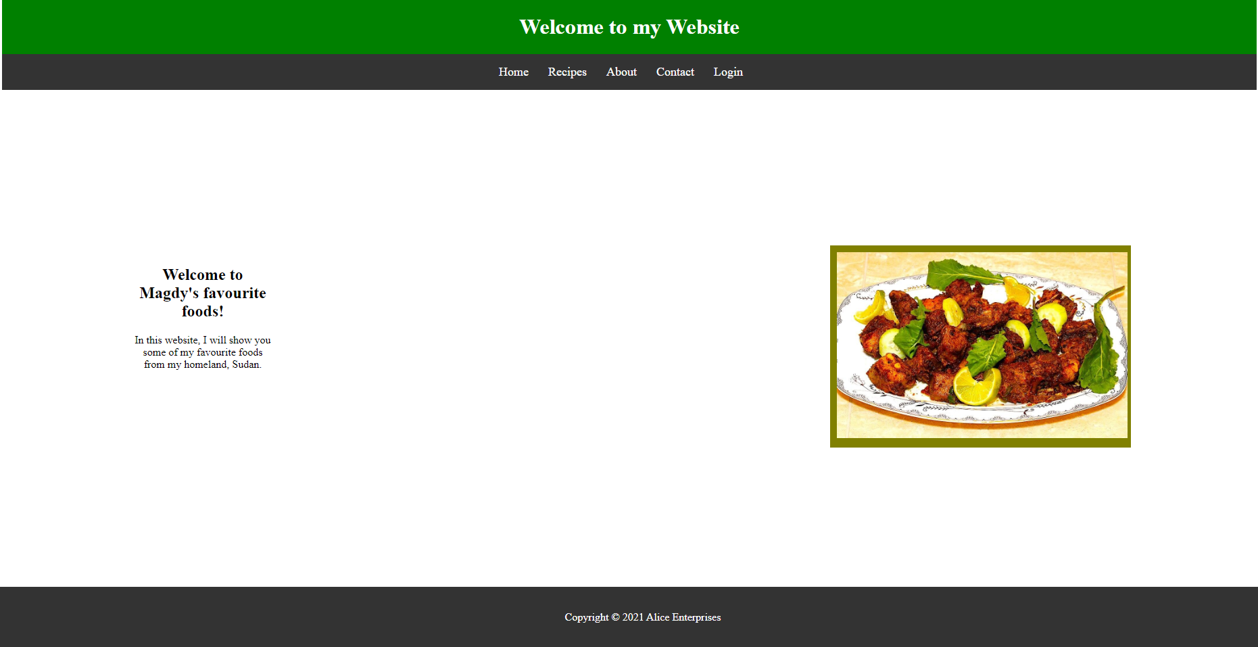
The is my home page for my website showing you the website. face

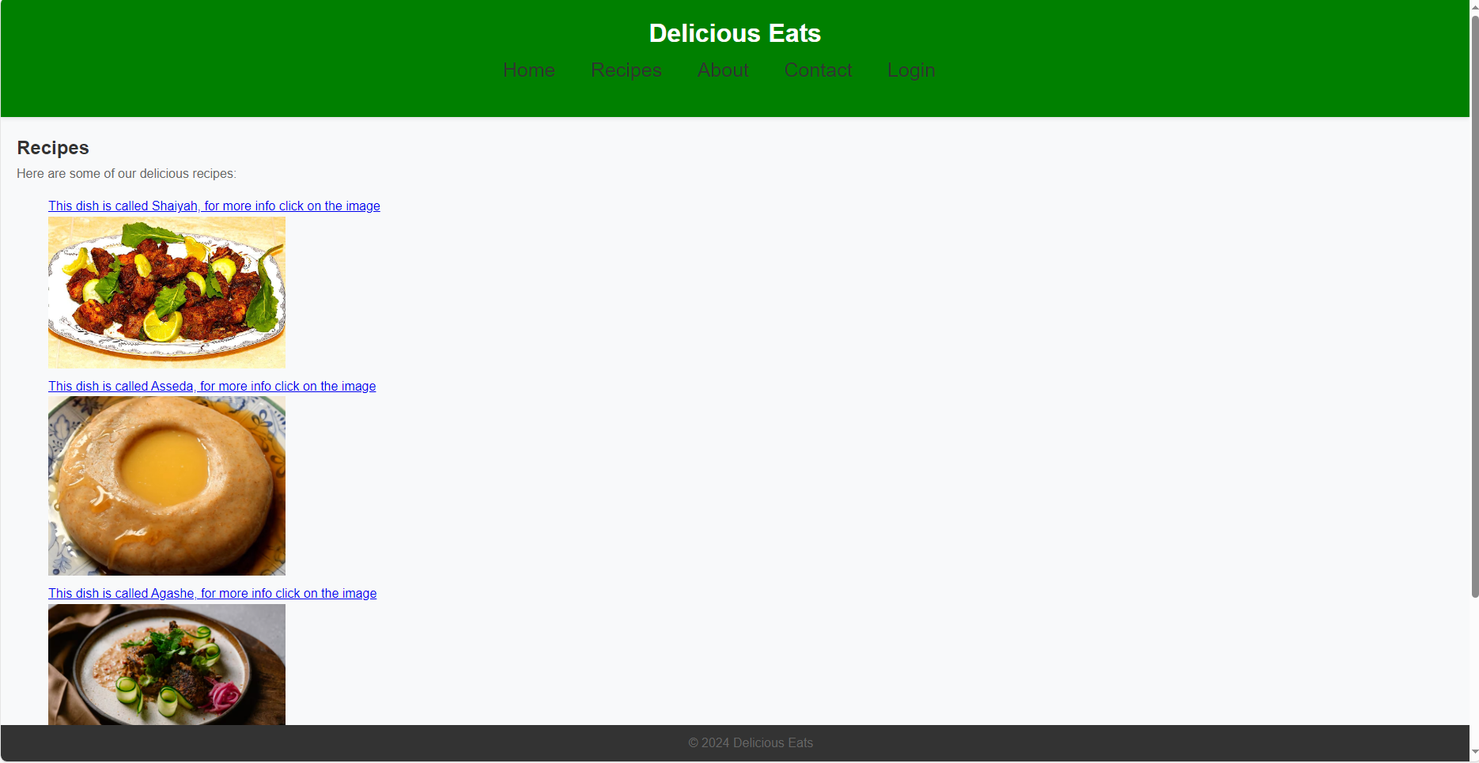

This is website Recipes page showing you the recipes.

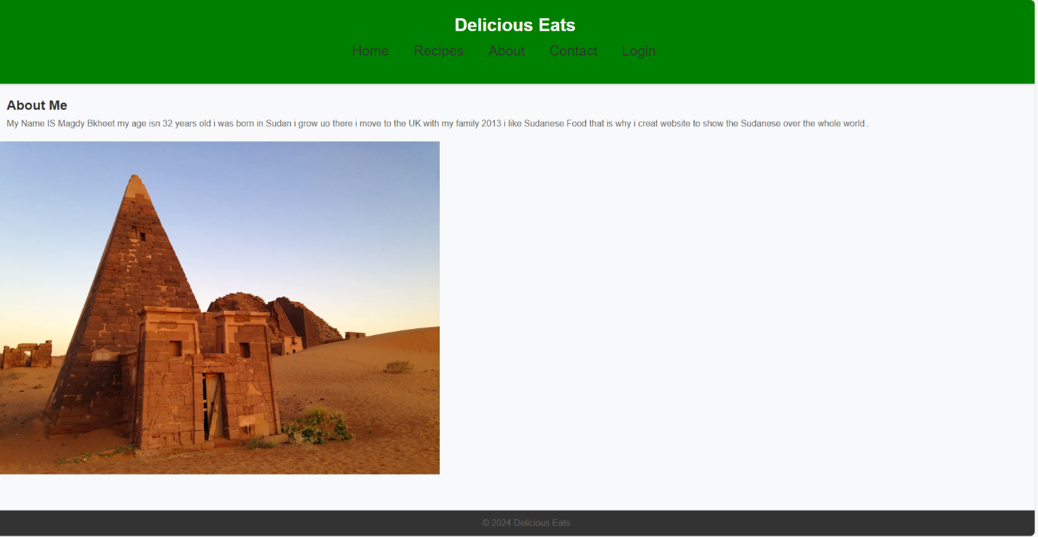
This is website page about me and image showing Pyramids my country

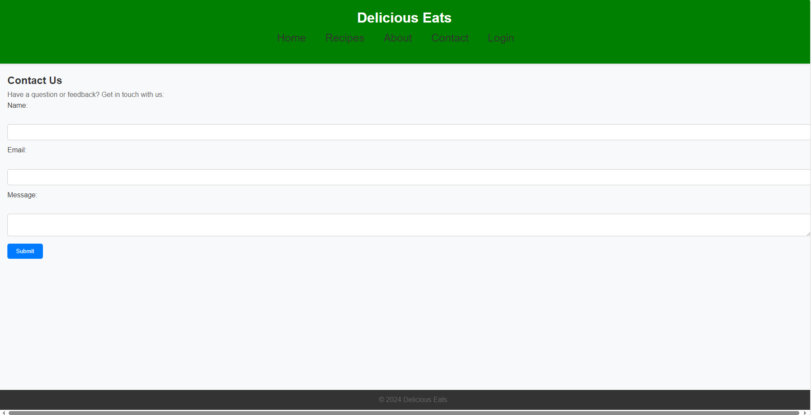
This is a contact page showing you how to contact with the staff on website.

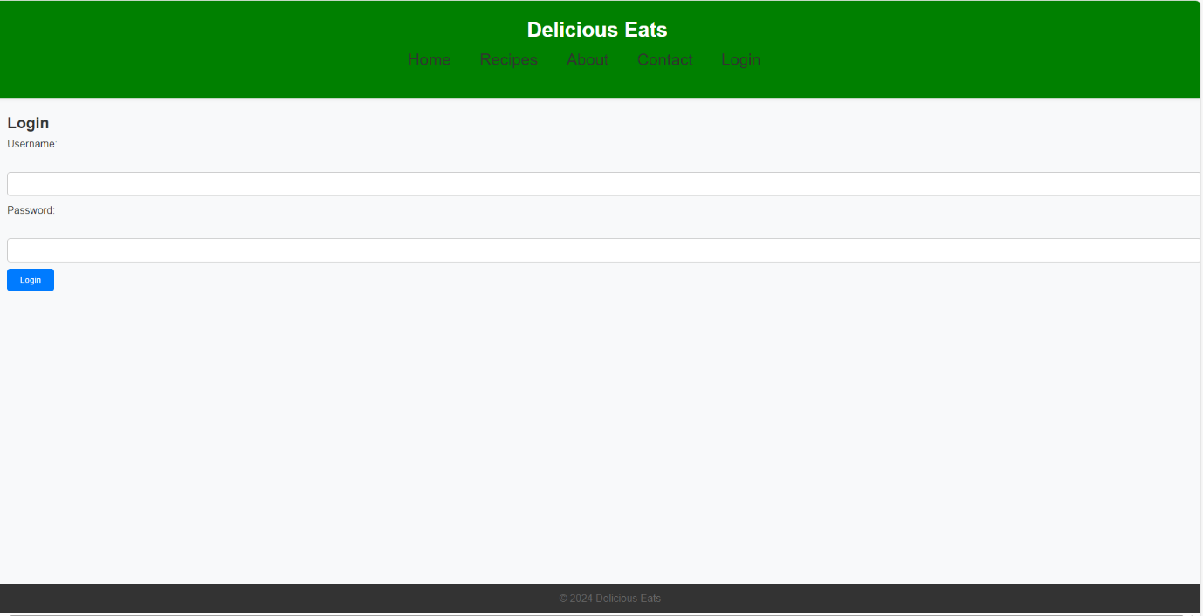
This is Login page direct you how to login the website and how to reach to your order.

VALIDATOR

HOME PAGE [ HTLM], I got 3 warning I have been understood the correct method.

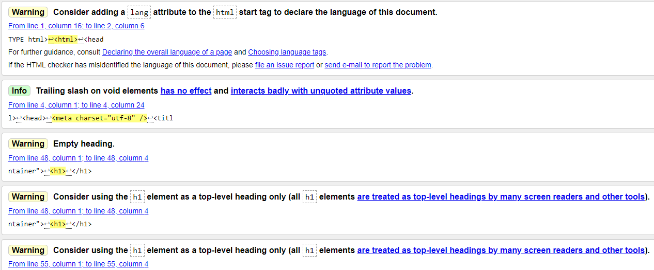

RECIPE PAGE [ HTLM] I got 6 errors I fixed.
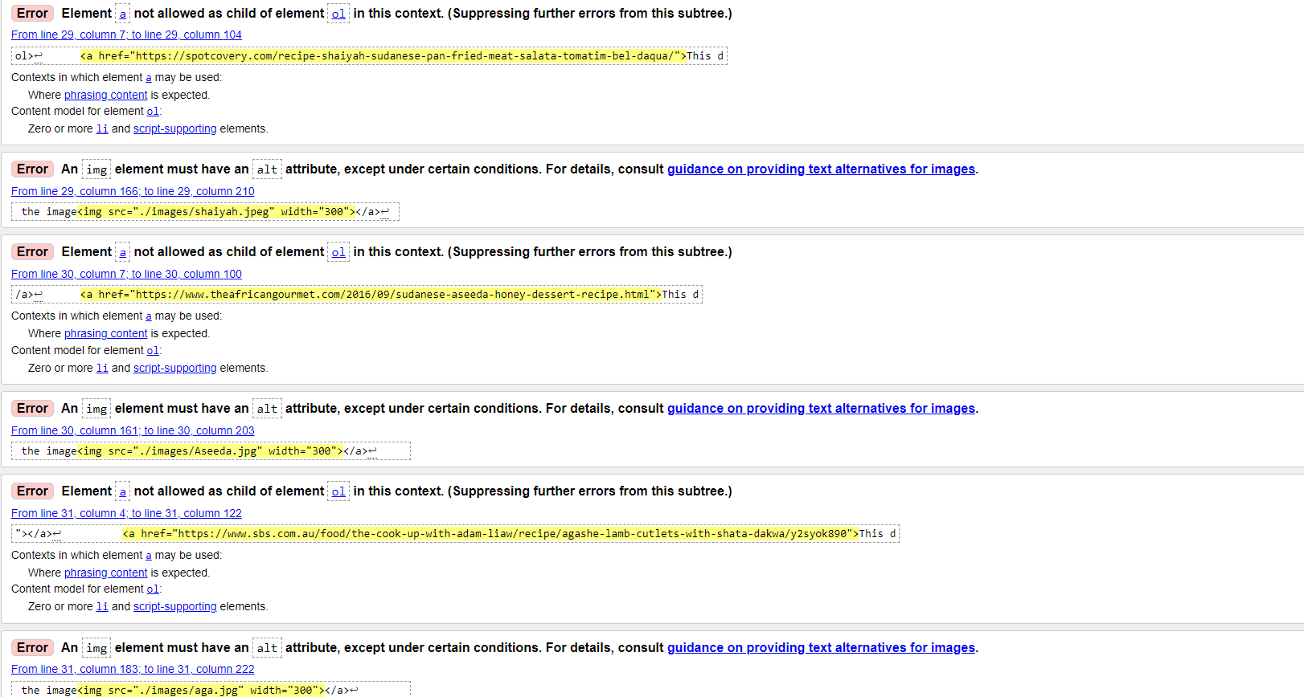

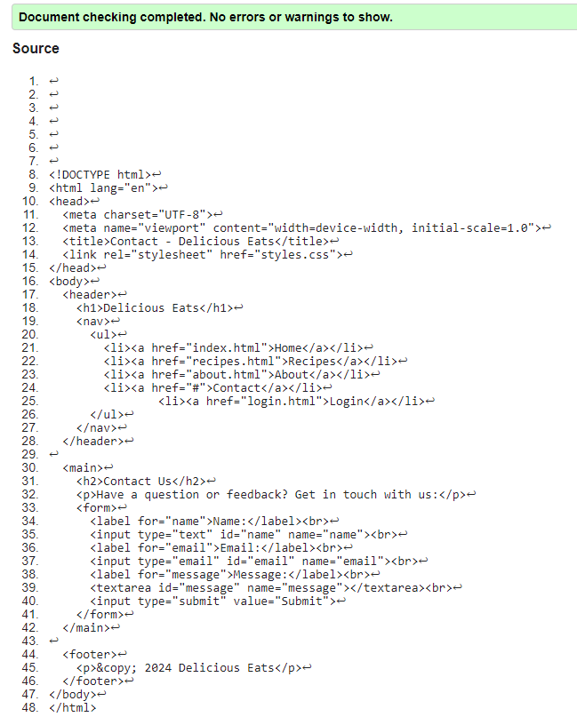
CONTACT ME PAGE [ HTLM] My codes have no errors!

ABOUT ME PAGE [HTLM] I got one error I fixed.

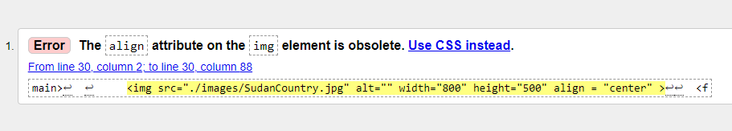

LOGIN PAGE [HTLM] M
y codes has no errors .
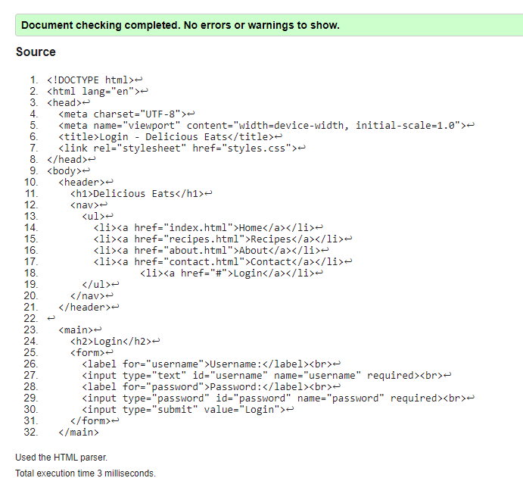

CSS.INDEX
I got two errors I fixed.
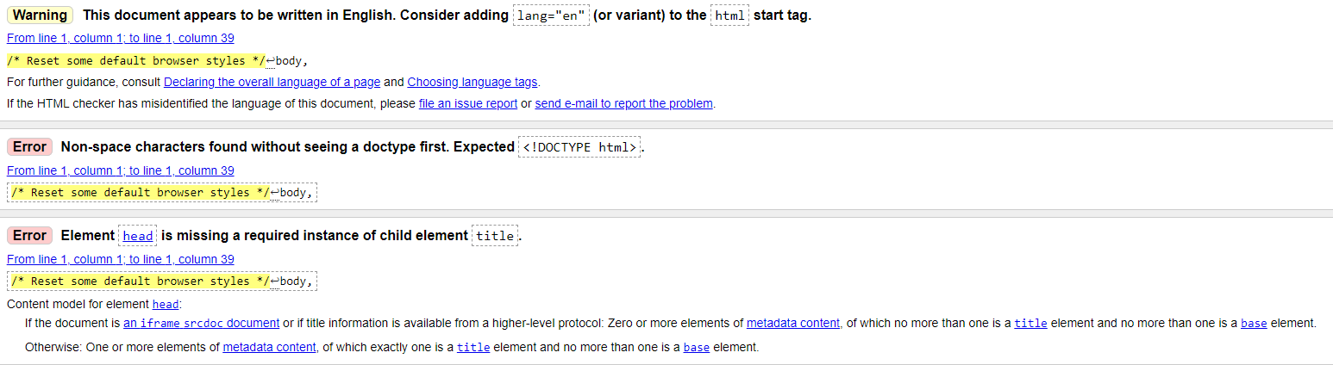

My CSS
I got two errors I fixed.
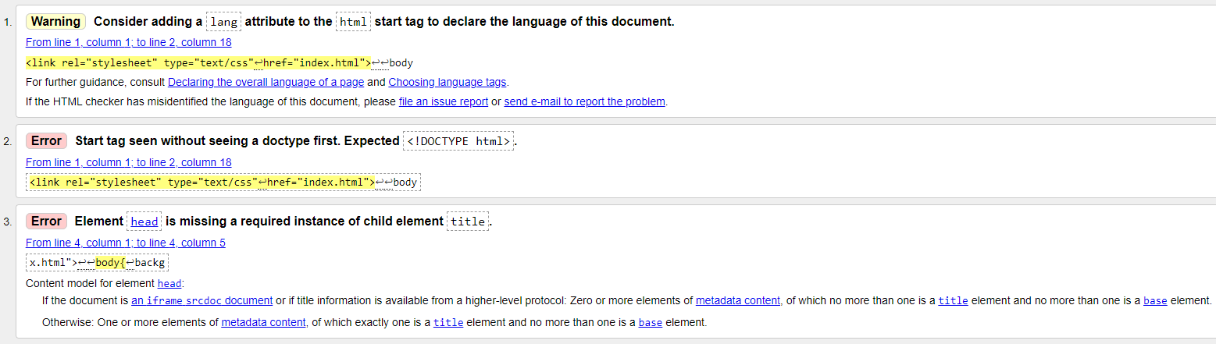

Evaluation:

- Usefulness (usability and utility) This is website has intuitive navigation that allows users to easily find the information they are looking for. Clear menu structures, breadcrumbs, and search functionality contribute to better navigation. [1]

Search Engine Optimisation (SEO):
The Website pages to has their visibility in search results. This includes optimizing meta titles, meta descriptions, headings, and image alt text with relevant keywords. Additionally, structuring content with pages headings, and clear formatting enhances usability and readability for both users and search. [2]

Accessibility:
This is Website making information available to users regardless of their abilities or assistive technologies. Easy to use. And has images and instructor on the pages. [3]

- Usefulness
I Created this website. Usability as the ease of use of a website or an app. It is an indicator showing whether a website is effective, easy to navigate and efficient from the users' point of view. Users are more likely to gravitate toward [4]products with better usability and more likely to recommend those products to other people. For websites, usability is particularly crucial. Visitors to a website can easily leave when they encounter difficulty or confusion.

Search Engine Optimisation (SEO)
I designed this is website engine optimization is a way to make websites easier to find on search engine result pages (SERPs). This helps users to find my website quickly and allows me to increase revenue. It is essential to boost the website's organic (unpaid) traffic by enhancing its authority and relevancy for search searches.

I helped search engines to find my website, optimize meta tags, keywords, and backlinks. It's also essential to focus on accessibility improvements, [5]

Accessibility:
Everyone should be able to navigate and use my website. This principle covers various aspects of navigation and control, all users can operate the site. The information and the way the website work it’s easy to understand. In other words, the website present readable content in an organized structure and predictable navigation [6]

References

[1] | B. Anaya, “BrainGu Logo,” 15 June 2021. [Online]. Available: https://braingu.com/news/importance-of-usefulness-in-ux-and-ui/#:~:text=Tl%3Bdr%20%2D%20To%20determine%20if,'Utility'%20measures%20its%20functionality.. [Accessed 25 April 2024].
[2] | Danny Goodwin, “Search Engine Land,” 2024. [Online]. Available: https://searchengineland.com/guide/what-is-seo. [Accessed 25 April 2024].
[3] | S. L. Henry., “W3C,” 07 March 2024. [Online]. Available: https://www.w3.org/WAI/fundamentals/accessibility-intro/#:~:text=products%20and%20services.-,What%20is%20Web%20Accessibility,and%20interact%20with%20the%20Web. [Accessed 25 April 2024].
[4] | S. Tyndall, “Inclind,” 31 October 2023. [Online]. Available: https://www.inclind.com/news/best-utility-website-examples. [Accessed 25 April 2024].
[5] | V. Pavlik, “Semrush Blog,” 30 Nov 2022. [Online]. Available: https://www.semrush.com/blog/what-is-seo/?kw=&cmp=UK_SRCH_DSA_Blog_EN&label=dsa_pagefeed&Net. [Accessed 25 April 2024].
[6] | R. Griggs, “Bath University,” 31 jul 2024. [Online]. Available: https://www.bath.ac.uk/legal-information/website-accessibility-statement/. [Accessed 25 April 2024].

Conclusion
I Designed this is basic Website using Html & CSS codes I learned more things as codes and how to design website and how to plan for it. It was not easy, but I learned a lot with practice can I design professional website. this website not only visually appealing but also functional, informative, and accessible to all users. This holistic approach to website design ultimately leads to better user engagement, satisfaction, and success. website design highlights the importance of user-friendly interfaces, visually appealing layouts, and easy navigation to enhance the overall user experience. It emphasizes the significance of incorporating high-quality images, clear menu structures, and responsive design to attract and retain visitors on food websites.

Appendices:
[HTLM ABOUT PAGE]

<!DOCTYPE html>
<html lang="en">
<head>
<meta charset="UTF-8">
<meta name="viewport" content="width=device-width, initial-scale=1.0">
<title>About - Delicious Eats</title>
<link rel="stylesheet" href="styles.css">
</head>
<body>
<header>
<h1>Delicious Eats</h1>
<nav>
<ul>
<li><a href="index.html">Home</a></li>
<li><a href="recipes.html">Recipes</a></li>
<li><a href="#">About</a></li>
<li><a href="contact.html">Contact</a></li>
<li><a href="login.html">Login</a></li>
</ul>
</nav>
</header>

<main>
<h2>About Me</h2>
<p>My Name IS Magdy Bkheet my age isn 32 years old i was born in Sudan i grow uo there i move to the UK with my family 2013 i like Sudanese Food that is why i creat website to show the Sudanese over the whole world..</p>
</main>

<img src="./images/SudanCountry.jpg" alt="" width="800" height="500" align = "center" >

<footer>
<p>&copy; 2024 Delicious Eats</p>
</footer>
</body>
</html>

[HTLM CONTACT PAGE]

!DOCTYPE html>
<html lang="en">
<head>
<meta charset="UTF-8">
<meta name="viewport" content="width=device-width, initial-scale=1.0">
<title>Contact - Delicious Eats</title>
<link rel="stylesheet" href="styles.css">
</head>
<body>
<header>
<h1>Delicious Eats</h1>
<nav>
<ul>
<li><a href="index.html">Home</a></li>
<li><a href="recipes.html">Recipes</a></li>
<li><a href="about.html">About</a></li>
<li><a href="#">Contact</a></li>
<li><a href="login.html">Login</a></li>
</ul>
</nav>
</header>

<main>
<h2>Contact Us</h2>
<p>Have a question or feedback? Get in touch with us:</p>
<form>
<label for="name">Name:</label><br>
<input type="text" id="name" name="name"><br>
<label for="email">Email:</label><br>
<input type="email" id="email" name="email"><br>
<label for="message">Message:</label><br>
<textarea id="message" name="message"></textarea><br>
<input type="submit" value="Submit">
</form>
</main>

<footer>
<p>&copy; 2024 Delicious Eats</p>
</footer>
</body>
</html>

[HTLM HOME PAGE]

<!DOCTYPE html>
<html>
<head>
<meta charset="utf-8" />
<title>Magdy</title>
<link rel="stylesheet" type="text/css"
href="MyCSS.css">

<style>
.grid-container {
display: inline-grid;
grid-template-columns: auto auto auto auto;
background-color: olive;
padding: 20px;
}
.grid-item {
background-color: rgba(255, 255, 255, 0.8);
border: 1px solid rgba(0, 0, 0, 0.5);
padding: 20px;
font-size: 30px;
text-align: center;
}
</style>

</head>
<body>
<header id="main-header">
<div class="container">
<h1>Welcome to my Website</h1>
</div>
</header>

<nav id="navbar">
<div class="container">
<ul>
<li><a href="#">Home</a></li>
<li><a href="recipes.html">Recipes</a></li>
<li><a href="about.html">About</a></li>
<li><a href="contact.html">Contact</a></li>
<li><a href="login.html">Login</a></li>
</ul>
</div>
</nav>

<section id="showcase">
<div class="container">
<h1>
</h1>
</div>
</section>

<div class="container">
<section id="main">
<h1>Welcome to Magdy's favourite foods!</h1>
<p>In this website, I will show you some of my favourite foods from my homeland, Sudan.
</p>
</section>

<aside id="sidebar">
<img src="./images/shaiyah.jpeg" width="430" alt="Shaiyah from my homeland of Sudan">
</aside>
</div>

<footer id="main-footer">
<p> Copyright &copy; 2021 Alice Enterprises</p>
</footer>

</body>
</html>

[HTLM RECIPES PAGE]

<!DOCTYPE html>
<html lang="en">
<head>
<meta charset="UTF-8">
<meta name="viewport" content="width=device-width, initial-scale=1.0">
<title>Recipes - Delicious Eats</title>
<link rel="stylesheet" href="styles.css">
</head>
<body>
<header>
<h1>Delicious Eats</h1>
<nav>
<ul>
<li><a href="index.html">Home</a></li>
<li><a href="#">Recipes</a></li>
<li><a href="about.html">About</a></li>
<li><a href="contact.html">Contact</a></li>
<li><a href="login.html">Login</a></li>
</ul>
</nav>
</header>

<main>
<h2>Recipes</h2>
<p>Here are some of our delicious recipes:</p>
<ol>
<a href="https://spotcovery.com/recipe-shaiyah-sudanese-pan-fried-meat-salata-tomatim-bel-daqua/">This dish is called Shaiyah, for more info click on the image<img src="./images/shaiyah.jpeg" width="300"></a>
<a href="https://www.theafricangourmet.com/2016/09/sudanese-aseeda-honey-dessert-recipe.html">This dish is called Asseda, for more info click on the image<img src="./images/Aseeda.jpg" width="300"></a>
<a href="https://www.sbs.com.au/food/the-cook-up-with-adam-liaw/recipe/agashe-lamb-cutlets-with-shata-dakwa/y2syok890">This dish is called Agashe, for more info click on the image<img src="./images/aga.jpg" width="300"></a>
<a href="https://globaltableadventure.com/recipe/recipe-sudanese-kisra-sorghum-crepes/">This dish is called Kisra, for more info click on the image<img src="./images/kis.jpg" width="300"></a>

<!-- Add more recipes here -->
</ol>
</main>

<footer>
<p>&copy; 2024 Delicious Eats</p>
</footer>
</body>
</html>

[HTML LOGIN PAGE]

<!DOCTYPE html>
<html lang="en">
<head>
<meta charset="UTF-8">
<meta name="viewport" content="width=device-width, initial-scale=1.0">
<title>Login - Delicious Eats</title>
<link rel="stylesheet" href="styles.css">
</head>
<body>
<header>
<h1>Delicious Eats</h1>
<nav>
<ul>
<li><a href="index.html">Home</a></li>
<li><a href="recipes.html">Recipes</a></li>
<li><a href="about.html">About</a></li>
<li><a href="contact.html">Contact</a></li>
<li><a href="#">Login</a></li>
</ul>
</nav>
</header>

<main>
<h2>Login</h2>
<form>
<label for="username">Username:</label><br>
<input type="text" id="username" name="username" required><br>
<label for="password">Password:</label><br>
<input type="password" id="password" name="password" required><br>
<input type="submit" value="Login">
</form>
</main>

<footer>
<p>&copy; 2024 Delicious Eats</p>
</footer>
</body>
</html>

[MyCss]

<link rel="stylesheet" type="text/css"
href="index.html">

body{
background-color:#f4f4f4;
color:#555;
font-family:Arial, Helvetica, san-serif;
font-size:16px;
line-height:1.6em;
margin:0;

}

.container{
width:80%;
margin:auto;
overflow:hidden;
text-align:center;
}

#main-header{
background-color:green;
color:#fff;
}

#navbar{
background-color:#333;
color:#fff;
}

#navbar ul{
padding:0;
list-style:none;
}

#navbar li{
display:inline;
}

#navbar a{
font-size:18px;
padding-right:25px;
}

a{
color:white;
text-decoration: none;
}

a:hover{
color:yellow;
}

#main-footer {
position: fixed;
left: 0;
bottom: 0;
width: 100%;
background:#333;
color:#fff;
text-align:center;
padding:20px;
margin-top:40px;
}

#main{

float:left;
width:15%;
padding:10px;
box-sizing: border-box;
}

#sidebar{
float:right;
width:30%;
background:olive;
color:#fff;
padding:10px;
box-sizing: border-box;
}

#showcase{
background-image:url("0131_cr.jpg");
background-size: 1280px;
opacity:1.0;
background-position:center right;
min-height:200px;
margin-bottom:30px;
text-align:center;
}

#showcase h1{
color:#fff;
font-size:30px;
line-height:1.6em;
padding:30px;
}

@media(max-width:600px){
#main{
width:100%;
float:none;
}

#sidebar{
width:100%;
float:none;
}

#navbar li{
display:block;
}

}

[Style Css]

body, h1, h2, p, ul, input, textarea, form {
margin: 0;
padding: 0;
}

body {
font-family: Arial, sans-serif;
line-height: 1.6;
background-color: #f8f9fa;
color: #333;
}

header {
background-color: green;
padding: 20px;
box-shadow: 0px 2px 5px rgba(0, 0, 0, 0.1);
}

header h1 {
color: white;
text-align: center;
}

nav ul {
list-style-type: none;
text-align: center;
}

nav ul li {
display: inline;
margin-right: 40px;
font-size: 25px;

}

nav ul li a {
text-decoration: none;
color: #333;

}

main {
padding: 20px;
}

h2 {
color: #333;
}

p {
color: #666;
}

ul {
margin-bottom: 20px;
}

li {
margin-bottom: 10px;
}

img {
max-width: 100%;
height: auto;
display: block;
margin-bottom: 10px;
}

.button,
input[type="submit"] {
display: inline-block;
background-color: #007bff;
color: #fff;
padding: 10px 20px;
text-decoration: none;
border-radius: 5px;
border: none;
cursor: pointer;
}

.button:hover,
input[type="submit"]:hover {
background-color: #0056b3;
}

form label {
display: block;
margin-bottom: 5px;
}

form input[type="text"],
form input[type="password"],
form input[type="email"],
form textarea {
width: 100%;
padding: 10px;
margin-bottom: 10px;
border-radius: 5px;
border: 1px solid #ccc;
}

footer {
position: fixed;
bottom: 0;
width: 100%;
background-color: #333;
color: #fff;
padding: 10px 20px;
text-align: center;
}

