Student ID: 1919631

Student Name: Wioleta Teresa Knysz

Module Code: BMSW4005_LON

Module Title: Professional Career Development

Lecturer Name: Saqib Shamim

Assignment Title: Personal Reflection on Career Development Planning

Assignment Date: 7 May 2021

Personal Reflection on Career Development Planning

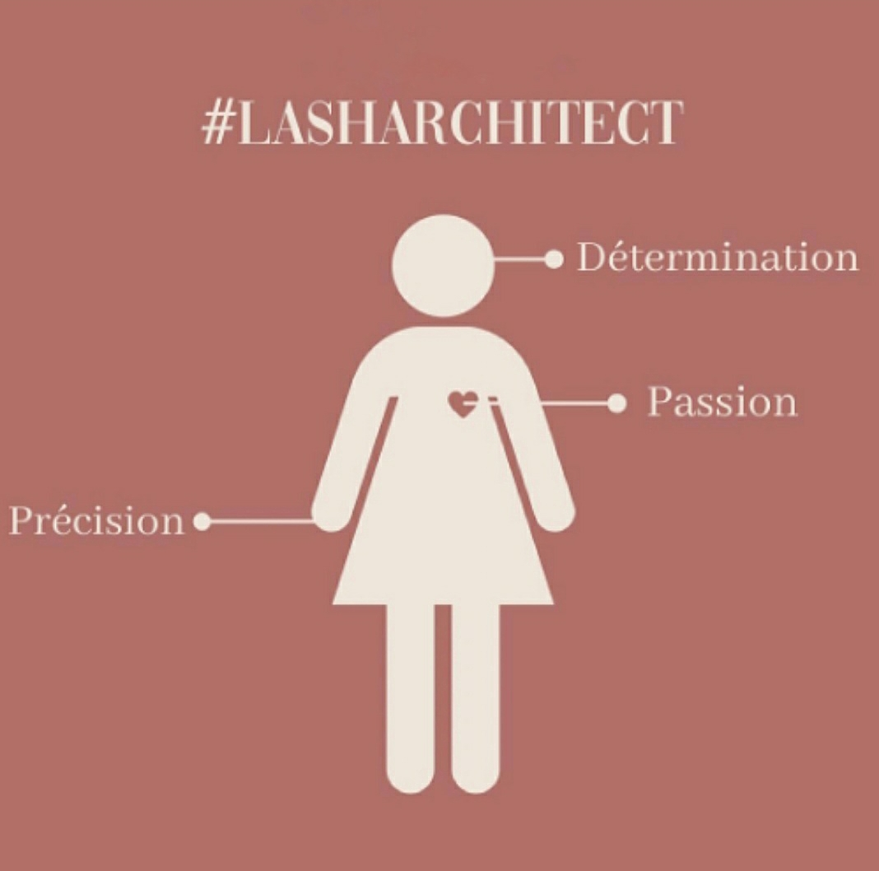

Abstract

In twenty-first century, we are surrounded by so many opportunities that help us grow and increase our lives that it would be a huge loss not to use them.

Commitment, hard work, awareness of our strengths and weaknesses are a strong foundation for implementing of our professional goals and dreams.

In this report, I will present, based on my example, how thanks to the conscious use of your predispositions and careful planning of each most minor step, you can gradually get closer to your goal.

Table of Content

- Introduction.
- Role Play Interview- Reflection.
- Self-Evaluation Review.
- Career Ambitions and Aspirations.
- Personal Development Planning.
- The World of Employment- Expectations.
- Conclusion.
- List of References.
- Appendices.

Introduction

Since I remember, I had big dreams and ambitious goals. I was always patient, composed and found the right solutions with ease. That sounds like an introduction to a successful story, right? Unfortunately, the truth is a bit different.

The light went out for a while after I started to pursue my goals. Some of the tasks were usually put off until the next day that never came.

And so, for many years, I lived in monotony, at work with no prospects, feeling that I limit myself at my own request because I can do more. So why am I not doing more?

I regret that it took me so long to understand that I finally must move. But at the same time, I am glad that I started to perform consistently, that I found a stubbornness to pursue my goal, no matter what happens.

I found passion – lash extensions. That was what inspired me to act, and it changed everything.

I learned to cherish my dreams, stick to my target plan and get closer to it day by day.

Today I know that I have an influence on all distractions, and I found the recipe for this- do not let them dominate me.

So, a self-confident, enterprising woman was born of an undecided girl full of plans. Now I transform my passion into fulfilled ambitions. The lash extension industry is a place where I finally found myself and with which I want to tie the next long years.

Although a long way ahead of me, I do not stop in activities.

Role Play Interview- Reflection.

It is an integral part of professional life to go through the choosing right candidate for the position by interview (Burton, 2015).

In agreement with Burton (2015), the process may be very stressful for a potential employee. Therefore, role-play exercise come to the rescue.

- The first most important thing is research (Burton, 2015).

From the experience of role-play during the last assignment, I can confidently say that proper groundwork for the company and the position for which we apply provides us with a 50% chance of successfully proceed the interview. Proper preparation gives confidence in the type of examination the job seeker will have to deal with (Burton, 2015).

You can expect that the recruiter will not only go through your CV and application form but may use scenario-based question, which you will pass only thanks to the knowledge of person specifications and responsibilities of the position (Burton, 2015).

As mentioned in the feedback given by my lecturer Saqib Shamim (2021), every question asked may be extended in order to obtain detailed information if they have not been given. However, this can be cleverly avoided by providing the most developed and possibly satisfying answers.

In addition, the interviewee can be asked about a crucial aspect of occupation, as in my case during the role-play, communication in the lash extension industry. My answer covered all possible issues in which I not only presented myself as a responsible and professional lash technician who understand the importance and impacts of the relationship with customers but also as a valuable and ambitious woman. And this is the other half of success in the interview.

- It is essential to know how to sell yourself to a potential employer (Burry, 2020).

While preparing for the role play, I have realised that when applying for the job, you start to be a product that an exact enterprise need- if you want the company to ultimately choose you, you must have a clear understanding of their expectations.

Self-confidence is a testimony to your worth (Burry, 2020). According to Burry (2020), How you answer the questions is important, but the attitude you have at the same time enhances the impression.

Non-verbal communication plays a big role to express that you are highly interested in the job (Burry, 2020).

First impression count. Therefore, from the very beginning is essential to maintain eye contact and a nice way of sitting or standing (Burry, 2020).

I have noticed when testing the role-play that good chance for further recruitment steps is to master the stress and be professional in every manner. All answers must be carefully considered (Burry, 2020). Because, trust me, the most important is to become unforgettable and appropriate for the position.

Thanks to the play-acting during the assignment, I learned to consider the time in a real-life interview. As explained by Burry (2020), a correctly approached selecting process should contain specific but valuable answers to effectively fill the time and not bore the listener.

Self-Evaluation Review

While my main desire is to become a lash instructor and have my online educating platform, being a perfect and fast lash technician is an essential part of it. And this is where difficulties begin.

I possess all essential skills for that profession but two need improvement in particular- time of the service and correct lash mapping to the eye shape. They are the most challenging and only available to achieve by kinaesthetic.

I have been prevented from perfecting these skills largely due to a lack of client because of virus restrictions. However, I treat them as my weaknesses which I must enhance, and I hope that until the end of 2021, I will be able to mark those tasks as done.

I joined the beauty industry three months before the first COVID lockdown, so in dedication, I opted to work for two jobs to earn money for the costly implementation of developing plans.

I decided to achieve my goal without any breaks and excuses. Although I could not work and practice on clients due to national lockdowns, I spend that time learning and improving lash techniques to be one of the best eyelash stylists. And here, my kinaesthetic abilities turned out to be a bonus.

The kinaesthetic learner is one of three types of VAK personalities who get understanding and achieve results by manually doing the same what already seen or read (Glinicka, 2021).
In agreement with Glinicka (2021), a person of this characteristic is incredibly effective at acquiring knowledge through lingering notes, coloured key information, and personally experiencing the physical feeling of doing things. Without highlighting the most important aspects, I would not properly understand the content from the books, even reading them several times.

Despite the gathered theory, it was only physical contact with the products (lashes/adhesive) that made me feel what it was about. The trial-and-error method also played a big role.
As a reflector type of disposition (Honey & Mumford learning style), I was constantly going through all social media posts of my ‘lash gurus’, studying them insightfully and non-stop watching how they perform the perfect treatments (Barkas, 2016). Then I try to recreate the process in my head, which gave me the mental first exercise (Barkas, 2016) and went through it physically on the mannequin.
According to Barkas (2016), the weakness of the reflector is a risk of low productivity, but if the individual makes progress in that silence and concentration, it is a big plus. And this is me. Understanding the issue through observation and careful reading gives me confidence in the assimilated material.

Despite the pandemic, I managed to develop only because of my commitment, time dedicated, hard work and self-motivation. Those are my strengths as well as my skills appropriate to the lash technician position. I am extremely precise and patient and pay great attention to details. I can work under pressure and build a professional relationship with the client for long-term cooperation.

I kept myself constantly motivated by following all successful stylists and trainers in the lash industry. Beautiful lash works, participating in championships crowned with a cup, passion and positive energy fuelled in me the desire for continuous development in this field. Thanks to the fact that I was strongly inspired by a wonderful eyelash extension stylist, I fell in love with this profession even before I started to deal with it as a lash technician.

Career Ambitions and Aspirations

Getting out of my comfort zone was usually very difficult for me. But I always felt I am very ambitious.

I trust that everything in life makes sense. I believe that a dream supported by determination and hard work will come true.

As I mentioned above, I strive to achieve my SMART goal of lash extension school by small but consistent steps.

I want to have an educational e-platform where my proprietary online training will be available to buy. I would also like intent to write and sell e-books as additional mentoring help. That all will be my primary source of income.

However, to achieve it, I need to be a successful lash technician first with the massive knowledge and experience I am collecting.

In addition, I plan to have a small but well prospering lash salon in which I will be able to perform treatments only for my passion, with fewer hours.

I imagine myself in five years as a fulfilled woman, loving her profession, introducing new ladies to the lash world. I will not only increase the quality of my life thanks to high earnings and freedom of travel. But also, I will finally have enough free time for my family.

Citing Confucius, “Choose a job you love, and you will never have to work a day in your life” (ColourQuotes, 2021).

Personal Development Planning

High awareness of body language, understanding someone’s needs and feelings is essential in good communication (Levin, 2016). In agreement with Levin (2016), whether we create our trustworthy image and whether people will want to cooperate with us depends only on how well we know ourselves and how we deal with that fact.

Expanding the self-awareness area (Johari Window tool) will allow us to have complete control over the company’s image, avoid mistakes, and develop and improve our skills and enterprise (Levis, 2016).

I am equally aware of my strengths and weaknesses, which I already indicated in that report. While building my clients base, I tried to manoeuvre it properly. Through the Instagram stories, I showed myself privately, in term of advantages, including high personal culture, humility and polite appearance. The post with photos of my lash work emphasized my professionalism, commitment and high sense of aesthetic. That approach has worked well with customer acquisition, and I will not change it.

There is something that clients does not know. I do not have many years of experience because I entered the market a few months before the pandemic. But I will be sharing that secret with my future lash students to motivate them, as that present weakness would be my strong point of success.

I am aware that the progress also depends on customer feedback. That is why I am opened to any suggestions, opinions and constructive criticism. When I see that my client during the treatment cannot lie down any longer, it is a signal for me that I am too slow, and I must improve the time of application. I believe that openness to accept things regarding myself that I have no idea about will help me develop and convince clients to my business.

The World of Employment- Expectations.

Over the years, the world of employment is changing. People become more aware. They see differences between work environments and begin to change their approach that they are for the position, not position for them (Smith, 2020). According to Smith (2020), employees start looking for a bit of freedom and increasingly put their mental well-being first. External support is also desirable (Smith, 2020).

I am not surprised that more and more people are deciding to run their own businesses. Only this gives fulfilment and more possibilities. That is why I did it myself. And challenging self-employment is much more enjoyable, despite the nerves and possible risk, than working full-time.

Conclusion

Today everyone has a chance to be whoever they want. The world of employment offers all possible workplace sectors where everyone can find something for themselves.

Today we have a chance to do what we want to, not what we have to. But whether we want to work for someone or run our own business, having the right skills, constant motivation, self-development, and discipline are essential to prospering successfully.

List of References

Barkas L. (12 December 2016), “What’s your personality type”, Talented Ladies Club, accessed 15 April 2021 <https://www.talentedladiesclub.com/articles/whats-your-personality-type/>.

Burry M. (19 November 2020), “How to Sell Yourself During a Job Interview”, The Balance Careers, accessed 4 May 2021 <https://www.thebalancecareers.com/how-to-sell-yourself-during-a-job-interview-4153288>.

Burton S. (11 June 2015), “Role-Play Interviews and Exercises: How to succeed”, ISC PROFESSIONAL, accessed 4 May 20201 <https://www.interview-skills.co.uk/blog/role-play-interviews-how-to-succeed>.

Glinicka M. (2021), “The Visual Auditory and Kinaesthetic (VAK) Approach to learning and teaching”, Language Services Direct Ltd., accessed 15 April 2021 <https://www.languageservicesdirect.co.uk/visual-auditory-kinaesthetic-vak-approach-learning-teaching/>.

Levin M. (24 June 2016), “How to Build More Self-Awareness & a Stronger Culture Using the Johari Window”, Successful Culture International, accessed 15 April 2021 <https://www.successfulculture.com/stronger-culture-using-johari-window/>.

Smith J. (10 March 2020), “Expectations at Work Are Changing”, Workplace Insight, accessed 15 April 2021 <https://workplaceinsight.net/expectations-at-work-are-changing/>.

Appendices

Appendix No.1

Questions asked during role play- Assignment Task 1.

- Tell me more about yourself.
- What are your weaknesses?
- Why did you decide to apply for this company?
- What distinguishes you from the competitors?
- As you know, there is no time to fail in this industry. What steps will you take when encountering a problem?

Appendix No.2

Application Form for Lash Technician

