

Applied Computing
Wales Institute of Science and Art (WISA)

Enterprise Networking, Security, and Automation (ENSA)
(ACCA6023)

Lab 6: VPN Design and Implementation

Objectives
- Understand the concept of VPN: Explain the use of VPNs in securing site-to-site connectivity in a small- to medium-sized business network.
- Implement Point-to-Point VPN
Background / Scenario
Your small- to medium-sized business has received quite a few new contracts lately. This has increased the need for teleworkers and workload outsourcing. The new contract vendors and clients will also need access to your network as the projects progress.
As network administrator for the business, you recognize that VPNs must be incorporated as a part of your network strategy to support secure access by the teleworkers, employees, and vendors or clients.
To prepare for implementation of VPNs on the network, you devise a planning checklist to bring to the next department meeting for discussion.
Required Resources
Device with internet access
Packet Tracer
Part 1
Visit any Internet site with VPN-implementation, or planning checklist examples. Use Packet Tracer to draw a topology of your proposed network for which no device configurations are necessary.
Your proposed network must include:
Two branch offices: the Internet cloud and one headquarters location
Current network devices: servers, switches, routers/core routers, broadband ISR devices, and local user workstations
On the Packet Tracer topology, indicate:
- Where you would implement VPNs?
- What types of VPNs would be needed? And Why?
- Based on the above answers, create a small VPN planning checklist
- Share your work with another student/ Instructor and discuss your views.

Part 2
Create this Topology and Implement Point to Point GRE VPN Tunnel.
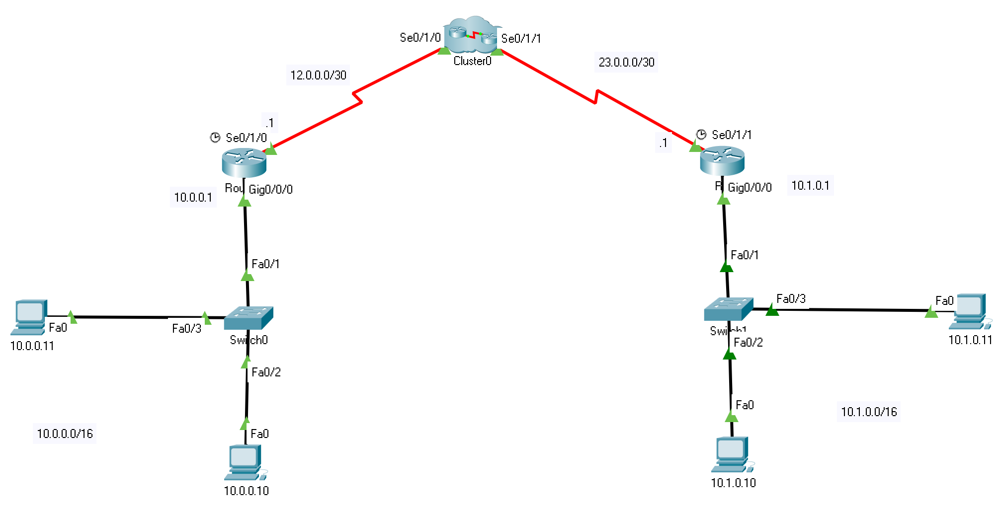

- Design the above stated topology or your own topology with similar infrastructure.
- Cluster 0 could be a combination of 2 or more routers directly connected with Public IP Address.
- Use the above stated IP Addressing scheme or design your own. Make sure the R0 and R1 LAN network uses Private IP Address and other Networks uses Public IP Address.
- Configure basic settings in R0 and R1.
  - Device Names
  - Passwords with Encryption
  - Disable DNS Lookup
  - Banners
  - Line Configurations
  - On DCE Serial Interfaces, clock rate at 128000
- Configure OSPF routing Protocol from R0 to R1 excluding both LANs
- Configure DHCP in R0 for R0’s LAN.
- At this Point, from R0 to R1 ping should be successful but both LANs could not ping.
- Configure GRE Tunnel interface in R0 and R1.
- Verify the GRE Tunnel Configuration
  - Show ip interface brief
  - Show interfaces tunnel 0
- What is the tunneling protocol used? What are the tunnel source and destination IP addresses associated with GRE tunnel on each router?

- Ping across the tunnel from the R0 router to the R1 router using the IP address of the tunnel interface.

- Use the traceroute command on the R1 to determine the path to the tunnel interface on the R0 router. What is the path to the router?

- Ping and trace the route across the tunnel from the R0 router to the R1 router using the IP address of the tunnel interface. What is the path to the R1 router from the R0 router?

- With which interfaces are these IP addresses associated? Explain.

Note: The ping and traceroute commands should be successful. If not, troubleshoot before continuing to the next part.

- Now, configure static routing so that the LANs on the R0 and R1 routers can communicate using the GRE tunnel. After the GRE tunnel is set up, the routing protocol can be implemented.

- Ping from PC-1 to PC-3. It should be successful. If not, troubleshoot until you have end-to-end connectivity.
- Traceroute from PC-1 to PC-3. What is the path from PC-1 to PC-3?

- What other configurations are needed to create a secured GRE tunnel?

- If you added more LANs to the R1 or R0 router, what would you need to do so that the network will use the GRE tunnel for traffic?

