ECEY4012C
The learning journey: developing skills for academic success
Myra Oakley
2612652

Content page:
Part 1 – Study timetable – pages 3- 5
Part 2 – AI activity pages 5 - 9
Part 3 – Poster and reference list – page 10
Part 4 – link to oral presentation also shared with lecture team – page 10

AI declaration
I acknowledge the use of Microsoft 365 Copilot [(AI Tool URL)] on 08/09/2026 to research different study skills and techniques. I used the
prompt(s):
1. I am a first year student doing an Early Years degree. Can you help me identify ways to develop my time management skills, please?
2. I am a first year student doing an Early Years degree. Can you help me find ways to take notes
3. [Prompt]
I confirm that I have not presented any AI generated text as my own work. I confirm I have copies of my drafts, notes, and other resources I used before, and after the use of AI tools which I may be asked to provide in evidence.

Part 1 – Study Timetable
Amser /Time | Llun  Monday | Mawrth  Tuesday | Mercher  Wednesday | Iau  Thursday | Gwener  Friday | Sadwrn  Saturday | Sul  Sunday
00:00 - 00:59 | Sleep | Sleep | Sleep | Sleep | Sleep | Sleep | Sleep
01:00 - 01:59 | Sleep | Sleep | Sleep | Sleep | Sleep | Sleep | Sleep
02:00 - 02:59 | Sleep | Sleep | Sleep | Sleep | Sleep | Sleep | Sleep
03:00 - 03:59 | Sleep | Sleep | Sleep | Sleep | Sleep | Sleep | Sleep
04:00 - 04:59 | Sleep | Sleep | Sleep | Sleep | Sleep | Sleep | Sleep
05:00 - 05:59 | Exercise | Exercise | Exercise | Exercise | Exercise | Sleep | Sleep
06:00 - 06:59 | Relax | Relax | Relax | Relax | Relax | Exercise | Exercise
07:00 - 07:59 | Relax | Relax | Relax | Relax | Relax | Relax | Relax
08:00 - 08:59 | Work | Work | Work | Work | Work | Family time | Reading
09:00 - 09:59 | Work | Work | Work | Work | Work | Family time & swimming (granddaughter) | Study - Familiarise with AI
10:00 - 10:59 | Work | Work | Work | Work | Work | Family time | Study - Familiarise with AI
11:00 - 11:59 | Work | Work | Work | Work | Work | Family time | Family time
12:00 - 12:59 | Work | Work | Work | Work | Work | Family time | Family time
13:00 - 13:59 | Work | Work | Work | Work | Work | Family time | Family time
14:00 - 14:59 | Work | Work | Work | Work | Work | Family time & Rugby with my son | Family time & Horse riding with my two daughters
15:00 - 15:59 | Work | Work | Work | Work | Work | Family time | Family time
16:00 - 16:59 | University | Family time | Work | Family time | Family time | Study - Do some work on Parts 2, 3 & 4 | Study - Do some work on Parts 2, 3 & 4
17:00 - 17:59 | University | Family time | Work | Family time | Family time | Study - Do some work on Parts 2, 3 & 4 | Study - Do some work on Parts 2, 3 & 4
18:00 - 18:59 | University | Family time – a meal out with my husband | Family time | Family time | Family time | Study - Do some work on parts 2, 3 & 4 | Family time
19:00 - 19:59 | University | Work | Family time | Study- practise voiceover | Family time | Socialising time – a meal out with friends | Family time
20:00 - 20:59 | University | Study – read a handbook | Study - Familiarise with AI and Copilot | Study- practise voiceover | Family time | Socialising time – a meal out with friends | Study – check over work for errors of spelling and grammar errors
21:00 - 21:59 | Family time | Study – read a handbook | Study - Familiarise with AI and Copilot | Reading | Reading | Socialising time – a meal out with friends | Work
22:00 - 22:59 | Relax | Relax | Relax | Relax | Relax | Relax | Relax
23:00 - 23:59 | Sleep | Sleep | Sleep | Sleep | Sleep | Sleep | Sleep

Part 2 – AI activity
Study skill one
Microsoft Copilot was accessed to explore two study techniques to support progression through the BA (Hons) Early Years Education and Care. Two prompts were used to create this information.
Promt.
I am a first year student doing an Early Years degree. Can you help me identify ways to develop my time management skills, please?
Response.
1. Create a weekly planning routine
A weekly plan stops overwhelm before it starts. List all assignments, readings, placements, and personal commitments
- Break each academic task into micro-steps
- Schedule them into realistic time blocks
2. Use time-blocking
- 20 minutes reading
- 30 minutes writing
- 15 minutes note-review
3. Prioritise using the 1–3 Rule
Each day, choose:
- 1 major task (write 300 words)
- 3 minor tasks (read one article, tidy notes, update your placement log)
5. Build short, consistent study sessions
- 20 minutes work
- 5 minutes break
- Repeat twice
Refined Prompt.
Can you give me the top three
- Weekly planning routine — Plan your week every Monday, break tasks into micro-steps, and schedule realistic blocks.
- Time-blocking — Set specific study blocks (e.g., 20 minutes reading, 30 minutes writing)
- Daily 1–3 priority rule — Choose 1 major task and 3 minor tasks each day to stay focused

Finding Resources
Can you find give me three reliable references to support this information
AI Suggests:
Liu, B., Ma, P. & Jia, F., 2026. Systematic review and meta-analysis of the impact of time management on college students’ learning outcomes. Frontiers in Psychology, 17, p.1700298.
Patzak, A., Zhang, X. & Vytasek, J., 2025. Boosting productivity and wellbeing through time management: evidence-based strategies for higher education and workforce development. Frontiers in Education, 10, p.1623228.
Patzak, A., Zhang, X. & Vytasek, J., 2025. Boosting productivity and wellbeing through time management: evidence-based strategies for higher education and workforce development. Frontiers in Education, 10, p.1623228.
Library Search
Barrow, C. (2019) Writing skills for education students . Edited by R. Westrup. London : Red Globe Press, pp. x, 146 pages :
Burns, T. (2022) Essential study skills : the complete guide to success at university . 5th edition. Edited by S. Sinfield. London ; Los Angeles :; London ; Los Angeles : SAGE.

Cottrell, Stella. Skills for Success : Personal Development and Employability, Macmillan Education UK, 2021. ProQuest Ebook Central, https://ebookcentral.proquest.com/lib/trinity/detail.action?docID=6577749.
Cottrell, S. (2021) Skills for success : personal development and employability . 4th edition. Edited by Stella Cottrell. London : Red Globe Press , p. 1 online resource (428).
Godfrey, J. (2023) Reading and making notes . Third editon. Edited by Jeanne Godfrey author. London : Bloomsbury Academic.

Academic Writing
Students entering higher education shouldn’t assume they already meet academic standards; they need to learn effective study skills because note-taking and time management can significantly affect success. These techniques help students organise information they receive, avoid feeling overwhelmed, and build steady study habits. Cottrell (2021) states that good study skills help students cope more effectively with their workload and avoid procrastination. These study skills examine note-taking and time management, compare AI-generated strategies with those recommended by academic research, and look at how these skills can support future learning.
Note taking helps you process and remember information. AI proposes methods such as the ‘Three-Column Method and Cornell Notes’. These methods align with Godfrey's (2023) view that effective note-taking involves identifying key points, organising them clearly, and putting information in your own words. Burns (2022) also states that active note-taking helps students understand the information better by encouraging them to ask questions and produce summaries rather than merely ‘copying’. The Three-Column Method links theory, real-life examples, and practical application, it supports Burns' (2022) notion that notes should help students achieve a deeper understanding. These techniques help students process complex information and build a solid foundation for future work.
If you are new to studying, you need to manage your time well. AI recommends strategies such as making weekly plans, using time-blocking, and setting task priorities, these methods coincide with those advised by academic experts. Cottrell (2021) states that effective time management helps students overcome procrastination by dividing their work into smaller parts. Burns (2022) says that poor time management can make it hard to balance studies with personal life. By focusing on routines and providing clear task lists, the AI supports these views by helping students stay focused and meet deadlines. Developing these abilities can help students develop consistent study habits and feel less stressed over time.
Note-taking and time management are skills to develop. AI and library research show that organised note-taking and mindful time management improve understanding and support learning.
Reference list
Barrow, C. (2019) Writing skills for education students. Edited by R. Westrup. London: Red Globe Press.
Burns, T. (2022) Essential study skills: the complete guide to success at university. 5th edn. Edited by S. Sinfield. London: SAGE.
Cottrell, S. (2021) Skills for success: personal development and employability. 4th edn. London: Red Globe Press.
Godfrey, J. (2023) Reading and making notes. 3rd edn. London: Bloomsbury Academic.

Reflection
Using Microsoft 365 Copilot to explore academic study skills was new to myself, and engaging with the tool highlighted both its strengths and its limitations. For this part of the assessment, I used Copilot to investigate two key study skills which would support new students entering degree-level study: note-taking and time management. I used two initial prompts to gather information, and Copilot generated a large amount of information. Although this provided a useful starting point, the responses were broad and needed refinement to make them more relevant to academic practice. This demonstrated that Copilot can be effective, but only when prompts are specific and clear.
A further prompt—“could you give me the top three”—was used to narrow the results. This gave a more concise and accessible structure, offering clear guidance on the most effective note-taking and time-management techniques. The process showed that Copilot can organise information well, but it relies on the user’s ability to ask precise questions. As someone who’s unfamiliar with AI tools, this was initially challenging, and it took time to understand how to adjust prompts to obtain meaningful results.
Besides my academic studies, I used Copilot to find references for my two chosen study skills. Copilot gave sources from websites, general study-skills platforms, and a catalogue of books from publishing companies. While these resources were relevant, they were generic and not designed for Early Years or the specific requirements of my course. To find academically reliable, specific materials, I used the UWTSD library and the module reading list. These provided more appropriate information, including works by Cottrell, Burns, and Godfrey, which work closely with the study skills being explored.
Using Copilot offered several benefits. It helped with giving ideas quickly, supported the organisation of information, and provided a useful basis for further research. Eventhough, limitations also existed with accuracy, reliability, and honesty. AI information must be checked against trusted academic sources, and is important to ensure that all work remains your own and properly referenced using the Harvard referencing style.
In future studies, Copilot could be used as an extra tool to expand on my ideas, summarise concepts, or refine structure. However, it will be important to combine AI support with academic reading, critical thinking, and guidance from course-specific resources to ensure accuracy in all future academic work.

Part two - Poster & Reference List
Poster
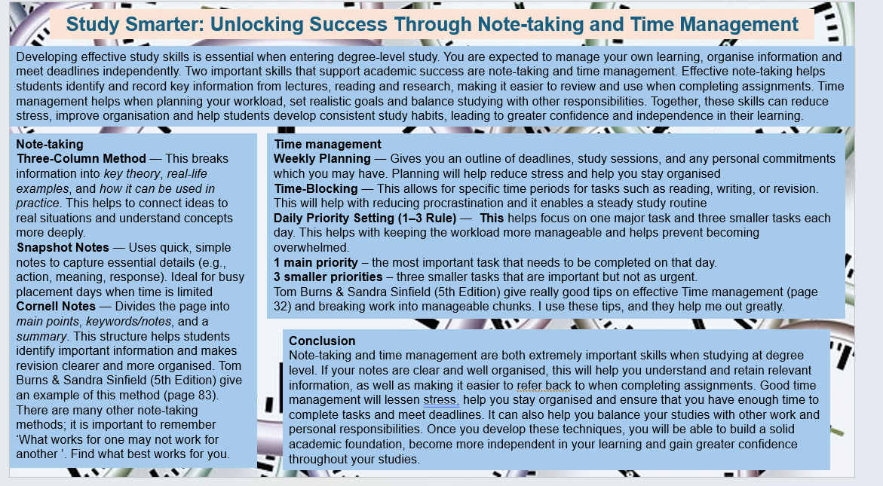
Reference list
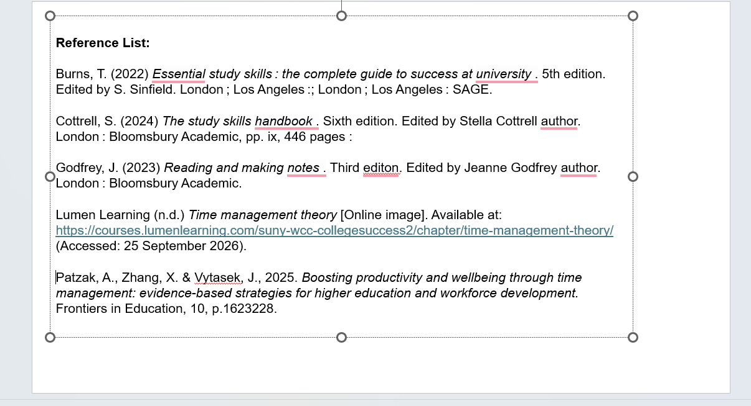
Voice over

