

MODULE: Project Management (LCLM5003_LON)

PROJECT PORTFOLIO: PART A, PART B & PART C
Central Transport Hub Redevelopment Programme: A Smart, Sustainable and Inclusive Transport Interchange for City

Student Name: Taisiia Pavliukova
Student ID: 2429456
Lecturer: Rexon Nting
Date of Submission: 13th August 2026

Table of Contents
Part A – Project Proposal Poster 3
Part B – Reflective Report 4
Reflection on Tutor Feedback 4
Part C – Project Management Plan 6
1. Introduction 6
2. Project Description 6
2.1 Project Budget and Funding 7
3. Project Scope 8
3.1 In Scope 8
3.2 Out of Scope 8
3.3 Scope Control and Change Management 9
4. Work Breakdown Structure (WBS) 9
5. Quad Chart: Project Overview 10
6. Gantt Chart and Project Milestones 11
7. Stakeholder Management 12
8. Resource Management and POLC 13
9. Project Risk Assessment 13
10. Conclusion 15
References 16

Part A – Project Proposal Poster
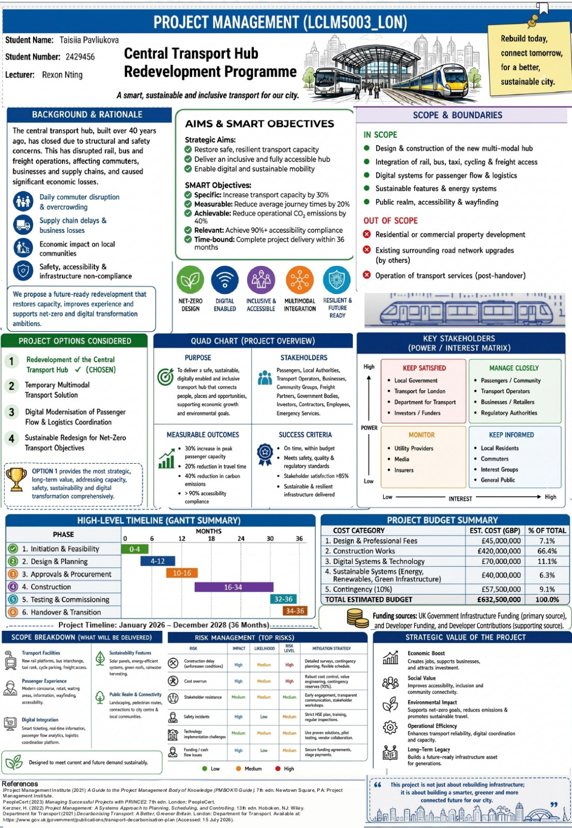

Part B – Reflective Report

Reflection on Tutor Feedback
Preparing the project proposal poster allowed me to apply project management theory to a realistic infrastructure project and transform academic concepts into a practical proposal. Before presenting the poster, I believed that it addressed the assessment requirements by explaining the project background, objectives, stakeholders, risks, funding strategy and strategic value in a clear and structured format. Presenting the poster to my tutor and peers provided an opportunity to receive constructive feedback, reflect on my initial decisions and identify improvements before developing the final Project Management Plan. This experience demonstrated the importance of reflection and continuous improvement within professional project management practice (Schön, 1983).
One of the strengths identified by the tutor was the overall structure and presentation of the poster. The information was logically organised and communicated the project proposal clearly. The redevelopment of the central transport hub was considered an appropriate response to the scenario because it addressed key challenges including transport disruption, ageing infrastructure, accessibility, sustainability and digital transformation. Including a 36-month delivery period and an estimated budget of £632.5 million also demonstrated that realistic project constraints had been considered.
However, the tutor identified areas where the proposal required further development. The first area concerned the project funding strategy. In the initial version of the poster, I included several potential funding sources, including UK Government Infrastructure Funding, Developer Contributions, Public-Private Partnerships (PPP), Green Bonds and Local Authority Investment. At that stage, I believed that presenting a wider range of financing options would demonstrate stronger knowledge of project funding. However, the tutor highlighted that including too many funding mechanisms reduced the realism of the proposal because each funding model has different purposes, requirements and stakeholder involvement.
Following this feedback, I carried out additional research into funding approaches used in UK transport infrastructure projects. This helped me understand the differences between funding mechanisms and evaluate which options were most appropriate for my project. UK Government Infrastructure Funding was selected as the primary source because the redevelopment of a major transport hub represents a public investment supporting accessibility, economic development and sustainability objectives. Developer Contributions were retained as a supporting source because surrounding regeneration activities could provide opportunities for private-sector involvement. Other options, such as PPP arrangements and Green Bonds, were considered less suitable because they would introduce additional financial complexity and governance requirements. As a result, I revised the poster by keeping only these two funding sources, which made the proposal more focused, realistic and easier to justify.
The second recommendation focused on the project objectives. My original objectives described the project's intentions but did not clearly explain how success would be measured. After reviewing the tutor's comments and project management guidance, I replaced the general objectives with SMART objectives (PMI, 2021). This change improved the proposal by introducing measurable targets, including increasing transport capacity, reducing journey times, improving accessibility and completing the project within 36 months. This process changed my understanding of objectives because I realised that they are not simply statements of intention but practical tools for planning, monitoring and controlling project performance.
Overall, the tutor's feedback encouraged me to evaluate my work more critically and support my decisions with additional research. The changes made to the funding strategy and objectives strengthened the realism, clarity and credibility of the proposal. These improvements will provide a stronger foundation for the final Project Management Plan by ensuring that project objectives, resources and financial decisions are aligned with recognised project management principles (APM, 2019; Kerzner, 2022; PMI, 2021).

Part C – Project Management Plan

1. Introduction
The closure of the Central Transport Hub, which was built more than 40 years ago, has disrupted rail, bus and freight operations, affecting commuters, businesses and local supply chains. Structural and safety concerns, together with accessibility and infrastructure compliance issues, have created a need for a long-term redevelopment solution.
This Project Management Plan sets out the proposed approach for delivering the Central Transport Hub Redevelopment Programme over 36 months, from January 2026 to December 2028, with an estimated budget of £632.5 million. The project aims to restore safe and resilient transport capacity while creating a sustainable, digitally enabled and inclusive multimodal transport hub.
Four project options were considered: full redevelopment of the Central Transport Hub, a temporary multimodal transport solution, digital modernisation of passenger flow and logistics coordination, and a sustainable redesign focused on net-zero transport objectives. Full redevelopment was selected because it provides the most comprehensive long-term response to the identified capacity, safety, accessibility, sustainability and digital transformation requirements.
The project will use a structured project life cycle supported by a hybrid project management approach. Predictive methods will be applied to major design and construction activities, while adaptive practices will support digital implementation and stakeholder engagement (Costantini, Hall and Rapanotti, 2021). Elements of PRINCE2, including defined responsibilities, governance, stage control and continued business justification, will also support project decision-making (PeopleCert, 2023). This approach provides appropriate control for a complex infrastructure programme while allowing flexibility where requirements may change.
The project objectives established in the proposal include a 30% increase in transport capacity, a 20% reduction in average journey times, a 40% reduction in operational CO₂ emissions and achievement of at least 90% accessibility compliance, with project delivery completed within 36 months.
The overall aim is to deliver a safe, sustainable, digitally enabled and inclusive transport hub that improves connectivity, supports economic growth and contributes to the city's environmental and long-term regeneration objectives.

2. Project Description
The Central Transport Hub is a critical metropolitan transport asset connecting rail, bus and freight services. Built more than 40 years ago, the hub has been closed because of structural and safety concerns. Its closure has disrupted commuter travel, freight operations and local business activity, resulting in overcrowding, supply chain delays and wider economic impacts on local communities.
The proposed project will redevelop the existing hub into a future-ready multimodal transport interchange. The redevelopment will restore transport capacity while improving passenger experience, accessibility, digital integration and environmental performance. The proposed solution will integrate rail, bus, taxi, cycling and freight access, together with modern passenger facilities, smart transport systems and sustainable infrastructure.
Four project options were considered as part of the project proposal. The first option was full redevelopment of the Central Transport Hub. The second was a temporary multimodal transport solution to provide short-term additional capacity. The third was digital modernisation of passenger-flow and logistics coordination systems without comprehensive physical redevelopment. The fourth was a sustainable redesign focused primarily on net-zero transport objectives. Full redevelopment was selected because it provides the most comprehensive long-term response to the project's capacity, safety, accessibility, sustainability and digital transformation requirements.
The project also supports wider strategic objectives. Improved transport capacity and reliability can support economic activity and local businesses, while improved accessibility and connectivity can create greater social value. Sustainable infrastructure, renewable energy systems and reduced operational emissions support environmental objectives, while digital passenger-flow and logistics systems can improve operational efficiency and resilience.
A PESTEL perspective was used to consider external factors that may influence project delivery (Yüksel, 2012). Political factors include government priorities for transport infrastructure and urban regeneration. Economic factors include the need to reduce disruption, support businesses and manage the significant investment required. Social factors include accessibility, inclusion and the needs of passengers and local communities. Technological factors include smart ticketing, real-time passenger information, passenger-flow analytics and logistics coordination. Environmental factors relate to carbon reduction, renewable energy and sustainable construction (Department for Transport, 2021), while legal factors include planning, safety, accessibility and regulatory compliance.
Overall, the project combines infrastructure redevelopment, digital transformation and sustainable design to create a safer, more accessible, resilient and connected transport hub for the city.

2.1 Project Budget and Funding
The project has an estimated total budget of £632.5 million, covering design and professional fees, construction works, digital systems, sustainable infrastructure and contingency. The largest proportion of expenditure is allocated to construction, reflecting the scale of the physical redevelopment. A 10% contingency provision is included to manage unforeseen costs and financial uncertainty.
The project will be funded primarily through UK Government Infrastructure Funding, supported by Developer Contributions. This funding structure reflects the public infrastructure purpose of the project while allowing supporting contributions from development-related activities (HM Treasury, 2020).

3. Project Scope
Project scope management defines the work required to achieve the project objectives and establishes clear boundaries for project delivery (PMI, 2021). For the Central Transport Hub Redevelopment Programme, clear scope definition is important to ensure that the project remains focused on the agreed deliverables and does not expand beyond the approved requirements.
The project scope will also be managed in relation to the Iron Triangle of project management, which highlights the relationship between cost, time and quality (Atkinson, 1999). For this project, changes to the approved scope may increase costs or extend the 36-month schedule, while pressure to reduce cost or accelerate delivery may affect the required quality and project outcomes. Formal change control will therefore be used to assess these impacts before approval.
The project scope covers the design and construction of the new multimodal transport hub, including the integration of rail, bus, taxi, cycling and freight access. It also includes digital systems for passenger-flow management and logistics coordination, sustainable features and energy systems, public realm improvements, accessibility and wayfinding.

3.1 In Scope
The main deliverables included within the project are:
- Transport facilities: new rail platforms, bus interchange facilities, taxi rank, cycle parking and freight access.
- Passenger experience: modern concourse, retail and waiting areas, passenger information, wayfinding and accessibility facilities.
- Digital integration: smart ticketing, real-time passenger information, passenger-flow analytics and logistics coordination systems.
- Sustainability features: solar panels, energy-efficient systems, green roofs and rainwater harvesting.
- Public realm and connectivity: landscaping, pedestrian routes and improved connections between the hub, city centre and local communities.

3.2 Out of Scope
The following activities are excluded from the project scope:
- Residential or commercial property development surrounding the transport hub.
- Existing surrounding road network upgrades that are the responsibility of other projects or organisations.
- Operation of transport services after project handover.

3.3 Scope Control and Change Management
Any proposed change to the approved scope will be assessed through a formal change control process. Its potential impact on cost, time, resources, quality and project objectives will be considered before approval. This approach will help prevent scope creep while allowing justified changes to be incorporated where they provide sufficient project value.
The defined scope provides the basis for the WBS, project schedule, resource allocation and risk management, ensuring that the subsequent elements of the Project Management Plan remain aligned with the project's approved objectives and deliverables.

4. Work Breakdown Structure (WBS)
A Work Breakdown Structure (WBS) divides the project scope into manageable work packages and provides a structured basis for planning, scheduling, resource allocation and project monitoring (PMI, 2021). For the Central Transport Hub Redevelopment Programme, the WBS translates the approved scope into six main lifecycle phases covering project management, design, construction, digital transformation, sustainability, and testing and handover.
The WBS provides a clear connection between the project scope and delivery activities. It also supports the development of the Gantt Chart, allocation of resources and monitoring of progress throughout the 36-month programme.
WBS Code | Lifecycle Phase | Key Work Packages | Key Deliverables
1.0 | Project Initiation & Management | 1.1 Project Governance;  1.2 Stakeholder Planning; 1.3 Baseline & Change Management | Project charter; governance; stakeholder plan; baseline
2.0 | Design & Planning | 2.1 Site Investigations; 2.2 Engineering & Architecture; 2.3 Statutory Approvals | Site assessment; detailed design; planning approvals
3.0 | Construction & Infrastructure | 3.1 Site Preparation & Demolition; 3.2 Main Station Concourse; 3.3 Multimodal & Accessibility Works | Demolition; station redevelopment; transport facilities; accessibility
4.0 | Digital Transformation | 4.1 Passenger Flow Systems; 4.2 Ticketing & Information; 4.3 Operational Integration | Smart monitoring; digital information; systems integration
5.0 | Sustainability Implementation | 5.1 Clean Energy Systems; 5.2 Sustainable Features; 5.3 Environmental Audits | Renewable energy; sustainable features; environmental monitoring
6.0 | Testing, Handover & Closure | 6.1 Systems & Safety Testing; 6.2 Stakeholder Acceptance; 6.3 Handover & Closure | Testing; training; stakeholder sign-off; handover
Figure 1. Work Breakdown Structure – Central Transport Hub Redevelopment Project
The WBS therefore provides a practical structure for organising the project's major deliverables and ensuring that the approved scope can be translated into specific and manageable areas of work.

5. Quad Chart: Project Overview
The Quad Chart summarises the project's purpose, key stakeholders, measurable outcomes and success criteria. These elements provide a concise overview of the project's strategic direction and the outcomes that will guide project delivery.
PURPOSE | STAKEHOLDERS
To deliver a safe, sustainable, digitally enabled and inclusive transport hub that connects people, places and opportunities, supporting economic growth and environmental goals. | Passengers, Local Authorities, Transport Operators, Businesses, Community Groups, Freight Partners, Government Bodies, Investors, Contractors, Employees, Emergency Services.
MEASURABLE OUTCOMES | SUCCESS CRITERIA
- 30% increase in transport capacity  - 20% reduction in average journey times  - 40% reduction in operational CO₂ emissions  - 90% accessibility compliance | - On time, within budget  - Meets safety, quality & regulatory standards  - Stakeholder satisfaction >85%  - Sustainable & resilient infrastructure delivered
Figure 2. Project Purpose, Stakeholders, Measurable Outcomes and Success Criteria
Figure 2 presents the project's purpose, key stakeholders, measurable outcomes and success criteria. These elements provide a clear link between the strategic aims presented in the project proposal and the practical delivery arrangements developed in this Project Management Plan.

6. Gantt Chart and Project Milestones
The Gantt Chart translates the project WBS into a time-based delivery programme and provides a practical tool for scheduling and monitoring progress (PMI, 2021). It shows the planned sequence and duration of major activities across the 36-month project period from January 2026 to December 2028. This allows the project team to identify dependencies, monitor progress and recognise potential schedule delays at an early stage.
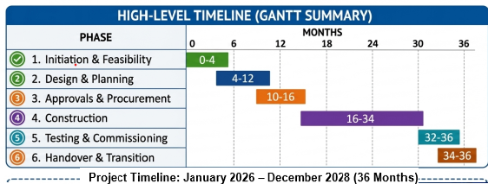
Figure 3. Gantt Chart – Central Transport Hub Redevelopment Project
The programme begins with initiation and feasibility activities during Months 0–4, followed by design and planning from Months 4–12. Approvals and procurement overlap with the later planning stage and continue through Month 16. Construction is the main delivery phase, running from Months 16–34, while testing and commissioning take place during Months 32–36. Handover and transition are completed during Months 34–36. This phased approach provides a structured sequence while allowing appropriate overlap between activities.
Table 1: Key milestones
Milestone | Target
Initiation and feasibility completed | Month 4
Design and planning substantially completed | Month 12
Approvals and procurement completed | Month 16
Construction substantially completed | Month 34
Testing and commissioning completed | Month 36
Handover and transition completed | Month 36

These milestones provide clear control points for monitoring progress against the approved programme. Any significant deviation from the planned dates will be reviewed and corrective action taken where necessary. Changes affecting the completion date will also be assessed in relation to cost, scope, quality and project objectives.

7. Stakeholder Management
Effective stakeholder management is essential because the Central Transport Hub Redevelopment Project involves organisations, service users and local communities with different levels of power and interest. Stakeholders were therefore assessed using a Power–Interest Matrix to determine the appropriate level of engagement (Mendelow, 1981).
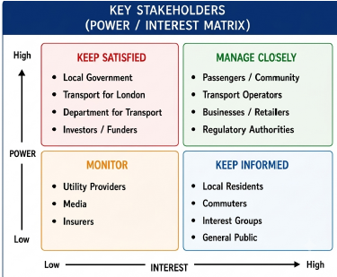
Figure 4. Stakeholder Power–Interest Matrix
The matrix categorises stakeholders into four groups: Manage Closely, Keep Satisfied, Keep Informed and Monitor. High-power stakeholders require particular attention because they can influence project decisions, approvals and resources, while high-interest stakeholders should receive regular information and opportunities to provide feedback.
Stakeholder engagement will continue throughout the project through progress meetings, consultation, updates and feedback mechanisms. Particular attention will be given to passengers, accessibility groups, local residents and businesses to ensure that concerns relating to accessibility, passenger experience and construction disruption are addressed. This approach recognises that successful project delivery depends not only on technical performance but also on effective stakeholder cooperation and engagement (Waris et al., 2022).

8. Resource Management and POLC
Effective resource management is required to coordinate the financial, human, technical and material resources needed to deliver the Central Transport Hub Redevelopment Project. Resource requirements will be linked to the WBS and project schedule to ensure that resources are available when required and used efficiently.
The POLC framework — Planning, Organising, Leading and Controlling — provides a useful structure for managing these resources (Gitman et al., 2018). Planning involves identifying the resources required for each work package, including engineers, construction teams, designers, digital specialists, materials and funding. Organising involves allocating these resources and establishing clear responsibilities between the project manager, sponsor, technical teams, contractors and suppliers.
Leading focuses on coordinating multidisciplinary teams and maintaining effective communication across the project. This is particularly important where construction, digital transformation and sustainability activities overlap. Controlling involves monitoring resource utilisation, expenditure and performance against the approved project baseline. Variances can then be identified and corrective action taken before they significantly affect delivery.
Resource requirements will change throughout the project life cycle. Construction resources are expected to be greatest during the main redevelopment phase, while digital specialists and testing teams will become increasingly important towards commissioning and handover. A phased approach to resource allocation will therefore support efficient use of resources while maintaining alignment with the project schedule and project objectives.

9. Project Risk Assessment
Risk assessment is an important part of project planning because infrastructure projects are exposed to uncertainty that can affect cost, schedule, quality and stakeholder confidence (PMI, 2021). For the Central Transport Hub Redevelopment Project, the main risks were assessed according to their impact and likelihood, with mitigation strategies identified for each risk.
RISK | IMPACT | LIKELIHOOD | RISK LEVEL | MITIGATION STRATEGY
Construction delay (unforeseen conditions) | High | Medium | High | Detailed surveys, contingency planning, flexible schedule.
Cost overrun | High | Medium | High | Robust cost control, value engineering, contingency reserves (10%).
Stakeholder resistance | Medium | Medium | Medium | Early engagement, transparent communication, stakeholder workshops.
Safety incidents | High | Low | Medium | Strict HSE plan, training, regular inspections.
Technology implementation challenges | Medium | Medium | Medium | Use proven solutions, pilot testing, vendor collaboration.
Funding / cash flow issues | High | Low | Medium | Secure funding agreements, stage payments.
Figure 5. Risk Management – Key Project Risks and Mitigation Strategies
The risk assessment identifies construction delays and cost overruns as high-level risks requiring particular attention. Stakeholder resistance, safety incidents, technology implementation challenges and funding or cash flow issues also require active monitoring and appropriate mitigation. Preventive measures include detailed surveys, cost control, early stakeholder engagement, safety procedures, pilot testing and secure funding arrangements.
Risk management will remain an ongoing activity throughout the project life cycle. The risk register should be reviewed regularly, with risk owners monitoring changes in likelihood, impact and mitigation actions. This will support proactive decision-making and help protect the project's scope, cost, schedule and quality objectives.

10. Conclusion
The Central Transport Hub Redevelopment Project requires a structured and integrated project management approach because of its scale, complexity and significant impact on transport users, businesses and the wider community. The proposed 36-month programme provides a clear framework for delivering a safer, more accessible, sustainable and digitally enabled multimodal transport hub.
The Project Management Plan translates the strategic aims and SMART objectives presented in the project proposal into practical delivery arrangements. The defined scope and WBS establish clear project boundaries and work packages, while the Gantt Chart and milestones provide a basis for scheduling and monitoring progress. Resource planning, budget allocation and the POLC framework support the effective coordination of financial, human, technical and material resources (Gitman et al., 2018).
The use of a hybrid project management approach, supported by relevant PRINCE2 principles, provides an appropriate balance between structured control and flexibility. The Iron Triangle provides an important basis for maintaining the balance between cost, time and quality, while formal change control will help assess the consequences of proposed changes before approval (Atkinson, 1999). Stakeholder engagement will also support cooperation between government bodies, transport operators, passengers, communities and other interested parties (PeopleCert, 2023; PMI, 2021).
The risk assessment further supports proactive project management by identifying key threats including construction delays, cost overruns, stakeholder resistance, safety incidents, technology challenges and funding issues. Regular monitoring assigned risk ownership and appropriate mitigation measures will help protect the project's objectives and delivery performance.
Overall, the proposed management approach provides a realistic framework for transforming the closed transport hub into a safe, inclusive, sustainable and future-ready transport interchange. Successful delivery will not only restore transport capacity but also contribute to improved passenger experience, economic activity, environmental performance and long-term value for the city.

References
Association for Project Management (APM) (2019) APM Body of Knowledge. 7th edn. Princes Risborough: Association for Project Management.
Atkinson, R. (1999) ‘Project management: cost, time and quality, two best guesses and a phenomenon, its time to accept other success criteria’, International Journal of Project Management, 17(6), pp. 337–342.
Costantini, S., Hall, J.G. and Rapanotti, L. (2021) ‘Using complexity and volatility characteristics to guide hybrid project management’, International Journal of Managing Projects in Business, 14(5), pp. 1135–1162. Available at: https://doi.org/10.1108/IJMPB-06-2020-0187 (Accessed: 9 August 2026).
Department for Transport (2021) Decarbonising Transport: A Better, Greener Britain. London: Department for Transport. Available at: https://www.gov.uk/government/publications/transport-decarbonisation-plan (Accessed: 10 August 2026).
Gitman, L.J., McDaniel, C., Shah, A., Reece, M., Koffel, L., Talsma, B. and Hyatt, J.C. (2018) Introduction to Business. Houston, TX: OpenStax.
HM Treasury (2020) National Infrastructure Strategy: Fairer, Faster, Greener. CP 329. London: HM Treasury. Available at: https://www.gov.uk/government/publications/national-infrastructure-strategy (Accessed: 10 August 2026).
Kerzner, H. (2022) Project Management: A Systems Approach to Planning, Scheduling, and Controlling. 13th edn. Hoboken, NJ: John Wiley & Sons.
Mendelow, A.L. (1981) ‘Environmental scanning – the impact of the stakeholder concept’, Proceedings of the Second International Conference on Information Systems (ICIS 1981), Cambridge, MA, 7–9 December, pp. 20–27. Available at: https://aisel.aisnet.org/icis1981/20 (Accessed: 9 August 2026).
PeopleCert (2023) PRINCE2® 7: Managing Successful Projects. London: PeopleCert.
Project Management Institute (PMI) (2021) A Guide to the Project Management Body of Knowledge (PMBOK® Guide). 7th edn. Newtown Square, PA: Project Management Institute.
Schön, D.A. (1983) The Reflective Practitioner: How Professionals Think in Action. New York: Basic Books.
Waris, M., Khan, A., Abideen, A.Z., Sorooshian, S. and Ullah, M. (2022) ‘Stakeholder Management in Public Sector Infrastructure Projects’, Journal of Engineering, Project, and Production Management, 12(3), pp. 188–201. Available at: https://doi.org/10.32738/JEPPM-2022-0017 (Accessed: 9 August 2026).
Yüksel, I. (2012) ‘Developing a multi-criteria decision making model for PESTEL analysis’, International Journal of Business and Management, 7(24), pp. 52–66.

