MC68 Process
Manufacturing Systems and Simulations
ACEA6002

University of Wales Trinity Saint David
School of Engineering
William Jake Taylor
1909829
28/07/2022

Contents

- Introduction

2.0 Reviewing the process
2.1Potetial Changes

3.0 Performed Timings

4.0 Changes and Reasoning

5.0 Conclusion

- Introduction
Every Manufacturing business strive to become Leaner and efficient to ultimately become a high production, highly effective with low cost and waste in the process. Throughout this report, a process within Gestamp Tallent will be chosen, and recommendations will be made to make the process more leaner with considerations of the different types of waste that occurs in the process, an analysis of what creates value from the customer’s perspective in relation to process or service, an evaluation of how the process/service can be leaner, considerations of potential problems associated with implementing improvements, costs of the improvements where possible and how these problems could be overcome.
A concept known as "lean manufacturing" aims to increase productivity while eliminating waste in industrial systems. Anything that customers do not think adds value to and are not prepared to pay for is considered waste. Lean manufacturing has many advantages, some of which include shorter lead times, lower operational expenses, and better product quality.
Organizations from a variety of industries can enable the practice of lean manufacturing, commonly referred to as lean production or lean.
Lean management practices can improve productivity, lower project costs, and even lower revenue in the automotive industry. Lean manufacturing principles offer a great framework for reducing manufacturing costs considering the present demand on product margins.

Key principles behind Lean Manufacturing can be summarized as follows:
Recognition of waste – Any material, process or feature which is not required for creating value from the customer’s perspective is waste and should be eliminated.
Standard processes – Lean requires the implementation of very detailed production guidelines, called Standard Work, which clearly state the content, sequence, timing and outcome of all actions by workers. This eliminates variation in the way that workers perform their tasks.
Continuous flow – Lean usually aims for the implementation of a continuous production flow free of bottlenecks, interruption, detours, backflows or waiting. When this is successfully implemented, the production cycle time can be reduced by as much as 90%.
Pull-production – Also called Just-in-Time (JIT), Pull- production aims to produce only what is needed, when it is needed. Production is pulled by the downstream workstation so that each workstation should only produce what is requested by the next workstation.
Quality at the Source – Lean aims for defects to be eliminated at the source and for quality inspection to be done by the workers as part of the in-line production process.
Continuous improvement – Lean requires striving for perfection by continually removing layers of waste as they are uncovered.
(Logu. P, 2021)

2.0 Reviewing the Process
After revising various processes within Gestamp Tallent, it has been decided to review the mc68 Process, purely because of this has the most gaps and potential improvements that could be implemented to create a Leaner Process. The Part is called Rear Floor Front Panel and it is positioned in the centre floor of the car body. This part is designed and supplied to Renault Palencia.

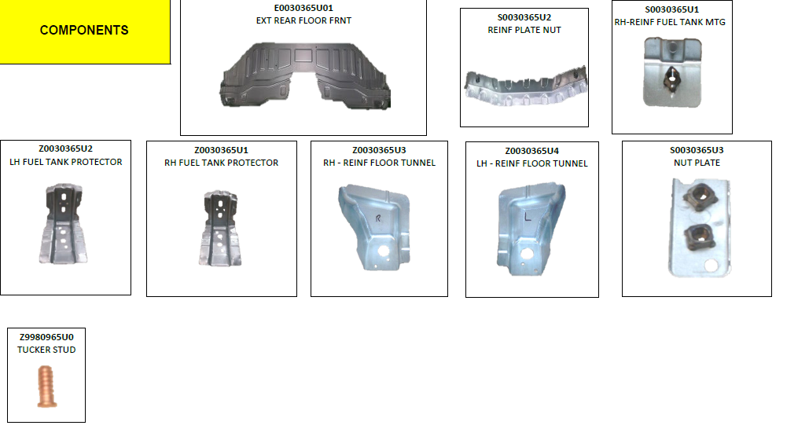
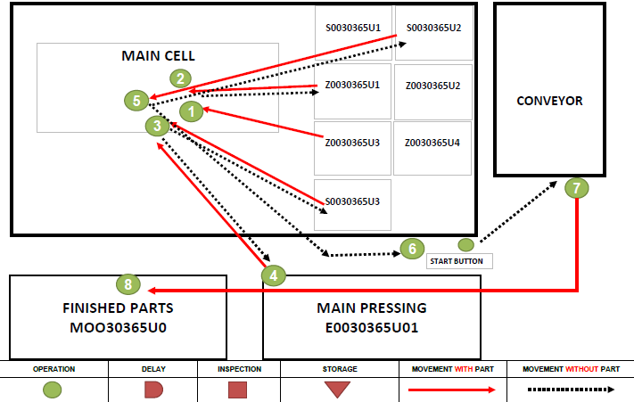
This Process consists of 8 Steps from start to finish product. The Product has many Key features including:
- 52 Resistance Spot Welds
- 8 Components
- 2 Child Parts
- 1 Copper Tucker Stud
- 2 x M6 1.25 Nut
- 4 x M10 1.5 Nut
Currently with the way the cell is laid out, all the components need to be collected and hung up on a rack inside the loading cell, making the operator cycle the cell and then collect one of each component while the machine cycles. During that time, it is expected that the operator needs to check every component for visually defects prior to loading the cell because it cost less time and money spotting the defect before the final assembly. After checking the components, they need to be hung on the rack inside ready for when the machine is ready for loading. Once the machine has cycled through and assembled the product, the product gets placed on a conveyor belt and transported to the operator. Once the operator has collected the part, he needs to inspect the presence of every component and perform a click type torque test to the copper tucker stud before placing the part inside a finished pallet.
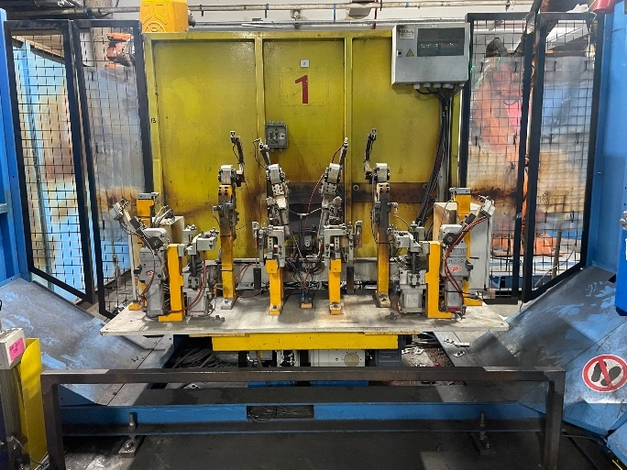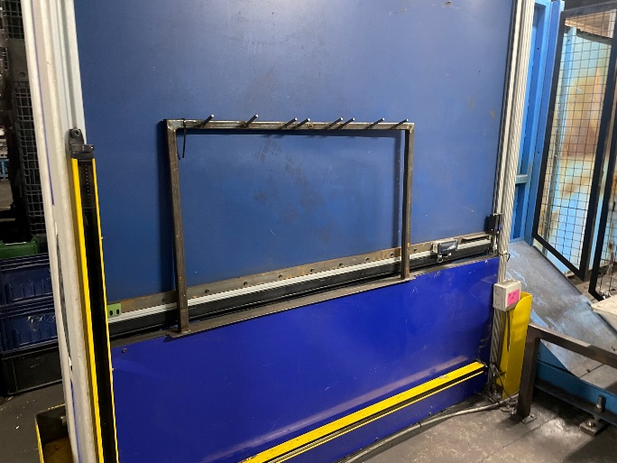
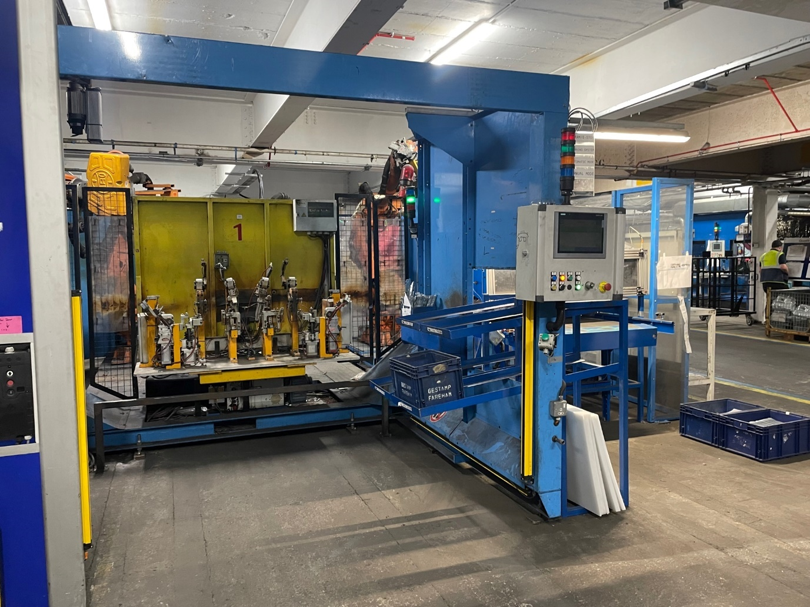

2.1 Potential Changes
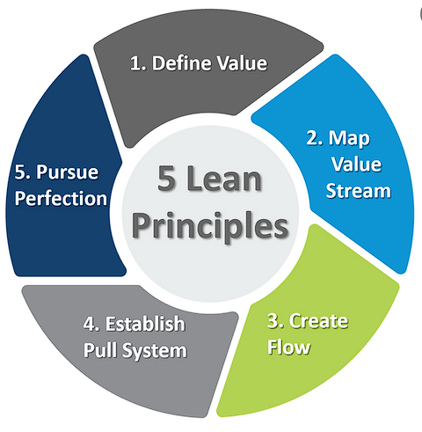
After visiting the cell, there can be a lot of solutions or improvements that be made on the cell to progress the progress into a leaner and better performing process
The Cell Layout can be improved and controlled to make the process quicker and more effective to a production standpoint.
Potentially remove racking for the smaller components instead introduce a rack system where multiple components can be stored in separate boxes inside the cell to reduce travel by the operator providing more time for the operator to check the product visually and ready the cell before the cycle has finished to reduce downtime between cycles.
Review Packaging Standard to potentially change how the parts are packaged to reduce time spent checking parts during Firewall Process. Currently the parts are stacked in two layers of 15 but not in the correct orientation that the customer require causing the Firewall Operators to decant all the parts while checking and repackage them back into the correct orientation that the customer require.
Reduce amount of Torque testing performed on the Copper Tucker Stud, currently the operator is performing this test on every single part produced as a standard check, a CAP study can be performed over a wide range to see the capability of the welding process to reduce the check from every part to once every hour, two hours, 3 hours or 4 hours dependant on how much data can be provided.
3.0 Performed Timings
To identify that the potential changes would make an impact to the timing of the process, timings were performed on the process and Firewall to see if there would be any improvement to the cell and firewall. The aim of this is to reduce any downtime that can occur and increase the performance and parts that can be produced.
The ACTUAL CYCLE TIME is the measured time between two good quality products produced in practice (Stamatis, 2011). Because these are actual times, the Overall Equipment Effectiveness (OEE) variables are taken into account as well: machine downtime, delays because of change overs and defects. These OEE related factors are visualized in illustration 1 with the red stocks. (MudaMasters, 2015)
Firstly, a time study was performed on the Process before making any changes, the time taken to load all the components and unload from the conveyor while performing the relevant checks took 79.2 seconds on average. This was performed by taking times at each stage 5 times to generate an average. But in-between cycles, the operator had to collect singular components to hung on the rack ready for when the machine requires another part.
These timings didn’t include the collection of each little component as during the timings performed, the components were stacked next to the entry of the cell, the timings were performed naturally and didn’t want to get the operator to perform any differently as this can produce untrustworthy results. But from what was observed, the operators stacking method next to the cell is highly recommended due to the accessibility for the operator to obtain each component.
After some changes were implemented, a significant difference can be seen, the time it took for the operator to gather, load and unload the cell dropped from 79.3 seconds down to 71.1 seconds on average. It can be seen by the table below, that a significant increase in production can be made just by adding in shelves so the operator doesn’t have to travel as far to gather the required components.
4.0 Changes and reasoning
Ideally for the machine to run at its highest capability, the operator needs to be able to collect travel and load the cell before the turn table is ready to collect the next part. To combat this issue, it is suggested that all the small components are to be collected into small boxes and to hung on to the shelves before the machine is scheduled to run. This will improve the cell timings by reducing all the travel time the operator has to perform on a part-by-part basis. To further improve the travel time performed to load the cell, the bigger components are to be hung on the racking in high quantities while the cell is still running so the operator only must travel from the tool to the rack and back.
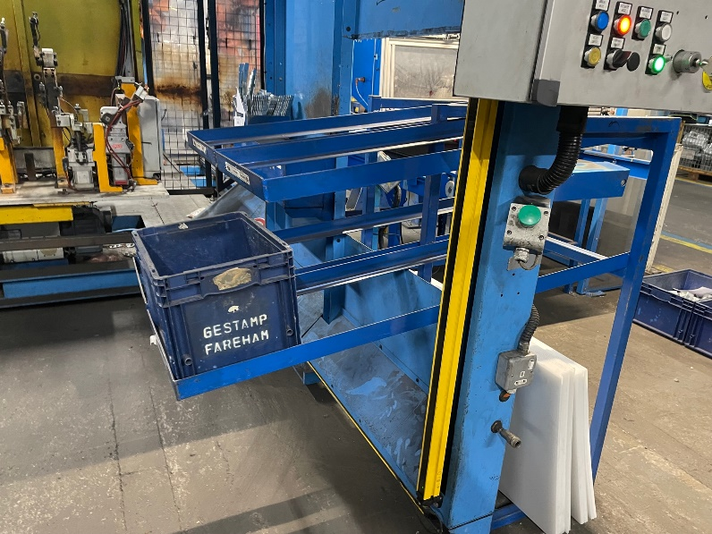
Data is collected from the Operators Record cards outlining all test results performed in the past 3 months. With this information, the process can be evaluated to see if process is reliable enough to reduce the amount of product testing performed on the part ultimately dropping the amount of wasted potential value the product has. Since the product hasn’t seen any failures in the past 3 months, destruction test has been reduced from 1 part every 2 hours to 1 daily check.
Once the part has been assembled, the value of the part is £10.67. Currently 8 parts are being destructed over a span of 16 hours a day, equalling to £107,553.60 a year.
If the lifetime of the product was to be considered, then over the span of 7 years contract with Renault Palencia, the cost would equate to £752,875.2. This would be enough incentive to aim to reduce the amount of waste produced by destruction testing. This process is a non-Value-added process, meaning this process doesn’t affect the price that customer pays.
Non-value added is any action that does not add value to a product or service, value being defined by the customer. It is the waste within a process. (ISIXSIGMA, 2022)
2 Hourly
Shift | Day | Week | Month | Year
£42.68 | £85.36 | £426.80 | £8,962.80 | £107,553.60

Daily
Day | Week | Month | Year
£10.67 | £53.35 | £1,120.35 | £13,444.20

The packaging of the product is a highly important requirement for the customer as it’s the most reliable stacking method that doesn’t damage the parts during transport, and it’s the best packaging to optimise their process once delivered to the customer, this requirement forces the Firewall Operators to take out all the products within pallet, inspect all components and replace back into the same pallet as requested by Renault. To create consistency and an optimised process, it is suggested that the operator changes the way they package their product to reduce risk of damage and create consistency to Firewall. During inspection, the full pallet is to be delivered for inspection, then another empty pallet of the same kind is to be placed next to the product ready for inspection. By doing this, the operator can take singular parts out of the pallet, inspect and place them into the new pallet to create a quicker inspection process than pervious. Although this will consume more temporary space in firewall with two pallets being used at a time, this creates a loop of pallets between the Process and Firewall.

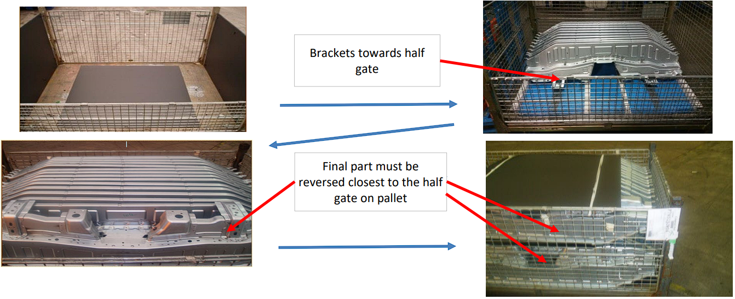

Currently, Due to the nature of Resistance Spotwelding, the electrode tip needs to be dressed or changed on a set frequency to reduce risk of producing unfused Resistance Spot Welds. This reduces the overall production time because when the machine reaches its tip change frequency, the machine goes on halt until a member of the Maintenance team arrives to manually change the tips of the 3 robots and check the electrode alignment. Although this is a preventative action that is required by the customer, Non-Destructive tests can be performed to ensure the quality of the spotwelds without destroying the product. Currently this tip change frequency is set to 150 Cycles before the machine automatically goes on halt. That is roughly 2 times per shift it goes down, for an average of 25minutes each time equalling to 45 minutes of average down time. A cap study could be performed on the cell to find out how many parts can the machine produce before a failure can be seen. With that information, a review of the tip change frequency can be reviewed to see if 250 is the correct number of cycles or if this can be extended while maintaining the quality of the product.

All spot-welding electrodes will wear. It eventually appears in the form of mushrooming. To counteract this and keep the process going there are two options. One choice is to use a current stepper to match the face growth with small current increases every so many welds. The other choice is to dress the electrode face back to its original size before its growth has caused degradation in the weld quality. (How To Resistace Weld, 2022)

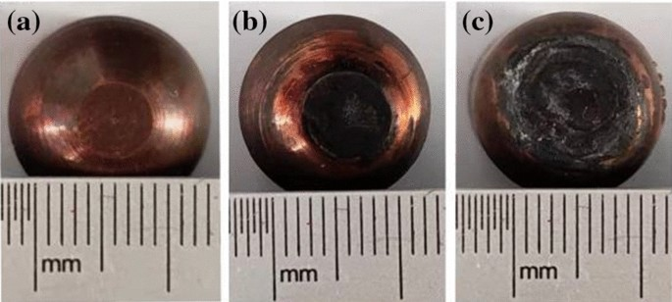

5.0 Conclusion
After Reviewing MC68 process and making suggestions, an improvement can be seen just by the raw timing data gathered. Although these changes aren’t the most optimal for this process, they have improved the amount of production that takes place, with a reduction of waste. To further optimise this process, it is suggested that the Cold Stamping process before the assembly machine, produce and stack the relevant components into the correct boxes and put them on a pallet to be delivered to the assembly cell. By doing this, the operator on MC68 would spend even less time gathering and loading the components at the start of his shift, to just grabbing the boxes provided by Cold Stamping straight on to his shelving unit

References
How To Resistace Weld. (2022). How do i determine a tip dressing frequency or program for a spot welding electrode? Retrieved from https://www.howtoresistanceweld.info/spot-welding/how-do-i-determine-a-tip-dressing-frequency-or-program-for-a-spot-welding-electrode.html
ISIXSIGMA. (2022). Non-Value-Added (NVA). Retrieved from ISIXSIGMA: https://www.isixsigma.com/dictionary/non-value-added/
Logu. P, A. B. (2021, 07 01). Implementation of Lean Manufacturing In Automotive Industries. Retrieved from INTERNATIONAL JOURNAL OF ENGINEERING RESEARCH & TECHNOLOGY (IJERT): https://www.ijert.org/implementation-of-lean-manufacturing-in-automotive-industries
MudaMasters. (2015, December 11). Takt-, Cycle-, Process-, and Lead time. Retrieved from MudaMasters: https://www.mudamasters.com/en/lean-toolbox-lean-production-lean-transformations/takt-cycle-process-and-lead-time

