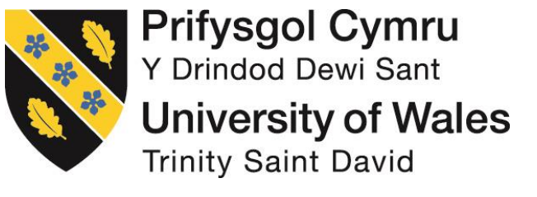

Unit code：BMMB7013
Unit title：Strategic Management
Tutor’s name: Gareth Hughes
Report title: Adidas AG strategic management analyzation based on financial statement
Student name: WANG QIAN
Student number: 2009563

Table of contents
1 Executive summary 1
2 Introduction 2
3 Porter's Five Forces 3
3.1 Suppliers’ Bargaining Power 3
3.1.1 Numbers of suppliers 3
3.1.2 Inability to offer the same goods 4
3.1.3 Payables turnover 6
3.2 Consumer’s Bargaining Power 6
3.2.1 Substitution 6
3.2.2 Elasticity 7
3.2.3 Consumer protection association 8
3.2.4 Receivables turnover ratio 9
3.3 Threats from Potential Entrants 11
3.3.1 Intangible asset 11
3.3.2 Under Armour 12
3.4 The Competitiveness of Existing Companies in the Industry 13
3.5 Competitive Capacity of Substitutes 16
4 Sequence of Blue-Ocean Strategy 17
4.1 Buyer Utility 17
4.2 Price 18
4.3 Cost 19
5 Conclusion 20
6 Recommendation 21
Reference list 22

Executive summary
As one of the famous sports brands in the world, Adidas receives mounting numbers of clients because of its superior quality and long history. When it comes to sports brands, Adidas are nearly in a noticeable position in this industry even though there are still many brands here. But in recent years, Adidas developed not as good as other brands, especially for some emerging companies which traditional products are not the competition products to Adidas. And then, Adidas’ financial performance was influenced by a great degree.
In my report, I will analyze this phenomenon in an external and internal environment under a method of Porter’s five forces and Bule Ocean Strategy to try to compare some key authority data- financial ratios - from its rival of Nike and give reasons in place. At the end of the paper, conclusion and recommendation are shown as a result.
Numbers of suppliers and payables turnover was adopted to measure suppliers’ bargaining power, suppliers recognized as little power if the number of suppliers is few or payables turnover is low. Buyers’ bargaining power is relative with substitution, elasticity, consumer protection association and receivable turnover ratio. High bargaining power in consumer always is expressed with more substitutions, rich elasticity, weak or no consumer protection association and low receivable turnover. Intangible asset value such as trademark or goodwill is seen as a way of reflecting the brand's image, the good image usually results in high value in these two intangible assets. As the biggest newcomer -- Under Armour and conventional rival—Nike’s core competitiveness is discussed too. Besides this, the Blue Ocean Strategy is always used by Adidas.

Introduction
Adidas as a Germany company but an international company provides sports products for women, men and kids. Its products cover a broad range of things like sports apparel, footwear and hardware. Till now, it has six global headquarters that are Shanghai, Boston, Panama, Portland, Hongkong and Amsterdam, those help it sale products all around the world and become one of the most well-known brands in the field with two brands of Adidas or Reebok. Products can be available for retail stores (on-line or out-line) or franchisees, in 2019, on-line retails including the Adidas UltraBoost 19, Predator, Continental 80, and Nite Jogger.
It is reported that the net revenue is EUR 23640 million for the fiscal year ended December 2019 with an increase of 7.9% higher than 2018(EUR 21915 billion). The same rising trend can be seen in operating profit (EUR 2660 million in 2019, EUR 2368 in 2018) and net income, as 16% higher in 2019.

Porter's Five Forces

Suppliers’ Bargaining Power

Numbers of suppliers
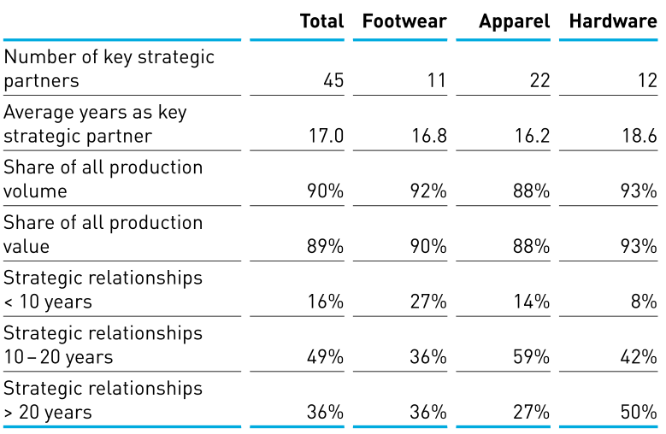
Figure 1 Key strategic partner relationships
From the picture, we can see that there are 45 firms (with a tenure of 17 years) having key strategic partner relationship with Adidas that occupied for 90% in the share of all production volume of 89% in all production value. Adidas sales production in footwear, apparel and hardware while at the background, forty-five companies are supporting it. In each sector, there are more than ten suppliers to take responsibility to produce, eleven suppliers in footwear, twenty-two firms in apparel and that of twelve in hardware. As we all know, if there have fewer retailers, Adidas has a strong power in cutting the price for a high margin. That to say, those companies get together having a critical important capacity role in offering products for Adidas, but for each segmented market, each of them has lower bargaining power because of large numbers of suppliers. Adidas own the bargaining power in diversifying the power of each supplier in numbers.
However, from the average year as a key strategic partner, we could draw a conclusion that those companies having business with Adidas have strong bargaining power. In common acknowledge, newly entrance in a market nearly have low pricing power in a weaker position, and then counterparty further cut your profit by its absolute advantages and comparable advantages until weaker one to quit the market. In reality, it is not. That is to say, for Adidas, those suppliers are the better cooperation enterprise who can meet its need and at rational prices. For suppliers, Adidas is good or bigger customers too, they can sustain their interest at a certain level, maybe they do not need to find more orders than before. They could take negotiation with Adidas using their key technology for long-time cooperation.
Diversification among different enterprise not only can reduce suppliers’ bargaining power, but also can diversify the business risk in operating. As the old saying that “Do not put all eggs in a basket”, a great probability has crisis facing lack of products when only one supplier provides the commodity if this supplier gets in trouble to produce. It will largely influence the operating environment of consumer confidence and push the customer to other brands products. Besides, in this situation, more suppliers mean that we can choose the best in the class in specific item producing to improve our merchandise quality. Each supplier has responsibility for only small item making, Adidas must make them up into finished goods, it cannot worry that supplier makes more goods to sale to reduce its revenue or its core producing secret was revealed.

Inability to offer the same goods
Adidas has already outsourced its products producing business all around the world with 545 suppliers which can be seen at the official website this year. Their supply-chain is completely globalization and multiple layered. Compared with other sports brand, Adidas directly have a contract with factories rather than an intermediary. Recently year’s figure shows that Asia is still the most important productive force whose productivity excess the United State by a large range and make Europe far more backwards. According to the data it published in 2018, Adidas set up cooperation with 700 factories that came from more than 50 countries, the top-three area are Asia where undertook the most serious producing workload (around73%), and next is Americas occupied for nearly one-fifth, last is Europe who accounts for less 10%.
Based on what we have discussed above, we can conclude that Adidas hardly has its manufactory to make their new orders. In 2019, it newly found out 19 independent manufacturing partners (2018:26) to expand its capacity to meet the demand. What’s more apparent, the 138 independent manufacturing partners provide the majority of commodities in 156 industry facilities universal.

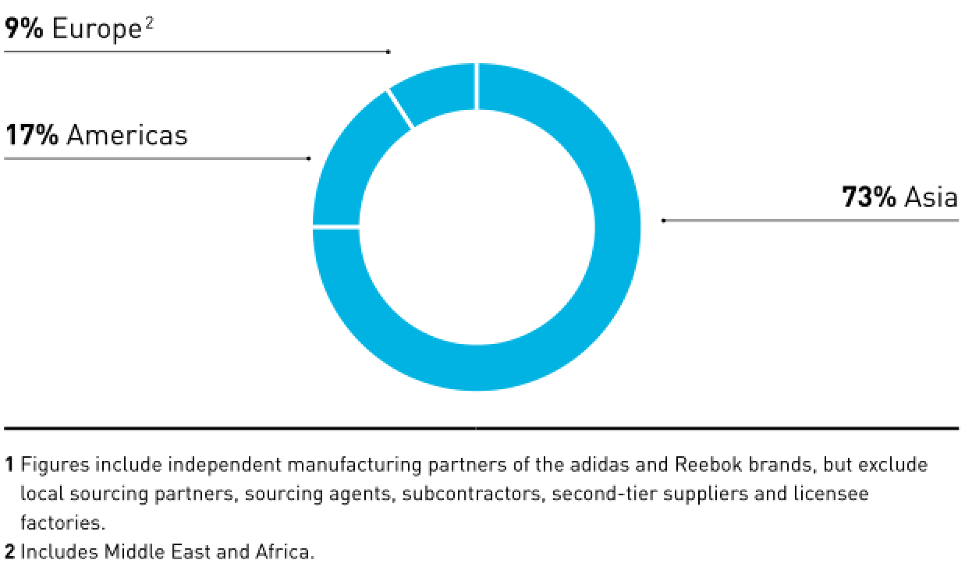
Figure 2 Independent manufacturing partners by region

Payables turnover

Figure 3 Payment Period and Payables Turnover
Adidas has some power in trading credit with an average payment period of 80 days, nearly close to 3 months according to the figures calculated based on SEC filling profile of 10-K Form. On the other hands, its supplier is in the weak position showed by the picture. Generally speaking, if the supplier has strong bargaining power, those two parties will trade with payment immediately to avoid the risk of buy on credit, and if counterparty of the seller is in the better position, it will ask a long period credit term and a discount.

Consumer’s Bargaining Power

Substitution
Unique feather that cannot be instead is critical characters, it can help the party to protect its benefit. What you own is special makes you are in the leading position, you can decide what price it is and who do you want to trade with. If your products are common goods in the perfectly competitive market, you are price taker, those who have no ability to negotiation but accept the price set. This substitution effect is also appearing in sports items. So many brands (Nike Inc., Air Jordans, Converse, Fila, Kappa, Puma, Skechers, New Balance, etc) can be chosen except for Adidas. Despite this, other kinds of style cloth have the same substitution effect as well, casual wear, formal cloth and some kind of like this.
According to this theory, the consumer has big bargaining power in the market. Countless choices and seldom using let consumer having priority in selecting items, while Adidas just like a dish on the table waiting be to selected. If Adidas lifts its products price, clients give up it to another or being appealed to other companies because of privilege, running a special, coupon day. Generally speaking, sportswear is not the sole style cloth for most residents especially for women, when you open your wardrobe there must be some sorts of styles for different occasions. Maybe we wear them only when we doing sports in physical education, in sports match event or training.

Elasticity
Elasticity, the responsiveness of the quantity purchased of an item to changes in the item's price, sometimes viewed as bargaining power. It is the natural feature of goods affecting what extent can you bargain. The price is not the same when you buy an equal quantity of salt and diamonds because of different elasticity. Luxury goods are rich in elasticity while durable goods are poor. That leads to consumers saving much money and having a higher consumer surplus when bargaining with the seller if the merchandise is similar to luxury goods, a bigger discount cannot be obtained in necessities.
The majority of products Adidas offered, for example, footwear, apparel, hardware, are normal goods with a range in the elasticity of zero to one. (N. Gregory Mankiw,2017) That’s to say, those goods lack elasticity rather than luxuries which elasticity is greater than one. Clients who buy Adidas products are in a weak position to cut prices, they spend much effort to try but receive nothing. On the other hand, according to the theory of the relationship between total revenue and elasticity, (N. Gregory Mankiw,2017) retailers who sale Adidas product will raise the price to boost the increase of total revenue. Hence, in this angle, consumers have less power in bargaining.
What does it mean for Adidas? Its consumer has strong bargaining power.

Consumer protection association
Generally speaking, consumers’ bargaining power decide by the numbers of customer and quality. The dominated consumer which influences selling volume always has a strong power in pricing. In this case, the main consumer Adidas faced is Tiro Pant, Z.N.E. Hoodie, the MyShelter Jacket and VRCT Jacket, UltraBoost 19, Continental 80, Predator, and Nite Jogger and so on. Each of the franchisees has its customer base, they can help Adidas sale more products to lift total revenue, based on this strength, they can negotiate with sports producer for a lower price or prefer settlement ways like sell-in-credit. In this win-win strategy, both Adidas and retailer can achieve their profit goal. In the real world, some too many consignees want to make the business. To occupy more market share, the retail distributor has to own more brands to meet their customers’ needs, otherwise, their clients will less use its platform to shopping. So, these distributors are in a weak position in cutting piece. Besides the substitution effect among franchisees, Adidas also has its website, department store to sell products, it definitely to cripple retailers’ superiority in selling.
However, if the shopper set up for a union such as a consumer protection association to protect their benefit in fake goods or low-quality issue, things will change. Thought these kinds of the union cannot benefit from promoting at the current time but they can influence units of sales in future by material public information released into the market.

Receivables turnover ratio

Figure 4 Receivables turnover ratio
Receivables turnover ratio, total operating revenues divided by average receivables, used to measure how effectively a firm is managing its accounts receivable. From the line chart, the ratio increases year by year. It began at 1.21 in 2015, and then having an extinct rise in 2016 (reach at 1.55), after three years a little bit escalated by the same degree, it stabled at 1.76 at the end year of 2019. Such a trend indicates that more net revenue covers account receivables in recently years. In other words, the speed of revenue increasing (EUR2416 million in 2015, EUR3289 million in 2016, EUR3732 million in 2017, EUR4128 million in 2018, EUR4444 million in 2019) is much quicker than that of account receivable.
Bargaining power is not only reflected by what range of price you can cut but also how long you should pay for the commodity and what kinds of payment method you can use in the trade. As we know, account receivable is a current asset account showing amounts payable to a firm by customers who have made purchases of goods and services on credit. Lower velocity in account receivable and a higher rate of receivables turnover ratio shows that the customer has more advantages in bargaining.
The same results can be seen in another finance ratio of collection period-- the number of days, on average, that a firm requires for collection of a credit sale. Five years ago, Adidas needed 302 days to receive the cash from selling, while that very different in the fiscal year of 2019, numbers of days decreased by one-fourth (about 158 days) to collect cash from main retailers. In the second year, it deeply wrote down the number of days to 236 that quite a similar figure in 2017. In recent two years, it nearly has no change.

Threats from Potential Entrants

Intangible asset

Figure 5 Intangible Asset
Adidas is in the position of powerful potential entrants’ affection. Goodwill and trademark as an intangible asset that cannot be changed in a short time. It is the ratio of customer loyalty representation. High customer loyalty is reflected by a high, stable ratio in goodwill or trademark. Clients who choose Adidas as their first choice have high brand reorganization that less likely to change the brand preference optionally. From the picture, the ratio of trademark per total asset scrimps nearly 70% at the end of 2019 compared with five years ago. It is indicating that some of Adidas’ customer was attracted to other brands and then the trademark is less worthy than before. And Under Armour is one of the most competitive newcomers to the sportswear industry. (Daniel Roberts,2015) Also, the value of goodwill in total number keeps constant over these years, but the ratio of goodwill per total asset fall in general trend except for 2017. The speed of goodwill is slower than that of total asset. It is supported by what we analyzed as well.
Table 1 Percentage of Intangible Asset
 | 2015 | 2016 | 2017 | 2018 | 2019
Trademark Per Total Asset | 12.20% | 11.07% | 9.09% | 5.41% | 4.15%
Goodwill Per Total Asset | 10.43% | 9.30% | 13.77% | 7.97% | 6.08%

Under Armour
In the field of sneaker making industry, Adidas was the cheat to beat in past years but now it lost the land completely. Besides its formidable rival Nike, Under Armour whose famous product is tight underwear follow behind. Those companies win the best sellers in worldwide popular sneaker factories (nine of ten belong to Nike, the last one belongs to Under Armour). Adidas is ranked in the third. (Raha, Sayantan, 2020, p96) Within fourteen years of research and development, Under Armour devote itself to innovations, finally excess Adidas in its advantage aspect.
Under Armour has a short period in shoes making but make a great success not only advance the material it using but also add high-technologies on its sneakers. Research and development of Under Armour are quite in the position of frontiers that differ from Adidas. Adidas put more efforts on how to improve products performance and Under Armour mix this with high-tech. Under Armour was created in 1996 when it launched the first products (prototype#0037) which is soft, skin-tight and stretchy. It kept athletes cool, dry and light. Ten years later（2006），it is the first time for the company to introduce football cleats, with this changes, it captured a 23% share of the market and became the official footwear supplier of the NFL. The first Super Bowl commercial as the foothold in the athletic footwear market is revealed by lines of performance trainers in 2008. And next year (2009) it marched into running shoes. Under Armour is worthy of the name of footwear brand proved by Speedform Apollo that designed for speed with zero distribution and made in an apparel factory. “This is what fast feels like” became the tagline in the year of 2014. Smart shoe (the UA SpeedForme Gemini 2 Record Equipped) was introduced by the company in 2016. Record SensorTM technology built-in tracks and stores data of time, distance, date, duration to build a running experience to exercisers with the free device. It sounds so cool! UA is selling 3D printing technology training shoes and chip smart running shoes for the first time in the Chinese market in 2017. In 2018, the company developed HOVR and line of HOVR running shoes and basketball shoes. This new pinnacle cushioning system for Under Armour footwear is not only soft enough to absorb impact, but it also returns energy and pushes athletes back up so it feels like zero gravity. Under Armour, 1. Gravity, 0. (Under Armour official website,2020).

The Competitiveness of Existing Companies in the Industry
It indicates that Nike Inc., Air Jordans and Converse are formidable competitors for Adidas even though Adidas dominates much of market share. (Raha, Sayantan, 2020, p96) Matovi, V., Stani, M., & Drini, I. .shared the similarity opinion in their dissertation (2019, p35). In the football market, the company’s share is in 39% percentage, but Nike is closing at a fast speed. The United States is seen as a place where the battle royal accounts for nearly 40% of global sports apparel and soccer wearing. In this ground, Nike owns nine of top-10 best sales products of sneakers, the tenth of that is a pair of shoes from the brand of Under Armour. Significantly, Adidas is crowded out.
Over the third quintile of respondents considered think that the decision of buying a brand product is important or very important in the feedback of questionnaire of Matovi, V., Stani, M., & Drini, I.. according to the questionnaire, more people prefer Nike rather than Adidas for the listed reasons: products’ quality, the impression left by clients, better resonance, recognized logo, easier slogan, package or design, and brand colour. In the research, the respondent was asked to give marks from 0-7 to these two companies. After statistics, Nike does better in those factors and further details were given. For the quality, the average mark Nike received in this variate is 6.06 (Adidas is 5.25). 42.31% of respondents give the highest score to Nike while Adidas got 32.14% of supporters in the full mark. And then Nike leaves a bigger impression to its customers, 46.15% of respondents give a full mark to Nike and a half of that to Adidas. Nike’s score on easily remembered slogans is 0.35 higher than Adidas but Adidas pull back a game in the index of brand’s resonance and recognizable logo. Adidas also has a higher average grade of the recognizable logo (4.27 in Nike and that of 5.04 in Adidas), interesting package and design (2.91 in Nike and that of 2.57 in Adidas) and colour of the brand, (Adidas is 1.68 and Nike is 1.33).
Investigation questionnaire compared Adidas and Nike in qualitative method and financial ratios give professional, accurate results in profitability, solvency and business operating. As ratios collected (MarketLine, 2020), Nike has a better financial performance in general no matter which parts it is. Even it has a non-ideal ratio, but the difference between these two firms is very little. Net profit margin and return on equity of Nike as a representative of profitability are higher than that of Adidas in most recent years, the difference of ROE in two corporations is remarkable which fluctuates at the rang of (-7%,16%). The short time solvency ratios (current ratio, quick ratio, cash ratio) of Nike are higher too, it demonstrates that Nike has a powerful ability to pay for its debt in a short time. It is worth noting that the leverage ratio of Adidas doubled in 2019 but it did not assist to improve its net profit margin or ROE. A high number of total asset turnover indicates that Nike has a strong selling ability and high utilization usage of the asset. This phenomenon was reflected by inventory turnover as well, high figures in this behalf that less inventory left or selling more products within the same period. In conclusion, Nike is a nonnegligible, driving opponent.
Table 2 Financial ratios of Adidas and Nike
Nike
 | 2016 | 2017 | 2018 | 2019 | 2020
Net profit margin | 11.61% | 12.34% | 5.31% | 10.30% | 6.79%
ROE | 30.70% | 34.20% | 19.70% | 44.60% | 31.50%
Current ratio | 2.80 | 2.90 | 2.50 | 2.10 | 2.50
Quick ratio | 1.90 | 2.00 | 1.60 | 1.40 | 1.60
Cash ratio | 1.00 | 1.10 | 0.90 | 0.60 | 1.10
Leverage ratio | 0.20 | 0.30 | 0.40 | 0.40 | 1.20
Total asset turnover | 1.50 | 1.50 | 1.60 | 1.70 | 1.40
Inventory turnover | 3.80 | 3.80 | 4.00 | 4.00 | 3.30
Adidas
 | 2016 | 2017 | 2018 | 2019 | 2020
Net profit margin | 5.50% | 5.20% | 7.80% | 8.40% | *
ROE | 15.70% | 18.20% | 26.70% | 29.10% | *
Current ratio | 1.30 | 1.40 | 1.40 | 1.20 | *
Quick ratio | 0.8 | 0.8 | 0.9 | 0.8 | *
Cash ratio | 0.3 | 0.3 | 0.4 | 0.3 | *
Leverage ratio | 0.3 | 0.2 | 0.3 | 0.7 | *
Total asset turnover | 1.3 | 1.5 | 1.5 | 1.3 | *
Inventory turnover | 2.7 | 2.8 | 3 | 3 | *

Competitive Capacity of Substitutes
    - Substitutes of other brands of sport wear
As we talked before, Nike is the biggest competitor for Adidas and Under Armour is formidable potential entrant, these company offers the same ranges of products with Adidas. Except for the two companies, Puma Se, Fila, New Balance, Callaway Golf Company, Converse, K-Swiss, Asics, Air Jordan are also a very strong force to Adidas. (Raha, Sayantan,20202) And Mizuno, Nmbro, Kappa, Diadora, lotto are traditional brands who entrance the market in early years with a long history that cannot be neglected. Some small national brands in the local country such as Li-Ning, ANTA, PEAK, 361° in China are popular with citizens because of affordable price. Those niche brand also have competition relationship with Adidas in Great China and Asia Pacific Area.
    - Substitutes of other kinds of cloth
Apparel can be substituted in daily exercise activities like jogging, walking around, rope skipping, playing badminton, but garment needed in professional sports (surfing, swimming, rock climbing). Sportswear is specific cloth in doing sport, it needs high performance in comfortable with sweat absorption, quick-dry, light and so on. These characters are not easily founded in other sorts of cloth. People can do daily exercise in any kinds of cloth which is not harmful to sporter but in the difference of comfort level. However, suitable clothing is needed in professional sports, it is not because of comfortable but protecting canvassers’ safety. To imagining that wearing a suit for rocking climbing is a dangerous activity, the cloth without a hook on, sporters may get injured if he falls down the rock. In this way, apparel cannot be instead.
For general people who do physical exercise, they have much more choice and for that of a professional athlete, they have limited choice resulted by performance, what they can select based on which brands offer this piece of garment. For example, a swimming athlete must choose the best swimming suit during the Olympic Games with the need of quickly-dry, low-drag force in the water. If Adidas standouts from thousand of brands, this swimming suit have no substitutes. If some brands provide the same goods in quality, it has substitutes.

A sequence of Blue-Ocean Strategy

Buyer Utility
The Adidas brand’s mission is to be the best sports brand in the world, by designing, building and selling the best sports products in the world, with the best service and experience, in a sustainable way. (Adidas annual financial report, 2020, p55) What Adidas does is meeting its clients need, it introduced a post-mastectomy sports bra for women who take surgery resulted from breast cancer with Stella McCartney in 2019. This special sports bra brings the right to doing exercise back to patients who undergo cancer. Additionally, Adidas rolled out a plan in all around its international own-retail stores to offer a bra-fitting program. To meet young customers interesting, Adidas rolled out “Stan yourself” program to change the image of Stan Smith on shoes’ tongue to yourself with three different colours in 2014. This pair of shoes not only the faddish but also the unique one that just belongs to yourself, it is really exciting for youngsters to wish for. After that, the brands launched “mi Adidas” which is short for “my individual Adidas”, different retail stores own its preference style, some stores are preferable the Original style but others love Performance line. This creative service makes great contributions to customer loyalty.

Price
Adidas should rationally price for products, there is a close relationship between its price and decisions of customer purchase power which is few affected by brands image. When the products priced at a sound number, people will have a large buying order. ( Madyan, Indah & Tiarawati, Monika, 2018, p614) and he also points that consumer will evaluate the price with quality of products, price should be affordable for clients and quality should be consistent with its price, only in this way, consumers will pay for the goods. The linear regression function is given by the author is:$Y=0.467X_{1}-0.031X_{2}+0.304X_{3}$, the variate of $X_{1}$ represents the quality of the products, more purchase order with high quality. $X_{2}$ behalf of the brand image which is few influences even though its coefficient is negative. $X_{3}$ is variate for low price, more buying numbers comes with a lower price under the condition of other variates are constant. Y is the decision to purchase Adidas’ products.

Cost
The article of Nike and Adidas Brand Strategy Analysis in the journal of Shoes (2019, pp.85) pointed out Adidas introduce a Centralized Sales department which response to commercial activities and promotion of the brand to support its global selling market in 2014. It was crafted by an integrated and centralized marketplace team; this global sales department was consisted of the wholesale institution and retail institution to meet different demand models of sales. Since it was created, it applies until now across its six global markets in the context of changing landscape. Adidas combined its planning and trading teams in the same place to ensure the maximum level of consistency and operating efficiently. In this way, the cost of operating can be declined.

Adoption
Adidas using the method of tipping point leadership, which change the extreme, to transform the mass’ purchase activities and brief. First of all, the Athlete collaborations. The brand achieves its sales goal in virtue of inviting sports celebrities as a spokesperson, with the prestige and rallying point of an outstanding person in sports filed, common consumers are more trustable for the products, and the advocators (usually is fans) of sports stars are crazy about everything their idol represent, it will boost the revenue of sales. Adidas is no exception. In past years, it collaborated with many popular stars in every faculty such as football star Toni Kroos, Mohamed Salah, Dybala, Son Heung-min, basketball stars Candace Parker, Liz Cambage, baseball athletes Carlos Correa, as well as tennis stars Angelique Kerber, Alexander Zverev. Second, the brand spouse global tournament event like the Rugby World Cup, the Boston, the FIFA Women’s World Cup, the UEFA Champions League, and Berlin Marathons. The third is high-profile teams: the national association football teams of Argentina, Spain, Colombia, Germany, Belgium, Mexico and Japan. Furthermore, the brand also enthusiastic in programs for the public good-- the She Breaks Barriers to remove barriers to sport for girls and endeavour to the equal conversation right across sexuality in sports. With the help of those methods, Adidas brings its products and services to the largest stage of the world.
Also, the company has counting numbers of creative and partner collaboration with a non-athlete. The partnership with Kanye West and Pharrell Williams is still highly influential. Adidas invited top designers and design studios which is including Stella McCartney, Alexander Wang, Yohji Yamamoto, and Raf Simons to cooperate with. Last year, it created new partnerships with Prada, Ninja, Beyoncé, and the International Space Station ISS. (Adidas 10-K Form, 2020, p57)

Conclusion
In summary, we can conclude that Adidas is in a very fierce competition industry and its strength is not significant so far even though it comes into the market early. Its stress comes from its consumers—retailers, potential entrants—Under Armour and its existing competitor—Nike. Its retailers have higher bargaining power reflected by low receivable turnover ratio, high collection period, less elasticity and more substitute brands can choice. One of the strong potential entrants it faces is Under Armour which sports company having big ability in research and development. That lead Under Armour to provide the market more technological, quality sportswear to excess Adidas in net income within two decades. Another serious problem that cannot be neglected is the existing competitive companies--Nike in the industry. Objectively speaking, Nike has perfectible quality in its products, it gives the client a better impression and easily remembered slogans. However, Adidas’ suppliers and substitutes would not have an important influence on its products’ price. Adidas has no productivity in producing products in its manufactories caused by outsourcing its products producing business all around the world with 545 suppliers in 2019. At the same time, its suppliers have lower bargaining power because of an over-diversified production line. The financial ratio of payment turnover states the same results as well. Also, there are few kinds of style clothes can instead sportswear. The reason is that sports uniform not just only is comfortable for people doing sports but also is safety protection in extreme sports.

Recommendation
By analyzing Adidas in Porters’ Five Force in details and its potential competitors-- Under Armour and Nike, some successive means can be absorbed. First, good quality of products based on research and development should be improved, this is the same method that both Under Armour and Nike used up till now. Second, the price should be rational, consumers take the price as a consideration when they making decisions, lower price in place would promote its selling numbers. And then some merits made success before should keep moving, such as recognizable logo, interesting package and design, the colour of the brand, creative and partner collaboration and so on.

Reference list
Adidas AG SWOT Analysis[J]. 2020. Market Line

Adidas. (2020) financial ratios. Available at: https://advantage-marketline-com.ezproxy.uwtsd.ac.uk/Company/Financials/adidas_ag_gd_27031#financialratios (Accessed at:15 December 2020)

Adidas. (2020) adidas-group. Available at: adidas - Home (adidas-group.com) (Accessed: 2nd, Dec 2020)

Matovi, V., Stani, M., & Drini, I. . (2019). Impact branding on consumer preference towards buying a certain product: comparative analysis of brands Nike and Adidas. DOI: 10.13140/RG.2.2.34813.18404

Madyan, Indah & Tiarawati, Monika. (2018). Pengaruh Kualitas Produk, Citra Merek, dan Harga terhadap Keputusan Pembelian Pond’s Flawless White. BISMA (Bisnis dan Manajemen). 6. 98. 10.26740/bisma.v6n2.p98-105. DOI: 10.26740/ bisma.v6n2. p98-105

Nike. (2020) financial ratios.Available at: https://advantage-marketline-com.ezproxy.uwtsd.ac.uk/Company/Financials/nike_inc#financialdashboard (Accessed at:12 December 2020)

Nike and Adidas Brand Strategy Analysis (2019) Shoes，19（05），pp. 84-87

N. Gregory Mankiw. (2017) Principles. of.Economics. 8th edn. Peking University

Roberts Daniel. (2015) ‘Can Kanye Save Adidas?’. Fortune, 171(7), pp.94,96-99.

Raha, Sayantan. (2020). ‘Brand Analysis of Adidas’. DOI: 10.13140/RG.2.2.34813.18404

Under Rarmour. (2020) brand story. Available at: https://about.underarmour.com/brand/our-story (Accessed at:12 December 2020)

Wikipedia. (2020) Elasticity. Available at: Financial Dictionary (thefreedictionary.com) (Accessed: 2nd, Dec 2020)

Wikipedia. (2020) Receivables turnover ratio. Available at: Financial Dictionary (thefreedictionary.com) (Accessed: 2nd, Dec 2020)

