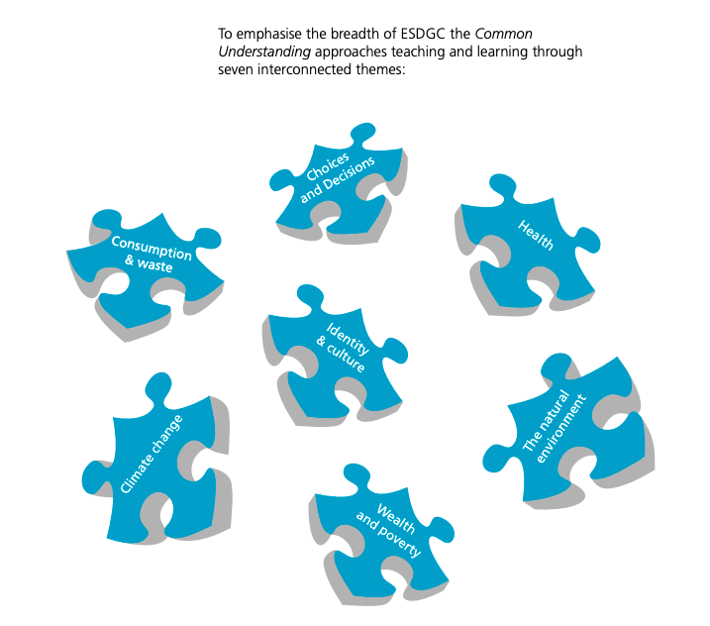

Identity and culture – Welsh poets and writers. Dylan Thomas

Wealth and poverty – dickens/Oliver twist.

Consumption and waste. -writing a letter to the council.

