Introducing the Modern Workplace

Executive Summary
The essay is really going to show organisational and behavioural influence on the activity and performance of any business. Organisational structure, design and cultures are defined for Organisational performance measures of the company like Tesco. In this essay of organisational structure, structural relationship with the functional behaviour are analysed based on the elements of the functional behaviour as well. Functional behavioural science and importance to mediate the behavioral aspects of the people are analysed based on the functional behaviour. Influences of organisational behaviour on functional areas of the individuals are tried to identified from the perspective of personality, perceptions, learning and motivation of that person.

Table of Contents
Introduction 4
Organization structure and its influence on organizational performances 4
Organizational design and structures of Tesco 4
Organizational performance 6
Structural and cultural influences on organisational performance 7
Influences of different factors on individual behaviour at work place according to behavioural approach 8
Behavioural Science Approach 8
Different factors influencing behavior in the workplace 8
Pivotal Importance of Leadership Ability within Times of Organizational Change 9
How influences individual behavior by different factors 9
Conclusion 10
Reference 11

Introduction
Organisation is a collective form of any combined and shared value and aim. The combined relationship is a collective form of people, sources and collection of method and process. So there has defined and structured item, management for managing the resource and people of the business (Dedahanov et al, 2017). Management is the sign of directions and accomplishments of the function of a business like a company, Tesco. Management of any business deals with transition, shift, ability, flexibility and the predictability of the business environment. Different departmental and the functional behaviour of the organisation are defined and established in a business for the sake of developing the productivity and profitability of the business. This essay is going for the issues like organisational structure, culture, functional behaviour and behavioral science and influence of the behaviour on the functional behavior of the company.

Organization structure and its influence on organizational performances

Organizational design and structures of Tesco
Organizational design is the process of ensuring the proper use of technology, gathering of information and the integrating people for achieving goals and objectives of an organization or business (Mullins, 2016). The organizational structure is the step-by-step structural responsibilities assigned to employees in different departments or positions to run an organization or business.
- Organizational Design of Tesco
There are different types of factor that affected between organizational design and structures of Tesco. These are organizational size, organizational life cycle, organization strategy, several technologies etc. For example: Several technologies: Proper use of different technologies is an element of organizational design. Every company or business organization uses different technologies in their business to achieve the goal. Similarly, Tesco uses a variety of technologies to increase their sales and to produce the right products.
- Organizational structure of Tesco
Tesco is a company which is common merchandise seller and also a multinational grocery company. Tesco Company follows a hierarchical organizational structure which is divided into many parts to ensure work will be done efficiently and effectively. Every manager of the Tesco's organizational structure is under the control of the Regional Manager. There are two types of structure of Tesco Company’s.

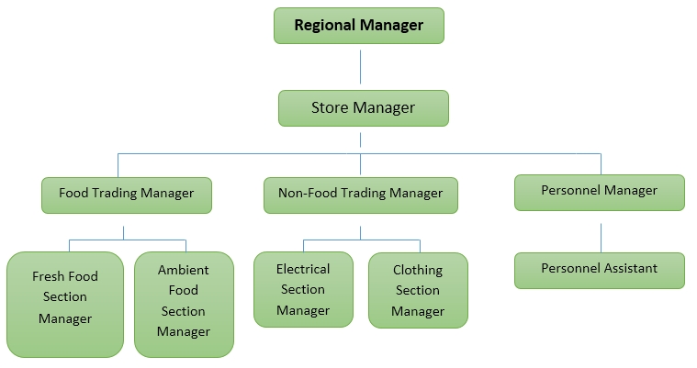
Figure: Tesco Organizational structure (Mullins, 2016)
Organizational cultures of Tesco
Organizational culture means the right way to behave among the members of the organization (Armstrong and Taylor, 2017). And it is also a collection of values, expectations and practices that control and inform the activities of all team members. Tesco also follows those organizational culture roles to guide and inform their members. There are three levels of organizational culture of Tesco Company followed.
Artefacts: The artefacts culture is the first culture of Tesco Company. It is a visible and non-visible culture of Tesco Company’s organizational culture. For example: company privacy, open door policy, policy for employees, office layouts and so on. The artefacts culture of Tesco Company is observed by worldwide because it is a multinational company.
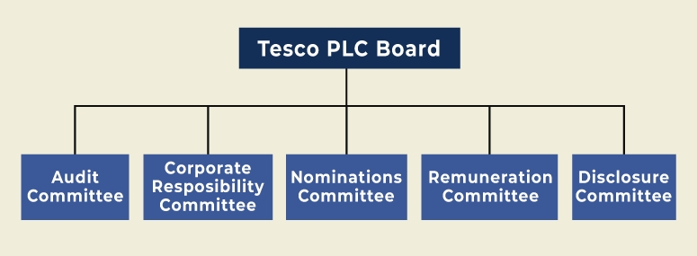

Figure 1: Tesco Corporate Governance (Dedahanov et al, 2017)
Values: The core value is very important thing for any company. The Tesco Company’s core value shared goals and objectives, principle and policies. Accountability, passion, quality and quantity, diversity are also core values of Tesco company's. Tesco Company simplify their core values so that employees can accept and modify easily.
Assumptions: The last and most important culture of any organization is assumptions culture. Assumptions culture play an important role to fill organizational goals and objectives. When employees remain unaware underlying the assumptions culture, they play an important role to form the cultural behaviors.

Organizational performance
Organizational performance means the key results or output of an organization that a company or business organization achieves by completing their overall functions (Huczynski and Buchanan, 2013). Which contains financial performance, marketing research, share values and so on. Tesco's performance is also very good. Their aim is ensuring good quality products and services in less price in market, cheaper than other competitors.
Tesco company's performance are creating high levels aspirations and strategic plan, reduce costs and innovation, measurement of tools and Technologies, communicating performance to shareholders, quality management and risk management, financial and marketing performance, proper and perfect mixing of marketing mix and so on.

Structural and cultural influences on organisational performance
Managerial behaviour and action: Managers’ decisions are influenced by both structurally and culturally. Organisational culture and structure play a significant role in organisational performance (Knights and Willmott, 2012). Without maintaining culture and structure properly, no organisation will able to reach its success. If organisational culture isn’t favourable to the employees, they will not surely give their best efforts and that will affect the organisation badly. Moreover, the employees lose their motivation to do work appropriately. On the contrary, employee’s confidence level will boost up if they get a culture which is according to their needs. Culture outside the organisation also play a vital role in organisation's success. If the culture remains in favourable of the organisation, it will definitely succeed. Organisational structure is also an important factor in the way of organisation's success. The structure must be helpful to the employees. Otherwise, the duties won't be done properly.
An analysis of the elements of effective managerial behaviour: Effective managerial behaviour means the behaviour which helps the employees to be motivated, done their duties properly and finally operates their efforts to the way of organisational targets and goals (Boddy, 2011). Effective managers must have the ability to make the employees efforts completed efficiently. Effective managers must be goal oriented. They have to plan well so that their activities of reaching those goals become simple. Then, they have to operate the employee’s efforts towards the goals. Their controlling ability must be strong. They have to see the employee’s activities and do correction if necessary. Their time management ability must be perfect so that organisational goals and objectives can be gained in time. They encompass on the organisational goals rather than personal achievements. The decisions must be given in a systematic way. Thus, effective managerial behaviours can help the organisations to be succeeded.

Influences of different factors on individual behaviour at work place according to behavioural approach

Behavioural Science Approach
Behavioural science approach refers to the approach in which managers encompass on the individuals' and groups' attitudes, performance and behaviour (Grey, 2017). A lot of scientists play pioneering role in behavioural science approach. Some of them are Abraham Maslow, Chester Barnard, Fredrick Herzberg, Douglas McGregor, Victor Broom, James March, Herbert Simon and so forth. Their thoughts and views enriched the approach widely. Managers operate the activities of the organisation in a scientific way. They focus on the human beings needs and wants based on this approach.
This approach can be also named as ‘human resource approach'. Maslow's hierarchy of needs theory, McGregor’s theory X and Y, Vroom's expectancy theory of motivation, Herzberg's two factors theory etc. have a huge contribution on this approach. These theories enriched this approach properly. This approach discusses about the attitudes, performance as well as behaviour of the employees. The assumptions of this approach are mentioned below:
- Socio-technical organisations
- Both social and psychological needs inspire the employees
- Conflicts can't be avoided
- Personal and organizational goals have to be operated in the same way.

Different factors influencing behavior in the workplace
Some factors influence managerial behavior in the workplace. In the below, I describe briefly these factors
Leadership: Managers set goals, Organizes the Business, and operates all the activities for achieving goals.so, managers and leaders influence the behavior of an individual at the workplace by their individual. Take for example if a manager will lately come to his office it is her foolishness to aspect her subordinate will come fast.
Work Culture: Work culture plays an influencing behavior of individual employees. The company needs to arrange a safe and suitable workplace for the employees as they feel comport. For maintaining a good situation in the workplace Tesco Company always try to arrange a good environment in the workplace and do not throw their employees at their bad time.
Effective communication: Communication is vital to every part of Business. For this reason, managers need to communicate effectively with employees (Mullins, 2016). It is necessary to maintain a friendly relationship in the workplace to acquire success.

Pivotal Importance of Leadership Ability within Times of Organizational Change
At the time of organizational change managers and leaders need to fulfill clarity, connection, and accountability as employee’s desire. In the below describe three steps that are essential for every time at the time of organizational change.
Adopting the change: At the time of organizational change, good managers take the situation easily and stay connected with other employees. Allocate the time and resources from the revenue and change initiative, set targets at the situation base.
Manage the Change: Leaders have the responsibility to manage organizational change. When employees become disillusioned, confused and unmotivated this time leader fulfill the change management role, changes are made efficiently and sustainably, and the expectations of their staff, partners, stakeholders, and clients are met.
Be Accountable and Transparent: At the time of organizational change, leaders stay accountable for their activities. What he does or what he does not do and no blame openness to other performance. Also, he always looks at the aspects of the organization like culture, process, and management.

How influences individual behavior by different factors
Every person is different from each other, behavior of humans is difficult to study. There are so many factors that influence individual behavior. Here, I describe some of these factors in below:
Personality: Personality is expressed by good manners, persistence, dominance, aggressiveness, and other qualities that are reflected through the behavior of the person within the organization (Martin and Fellenz, 2010). A person who has a good personality he or she considered a smart person by others.
Perception: Perception is the capability of a person in different situations. Sometimes it is considered as a process to obtain sensible meaning and allows information to enter.
Learning: Learning brought a permanent change in the behavior of employees. It helps employees to interrelations with different situations. So, learning has a good influence on a person's mind.
Motivation: Motivation influence employees to do the work attentively. Motivation is the degree that influences an individual to choose and engage in new work for reward. The main purpose of motivation is to predict behavior.
Satisfaction: Company needs to satisfy it employee’s desires, expectations, needs, and demand. It is the ultimate form of pleasure. These factors influence an employee's behavior to do work with joy and happiness. Without satisfaction in the workplace, no one can stay in the organization in the long run.
Organisational structures and behaviour have influence on the business performance. Besides, the behavioral approach of any business has influence on the behaviour of the workforce in a business.

Conclusion
Finally, the organisational performance and behavioral aspects of any business have been reviewed from the internal analysis of Tesco. So the overview of the business has been evaluating from the perspective of the company (Martin and Fellenz, 2010). Better management and the implementation of business policies are the reflections of the organisational behaviour and other functional behaviour of the company. So the company has to have flexible and adaptable organisational structures along with the beneficial work cultures in the business. Functional behaviour of the company are the reflections of the managerial performance of the company. So the management activities and function have to be defined and evaluated by the practical scope.

Reference
- Armstrong, M., Taylor, S., (2017) Armstrong's Handbook of Human Resource Management Practice, 14th Edition, Kogan Page
- Boddy, D., (2011) Management: An Introduction (5th edition) Harlow: Pearson
- Dedahanov, A.T., Rhee, C. and Yoon, J., 2017. Organizational structure and innovation performance. Career Development International.
- Grey, C (2017) A Very Short, Fairly Interesting and Reasonably Cheap Book about Studying Organisations (4th edition) London: Sage
- Huczynski, A., Buchanan, D (2013) Organisational Behaviour (8th edition) Harlow: Pearson
- Knights, D., Willmott, H., (2012) Introducing Organizational Behaviour and Management (2nd edition) Andover: South Western/Cengage
- Martin, J., Fellenz, M., (2010) Organizational Behaviour and Management (4th edition) Andover: South Western/Cengage
- Mullins, L, (2016) Management and Organisational Behaviour 11th Edition, Pearson

