
Full Interface & Testing |   Module: Usability Engineering  Module code: ACCB6017  Lecturer: Dr. Nassir Ibrahim  Student name: Alexei Nica  Student ID number: 2232919  Submission deadline: 14 November 2025

Table of Contents

Introduction 2
Full colour design storyboards 3
Feedback collected from Users for Prototype 8
Information collected from users for the working version of the Mobile App to be potentially built and released 9
Additional Usability Considerations 11
Personal Reflection 12
References 13
Appendices 15

Introduction

Component 2 focused on transforming the ideas developed earlier into a set of clear, structured, and usable storyboard screens. While Component 1 concentrated on understanding the users and defining their needs, this stage was about turning that understanding into real design decisions. The aim was to create screens that were not only functional but also easy to follow and comfortable for the personas identified previously.
The work began by reviewing the low-fidelity wireframes and analysing where they needed improvement. Some layouts required more space, some actions needed better visibility, and certain flows had to be simplified. These adjustments were not made randomly; each change was guided by the needs of the personas and by the principles of usability learned throughout the module. The process involved looking carefully at how information should be organised, how navigation should feel, and what visual cues help users understand the next step.
Colour storyboards were then created to show the final interaction paths of the app. These screens highlighted the major functions of the game, the transitions between actions, and the overall structure of the experience. Component 2, therefore, served as the practical stage of the project, where ideas stopped being theoretical and became a usable, coherent interface.

Full colour design storyboards

The full-colour storyboard stage represents the transition from structural planning to a complete visual identity for the UWTSD Cluedo mobile game. The aim in this phase was to create a clear, consistent, and intuitive interface that feels natural on a mobile screen while improving the ideas developed in the low- and mid-fidelity wireframes [1].
The chosen colour scheme is built around three main tones: Warm Gold (#F7B731), Deep Royal Blue (#243B6B), and Soft Ivory White (#F8F9FA). Warm Gold is the primary action colour and is used for all main buttons and interactive elements. This makes calls-to-action immediately visible and helps users recognise where they can tap without extra effort, supporting the “recognition rather than recall” principle in mobile interaction design [2]. Deep Royal Blue is used as a secondary colour for icons, text, and structural accents, creating a clear contrast with the gold buttons while keeping the interface calm and readable. Soft Ivory White is reserved for the background, giving the screens a clean, light base that reduces visual fatigue and keeps the focus on the interactive elements. Together, this palette offers strong contrast for legibility and touch accuracy, in line with recent accessibility recommendations for mobile user interfaces [3].
To create the full-colour storyboards, two tools were used together: Canva for the visual design and Adalo for the interactive prototype. Canva made it possible to build clean, consistent screens as well as unified icons and typography. The finished screens were then imported and connected in Adalo, where links between buttons and screens were set up to mirror the real steps of a game session. This meant that all four personas from Component 1 could test the prototype by tapping through the interface on a mobile device, rather than only looking at static images. They could move from the main menu to game mode selection, enter the gameplay map, open the notebook, and reach the game over screen following the exact flow of a typical playthrough. This kind of click-through prototype is recommended in recent usability practice because it gives more realistic feedback on navigation, button placement, and timing of actions [4][4]. The comments collected from these interactive tests directly informed the final adjustments to spacing, button size, and visual emphasis in the storyboard set.
The main menu screen (Figure 1) shows clear improvements compared to the mid-fidelity version. The coloured design uses larger, well-spaced buttons and a simple vertical structure, making the screen easy to scan and more comfortable for users with motor limitations, such as Persona 3 [5].
The Game Mode Selection screen (Figure 2) keeps the same clean style but focuses on choosing how to play: Single Player, Multiplayer, or Practice. Each mode has its own label and icon, with consistent sizing and spacing to make the options easy to compare immediately. This clearer separation reduces confusion between modes and supports efficient decision-making, which is especially important for Persona 4, who values logical and streamlined interaction [6].

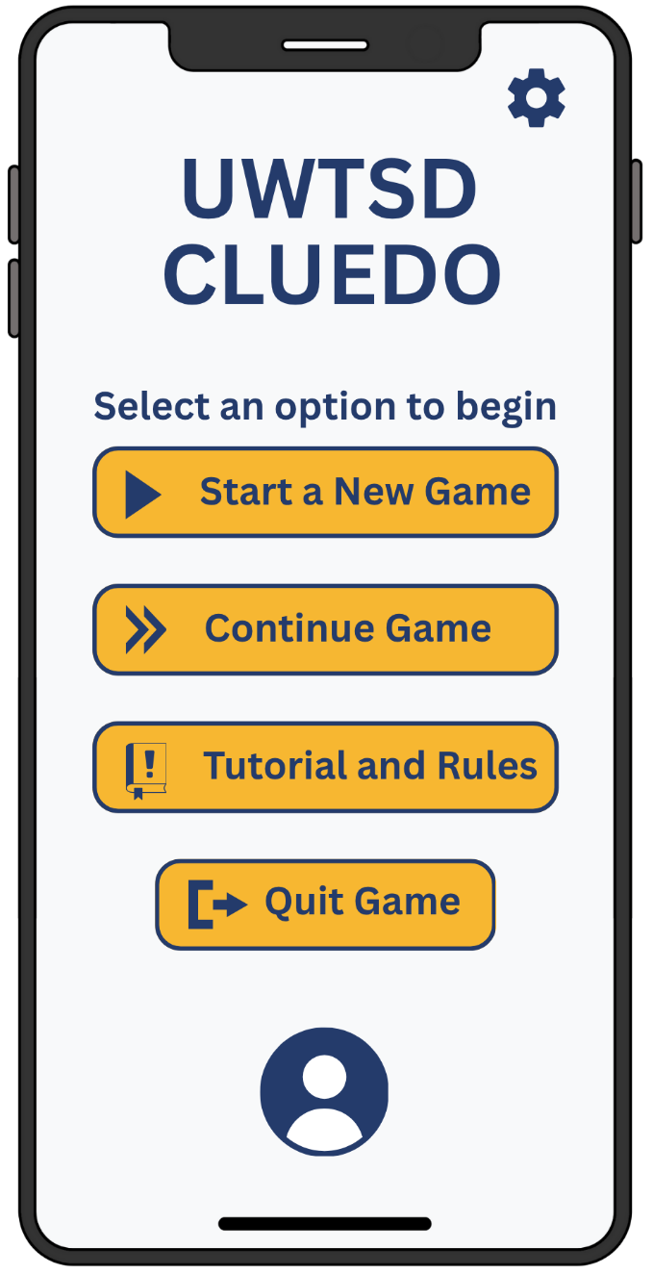
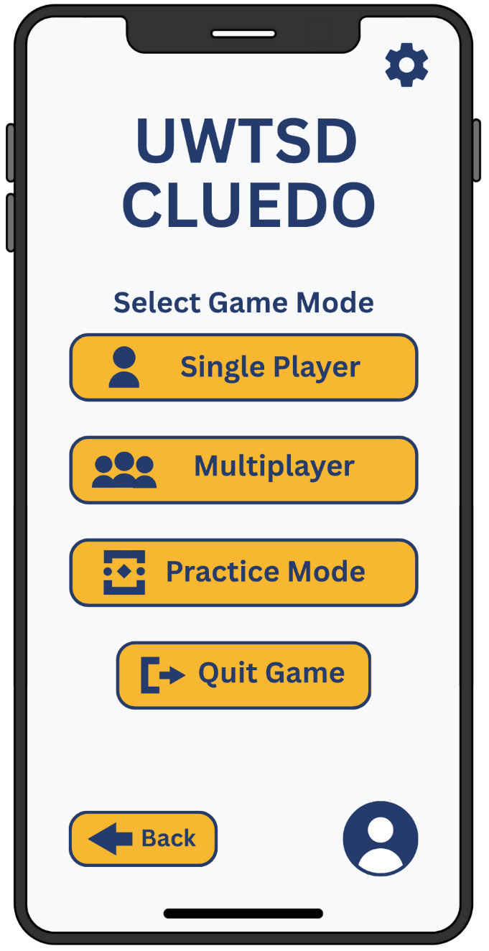

Figure 1. Mode Selection – distinct, easy-to-scan options for choosing the game mode.

Figure 2. Main Menu – clean, well-spaced entry screen that guides the player instantly to core actions.

The gameplay screen (Figure 3) focuses on guiding the player through each turn with minimal confusion. The layout supports Persona 1’s fast decision-making while still being easy to follow for Persona 2, who prefers visual clarity. The action buttons at the bottom keep the main interactions in one place, reducing unnecessary navigation and making the flow of the game more intuitive compared to the wireframe version [7].
The Settings menu (Figure 4) is structured to help users adjust the experience simply and predictably. The options are grouped clearly so that users like Persona 4 can navigate quickly, while Persona 2 benefits from seeing each category separated and easy to understand. The spacious layout also supports Persona 3, who needs straightforward screens that reduce the chance of accidental taps [8].

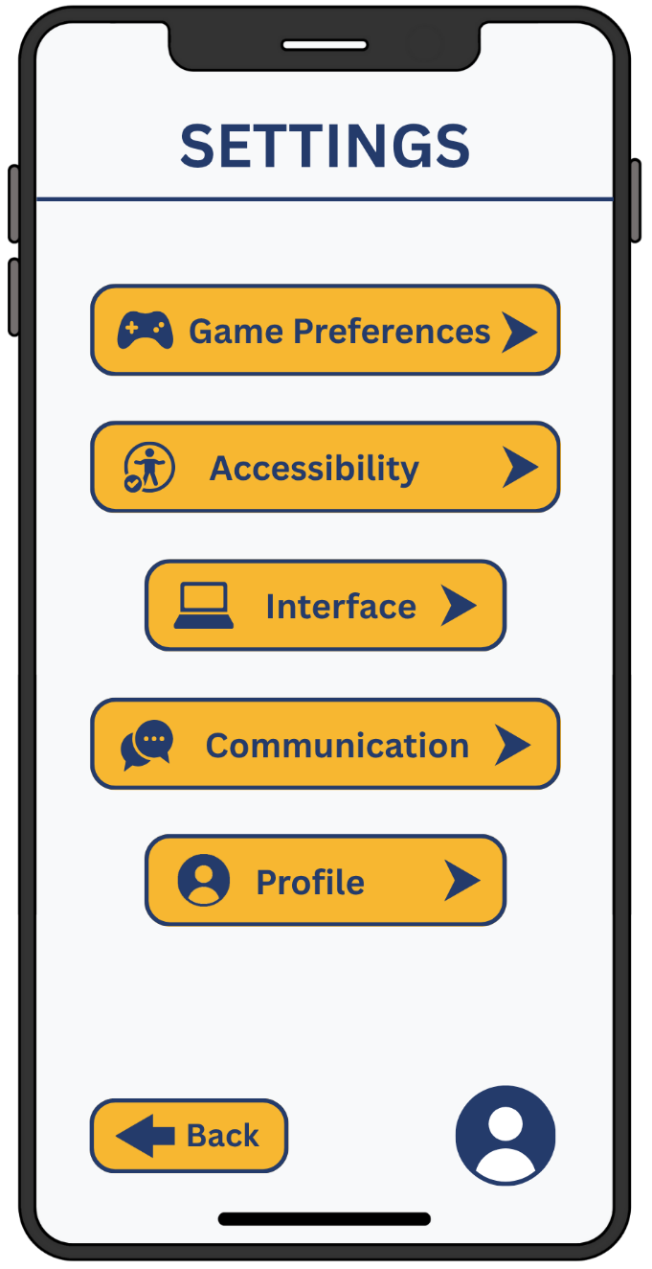
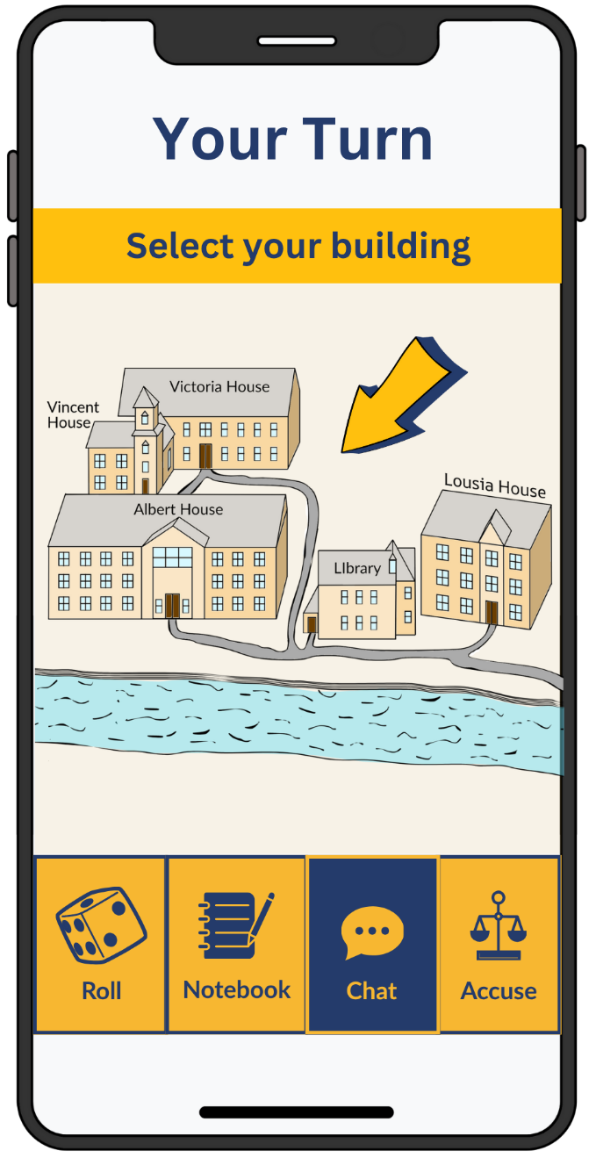

Figure 3. Settings – organised options that let players adjust the game without effort.
Figure 4. Gameplay – focused turn layout that keeps all main actions within easy reach.

The Accusation (Figure 5) screen is designed to keep the final decision simple and structured. The three selection steps are presented in a clear sequence so that users like Persona 2 can follow the logic without confusion. The simple, well-separated choices also help Persona 3 avoid mis-taps at this stage, where selecting the wrong option would affect the outcome. Compared with the wireframe, the final version makes the decision flow more obvious and limits the chance of choosing the wrong option by mistake [9].
The Game Over screen (Figure 6) focuses on giving players clear feedback and a quick next step. Persona 1 benefits from the immediate “Play Again” option, while Persona 4 can check the statistics without navigating through multiple menus. By grouping the results, stats, and actions in a simple layout, the screen feels easy to understand for all personas and avoids the clutter seen in the early wireframe version [10].
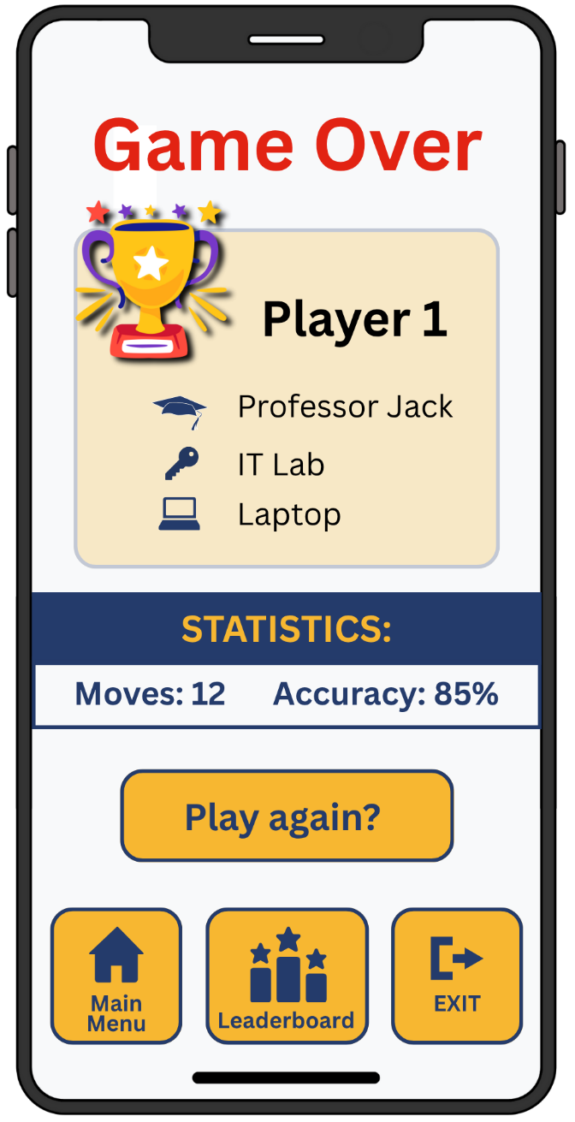
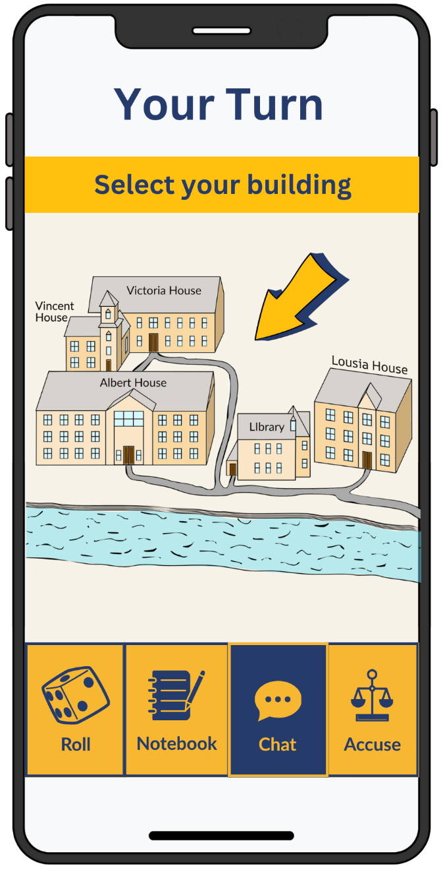

Figure 5. A concise summary of results with direct options for the next step.
Figure 6. A clear three-step choice for making the final accusation confidently.
Across all screens, the colour storyboards introduce improvements that directly reflect user testing from Component 1 and core principles of interaction design. The interface is now more accessible, more consistent, and easier to navigate thanks to clearer visual hierarchy, improved contrast, and larger controls. These changes are supported by usability research, which emphasises the importance of consistent patterns, simplified layouts, and strong visual cues in mobile game interfaces [11]. The complete set of storyboards is included in the Appendix A, while this section has presented the main screens to show how design ideas evolved into a polished, functional visual system aligned with the needs of the identified personas.

Feedback collected from Users for the Prototype

The feedback for the interactive prototype was collected using a small but carefully selected group of participants, the same four personas defined in Component 1. Because each of them represented a different set of needs, backgrounds, and expectations, involving all four ensured that the testing covered the full range of user types identified earlier [12]. This gave the evaluation a balanced perspective, mixing fast-thinking players, users who prefer clarity and calm pacing, a participant with motor limitations, and a detail-oriented technical user [13].
To keep the process natural, each participant tested the prototype using Adalo, where they could tap through the screens exactly as they would in a real game. This allowed them to experience transitions, button placement and the overall rhythm of the app rather than imagining it from static images.
The usability feedback was mostly positive. All users said that the coloured version felt easier to understand than the older wireframes because the spacing, icons, and consistent style made the interface “calm” and “simple to follow”. Persona 3 mentioned that the larger buttons and wider gaps reduced mis-taps, which confirmed that the adjustments from the storyboard stage were effective. Persona 1 appreciated that he could reach the main actions in just a couple of taps, and he described the flow as “fast and clean”. Persona 2 found the icons helpful, especially in the gameplay screen, where he relied more on visuals than text.
Not all comments were expected. For example, Persona 4 was more sensitive to balance and spacing than anticipated and pointed out small alignment issues that other users did not notice. Persona 1 also requested a slightly quicker transition between screens, which helped refine the pacing. These observations were valuable because they pushed the design towards a more polished and universal solution [14].
Overall, the feedback confirmed that the prototype successfully matched the needs of all four personas. Each user recognised improvements compared to the earlier wireframes, and their emotional responses helped validate that the interface felt approachable, modern, and intuitive. The insights gathered here directly guided the refinements shown in the final storyboard set and set a strong foundation for the next design stage [15].

Information collected from users for the working version of the Mobile App to be potentially built and released

When designing the working version of the UWTSD Cluedo mobile app, it becomes important to understand what information should be collected from real users. The purpose is not only to improve the interface but also to make sure the game continues to support the needs of the four personas defined. A thoughtful collection of data helps refine navigation, pacing, and accessibility without overwhelming users or invading their privacy [16].
The first type of information needed is usage data. This includes the practical elements of interaction: which screens users visit most often, how long they stay on each part of the game, where they hesitate, and which actions they repeat. Such behavioural patterns help identify areas that feel slow, confusing, or poorly placed. For example, if many players return to the notebook before making an accusation, this indicates that the notebook is central to decision-making and may require even faster access. Usage data is factual and objective and can be collected automatically through built-in analytics without interrupting the player’s flow. This automatic approach makes it especially useful for large-scale improvement, as it highlights patterns across hundreds of sessions [17].
In contrast, usage data alone cannot explain the full experience. Two users may interact with the same screen in the same way but feel completely different. This is where emotional and subjective feedback becomes essential. The working version would include short, optional micro-surveys after a game or after trying a feature for the first time. These questions would ask about clarity, frustration, enjoyment, and overall comfort. This distinction between what users do and what they feel is important [18]. As highlighted in evaluation practice, a user can complete a task successfully while still feeling unsure or uncomfortable. For this reason, the app needs both behavioural data and voluntary subjective feedback, so that performance and emotional experience can be understood together.
For accessibility-focused users like Persona 3, automatic data is not always enough. A system cannot automatically detect mis-taps, hand fatigue, or physical difficulty with controls. In these cases, direct interaction—short interviews, follow-up questions, or guided sessions- remains valuable. These conversations help uncover the reasons behind certain behaviours, something no analytics tool can capture on its own [19].
Another category is technical performance data, such as loading times, animation delays, or device-specific issues. This information is collected automatically and helps maintain a smooth experience for users like Persona 4, who are more sensitive to performance inconsistencies.
The working version would rely on a balanced combination of automatic analytics and direct human feedback. Usage data shows what users do, while emotional and accessibility-focused feedback explains how they experience the interface [20].

Additional Usability Considerations

If the app had been approached strictly from a usability-only perspective, the storyboards would have looked noticeably different. Usability tends to push designs towards maximum efficiency, minimum decoration, and a strong focus on clarity and task completion. In contrast, the version created for this project aimed to balance usability with a pleasant overall experience, which meant keeping some elements that support atmosphere, theme, and emotional engagement [21].
For example, the Main Menu would have been even simpler in a purely usability-driven approach. Instead of using icons, spacing, and a friendly layout, the screen could have relied on plain, high-contrast buttons with minimal visual styling. While this would increase efficiency, it would make the interface feel less inviting for users like Persona 2, who respond better to a calm and visually supported layout. So, the final version kept a balanced design instead of going fully functional [22].
A second conflict appeared in the Gameplay screen. From a usability viewpoint, the focus would be on speed: larger buttons, less detail in the map, and fewer visual elements. But the map is important for the game’s identity. Completely removing stylistic elements would have made the experience feel flat and less engaging. Instead, the final design kept the map visually present while simplifying colours and reducing distractions, offering both clarity and a sense of place [23].
The Accusation screen also illustrates a useful compromise. Usability alone would suggest one large list per category (suspect, weapon, location) and the fastest possible selection method. However, using slightly more visual separation made the decision easier to process for Personas 2 and 3. It slowed the interaction by a second but improved accuracy and confidence.
Another area where usability and experience influenced each other was pacing. A purely usability-driven design might reduce transitions to a minimum, switching instantly between screens. But during testing, Persona 1 and Persona 4 found extremely fast transitions slightly confusing. Slowing transitions just enough to feel natural improved comprehension without harming efficiency [24].
The conflicts between usability and user experience were solved by choosing clarity first, but without removing the elements that made the app feel friendly, thematic, and approachable. The final storyboards represent a careful middle point where usability supports the experience, and the experience supports the usability.

Personal Reflection

Working on this project did not feel like a simple exercise in arranging screens; it felt more like learning to observe with greater attention. At the start, the process was shaped mainly by wireframes, personas, and theoretical principles. However, once the prototype began to reflect real user needs, the work gained a different meaning. Interactions imagined in Component 1 became clearer when the storyboard screens were analysed through the lens of the personas, especially those representing users with motor or cognitive difficulties. Seeing that the design choices supported these needs without creating frustration offered a strong sense of purpose.
A continuous balance had to be maintained between efficiency and warmth. Strict usability pushed the design toward minimalism, while user experience encouraged a more inviting and recognisable interface. The map on the gameplay screen is a good example: simplifying it too much would have improved speed but removed its character, while keeping it visually heavy would have reduced clarity. The final version showed that usability and visual identity can coexist when decisions are made carefully.
Unexpected feedback also played an important role in shaping the outcome. Small comments and details that had not been noticed initially guided adjustments that improved clarity, consistency, and comfort. This process reinforced the idea that design is not about imposing a vision but about shaping an environment that feels natural for different types of users.

References
[1] P. Weichbroth, "Usability testing of mobile applications: A methodological framework," Applied Sciences, vol. 14, no. 5, pp.1792, 2024.
[2] J. Nielsen. "10 Usability Heuristics for User Interface Design." Nielsen Norman Group. https://www.nngroup.com/articles/ten-usability-heuristics/
[3] M. A. Faudzi, et al., "User interface design in mobile learning applications: Developing and evaluating a questionnaire for measuring learners' extraneous cognitive load," Heliyon, vol. 10, no. 18, 2024.
[4] J. Natarajan, "From Wireframes to Interfaces: Developing a Practical Framework for UI/UX Design," 2025.
[5] J. E. Reyes Arias, et al., "Accessibility feedback in mobile application reviews: A dataset of reviews and accessibility guidelines," CHI Conference on Human Factors in Computing Systems Extended Abstracts, 2022.
[6] M. Muhanna, A. Masoud and A. Qusef, "Usability heuristics for evaluating Arabic mobile games," International Journal of Computer Games Technology, vol. 2022, no. 1, pp.5641486, 2022.
[7] Z. Li, "Research on Interactive Interface Design," Proceedings of the 2nd International Conference on Culture, Design and Social Development (CDSD 2022), 2023.
[8] J. Fernández and J. A. Macías, "Heuristic-based usability evaluation support: A systematic literature review and comparative study," Proceedings of the XXI international conference on human computer interaction, 2021.
[9] V. Hsu and D. B. Ling, "A study of the Material Design for mobile game UI/UX," International Symposium on Affective Science and Engineering ISASE2023, 2023.
[10] Z. Huang and M. Benyoucef, "An Empirical Study of Mobile Application Usability: A Unified Hierarchical Approach," Int.J.Hum.-Comput.Interact., vol. 39, no. 13, pp.2624–2643, 2023. doi: 10.1080/10447318.2022.2082021.
[11] A. Andersson, "How to design a user-friendly mobile user interface with the power of visual usability," 2021.
[12] A. Inan Nur, H. B. Santoso and P. O. Hadi Putra, "The method and metric of user experience evaluation: a systematic literature review," Proceedings of the 2021 10th International Conference on Software and Computer Applications, 2021.
[13] N. F. Syahrozad and A. P. Subriadi, "Evaluation of user experience: a systematic literature review," E3S Web of Conferences, 2024.
[14] J. Gothelf and J. Seiden,Lean UX : designing great products with agile teams, Sebastopol, California: O'Reilly Media, Incorporated, 2021.
[15] A. Berni and Y. Borgianni, "FROM THE DEFINITION OF USER EXPERIENCE TO A FRAMEWORK TO CLASSIFY ITS APPLICATIONS IN DESIGN," 2021. doi: 10.1017/pds.2021.424.
[16] Y. Liu, et al., "Enhancing user engagement through adaptive UI/UX design: A study on personalized mobile app interfaces," Computer Science & IT Research Journal, vol. 5, no. 8, pp.1942–1962, 2024.
[17] H. Lee, J. Park and U. Lee, "A systematic survey on android api usage for data-driven analytics with smartphones," ACM Computing Surveys, vol. 55, no. 5, pp.1–38, 2022.
[18] A. Dirin, M. Nieminen and T. H. Laine, "Feelings of being for mobile user experience design," International Journal of Human–Computer Interaction, vol. 39, no. 20, pp.4059–4079, 2023.
[19] L. Seixas Pereira, M. Matos and C. Duarte, "Exploring mobile device accessibility: challenges, insights, and recommendations for evaluation methodologies," Proceedings of the 2024 CHI Conference on Human Factors in Computing Systems, 2024.
[20] S. A. Perrig, et al., "Measurement practices in user experience (UX) research: A systematic quantitative literature review," Frontiers in Computer Science, vol. 6, pp.1368860, 2024.
[21] P. Simsek Caglar, V. Roto and T. Vainio, "User experience research in the work context: Maps, gaps and agenda," Proceedings of the ACM on Human-Computer interaction, vol. 6, no. CSCW1, pp.1–28, 2022.
[22] K. Scholleová, "Hedonic or pragmatic preferences? A comparative analysis of Android and iOS users from the perspective of UX and information behaviour," 2021.
[23] S. Gulzar and N. A. Ansari, "Understanding Usability Challenges in Educational Games Through the Lens of the Mechanics, Dynamics and Aesthetics Framework," ProScholar Insights, vol. 4, no. 1, pp.185–197, 2025.
[24] L. Corral, I. Fronza and T. Mikkonen, "User Interface matters: analysing the complexity of mobile applications from a visual perspective," Procedia Computer Science, vol. 191, pp.9–16, 2021.

Appendices
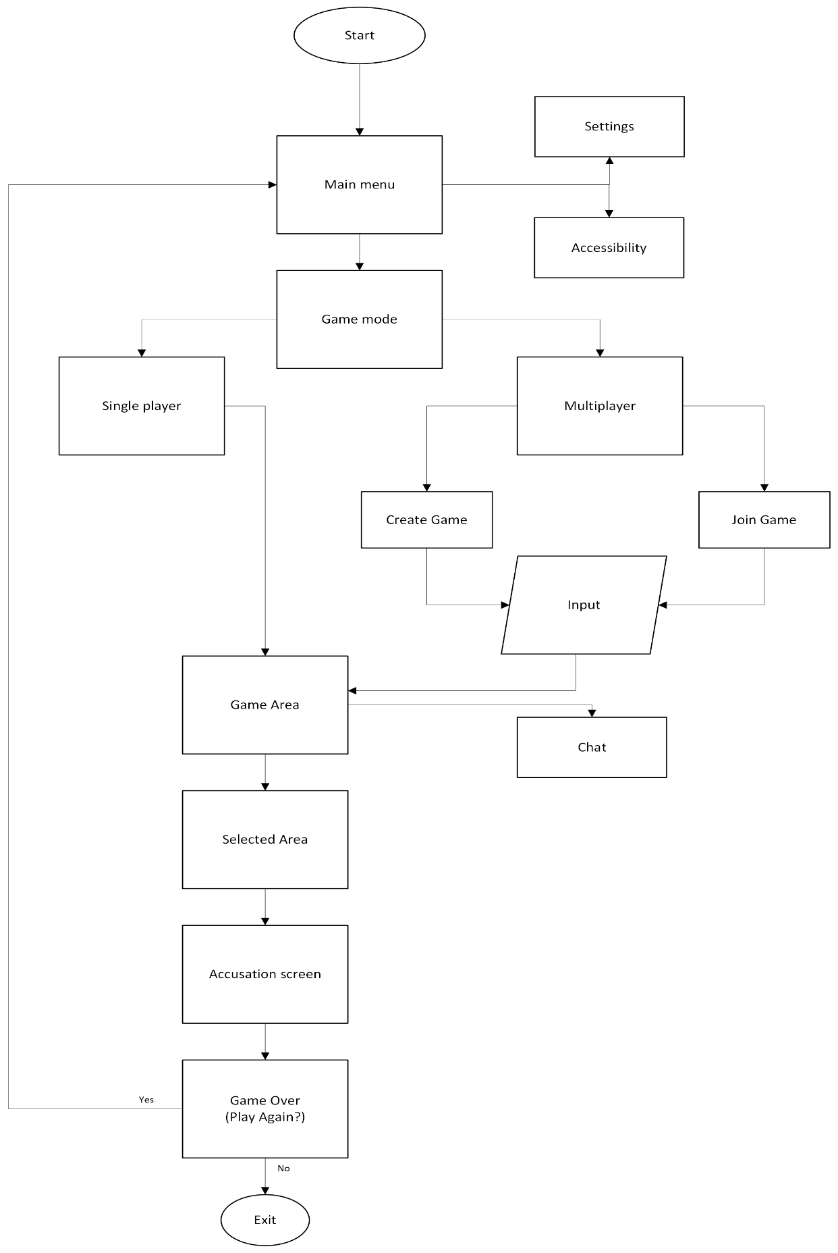
Figure 7. Game flowchart



