
(Source: Pixabay.com, 2023
Programme: MBA – Master of Business Administration | Module: International Business
Module code: LCMB7014 | Lecturer: Lan Dang
Student Name: Stilyana Mincheva | Student ID number:1816276
Assignment Title: International Business | Submission date:28/07/2023
Word count: 5000 words

Table of Contents
Introduction 4
Objective and Scope of the Report 4
Significance of Internationalisation Strategy in the Business Environment Globally 4
Background Details on AstraZeneca 5
Internationalisation Strategies: Ethnocentric, Polycentric, and Geocentric Approaches 6
Definition and Explanation of Ethnocentric, Polycentric, and Geocentric Strategies 6
Characteristics, Advantages, and Limitations of Three Strategies 7
AstraZeneca's Adoption of One of These Strategies for Its Foreign Subsidiaries 9
Evaluation of the Interrelation Between Political, Economic, Social, Technological, Environmental and Legal Factors Influencing AstraZeneca's Choice of Engagement Approach. 10
PESTEL Analysis of the Host Country – India, and Opportunities and Challenges which AstraZeneca can face. 11
Discussion of How These Contextual Factors Align with AstraZeneca's Strategic Objectives and Operational Capabilities 18
Identification and Analysis of Critical Features Contributing to the Business Environment Internationally. 20
Analysis of Central Institutions Influencing Business Operations Internationally 22
Critical Decisions Underpinning Organizational Strategy at International Level 23
Discussion Related to Strategic Decisions Engaged in International Organisational Strategy 23
Evaluation of the Factors Influential for Decision-Making in the Formulation of International Business Strategy 23
Examination of How These Decisions Impact the Internationalisation Approach of AstraZeneca. 24
Methods of Engagement with International Markets 25
Explanation of Different Methods of Engagement with International Markets 25
Significance of Contextual Factors That Stimulate AstraZeneca's Choice of Internationalisation Strategy 26
Research and Theoretical Insights on International Business Issues 27
Overview of Relevant Research and Theoretical Insights on International Business Issues 27
Application of Theoretical Frameworks to the Analysis of AstraZeneca's Internationalisation Strategy 29
Evaluation of the Appropriateness and Effectiveness of the Chosen Strategy Depending on Theoretical Perspectives 30
Conclusion 30
References 31

Introduction

Objective and Scope of the Report
This report will provide an overview of the international business environment using the PESTLE framework and identify and evaluate the main components contributing international business environment before analysing key institutions that influence international business operations. In addition, critical decisions supporting the global strategy would be discussed with proper evaluation and examination. Other factors about international business, processes, procedures, issues, and others would be addressed. This would benefit the learnings related to the global business strategy of companies, especially pharmaceutical companies like AstraZeneca and their choice of an international approach to expand in India.

Significance of Internationalisation Strategy in the Business Environment Globally
International business is based on predicting tangible flows of services and goods, monetised transactions out of national borders, and limited access to open resources to compete in a larger market environment full of challenges (Nambisan et al. 2019). Global strategy development in a business environment is essential to achieve a successful business supporting sales increment, increasing brand awareness and resources reducing cost budget while selling services and goods outside its domestic market field. AstraZeneca is committed to implementing a focused biopharmaceuticals strategy globally, which is innovation-driven. This lets the company take advantage of diversified risks, economic scale, and flexibility. Business internationalisation emphasises the association between countries, people, systems, institutions, and cultures. In addition, it helps in achieving competitive advantages, customer satisfaction, and other opportunities for doing business and earning more profit percentage by that.

Background Details on AstraZeneca
The leading multinational British and Sweden-based company AstraZeneca is one of the tops among ten pharmaceutical companies in the world; founded in 1913, that does operations for developing products that are helpful for therapy areas such as cardiovascular, respiratory, metabolic, and renal diseases, autoimmune, neurological diseases, and cancer. The organisation is a globally recognised, patient-focused, science-led pharmaceutical company dedicated to transforming the healthcare industry's future by unveiling the power of science. All AstraZeneca operations aim to do better for society, people, and the planet (AstraZeneca, 2022). AstraZeneca works with the mission to transform people’s lives affected by rare diseases through various activities to develop and deliver innovative medicines with supportive technologies for healthcare services. The company revenue was nearly 43 billion USD in 2022.
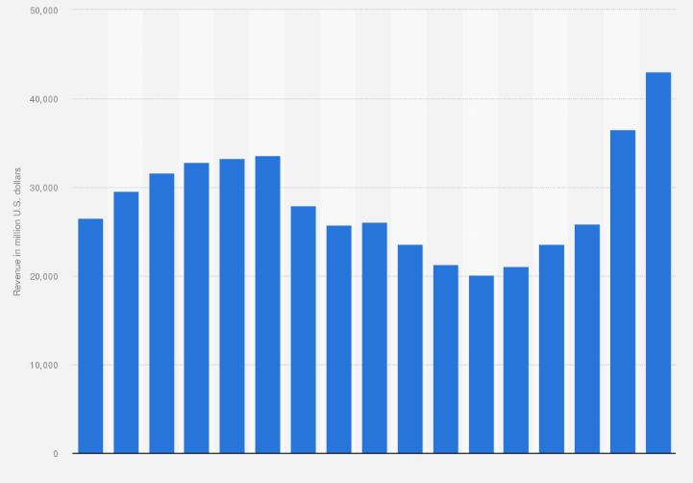
Figure 1: Revenue of AstraZeneca
(Source: Statista, 2023)

Internationalisation Strategies: Ethnocentric, Polycentric, and Geocentric Approaches

Definition and Explanation of Ethnocentric, Polycentric, and Geocentric Strategies
An internationalisation strategy refers to selling services or products outside the domestic market. The international market has plenty of opportunities to get fruitful results from the host market. Heightened globalisation, enhancing network value chain and technological advances are needed not only for organisation growth but slow to evolve outside the boundary (Gnizy, 2019). Companies are only focused on three strategies for efficiently advancing in the international market, which are polycentric, ethnocentric, and geocentric.
Ethnocentric Approach: when a company goes from a domestic country to its host country, it must face several difficulties like cultural differences, language barriers and colossal competition. To solve such issues, the company adopts ethnocentric approaches focusing on the home country's ethics, beliefs, and values (Karasu et al., 2022). Formulated strategies are for domestic governments, and international business becomes secondary. The first business charter is created for the demand of the domestic country and the surplus trade distributed in foreign countries.
Polycentric Approach: Following the policy, business owners focus on the demand of the host country. Hence, every country has its different culture and different preferences. Therefore, businesses must comply with the host country's requirements to capture a significant market. That is why enterprises open subsidiaries in adherence to the customs and practices of the host country (Zhu, 2019). For example, Starbucks and McDonald's use polycentric approaches. These subsidiaries can independently make decisions, and the home country’s personnel occupies their crucial position. Lastly, the remaining parts are occupied by the host country’s employees.
Geocentric Approaches: in this approach, business owners consider the whole world as a single country where a large-scale business is operated. The best talent is required under these companies, and many subsidiaries are located worldwide (Dar, 2019). This approach is mainly used by giant companies like Dell and Apple.

Characteristics, Advantages, and Limitations of Three Strategies
Ethnocentric Approach
Characteristics | - This approach is home-country oriented.  - The critical position of the company is occupied by home country staff.  - The policy and regulations of the home country are applied to subsidiaries.
Advantages | - The company does not need to fledge the international labour market entirely.  - Build competitive advantage through an emphasis on authenticity and differentiation strategy (Bryła, 2019)  - Better coordination incurred between the subsidiary and parent company.
Limitation | - Maintaining the host country’s subsidiaries from the home country can be difficult.  - The company might fail; to recruit prominent employees from the host country.
Polycentric Approach
Characteristics | - In this approach, the company gives priority to the host country's culture and preferences.  - Company key figures need to update business progress to headquarters; however, it has the authority to make decisions (Lofthouse and Herzberg, 2023)
Advantages | - This approach helps to increase the morale of employees tremendously.  - It saves huge money on relocation and hiring.  - It builds up cultural knowledge and local support which promote business growth.
Limitation | - The connection between subsidiaries and the parent company becomes poor.  - The operational process within the company becomes problematic.
Geocentric Approach
Characteristics | - Employees are recruited with the best talent irrespective of nationality.  - Most of the manger previous experience in the job  - A good collaborative approach is present between subsidiaries and the company.
Advantages | - Uniform strategy is applied at home and aboard country (Vogelsang and Pilz, 2021)  - A diverse culture in a corporation conducted through a geocentric approach (Gong et al. 2021)  - Racism and biases can be alleviated through this approach.
Limitation | - The cost of training an employee is high.  - Relocation of staff from partner companies to subsidiaries is high.

AstraZeneca's Adoption of One of These Strategies for Its Foreign Subsidiaries
The above section highlights three approaches where ethnocentric approaches focus on the home country and poly-centric approaches focus on the host country's needs. In the case of Geocentric, it considers the whole world a single unit.
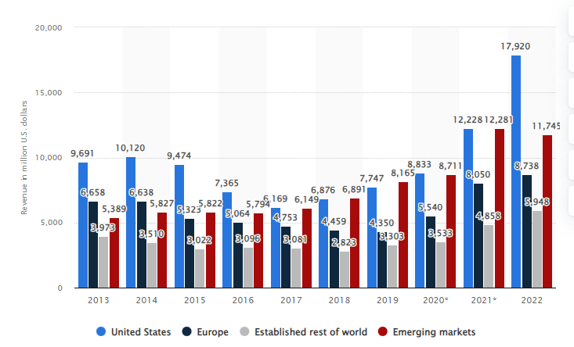
Figure 3: Revenue of AstraZeneca from Different Regions
(Source: Statista, 2023)
AstraZeneca falls under one of the most successful and leading pharmaceutical companies. AstraZeneca owns many subsidiaries worldwide, generating a revenue of 42,998 million dollars in 2022 (Statista, 2023). The above figure shows income earned from established and emerging markets where the US offers promising numbers. AstraZeneca provides freedom to national businesses to conduct operations which are appropriate for the market. In the meantime, the company tries to construct an identical mindset commonly shared within the employee's mind. AstraZeneca operates in countries like the UK, Sweden, the US, Germany, Canada, Poland and India which denotes a large-scale subsidiary (AstraZeneca, 2023). The geocentric approach will be the best for the company. Henceforth it operated in different countries. It helps companies to recruit the best talent irrespective of their nationality. For instance, AstraZeneca can overcome language barriers by recruiting prominent local employees. Google, Coca-Cola, and Apple also adopt geocentric approaches in expanding in different countries (Grgić, 2020). The company can implement local business philosophies in the host country's business. AstraZeneca should adopt Geocentric approaches; hence it treats every market as one.

Evaluation of the Interrelation Between Political, Economic, Social, Technological, Environmental and Legal Factors Influencing AstraZeneca's Choice of Engagement Approach.
Interconnection between external factors must be identified to understand host countries' cultures. Professionals use this process for decision-making regarding business progression. Government, regulatory and political factors are crucial for understanding the host countries' legal norms, which must be complied with for expanding in other countries (García-Álvarez et al. 2019). On the other hand, culture and environment help to understand the preferences of host countries' people that support AstraZeneca to create an appropriate strategy. In case the culture of an area is to buy quality products despite the high price, a cost leadership strategy will not be effective. At that time, the company needs to manufacture quality products to meet the company’s needs.

PESTEL Analysis of the Host Country – India, and Opportunities and Challenges which AstraZeneca can face.
Political Opportunities for AstraZeneca in the Indian Pharmaceutical Market:
Favourable Government Policies: 2.5 political index shows solid and effective political stability. The Indian government has actively promoted the pharmaceutical sector by attracting foreign investment, encouraging research and development, and fostering innovation. AstraZeneca can benefit from these policies to expand its presence and investments in India. (mca.gov, 2023)
Growing Healthcare Access Initiatives: India has been implementing healthcare access programs, such as the National Health Protection Scheme (Ayushman Bharat), to improve healthcare services for millions of citizens. AstraZeneca can align its product offerings to cater to the demand generated by such initiatives. (india.gov.in, 2023)
Partnerships and Collaborations: AstraZeneca can explore partnerships and collaborations with the Indian government, research institutions, and local pharmaceutical companies to enhance its market presence, facilitate technology transfer, and access regional expertise.
Political Challenges for AstraZeneca in the Indian Pharmaceutical Market:
Regulatory Complexity: The Indian pharmaceutical market is subject to complex and evolving regulations, including pricing controls and stringent approval processes. Companies of India are controlled by “Companies Act, 2013”. The FDI police manage foreign investment in India. (MCA. gov,2023)
Navigating these regulations can be challenging for AstraZeneca and may lead to delays in product launches and increased compliance costs.
Intellectual Property Rights Protection: While India has improved its intellectual property protection, concerns about patent enforcement and data exclusivity still exist. AstraZeneca must safeguard its intellectual property to prevent unauthorised generic competition.
Price Control Measures: The Indian government has implemented price control mechanisms for essential medicines to ensure affordability and accessibility. These controls can impact the pricing and profitability of AstraZeneca's products in the Indian market.
Trade Policies and Import Duties: Changes in trade policies or the imposition of import duties can impact AstraZeneca's supply chain and distribution costs, mainly if the company relies on importing certain raw materials or finished products.
Economic Challenges for AstraZeneca in the Indian Pharmaceutical Market:
Price Sensitivity: India is known for its price-sensitive market, and the pharmaceutical industry is no exception. The demand for low-cost medicines can create challenges for AstraZeneca, which primarily deals with innovative and higher-priced drugs.
Generic Competition: The Indian pharmaceutical market has a significant presence of generic drug manufacturers, leading to intense competition and pricing pressure for multinational pharmaceutical companies like AstraZeneca.
Affordability and Access: While India presents a vast market, ensuring affordability and access to healthcare services and pharmaceutical products can be challenging, especially in rural and economically disadvantaged areas. (India.gov.in, 2023)
Healthcare Infrastructure: India's healthcare infrastructure varies across regions, with rural areas often facing inadequate facilities and limited access to medicines. AstraZeneca may encounter logistical challenges in reaching these underserved areas.
Economic Opportunities for AstraZeneca in the Indian Pharmaceutical Market:
Growing Healthcare Expenditure: India's healthcare expenditure has been increasing steadily, driven by a growing middle-class population and rising healthcare awareness. Indian GDP growth rate will be 6.4% by 2023, and the inflation rate will be 6.67 % in 2022 (Statista,2023). AstraZeneca can benefit from this trend as it indicates a higher demand for pharmaceutical products and healthcare services.
Significant and Diverse Market: India's population of over 1.3 billion represents a vast and diverse market with various healthcare needs. (Statista, 2023) AstraZeneca can tap into this market by offering a wide range of pharmaceutical products catering to different segments.
Favourable Demographics: India has a large and ageing population, which creates significant demand for medications related to chronic diseases and age-related conditions. AstraZeneca can capitalise on this demographic trend by offering relevant drugs and therapies.
Increasing Focus on Research and Development: India has been gradually increasing its focus on research and development in the pharmaceutical sector. Collaborating with Indian research institutions or investing in R&D facilities in India can provide AstraZeneca access to local expertise and insights. (India.gov.in, 2023)
Social Opportunities for AstraZeneca in the Indian Pharmaceutical Market:
Increasing Healthcare Awareness: Healthcare awareness has increased in India, with people becoming more conscious of their health and seeking better medical treatments. AstraZeneca can leverage this trend to create awareness about its pharmaceutical products and therapies.
Disease Burden: India faces a significant burden of non-communicable diseases such as cardiovascular diseases, diabetes, and respiratory illnesses. AstraZeneca can address these healthcare needs by focusing on therapeutic areas like cardiovascular and respiratory medicine.
Focus on Preventive Healthcare: There has been a growing emphasis on preventive healthcare measures in India. AstraZeneca can play a role in promoting preventive medications and therapies to reduce the incidence of certain diseases.
Healthcare Partnerships: AstraZeneca can collaborate with various stakeholders in the Indian healthcare ecosystem, including healthcare providers, non-profit organisations, and patient advocacy groups, to improve patient access and outcomes.
Social Challenges for AstraZeneca in the Indian Pharmaceutical Market:
Healthcare Disparities: India faces significant healthcare disparities between urban and rural areas, with urban centres typically having better access to healthcare facilities and services. AstraZeneca may face challenges ensuring equitable access to its pharmaceutical products across different regions.
Cultural and Language Diversity: India has multiple languages, cultures, and belief systems. AstraZeneca must consider these cultural nuances while designing marketing and educational campaigns for its products.
Generic Preference: Generic drugs are widely accepted and preferred in India due to their lower cost. Convincing consumers to choose branded pharmaceutical products over generics can take time for AstraZeneca.
Vaccine Acceptance: Recently, vaccine hesitancy has been a concern in some parts of India. AstraZeneca, focusing on vaccines, may face challenges in gaining public acceptance and ensuring widespread vaccination. (India.gov.in, 2023)
Technological Opportunities for AstraZeneca in the Indian Pharmaceutical Market:
Digital Health Solutions: India has been witnessing a growing adoption of digital health solutions, including telemedicine, health apps, and electronic health records. “Information Technology Act, 2000” must comply with every IT sector of India (meity.gov, 2023). AstraZeneca can explore opportunities to integrate its pharmaceutical products with digital health platforms to enhance patient engagement and healthcare outcomes.
Artificial Intelligence and Data Analytics: Leveraging artificial intelligence and data analytics can significantly benefit drug discovery, clinical trials, and personalised medicine. AstraZeneca can collaborate with Indian technology companies and research institutions to harness these technologies effectively.
Manufacturing Automation: Automation and advanced manufacturing technologies can improve efficiency and reduce production costs for pharmaceutical companies. AstraZeneca can invest in state-of-the-art manufacturing facilities in India to enhance its production capabilities.
E-commerce and Direct-to-Consumer Channels: The growth of e-commerce in India allows AstraZeneca to reach a broader consumer base and offer its products directly through online platforms.
Technological Challenges for AstraZeneca in the Indian Pharmaceutical Market:
Data Security and Privacy: As digital health solutions and data-driven technologies become more prevalent, ensuring data security and privacy becomes crucial. AstraZeneca must comply with Indian data protection regulations and build trust among patients and healthcare providers regarding data handling.
Connectivity and Infrastructure: India's technological landscape varies across regions, and some areas may need more internet connectivity and infrastructure. AstraZeneca may face challenges in implementing digital health solutions in such areas.
Regulatory Compliance for Technology Integration: Integrating pharmaceutical products with digital health solutions might involve regulatory complexities. AstraZeneca must navigate these regulations to ensure compliance with Indian laws.
Intellectual Property Protection for Technology: Protecting intellectual property related to technological advancements is vital. AstraZeneca must implement robust strategies to safeguard its technology-related innovations from infringement and unauthorised use.
Environmental Opportunities for AstraZeneca in the Indian Pharmaceutical Market:
Sustainable Manufacturing Practices: Implementing sustainable manufacturing practices can help AstraZeneca reduce its environmental footprint in India. Emphasising energy efficiency, waste reduction, and responsible water usage can enhance the company's reputation and appeal to environmentally conscious consumers.
Green Initiatives and Certifications: Participating in green initiatives and obtaining environmental certifications can demonstrate AstraZeneca's commitment to sustainability in its operations and products, potentially attracting environmentally conscious customers and partners.
Focus on Green Products: Developing and promoting eco-friendly pharmaceutical products can address the growing demand for environmentally sustainable solutions. AstraZeneca can explore research and development opportunities in green chemistry and ecologically friendly packaging areas.
Environmental Challenges for AstraZeneca in the Indian Pharmaceutical Market:
Waste Management: Proper pharmaceutical waste disposal, including unused or expired medications, is a significant environmental challenge. AstraZeneca needs to comply with waste management regulations to prevent environmental contamination.
Water Pollution and Resource Management: Pharmaceutical manufacturing processes can generate wastewater with potentially harmful substances. AstraZeneca must implement effective water treatment and resource management practices to mitigate environmental impacts.
Carbon Emissions and Transportation: Transportation of pharmaceutical products and raw materials contributes to carbon emissions. India aims to meet Zero carbon emissions by 2070 (Statista, 2023). AstraZeneca can explore ways to reduce its carbon footprint, such as optimising transportation routes and adopting cleaner energy sources.
Environmental Regulations and Compliance: India has increasingly focused on environmental regulations and sustainable practices. AstraZeneca must ensure compliance with these regulations to avoid potential penalties and reputational damage.
Legal Opportunities for AstraZeneca in the Indian Pharmaceutical Market:
Intellectual Property Protection: India has been improving its protection of intellectual property rights (IPR). AstraZeneca can leverage this improved IPR environment to protect its pharmaceutical innovations and prevent unauthorised use of its patented drugs. (meity.gov, 2023)
Collaborations and Licensing: AstraZeneca can explore partnerships and licensing agreements with Indian pharmaceutical companies to expand its product portfolio and market presence in India.
Regulatory Support for Innovation: The Indian government has been encouraging innovation in the pharmaceutical sector. AstraZeneca can use regulatory support for research and development, clinical trials, and faster drug approvals. (India.gov.in, 2023)
Legal Challenges for AstraZeneca in the Indian Pharmaceutical Market:
Generic Competition: The Indian pharmaceutical market has a robust presence of generic drug manufacturers, leading to intense competition and pricing pressure for branded pharmaceutical companies like AstraZeneca.
Price Control Measures: The Indian government has implemented price control mechanisms for essential medicines to ensure affordability and accessibility. AstraZeneca may need help to maintain pricing flexibility for its products. (india.gov, 2023)
Data Exclusivity: India's data exclusivity regulations may offer a different level of protection than in other countries. AstraZeneca must navigate data exclusivity laws to safeguard its clinical trial data and research investments.
Patent Enforcement: While India has improved patent enforcement, legal disputes regarding patents and intellectual property rights can still be complex and time-consuming.

Discussion of How These Contextual Factors Align with AstraZeneca's Strategic Objectives and Operational Capabilities
Above mentioned factors are all external factors that significantly affect the organizational operation, revenue, and personnel. To expand to a new country, a company must consider external factors to minimise consequences. According to Katsikeas et al. (2020), the company adopted a “Concentration and Spreading strategy” for expanding in the host market. That is why monitoring the dynamic nature of contextual factors allows a business to protect itself from unpredictable or unexpected changes.
Technological advances help break through from different colleges, like a healthcare provider can collect detailed information using modern technology.
When economic trends decrease, unemployment increases, henceforth it creates a business to appoint employees at fewer salaries (Pasara and Garidzirai, 2020)
Tariffs, Taxation, and employment law affect the advancement of business. For instance, a high corporate tax increases product prices. In India, corporate tax is high is 25%; henceforth, AstraZeneca faces enormous challenges to grab a stable position in this market.
Demographic factors, like age, gender and preferences, significantly affect business growth. For instance, Indian people prefer a specific composition of medicine that AstraZeneca needs to identify.
AstraZeneca's strategic objective is to return to its growth again and gain scientific leadership. CEO of AstraZeneca Pascal Soriot stated that their company has committed to providing great medicine through innovative science and excellent development. In addition, its vision is to create a “global biopharmaceutical company” where the investor gets attractive returns (AstraZeneca, 2023). Henceforth, AstraZeneca needs to consider factors that help establish a sustainable market. To maintain better operational capabilities, AstraZeneca needs to choose a financial structure and corporate entity that ramps growth (Forbes, 2023). Understanding contextual factors helps AstraZeneca choose a better internationalisation approach that meets its strategic objectives.

Identification and Analysis of Critical Features Contributing to the Business Environment Internationally.
In the international business ecosystem, the Uppsala Model of internationalisation has typically viewed the internationalisation process as a sequential process in stages. According to the model, gaining market knowledge through current activities, market commitments, and commitment decisions are key factors that lead to grabbing market opportunities. The model in 2009, with its modified version, set another four pillars stating knowledge opportunities, including decisions based on relationship commitment, learning, creating and building trust, and network position that helps recognise market opportunities. Next, in 2017 capabilities were added to the model that consists of commitment processes, knowledge development processes, and performance, which add more advantages to the international business environment. This evaluation made the business strategies become developed with time.

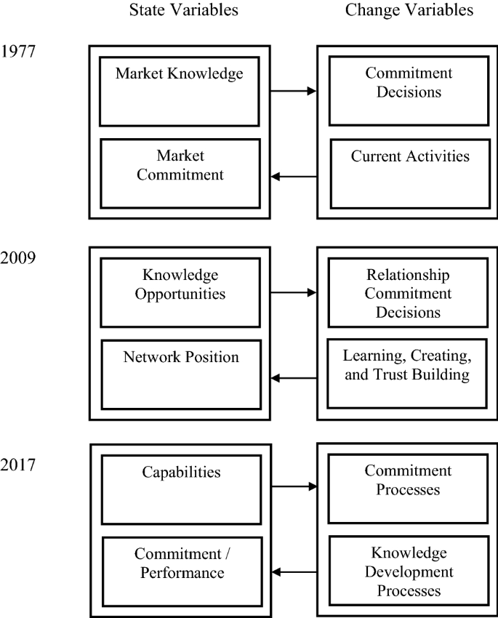
Figure 2: Upsala Model Evolution
(Source: Hult et al. 2020)
Research and development internationalisation as a part of innovation is another key contributor to the international business environment (Vrontis and Christofi, 2021). The UK-based company with global recognition AstraZeneca focuses on pushing the boundaries of science to provide life-changing medicines. Here innovation, science, and technology are working as factors in getting an advantage in business strategy adding scientific touch to healthcare and business. Innovation has become an integral part of the business community in the UK with a significant focus on R&D. AstraZeneca continuously invests in business for development and intends to build an R&D centre for more effectiveness in its operation (AstraZeneca, 2022b). This creates a great advantage to its business strategy to penetrate the global market with more potency.

Analysis of Central Institutions Influencing Business Operations Internationally
International organisations serve many diverse functions, including collecting market information and monitoring trends as per current times. There are more than 300 high-level intergovernmental organisations worldwide to work for business growth analysing international trade, capital market flows, foreign direct investments, diffusion of technology, and others. International trade associations are one of the leading institutions influencing global operations related to business.
Then with the association of 44 countries, different activities were established related to the “International Monetary Fund” or IMF, “The International Bank of Reconstruction and Development” or IBRD, and “international tragedy organisation” or ITO. All these three associations were recognised as three columns for global economic improvement. IBRD, or World Bank, is a significant name that carries a role in economic growth, foreign direct investment, and financial development. That provides data related to financial operations that help in market research and developing market strategies according to different business market environments (Nasir et al. 2019). World Bank is working way more than offering money simply for the development of infrastructure, industry, agriculture, and health. It works to reduce rural poverty and increase income rates that directly impact the business environment internationally. “International Development Association” helps underdeveloped country providing loans with simple terms that affect international business terms. “International Finance Corporation”, “Multinational Investment Guarantee Agency”, and others also work for financial development that impacts business strategy and operation internationally.

Critical Decisions Underpinning Organizational Strategy at International Level

Discussion Related to Strategic Decisions Engaged in International Organisational Strategy
Strategic decisions involve the entire environment in which an organisation operates—the resources and stakeholders who relate to the company and the collaboration between the two. The strategic choices look after the environment with the intention of development. Integration of agility in organisational operations or different operational areas of the supply chain, information technology, production, and others can help organisations drive improvement by making corporate strategic decisions (Shams et al. 2021). Strategic choices have enormous resources for organisational development and deal with administrative resource capabilities harmonising with different opportunities and threats. It involves changes in a corporate process for operating in an ever-changing environment. The complex nature of strategic decisions helps deal with future uncertainty along with others.
Artificial intelligence can be used strategically to create value for business internationally, and the integration of Artificial intelligence into a strategy of an organisation can increase potentiality, benefits, and opportunities mitigating challenges (Borges et al. 2021). It can help gain long-term benefits in the future, helping in organisational growth and sustainability and meeting corporate vision and mission.

Evaluation of the Factors Influential for Decision-Making in the Formulation of International Business Strategy
The ability of strategic decision-making to make impactful international business strategies is affected by factors related to an organisation's values, mission, and vision. Several important facts are present that influence decision-making. Organisational, entrepreneurial marketing practices of internationalising firms’ management must take risks and engage in behaviours related to opportunity-driven matters, which can create value for customers and integrate innovation (Crick et al. 2020). Pharmaceutical companies need to take extra care of the health factors of customers in addition to this for better decision-making.
There are impacted by attention, sentiment, emotion, creative thinking power, and others. Emotional factors direct principles and purposes for governing activities in an organisation and interact with the purpose for internal and external fulfilment. Significant factors encompass evaluating past experiences, commitment escalation, analysing outcomes, and understanding varieties of cognitive biases. Individual and organisational differences include socioeconomic status and relevance that impact decision-making and decisions that must be made. Experience in the business process impacts the future decision-making process, and in international business, it is essential to understand the advantageous and drawback factors influencing decisions in the future. While working to make strategic decisions, uncertainty is needed to understand for more effectiveness (Sharma et al. 2020). In addition, these cognitive biases influence strategic decision-making with thinking patterns based on individual observation.

Examination of How These Decisions Impact the Internationalisation Approach of AstraZeneca.
Intensified competition in multinational enterprises has been increasingly a matter of concern with innovative activities in the business. This in emerging economies has led to an essential destination for research and development related to foreign direct investment of organisations like AstraZeneca departing from its traditional role for low-cost production sites. AstraZeneca always has involved science and innovation in its production and business strategy, which has made an impactful result making it one of the leading organisations in the world.
AstraZeneca has designed a dynamic communication model that increases understanding of communicational barriers in a company's internal and external environment during the implementation of change (Robertson, 2019). Significant waves of internationalisation of R&D and its objectives for improved strategy has been evolved with time, which made AstraZeneca outstandingly develop its process. AstraZeneca implemented R&D internationalisation in China to drive more resources and opportunities based on location. AstraZeneca has experienced gradual development depending on local insights and knowledge that triggered transformational changes in its operation in China.

Methods of Engagement with International Markets

Explanation of Different Methods of Engagement with International Markets
Several market entry methods include exporting, licensing, and joint ventures. These methods help in market penetration at the international level. Exporting is considered the direct sale of services and goods in a foreign market that possibly knobs as the best method for entering the global market at the lowest risk. It is the most effective way also in production facilities in a chosen country. Licensing allows a business with another method of targeting a country to use property in another area overseas. Franchising is like licensing, which gives rights to intellectual property.
Countries with more vigorous contract-related enforcement and more efficient trade regulations internationally can attract more FDI (Contractor et al. 2020). Researchers suggest multinational companies are interested in trading internationally and investing in countries for more vigorous enforcement of contracts. Joint ventures are another method for companies to establish and own a business jointly owned. Foreign direct investment directly invests in facilities in overseas markets requiring much capital to cover costs such as staff, premises, and technology.

Significance of Contextual Factors That Stimulate AstraZeneca's Choice of Internationalisation Strategy
Since 1970, several businesses have focused on internationalisation and R&D of operations. Most multinational enterprises are expanding their centre on the international market to gain various benefits through internationalisation strategies. In underdeveloped countries, these enterprises exploit technological resources and “Low human capital cost” (De Wit and Altbach, 2021). However, expanding in a host country does not come with great opportunities. Instead, it involves several risks, like competition, that lead internationalisation to failure.
The second contextual factor is the market's competitiveness in case the market has a high competition internationalisation strategy involving the acquisition or cost leadership methods. Some legal and governmental factors are involved in tariffs increasing product value; henceforth, the company needs to consider other value chain methods. Peculiarities of Cultural and social segmentation influence choosing a definite internationalisation strategy. For instance, Walmart cannot understand local culture and does not meet customers' requirements, resulting in decreased store numbers (Statista, 2023). The company can better control new markets by understanding local cultural and customer preferences. In addition, environmental, regulatory, and economic functions also influence choosing a particular internationalisation strategy.

Research and Theoretical Insights on International Business Issues

Overview of Relevant Research and Theoretical Insights on International Business Issues
Internationalisation of business means entering a new market to grab new opportunities which manifest revenue growth. However, internationalisation not only comes with options but also involves many treaties and competition.
International business issues
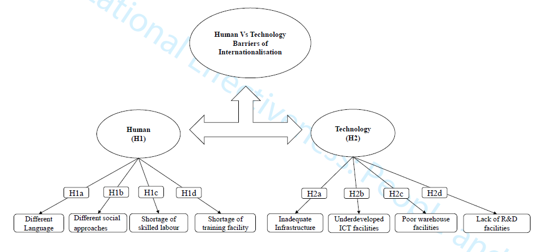
Figure 4: Human vs Technological Barriers to Internationalisation
(Source: Mendy and Rahman, 2019)
Language Barrier: one of the major problems in international business is language issues which the company faces in its initial phase. In case companies are operated in different languages, and their communication methods of the host country are other henceforth, packaging, customer support and marketing need to be conducted in the local dialect to get better results; consumers become emotionally connected to the product.
The Poor Talent of Employees: Rigid to the local market alleviated the cache of companies gaining a higher profit percentage. In addition, finding talented employees is also tricky, that why HR depart invest money in recruiting and selection procedure (Anton et al., 2019). Hence, prominent employees will be more productive and work more effectively for business growth. Hiring skilled employees can be difficult for a company, and weak infrastructure is also an issue in international business.
Currency Exchange: companies operate in different countries where currency also changes. In such a situation. Currency fluctuates daily, and the inflation rate also alternates.
Cultural Differences: cultures differ on a country basis; henceforth, a company needs to respect and be mindful towards each country’s differences (Mendy and Rahman, 2019). Good work culture and understanding of customer preferences make a business flow streamlined.
Supply Chain Issue: international regulations and laws affect importing different materials for businesses (Haag et al. 2019). Moreover, import and export complexity and several taxations make the product price extremely high. Such a situation creates difficulties for other companies to compete in the local market.
High competition: it is a big issue in the international market facing tremendous competition when entering the market. Sun Pharmaceutical and Cipla are two major competitors in India, creating problems for AstraZeneca.
“Mercantilism theory” explains that an organisation will profit by increasing its exports and alleviating imports. By this theory, the market should be increased for the delocalisation of products which increases exports of products. When AstraZeneca will expand to the international market, demand for its product will increase. In that way, the export of products partly increases and revenue also. “Absolute advantage theory” explains manufacturing a product with superior efficiency to gain an advantage over other companies (Osagie and Ukwuoma, 2022). by this theory, AstraZeneca will get the upper hand by adhering to product quality, and consumers will choose AstraZeneca’s product over another rival company. By “Social cognitive theory”, customer behaviour is also a significant aspect of expanding business.

Application of Theoretical Frameworks to the Analysis of AstraZeneca's Internationalisation Strategy
AstraZeneca adopted a geocentric internationalisation strategy where this company treats the whole world as a single country. Companies might face several issues in expanding, like language barriers and cultural differences.
“Mercantilism Theory” explains increasing profit for a company by increasing product export; by this theory, the private sector establishes secured territory by alleviating external dependencies (Farrand and Carrapico, 2022). Here, AstraZeneca implemented a geocentric strategy to help increase the material supply. A new market means a new target audience. Henceforth, profit will increase for AstraZeneca.
Under the “Absolute Advantage Theory” (Yoshii et al. 2019), AstraZeneca will get a competitive advantage by maintaining high-quality products for customers. Hence, AstraZeneca deals with a pharmaceutical product; a better result will attract many customers.
Lastly, “Social Cognitive Theory” explains that customers' behaviour should be efficiently handled for better results (Nih.gov, 2023). Hence, the geocentric approach chooses employees irrespective of nationality; it helps to understand the local culture in a better way by recruiting local people.

Evaluation of the Appropriateness and Effectiveness of the Chosen Strategy Depending on Theoretical Perspectives
The geocentric approach is chosen for expanding business in the international market. The view of the “Absolute Advantage Theory” provides a better understanding of the quality product. It provides an absolute advantage to international trading by discovering new markets (Yoshii et al. 2019). Such products open different opportunities in the local market and effectively compete with rival companies like sun pharma. Understanding the local market is appropriate and effective.
Moreover, creating a local webpage further enhances business growth (Forbes, 2023). According to “Social cognitive theory,” every person behaves differently, influenced by the environment and personal characteristics. The geocentric approach allows benefits to recruit the most talented employers, where local employees help create various opportunities for AstraZeneca.

Conclusion
AstraZeneca is a leading pharmaceutical company that was established in the year 1913. This company deals with a different medical areas like autoimmune, respiratory, and renal diseases. Global expansion is necessary for getting a high-profit percentage from the international market. This company mainly adopted a geocentric approach to internationalisation. In the geocentric system, AstraZeneca considered the whole world a single country. In addition, the company will recruit promising candidates irrespective of nationality; by “The Mercantilist Theory” and “Absolute Advantage Theory”, company profits increase by exporting superior quality products. Several challenges are present in internationalisation, like the language barrier and cultural differences. Therefore, it is recommended to recruit talented local people to overcome such challenges and propel business success.

References
Anton Shufutinsky PhD, D. and Ryan Cox, M.B.A. (2019) Losing talent on day one: Onboarding millennial employees in health care organisations. Organization Development Journal, 37(4), pp.33-51.
AstraZeneca (2022) AstraZeneca in the UK, [online] Available at:
AstraZeneca (2022) AstraZeneca. AstraZeneca. Available at: https://www.astrazeneca.com (Accessed: 23 June 2023)
AstraZeneca (2023) AstraZeneca Available at: https://www.astrazeneca.com/global/en/AstraZeneca-Websites.html (Accessed: 20 June 2023)
AstraZeneca (2023) AstraZeneca outlines a strategy to return to growth and achieve scientific leadership, Available at: https://www.astrazeneca.com/media-centre/press-releases/2013/astrazeneca-growth-scientific-leadership-strategy-21032013.html# (Accessed: 20 June 2023)
AstraZeneca (2023) Available at: https://www.astrazeneca.co.uk/about-us.html#:~:text=AstraZeneca%20in%20the%20UK,to%20deliver%20life%2Dchanging%20medicines (Accessed: 23 June 2023)
Bryła, P. (2019) Regional ethnocentrism on the food market as a sustainable cons. Sustainability, 11(22), p.6408.
Clc.gov.in (2023) Chief Labour Commissioner, Available at: https://clc.gov.in/clc/labour-law (Accessed:20 June 2023)
Contractor, F.J. et al. (2020) How do country regulations and business environment impact foreign direct investment (FDI) inflows? International Business Review, 29(2), p.101640.
Crick, J.M., Crick, D. and Chaudhry, S. (2020) Entrepreneurial marketing decision-making in rapidly internationalising and de-internationalising start-up firms. Journal of Business Research, 113, pp.158-167.
Dar, I.A. (2019) Internationalisation of SMEs: how does global mindset and network relationships impact in India. International Journal of Business and Globalisation, 23(4), pp.568-581.
De Wit, H. and Altbach, P.G. (2021) Internationalization in higher education: global trends and recommendations for its future. Policy Reviews in Higher Education, 5(1), pp.28-46.
India.gov.in. (2023), Available at: https://www.india.gov.in/spotlight/ayushman-bharat-national-health-protection-mission (Accessed: 20 July 2023)
Falahat, M. et al. (2020) SMEs internationalisation: The role of product innovation, market intelligence, pricing, and marketing communication capabilities as drivers of SMEs’ international performance. Technological Forecasting and Social Change, 152, p.119908.
Farrand, B. and Carrapico, H. (2022) Digital sovereignty and taking back control: from regulatory capitalism to regulatory mercantilism in EU cybersecurity. European security, 31(3), pp.435-453.
Forbes (2023) 5 Tax Strategies For Growth-Oriented Businesses, Available at: https://www.forbes.com/sites/forbesfinancecouncil/2022/08/02/5-tax-strategies-for-growth-oriented-businesses/?sh=56f68aa21a5e (Accessed: 23 June 2023)
Forbes (2023) Business Can Aim For A More Local Marketing Approach, Available at: https://www.forbes.com/sites/forbesagencycouncil/2020/04/06/12-ways-a-business-can-aim-for-a-more-local-marketing-approach/?sh=82b92e2252da (Accessed: 20 June 2023)
García-Álvarez de Perea, J. et al. (2019) Internationalization business models and patterns of SMEs and MNEs: A qualitative multi-case study in the agri-food sector. Sustainability, 11(10), p.2755.
Gnizy, I. (2019) The role of inter-firm dispersion of international marketing capabilities in marketing strategy and business outcomes. Journal of Business Research, 105, pp.214-226.
Goncalves, M. and Smith, E.C. (2019) Lusophone-African SME internationalisation: A case for born global and international joint ventures. Journal of Transnational Management, 24(3), pp.231-258.
Gong, Z. (2021) December. Using the long-lived Mesoproterozoic Laurentia-Baltica (NENA) connection to test the geocentric-axial-dipole (GAD) model at 1.46 Ga. In AGU Fall Meeting Abstracts, Vol. 2021, pp. GP35D-0342.
Gov. in (2023) The child labour (prohibition and regulation) Act, 1986, Available at: https://labour.gov.in/sites/default/files/act_2.pdf (Accessed:23 June 2023)
Grgić, J. (2020) Coca-Cola internationalisation strategies, Doctoral Dissertation, University of Zagreb. Faculty of Economics and Business. Department of International Economics.
Haag, L., Sallnäs, U. and Sandberg, E. (2019) Supply chain capabilities for facilitating the internationalisation of retailers–a multiple case study of three Swedish retail companies. The International Review of Retail, Distribution and Consumer Research, 29(3), pp.321-339.
Hult, G.T.M. (2020) The theoretical evolution and use of the Uppsala Model of internationalisation in the international business ecosystem. Journal of International Business Studies, 51, pp.38-49.
India.gov (2023) Constitution of India, Available at: https://www.india.gov.in/my-government/constitution-india#:~:text=It%20is%20a%20Sovereign%20Socialist,force%20on%2026th%20January%2C%201950.
Karasu, F. et al. (2022) The determination of intercultural sensitivity and ethnocentrism levels among nurses and nursing students: A border of the city, Turkey. Perspectives in psychiatric care, 58(1), pp.314-322.
Katsikeas, C. (2020) Revisiting international marketing strategy in a digital era: Opportunities, challenges, and research directions. International Marketing Review, 37(3), pp.405-424.
Lofthouse, J.K. and Herzberg, R.Q. (2023) The continuing case for a polycentric approach for coping with climate change. Sustainability, 15(4), p.3770.
Luo, Y. (2021) New OLI advantages in digital globalisation. International Business Review, 30(2), p.101797.
Mca.gov (2023) The Companies Act, 2013, Available at: https://www.mca.gov.in/Ministry/pdf/CompaniesAct2013.pdf (Accessed: 20 June 2023)
Meity.gov (2023) Information Technology Act 2000, Available at: https://www.meity.gov.in/content/information-technology-act-2000-0 (Accessed: 20 June 2023)
Mendy, J. and Rahman, M. (2019) Supporting SMEs’ internationalisation through a deeper understanding of human and technology barriers: Applying effective HRM processes from a developing country. Journal of Organizational Effectiveness: People and Performance.
Nambisan, S. et al. (2019) Global platforms and ecosystems: Implications for international business theories. Journal of International Business Studies, 50, pp.1464-1486.
Nasir, M.A. et al. (2019) Role of financial development, economic growth & foreign direct investment in driving climate change: A case of emerging ASEAN. Journal of environmental management, 242, pp.131-141.
Nih.gov (2023) Social and Behavioural Theories, Available at: https://obssr.od.nih.gov/sites/obssr/files/Social-and-Behavioral-Theories.pdf (Accessed: 18 June 2023)
Osagie, O.E. and Ukwuoma, A.C. (2022) Absolute advantage theory. BW Academic Journal, pp.5-5.
Pasara, M.T. and Garidzirai, R. (2020) Causality effects among gross capital formation, unemployment, and economic growth in South Africa. Economies, 8(2), p.26.
Pixabay.com (2023) Available at: https://pixabay.com/photos/business-worldwide-global-6851888/ (Accessed on: 25 June 2023)
Robertson, A. (2019) The importance of communication during organisational transformation: A case study at AstraZeneca about communication barriers.
Shams, R. et al. (2021) Strategic agility in international business: A conceptual framework for “agile” multinationals. Journal of International Management, 27(1), p.100737.
Sharma, P. et al. (2020) Managing uncertainty during a global pandemic: An international business perspective. Journal of business research, 116, pp.188-192.
Statista (2023) AstraZeneca's revenue from 2013 to 2022, by region, Available at: https://www.statista.com/statistics/266550/revenue-of-astrazeneca-by-region-since-2006/ (Accessed: 18 June 2023)
Statista (2023) Unemployment rate in India 2022, Available at: https://www.statista.com/statistics/271330/unemployment-rate-in-india/#:~:text=The%20statistic%20shows%20the%20unemployment,estimated%20to%20be%207.33%20percent (Accessed: 18 June 2023)
Statista (2023) AstraZeneca revenue 2006-2022. Available at: https://www.statista.com/statistics/266542/revenue-of-astrazeneca-since-2006/#:~:text=In%202022%2C%20the%20company (Accessed: 18 June 2023)
Statista (2023) Emissions in India - Statistics & Facts India, Available at: https://www.statista.com/topics/8881/emissions-in-india/#topicOverview (Accessed: 18 June 2023)
Statista (2023) Inflation rate in India 2028, Available at: https://www.statista.com/statistics/271322/inflation-rate-in-india/ (Accessed: 18 June 2023)
Statista (2023) Number of Walmart stores in China from 2013 to 2023, by type*. Available at: https://www.statista.com/statistics/752119/china-walmart-store-number/ (Accessed: 18 June 2023)
Tien, N.H. et al. (2019) The role of international marketing in international business strategy. International journal of research in marketing management and sales, 1(2), pp.134-138.
Vogelsang, B. and Pilz, M. (2021) Conditional factors for training activities in Chinese, Indian and Mexican subsidiaries of German companies. European Journal of Training and Development, 45(4/5), pp.419-435.
Vrontis, D. and Christofi, M. (2021) R&D internationalisation and innovation: A systematic review, integrative framework, and future research directions. Journal of Business Research, 128, pp.812-823.
Yoshii, S. et al. (2019) Was Adam Smith a Proponent of Absolute Advantage Theory? A formative history of an urban legend and lessons learned (No. 190). NUCB Discussion Paper.Borges, A.F. et al. (2021) The strategic use of artificial intelligence in the digital era: Systematic literature review and future research directions. International Journal of Information Management, 57, p.102225.
Zahra, S.A., 2021. International entrepreneurship in the post-Covid world. Journal of World Business, 56(1), p.101143.
Zhu, J.S. (2019) Chinese multinationals’ approach to international human resource management: A longitudinal study. The International Journal of Human Resource Management, 30(14), pp.2166-2185.

