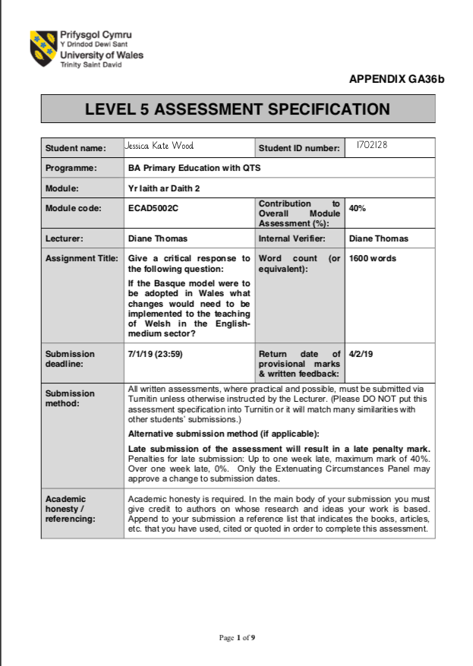
Give a critical response to the following question:
If the Basque model were to be adopted in Wales what changes would need to be
implemented to the teaching of Welsh in the English-medium sector?

Within this assignment will be a critical response regarding the use of the Basque model in Wales to teach Welsh in the English-medium sector. The Basque model consists of three types of schools A-model, B-model and D-model schools and contains a mixture of opinions and facts on how the Basque model works in the Basque country (Hopwood et al. 2018). The text will be discussed in light of its benefits and limitations and how the Welsh government can adopt the model in English-medium schools.

Currently Welsh is compulsory in English-medium schools up until the age of 16, in Foundation Phase, Welsh comes under the Welsh Language Development area of learning and in Key Stage 2 Welsh is its own subject Welsh Second Language. Although Welsh is separate to other subjects in the curriculum, Curriculum Cymreig is used across the curriculum to ensure that Welsh is used constantly in children’s learning. The Welsh second language curriculum is a mixture of both A and B-model schools in the Basque model as Welsh is taught purely as a subject, but Welsh is used incidentally across the curriculum.

D-model schools in the Basque model use the CLIL approach to teach a second language (Hopwood et al. 2018). This could be adopted to Wales by using the CLIL approach to teach Welsh, it would require children to learn another subject through the medium of Welsh. Hopwood et al. (2018) believes this would strengthen the use of the second language and Marsh (2002) suggests that the CLIL approach increases children’s multilingual interests and attitudes which WAG (2012) believes is vital in increasing the attainment of the Welsh language. CLIL brings the learning to real life situations in a context the children can understand (Barnes, 2015). However, the Basque model does highlight that a team is dedicated in creating resources for schools to use through the CLIL approach (Hopwood et al. 2018). This would be very time consuming to create the resources, implement into schools as it takes 5-7 years for the children to become competent in the language and cost money to train teachers to use the CLIL approach efficiently (Freeman, 2004). Estyn (2017) suggests that pupils do not have the confidence to speak Welsh outside the classroom, the D-model schools enable pupils to gain confidence in speaking the second language (Hopwood et al. 2018). Although, there are no assessments in the oral element of the CLIL approach in
D-model schools, so it is difficult to assess pupils on their oral abilities (Hopwood et al. 2018). This could be adapted in Wales to include some formative assessment to ensure pupils know where they are, the next steps and how to get there but some subjects likes Maths and Science would be difficult to teach through the medium of Welsh due to scientific and mathematic terms that they would not recognise in English if they were to go on to higher education through the medium of English.

However, the Basque model concentrates on the CLIL approach and does not explore any other approaches to teaching a language (Hopwood et al. 2018). Unless over 16s and adults take on the Euskaltegiak which looks at the relationship between the text and the context there is no study of grammar, vocabulary, punctuation or spelling only in language lessons at secondary school (Hopwood et al. 2018). Wales could adopt the Basque model but including some elements of the grammar model which allows pupils to learn the rules of the language from a younger age focusing on reading and writing rather than the oral element which CLIL concentrates on (Richards and Rogers, 2001). Total Physical Response (TPR) is another method that could be introduced along with CLIL and the grammar method. TPR is closely linked with the grammar method as it focuses on learning vocabulary but through the use of repeated actions and moves on to verbalising the actions (Richards and Rogers, 2001). It allows children to become confident in speaking Welsh which Estyn (2016-2017) and WAG (2013) suggest it is a priority for schools as children lose their confidence easily with languages, so it is important for teachers not to correct too much and making the learning memorable and fun. Although it is vital not to use the TPR method too much as it becomes repetitive and it is restrictive as you can only teach vocabulary and basic instructions with it.

Within the Basque model there is no mention how 6-year olds are introduced to the Basque language when starting school (Hopwood et al. 2018). In Wales children are introduced to Welsh as soon as they start school at the age of 3 in English-medium schools through the Foundation Phase. However, Estyn (2016-2017) believes that in the Foundation Phase Welsh is very successful but in Key Stage 2 Welsh becomes diluted and children do not use Welsh on a daily basis. Donaldson (2015) believes that the Welsh language is a vital part of the Welsh curriculum as it gives children a sense of belonging and value to their own culture. In Successful Futures, Donaldson (2015) believes that the Welsh language should be embedded within the curriculum and not an extra subject as the future of the Welsh language is within the children who should be ambitious, capable learners who can communicate both in English and Welsh. In order to reach the goal of a million Welsh speakers by 2050, there needs to be more support and learning the language from a young age to create a strong foundation to build upon (WAG, 2017). Although, Donaldson (2015) suggests that Welsh is to be at the foundation of Successful Futures this will hold a lot of challenges.

WAG (2013) advises that the status of Welsh needs to be raised as Estyn (2016-2017) research says that not enough teaching time is devoted to the Welsh language which leads to a change needed to the curriculum where Welsh is seen as important as English and Maths. Children lack the confidence to speak Welsh outside the classroom and teachers also lack the confidence to speak Welsh. To be able to raise the confidence of the children the teachers need good Welsh language skills (WAG, 2017, Furlong, 2015) which can be addressed by following the example of the Basque model where they created a range of intense full-time and part-time courses for teachers to learn the Basque language whilst still being paid (Hopwood et al. 2018). Although, there are sabbatical schemes within Wales they are used mostly for Welsh-medium teachers leaving the English-medium teachers lacking the skill and confidence needed to teach Welsh. Intense courses allow teachers to have good Welsh language skills but the courses cost money as teachers are fully paid whilst on the course have to get supply teachers to cover them, the courses are no quick fix as the ones in the Basque model last sometimes up until 3 years and require refresher courses (Hopwood et al. 2018). Also, it is not up skilling all teachers it is only a selected few that become skilled in the Welsh language, so the children’s Welsh language skills suffer if they have a teacher who does not have good Welsh language skills (Grigg, 2015).

In the Basque country, for high skilled jobs such as doctors require a high level of fluency in Basque which enables the Basque people to see the value of learning Basque as it can lead them to gaining high level skilled jobs (Hopwood et al. 2018). However, this could put pressure on young people to learn a language they do not want to learn. Whereas in Wales, pupils do not see the value of learning Welsh as there is no incentive for them although young people do qualify for grants from the government if they study higher education in Welsh but there are very little universities that offer the grant. The status of the Welsh language needs to raise by putting more funding into the Welsh language creating a continuum of learning and teaching from primary school to university and getting employers to want Welsh speakers in order for young people to see the value of learning the language (Donaldson, 2015). Children need to be made aware the benefits of being bilingual one of which being it helps increase intelligence (Estyn, 2017 and Baker, 1988).

From personal experience children only use Welsh within school and not at home as parents cannot speak Welsh, so if not used constantly the language is forgotten making it harder for teachers to enable the children to become fluent (WAG, 2013). The Basque model provides Basque language schools for adults to learn the language which could be used in Wales to provide adults with night classes to learn Welsh (Hopwood et al. 2018). The adults can communicate with their children through the medium of Welsh and the children can teach their parents Welsh so that it improves both the child’s and parent’s Welsh language skills. Involving parents in their children’s education has huge amounts of benefits such as increased motivation, self-esteem and higher attainment (Grigg, 2015). On the other hand, getting the funding for night classes will be difficult and getting parents to engage with the night classes will be a challenge especially in deprived areas where many parents are illiterate and many parents work long hours so lack the time and commitment needed (García and Baker, 2007).

In conclusion, there are many positives to Welsh language education in Wales in
English-medium schools currently but there is a lot of room for improvement. Using the Basque model as an example to change the Welsh education will be very beneficial. The value both teachers and children see in learning the Welsh language must improve like the Basque people see value in learning Basque. Introducing children to the benefits that they can obtain such as gaining access to different cultures, expanding their imagination, interact with different communities and gives greater social equality (Estyn, 2017 and García, 2009). Improving the confidence and skill of teachers is highly important by giving sufficient training before qualifying and whilst teaching to ensure the children receive a good education.

References
Barnes, J. (2015) Cross-curricular Learning 3-14. 3rd edn. London: SAGE Publications.
Baker, C. (1988) Key Issues in Bilingualism and Bilingual Education. Clevedon: Multilingual Matters Ltd.
Donaldson, G. (2015) Successful Futures. Cardiff: Crown.
Estyn. (2017) Supplementary Guidance: Welsh, Autumn 2017. Cardiff: Crown.
Estyn. (2016-2017) The Annual Report of Her Majesty’s Chief Inspector of Education and Training in Wales 2016-2017. Cardiff: Crown.
Freeman, R. (2004) Building on Community Bilingualism. Philadelphia: Caslon.
Furlong, J. (2015) Teaching Tomorrow’s Teachers. Oxford: University of Oxford.
García, O and Baker, C. (2007) Bilingual Education, An Introductory Reader. Clevedon: Multilingual Matters Ltd.
García, O. (2009) Bilingual Education in the 21st Century: A Global Perspective. West Sussex: Wiley-Blackwell.
Grigg, R. (2015) Becoming an Outstanding Primary School Teacher. 2nd edn. Oxon: Routledge.
Hopwood, M. et al. (2018) An Overview of the Assessment of Language Proficiency in a Sample of Bilingual Jurisdictions. Carmarthen: UWTSD.
Marsh, D. (2002) CLIL/ EMILE – The European Dimension. Finland: UniCOM
Richards, J.C. and Rodgers, T.S. (2001) Approaches and Methods in Language Teaching. 2nd edn. Cambridge: Cambridge University Press.
WAG. (2012) A Living Language: A Language for Living. Cardiff: Crown.
WAG. (2017) Cymraeg 2050: A Million Welsh Speakers. Cardiff: Crown.
WAG. (2013) One Language for All. Cardiff: Crown.

