

Creativity and Value Creation
ACCA5033

Assignment 2: Project Management & Innovation

Student ID – 2432768
Student Name – Jozef Szepesi

Lecturer Name: Dr Osman Elgawi

Date: 23/07/2026
Table of Contents
Introduction 2
Task 1: Project Management & Project Design 3
Project Management & Planning 3
Project Design 4
Task 2: Enterprise & Innovation 4
PEST Analysis (Example Tech Company) 4
Legal & Ethical Considerations 5
SWOT Analysis (Amazon – Example) 5
Start-Up Concept for My Project 6
Task 3: Project Reflection 7
Conclusion 9
References 10
Appendices 11
Appendix A – Gantt Chart (Project Timeline) 11
Appendix B – PEST Table (Example Tech Company) 12
Appendix C – SWOT Analysis (UniWell Tracker – Student Fitness App) 12
Appendix D – ERD Diagram (UniWell Tracker) 13

Table of Figures

Figure 1 Project timeline showing weekly tasks for UniWell Tracker. 11
Figure 2 PEST analysis showing positive and negative external factors affecting a tech company. 12
Figure 3 SWOT analysis outlining strengths, weaknesses, opportunities, and threats for UniWell Tracker. 12
Figure 4 Entity Relationship Diagram showing one-to-many relationships between User and Logs. Created using Draw.io (2026). 13
Figure 5 Dashboard wireframe showing main navigation options for UniWell Tracker. 14
Figure 6 Hydration Tracker wireframe showing water intake and logging options. 14

Introduction
University students often struggle to maintain healthy routines while balancing study, work and personal responsibilities. Busy schedules, long commutes and irregular habits can affect wellbeing, motivation and academic performance. Many students want to improve their daily lifestyle, but they lack simple tools that help them track progress and stay consistent. This creates a clear need for a practical digital solution that supports healthier routines in an accessible way.
My project focuses on developing a Fitness and Lifestyle Mobile App for Students, designed to help users monitor steps, hydration, sleep and daily habits. The aim is to create a straightforward app that encourages small, positive changes through reminders, progress tracking and simple visual feedback. The app is intended to be easy to use, low-cost and suitable for students who want to improve their wellbeing without relying on complex or expensive fitness platforms.
This report outlines how the project will be planned, designed and evaluated. Task 1 discusses project management, including the scope, timeline, development method and design artefacts such as an ERD and wireframes. Task 2 explores enterprise considerations, including PEST, and SWOT analysis, as well as potential start-up ideas linked to the app. Task 3 provides a reflection on personal skill development, social impact and project risks. Together, these sections demonstrate how the project idea can be managed, developed and applied within an academic and practical context.

Task 1: Project Management & Project Design

Project Management & Planning
The aim of my project is to plan and design a Fitness and Lifestyle Mobile App for university students. Many students struggle to maintain healthy routines because of academic pressure, long commutes and inconsistent daily habits, which can negatively affect mental wellbeing [10]. The app aims to support wellbeing by helping users track steps [1], hydration [4], sleep [2] and simple daily habits. The proposed solution is a lightweight mobile application that uses basic phone sensors and manual inputs to encourage healthier routines through reminders, progress tracking and simple visual feedback. Sleep and wellbeing are closely linked, so supporting healthy routines can improve overall mental performance [5]. The project focuses on planning and design rather than full development, which keeps the work achievable within the assignment scope.
To complete the project, I will use several accessible tools and resources. Trello or Microsoft Planner will help organise tasks and monitor progress throughout the project. Draw.io or Lucidchart will be used to create diagrams such as the ERD, while Canva or Figma will support the creation of wireframes. These tools are suitable for a student project because they are free, easy to use and do not require advanced programming knowledge. Digital health tools must meet recognised standards to ensure quality and usability [8], and academic sources on project management, Agile methods and digital wellbeing [5] will support the decisions made during the project.
The project will follow a simple timeline spread across several weeks. Week one will focus on research and defining the project scope. Week two will involve gathering requirements and producing early sketches of the app’s layout. In week three, I will create the ERD and wireframes to show how data flows through the system and how the interface might look. Week four will be used to produce the Gantt chart and finalise the project plan. The remaining weeks will be dedicated to completing Task 2, Task 3 and final editing. A full Gantt chart will be included in the appendix to show each stage clearly and demonstrate how the project is scheduled.
There are several constraints that shape the project. Time is the most significant constraint, as the assignment has a fixed deadline and each task requires careful planning. Another constraint is that the project does not involve coding or full development, so the app must remain conceptual. I also have limited access to advanced development tools, meaning the design must be achievable using simple software. Finally, the project relies on secondary research rather than real user testing, which limits the level of evaluation that can be carried out.
To manage the project effectively, I will use an Agile inspired development method. Agile is suitable because it breaks work into smaller, manageable stages and encourages regular review. I will create a small backlog of tasks, plan weekly sprints and check progress at the end of each stage. Even though the project does not involve programming, Agile principles help maintain structure and flexibility, allowing me to adjust the plan if needed. The method supports continuous improvement and helps ensure the project remains organised and achievable.

Project Design
Two design artefacts will be produced to support the project. The first is an Entity Relationship Diagram (ERD), which shows how user data such as steps [1], hydration [4], sleep [2] and habits related to wellbeing [10] would be stored and connected. The ERD helps clarify the data structure and relationships between different parts of the system, ensuring the app’s information flow is logical and well organised. The second artefact is a set of wireframes that illustrate the main screens of the app, including the dashboard, hydration tracker. These wireframes show how users would interact with the app and how information is presented visually, following recognised digital health design principles [8]. Both artefacts will be included in the appendix and form part of the overall design documentation for the project.

Task 2: Enterprise & Innovation

PEST Analysis (Example Tech Company)
To understand enterprise considerations within the technology sector, I reviewed example PEST and SWOT analyses from a well-known tech company, Amazon. This helps identify external influences, risks and opportunities that affect digital businesses [8]. These models also highlight legal and ethical issues that smaller start-ups must consider, especially around responsible digital health practices [8].
PEST Analysis (Amazon – Example)
Political: Technology companies operate under strict government regulations, especially around data protection. Laws such as GDPR require companies to store and process user data responsibly, which is essential for digital health and wellbeing tools [8]. Political support for digital innovation and online services also benefits tech companies, as governments often encourage digital transformation in education, healthcare and commerce.
Economic: Amazon is influenced by global economic conditions, including inflation, consumer spending and employment levels. Economic uncertainty can reduce demand for digital services, while strong economic periods increase online activity. Tech companies must also consider operational costs such as cloud infrastructure, staffing and logistics.
Social: Social trends strongly influence digital businesses. Increased use of smartphones and demand for convenience shape how people interact with technology, including health and wellbeing apps [9]. Growing awareness of wellbeing also affects user expectations, as mental health and lifestyle habits are becoming more widely recognised [10]. Ethical expectations are rising too, with users expecting transparency, fair treatment and responsible data handling [8].
Technological: Rapid technological change creates both opportunities and challenges. Companies must invest in cloud computing, automation, cybersecurity and mobile platforms to remain competitive, especially as digital health tools and mobile applications continue to evolve [8]. Increased reliance on smartphones and mobile services also means that companies must keep pace with user expectations and industry trends [9]. Failure to innovate can lead to loss of market share.

Legal & Ethical Considerations
Tech companies face several legal and ethical responsibilities [8]:
Data protection: GDPR requires clear consent, secure storage and responsible data use, which is essential for digital health tools [8].
Intellectual property: Companies must protect their software, branding and digital assets.
Ethical use of data: Users expect transparency, fairness and privacy when interacting with digital platforms [9].
Cybersecurity: There is an ethical responsibility to protect users from breaches and misuse, especially when wellbeing-related information is involved [10]. These considerations apply directly to smaller start-ups, including my student fitness app [8].

SWOT Analysis (Amazon – Example)
Strengths: Strong brand recognition, advanced technology, global reach and reliable cloud infrastructure.
Weaknesses: Public criticism over data practices and privacy concerns [8], reliance on global supply chains and high operational costs.
Opportunities: Expansion into new markets, development of new digital services [9] and partnerships with educational institutions that promote wellbeing and digital engagement [10].
Threats: High competition within the digital services and app market [9], cybersecurity risks requiring strong protection measures [8], regulatory pressure linked to digital standards and data protection [8], and rapid technological change that affects mobile and cloud-based services [9].
This example helps guide enterprise thinking for my own project.

Start-Up Concept for My Project
To apply enterprise thinking to my project, I developed a potential start-up concept for the student fitness app. The start-up would focus on wellbeing [10], simplicity and accessibility for university students.

Start-Up Name and Logo Concept
The proposed name is “UniWell Tracker”, chosen because it clearly reflects student wellbeing [10] and daily lifestyle monitoring. The logo would be a simple design combining a water droplet to represent hydration [4] and a step icon to represent physical activity [1]. A minimal logo style keeps the brand clean and easy to recognise, following basic digital design principles [8].
Business Type (Legal Classification)
The start-up would operate as a Private Limited Company (Ltd). This structure is suitable for small tech businesses because it limits personal liability, allows controlled growth and is widely used for digital products [8]. It also makes the business more credible when applying for funding or forming partnerships.
Business Strategy
The strategy would focus on offering a free basic version of the app, supported by optional premium features such as advanced analytics, personalised habit plans or integration with wearable devices. This “freemium” model keeps the app accessible to students while creating potential revenue streams, which is common in the health and wellbeing app market [9]. The app would emphasise simplicity, wellbeing [10] and daily habit tracking, including hydration [4] and physical activity [1], rather than competing directly with large commercial fitness platforms.
Funding Initiatives
Several funding options could support the start-up:
• University innovation grants, which often support wellbeing and digital transformation projects [10][8].
• Crowdfunding, allowing students and supporters to contribute small amounts. • Partnerships with student unions, wellbeing teams or academic departments [10].
• Small business start-up loans, available for early-stage digital companies [8]. These initiatives help reduce financial risk and make the start-up more sustainable, especially in a growing digital health and wellbeing market [9].

Task 3: Project Reflection
This project has given me the opportunity to reflect on how I can develop new skills and apply them in both academic and professional contexts. Planning and designing a Fitness and Lifestyle Mobile App for Students has helped me understand how digital wellbeing tools can support healthier routines [8], but it has also shown me how important structured project management is when working on a technical idea. Supporting wellbeing involves encouraging healthy sleep [2][5], hydration [4], and physical activity [1], all of which contribute to better mental health and daily performance [10]. Through this reflection, I will consider the skills I intend to develop, the potential positive impact of the project on society, and the risks and challenges that may arise, along with ways to reduce them. One of the main skills I aim to develop through this project is stronger project planning. Working with timelines, schedules and design artefacts has helped me understand how important it is to break work into manageable stages, especially when designing digital wellbeing tools [8]. Using tools such as Trello and Draw.io has improved my confidence in organising tasks and creating visual designs. I also want to strengthen my understanding of Agile methods, especially sprint planning and backlog management. Even though the project does not involve coding, Agile principles have helped me stay organised and adapt my plan if needed. Another skill I hope to develop is clearer academic writing. Producing structured sections, using references and explaining concepts in a simple way has helped me communicate ideas more effectively, particularly when discussing wellbeing and healthy routines [10][5]. The project also encourages personal development in areas such as digital wellbeing [8], user-centred design and problem solving. Designing an app that supports hydration [4], sleep [2][5] and physical activity [1] has made me think more carefully about how technology can influence behaviour and daily routines [10]. I have learned that simple features, such as reminders and progress tracking, can make a meaningful difference to students who struggle with routine [10]. This has helped me appreciate the value of designing tools that are accessible, easy to use and focused on real needs rather than unnecessary complexity [8].
In terms of social impact, the project has the potential to contribute positively to student wellbeing [10]. Many students experience stress, irregular sleep patterns [2][5] and poor hydration [4] because of academic pressure and busy schedules. A simple app that encourages healthier habits, including physical activity [1], could help reduce these issues and support better mental health [10]. Universities are increasingly focusing on wellbeing, and digital tools can play an important role in this area [8]. If developed further, the app could be used by student unions, wellbeing teams or academic departments to promote healthier lifestyles [10]. It could also help raise awareness about the importance of daily routines and encourage students to take small steps towards improving their wellbeing [5][10].
However, the project also faces several risks and challenges. One challenge is maintaining user motivation. Many people download wellbeing apps but stop using them after a short time [9]. To reduce this risk, the app would need features that encourage consistency, such as streaks, simple goals and positive feedback [10]. Another challenge is data privacy. Because the app would collect personal wellbeing information, it must comply with GDPR and handle data securely, following recognised digital health standards [8]. Clear privacy settings, transparent data policies and secure storage would be essential [8]. A further challenge is competition, as there are many fitness apps already available [9]. To address this, the app would need to focus on simplicity and student-specific features rather than trying to compete directly with large commercial platforms [10].
There are also practical risks related to development. As a student project, I have limited time and resources, which means the app must remain realistic and achievable. To reduce this risk, I focused on planning and design rather than full development [8]. Creating wireframes, ERD diagrams and a clear project plan helps ensure the idea is well structured even without coding. If the project were developed further in the future, collaboration with other students or support from university innovation teams could help overcome resource limitations.
Overall, this project has helped me reflect on my skills, the potential impact of digital wellbeing tools [8] and the challenges involved in creating a student-focused app. It has shown me the importance of planning, design and responsible decision making, and it has encouraged me to think about how technology can support healthier lifestyles [10][5][1] in a simple and accessible way..

Conclusion
This project has allowed me to explore how a simple digital idea can be planned, analysed and reflected on in a structured way. By developing the concept for a Fitness and Lifestyle Mobile App for Students, I gained a clearer understanding of how project management methods, enterprise models and personal development all link together. Task 1 helped me plan the project using timelines, design artefacts and an Agile-inspired approach, which showed me the importance of organising work into manageable stages. Task 2 demonstrated how external factors such as regulation, competition and funding influence technology start-ups, and how tools like PEST and SWOT can guide strategic thinking. Task 3 encouraged me to reflect on the skills I am developing, the potential social impact of the app and the risks that need to be considered.
Overall, the project has shown me that even a small digital idea requires careful planning, awareness of external influences and responsible decision-making. It has also highlighted how technology can support student wellbeing in a simple and accessible way. Completing this report has strengthened my confidence in project planning and has helped me understand how creative ideas can be shaped into practical solutions within an academic and enterprise context.

References

[1] “WHO GUIDELINES ON PHYSICAL ACTIVITY AND SEDENTARY BEHAVIOUR,” Accessed: July 23, 2026. [Online]. Available: https://iris.who.int/server/api/core/bitstreams/faa83413-d89e-4be9-bb01-b24671aef7ca/content

[2] NHS, “Dehydration,” 2022. Accessed: July 23, 2026. [Online]. Available: https://www.nhs.uk/conditions/dehydration/

[3] NHS, “Insomnia,” Mar. 2024. Accessed: July 23, 2026. [Online]. Available: https://www.nhs.uk/conditions/insomnia/

[4] Centers for Disease Control and Prevention, “Healthy Eating for a Healthy Weight ,” Mar. 2023. Accessed: July 23, 2026. [Online]. Available: https://www.cdc.gov/healthyweight/healthy_eating/index.html

[5] Mayo Clinic, “Water: How Much Should You Drink Every day?,” Oct. 2022. Accessed: July 23, 2026. [Online]. Available: https://www.mayoclinic.org/healthy-lifestyle/nutrition-and-healthy-eating/in-depth/water/art-20044256

[6] “Sleep and Mental Health - Harvard Health Publishing - Harvard Health,” June 2011. Accessed: July 23, 2026. [Online]. Available: https://www.health.harvard.edu/mind-and-mood/sleep-and-mental-health

[7] “Exercise and Physical Activity,” 2026. Accessed: July 23, 2026. [Online]. Available: https://www.heart.org/en/healthy-living/exercise-and-physical-activity

[8] Department of Health and Social Care, “Physical activity guidelines: adults and older adults,” Sept. 2019. Accessed: July 23, 2026. [Online]. Available: https://www.gov.uk/government/publications/physical-activity-guidelines-adults-and-older-adults

[9] “Digital health,” NICE, 2025. Accessed: July 23, 2026. [Online]. Available: https://www.nice.org.uk/what-nice-does/digital-health
[10] S. J. Dixon, “Social Media - Statistics & Facts,” July 2024. Accessed: July 23, 2026. [Online]. Available: https://www.statista.com/topics/1164/social-networks/#topicOverview

[11] World Health Organization, “Mental health,” June 2022. Accessed: July 23, 2026. [Online]. Available: https://www.who.int/news-room/fact-sheets/detail/mental-health-strengthening-our-response

[12] NHS, “Exercise,” 2021. Accessed: July 23, 2026. [Online]. Available: https://www.nhs.uk/live-well/exercise/

Appendices

Appendix A – Gantt Chart (Project Timeline)

Project Title: UniWell Tracker – Student Fitness & Lifestyle App
Project Duration: 7 Weeks
Method: Agile-inspired weekly sprints

Task / Week | W1 | W2 | W3 | W4 | W5 | W6 | W7
Research & Project Scope | ███
Requirements Gathering & Early Sketches |  | ███
ERD Diagram |  |  | ███
Gantt Chart & Final Project Plan |  |  |  | ███
Task 2 – Enterprise Section |  |  |  |  | ███
Task 3 – Reflection Section |  |  |  |  |  | ███
Final Editing, Conclusion & References |  |  |  |  |  |  | ███
Figure 1 Project timeline showing weekly tasks for UniWell Tracker.

Appendix B – PEST Table (Example Tech Company)

Positive Factors | Negative Factors
Government support for digital innovation and online services | Strict data protection laws such as GDPR
Growing demand for mobile and cloud-based services | Economic uncertainty affecting consumer spending
Strong technological infrastructure enabling fast development | High competition in global tech markets
Social trends encouraging digital wellbeing and convenience | Ethical concerns around data usage and privacy
Figure 2 PEST analysis showing positive and negative external factors affecting a tech company.

Appendix C – SWOT Analysis (UniWell Tracker App)

Strengths | Weaknesses
Simple, student-focused design | Limited features compared to major fitness apps
Encourages hydration, sleep and activity | No full development yet (concept only)
Low-cost and accessible for students | Relies on self-reported data
Easy to use and minimal interface | Requires regular updates to stay relevant
Opportunities | Threats
Universities promoting student wellbeing | Strong competition from existing fitness apps
Potential partnerships with student unions
  Data privacy concerns (GDPR compliance needed)
Possible funding from innovation grants | Low engagement if students stop using the app
Rising interest in digital wellbeing | Rapid changes in technology and user expectation
Figure 3 SWOT analysis outlining strengths, weaknesses, opportunities, and threats for UniWell Tracker.

Appendix D – ERD Diagram (UniWell Tracker)

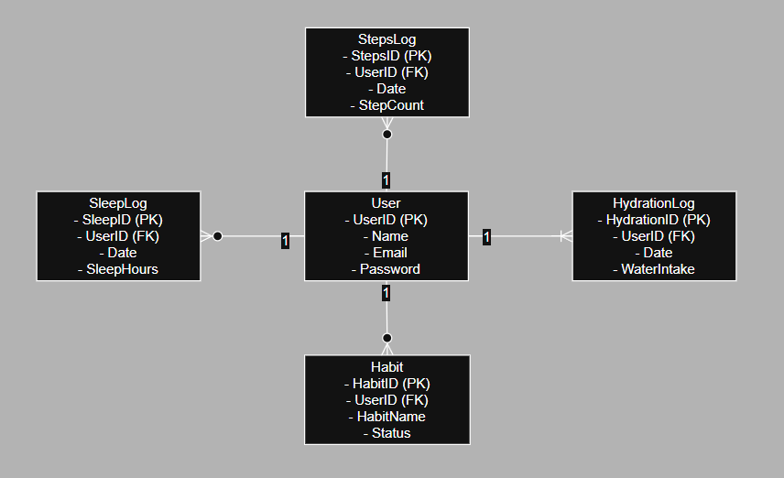
Figure 4 Entity Relationship Diagram showing one-to-many relationships between User and Logs. Created using Draw.io (2026).

Appendix E1 – Wireframe: Dashboard Screen

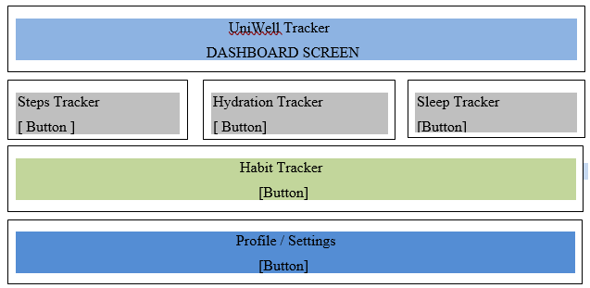
Figure 5 Dashboard wireframe showing main navigation options for UniWell Tracker.

Appendix E2 – Hydration Tracker Wireframe

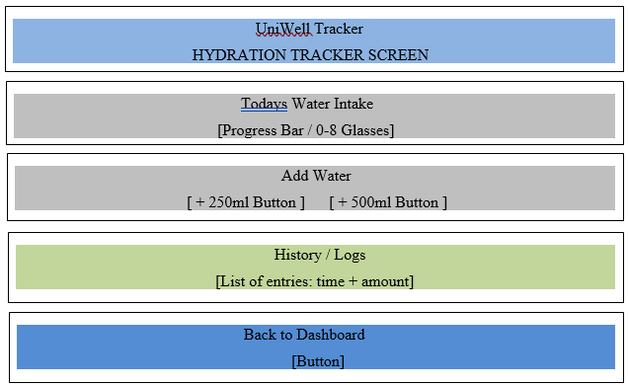
Figure 6 Hydration Tracker wireframe showing water intake and logging options.

