Curtis Stephens
1903184 University of Wales Trinity Saint David
ACCA5023 Network operating systems and services Worksheet one

Contents
1. Introduction 2
2. Creating the virtual machines 3
2.1 Server Screenshots 3
2.2. Client Screenshots 4
3. Installing Windows 5
3.1. On the server 5
3.2. On the client 7
4. Virtual Network Configuration 9
4.1. Setting up Virtualbox for networking 9
4.2. Configuring Windows for networking 10
5. Observational Tasks 14
5.1. Hypervisors 14
5.1.1. Type 1 hypervisor 14
5.1.2. Type 2 hypervisor 14
5.1.3. Which type to choose? 15
5.2. The Subnet Mask 15
5.2.1. Why are subnets so important? 15
5.3. Cloud Computing 15
5.3.1. Types of cloud computing 16
5.3.2. Cloud computing vendors 16
5.4. Terminologies 16
5.4.1. Ping 16
5.4.2. Firewall 16
References 17

1. Introduction
In this part of the assignment, I have been asked to set up two virtual networks using Oracle Virtualbox software. This will involve four hosts – two being servers running Windows Server 2019, and two of them being workstations running Windows 10.
Firstly I will need to configure the machines on Virtualbox. Settings such as the amount of RAM and storage need to be configured. After that, I will need to perform an install of the respective versions of Windows – Server 2019 for the servers, and Windows 10 for the workstations.
I will also need to set up networking within Virtualbox, as well as configuring the hosts for networking – in this worksheet I will be setting up IP addressing, configuring the network itself as well as verifying connectivity by using the Ping command.
There are also observational tasks to be undertaken, which relate to the activities that I have undertaken in the worksheet.

2. Creating the virtual machines
As mentioned above, four virtual machines were created – two running Windows Server 2019 and two running Windows 10. The servers were made with 4GB of RAM and 25GB storage, and the workstations were made to run with 4GB of RAM and 20GB storage.

2.1 Server Screenshots
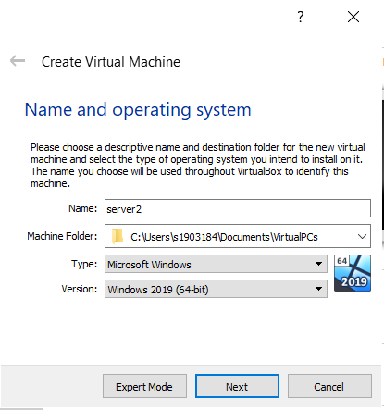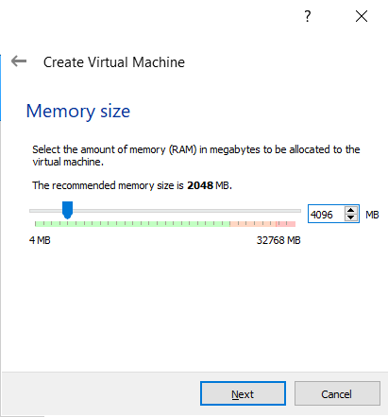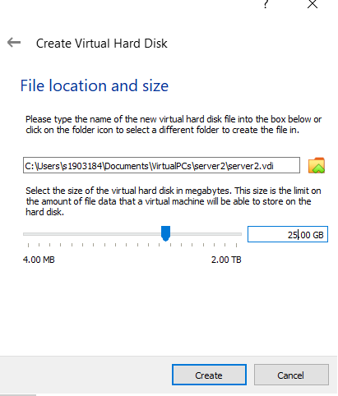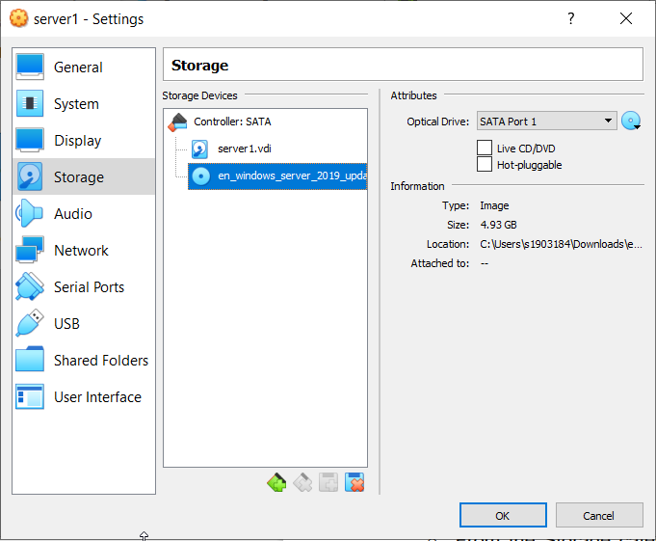
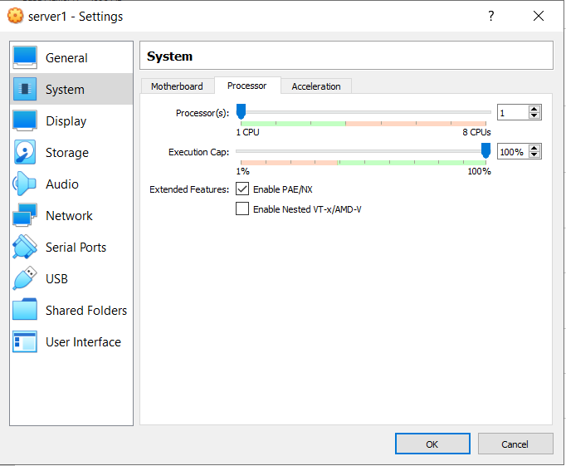

2.2. Client Screenshots
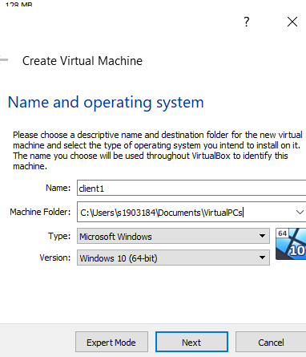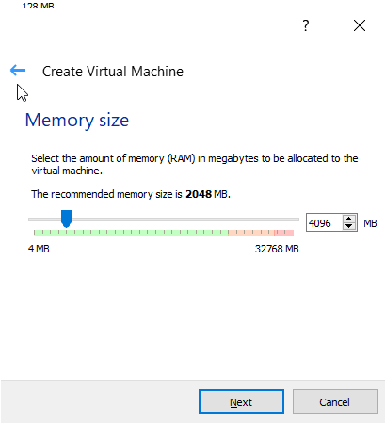
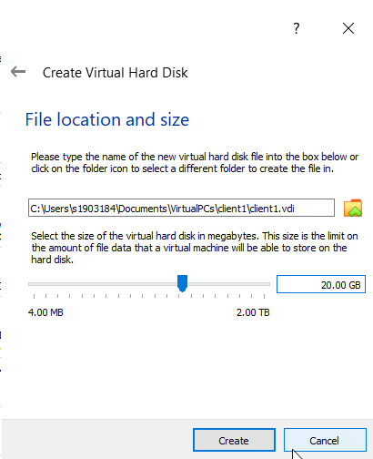
In both sets of screenshots, I have shown the settings that I have used to set up the virtual machines. The hard drives used are both dynamically allocated Virtual Disk Images (VDIs).
For the client screenshots, I have not screenshotted the operating system file selection, however I have taken the same process as I did with the server. I have also checked ‘Enable PAE/NX’ on all of the machines. All machines have 128mb video memory as specified in the worksheet.

3. Installing Windows
Installs of both Windows 10 and Windows Server 2019 were performed on the hosts. Below are screenshots of the installations.

3.1. On the server
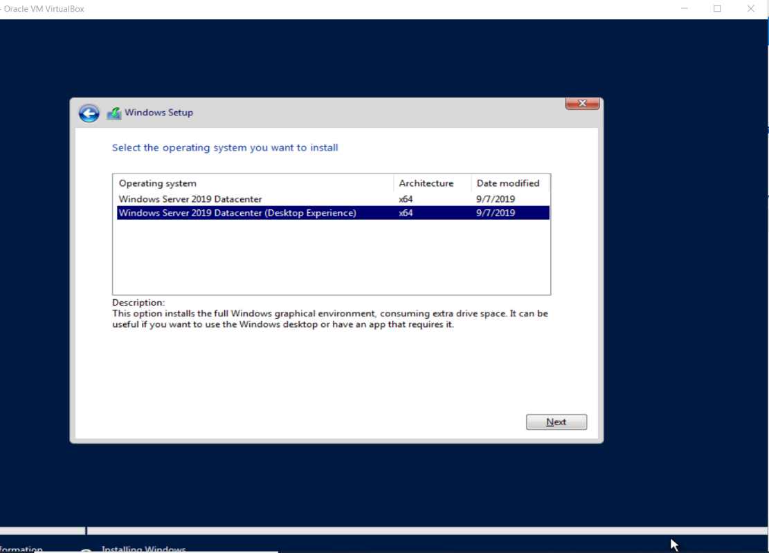
The desktop version of Windows Server was installed. This is because it is much easier to use than the command line interface, and also allows the user to do normal computing tasks if needed.
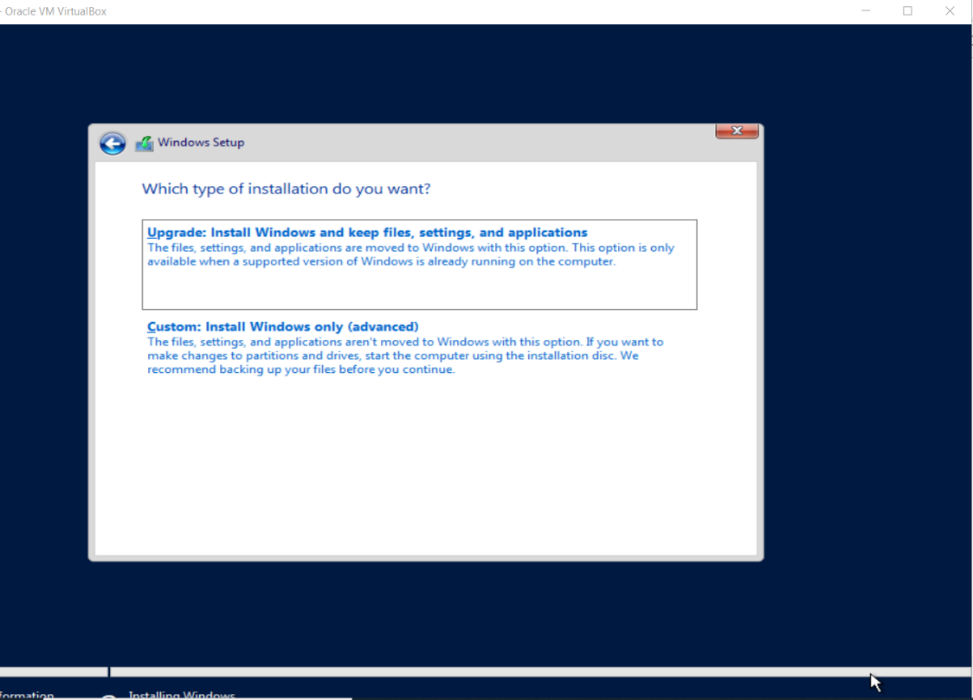
On this screen, a custom install was chosen. This is due to it being a clean install and not an upgrade from a different version of Windows.
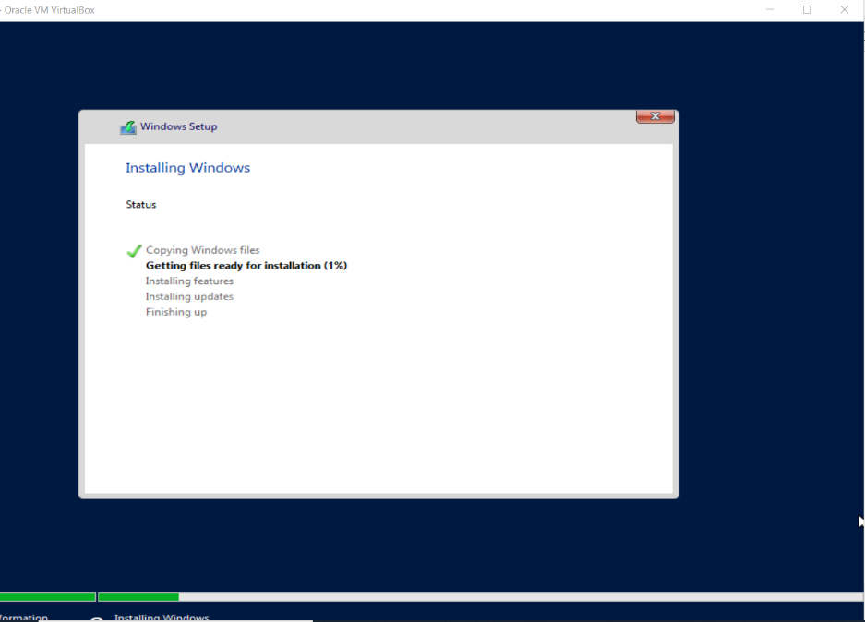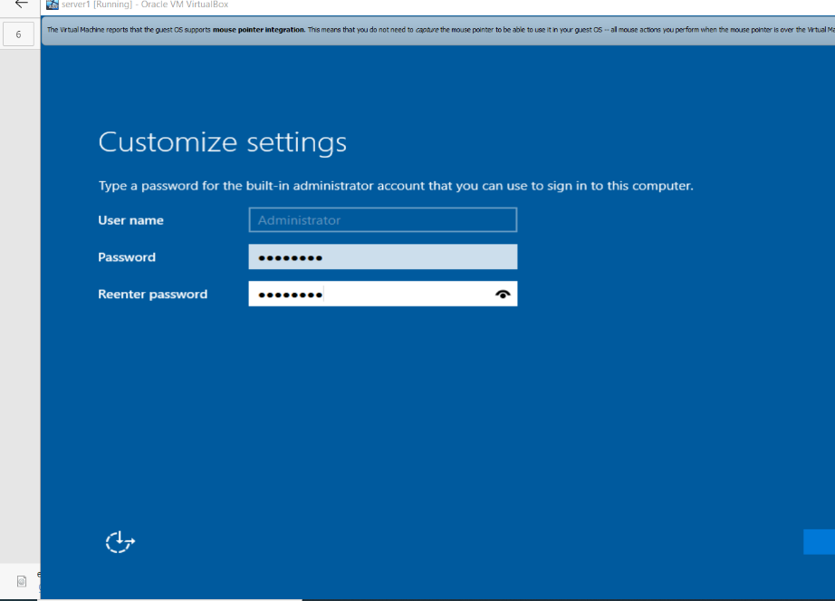
Above is the installation screen as well as the password entry screen for the server. The password used for the administrator account is P@ssw0rd.
I haven’t screenshotted the hard drive selection and the product key to reduce the amount of screenshots in the document, however Windows was installed to the hard drive that was specified when building the machine (the only hard drive) and at the product key screen, ‘I don’t have a product key’ was selected.

3.2. On the client
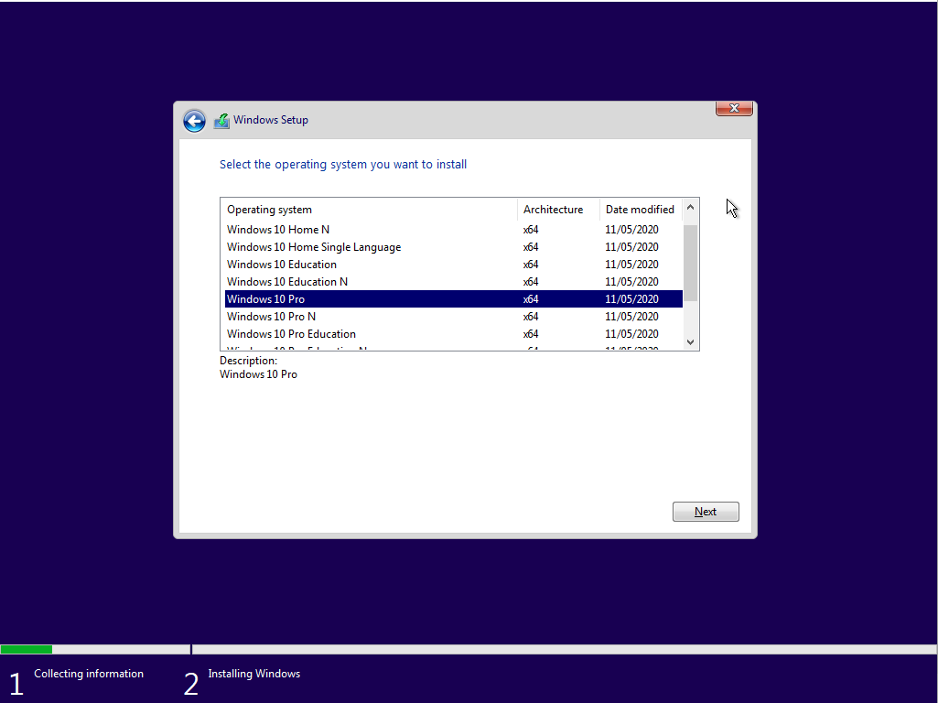
Windows 10 Professional has been installed on the workstation machines. This felt like the most appropriate choice for the purpose it is being used for.
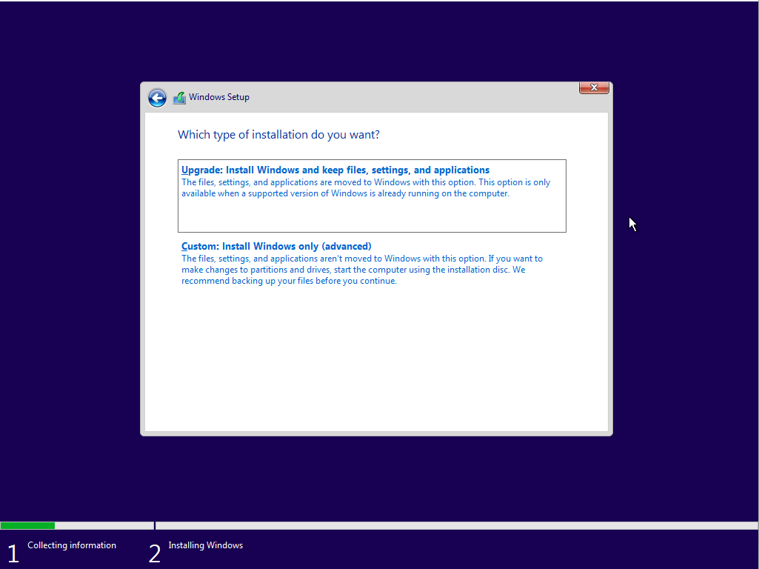
Again, a custom install was chosen as an upgrade cannot be completed on a fresh install of Windows.

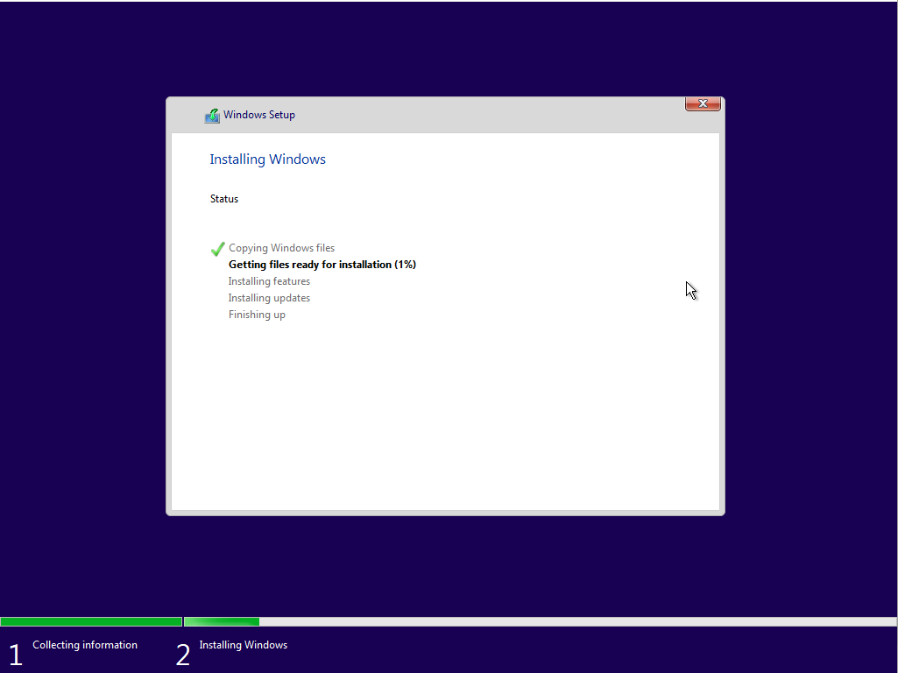
Finally, here is the install screen which shows Windows 10 installing.
Again, some of the dialogs were not screenshotted as to reduce the amount of clutter, as they were only basic options e.g. terms of service and product key.

4. Virtual Network Configuration
For this worksheet, two virtual networks have been set up – one network between Client one and Server one, and one between Client two and Server two. This will be split into two parts – setting the hosts up for networking on Virtualbox, and then configuring the network on Windows.

4.1. Setting up Virtualbox for networking
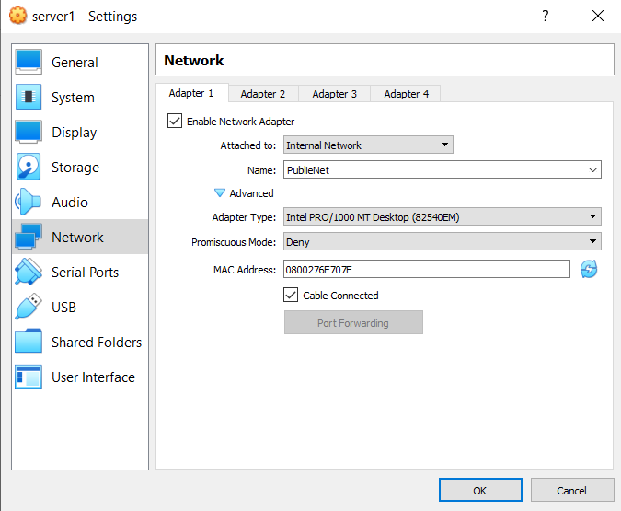
Here are the settings used for the server. We enable the network adapter and change the network type to an internal network. This allows for networking between two virtual machines. The adapter has been named PublicNet as that is the network that it is connected to.

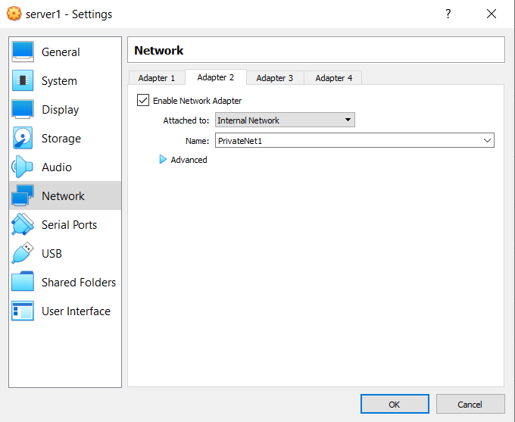
Another adapter has been set up – this will be used for the PrivateNet1 network between server one and client one.

The same adapters have been set up for the second network, however the names of the networks are slightly different – one is PublicNet and the other is PrivateNet2.

4.2. Configuring Windows for networking
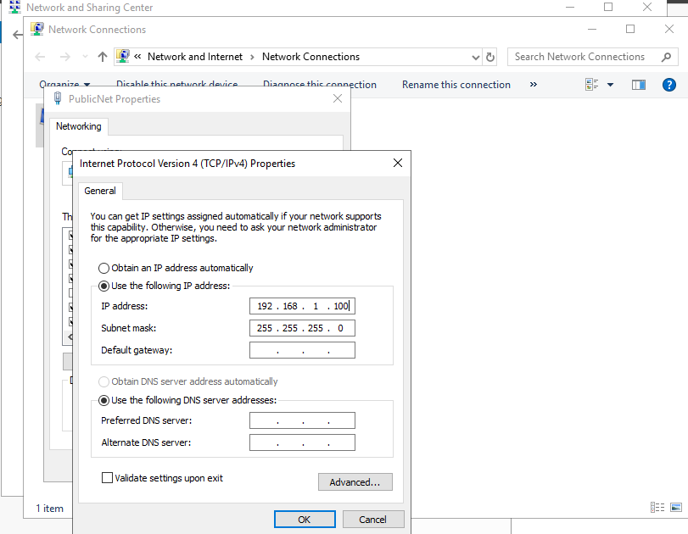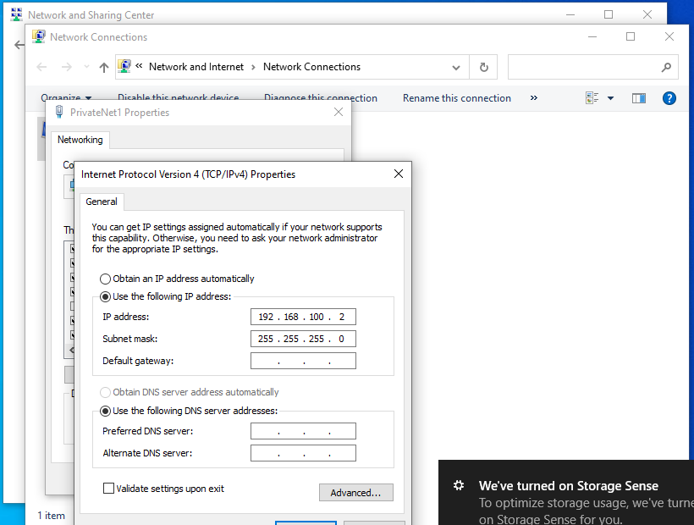
The above screenshots show the IP address being configured for both client one and server one. The IP addresses are 192.168.1.100 and 192.168.100.2 for the server and client, respectively.

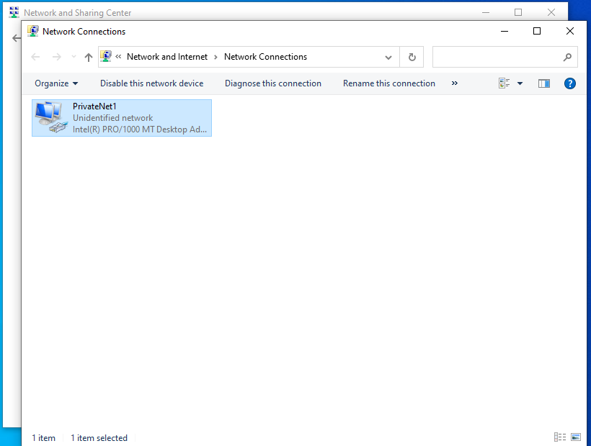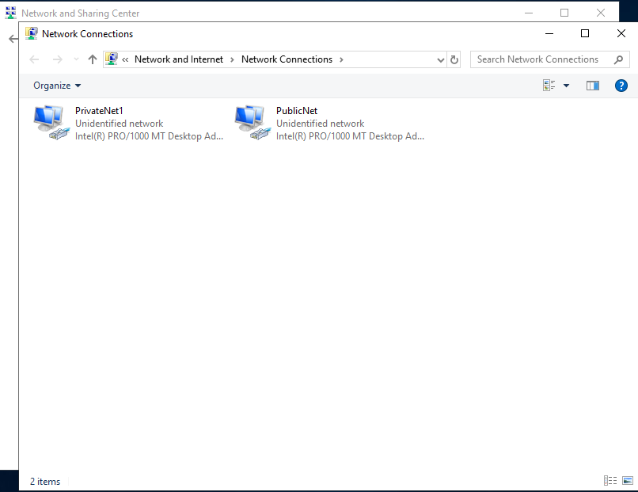
The screenshots above show the names of the adapters for the networks that are running between server one and client one.
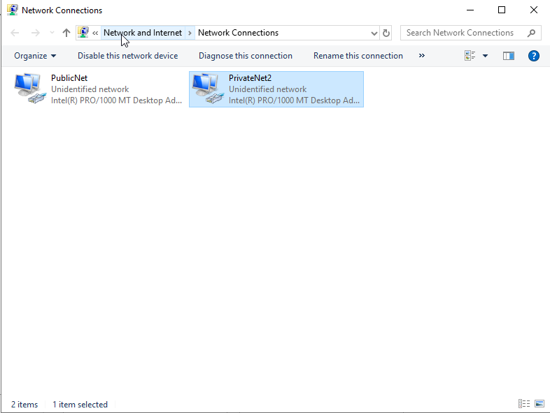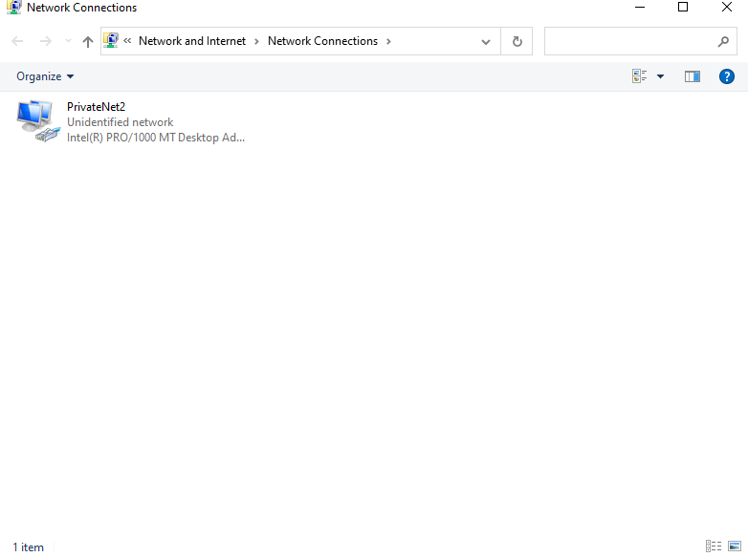
The above screenshots show the names of the adapters for the networks running between server two and client two.

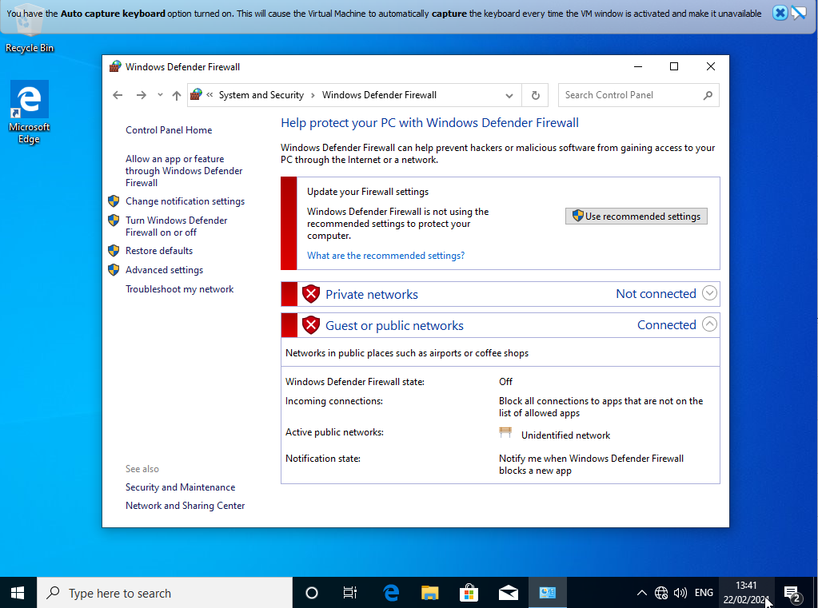
In order to verify connectivity, the ‘Ping’ command needs to be used. However, as a virtual machine is being used, the firewall must be disabled otherwise the command will be denied. The firewall was disabled on all hosts on the network.

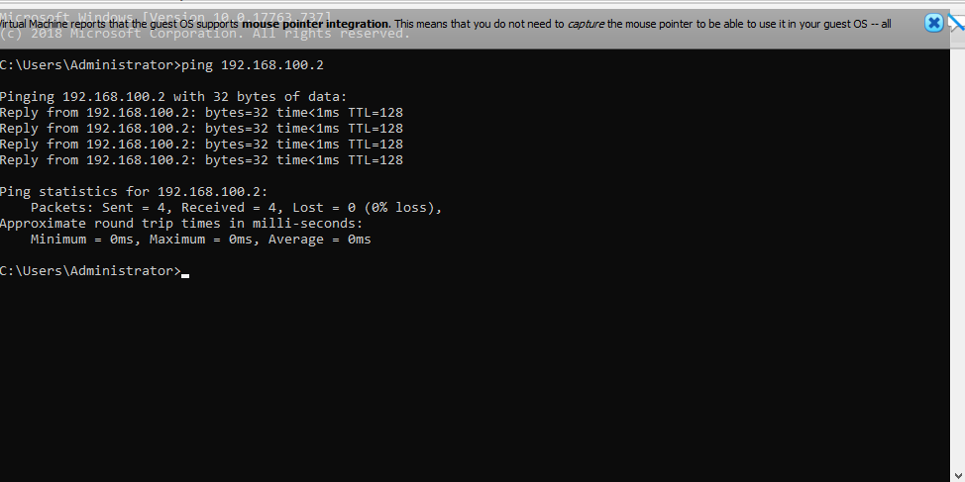
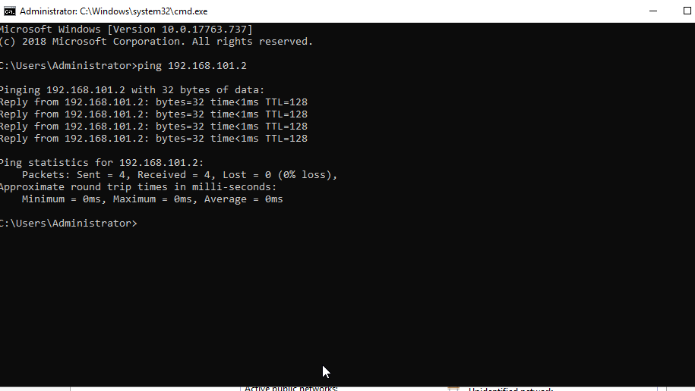
Finally, the ping command was issued. The above screenshots show the connectivity between client/server 1 and client/server 2 respectively. Running the ping command verifies that the machines are connected to each other and can communicate with each other.

5. Observational Tasks

5.1. Hypervisors
Hypervisors are used to virtualise servers. They emulate available resources in order for guest machines to use them. You can boot up any operating system using a virtual machine and it will think that there is actual hardware available to run it. Virtual machines do not know that they are running within a machine, or that they are sharing hardware with the host computer.
There are two different types of hypervisor – type 1 and type 2.

5.1.1. Type 1 hypervisor
A type 1 hypervisor is also known as a bare-metal hypervisor, and is installed directly onto a physical server and its hardware. There is no operating system in between the hardware and the virtual machine. Type 1 hypervisors are operating systems – however they can only be used to run virtual machines and nothing more.
One of the best features of this type of hypervisor is the ability to over-allocate resources. For example, if the host machine has 128GB of RAM and is running eight virtual machines, 24GB can still be assigned to each virtual machine. The machines will think they have 24GB of RAM each, however they will only use the amount of RAM that they require and are very unlikely to need 24GB each.
Vendors of type 1 hypervisors include VMWare with their vSphere offering, which also comes with a free version with limited features. Linux has KVM (Kernel-Based Virtual Machine) with allows a user to turn a Linux kernel into a hypervisor. This is an open source hypervisor and contains all of the features of linux and more, making it a very popular choice for virtualisation.
Finally, Microsoft offer their Hyper-V package which is a paid offering. Hyper-V does not have as many features as the VMWare offering, but it does allow for basics such as machine replication and dynamic memory allocation. This also has a free version, with less features.

5.1.2. Type 2 hypervisor
A type 2 hypervisor runs on top of an operating system. This means that there is no need for an external management console to be able to set up and manage the machines, as it is all done from one machine. Type 2 hypervisors are essentially a computer inside a computer.
When using type 2 hypervisors, the user needs to be careful about how much of the host resources they give the virtual PC. The virtual machines take RAM from the host and therefore the host will not run quickly if too much RAM is given to the virtual PCs.
This type of hypervisor is useful for testing things as the user just needs to open it from their host PC, and nothing will be altered on the host PC if anything goes wrong.
Vendors of type 2 hypervisors include Oracle with Virtualbox as used in this assignment. This is a free product with plenty of features, and it is good for both server and desktop virtualisation. VMWare have made Workstation Pro, which is a paid product. There are more advanced features than Virtualbox in this product as well. There is a MacOS version called VMWare Fusion which has less features but is also cheaper.

5.1.3. Which type to choose?
The type chosen depends on what you need the virtual machine for. If the machine is for personal use and running one or two virtual PCs, then a type 2 hypervisor is probably the better way to go. However, if the user plans to run a server which is very resource-demanding, then a type 1 hypervisor may suit the purpose better. In my opinion, I would say that type 1 is better suited to enterprise use, and that type 2 is better suited to personal use. (1)

5.2. The Subnet Mask
A subnet mask is a 32-bit address which is used to distinguish between a network address and a host address. A subnet mask is used to identify which part of an IP address is the network address, and which is the host address.
For example, if a subnet mask is 255.255.255.0, it means that the first 24 bits are the network address. This means that there are only 254 available hosts for the network as the first and last addresses are typically reserved.
Home networks will typically have a subnet mask of 255.255.255.0 which can connect 254 hosts, however this can be changed to handle more hosts if required. Changing the subnet mask to 255.255.0.0 can allow 65,536 hosts.

5.2.1. Why are subnets so important?
Subnets can provide security to a network, as if two devices are on the same subnet there can be free communication between them, but devices on other networks will not be able to access the subnet.
A subnet will also increase the amount of devices that can access the internet. There are only around three billion IP addresses available with standard IPv4 networking and this isn’t enough to meet global demand.
A subnet can therefore be used to connect a collection of devices to the internet using a single IP address using a router. (2)

5.3. Cloud Computing
Cloud computing is where services such as servers, storage, networking and software are provided over the internet.
Many businesses have chosen to make the shift over to cloud computing for various reasons. These include the cost, the speed, as well as performance and reliability of cloud computing.
Using the cloud for business works out cheaper as it does not require the user to purchase any expensive hardware, and also means that they do not have to employ anybody to set up the hardware and software for them. It also saves money as the business also does not have to pay out for electricity to run servers and their infrastructure.
Cloud computing is also a lot more reliable as data can be mirrored, meaning that backups are always available. Data is also stored at data centres meaning that there is a high level of security, and lower chance of a disaster occurring.
Finally, performance is a huge part of cloud computing. As cloud computing runs using data centres, this ensures that hardware is upgraded as much as possible. This ensures that network latency is reduced and that there is better scalability.

5.3.1. Types of cloud computing
There are three main types of cloud computing. Firstly, Infrastructure as a Service (IaaS) is where companies or individuals rent infrastructure such as servers, storage and operating systems from a provider, and they are usually on a pay-as-you-go basis.
Platform as a Service (PaaS) provides an environment for people to develop, test and manage software. PaaS is designed to make it easier for developers as they do not need to worry about the infrastructure of servers, storage etc. that they are using.
Finally, Software as a Service (SaaS) uses the Internet to deliver software, which is usually on a subscription basis. These applications include cloud storage (e.g. OneDrive, Google Drive), E-mail providers as well as some server management tools. (3)

5.3.2. Cloud computing vendors
Currently, Amazon Web Services (AWS for short) is the leading cloud computing vendor. AWS was the first known cloud computing vendor, and allows users to create and publish their application in the cloud. It is also easy to use and manage, which also makes it one of the top choices for cloud computing.
Google Cloud Platform is another provider, whilst not as popular as AWS it is still well known. GCP uses AI and analytics to solve issues that may arise in a project. It also provides the user with a suite of cloud based services alongside those which Google already provides to mainstream users.
Finally, Kamatera have produced a cloud server tool which uses a virtual infrastructure to operate, which makes It cost effective. The company uses 13 data centres spread around the world to guarantee availability, and also guarantees 99.95% uptime to the people that use the services. (4)

5.4. Terminologies
Here, I will be explaining terminologies that have been used in the worksheet, and I will also compare them with the equivalent terminology in different operating systems such as Linux and MacOS.

5.4.1. Ping
On Windows, ping is used in the command prompt and can be used to verify connectivity within a network. The user simply writes the word ‘ping’ followed by the IP address of the device they wish to communicate with, and the host attempts to send data packets through to the computer. If the packets are sent it means that the ping is successful and that there is connectivity. If they are not sent it means that there is probably no connection between the two workstations.
On MacOS, there are two different ways to issue the ping command. One way is to use the terminal and type the command the same as you would on Windows. The second way is to use the Ping function under Network Utility, and do it that way. When using the terminal, unlike Windows, MacOS pings infinitely and the user stops the command. (5)
Linux uses the same command, and works the same as Windows and MacOS.

5.4.2. Firewall
Firewall works largely the same on Windows, MacOS and Linux. A firewall is used to filter incoming connections and traffic. The firewall will have a set of security rules to work by, and uses these to decide whether to allow or block connections.
There are many different types of firewall. These include a proxy firewall, which usually prevents direct connections from outside the network. One of the most commonly used firewalls is a ‘Stateful Inspection Firewall. This allows or blocks traffic based on the state, port and protocol. It can monitor all activity until a connection is closed. Filtering is based on administrator-defined rules as well as information gathered from previous connections.
A lot of companies are also using ‘Next-generation Firewall’ or NGFW for short. These can be used in order to block threats such as malware and application-layer attacks.
According to Gartner Inc., a NGFW must include:
- Normal firewall capabilities, such as stateful inspection (as mentioned above)
- Built in intrusion prevention
- Application awareness to block apps that may be harmful
- Upgrade paths to allow for the inclusion of future information feeds
- Ways to address new and evolving security threats
Even though these are standard capabilities which should be met, these types of firewalls can do more than that. (6)

References
1. Simic, Sofija. What Is A Hypervisor? Types Of Hypervisors 1 & 2. PhoenixNAP. [Online] 24 January 2019. [Cited: 2 March 2021.] https://phoenixnap.com/kb/what-is-hypervisor-type-1-2.
2. What is a Subnet Mask Address and How to Find Yours. Networking Guides. [Online] [Cited: 2 March 2021.] https://networkingguides.com/what-is-a-subnet-mask-address-how-to-find-yours/.
3. Microsoft. What is cloud computing? A beginner's guide. Microsoft Azure. [Online] [Cited: 3 March 2021.] https://azure.microsoft.com/en-gb/overview/what-is-cloud-computing/.
4. Guru99. Top 25 Cloud Computing Service Provider Companies (2021). Guru99. [Online] 2021. [Cited: 3 March 2021.] https://www.guru99.com/cloud-computing-service-provider.html.
5. Haslam, Karen. How to Ping on a Mac. Macworld. [Online] 10 July 2018. [Cited: 5 March 2021.] https://www.macworld.co.uk/how-to/ping-test-mac-3524076/.
6. Cisco. What is a Firewall? Cisco. [Online] [Cited: 5 March 2021.] https://www.cisco.com/c/en/us/products/security/firewalls/what-is-a-firewall.html#~types-of-firewalls`.

