Liam Joseph Berner
1706870
HND Construction Management
Learning Contract Submission 1
Work Based Project
Ceredigion Sustainable Development
Peter Egan, 07720155434
ACBA5009

Index
Page 1
Index
Page 2
Body of work
Page 3
Body of work, References
Page 4
Appendix 1
Page 5
Appendix 2
Page 6
Appendix 3
Page 7
Appendix 4
Page 8
Appendix 5

My role within the company where I am experiencing elements of my work- based project is a part time assistant construction site manager. The company operates as a private development company in mid-Wales. The company buys land and develops sites for new domestic housing. All the development projects undertaken by the company include the minimum provision of affordable housing as per the legal requirements of the Section 106 agreements (Wales.Gov.UK) these agreements apply to each individual development site. Further regulations which apply to each development site include Planning (Ceredigion.Gov.UK), Building Regulations (Wales.Gov.uk 2010), Sustainable Drainage Systems (Wales.Gov.UK 2019), Health and Safety (HSE.GOV.UK) and various section agreements as required by adoption procedures for roads and drainage (Department of Transport 2017). All of the regulations and agreements mentioned will be involved in the processes that I will experience. Therefore, how I as an individual engage in activities and participate in opportunities to learn afforded by my workplace placement will be critical to the success of my placement and knowledge to be gained (Billett 2001 p209).
My first experience on site with the company in my current role has been the drainage system to nine number domestic dwellings. All the drainage work carried out on the nine dwellings has been in the curtilage of each plot and not in areas affected by the Section 104 and Section 38 agreements (Ceredigion.Gov.UK). The layout of the roads and drainage system can be seen in appendix (1). Evidence of the work undertaken with my involvement can be seen in appendix (2 to 5). This work required my involvement with the setting out of the levels required for the new pipe-runs and manholes. The drainage as installed in the photographic evidence in appendixes was installed at levels agreed from drawings prior to the foul drainage system having been completed in the road. The hands-on experience from my involvement in the tasks, I feel has enhanced my personal skillset and knowledge base. Studies across a range of industries have identified the importance of an individual’s active participation in a range of work activities such as observation, monitoring and engagement for learning (Malloch, Cairns and O’Connor 2011 p.62).
The drainage works carried out required the use of a five-ton tracked digger and a five-ton dumper to complete the excavation of the trench runs. The trenches were marked out and dug as per the architects and Civil Engineers companies’ drawings. The pipework laid into the trenches was 100mm plastic surrounded by pea gravel as can be seen in appendix (1). During the time of my involvement on site the works being carried out would have implications on the health and safety company procedures and operations. An example of this is can be seen in appendix (2), whereby the depth of the trench dig could have an impact on the risk assessment for the drainage works that had been carried out. A risk assessment under ‘health and safety at work regulations’ can be defined as the identity of what hazards exist in the workplace and how likely any hazards identified are to cause harm. (HSE, Work Regulations 1999). If the trench dug was of sufficient depth, guard rails would have been required around the top of the excavations to prevent anyone falling into the excavation and being injured (HSE, high risk activities 2013). The guard rails would be a requirement if the trenches were of sufficient depth as the drainage installed requires a minimum of 24 hours’ notice for inspection by building control before the trenches can be backfilled, a requirement of Building Regulations (Welsh.Gov.uk 2010).
The development company itself is a small private limited company (PLC), all areas of the day to day running of the company require that all the assets owned be they physical or financial are part of the output of the company. The company has a financial director, project manager, construction site manager, site foreman and various employed operatives and subcontractors all of them being part of the day to day running of the company. Therefore, as a small PLC using all the human resources available to the company, it is critical that there is flexibility in HRM management in response to fluctuations in demand and output of the company (Dainty and Loosemore 2012 p.19).
The drainage system of the nine houses in appendix (1 to 5) requires a completion date prior to the 28th of February 2020. After this date, six of the nine houses are programmed to be transferred to new owners. The three remaining detached houses on completion are part of a sales and marketing open day whereby the selling agents acting for the development company will invite members of the public to the site who they consider potential purchasers. The company site manager and company director informed me that in the past the company has achieved at least fifty percent of the sales on site today by having open days where invited members of the public view completed properties. The company site manager also confirmed that a majority of the communication with potential purchasers is made initially online in the form of email.
The drainage system I am involved with installing requires the use of Computer Aided Design software (CAD), used by the Civil engineers advising the company and dealing with the local authority for the adoption of the road and drainage systems. The drawings as supplied for each house have been drawn using CAD by the architects, these drawings include dimensions and levels required to adjoin to driveways, footpaths and roads. On site I have been using a laser level as can been seen in appendix (2 to 5), there is also the use of laptops and tablets (Hardware) by team members on site.
The work placement I have with the company requires that I spend one day a week in attendance on site to be involved in the processes required to complete the works relevant to the section 38 and section 104 adoption agreements. My agreement with the company is that I will attend for eight hours on every Friday until my work-based project module is completed.
Word Count 1013
References
Welsh Building Regulations, (2010) Approved Document, New Dwellings, Merthyr Tydfil, Welsh Government
Ceredigion Planning Policy (2012) Unitary Development Plan, Aberaeron
Wales.Gov.UK (2010) Sustainable Drainage Systems, (SUDS) Statutory Guidance, Merthyr Tydfil, Welsh Government
Department for Transport (2017) Highways Adoption, The adoption of roads into the public highway (1980 Highways Act), London, Department for Transport
Health and Safety Executive, HSE.Gov. Uk
Billett S (2001) Learning through work: Workplace affordances and individual engagement. Journal of Workplace Learning 13 (5) 209-214
Malloch M, Cairns L, Evans K, and O’Connor B.N. The Sage Handbook of Workplace Learning, London, Sage Publications
Health and Safety Executive (1999) Work Regulations, London, HSE.Gov.UK
Health and Safety Executive (2013) High Risk Activities, London, HSE.Gov.UK
Dainty A and Loosemore M (2012) Human Resource Management in Construction, Oxford, Routledge
Appendix 1
Shows the immediate foul drainage to a property before connection into the foul adopted drainage.
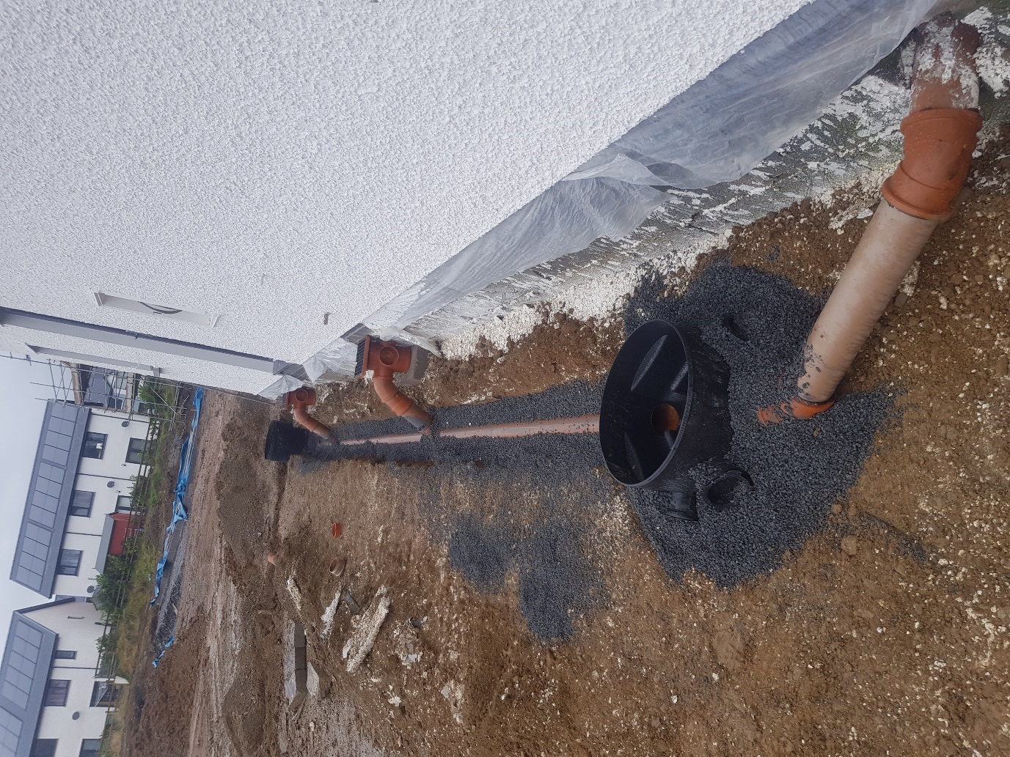

Appendix 2
Shows the use of a laser level staff to check the level against the setting out level
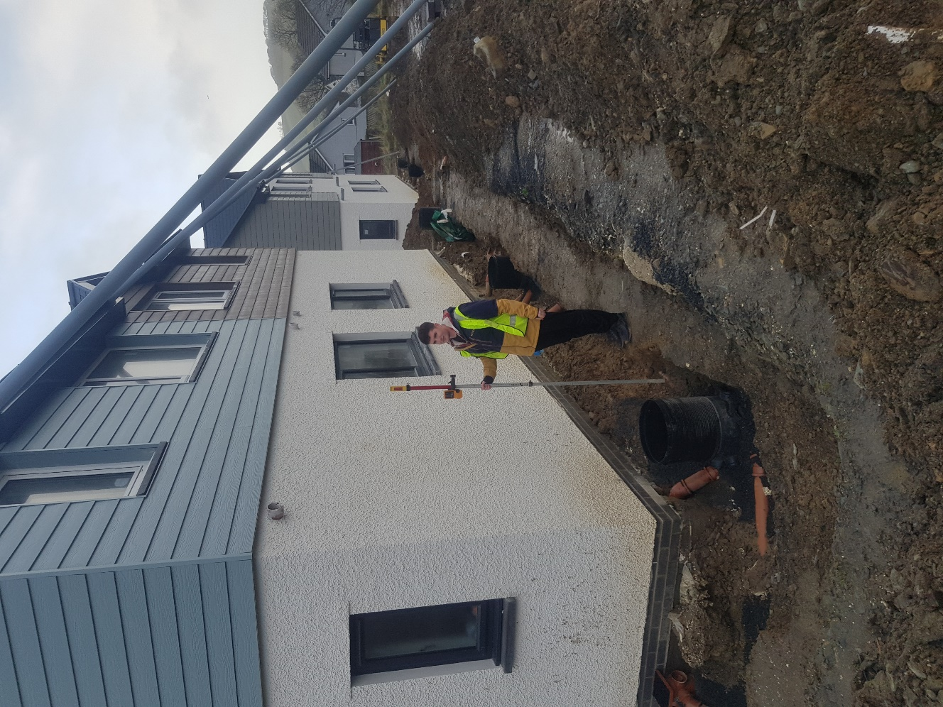

Appendix 3
Shows the use of a laser level staff to check the level against the setting out level on another drain run which is at a deeper level to the existing ground.
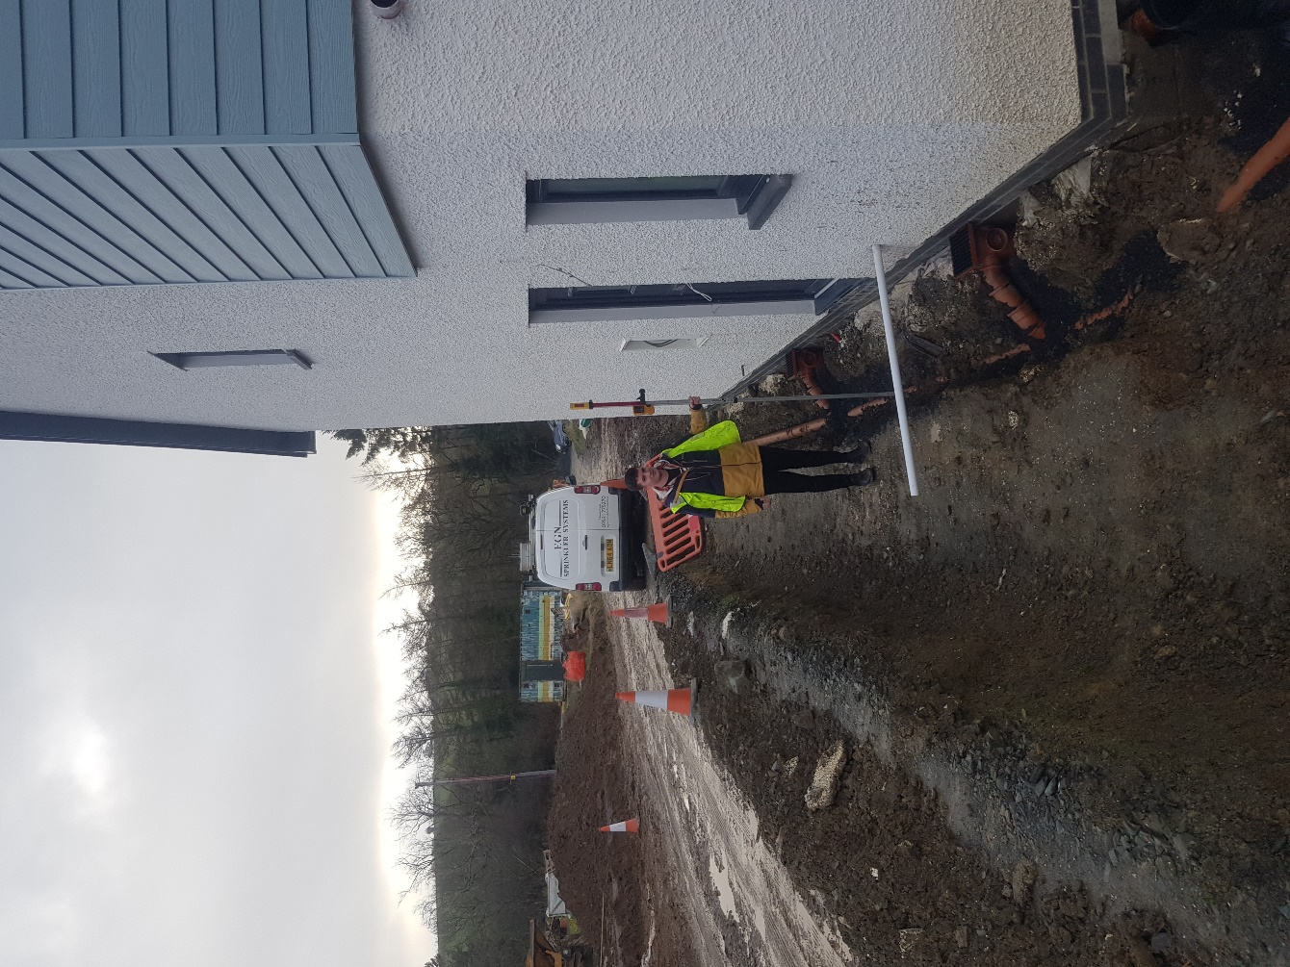

Appendix 4
Shows further checking of levels against setting out levels, the constructed levels are critical when the main adopted drainage system has not been constructed.
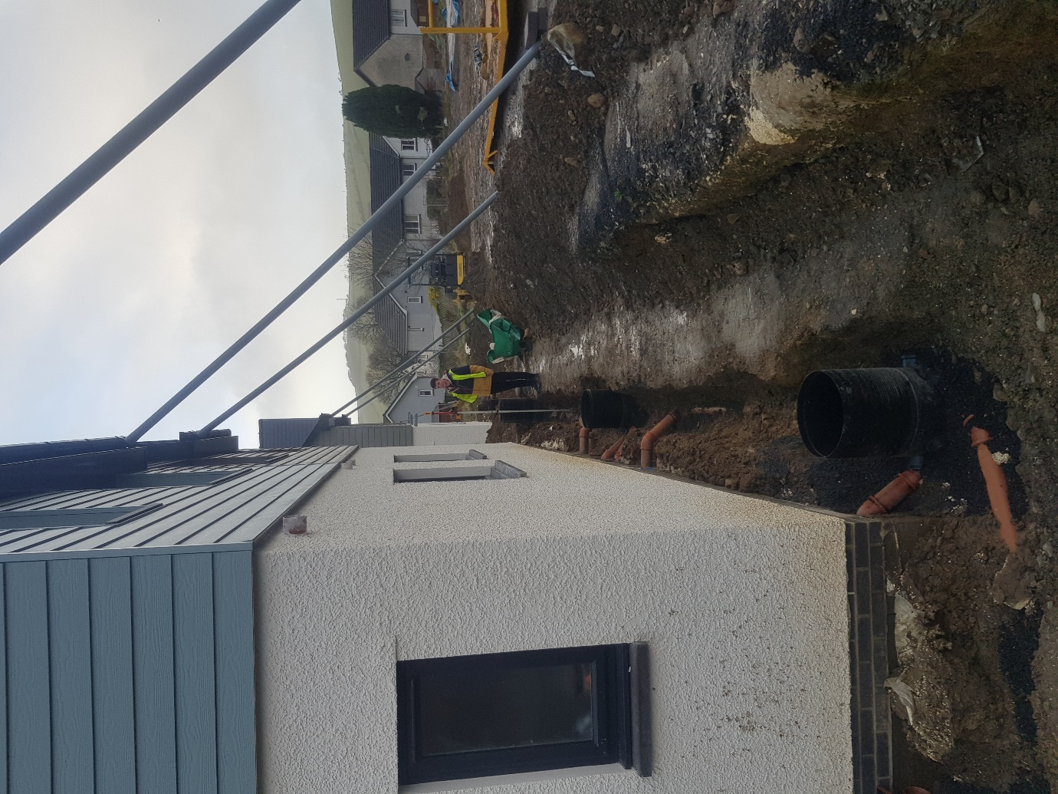

Appendix 5
Further checking of levels against setting out levels, the constructed levels are critical when the main adopted drainage system has not been constructed.



