Individual Business Model Canvas with entrepreneurial reflection
Student name Alina Elena Craciun

Student number 2212851
Module title Entrepreneurship
Module code BMIH5001
Lecturer name Christopher Wilkin

INTRODUCTION
The term entrepreneurship refers to the ability to run and organise a business organisation along with different types of uncertainties. Entrepreneurship plays an important role in economies, as it is connected with natural resources, land, capital and labour to generate profits. Entrepreneurship is motivated by five different concepts such as creativity and leadership, coordination and organisation, risk-bearing, managerial skills and business-oriented (Abelenda, Aiouache, and Moreno-Mediavilla, 2023). This essay is based on CHOCO CAFFE Portsmouth, which is a new start-up. In this essay, there will be a discussion about key partnerships, activities, value propositions, and customer relationships of the company. In addition to this, there will discussion about Gibb’s reflective cycle for the reflective essay.

MAIN BODY
Entrepreneurship is about growing and starting a new business and innovation is about finding new and better methods to create value for customers. The business is highly involved in terms of providing high-quality products and services to its customers. The business model canvas is one of the strategic management tools which have been used for developing a new business CHOCO CAFFE PORTSMOUTH (Conceptboard app(2024) Individual Business Model Canvas.Available at : https://app.conceptboard.com/board/tce3-1u9c-dysa-p3qt-0r10 (Accessed:04 February 2024). A proper understanding of the core elements of the business model canvas helped make the new business more successful and facilitated a better understanding of the importance of each element (Su, Zhang, and Ma, 2020). Understanding the importance of value proposition was essential for the new business as it allowed to develop a short statement that the company communicates to its potential customers why they need to experience the services and products of the café (Daou, and et.al, 2020). The coffee deals in serving high quality of services to its customers at affordable cost to capture high market share and enabling customers to experience company’s facilities. The customer segmentation part of the business model canvas helped in analysing what type of customers can experience the products and services of the new start-up and which type of communication channels the business need to adopt for a better customer journey.The customers of the company is segmented on the basis of their age, gender,professional, educational background and other factors.
People who are 20 years old onwards.
Parents between 20 -55 with infants and young children's seeking a short break.
Schools and educational institutions seeking for an attraction for a day trip in town.
Thorntons customers ar more female then male whith a age segment between 25-34(pro.similarwebb.com/Thorntons)
The revenue stream represents the cash which a new business can generate from each customer segment and the areas involve referrals, events meetings and customers experience : seling coffee and coffee products,chocolate and chocolate products, sweets and cakes,sealed coffee and chocolate products for home use ,branded cups for coffee and chocolate,T-shirts branded with the company logo,keys tags, magnetic gifts, deliverys Also, the company will partnership with different players such as government, agencies, food vendors, and many others. In addition to this, the channels in the business model canvas helped in representing the way new businesses can approach their customers with their products (Amoussohoui, and et.al, 2022). The new business uses social ways to develop relationships with its customers and influencers through customer support and content marketing as Thorntons does(pro.similarwebb.com/Thorntons) . The location of the new business is Portsmouth city center mall. Portsmouth is a port city, in England and this type of location can be effective for the organisation in terms of attracting a mass number of customers. The new business has different types of services and products for their customers through which they can create value for themselves. Their uniqueness is that they provide qualitative products to their customers at affordable prices, specially 21 different chocolate flavours like brandy,strawberry,forest fruit,ginseng. Providing superior quality products at an affordable cost can be helpful for the company in creating value for their customer and reducing their shifting cost towards the available competitors in the market. With the adoption of good practices of business, they can create value for their customers and earn good profits as well. The business focuses on maintaining good relationships with its customers and the customer service department and aims towards making good connections with people positively (Kraus and et.al., 2019).
There are certain main channels of communication at the digital level which include TV, social media platforms, Facebook, Instagram, YouTube, emails and Twitter as well. Choco CAFFE PORTSMOUTH will use social media channels Facebook , Instagram ,Emails ,text messages. These are the effective ways through which a company can communicate with its customers in a result-oriented manner.
For generating revenue on a larger scale at the level of organisation, the company will use different types of strategies to promote the brand over different digital platforms. For attracting customers on a larger scale, the companie will use different strategies such as the organisation providing referral cards to their customers to attract customers towards the organisation in result result-oriented manner. Also, communicating with customers and maintaining relationships with them through the use of social media channels and unique content like Thorntons do (pro.similarwebb.com/Thorntons) help the company in creating brand awareness in the market. So in overall terms, the company will try to focus on every parameter of promotion of its brand so that it can enhance its level of performance in the market .
The business organisation involves different types of internal and external factors that influence the decision-making process of the organisation. There are different types of factors which drive the decision-making process of the organisation.Providing a good working environment for employees of the organisation can be one of the most effective ways to manage and control different functions of the company such as marketing, finance, human resources, information technology and sales. Attitude of risk is another factor for business decisions in which the company take a risk of innovation to take the business towards higher success. Several big players in the manufacturing chocolate industry like Thorntons (pro.similarwebb.com/Thorntons) take risks to obtain better opportunities in their business practices. Also, the poor decision-making practices within the company are punished to eliminate the negative impact of the wrong decision-making practices on business. Also, the data availability and reliability factor in the decision-making process of the company emphasises on credit of the human capital of the organisation. The CHOCO CAFFE PORTSMOUTH keep proper track of the employees’ data to assess the background of the employees. In addition to this, the company keep track of the customers and the available competitors in the industry of chocolate like Thorntons(pro.similarwebb.com/Thorntons) , due to which the new strategies and methods can be easily adopted in their decision-making process. Lastly, the external environment factor is considered one of the most effective and important parts of the decision-making process of the organisation. The CHOCO CAFFE PORTSMOUTH make decisions following the changes in the external business environment and uncertainties associated with the business (Bocken, and Snihur, 2020).

Reflective Essay
During my academic journey, my tutor assigned a questionnaire based on entrepreneurship by which I was able to analyse my own strengths and weaknesses and the different aspects related to entrepreneurship. Involving active participation in the entrepreneurship questionnaire, I obtained a 42 score out of 48, which represented that I have the necessary qualities needed to be an entrepreneur. Also, I have appeared for the GET2 test which enabled me to analyse the tendency to start up and manage projects. Actively involved in the test provided me with an idea of my enterprising potential. The overall GET 2 test score mine was 52% which suggested that I have some entrepreneurial characteristics. The GET 2 test focused on different areas in the context of entrepreneurship. The need for achievement aspect of the test represented that I have a medium score, I was supposed to recognise some characteristics of a high need for achievement in me such as reliance on my ability, effective time management, goal–oriented and many others. I obtained a medium score in the need for autonomy aspect which showed that I need to cultivate a strong leadership ability. Also, I had low scores in creative tendency and based on the scores, I need to focus on developing good creativity skills for better innovative and creative business solutions. In addition to this, I calculated my risk-taking ability by which I obtained a medium score and lastly, I obtained a medium score in locus of control which represented that I need to develop my self-confidence and enterprising skills for setting up a successful business. performing such type of test, it became easy for me to analyse the ability to start a new business as per my own areas of strength and weakness. While preparing a business model canvas, I understood the key points which need to be covered for a new business start-up. I got a feeling of entrepreneur while preparing the business plan and helped me in learning about the key factors which drive the decision-making process of the organisation. The business objective, attitude of risks, organisational structure, external environment and data availability and reliability (Jabbour, and et.al, 2020).
The description stage of Gibb’s reflective model reflects that the overall business model canvas for the CHOCO CAFFE PORTSMOUTH was quite an interesting experience for me. The business model canvas enabled me to focus on the different types of entrepreneurial and management skills. I analysed that key partnerships, key Activities, value propositions, customer relationships and customer segments are the key factors which are considered by leaders and managers for better decision-making processes. The following stage of Gibb’s reflective model enabled me to assess the positive and negative aspects of the experience. The negative side of the experience involved a lack of good analytical and digital skills. The positive side of the experience involved the use of communication, planning and time management skills for performing the business model canvas on CHOCO CAFFE PORTSMOUTH. In addition to this, I have analysed that I need to put efforts into improving core weak areas such as analytical and digital skills (Wu, and et.al, 2020). The conclusion stage of the model reflects that the overall entrepreneurship experience was quiet and interesting. Also, it has given me a lesson to be more creative and innovative for obtaining success in this highly competitive business environment through the action plan stage.

CONCLUSION
From the above essay, it has been discussed that business model canvas plays a major role in providing proper understanding to the customers and investors regarding the values and the business. Also, it has been discussed that business objectives, attitude to risks, organisational structure, external environment and data availability and reliability are the key factors which drive the decision-making process.

REFERENCES:

Books and Journals
Abelenda, A.M., Aiouache, F. and Moreno-Mediavilla, D., 2023. Adapted business model canvas template and primary market research for project-based learning on management of slurry. Environmental Technology & Innovation, 30, p.103106.
Adeani, I.S., Febriani, R.B. and Syafryadin, S., 2020. Using GIBBS’reflective cycle in making reflections of literary analysis. Indonesian EFL Journal, 6(2), pp.139-148.
Amoussohoui, R., and et.al, 2022. An extended Canvas business model: A tool for sustainable technology transfer and adoption. Technology in Society, 68, p.101901.
Bag, S., Yadav, G., Dhamija, P. and Kataria, K.K., 2021. Key resources for industry 4.0 adoption and its effect on sustainable production and circular economy: An empirical study. Journal of Cleaner Production, 281, p.125233.
Barbieri, R. and Santos, D.F.L., 2020. Sustainable business models and eco-innovation: A life cycle assessment. Journal of Cleaner Production, 266, p.121954.
Bocken, N. and Snihur, Y., 2020. Lean Startup and the business model: Experimenting for novelty and impact. Long Range Planning, 53(4), p.101953.
Cardeal, G., Höse, K., Ribeiro, I. and Götze, U., 2020. Sustainable business models–canvas for sustainability, evaluation method, and their application to additive manufacturing in aircraft maintenance. Sustainability, 12(21), p.9130
Daou, A., and et.al, 2020. The Ecocanvas as a business model canvas for a circular economy. Journal of Cleaner Production, 258, p.120938.
Day, G.S., 2020. The dynamics of customer value propositions: An outside-in perspective. Industrial Marketing Management, 87, pp.316-319.
Dzeraviaha, I., 2023. The impact of firm size on environmental sustainability: The assessment based on the analysis of cost structure. Business Strategy & Development, 6(1), pp.20-32.
Jabbour, C.J.C., and et.al, 2020. Stakeholders, innovative business models for the circular economy and sustainable performance of firms in an emerging economy facing institutional voids. Journal of environmental management, 264, p.110416.
Jabbour, C.J.C., de Sousa Jabbour, A.B.L., Sarkis, J. and Godinho Filho, M., 2019. Unlocking the circular economy through new business models based on large-scale data: an integrative framework and research agenda. Technological Forecasting and Social Change, 144, pp.546-552.
Keiningham, T., and et.al, 2020. Customer experience driven business model innovation. Journal of Business Research, 116, pp.431-440.
Kraus, S., Palmer, C., Kailer, N., Kallinger, F.L. and Spitzer, J., 2019. Digital entrepreneurship: A research agenda on new business models for the twenty-first century. International Journal of Entrepreneurial Behavior & Research, 25(2), pp.353-375.
Mishra, S. and Tripathi, A.R., 2020. Platform business model on state-of-the-art business learning use case. International Journal of Financial Engineering, 7(02), p.2050015.
Ojasalo, J. and Ojasalo, K., 2020. Service logic business model canvas for lean development of SMEs and start-ups. In Sustainable Business: Concepts, Methodologies, Tools, and Applications (pp. 436-463). IGI Global.
Salvador, R., and et.al, 2021. Circular economy strategies on business modelling: Identifying the greatest influences. Journal of Cleaner Production, 299, p.126918.
Shakeel, J., amd et.al, 2020. Anatomy of sustainable business model innovation. Journal of cleaner production, 261, p.121201.
Su, J., Zhang, S. and Ma, H., 2020. Entrepreneurial orientation, environmental characteristics, and business model innovation: a configurational approach. Innovation, 22(4), pp.399-421.
Wu, C., and et.al, 2020, September. Research on Source-Grid-Load-Energy Storage Collaborative Service Business Model Based on Business Model Canvas Approach. In 2020 12th IEEE PES Asia-Pacific Power and Energy Engineering Conference (APPEEC) (pp. 1-5). IEEE.
https://www.mindmaps.app 03/02/2024
https://app.conceptboard.com/board/tce3-1u9c-dysa-p3qt-0r10 04/02/2024
https://pro.similarweb.com/#/digitalsuite/websiteanalysis/audience-demographics/*/999/3m?webSource=Total&key=thorntons.com

Appendix
Business Model Canvas

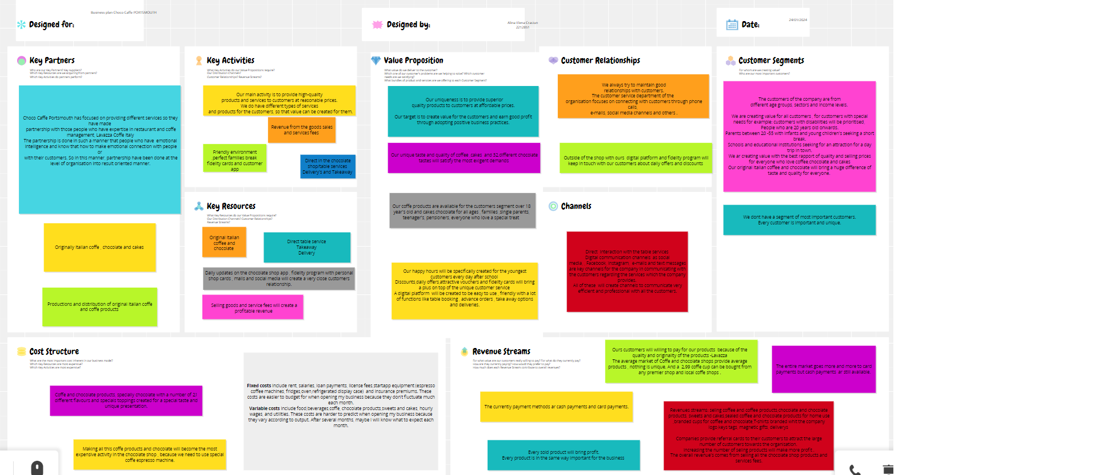

https://app.conceptboard.com/board/tce3-1u9c-dysa-p3qt-0r10

Class test

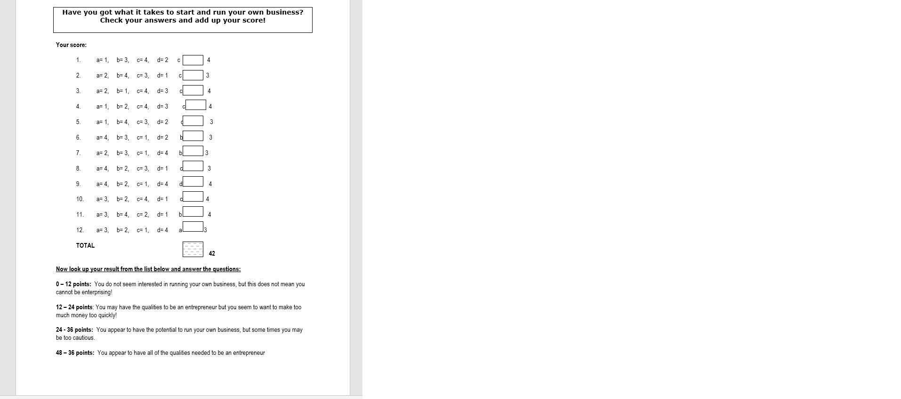

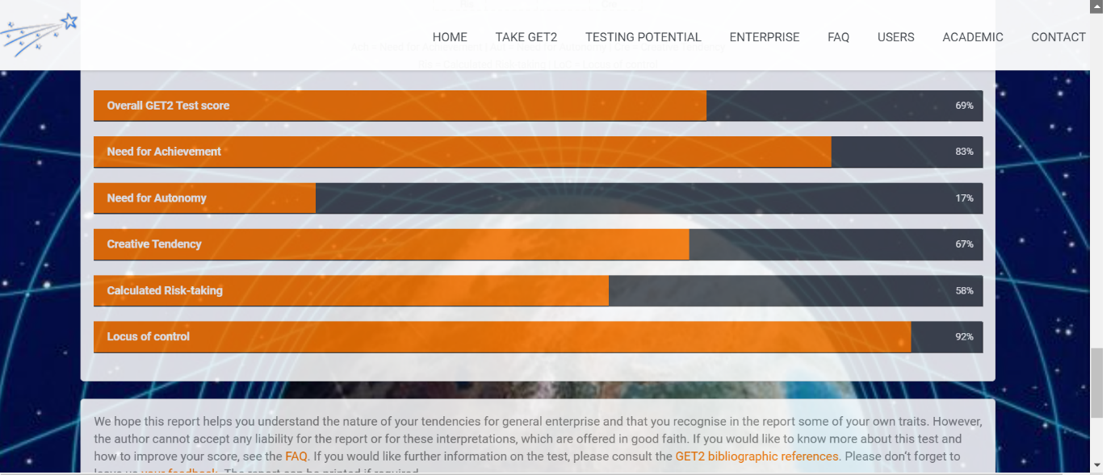

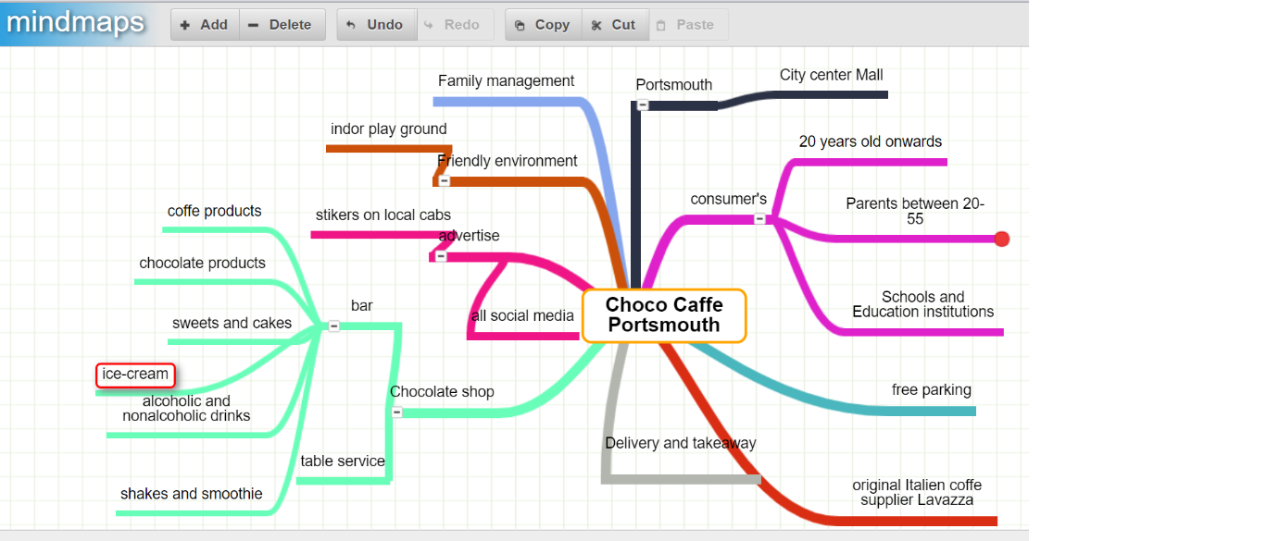
https://www.mindmaps.app 03/02/2024

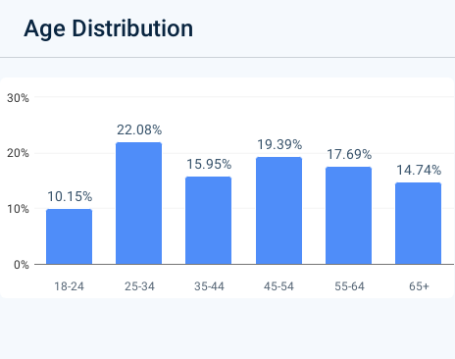
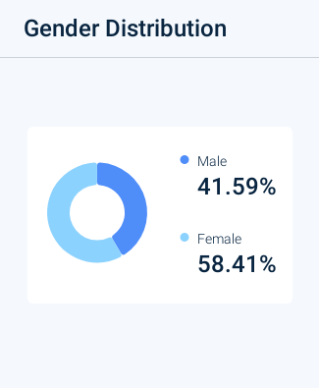

https://pro.similarweb.com/#/digitalsuite/websiteanalysis/audience-demographics/*/999/3m?webSource=Total&key=thorntons.com

