

University of Wales Trinity of St David:
Ordnance Munitions and Explosives

Academic Year 2024 - 2025

Lewis Gray (2224230)

Design of a Shaped Charge
Supervisor: Kelvin Donne

November 2024

Academic Integrity Declaration
I declare that:
- the thesis submitted has been written by me alone.
- the thesis submitted has not been previously submitted to this university or any other.
- that all content, including primary and/or secondary data, is true to the best of my knowledge.
- that all quotations and references have been duly acknowledged according to the requirements of academic research.
I understand that to knowingly submit work in violation of the above statement will be considered by examiners as academic misconduct.

Abstract
Shaped charges have been used throughout history from being used in industry, to being utilised by the world’s militaries past and present. This report will examine and compare types of shaped charges using the computer aided engineering software Abaqus, as well as examine the material mechanics, such as stress, strain and tension, present inside the charges whilst undergoing detonation.
Two two-dimensional simulations were constructed in order to compare the effects of a wave shaper on the performance of the penetrative superplastic jet and a three-dimensional simulation was also constructed and was compared to the two-dimensional simulation of the same nature.

Table of Figures
Figure 1: Visual of an American M830 HEAT Round [4] 8
Figure 2: Sketch of Conical Liner 9
Figure 3: Sketch of the Casing 9
Figure 4: Sketch of the Wave Shaper 9
Figure 5: Sketch of the HE Filler with Wave Shaper Cavity 10
Figure 6: Assembly of Shaped Charge Containing a Wave Shaper 12
Figure 7: Assembly of Shaped Charge Without Wave Shaper 12
Figure 8: Shaped Charge Casing Mesh 13
Figure 9: Shaped Charge HE Filler Mesh 14
Figure 10: Shaped Charge HE Filler Part with Wave Shaper Cavity 14
Figure 11: Shaped Charge Conical Liner Mesh 15
Figure 12: Shaped Charge Wave Shaper Mesh 16
Figure 13: Assembly of Meshed Charge with Wave Shaper 16
Figure 14: Assembly of Meshed Charge Without Wave Shaper 17
Figure 15: Velocities of the Nodes at the Tip of the Superplastic Jet (No Wave Shaper) 17
Figure 16: Propagation of the Pressure Wave Within Shaped Charge (No Wave Shaper) 18
Figure 17: Maximum Principal Stress (No Wave Shaper) 19
Figure 18: Velocities of the Nodes at the Tip of the Superplastic Jet (Wave Shaper) 20
Figure 19: Propagation of the Pressure Wave Within Shaped Charge (Wave Shaper) 21
Figure 20: Maximum Principal Stress (Wave Shaper) 21
Figure 21: Three-Dimensional Model Meshes 22
Figure 22: Assembled Three-Dimensional Mesh 23
Figure 23: Velocities of the Nodes at the Tip of the Superplastic Jet (Three-Dimensional) 23
Figure 24: Propagation of the Pressure Wave Within Shaped Charge (Three-Dimensional) 24
Figure 25: Maximum Principal Stress (Three-Dimensional) 25

Table of Tables
Table 1: Material Properties of Copper 11
Table 2: Material Properties of TNT 12
Table 3: Material Properties of Low-Density Steel 12

Contents
Academic Integrity Declaration 2
Abstract 3
Table of Figures 4
Table of Tables 5
Introduction 7
What is a Shaped Charge 7
How Do Shaped Charges Work 8
Construction of Simulated Shaped Charges 8
Sketching 8
Part Creation and Assembly 11
Part Meshing 13
The Casing 13
The HE Filler 14
The Liner 15
The Wave Shaper 16
Meshed Assembly 17
Simulation of Shaped Charge Without Wave Shaper 17
Analysis of Pressure Wave 18
Analysis of Maximum Principal Stress 19
Simulation of Shaped Charge with Wave Shaper 20
Analysis of Pressure Wave 20
Analysis of Maximum Principal Stress 21
Three-Dimensional Model With Wave Shaper 22
Results of Three-Dimensional Simulation 23
Analysis of Pressure Wave 24
Analysis of Maximum Principal Stress 25
Conclusions 25
References 27

Introduction

What is a Shaped Charge
Described as a ‘cylinder of explosive with a hollow cavity at the end opposite the initiation train’ by William Walters of the Army Research Laboratory [1], a shaped charge is an explosive munition that utilises the Munroe effect in order to increase the effectiveness of the explosive. Walters makes the distinction between ‘hollow charges’ and ‘shaped charges’ whereby a hollow charge has a cavity that does not contain a conical liner, however, if the cavity in the charge is lined with a metal, alloy, ceramic or another material, then it is referred to as a shaped charge, a cumulative charge in Soviet literature, or ‘Hohlladung’ in German. Shaped and hollow charges were initially used in industry, specifically in mining, to increase the effectiveness of explosives charges and reduce the quantity of HE filler used. By the 20th century, however, military applications were sought for the Munroe effect as experiments began to explore the use of charges to penetrate armour plates. In 1935, Henry Hans Mohaupt, a Swiss chemical engineer, developed the first shaped charge munition which was demonstrated to the Swiss, British and American militaries. Shaped charges played a crucial role in the Second World War with numerous militaries utilising the technology in the form of High Explosive Anti-Tank (HEAT) munitions. HEAT rounds continue to be used to this day in militaries around the world with the RPG-7 being one of the most common light anti-tank weapons available to militaries and insurgent groups.

How Do Shaped Charges Work
Shaped charges typically consist of three main components; being a liner, usually made of copper, a high explosive component which is usually a mix of RDX and TNT, as well as a case to house the components of the munition. The casing is normally made from steel.
A shaped charge uses the explosive power of the HE filler to focus the liner into a penetrative jet. After ignition, detonation waves propagate at supersonic speeds through the munition, while being forced inward toward the axis of the cone by the conical shape of the explosive compound. This creates a region of high pressure at the apex of the liner which then causes the conical liner to collapse inwards resulting in a superplastic jet measured at velocities measured in the 1000s of metres per second. When the jet impacts a target, be it enemy armour in a military charge or a rock formation in industrial use, the jet applies localised stress, far beyond the material’s yield strength, causing strain exceeding the elastic limit of the target which causes plastic deformation and penetration.
Modern military HEAT rounds contain within them a wave shaper. This is a specially shaped piece of copper or ceramic which further shapes the propagating detonation wave to focus more effectively on the apex of the conical liner which creates an area of higher pressure. This enables the liner to collapse in on itself with greater force and allows the superplastic jet to form with much higher velocities, leading to an increase of the potential penetration achievable by the jet. Typically, a shaped charge will achieve a tip velocity of approximately 6000 to 8000ms⁻¹ [2], however, with the addition of a wave shaper, the tip velocity of the superplastic jet can achieve up to, and exceeding, 14000ms⁻¹ [3].

Construction of Simulated Shaped Charges

Sketching
In order to create the parts required to assemble and simulate a shaped charge using the Computer Aided Engineering (CAE) software Abaqus, the parts must be sketched beforehand. Preliminary research was conducted into the dimensions and construction of modern, in-service HEAT rounds and the feasibility of reconstructing them in the Abaqus software. It was later determined that obtaining the exact dimensions were impossible to obtain so a visual of the American M830 HEAT round was used as a guide to estimate measurements and angles of the shaped charge.

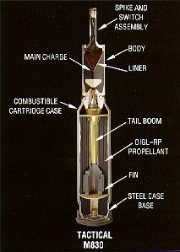
Figure 1: Visual of an American M830 HEAT Round [4]

Sketches to be used in the simulation of a shaped charge were then based off this image. It is important to note that only the projectile section of the round was used and the casing containing the propellant, as well as the tail boom and fins were ignored as they were unnecessary with regards to the simulation. Four sections were required to be sketched in order to simulate the charge, these being: the liner, the HE compound, the wave shaper and the casing which houses all the components. Only half of the part was required to be sketched as later in the simulation, the parts are reflected across the central Y axis, giving a 180° visualisation of the assembly.
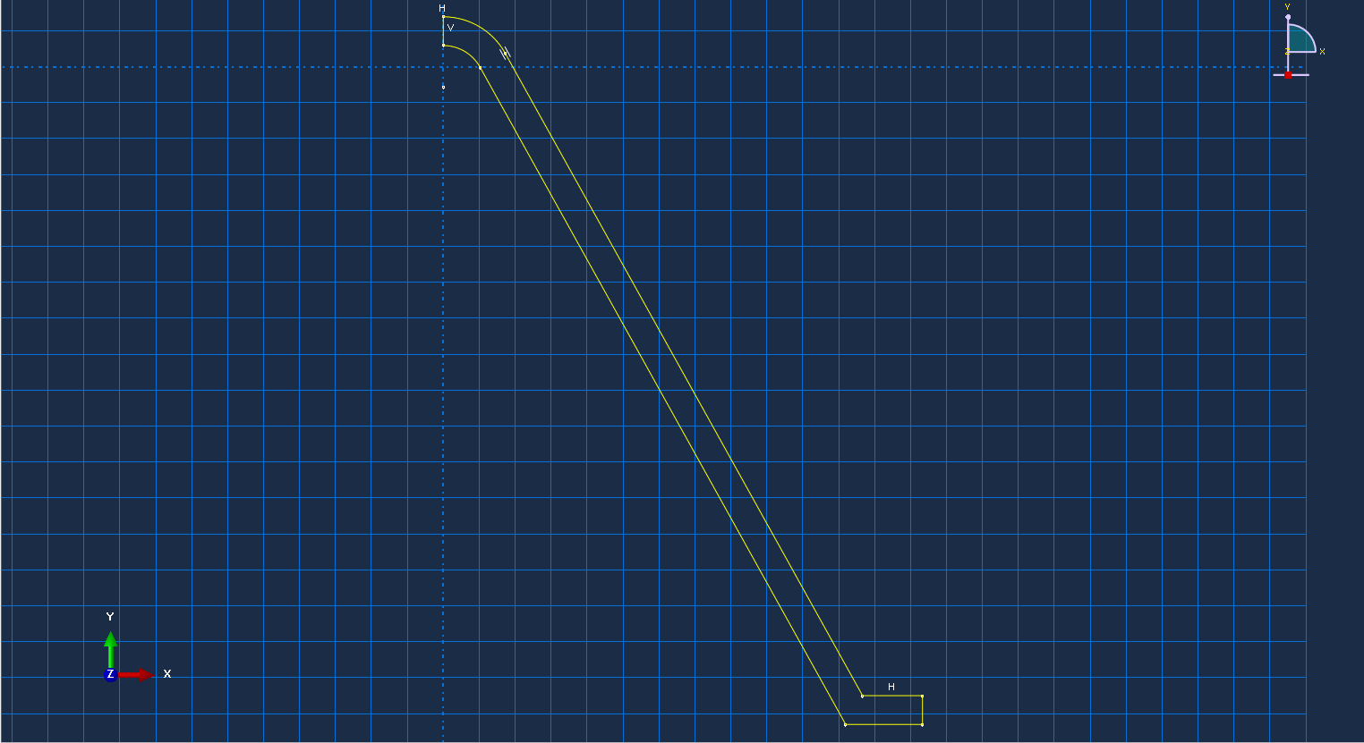
Figure 2: Sketch of Conical Liner
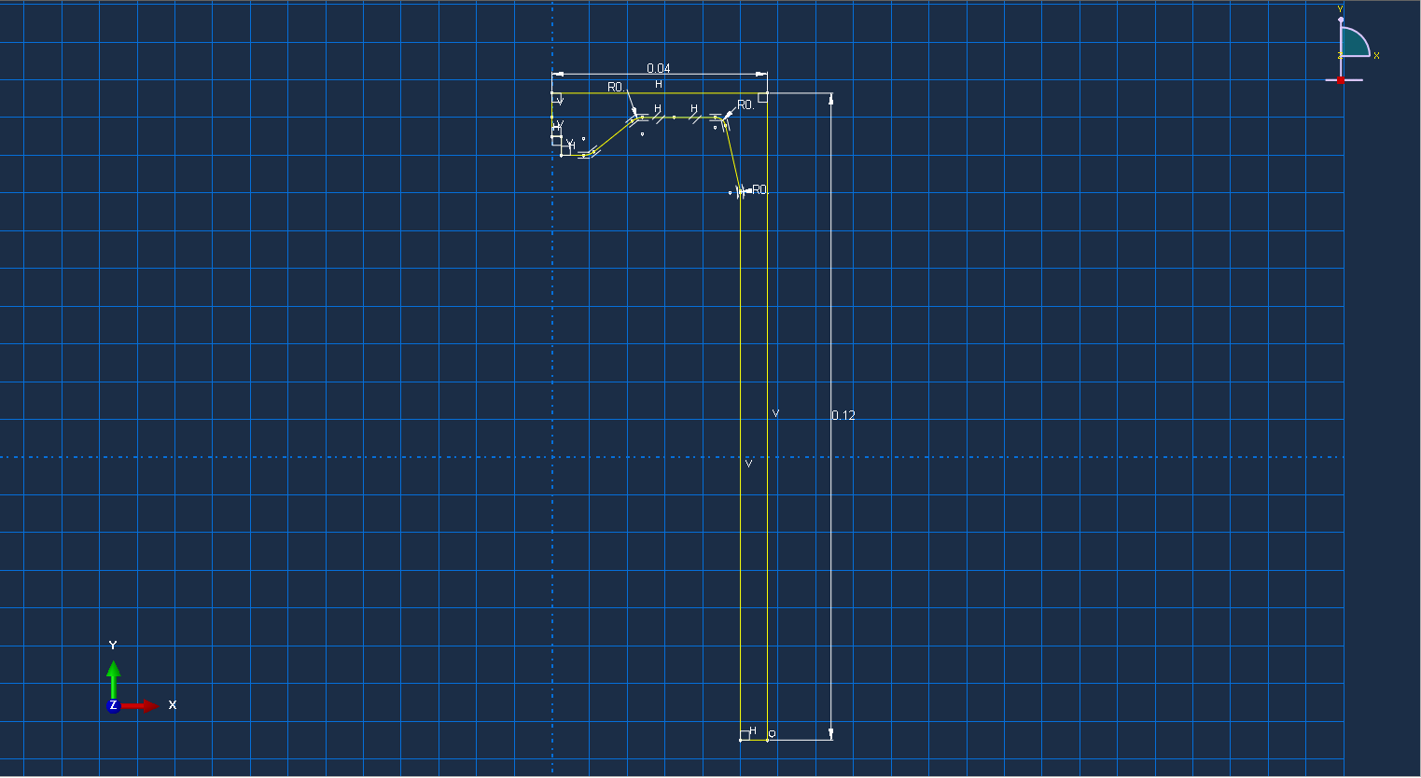
Figure 3: Sketch of the Casing
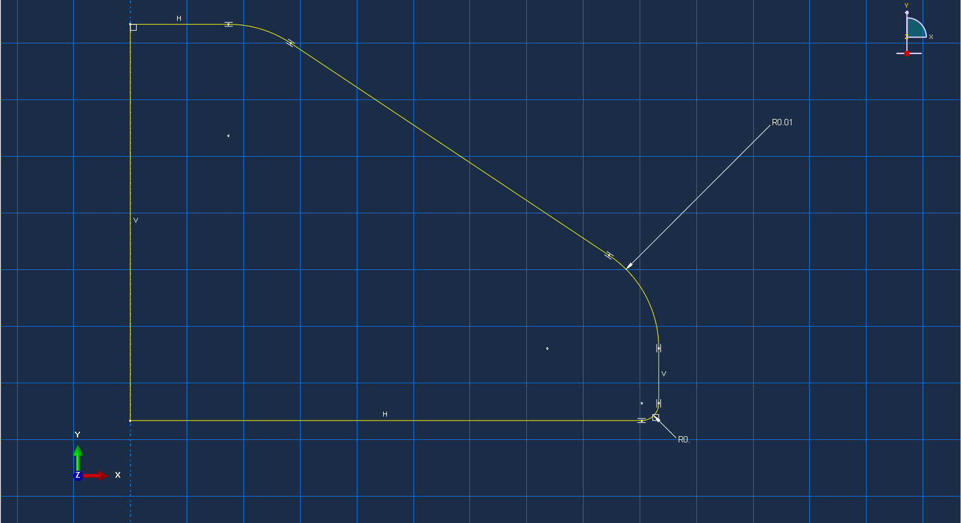
Figure 4: Sketch of the Wave Shaper

Two parts regarding the HE filler were sketched in order to accommodate the inclusion of the conical wave shaper in amidst the explosive composition. One part included a cavity for the wave shaper to be fitted, while the other had no such cavity and the space was occupied entirely by the HE compound.

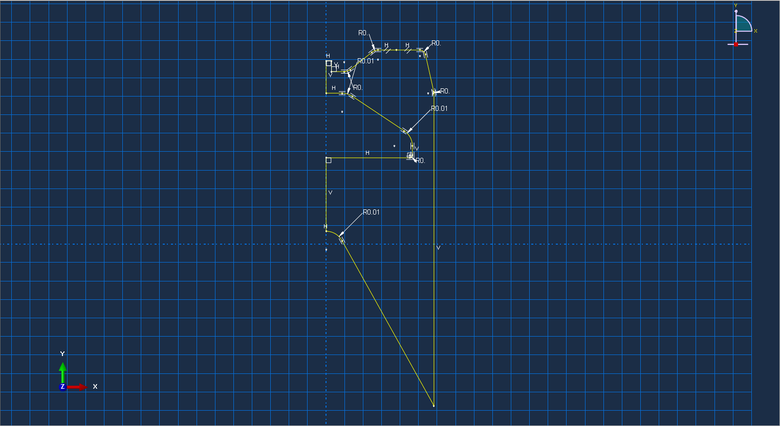
Figure 5: Sketch of the HE Filler with Wave Shaper Cavity

Part Creation and Assembly
Once the Sketches were completed, the parts were modelled and given properties corresponding to the materials used to construct them. The conical liner and wave shaper were to be made of copper due to its ductile properties, the casing was to be made from steel and the HE filler was to be TNT. The Johnson-Cook values for each material were sourced and keyed into Abaqus’ materials manager, ready to be assigned to a specific part. The material properties used for each part are shown below in the following tables.

Density | 8960 kgm⁻³
Shear Modulus | 46.3GPa
Johnson-Cook Schear Plastic Properties | A: 90MPa  B: 292MPa  n: 0.31  m: 1.09  T_{m}: 083°C  T₀: 25 °C
Equations of State | C₀: 3490ms⁻¹  S: 1.49  γ₀: 2.02
Table 1: Material Properties of Copper [5]

Density | 1800kgm⁻³
Equations of State | Detonation Wave Speed: 6930ms⁻¹  A: 3738E⁺⁸  B: 3747E⁺⁶  Ω: 0.33  R1: 4.6  R2: 1.05  Detonation Energy Density: 606E⁺⁴Pa  Pre-Detonation Bulk Modulus: 0
Table 2: Material Properties of TNT [6]

Density | 6800kgm⁻³
Elastic Properties | Young’s Modulus: 160,000MPa  Poisson’s Ratio: 0.3
Johnson-Cook Plastic Properties | A: 380MPa  B: 1.86GPa  n: 1.02  m: 0.87  T_{m}: 1450°C  T₀: 27°C
Johnson-Cook Hardening Properties | C: 0.0067  έ₀: 0.01
Table 3: Material Properties of Low-Density Steel [7]

Once the materials have assigned to their respective parts, the shaped charge can be assembled. In the Abaqus assembly manager, the parts created from the sketches were selected and put together, yielding a single part assembly with three component pieces. Overall, two part assemblies were created over the spam of the simulations; one assembly that contained the copper wave shaped, and one assembly that did not. The two assemblies can be seen in the figures below.

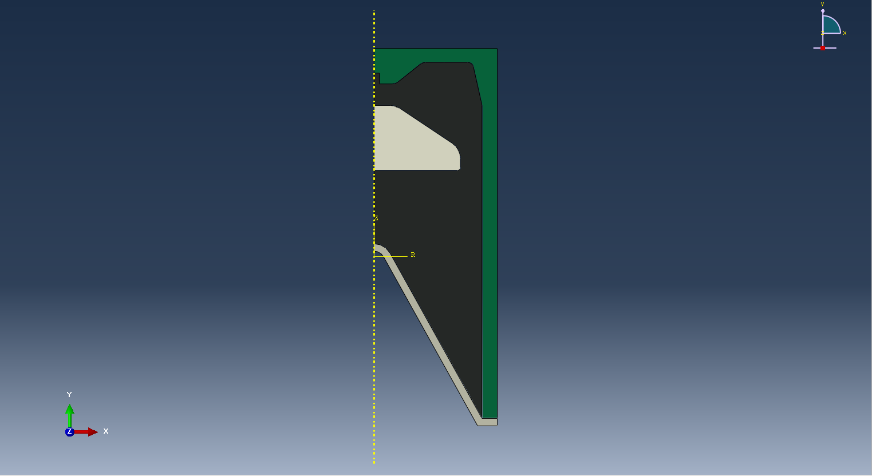
Figure 6: Assembly of Shaped Charge Containing a Wave Shaper
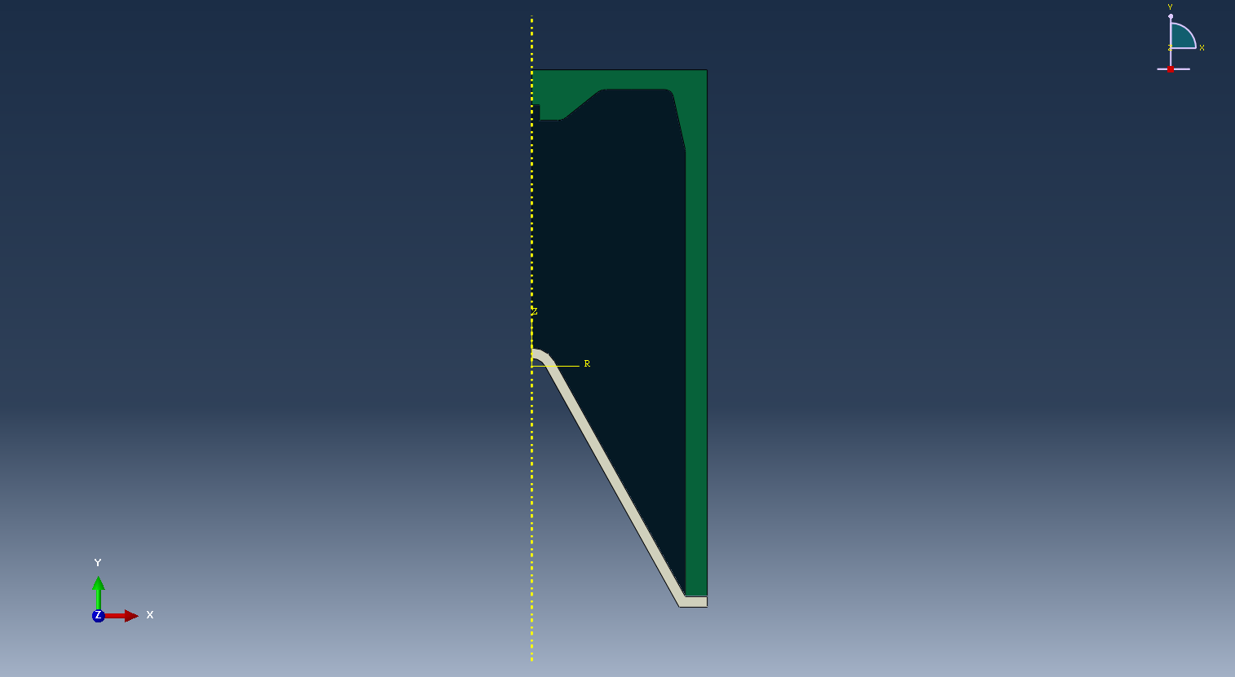
Figure 7: Assembly of Shaped Charge Without Wave Shaper

Once assembled, the point of detonation had to be found in order to make the simulation work. This was done using the query node tool option. The point of detonation was selected and the three-dimensional cartesian coordinates of the node were recorded and inserted into the TNT material manager under ‘detonation point’.

Part Meshing
In order to allow the parts to interact and respond to stimuli and mechanical forces, the parts must be meshed. The sizing of the mesh is crucial to a successful simulation as meshing the is an inappropriate size for the relevant part will lead to nodal breakage which can cause the simulation to crash. There was also a global mesh node limit of 250,000 nodes. A simulation with a greater number of nodes will also take a considerably greater period of time to complete processing and analysis. Therefore, the size of the meshing and number of nodes generated were given careful consideration.

The Casing
The steel casing of the charge was given a global mesh of approximately 0.001 as it was not necessary to obtain detailed simulation results from the casing. As such, the casing mesh was coarser than the liner mesh.
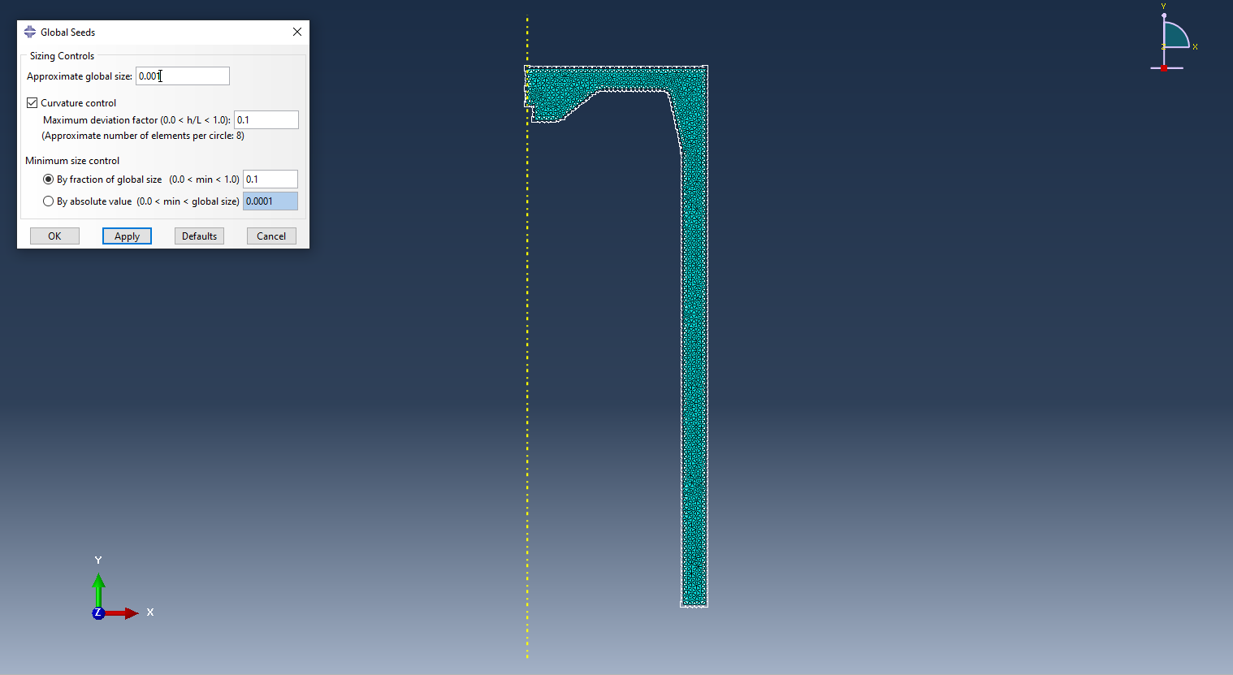
Figure 8: Shaped Charge Casing Mesh

The HE Filler
Meshing the HE filler part of the assembly was tricky as during early simulations of the system, the HE mesh nodes had a tendency to phase through the casing mesh. This was due to earlier assemblies having a finer HE mesh than the casing. In the final iterations of the shaped charge assembly, the meshes of the casing and the HE filler were adjusted so that the casing was given a finer mesh than the filler composition part. The HE filler was given an approximate global mesh size of 0.002, around twice the size of the casing mesh. Making this change resulted in improved mesh behaviours during simulation and solved many of the simulation crashes due to extreme node distortion, allowing the simulation to progress further and yield more complete results.

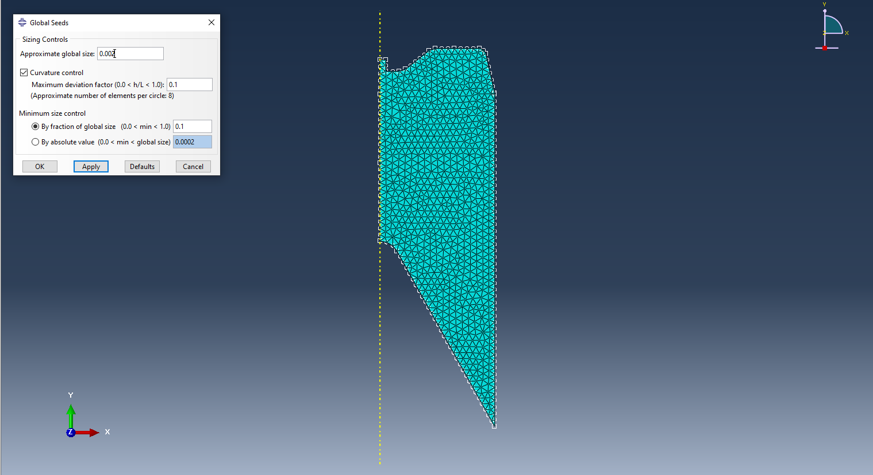
Figure 9: Shaped Charge HE Filler Mesh
Another HE filler part was also created and meshed to allow for the inclusion of the copper wave shaper. This part was given the same mesh size as the other HE filler part.

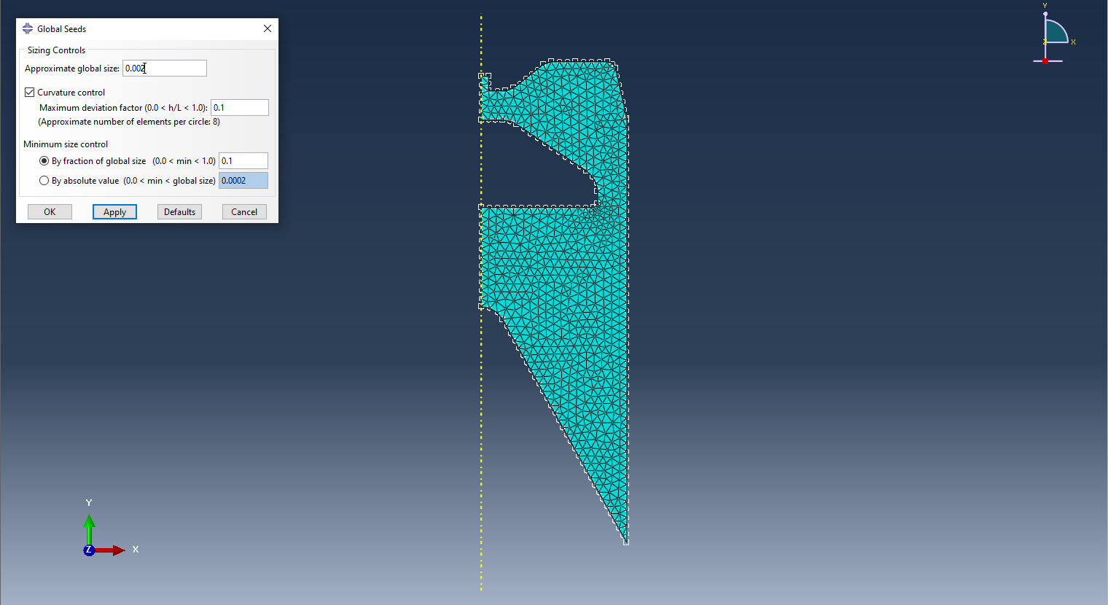
Figure 10: Shaped Charge HE Filler Part with Wave Shaper Cavity

The Liner
The most important part involved in the simulation was the conical copper liner that produces the superplastic jet. As the most detailed part of the simulation and the part most distorted by the detonation and propagating shockwave, the liner required the finest mesh out of all parts in the assembly. Again, a global mesh was assigned to the liner; this time, the mesh size was approximately 0.0008, making it slightly finer than the casing with which it was attached to. The finer mesh was adjusted in order fix crashed in the simulation and extreme distortions of the nodes. In earlier simulation runs, the liner nodes warped through the casing and HE composition and expanded sharply in random directions. This was due to interactions between the meshes of the liner, casing, and HE composition and had to be amended in order for the simulation to run properly, and for an acceptable result to be obtained.
Consideration was also given to the nodal limit imposed on the assembly. In order to obtain the most detailed result, the mesh of the liner had to be finer that the other assembly parts, however, increasing the number of mesh nodes too much would have adverse effects on the software analysis of the simulation and the 250,000 node limit could not be exceeded on the student version of Abaqus. However, the node limit wasn’t a problem as a node count anywhere near 200,000 would mean the simulation would be calculating and analysing the result for hours.

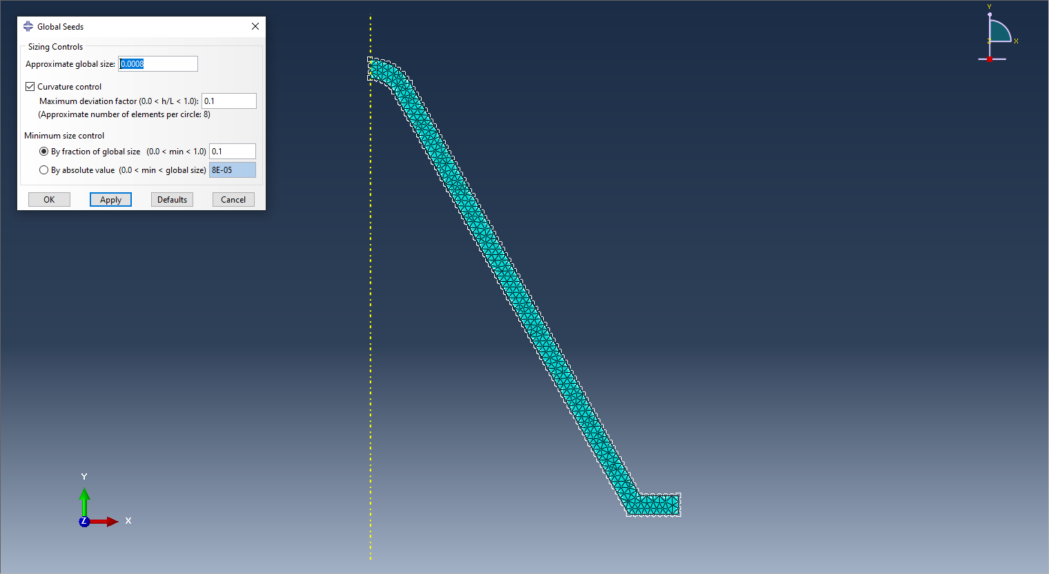
Figure 11: Shaped Charge Conical Liner Mesh

The Wave Shaper
The wave shaper was only used as part of one of the two shaped charge designs created for the simulations. The wave shaper was made to have the same mesh size as the steel casing as larger mesh sizes incurred issues with the interaction between it and the surrounding HE mesh. A mesh of a finer build had no beneficial effect on the performance of the simulation but did, however, negatively affect the calculation and simulation analysis performed by the Abaqus software as the space that would instead be filled by the HE composition was now occupied by the copper wave shaper which was had a smaller mesh with more nodes. Therefore, a mesh size of 0.001 was chosen.

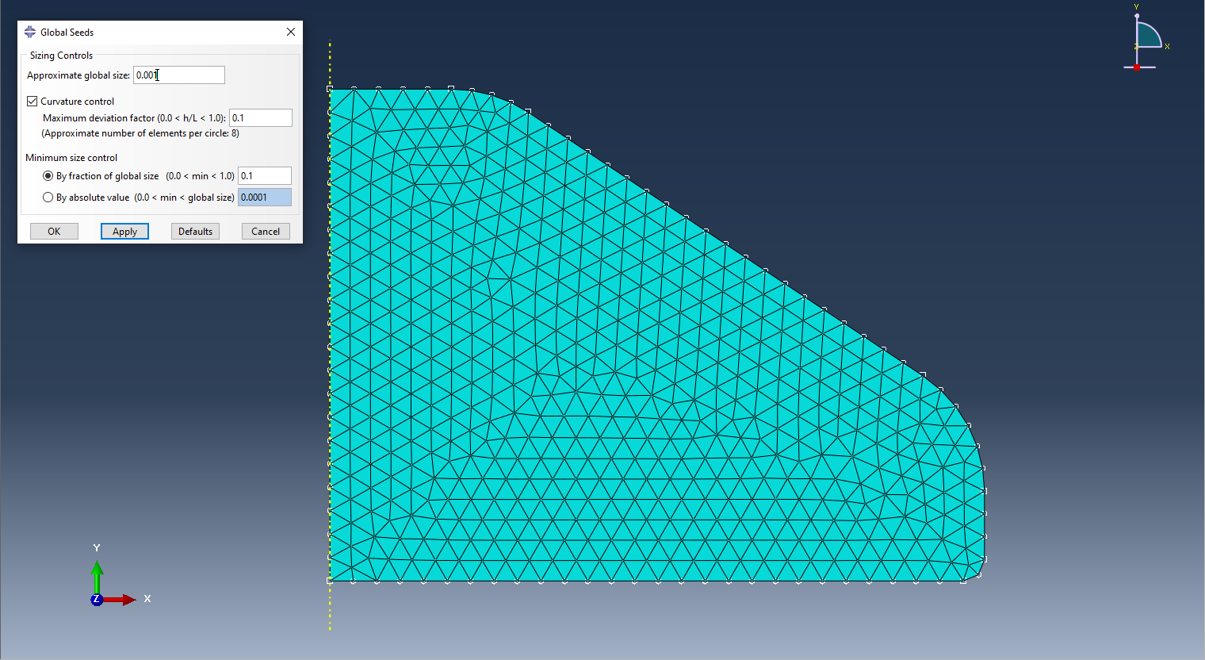
Figure 12: Shaped Charge Wave Shaper Mesh

Meshed Assembly
The meshed parts can be viewed as part of the full assembly with the difference between the coarser and finer meshes being more apparent. It is on these models that the simulations will be conducted.

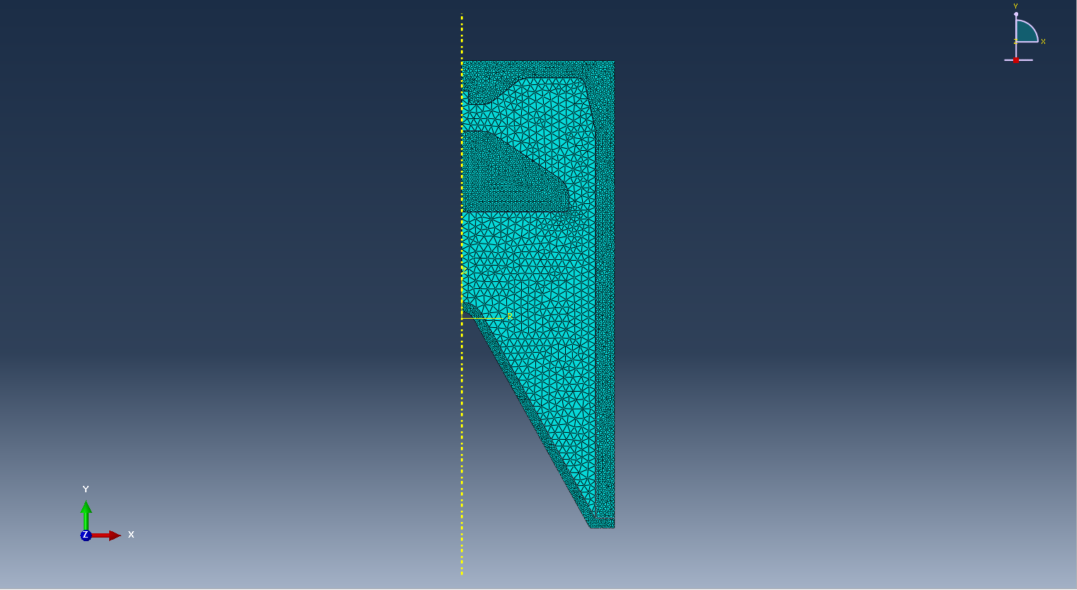
Figure 13: Assembly of Meshed Charge with Wave Shaper

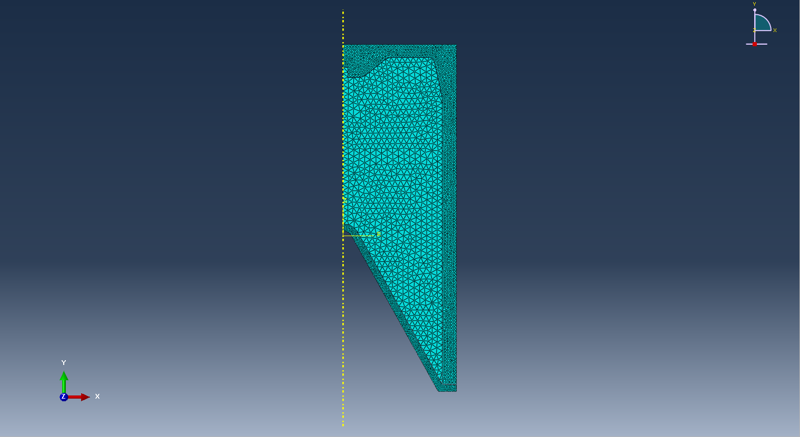
Figure 14: Assembly of Meshed Charge Without Wave Shaper

Simulation of Shaped Charge Without Wave Shaper
A job was created to begin the simulation using the shaped charge that did not contain the wave shaper. Two hundred steps were set to be competed with a capture frequency of 5e⁻⁴ seconds. After the simulation finished processing, the results were analysed the findings recorded.

The jet tip velocity of the charge was recorded to have a peak velocity of approximately 6000ms⁻¹ according to the graph produced by measuring the velocities of the nodes at the tip of the superplastic jet.

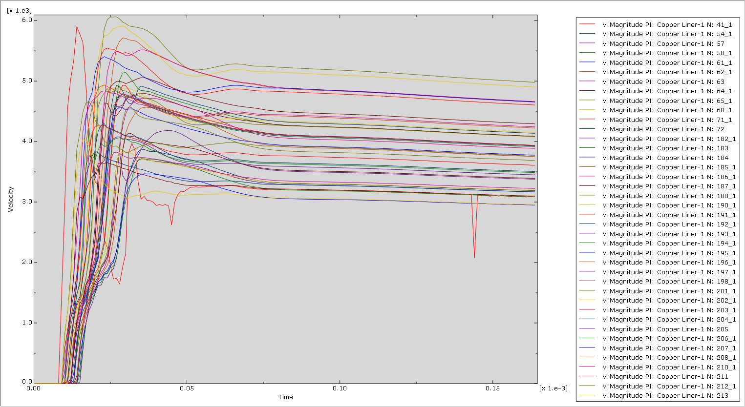
Figure 15: Velocities of the Nodes at the Tip of the Superplastic Jet (No Wave Shaper)

Analysis of Pressure Wave
After detonation, the pressures within the charge can be seen expanding and propagating down towards the conical liner, through the HE filler composition. The expansion caused by the detonated HE filler pushes against and warps the steel casing of the charge outward, while being directed downward by the shape of the casing. Upon impact of the pressure wave against the casing mesh, significant stress is exerted on the case which causes it to stretch and expand in the direction of the pressure wave pushing against it.

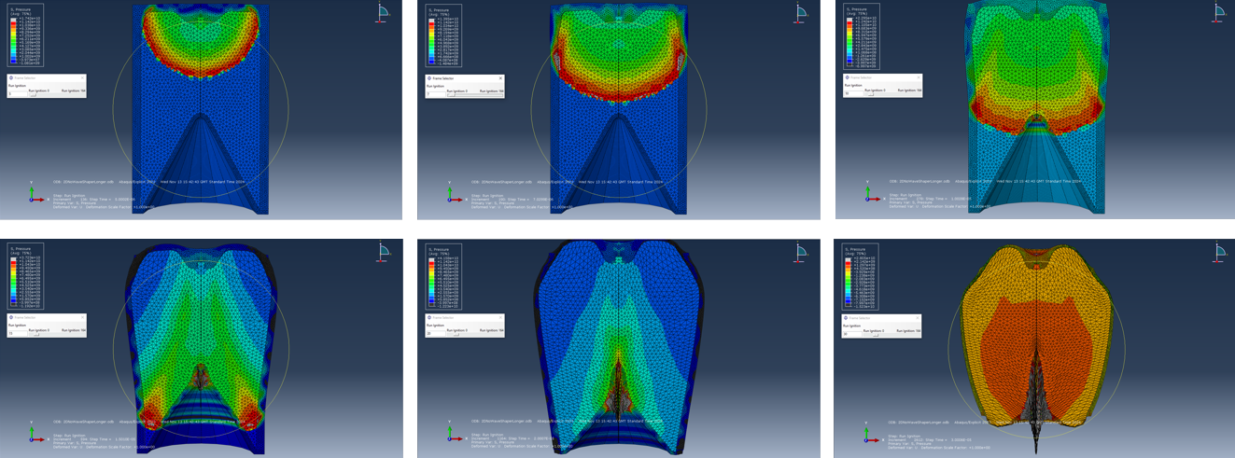
Figure 16: Propagation of the Pressure Wave Within Shaped Charge (No Wave Shaper)

As can be seen in Figure 16, the pressure wave travels across and down the casing through the detonating HE filler, culminating in an area of extremely high pressure around the apex of the conical liner. A pressure of around 9e⁹Pa is achieved in this region, causing the outside of the liner to collapse inward while the pressure wave propagates further down the shoulder of the liner causing further collapse, which leads to the creation of the superplastic jet of copper emanating from the centre of the conical liner. As the liner begins to collapse, pressures of 6e⁹Pa form around the liners shoulders, which as now under extreme internal tension as the copper liner begins to be stretched along the Y-axis with extreme force.

Analysis of Maximum Principal Stress
As can be seen in Figure 17, as the pressure wave reaches the apex of the conical liner, a massive compressive force of around 5e⁹Pa is being exerted upon it, which results in a huge tensile force being exerted on the inside of the liner which was found to range from 1e⁹Pa to over 7e⁹Pa.

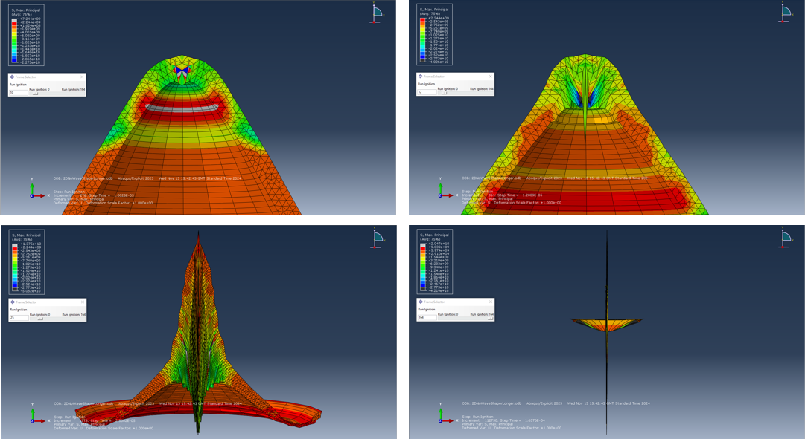
Figure 17: Maximum Principal Stress (No Wave Shaper)

As the liner collapses further inward, forming a thin, rapidly expanding jet of superplastic copper, greater tensile forces continue to be exerted on the inside of the liner. A stress of 2e⁹Pa is applied to the shoulders of the liner, causing further collapse in the structure of the copper, resulting in the material in the cone to be compressed and forced downward at great velocities. As previously mentioned, the peak velocity of the jet was just over 6000ms⁻¹.

Simulation of Shaped Charge with Wave Shaper
In theory, the shaped charge simulation with the copper wave shaped should yield improved results with regards to the velocity and formation of the superplastic copper jet. However, upon analysis of the results recorded by the simulation, it is clear that is not the case. Upon selecting the mesh nodes at the tip of the superplastic jet and inspecting the velocities achieved by them, it is clear the performance of the shaped charge is inferior to the one that lacked the wave shaper.

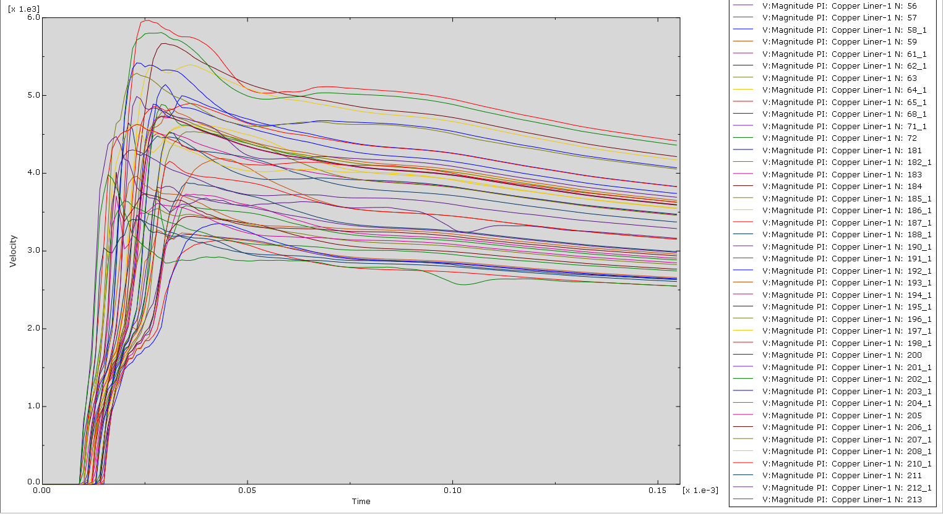
Figure 18: Velocities of the Nodes at the Tip of the Superplastic Jet (Wave Shaper)

As shown by Figure 18, the charge with the wave shaper achieved a peak velocity of just under 6000ms⁻¹, compared to the charge without which managed to exceed 6000ms⁻¹. The velocities of the other nodes weren’t any more or less focused, with their velocities being just as sporadic as the previous simulation.

Analysis of Pressure Wave
The pressure wave follows a similar path to the pressure wave found in the charge without the copper wave shaper as immediately after detonation, the wave travels outward along the X-axis, before heading down towards the conical liner, causing stress and strain on the casing as it goes. The difference in this simulation, is the presence of the wave shaper absorbs some of the propagating wave, causing in area of extremely high pressure within the copper. The pressure withing the wave shaper reaches a peak of 2.1e¹⁰Pa in some regions, while the same exertion of pressure is being applied to the steel casing around wave shaper as the pressure wave is directed diagonally down the geometry of the wave shaper and into the internal walls of the casing, as can be seen in Figure 19.

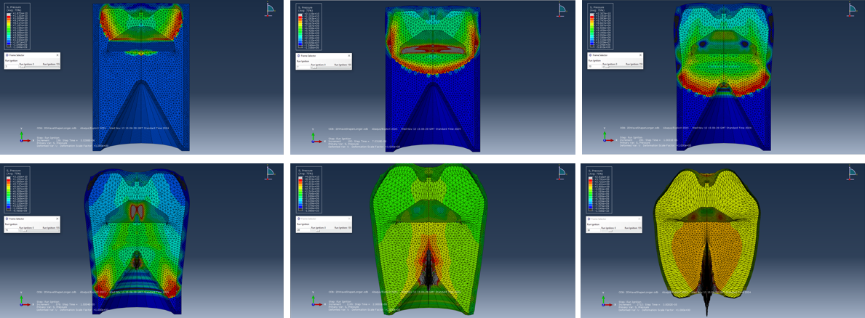
Figure 19: Propagation of the Pressure Wave Within Shaped Charge (Wave Shaper)

As seen in Figure 19, there is no single area of high pressure located around the apex of the conical liner, instead, pressures of around 3e⁹Pa to 4e⁹Pa are dissipated along the upper shoulders of the liner, which causes the copper to begin to collapse in on itself. Further on in the simulation, extremely high pressure of up to 8.5e⁹Pa can be seen around the now collapsing liner which is under immense internal tension, causing the copper to be stretched along with Y-axis.

Analysis of Maximum Principal Stress
As seen in Figure 20, the apex of the cone experiences massive stress measured at around 2.3e¹⁰Pa while the shoulders of the conical liner also experience high levels of stress, roughly 1.5e¹⁰Pa, which will cause the liner to cave in on itself, generating the tension required to stretch the liner and form the superplastic jet.

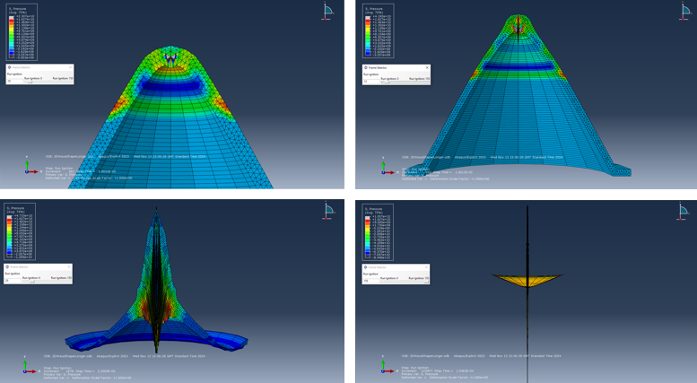
Figure 20: Maximum Principal Stress (Wave Shaper)
The casing then begins to exhibit significant levels of internal strain as the copper liner instantaneously collapses and forms a thin, superplastic jet. It can be observed that, due to the concentration of pressure directed by the wave shaper, there is more internal stress in the shoulders of the liner, with around 8e⁹Pa being concentrated on the upper shoulders of the liner which have, at this point, nearly collapsed in on themselves, forming the penetrative jet.

Three-Dimensional Model With Wave Shaper
For the three-dimensional model, the parts had to be re-meshed in order to be used. The same parts were used with adjusted meshing, the same principals regarding coarse and fine meshes being kept the same as the two-dimensional models.

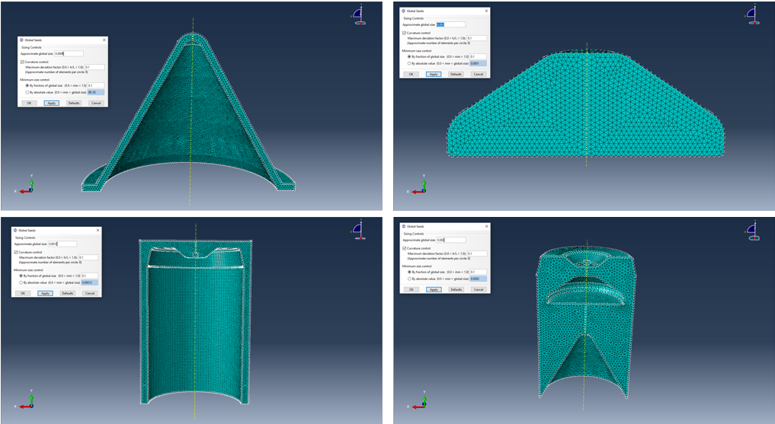
Figure 21: Three-Dimensional Model Meshes

The parts were them assembled in the same manner as the assemblies used in the 2D models.

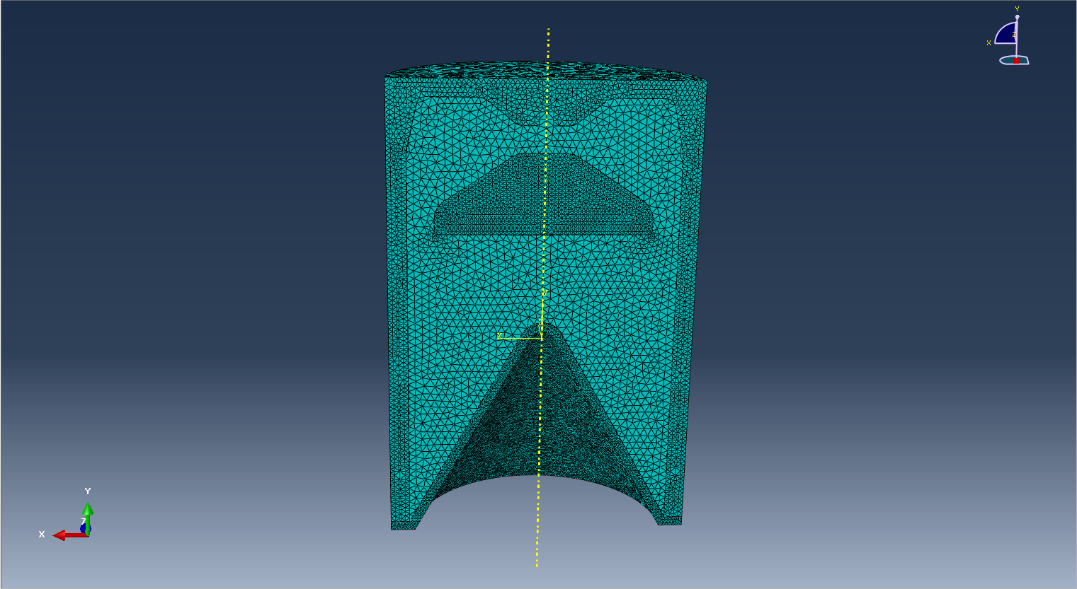
Figure 22: Assembled Three-Dimensional Mesh

Results of Three-Dimensional Simulation
The results produced by the 3D model were similar to the results obtained by the 2D model of the same nature, although, of much better quality. There were some issued with the mesh warping through adjacent meshes, however, these issues did not prove to be detrimental to the overall simulation and were unavoidable regardless of how the mesh was adjusted.

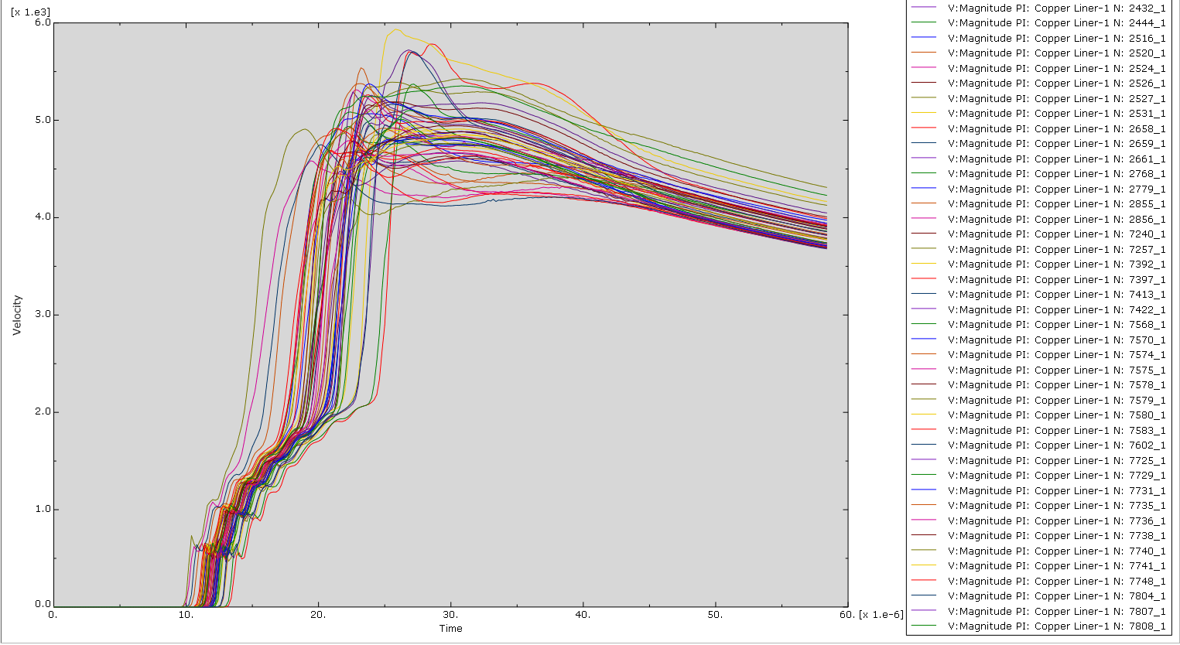
Figure 23: Velocities of the Nodes at the Tip of the Superplastic Jet (Three-Dimensional)
As can be seen by Figure 23, the peak velocity of the 3D simulation was slightly lower than 2D simulation of the same nature, however, the superplastic jet formed by the 3D simulation is much more coherent compared to the jet formed by the 2D model. The 3D jet also has a higher mean velocity, making the protruding jet a lot stronger and thus, more effective. This could be the result of the wave shaper and the behaviour of the propagating pressure wave being more realistic in the 3D model as there are more mesh nodes and the third dimensional axis to interact with.

Analysis of Pressure Wave
After detonation of the HE compound, the pressure wave immediately begins spreading out across all axes before making contact with the copper wave shaper. Similar to the 2D simulation, the propagating shockwave yields within the wave shaper a region of extreme pressure, resulting a peak pressure of 2.45e¹⁰Pa internally. This is significantly higher than the pressures yielded in the 2D model.

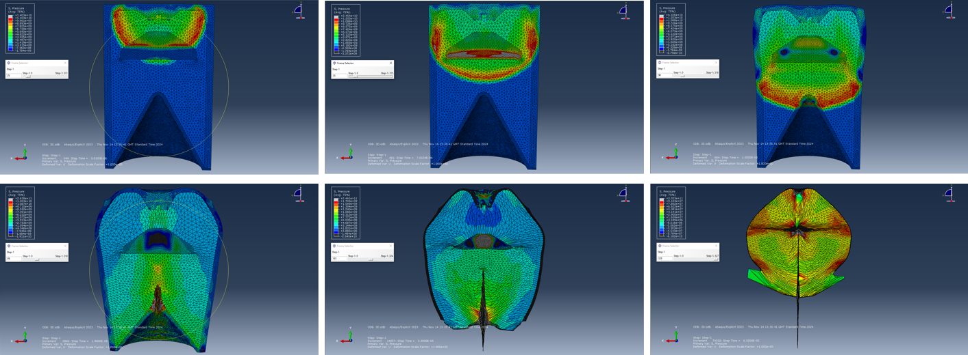
Figure 24: Propagation of the Pressure Wave Within Shaped Charge (Three-Dimensional)

As can be seen in Figure 24, the detonation wave propagates down through the charge towards the apex of the conical liner. As the reaches the liner, extreme pressures are exerted on the shoulders of the liner, just below the apex, which begin the cause internal strain within the copper, leading to the collapse of the upper section of the liner. Immediately after the partial collapse of the liner, a region of high pressure appears above the now distorted liner, which is experiencing extreme tension as the copper is ejected from centre of the liner. This region of around 8e⁹Pa is exerting strain on the apex of the copper liner, compressing more of the copper into the centre of the liner which in turn increases the stress on the material, forcing it into the forming superplastic jet.
Towards the end of the formation, another region of high pressure forms around the shoulders of the now developed jet. This region of approximately 1.5e9Pa continues to exert force on the now tensile shoulders of the liner, forcing them to collapse which aids the formation of the penetrative jet.
We can see at the final stage of the simulation in Figure 24 that most of the pressure within the model is now located within the copper wave shaper. The pressures of over 2e¹¹Pa are the result of the system collapsing the wave shaper in on itself as the pressure wave is reflected off the walls of the casing and collide wave shaper which also cause a massing area of pressure along the X and Z-axis around the copper.

Analysis of Maximum Principal Stress
Just below the apex of the conical liner, a ring of extreme tension forms. Approximately 1.5e¹⁰Pa is concentrated around this region on the underside of the apex of the copper cone. Just above this region of extreme tension is an area of immense stress as around 1.5e¹⁰Pa is working to collapse the top of the copper liner in on itself, as can be observed in Figure 25.

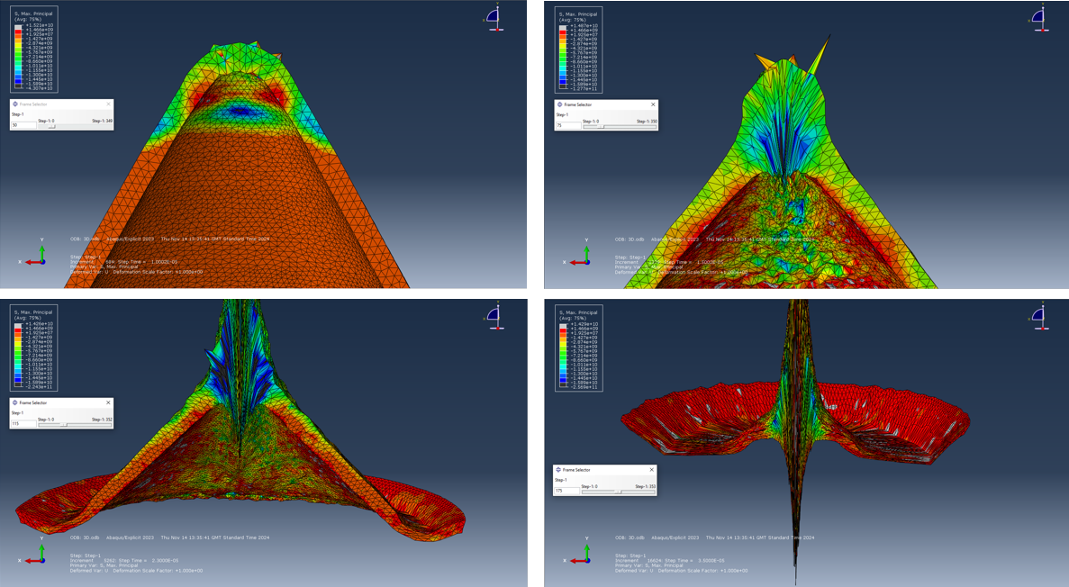
Figure 25: Maximum Principal Stress (Three-Dimensional)

As the Simulation progresses, large measurements of tension are shown by the blue region on the underside of the now deformed conical apex. Around 1.35e¹⁰Pa of tension is being exerted on the liner, pulling more of the copper into the early formation of the penetrative, superplastic jet.
As the simulation progresses, the tension on the underside of the conical apex can be seen to intensify as more material becomes stretched into the forming jet stream. The shoulders of the liner can now be seen to be experiencing 2e⁷Pa of stress as the material is compress by the rest of the collapsing liner. This can be seen to a greater extent in the last image of Figure 25 as the liner is the middle of complete collapse, having been partially inverted.

Conclusions
In conclusion, all shaped charge simulations were successful in generating a penetrative, superplastic jet of copper. The two-dimensional simulations provided a direct comparison between a shaped charge that does and does not contain a wave shaper while the three-dimensional simulation provided a more accurate and robust simulation of the material mechanics within the detonating shaped charge.

The two-dimensional charge without the wave shaper provided a benchmark with which to compare the performance of a shaped charge with the addition of a wave shaper against. The jet produced from this simulation yielded a peak velocity of just in excess 6000ms⁻¹ which is within the parameters for the typical jet velocity of a standard shaped charge. Overall, the simulation produced results expected of the average shaped charge and was a good candidate with which to conduct a comparison.

The two-dimensional charge with the wave shaper also performed well. However, on the surface, this simulation produced inferior results to that of the charge lacking the wave shaper; when theoretically, the opposite should be true as shaped charges with the addition wave shapers can have a jet velocity of up to and beyond 14000ms⁻¹. Upon further examination, however, the results can be interpreted as a successful utilisation of a wave shaper as, despite containing a substantially smaller quantity of HE composition, the shaped charge with the wave shaper achieved a peak jet velocity just under that of the charge without. The substantially lower velocity in comparison to the theoretical value is undoubtedly due to the geometry and placement of the shaper inside the charge as measurements and positioning were done from visual reference as opposed to any real measurements or plans. In future, more experimentation should be done regarding the geometry and positioning of the wave shaper in order to determine if more favourable results can be obtained.

The three-dimensional simulation produced the most robust and accurate results out of the three simulations due to the availability of interaction with three dimensions as well as the number of nodes present in the simulation. This resulted in the strongest and most effective jet formation and the most noticeable effect from the wave shaper. Because the model is based on the two-dimensional simulation of the same nature, it has the same shortcomings regarding the geometry and positioning of the wave shaper.

References

[1] | W. Walters, “A Brief History of Shaped Charges,” 2008. [Online]. Available: https://apps.dtic.mil/sti/pdfs/ADA497450.pdf. [Accessed January 2025].
[2] | B. Ma, Z. Huang, Y. Wu, Y. Wang, X. Jia and G. Gao, “Research on the Formation Characteristics of the Shaped Charge Jet from the Shaped Charge with a Trapezoid Cross-Section,” 2022. [Online]. Available: https://www.mdpi.com/1996-1944/15/23/8663?form=MG0AV3. [Accessed January 2025].
[3] | D. R. Scheffler and W. P. Walters, “A method to increase the tip velocity of a shaped charge jet using a hollow cavity,” 2007. [Online]. Available: https://www.witpress.com/Secure/elibrary/papers/CBAL07/CBAL07009FU1.pdf?form=MG0AV3. [Accessed January 2025].
[4] | GlobalSecurity.org, “M830A1 High Explosive Anti-Tank-Multi Purpose - Tracer (HEAT-MP-T),” [Online]. Available: https://www.globalsecurity.org/military/systems/munitions/m830a1.htm. [Accessed January 2025].
[5] | S. Yin, X. Wang, X. Suo, H. Liao, Z. Guo, W. Li and C. Coddet, “Deposition behavior of thermally softened copper particles in cold spraying,” 2013. [Online]. Available: https://www.sciencedirect.com/science/article/pii/S1359645413003145#s0015. [Accessed January 2025].
[6] | I. Keskin, M. Y. Ahmed, N. R. Taher and M. Gor, “An evaluation on effects of surface explosion on underground tunnel; availability of ABAQUS Finite element method,” 2021. [Online]. Available: https://www.sciencedirect.com/science/article/pii/S0886779821004971. [Accessed January January 2025].
[7] | H. Kumar, M. Tiwari, R. Manna and B. Khan, “A modified Johnson-Cook model to determine plastic flow behavior of Fe-30Mn-9Al-0.8 C low-density steel during warm multiaxial forging,” February 2024. [Online]. Available: https://www.sciencedirect.com/science/article/pii/S2352492824002502#eqn0040. [Accessed January 2025].

