BMIH4005
Marketing essentials
Component A
Word count: 1331

Marketing plan for Moxy hotels

Introduction
I am going to introduce a marketing plan for the Moxy hotels which are relatively new in the hospitality industry with their first hotel opened in 2014 in Milan. Currently there are more than 70 locations opened on four continents. Their main target customers are the so called millennials (young people).
This project is prepared for my university tutor and within my work I am going to be using multiple frameworks such as SWOT analysis , Marketing mix , Ansoff’s matrix , Bowmans’s strategy clock , PESTLE analysis tool etc, that will help me examine the brand correctly and effectively.

Situational analysis
Identifying Moxy’s strengths, weaknesses, opportunities and threats will help us get better understanding of the brand
Moxy has incredible decoration from the inside and out of their hotels. It is their unique concept of providing customers with stylish yet affordable and friendly atmosphere and experience. One of Moxy’s top features is the complimentary drink offered at the bars which are also the check in spot. Moxy are owned by Marriott and sponsored by IKEA so they have big financial support.
On another note for some people the brand’s concept could be a bit difficult to understand because they are supposed to be a hotel where people can rest but in the same time they offer non-stop party. They are also quite expensive compared to their competitors and according to multiple customer reviews the rooms are equipped with just the basics and are not always clean to high standards. They don’t have enough social media presence
The main thing the brand can focus on as opportunity is to expand in new locations as well as engage with digital marketing
Having how successful Moxy is there are already other brands following the same strategy so they have to find a way of becoming stable.
The Moxy’s main demographic target are millennials , young people who are also fun-hunters. Having that the targeted segment for this company is becoming the desired one for many others , young people need a reason to choose Moxy over their competitors. What differentiates Moxy is their personal service to guests as well as their stylish and hipster decoration.
According to Similar Web 25.49% of the visitors are directly visiting the Moxy website when exploring the hotel. YouTube runs almost 100% of the social network traffic which shows lack of involvement with digital channels , social media and websites. The company partnered with online dating site Bumble as ‘’inclusive environment to meet your Bumble connections whether for hook-ups or professional networking’’
PESTLE , or what are the external factors that could affect our brand. The political climate is crucial for businesses success for example if there is military conflict as the one currently in Ukraine that would definitely disrupt business. Airbnb could be a technological factor that poses a threat to traditional hotels as 6 million people stayed in Airbnb properties in 2013 alone. Environmental factors that could impact the industry are the rising electricity and fuel prices. The change of climate for example the rising ocean level that could flood beaches or the global warming that could make some beaches too hot to stay could affect Moxy and other hotels.
The current marketing strategy that Moxy is following is targeting young people who appreciate stylish and affordable places with great service. For Moxy the service is more important than the product. They are reaching to their customers through social media and display ads offering nice atmosphere at amazing destinations.

Objectives
When analysing the brand we identified gap in Moxy’s room amenities and digital marketing. Customers tend to say they expected larger, cleaner and better equipped rooms for the price they have paid so our goal is within 1 year time frame to improve and introduce fridge, wardrobe and desk in the king size rooms as a beginning as well as bring social traffic and engage people with our improved product .

Strategy
We set a marketing goal after identifying what the company is currently missing on and could improve. Ansoff’s matrix is going to be in use here because it will guide us through the way of improvement using one of its four strategic choices which for this marketing plan is going to be product development. Moxy can make changes to its existing product by improving it and adding new amenities in guest rooms which will increase the customer demand and sales. When coming to the not really developed digital marketing we plan to change this by investing in social media marketing and improving search engine marketing.

Tactics
After coming up with a strategy now it’s time for the real work to be done. How are we going to add value to the product and reach out effectively to the demographic target? We observed the marketing mix and realised that changes should be made especially to the product and the way we market the brand. Similar Web showed that Moxy is lacking efficient digital marketing. The Moxy’s concept and product is without doubt hugely successful and unique but if they want to fully satisfy customers they need to invest in extra room amenities and in online advertising. This means the main focus of the marketing plan would be altering the place and the product from the marketing mix 4P’s. We wouldn’t wish to increase or decrease the current prices because that’s what the brand is most popular for - the affordability of the product. The vast majority of people were satisfied with the pricing. The target segment which are again young people engage a lot with social media channels so this would definitely be one of the right digital channels to use to market and distribute our product. By posting consistently content on social media is a way of reaching our desired audience. For some businesses this may not be a brilliant idea but I think in our case influencer marketing might be beneficial because the young generation is following these fake stars content and admiring everything they do and by paying a legitimate influencer who has many followers to promote our product this would definitely reach many of the target segment. Adding keywords related to our product and backlinks to other websites onto our main Moxy website we would be upper in the google ranking , like this we are optimising the search engine marketing. Once we reached out to people and generated sales we want to engage them with the product and make them regular customers through personalisation. Adding 15% discount to a loyal customer’s next stay with the hotel would be thrilling.

Action
Now that we know what our audience wants and which channels they use it is time to deliver
Gannt Chart is a visual representation of when I am going to do certain type of marketing activity and the period of time planned for that activity. After looking at Similar web we noticed that comparing to last month , this month there is decreasing to the traffic and visits by 6.65%. We will introduce a 3months sales activity from April to July and also add Promotional codes from March until June to attract customers. Having that there are many not that good reviews about the hotel we will aim to maintain and improve relationship with customers by using public relations. 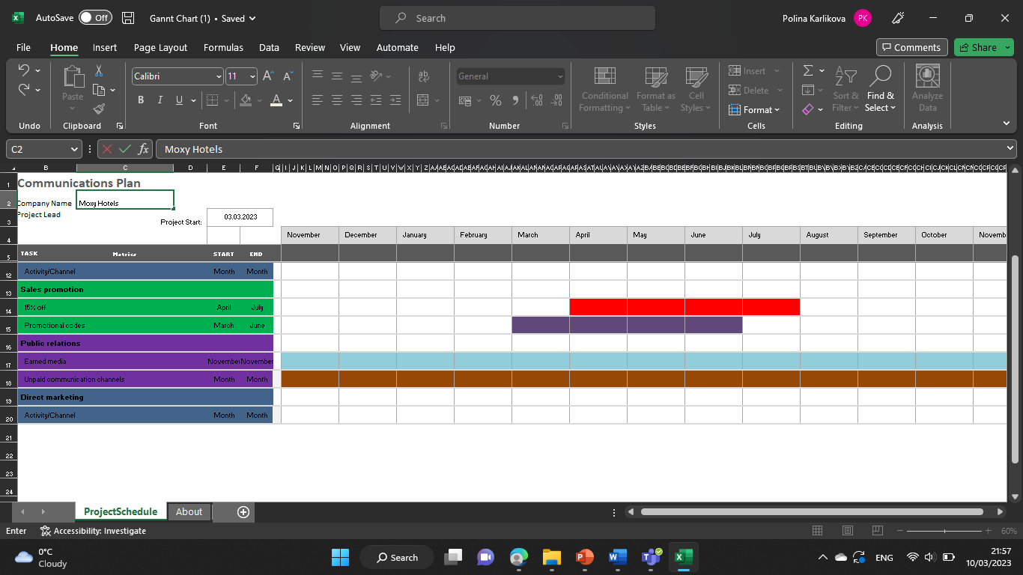

Control
After creating a business plan and strategy we want to measure our success through the key performance indicators that will show us the customer behaviour and acceptance of our new ideas. The marketing channels that we used and the improvements that we introduced will be monitored in order for us to see if the customers are engaging and showing interest to our product

Conclusion
After having a deep look into Moxy hotels current marketing strategy we were able to identify what they are doing good at the moment ,what are their gaps and outlined a marketing plan to improve those gaps with the help of few proven business frameworks.

Appendix
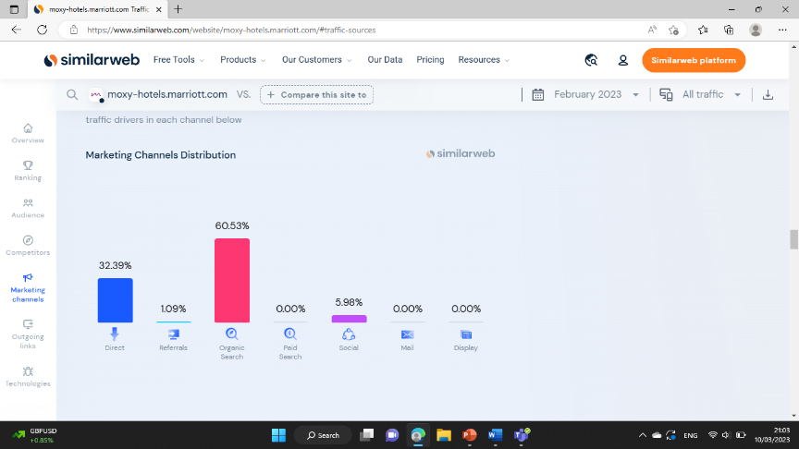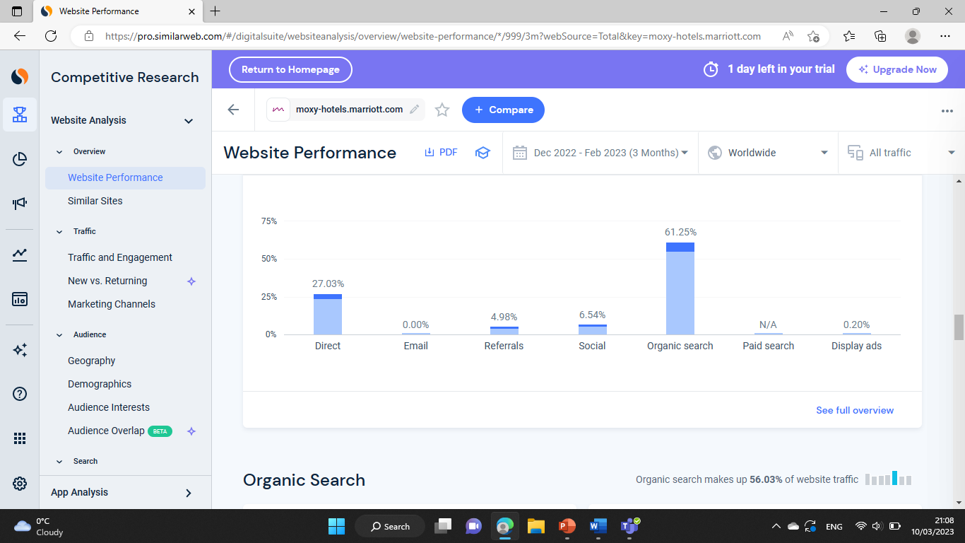
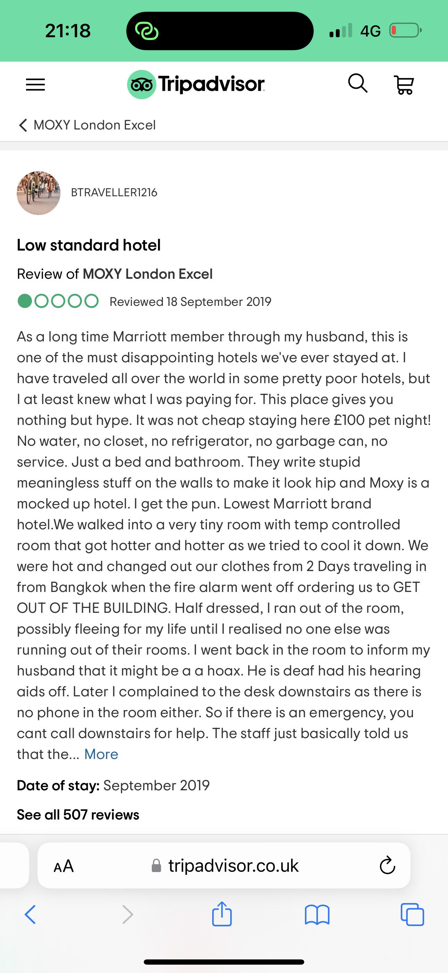
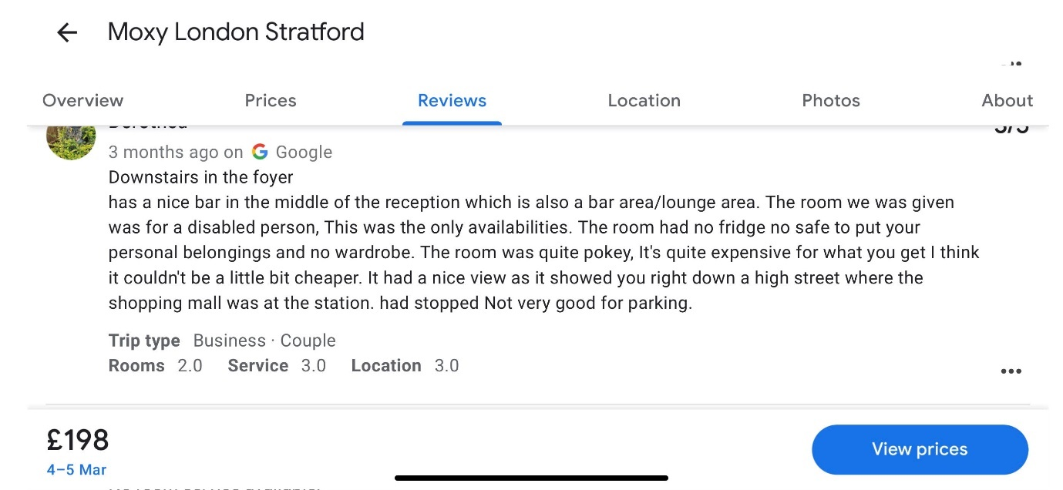
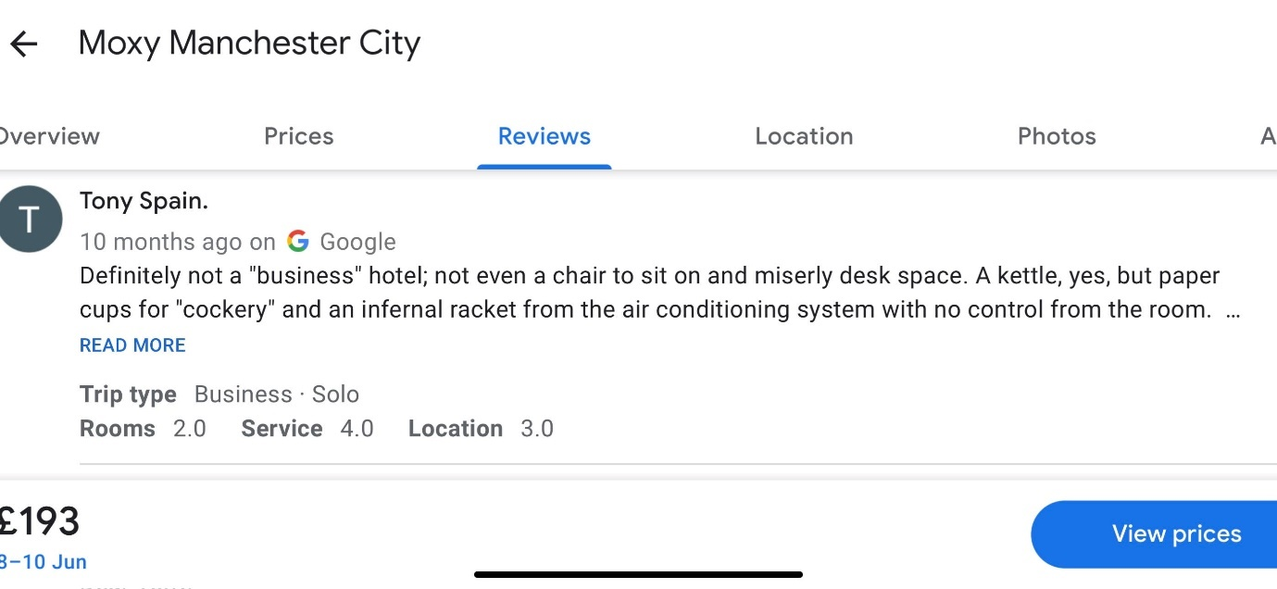
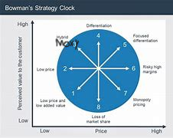

Presentation slides
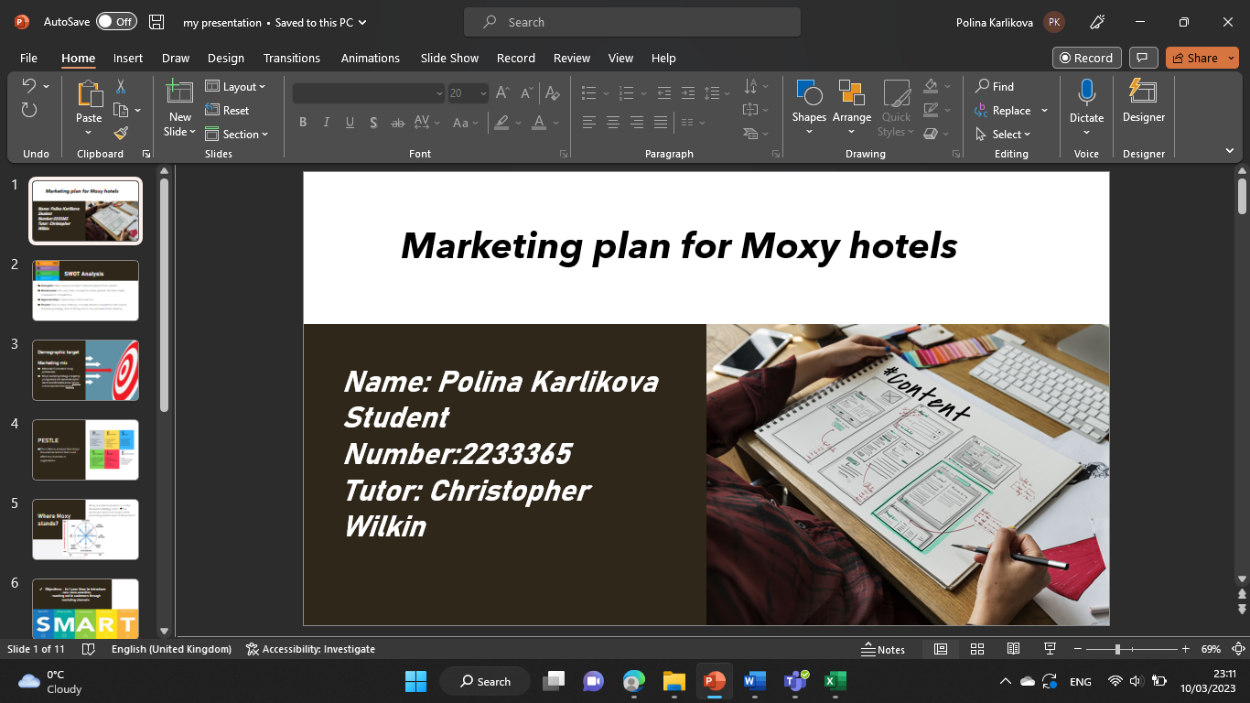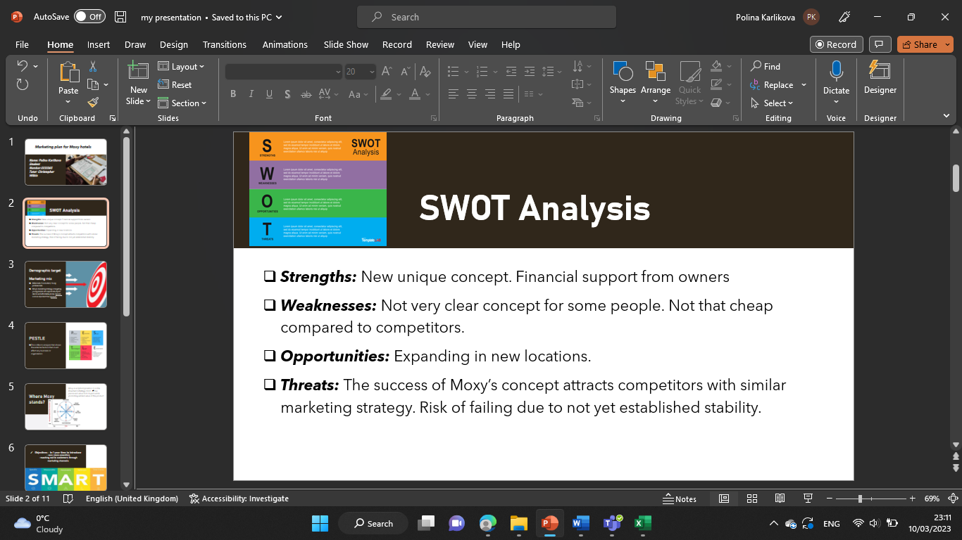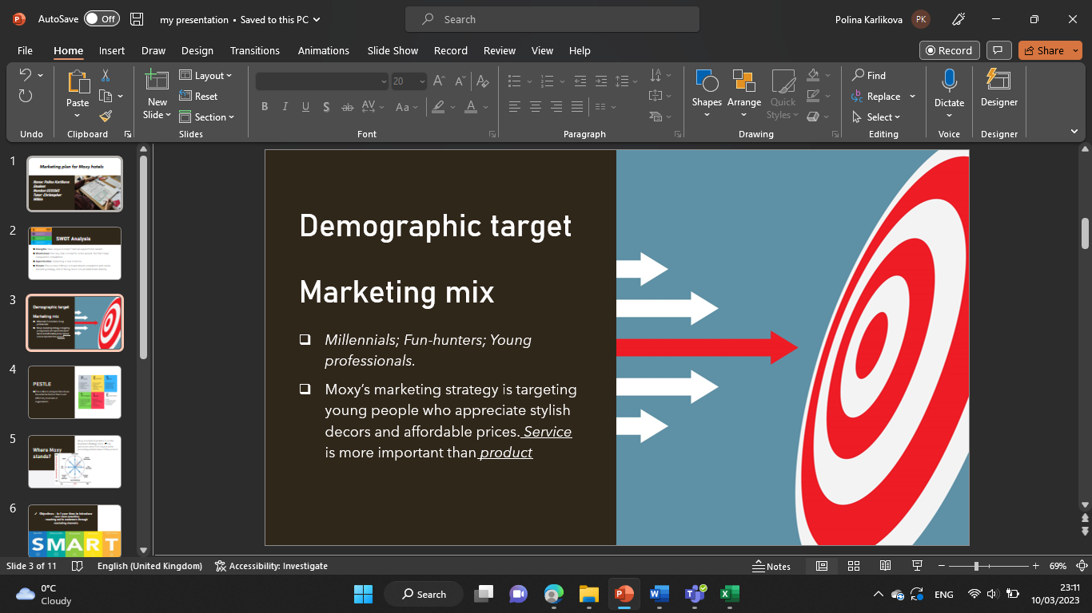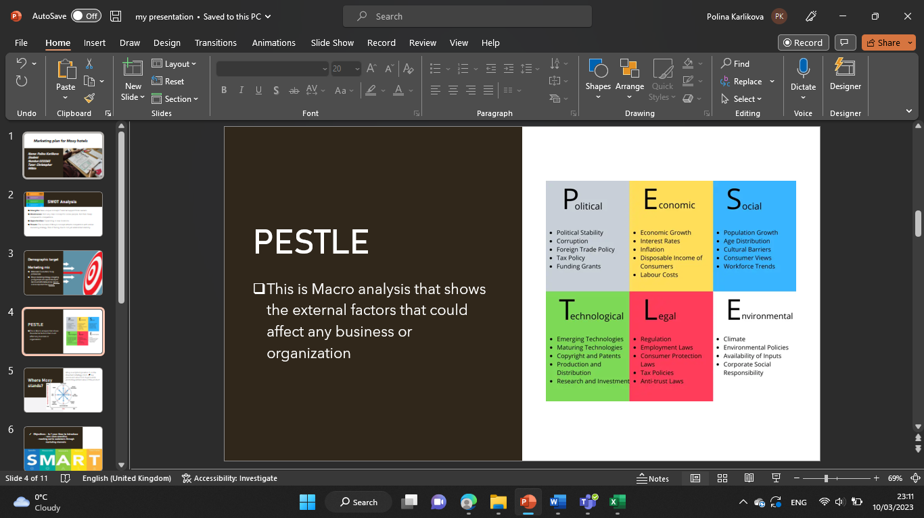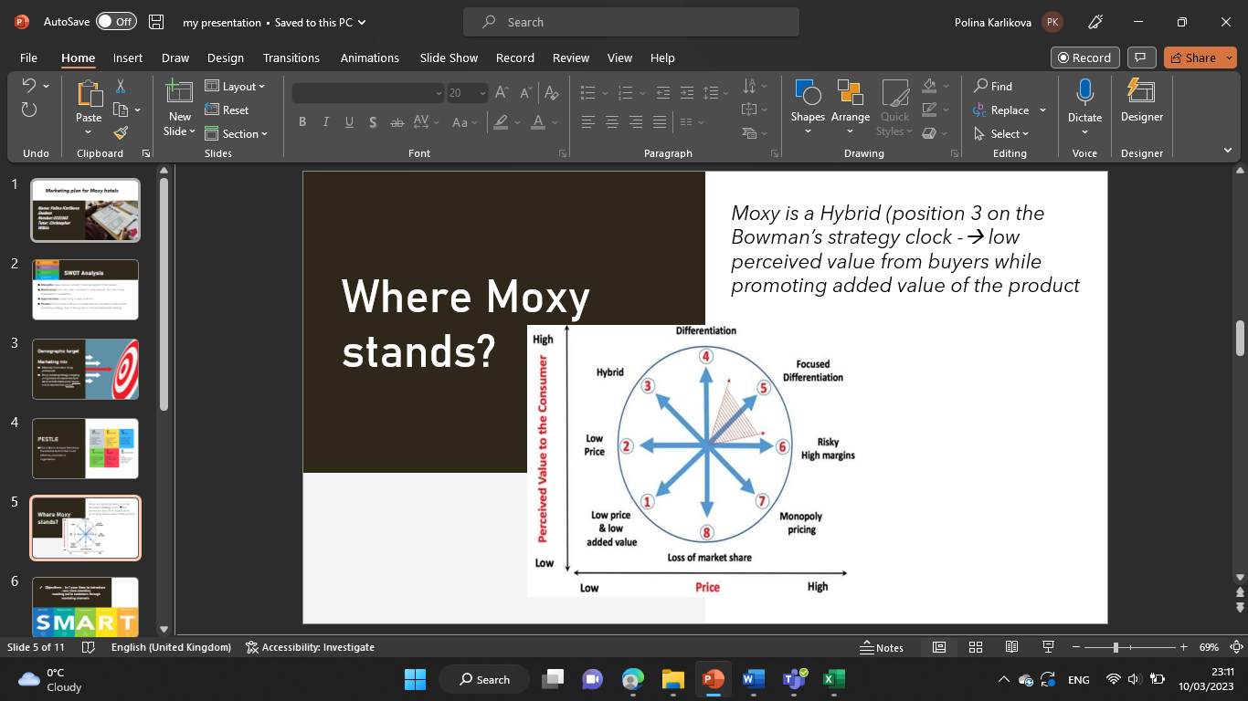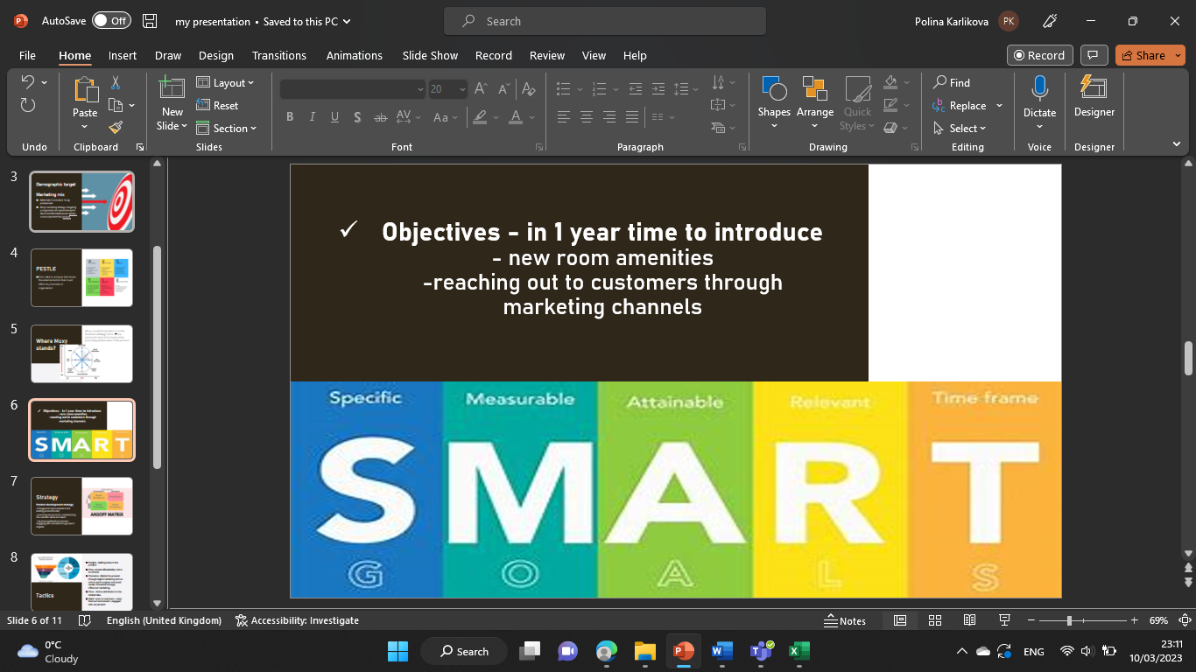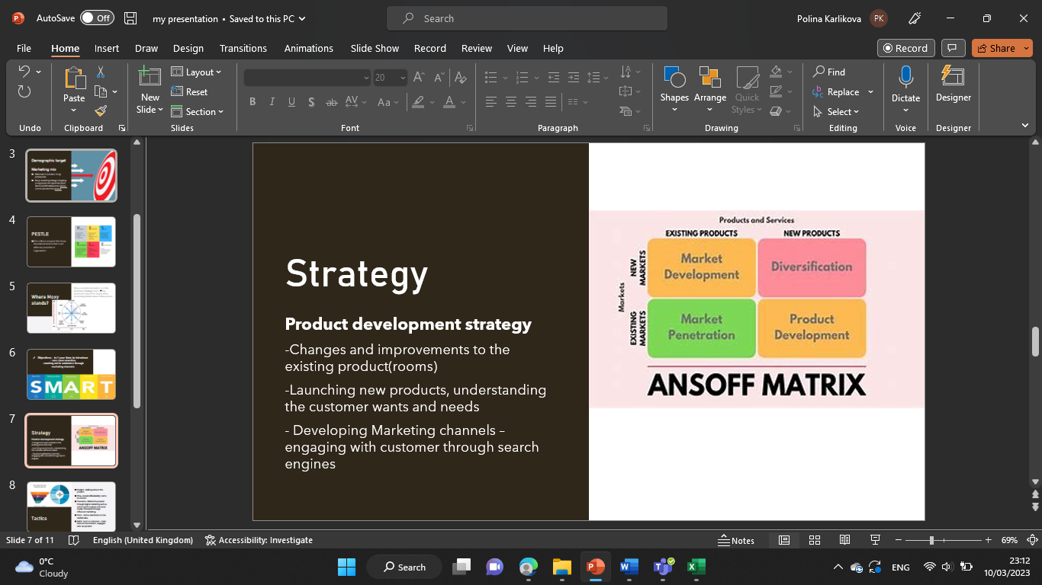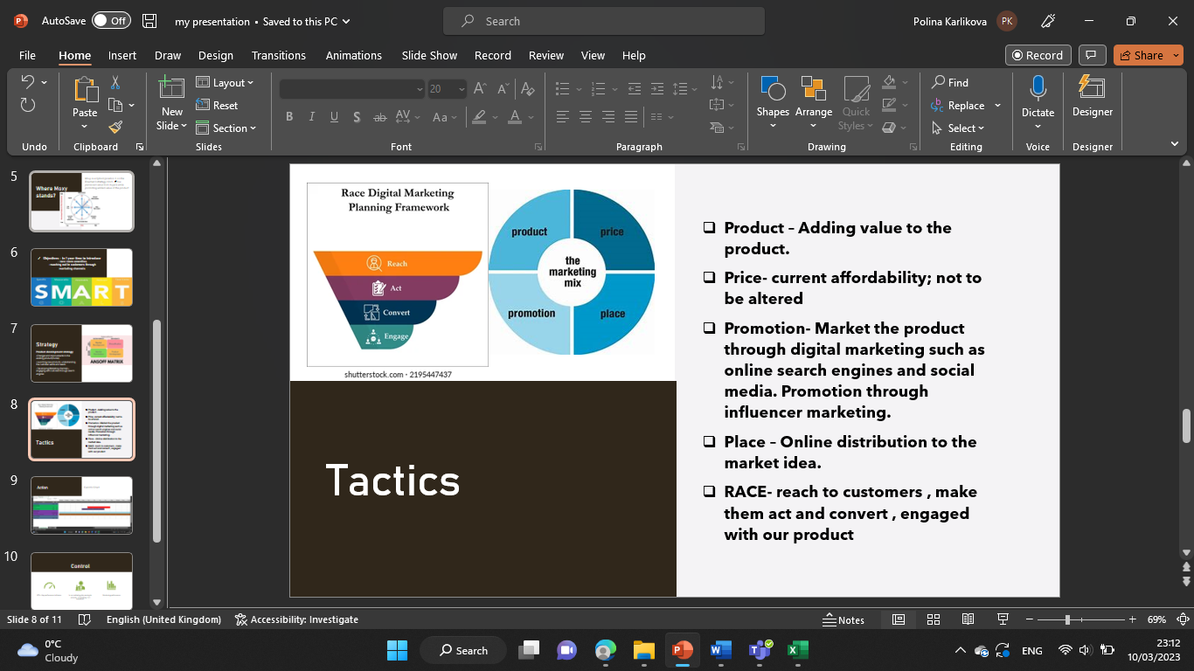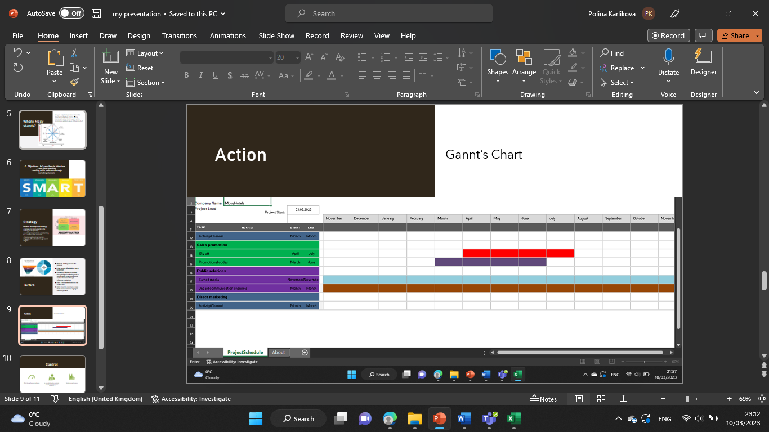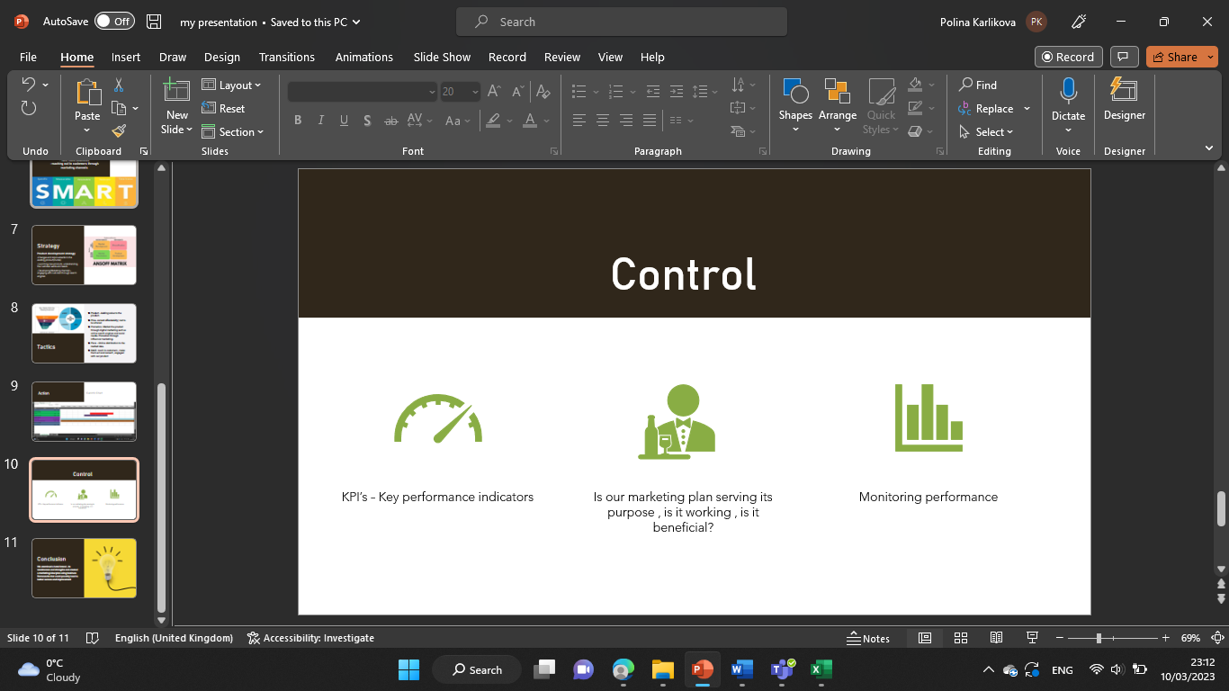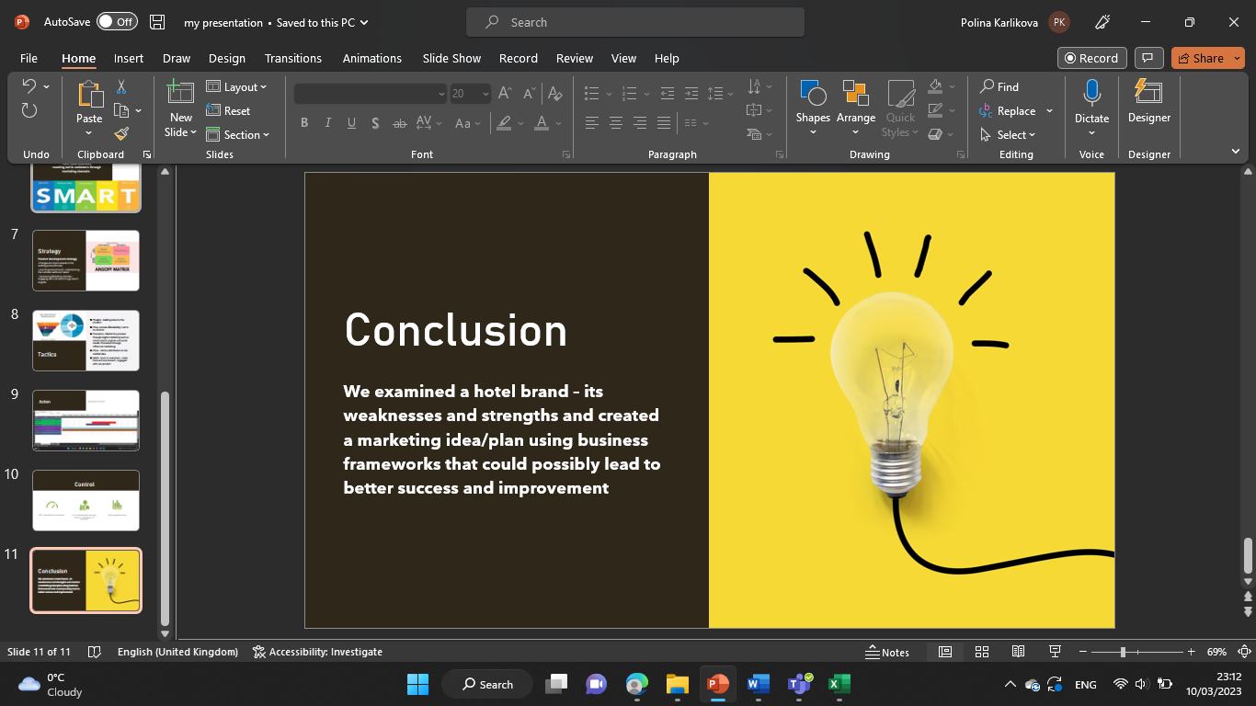

Reference list
Hanlon, A. (2021) The ansoff model, Smart Insights. Available at: https://www.smartinsights.com/marketing-planning/create-a-marketing-plan/ansoff-model/ (Accessed: March 10, 2023).

Introduction to bowman’s strategy clock (no date) Lucidity. Available at: https://getlucidity.com/strategy-resources/introduction-to-bowmans-strategy-clock/ (Accessed: March 10, 2023).

Managing public relations and the media(2022) Gov.au. Available at: https://www.business.qld.gov.au/running-business/marketing-sales/marketing/activities/public-relations (Accessed: March 10, 2023).

Stylish & playful hotels (2019) Moxy Hotels. Available at: https://moxy-hotels.marriott.com (Accessed: March 10, 2023).

The 4 PS of marketing: What they are and how to use them (2022) Coursera. Available at: https://www.coursera.org/articles/4-ps-of-marketing (Accessed: March 10, 2023).

Unknown (no date) The moxy hotels: Creating experiences as the new Marketing approach (by lea Scholz), Linchikwok.net. Available at: https://www.linchikwok.net/2018/04/the-moxy-hotels-creating-experiences-as.html?m=1 (Accessed: March 10, 2023).

Berry, E. (2017) Pestle analysis: Prepare the best strategies in advance. North Charleston, SC: Createspace Independent Publishing Platform.
G., D. (2018) Services Marketing Mix: The 7 P’s of Marketing explained, expert. EPM. Available at: https://expertprogrammanagement.com/2018/03/services-marketing-mix-7-ps/ (Accessed: March 10, 2023).

SimilarWeb Identity (no date a) Similarweb.com. Available at: https://pro.similarweb.com/#/digitalsuite/websiteanalysis/traffic-overview/*/999/3m/?category=no-category&webSource=Total&key=moxy-hotels.marriott.com (Accessed: March 10, 2023).

SimilarWeb Identity (no date b) Similarweb.com. Available at: https://pro.similarweb.com/#/digitalsuite/websiteanalysis/overview/website-performance/*/999/3m?webSource=Total&key=moxy-hotels.marriott.com (Accessed: March 10, 2023).

Boogaard, K. (2021) “How to write SMART goals,” Work Life by Atlassian. Atlassian, 26 December. Available at: https://www.atlassian.com/blog/productivity/how-to-write-smart-goals/amp (Accessed: March 10, 2023).

Grant, M. (2010) Gantt charting: Definition, benefits, and how they’re used, Investopedia. Available at: https://www.investopedia.com/terms/g/gantt-chart.asp (Accessed: March 10, 2023).

MindTools (no date) Mindtools.com. Available at: https://www.mindtools.com/amtbj63/swot-analysis (Accessed: March 10, 2023).

Moxy’s Positioning Statement (2019) blogmarketing1819b_8.1. Available at: https://blogmarketing81.home.blog/2019/05/20/moxys-positioning-statement/ (Accessed: March 10, 2023)

(No date) Tripadvisor.co.uk. Available at: https://www.tripadvisor.co.uk/Hotel_Review-g186338-d12124894-Reviews-MOXY_London_Excel-London_England.html (Accessed: March 10, 2023).

