Branding
  - Dissertation proposal
Courtney Jane Price | Graphic Design | 10/05/2018

Branding has always been around and its part of the society of today, it moves masses and it’s the identity of a company or of the creator.
Branding is not all about the looks, it also plays a big part in what a product is going to be like. For example, in the supermarket industry, low price supermarkets such as B&M use very vibrant and bold letters, which indicates a low budget supermarket, while stores like John Lewis and Harrods use more slick fonts with upper and lower-case letters, with the objective to look more upper class.
I chose this subject because the idea of having a part of my creation on a successful product that can be seen by the world, would give me great satisfaction in what I do.
The three thinkers I have chosen to look in to are:
David Airey – specializes in branding, modern
David Carson – breaks the rules with typography
Stephen Sagmeister- Typographer

These three keywords will explain what my plan is for this dissertation:
- Typography: It’s an essential part of any good branding, it’s not about the best-looking style of font, but the one that best represents the brand in question, just like the examples about the stores mentioned in the introduction.
  - These are quotes that I will use from a blog. ‘Typography is an art form that can manipulate the significance of what it communicates. Due to its effects on the context of communication, understanding typography is especially important when developing a brand identity.’ ‘When developing a brand identity, you need to consider how typography will fit into the overall brand architecture. All communication in association with your brand will utilize your typographic decisions.’ Meanings: ‘typeface: the overarching style of a group of fonts. For example, Helvetica, Arial or Times New Roman. Each typeface has distinguishing characteristics which are represented in its fonts. Font: A specific variation of a typeface. For example, Helvetica Bold 12pt. Type family: a comprehensive collection of all sizes and styles (bold, italic, medium) of a single typeface.’ (Rolek, n.d.)
  - Monograms and Word Marks: In a world where English has established itself as the language for international business, the use of monograms as the identity of a business has become very popular, companies using this type of branding include Google, Sky, Tesco… It opens up more possibilities than an illustrative symbol, the world of today is full of symbols right now and a creative, slick, professional looking word mark will stick out.
  - An interesting quote that I like and would add to my dissertation is ‘Choosing a font is like dressing the right way depending on the impression you want to make’. (Mission, n.d.)
  - Type choices: Choosing what type of font, will it be serif or sans serif will make a big difference in what the consumer is going to see the product as. The choice of type will also give personality to the identity of the brand, while a sans serif typeface would give the brand a sense of modernity, a serif typeface would give the brand a sense of tradition. But not only the personality of the brand is important while choosing a type, also legibility, flexibility and consistency are highly important.
  - Calligraphy and handwriting can also be classified as fonts as they came around after Gutenberg invented the printing technology. The choices determine the impression you are trying to portray and what audience you are trying to attract so having the right type choices is very important to the brand in order for it to be successful.
  - Type and meaning: Depending on what typestyle used, the product will move in a different direction, if the product wants to be targeted to a young audience for example, the typestyle is not going to reference classic print ads from the 1950s, but something more modern and up to date.
  - Stephen Sagmeister – makes type come alive.
    - Takes type and fashion solutions that are visually dynamic above and beyond.
    - Worked for Rolling Stones, The Talking Heads, Lou Reed, Jay Z, Aerosmith and Pat Metheny.
    - Mixes it up with a typeface and handwriting throughout his work. Uses a variety of materials and techniques and imagery to create an identity

- Logo:
  - David Airey – a modern graphic designer that specializes in branding and logo design. He quotes that what makes a design successful is ‘appropriate (for the business it presents, Distinctive (to increase customer recognition, Practical (so it works across a wide range of media and Containing one message ‘saying too much will dilute the idea.’
  - I am going to talk about how he comes up with his ideas for his branding business as he quotes on printmag.com ‘asks questions, research, question some more, sketch, come up with ideas, sketch again, discuss, narrow the options, digitize the strongest, present, persuade, potentially refine, then I’ll deliver some files.’ (Design inspiration , 2014)
  - David Airey quotes in one of his blogs that after testing people on their memory of logos that ‘80% selected the correct palettes for their drawings, while shapes proved harder to recall. This highlights how beneficial it can be to assign logos with colours that are clearly different from competitors.’ (Millman, 2017)
  - Definition of a logo in branding: ‘A logo is the graphic symbol that represents a person, company or organization. If the logo is well known enough, you may even see a logo used without the name of the business that is associated with.’
  - I will talk about wordmark and logotype which is a purely typographic logo made only out of type. E.g. coca-colas script type.
  - Why a logo is important to a brand:
‘Step 1: A Potential customer sees a logo.
Step 2: if the logo is familiar to them (such as Nike’s swoosh), they will instantly remember all the experiences they’ve had with the brand – the commercials, your experience owning Nike products, the packaging etc.
Step 3: these memories trigger the emotional and intellectual response.
Step 4: they decide to purchase the latest pair of Nike shoes.’ (Beachy, 2015)
  - Some examples of the meanings of some famous logos are:
    - ‘Amazon: the yellow arrow in their logo starts at the letter ‘a’ and ends at the letter ‘z’, implying that they sell everything from a to z.
    - Beats: the circle isn’t just a circle, it represents a human’s head, and the ‘b’ letterform represents the brand’s headphones.
    - BMW: the colours come from the Bavarian flag, which are blue and white. Their logo is derived from the Rapp Motor Works’ logo, which is very similar. It is commonly thought that the logo represents the blades of a spinning propeller, due to their aviation history and an ad created in the 1920s.
    - LG: the ‘l’ makes the nose and the ‘g’ makes up the rest of the face. This gives the brand a human element.
    - Audi: the four rings represent the four companies that came together to create the original Audi, Auto Union.’ (jordan, n.d.)

- Visual Hierarchy:
  - In my dissertation I am going to be using these quotes: ‘Use Size to Enhance (or Reduce) Visibility.’ ‘Colour and Contrast: Direct Viewer’s Attention.’ ‘Typographic hierarchy: Start with 3 levels to organize your design.’ ‘Fonts: choose typeface categories & styles Carefully.’ ‘Spacing: give your layout Balance, flow and focus.’ ‘Composition: give your design structure.’ (Zeven, 2016) This is the step by step guide on how to make sure that your hierarchy is correct to enable good designs.
  - David Carson does not stick to the correct visual hierarchy. He likes to experiment with different lay outs – his work is very original and grungy.
  - The importance of visual hierarchy in graphic design to become a successful designer.
  - ‘Hierarchy is defined as: A logical way to express the relative importance of different elements by providing a visual guide to their organization.’
  - Enables the end consumer to recognize and clearly read any information given to them. It’s a design job that needs to be thought about in great depth to be successful.
  - Visual Hierarchy meaning: the arrangement of elements part of a design that leads the human eye to the correct position in order to read it clearly.
  - ‘The visual characteristics that a designer can use to influence users’ perception of the information are:
- Size: the larger the element, the more attention it will attract
- Colour: bright colors are more likely to draw attention over muted ones
- Contrast: dramatically contrasted colours will catch the eye easily
- Alignment: an element that breaks away from the alignment of others will attract more attention
- Repetition: repeating styles can give the impression that content is related
- Proximity: closely placed elements will also appear related
- Whitespace: more space around elements will attract the eye toward them
- Texture and style: richer textures will attract more attention than flat ones’. (interaction design design foundation, n.d.)
  - These are the quotes I am going to be using by one of my artists, David Carson. ‘Ray Gun magazine January 1995 – ray gun had no grid, formula or format, letting the music and individual articles dictate the direction of the design and layout. Every page was an entirely new design assignment, making it a lot more work than most magazines, but also a lot more fun, and I believe with more effective results.’ (Carson, 1998)
    - ‘Grunge’ work- chaotic designs using works, textures, background.
    - Most famous for his magazine designs where using grids and hierarchy correctly yet added his own touch by breaking the rules.
    - ‘known for his experimental, deconstructive typographic designs and art direction for Ray Gun magazine.’ (Neli Todorova's Blog, 2013).

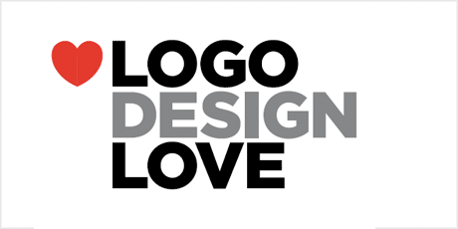
Figure 1 (Airey, 2009)
In Figure 1, there is a piece of David Airey’s work that I am going to use in my dissertation. I have chosen to use this image as it shows the use of structure within the type, so it links with my typography key word and hierarchy along with the logo. This logo is from a book he had written that I want to purchase to read for my dissertation as I haven’t been able to find it yet.

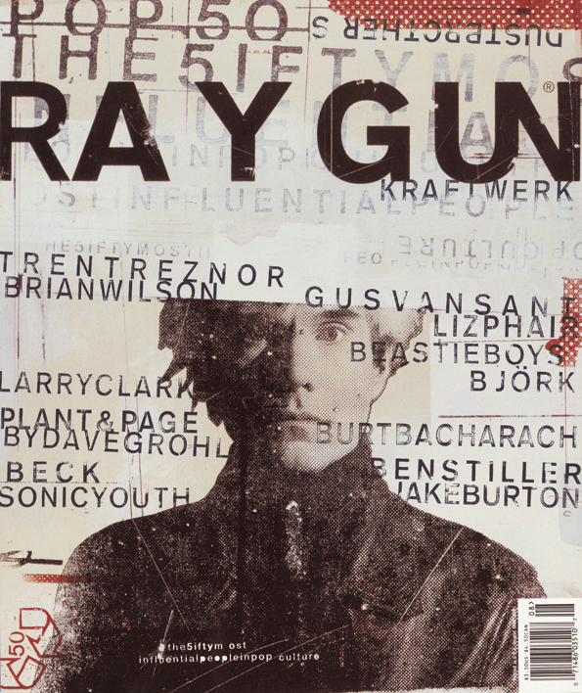
Figure 2 (Carson, 1998)
Figure 2, is the image from David Carsons work that I will be including in the dissertation as I think this shows mostly his use of grid and breaking the rules the way he does.

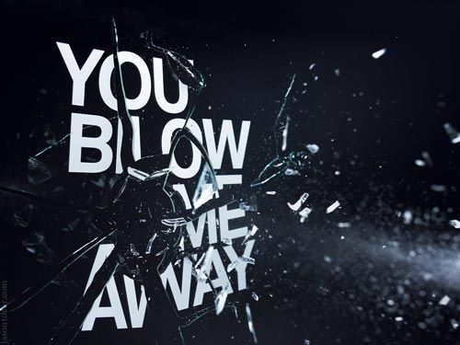
Figure 3 (Sagmeister, n.d.)
Figure 3 is the image that I will be using in my dissertation by Stephen Sagmeister. I have chosen this image because it shows his use of typography and how he experiments with it. As well as that, it is one of his most famous pieces.
Conclusion:
Taking in to account what I have said throughout, it has lead me on to a question based on branding. I am going to be focusing on the three key words, typography, logos and visual hierarchy as well as three thinkers in graphic design, David Carson, Stephan Sagmeister and David Airey. From looking at these I am going to do branding research, the importance of branding to a business and what a successful brand will be made up of.
Question:
How powerful is branding in modern society, and what techniques are used to create the perfect brand.

Bibliography
Airey, D., 2009. logo design love. [Art].
Aszman, A., 2017. designer of the week : David Airey. [Online]
Available at: http://www.printmag.com/designer-profiles/designer-of-the-week-david-airey/
Beachy, W., 2015. logo design vs. branding - what's the difference?. [Online]
Available at: https://gomedia.com/zine/insights/difference-between-logo-design-and-branding/
Butler, A., 2014. interview with graphic designer David Carson. [Online]
Available at: https://www.designboom.com/design/interview-with-graphic-designer-david-carson-09-22-2013/
Carson, D., 1998. RayGun. [Art].
Design inspiration , 2014. David Airey. [Online]
Available at: http://designinspiration.blogspot.co.uk/2009/03/david-airey.html
interaction design design foundation, n.d. Visual Hierarchy. [Online]
Available at: https://www.interaction-design.org/literature/topics/visual-hierarchy
jordan, C., n.d. the hidden meanings behind 50 of the world's most recognisable logos. [Online]
Available at: https://www.canva.com/learn/hidden-meanings-behind-50-worlds-recognizable-logos/
Kliever, J., n.d. the design school guide to visual hierarchy. [Online]
Available at: https://www.canva.com/learn/visual-hierarchy/
Millman, D., 2017. famous logo drawn from memory. [Online]
Available at: https://www.logodesignlove.com/famous-logos-drawn-memory
Mission, n.d. Why typography plays an important part in branding. [Online]
Available at: https://www.mission.no/en/insights/branding-through-typography/
Neli Todorova's Blog, 2013. David Carson - the father of grunge. [Online].
pentagram, n.d. [Online]
Available at: https://www.pentagram.com/about/paula-scher
Rolek, A., n.d. Brand identity: typography. [Online]
Available at: http://blog.brandisty.com/brand-management-blog/brand-identity--typography/
Sagmeister, S., n.d. you blow me away. [Art].
visible Logic, 2013. logo, brand identity, brand : what is banding?. [Online]
Available at: https://www.visiblelogic.com/blog/logo-brand-identity-brand-what-is-branding/
Zeven, 2016. a graphic designer's guide to visual hierarchy. [Online]
Available at: https://zevendesign.com/designers-guide-to-visual-hierarchy/

