

Assessment 1 – Reading Task Template
PART 1: Upload your photo of your A3 in-class notes here:
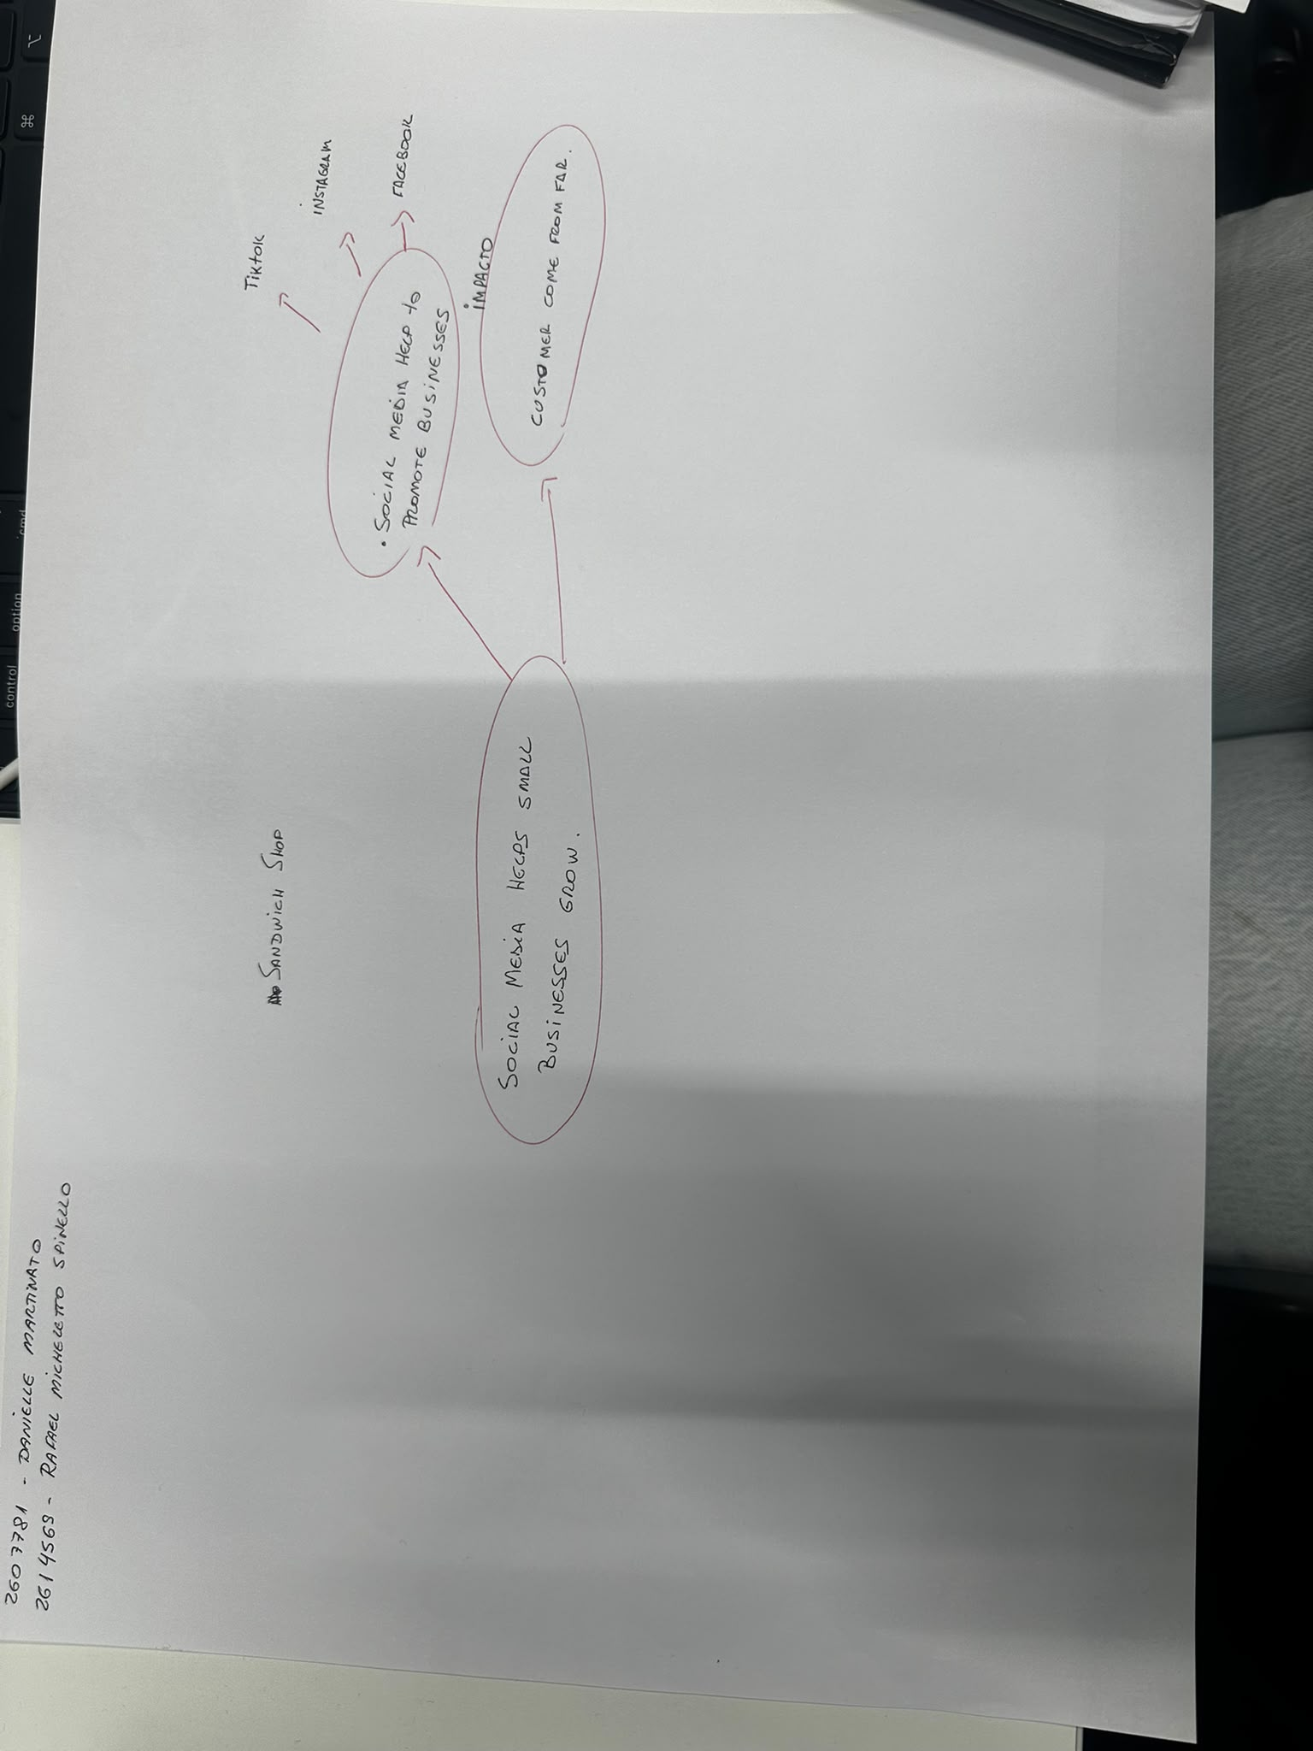

PART 2:
- Answer every question below in 1-3 full sentences.
- Use your own words. Do not use generative AI to answer these questions.
- Include a specific detail from the text when asked.
REMINDER
- The main idea is the overall message of the whole text.
- A key point helps to explain the main idea.
- A specific detail or example from the text shows that the key point is true.

- What is the main idea of the whole text?
To demonstrate that social media platforms, such as TikTok and

Instagram, help small businesses reach far more customers.

- What is one key point that supports the main idea, and which specific example from the text shows this?
Posts made by customers or owners on social media can attract
customers from far and wide.

- What is a different key point that supports the main idea, and which specific example from the text shows this?

Content that is organic and with which people can relate and engage.

Example: Krystalls Boutique posts sketches of funny moments that

have happened in the shop. These sketches have racked up millions of

views, and now teenagers are travelling from the Channel Islands and

even from Cyprus to buy a dress after watching them.

- Which part of the text do you think is most important, and why?
People buy from people.
Why: The companies mentioned in the text went viral because
their content seemed authentic and people could relate to it.

Reflection:
- What did you find difficult in this task (including in-class components), and why was it difficult?

The difficulty with this task was that, although my English is improving,
I still need to look up the meaning of some words. As there was still time
before the deadline, I wasn’t sure whether I should hand in my work or
try to understand the text better

- What helped you with this difficulty, and how did it help you?

I understood perfectly what I needed to do, but I needed more time.

