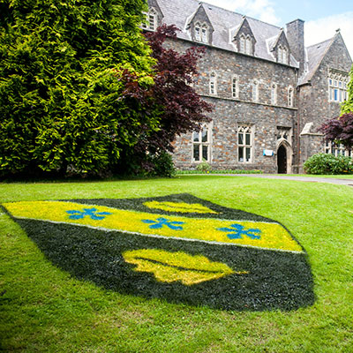  New community engagement  Assessment one | LECTURE : Karen Howells  STUDENT : MADALINA LARISA VASILE, 2022389  Community Engagement (LCBB4002)

Table of Contents

Introduction 2
The foundations of a community engagement 2
Simplified strategy 2
The story connects lives 3
Ways of communication 3
“INSTAGRAM” 4
“FACEBOOK” 4
“TWITTER” 4
Activities included in the community 5
Future activities 6
Conclusion 7
References 8

Introduction

This assessment will lean towards a more systematic basis, and the content is due to the courses at “University of Wales Trinity Saint David” and also the online resources that “UWTSD” has made available to all the students.
It will be based on a systematic and logical idea, but physical resources such as pictures, documents or anything else cannot be valid. This fact is affirmed because any enterprise finds its existence through many gestures similar to those mentioned above that offer confidence to the chosen public.
But they will be presented in this assessment: the activities and their way of development, the results or the significance of each activity, the chosen way of advertising to communicate with people, the current location but also the future ones, personal conclusions.

The foundations of a community engagement

It is always good to understand the meaning of things before we get involved, the questions like "Why?", "How?" and so on are also encouraged . People have ideas that they turn into projects, and these projects offer something to a person or a group that belongs to a certain pattern.
When choosing a type of community that you want to lay the foundations of, must be thought of something that will have a strong impact with the chosen audience or even more than the proposed one. In general, it is about the necessary changes in the environment of any pattern that is harmful. There are collaborations or management alone. If a collaboration is chosen, it must be ensured that there is a common interest or at least similar, thus ensuring that any approach / intention for the better will be carried out correctly and in a timely manner.
(Dave, et al., 2019) (Day, 2006)
In this case, the goal can be called a humanitarian one, because it tries to avoid mental / heart problems. Mostly focus on counseling so there will be no crimes (voluntary or involuntary) in families or on the street, there will be no cases of illness on the diagnosis of depression and much more.

Simplified strategy

This assessment is about "counseling about any relationship" (also the name of the company, consisting of the first letter of each word and resulting CAAR ). It is related to the community commitment because it is based on the principles of equity (it is about communication and mutual respect in any type of relationship), it intends to change the attitude of those who want this to induce a pleasant professional / personal aspect in their existence based on the empathy and power of a specialist (student / doctor), the methods will be as simple and as logical as possible, starting with listening to the subject, splitting into several threads for a deep understanding of feelings, analysis of reactions to events of people, the end is the most important and the most complex (it consists in explaining the ways of understanding that apply both personally and professionally, and it is very important not to suggest directly what actions are believed to be beneficial to implement from case to case , it is correct to be induced the notion of good and to be dissolved and applied by each person voluntarily).

The bases of the community are urban, but must be expanded (rural, suburban) with the help of collaborators who want the same involvement in the world and also the support from GOV UK ! As specified above, the location is in Sherwood, Nottingham and having developed with small steps, there is also involvement from the “Sherwood URC” church.
(Dave, et al., 2019) (Day, 2006)

The story connects lives

The idea began with the involuntary pursuit of neighbors in the neighborhood (Sherwood, Nottingham). In general, the management of feelings is difficult and to be cured it costs an exaggeratedly large amount, so the idea needs to be implemented for free! Free to ensure the survival of persons involved in any negative event of a professional or personal nature that is at any level of the social scale. It happens that people who are not neighbors need help, so the aim is to expand this community that started in a small neighborhood.
This community about relationship is also related to parenting. If you relate correctly in any event received bad or even good, so those around you are influenced. And important are also the little souls (a child) who are in the care of a single parent or a couple. This community is created for the good of all, thus avoiding crimes, depression and much more.
(Dave, et al., 2019)

Ways of communication

This is where community advertising comes in. At the beginning, posters and leaflets distributed to those in the neighborhood are used. As soon as the growth is necessary, the social environment on the internet must be involved, the most common will be used starting with twitter (a wide audience with the possibility of involvement in expanding the community), then facebook (targeting middle-aged people), and finally instagram (which is mostly used by young people).
These three social channels are the easiest to use for community advertising, either for a fee or not.

“INSTAGRAM”

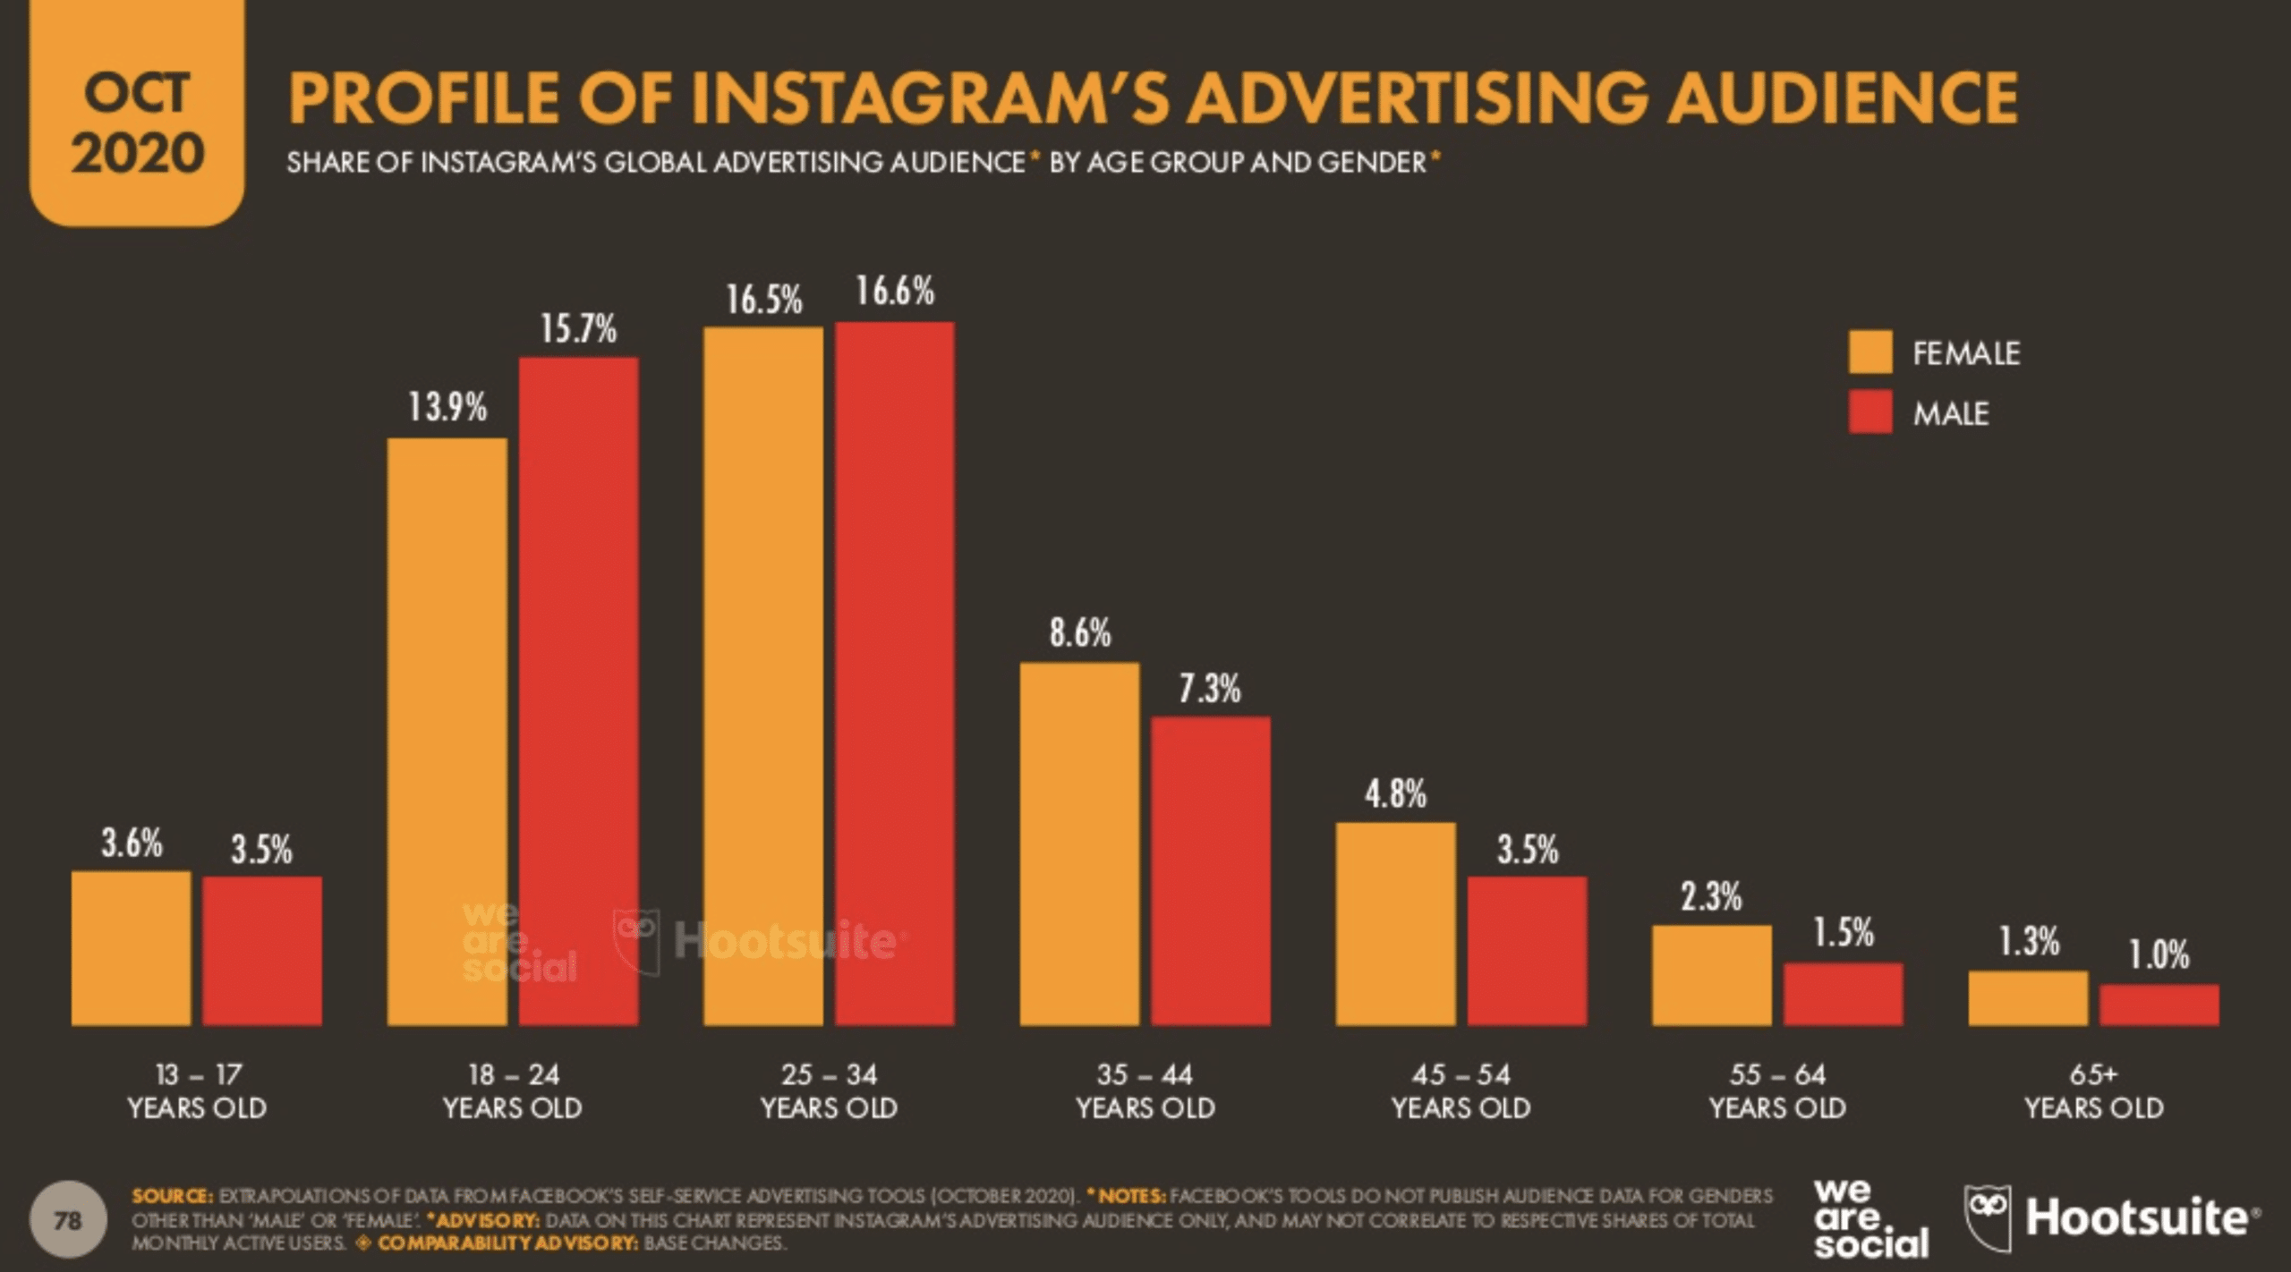 (Katie, 2020)

“FACEBOOK”

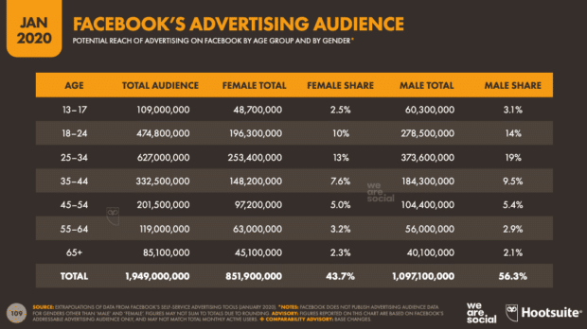 (Katie, 2020)

“TWITTER”

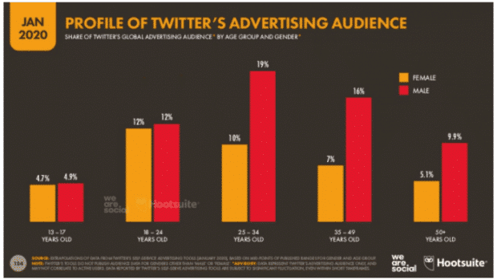 (Katie, 2020)

Activities included in the community

The first impression is very important so it must be something that attracts any type of person from the beginning. Visual aspects are important, trust in inclusion in the activity. Thanks to the support of the local church, we have at our disposal the most beautiful landscape. We use the courtyard of a church (Sherwood URC) that is full of flowers, colorful chairs and tables. Papers are placed on the tables that contain the activities, but at the end we offer other papers in which we recommend the continuity of activities at the home environment.
They are also offered empty badges to write their name on, so we make them understand that they are important and that we are interested in each member. We offer them punch to make them feel in a more welcoming environment and to help them understand that they need to be relaxed in the activities that follow to be. The activities are more about confession.
The first and second activity is about the beginning, it is not repeated on other days unless there are new individuals in the community and the presentation is necessary.
The first activity is about discovering the personality of the individual himself. Each individual has 5 minutes to say personal details such as: place of birth, date of birth, to describe the role of a tree on the Earth, and if he/she came here for him / her or with someone for the couple of any kind. Thus, everyone gains a little confidence knowing details about the others.
In the second activity are given 10 minutes to respond to the "description of childhood" (so we can add that everything that was done during childhood defines the real desires of adulthood, and here we will make them meditate on pleasant activities done between 8 and 14 years) and "the description of life without problems" (thus, we find out subtly what the problem of the individual is, what presses him/her, what he/she insists on when he/she tells the story).
It is good to have a break so as not to strain anyone, after the activity of 5 and 10 minutes for each person there will be a break of 15 minutes. Within 15 minutes, the person responsible for carrying out the activity on that day, must note who interacts with or not in the 15 minutes break after the important details have been communicated in the two activities (which must also be noted by the person responsible for carrying out activities from that day). These being done we can understand faster who is more open to change or more interactive, receptive and so on (in general, when you start to know details there is a desire to communicate more, and after such activities there is also the advantage that you can interact more easily)
The third activity is about a single question that must be answered "if you had a magic wand what would you change in your life and why?". Here we allocate unlimited time, as much as everyone wants to talk, that's how much they will talk (but time must be noted, so it will be noticed how big or important the wound of each individual it is).
And the rest of the activities are about listening to each individual about the expectations he/she has about this community. Notions related to relationships will also be taught, and each individual must "play a role" (will be a lot of “play a role” in this community) to show as an example that he/she understood the lesson taught that day. For example when discussing the title "empathy" and an example of a reaction is asked about: "The partner has to deal with a task at home and does not complete it. HOW DO WE REACT?". Each individual can answer simply or choose a partner from the "public" to make everything more real and step by step (to create a short play, as we recommend).
These openings of discussions will be at least 2 times a week, and each member will be announced in advance (it is necessary for the specialists who will be present, professionals / students will be as volunteers, ie it is not their permanent presence is possible, but it will be a short and useful presence)
(BetterHelp, 2021)

Future activities

How do we proceed for the future ?? We update the data / results obtained in Sherwood, Nottingham. Then we come up with a poll for the future where to act. We let people choose our place, so we know for sure that we find people who really need our help and the fact that we let them get involved must convey to them that they can confidently participate in “CAAR” activities.
What does the survey consist of? We want to look for the most infamous areas in the UK on our own, add them to a table and let people vote on where to set up our next location. But we want to give them access to the survey so that they can suggest another location that we can consider.
Support for our activities we will continue to seek from the government, donations (announcements in which we specify that we need the support of the people). The activities will continue through the voluntary support of professional therapists.

Conclusion

That such a community is always present for your needs in an involuntary way that helps you to trust yourself, but at the same time to rely a lot on your efforts in the end, such a community is more than necessary (especially it would be important to expand in countries with fewer possibilities, but with great desire to understand personal / professional relationships).
The basic idea of ​​this community is to communicate. Communication is the key that opens any door. In this case, communication helps to discharge negative emotions and amplify the desire to solve the existing problem, especially in a non-judgmental environment such as this community. Another important gesture is the appreciation of the individual. Mostly people join a community out of the need to assert themselves in society / relationship, etc. In order to feel seen, there must be equality in the discussions in the community. Badges are a strong point, so it can be seen that they as individuals are appreciated by the community.

References

BetterHelp, 2021. BetterHelp. [Online]
Available at: https://www.betterhelp.com/advice
[Accessed 08 08 2021].
Dave, B., Stephen, S. & Michelle, N., 2019. 100 Great Community Engagement Ideas. [Online]
Available at: https://metroquest.com/wp-content/uploads/Guidebook-100-Great-Community-Engagement-Ideas.pdf
[Accessed 02 08 2021].
Day, G., 2006. Community and everyday life. 1st ed. London: Routledge.
Katie, S., 2020. Hootsuite. [Online]
Available at: https://blog.hootsuite.com
[Accessed 02 08 2021].

