

Name: Pecos Dingu
Student Number: 1605452
Module Tittle: EMPL4010
Assignment Title: Pathway Project 2
Module Lecturer’s Name: Diola bijlhout

Table of Contents
Introduction: 3
Description 3
Feelings 4
1. Report Writing: 4
2. Group Communication and Presentation Skill: 4
Evaluation 6
Analysis 7
Conclusion 7
Action Plan 8
References 9

Introduction:
This report contains the details of my outcome about the project that I have completed in a group. The overall writings are designed in a reflective way that actually showing the practical experience of mine during the project. What I learnt, which skills have been developed etc. I am using Gibbs model of reflection which has been divided into six cycle. Under those six cycle, I am going to analyze and write a reflective about the personal development plan and my future plan and many more situational analysis in a reflective way.

Figure: Gibbs Reflective Cycle
Source: https://www.pinterest.co.uk/pin/296182112980034822/

Description
In modern age of technology and globalization, business is becoming competitive day by day. I have done a report actually a business plan opening a coffee shop in a group. In this group work, I have developed a lot of skills of mine and got to know many things which were actually unknown to me in past. I have developed my theoretical knowledge in a practical way. I mainly did the restaurant’s products and services portions of our business plan. Along with this, I have also developed my typing skills, MS Office skills, presentation skills and group work skill. I now can know how to open a business and how to expand a business, what are the basics components of opening a business and what is a business plan etc. These guidelines will help me in my future plan and activities and also have a positive effect on by both academic and professional career.

Feelings
Actually we have done our project on a business plan about opening a coffee shop. So, we had made a group and as it was group projects, we have cooperate a lot. Which actually possible only for a better communication. According to Paul, he stated that communication is the better approach for an effective team work (Paul, 2013). Actually the works were divided into some parts. I have done location and financial statement part. The financial parts were actually a mixed work. From the group work, I have learnt how to make a business plan and the referencing system. According to Mosley, business plan is very much important for a business (Mosley, 2014). I have learnt how to develop skills and communication in a group. The learning outcome is given below-

Report Writing:
I have learnt a structured report writing format and also learnt how to make a business plan. During our project, I have done products and services parts. From that I have develop my skills of writing various information in a report, referencing them and make a table of contents. As it was a group project, I also checked internet, web journal and different sources of information to find data about finding location, what is the importance of a business to have a best location, where to put our effort in the business plan etc.

Group Communication and Presentation Skill:
Group communication is important. According to Hesley, he stated that team work and group work make a task efficient and effective (Hesley, 2016). I have learnt different approaches of group communication, how to maintain those communication and how to solve group conflict in a different situation. I also learnt to make a presentation slide. I didn’t actually have any idea about making a presentation slide before but with the help of the project, I made my own presentation slide and make the report of my own. I also have courage to give a formal presentation in front of my instructor now. Fear of presentation has already been decreased form me because I had given some demo presentation during my group work. It actually enabled my personal development plan in a very efficient way.
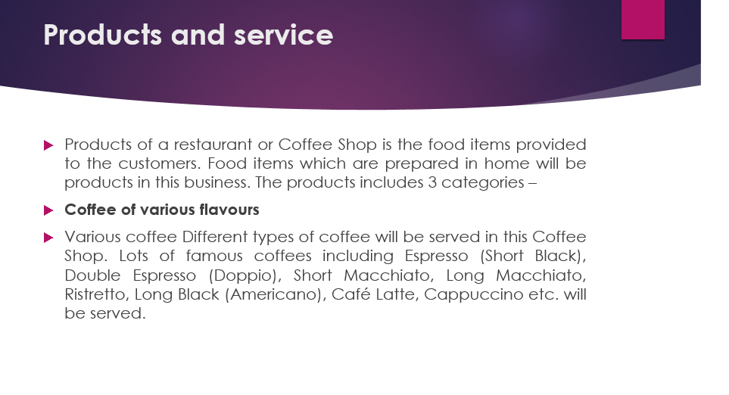
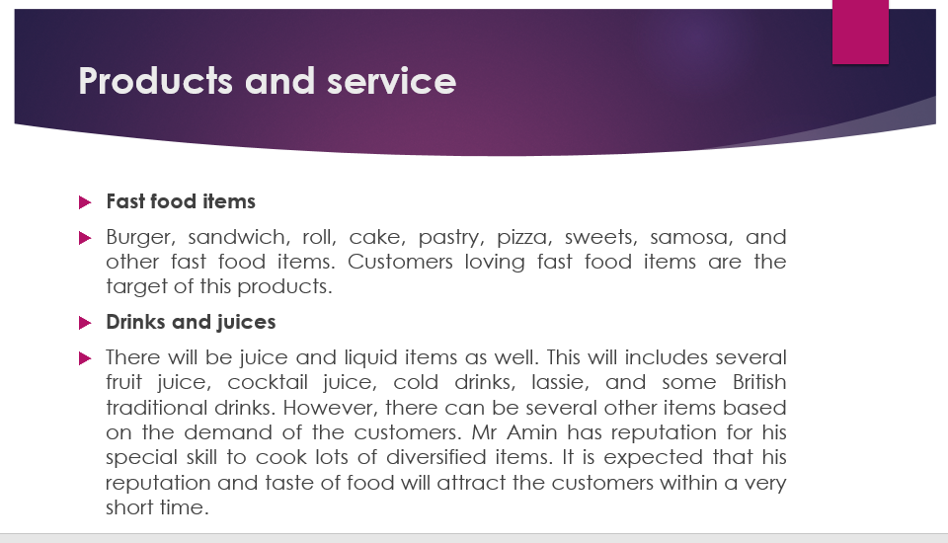
Figure: My presentation slide

Evaluation
I have done my project in a group. Sometimes I found some conflict among the group members. But that were not the ultimate or very nasty conflict in my eyes. Actually sometimes it was difficult to accumulate time everybody in a same time. As I have done location part and some portions of financial cash flow part, I needed to be updated with other’s work. So, I felt that people were ignoring me may be because of my questions. So, I thought our group may be a conflicted group. According to Vohra, he stated that conflict among the team members can hamper the productivity and output of a task which suffers in the long-run (Vohra, 2011). But the positive sight were high on that time. We all were doing a great job among us. Anybody was cooperative. We worked through email, Skype and TeamViewer application to be updated with the work. Everybody was actually serious about the project which was the main positivity of our work. But I think I have developed a lot of my hard and soft skills working with this group. Before that group work, I didn’t have any idea about a business plan. When I formed my group and met with my group members, they actually helped me a lot for market segmentation, target market analysis and SWOT analysis which actually helped me to identify the nest location, what is the importance of a location for a business etc. in a business plan, each and every details should be there. So, location is the main factor for a business. When I got my work, I was bit nervous and felt shy. But my group members helped me during that time. They were not only cooperative but also funny to make made me understandable about my part. I did my part based on their cooperation, information sources from internet and group discussion. So, I have acquired and seen the effectiveness of a group discussion and group work. In future, if I want to open a restaurant or something like that this report and knowledge will help me judge about the target market, market segmentation and different approaches of communication with my partners or investors. Group work actually enabled my experience and theoretical knowledge in a practical way of learning. Though we had some conflict regrading various issues nut we had solved those problems and made our project. I think, practically, it helped me to develop my personal development plan and my analytical ability for my future preference and choice of doing any business.

Analysis
Group work is effective now a days. According to Mitchel, he stated that effective group work and communication is important for both academic purpose and in professional sectors to solve and analyze critical situation (Mitchel, 2015). So, I have analyzed the importance of a group work and team work. As I have done the location and some portions of financial statement like cash flow, I have analyzed the mathematical importance of a financial statement and the calculation of some variables. Those variables will help my numeric skills and as a professional for my future development or my future business ideas, this calculation will help me to evaluate the current market strategies and situation for opening a business. A business plan like a market research. So, I have also acquired the knowledge of different theories and their relationship which actually broaden my concepts and practical knowledge in a big way. I have also analyzed the market segmentation in some way for targeting the location of our coffee shop. By doing so, I have gathered some secondary data about restaurant industry. Those data can also reflected by me for future business plan or any other business portfolios. With the help of the report of Universal Coffee Shop, I have realized the importance of investment. According the Saha, investment and business is interrelated with each other and profit maximizing is depending on the sales of a product/service (Saha, 2006). So, I also realized that without investment, a business can’t be free in the market. Potential buyers and their choices are the main key factors for a business. In one sense, I have analyzed about a whole perspective of business, how it goes in the market and the investment in a business. In my personal development, this parts are my helping hand if I want to open a business in future. This situation actually based on the business type and some factors of external analysis. I have acquired that knowledge and analyzed the importance of those knowledge and also developed a personal development plan to broaden my skill set in academic and professional career of mine.

Conclusion
The latest business world is depending much on the technological advancement (Chipman, 2015). So, accumulating and competing with new business and business ideas, I must have the knowledge of different business approaches and thinking process related to the business idea. For personal development plan, those ideas will help me a lot to engage with a business and to analyze the importance of business. In our project, we have done a restaurant business plan and I personally developed the target market analysis and location and some portions of financial calculations which actually enable my numerical knowledge about investment, cash flow, sales, revenue and some other topics and theories. Location is one of the most important factor for opening a new business and I am now well known about a location planning of a restaurant. This reflective actually shows my personal development and my skills which I gained from the group project and how I think any business in future with the help of my theatrical and practical knowledge from the group project.

Action Plan
If the problem arise again like with a new business idea or new business portfolios, I will analyze the problem and situation in a team and discuss about the industry. After that I will make a business plan and divide all the works and parts to my group members for an efficient and effective work. I will make a target market, market segmentation as we have already made one for our Universal Coffee Shop and also apply some theories relating with those problems. As I have seen some conflicts occurred in my group work, so, I will develop a flexible time schedule for all of our group member. This will help us to maintain a flexible work time and schedule. As communication is the key factor for a group discussion, we will make some informal group discussion. In an informal group discussion, all the members will feel free to discuss about their ideas which will actually increase the productivity and output of the discussion. After that, I will make a report about our business plan and ideas in a very structured way. The report will contains about our target market, whom we are going to target, our segmentation of the market, how we divide the market, financial and capital of the project and the location of the shop with our offered products/services. I have analyzed the same industry after that for a better view of our project. With the help of my team members, we will analyze various data from internet and other sources for a better view and idea for our business. Last of all, we will make a financial forecasting using our targeted capital and sales. So, in my professional career, if I want to open or expand any business of my own, I must use those theoretical and practical knowledge in a very tactical way which actually reflect my academic skills in the professional way.

References
1. Chipman, S. (2015, February 16). 15 Important Advances in Business Technology. Retrieved from CRMSwitch: https://www.crmswitch.com/business-technology/important-advancements-business-tech/
2. Hesley. (2016). Communication Approaches in the Workplace. An Analysis of Personal Development for Employees, UK, 1(12), 123-125.
3. Mitchel. (2015). Group Work and Communication Approaches for the Managers. Organizational Wrokplace in UK, 1, 120-123.
4. Mosley. (2014). Business Methods for Professionals (5 ed., Vol. 3). London: Pearson Publication.
5. Paul. (2013). Effective Team Work and Communication. An Evaluation of Organizational Workplace, UK(23), 56-58.
6. Saha. (2006). Managerial Finance (13 ed., Vol. 12). New Jersey: Pearson Publication.
7. Vohra. (2011). Organizational Behavior (14 ed., Vol. 4). Chicago: Pearson Publication.

Appendix

