How far do the Acropolis Museum and The Metropolitan Museum of Art mirror the Panathenaia festival?
Seen as one of the most important religious festivals in ancient Athens, the Panathenaia is represented in different ways in museums today (Kousser, 2009). This essay will discuss the material culture of the Panathenaia representation in the two museums, one located in Athens, the Acropolis Museum, and, on the other side of the world, in America, The Metropolitan Museum of Art. This essay will argue, can museums mirror a specific event, in this case, the Panathenaia festival and how do they do this, also grading the museum in the level of representation they have with the festival using five levels from excellent, very good, good, average and poor. Museums mirror society as museums contain what our society deems as valuable and reflects what our society values (Vilkuna & Vuorinen, 2017; Arinze, 1999). Due to the situation currently, physical visits are not possible, data collecting will occur through communication with the museums, their websites and any online catalogues from that museum. However, this will only give an online opinion of these museums and not what is on display in the museum. The Panathenaia festival is mainly presented by the two museums through a variety of ways, this includes there collection, on display, special exhibitions, events and their website.
Before discussing the representation of the festival in the museums, we must look at the museums holistically and what they are presenting in their collections. The Acropolis Museum, located at the bottom of the Acropolis hill, is a key museum in Athens and Greece. Opening in 2009, it is a specialist museum holding a large collection of objects from the Acropolis hill and holds the remnants of the Parthenon frieze. This means that the Acropolis Museum only presents artefacts that are to do with or were excavated from the Acropolis area. The Metropolitan Museum of Art is a famous American museum, based in New York. Founded in 1870, the Met as a holistic museum has three museum sites across New York: The Met Fifth Avenue, Met Breuer and the Met Cloisters (The Met, 2010). Something noteworthy is that the different parts of the museum have different approaches and focus on different aspects, one focuses on the local history, and the other focuses on art history over time. The museums due to their differences have different collecting practices and so in their focus hold different types of items in their collection. This is seen in the Met having collected painted terracotta amphoras and that the Acropolis Museum have stone slabs from the Parthenon. Another thing with this is that they both attract different audiences, meaning that they target differently and so they display things differently.
The Panathenaia was paramount to the Athenians. The lesser Panathenaia is the festival to celebrate the birthday of Athena, the protector of Athens, occurring every year (Renshaw, 2010). The festival was highly important to the Athenians that they created the Greater Panathenaia, an extended version of the lesser Panathenaia this was celebrated every four years (Renshaw, 2010, p. 29). Starting in 566 B.C., the great Panathenaia included a large range of events and activities that did not occur at the lesser Panathenaia (Cohen, 2010). The Greater Panathenaia ranged activities, from athletic, choral and music competitions (Renshaw, 2010, p. 29; Hadziaslani, 2003). The festival only lasted eight days occurring in the middle of the year (Renshaw, 2010, p. 30). The festival culminated with the prize giving and the procession on the final day (Renshaw, 2010, p. 30 & 33).
The Acropolis Museum representation of the Panathenaia and especially the great Panathenaia is seen in the frieze of the Parthenon which is in the museum’s collection and is on display (Acropolis Museum, 2020). The frieze of the Parthenon depicts the Panathenaic procession and is the primary way that the festival is illustrated and debated (Acropolis Museum, 2020). The frieze is 160 metres long and consists of 115 blocks of which the Acropolis Museum holds 50 metres of the frieze (Acropolis Museum, 2020). The remaining blocks of the frieze are scattered in museums across the world; most are housed in the British Museum in London. This is a major debate with the removal of the marbles from the Parthenon to the UK and the repatriation of these objects. The procession starts on the southwest corner of the frieze and depicts the procession travelling to the top of the Acropolis hill (See Appendix 1). Since the frieze was created, the blocks have deteriorated and been damaged; this has caused some of the blocks to be lost. This makes the representation of the festival hard as material evidence to the events has been lost and drawings replaced some of the gaps in the frieze. This makes it harder to get a full picture of the festival, especially with the scattering of the remaining pieces scattered across the world. However, on display they leave gaps instead of having the drawings there, this makes the Museum an average distinction.
A key way that the Great Panathenaia is mirrored is in the peplos displayed in Block V of the Parthenon on the east side (see Appendix 2). In this block, it depicts a man and a boy holding the peplos and folding it. This block is not in the Acropolis Museum but is in the British Museum. However, the Acropolis Museum depicts certain blocks that are in other museums differently than the actual blocks from the Parthenon. As these blocks are replicas of the original they are a different colour and are depicted lighter. Actual parts of the frieze are seen as discoloured. This gives the artefacts a different representation in the eyes of the visitors with the authenticity of the replicas as fake for display purposes. The initiative with the colour of the stone shows that the museum is deliberate about showing the real artefacts in comparison to the fakes. This also shows how the museums see themselves as an educational facility, with them highlighting this aspect. At this stage, the Acropolis has a good level of representation and could be improved with signs with the information on them to create a better level of understanding.
One of the blocks held in the Acropolis Museum is on the West side of the frieze. Block XVI depicts the dress code for one of the most important dates in the Athenian calendar, that being the procession (See Appendix 3). In addition, this block shows the male preparing for the procession. The frieze depicts a nude male putting on a chalamys (short cape worn with a brooch) (Actropolis Museum , 2009; Acropolis Restoration Service, 2009). The depictions of this in the museum shows that they want to highlight the preparation for the festival and this can be seen on the repository website for the Parthenon frieze (written partly by the Acropolis Museum), where they highlight and identify the block as part of the preparation (Acropolis Restoration Service, 2009). This is a highly important representation of the festival as it shows a behind the scenes of the event. However, I noticed through research that the frieze panels are not identifiable in the museum and this is seen in the Google Arts and Culture walkthrough of the Museum (Google Arts and Culture, 2020). This thing combined creates an excellent representation of the Panathenaia and the museum as a mirror of society through the fact that the digital technology of walking around the museum and opens up the museum to people who are not able to visit.
Another way that the Acropolis Museum has presented the Panathenaia is that it highlights the museum’s place in society as a place for education. This is illustrated by the use of the museum holding a tour on the festival, through the museum’s galleries materials (Acropolis Museum, 2015). The tour would have discussed the forms, what occurred as part of the festival, the festivals evolutions in history and how important the festival was to the Athenians. This highlights that the museum recognises itself as a centre of learning and by holding this event creates an image of the festival that gives a fairly accurate representation. A way that the museum could improve is if they held this talk more regularly instead of a one of a talk five years ago, as ideas with a topic are constantly changing and new things are being discovered. This will also open up the talk to more people as only a limited number of people got to experience this event. This representation of the festival is poor because it was a one-off event that lasted forty minutes (Acropolis Museum, 2015).
Overall, the Acropolis Museum represented the festival very well through the use of the frieze and the talk. However, the collection mainly contains artefacts from the Acropolis hill, as that is their main focus. This does mean that the representation of the Panathenaia will be limited meaning that they miss out on a large number of artefacts concerning objects to do with the topic. The Metropolitan holds different aspects of the Panathenaia because they focus on world art as a whole. In conclusion, I give the Acropolis museums a very good distinction due to the combing factors of representation.
The Metropolitan Museum holds a variety of items from over five thousand years of history and from all over the world (The Met, 2010). The collection that they hold relating to the Great Panathenaia are mainly amphoras. The amphorae were given as prizes to the competitions in the Panathenaic games and would contain olive oil (Marx, 2003). The Met collection holds 20 amphorae pertaining to different competitions. These amphorae contained 38 litres of oil and on one side would depict Athena with the inscription ‘from the games at Athens’ (Renshaw, 2010, p. 31)(See Appendix 6, 7, 8 and 9). The other side would hold an image of the contest in which these were given as prizes (Renshaw, 2010) (Hadziaslani, 2003).
Part of the Panathenaic games hosted a variety of sporting events. This included: stadion, combat events, pentathlon and equestrian events (Renshaw, 2010). One of the sporting events was the footrace. The footrace was one of the earliest events in the Panathenaia games and is represented in the terracotta Panathenaic prize amphora depicting the footrace (Museum No 14.130.12, See Appendix 9) (The Met, 2020). The representation of this race in the museum is very good with the highlighting and the mentioning of the footrace as an event that started early on in the history shows the need to spread the knowledge of the evolution of the games and the Panathenaia, giving the met the distinction of very good.
The museum holds amphorae from other sporting events such as the chariot racing and pankration. The chariot racing was an important part of the Panathenaic games, seen in the different types of chariot racing. Amphora 07.286.80 depicts a chariot race showing a post marking a turn in the course (The Met , 2020)(See Appendix 7). The representation of this event is important as it was a key fixture within the games. Another thing that this amphora tells us is that the place where it was acquired from Italy and not Greece. This informs us that people outside of Greece might have come to participate but also shows the movement of goods in and around the Mediterranean. And not just representing the festival but also Athenian society and religion to the world. The representation of this contest in the museums' display is good, especially with the representation of an important event with the Panathenaic Games and the Olympic Games (The Met, 2004).
The other sporting event that the Met museum hold is an amphora of the pankration. The pankration which is a mix of martial arts, combining wrestling and boxing. Museum object 16.71, is a prize amphora from the Panathenaic games (The Met, 2020)(See Appendix 6). It is interesting to note that the vase depicts the two fighters with a judge standing next to them (The Met, 2020). This shows how dangerous the pankration was. The museum’s website also identifies the group that the painter might be from due to trademarks left by them and in this case, this amphora has been identified from the Kleophrades group (The Met, 2020). The representation of this jar in the museum highlights that the museum doesn’t just want to present certain sports but also violent sports. In addition, with the highlighting of the painters’ group suggest with their focus on art that they want to represent and present different artists and different style and not just different events in the Panathenaic games, giving them a good distinction.
Outside of sports contests, the Panathenaic games include music competitions. One of the contests was the aulos contests, this was a contest for auletai players, the modern-day flute (Hadziaslani, 2003). As seen on the amphora 1989.281.89, depicts two flute players, similar to the competition (The Met, 2020)(See Appendix 5). It is interesting to note that though the amphora is not a prized one at the games due to the absence of the inscription of the games, it is, however, identified by the Met clearly as a Panathenaic shape due to the similar shape of the jar with the prized amphoras (The Met, 2020). This illustrates the museum’s focus at considering art overall in the world rather than on just a single society or topic, unlike the Acropolis Museum. This also highlights that the Panathenaic games influenced art in the wider spectrum outside the games and Athens. This further supports the idea that the museums' main aim as an educational facility to spread the knowledge, clearly indicating that museums are mirrors of society both in history and now.
In honour of the 2004 Olympic Games in Athens, the Metropolitan Museum hosted a temporary exhibition called ‘The Games in Ancient Athens: A Special Presentation to celebrate the 2004 Olympics’ (The Met, 2004). The exhibition included fifty artefacts between the 6th and the 4th Century BC, in relation to athletics in Athens and the Panathenaic games. The exhibition highlighted the Panathenaic games, this is seen in the nine Panathenaic prize amphorae from the collection on display as part of the exhibition (The Met, 2004). This demonstrates that the Metropolitan Museum has represented one part of the Great Panathenaia through the exhibition but does not give an overall representation of the Panathenaic festival but shows the Great Panathenaia. This would be because the exhibition is only highlighting artefacts to do with sports in Athens and other than the Panathenaic games there is no sport at the festival. Another reason this could be is due to the lack of material culture held in the museum outside of the games to do with the festival. The level I would give to the metropolitan is a good distinction due to the collection when it comes to displaying the Panathenaic games of the greater Panathenaia, however, there is no representation of the lesser Panathenaia in the collection, display or the website.
In conclusion, both the Metropolitan Museum and the Acropolis Museum present different sides of the Panathenaia festival, with the Acropolis Museum representing the festival more clearly, awarding it a very good distinction in mirroring the procession of the Parthenon. The Met presenting the Panathenaic games receiving a distinction of good. These two museums provide two different views of the festival, this could be because of their focus as a museum to educate people on different topics. So, of course, they going to illustrate different views of the festival. Acropolis Museum gives a better view on the festival seen in the fact that the procession is illustrated on the Parthenon, which occurred every year, whereas the Panathenaic games occurred with the Great Panathenia every four years. In terms of material culture held by the two museums, they also vary differently for the same reasons. Another thing is the lack of material culture to do with the festival, underlines museum’s collection as a whole due to the loss of the artefacts and the evidence not existing in the first place. The representation of the festival demonstrates the role museums have for education, the passing of knowledge and the communication in modern-day society.

Bibliography
Acropolis Museum, 2015. The Panathenaic festival- Saturday 14 March 2015. [Online]
Available at: https://www.theacropolismuseum.gr/en/content/panathenaic-festival
[Accessed 18 04 2020].
Acropolis Museum, 2020. Museum History- Acropolis. [Online]
Available at: https://www.theacropolismuseum.gr/en/content/museum-history
[Accessed 20 04 2020].
Acropolis Museum, 2020. The Parthenon Gallery - The Frieze. [Online]
Available at: https://www.theacropolismuseum.gr/en/content/frieze-0/3
[Accessed 19 04 2020].
Acropolis Restoration Service, 2009. The Parthenon Frieze Repository- Block E V. [Online]
Available at: http://repository.parthenonfrieze.gr/frieze/handle/10442/ev
[Accessed 20 04 2020].
Acropolis Restoration Service, 2009. The Parthenon Frieze. Block W XVI. [Online]
Available at: http://repository.parthenonfrieze.gr/frieze/handle/10442/wxvi
[Accessed 21 04 2020].
Actropolis Museum , 2009. The Parthenon Frieze. Block W XVI. [Online]
Available at: http://repository.parthenonfrieze.gr/frieze/handle/10442/wxvi
[Accessed 18 04 2020].
Arinze, E., 1999. The Role of the Museum in Society - Public Lecture. Georgetown: s.n.
Casson, S., 1921. Catalogue of the Acropolis Musuem- Volume II- Sculpture and Architectural Fragments. Cambridge: Cambridge at the University Press.
Cohen, B., 2010. Review: The Acropolis Museum, Athens, opened 20 June 2009. American Journal of Archaeology, 114(4), pp. 745-753.
Google Arts and Culture, 2020. Acropolis Museum - Explore the Museum. [Online]
Available at: https://artsandculture.google.com/streetview/acropolis-museum/IwFUpQvIJ1QDVA?sv_lng=23.7282063&amp%3Bsv_lat=37.9682265&amp%3Bsv_h=80.09660992817885&amp%3Bsv_p=2.198053202193691&amp%3Bsv_pid=1eIXOIPUaS2hPmrMwGYkQQ&amp%3Bsv_z=1&sv_lat=37.9682478&sv_h=54.704
[Accessed 18 04 2020].
Hadziaslani, C., 2003. ΤΩΝ ΑΘΗΝΗΘΕΝ ΑΘΛΩΝ (Prizes from Athens. The Panathenaic Games). Athens : Acropolis Restoration Service.
Kousser, R., 2009. Destruction and Memory on the Athenian Acropolis. The Art Bulletin, 91(3), pp. 263- 282.
Marx, P. A., 2003. Athena on Early Panathenaic Amphoras. Antike Kunst, Volume 46, pp. 14- 30.
Popkin, M. L., 2012. Roosters, Columns and Athena on Early Panathenaic Prize Amphoras: Symbols of a Athenian Identity. Hesperia: The Journal of the American School of Classical Studies at Athens, 81(2), pp. 207- 235.
Renshaw, J., 2010. In Search of the Greeks. London: Bristol Classical Press.
RICHTER, G. M. A., 1936. Red-Figured Athenian Vases in the Metropolitan Museum of Art. London: Yale University Press.
Sourvinou-Inwood, C., 2011. Athena Polias, Panathenaia, and the Peplos. In: R. Parker & C. Sourvinou-Inwood, eds. Athenian Myths and Festivals: Aglauros, Erechtheus, Plynteria, Panathenaia, Dionysia. s.l.:s.n.
The Met , 2020. Terracotta Panathenaic prize amphora (jar)- 07.286.80. [Online]
Available at: https://www.metmuseum.org/art/collection/search/247960
[Accessed 19 04 2020].
The Met, 2004. The Games in Ancient Athens: A Special Presentation to Celebrate the 2004 Olympics- Exhibtion overview. [Online]
Available at: https://www.metmuseum.org/exhibitions/listings/2004/games-in-ancient-athens
[Accessed 19 04 2020].
The Met, 2004. The Games in Ancient Athens: A Special Presentation to Celebrate the 2004 Olympics Press. [Online]
Available at: https://www.metmuseum.org/press/exhibitions/2004/the-games-in-ancient-athens-a-special-presentation-to-celebrate-the-2004-olympics
[Accessed 19 04 2020].
The Met, 2004. The Games in Ancient Athens: A Special Presentation to Celebrate the 2004 Olympics- Return to The Games in Ancient Athens. [Online]
Available at: https://www.metmuseum.org/exhibitions/listings/2004/games-in-ancient-athens/photo-gallery
[Accessed 19 04 2020].
The Met, 2010. An Overview of the Museum- Press. [Online]
Available at: https://www.metmuseum.org/press/general-information/2010/an-overview-of-the-museum
[Accessed 18 04 2020].
The Met, 2020. Terracotta neck-amphora of Panathenaic shape (jar)- 20.245. [Online]
Available at: https://www.metmuseum.org/art/collection/search/250994?searchField=All&amp;sortBy=Relevance&amp;ft=panathenaic&amp;offset=0&amp;rpp=80&amp;pos=19
[Accessed 20 04 2020].
The Met, 2020. Terracotta neck-amphora of Panathenaic shape- 1989.281.89. [Online]
Available at: https://www.metmuseum.org/art/collection/search/255967?searchField=All&amp;sortBy=Relevance&amp;ft=1989.281.89&amp;offset=0&amp;rpp=20&amp;pos=1
[Accessed 20 04 2020].
The Met, 2020. Terracotta Panathenaic prize amphora (jar)- 56.171.4. [Online]
Available at: https://www.metmuseum.org/art/collection/search/254862?searchField=All&amp;sortBy=Relevance&amp;ft=panathenaic&amp;offset=0&amp;rpp=20&amp;pos=6
[Accessed 19 04 2020].
The Met, 2020. Terracotta Panathenaic prize amphora- 14.130.12. [Online]
Available at: https://www.metmuseum.org/art/collection/search/248902?searchField=All&amp;sortBy=Relevance&amp;ft=14.130.12&amp;offset=0&amp;rpp=20&amp;pos=1
[Accessed 19 04 2020].
The Met, 2020. Terracotta Panathenaic Prize Amphora ca. 500BC- 16.71. [Online]
Available at: https://www.metmuseum.org/art/collection/search/249067?searchField=All&amp;sortBy=Relevance&amp;ft=panathenaic&amp;offset=0&amp;rpp=80&amp;pos=7
[Accessed 19 04 2020].
Vilkuna , J. & Vuorinen, P., 2017. Museums as mirrors of society: a case study of Finnish Museums. The Museum Review, 2(1).

Appendix
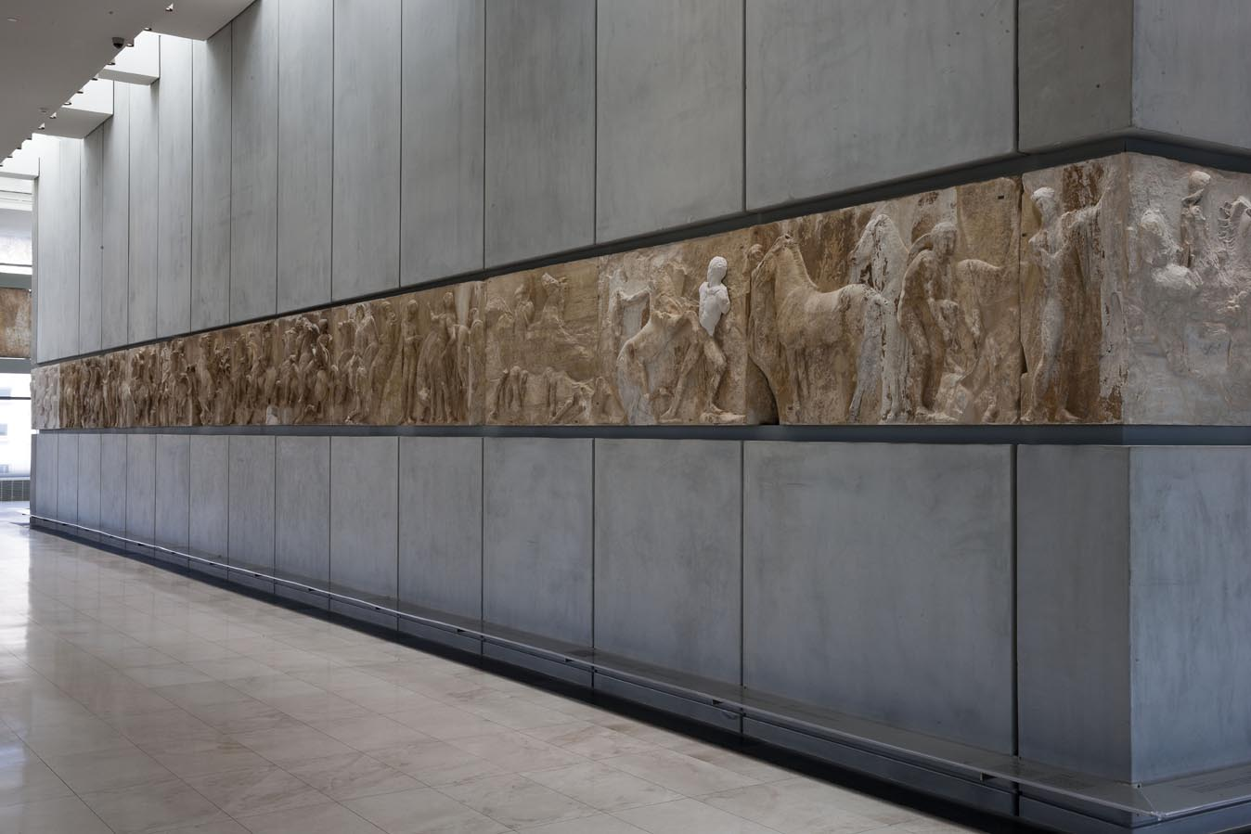
Appendix 1- South-West corner of the Frieze of the Parthenon
(Credit: South-West corner of the Frieze of the Parthenon © Acropolis, 2013, Socratis Mavrommatis.)
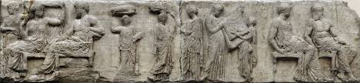
Appendix 2- Image of the Parthenon Frieze, East side Block V, (Acropolis Restoration Service, 2009)
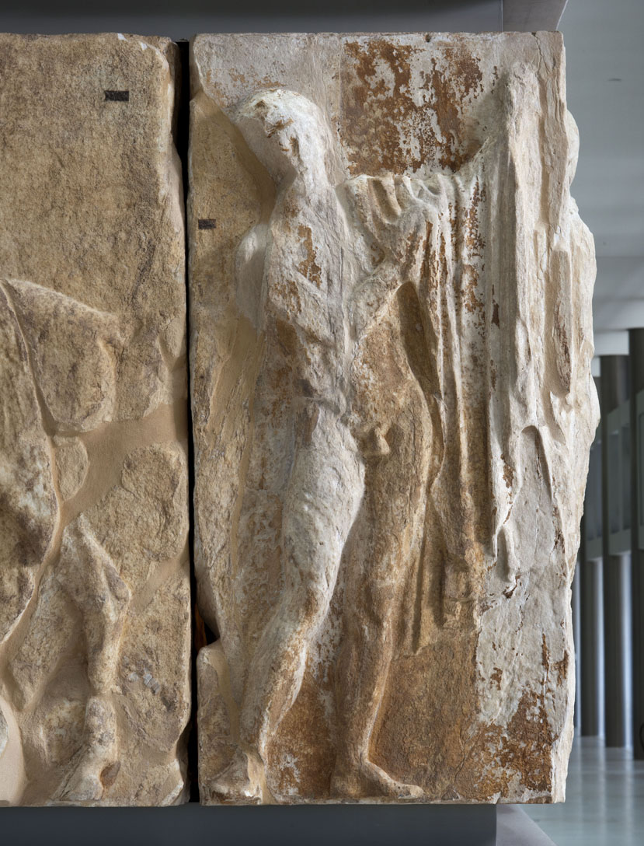
Appendix 3- Image of Block XVI – West side of the Parthenon frieze
(Credit: West Frieze of the Parthenon, block XVI © Acropolis, 2012, Socratis Mavrommatis.)
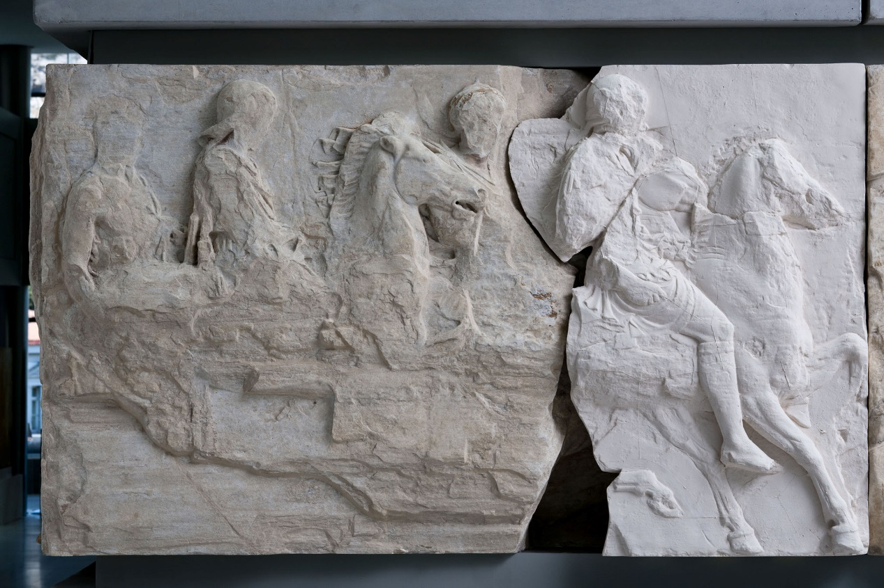
Appendix 4- Image of Block I on the South frieze.
(Credit: South Frieze of the Parthenon, block I © Acropolis, 2012, Socratis Mavrommatis.)
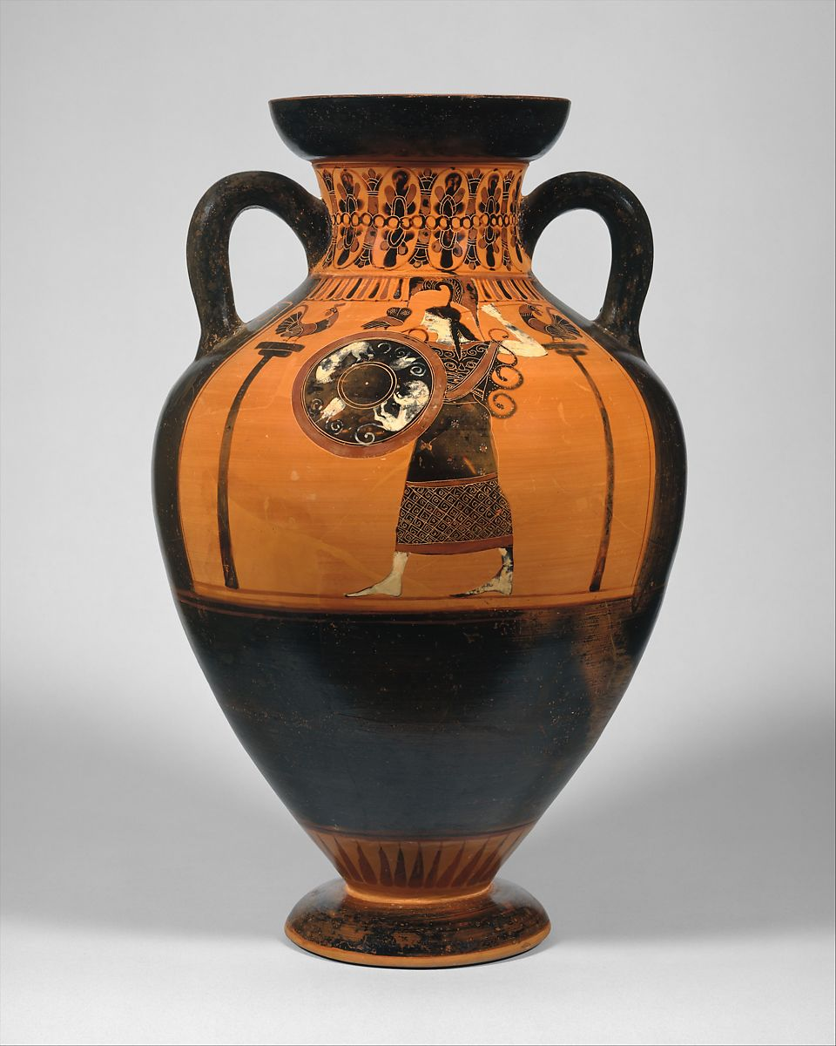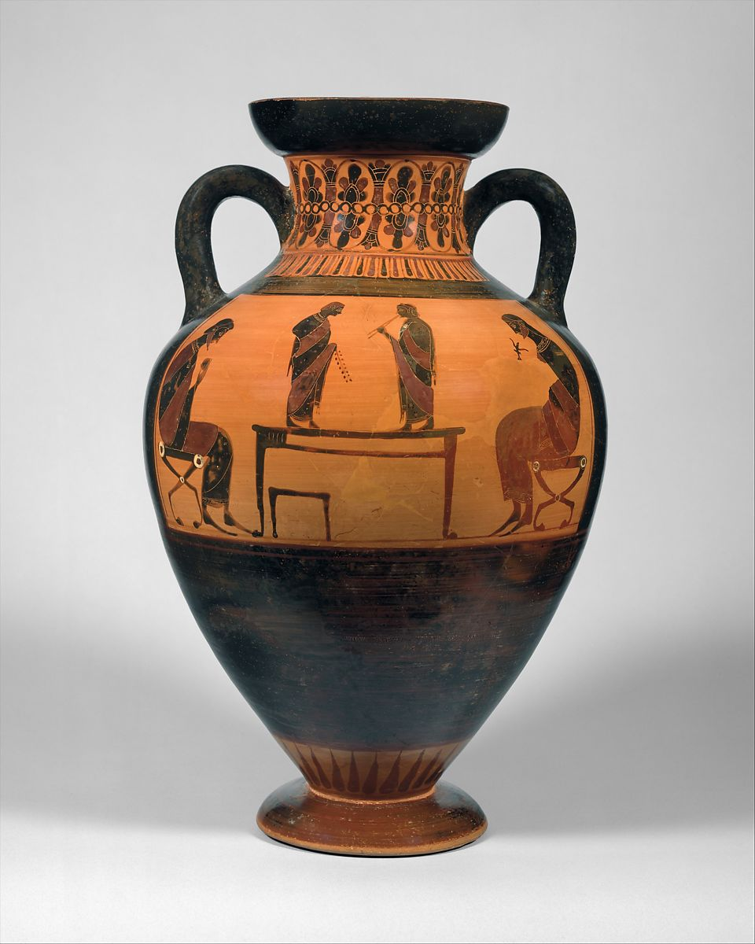
Appendix 5- Image of Terracotta neck-amphora of Panathenaic Shape – Museum number: 1989.281.589. Left- Athena, Right- Flute players. (The Met, 2020)
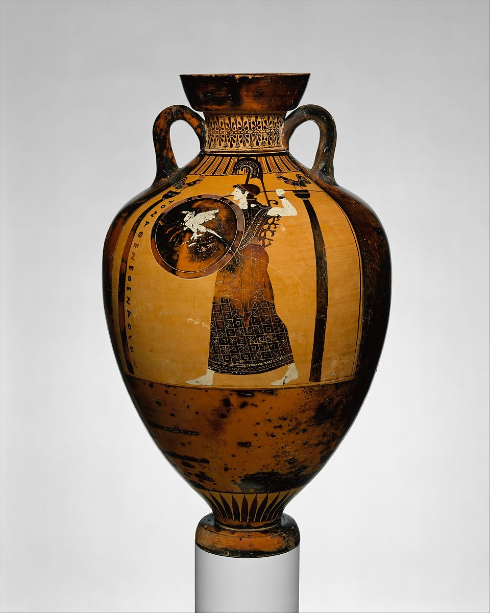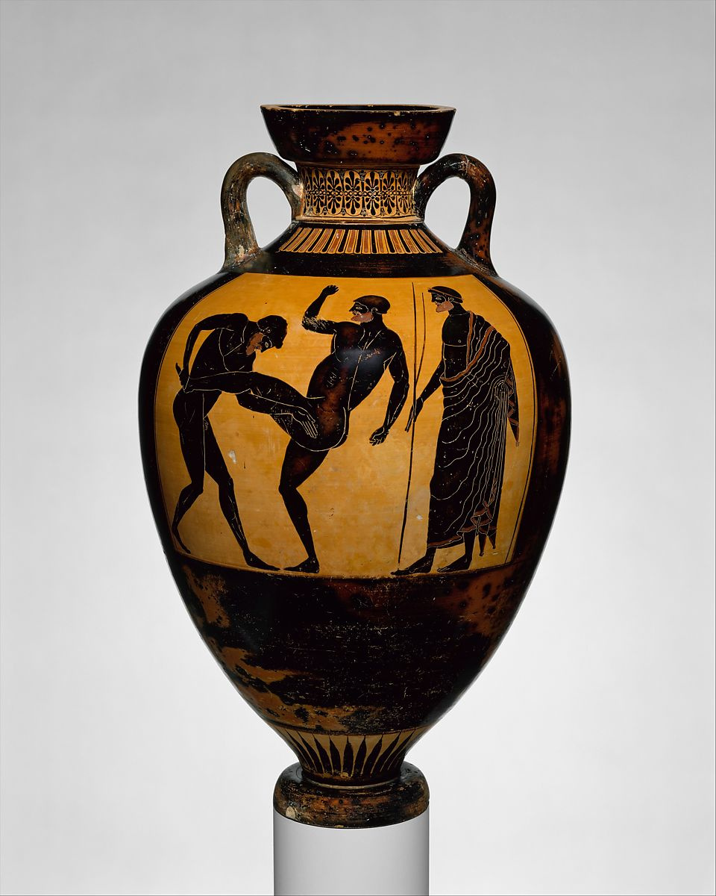
Appendix 6 – Terracotta Panathenaic prize amphora- Museum number: 16.71. Left- Athena. Right – Pankration. (The Met, 2020)
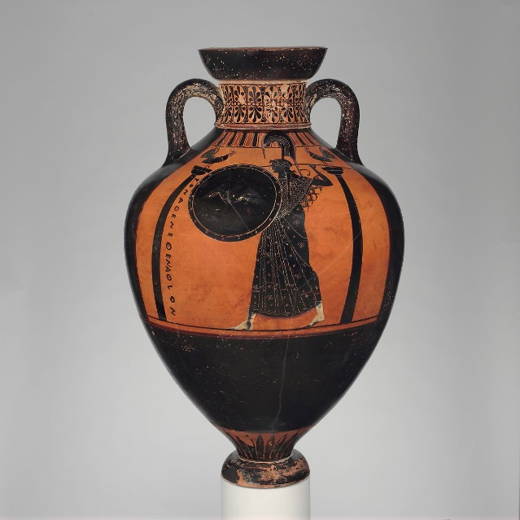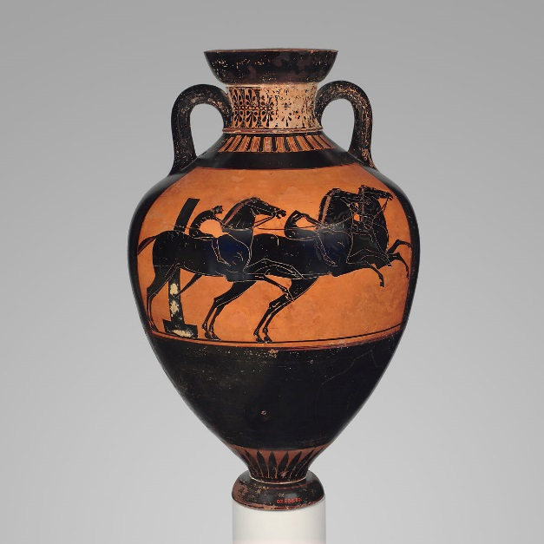
Appendix 7 - Terracotta Panathenaic prize amphora- Museum Number: 07.286.80. Left – Athena, Right – Horse Race. (The Met , 2020)

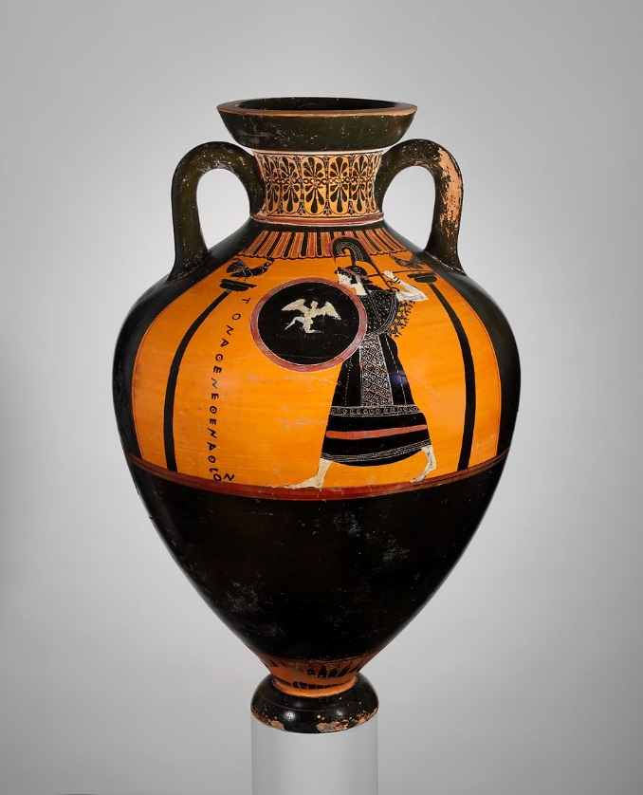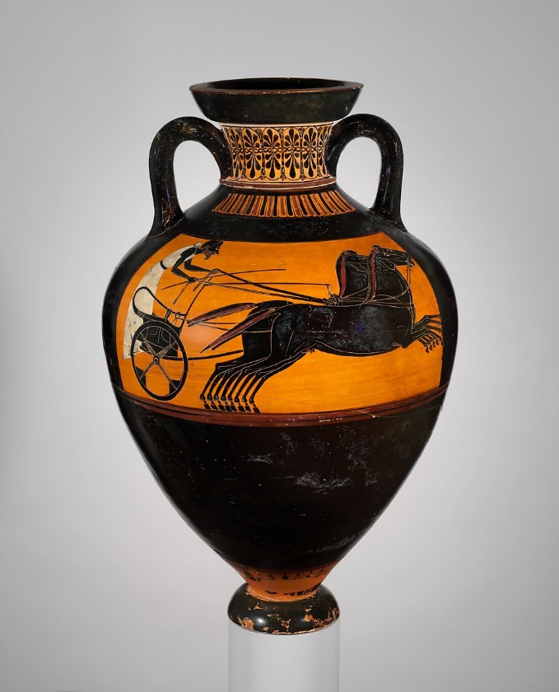
Appendix 8- Terracotta Panathenaic prize amphora- Museum number: 56.171.4. Left – Athena, Right- Chariot Race. (The Met, 2020)

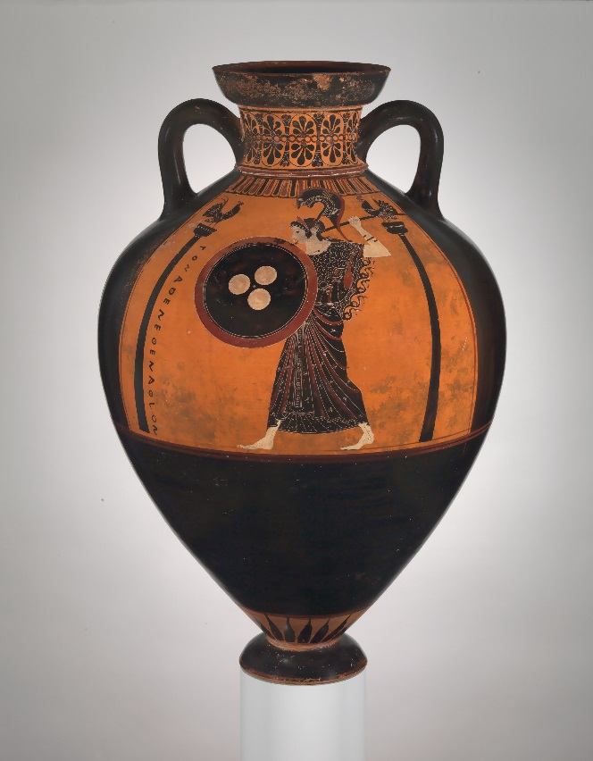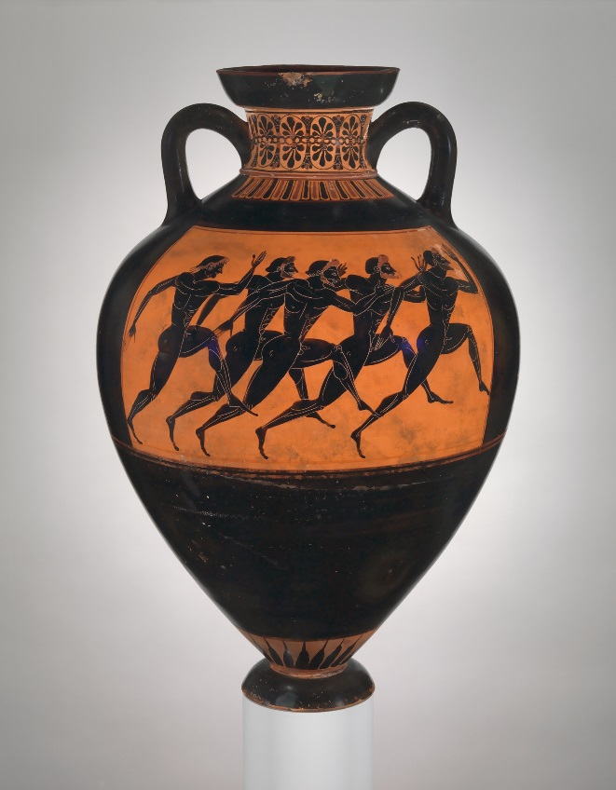
Appendix 9 – Terracotta Panathenaic prize amphora. Museum number: 14.130.12. Left- Athena, Right – Footrace. (The Met, 2020)

