Ultrasonic Attenuation Coefficient Determination
Jian Song 06/01/24
Abstract：
This experiment on mild steel rectangular block and brake disc attenuation coefficient measurements are generally used ultrasonic detection, due to ultrasonic waves in different propagation, will produce absorption and scattering, so that the ultrasonic energy with the propagation distance increases and reduces the ultrasonic energy, that is, due to the impact of the material material caused by the ultrasonic attenuation, through the analysis of the results of the measurements and processing of the attenuation coefficient of the two materials are calculated. In this paper, the ultrasonic attenuation coefficient of the two materials for the measurement of the accuracy of the error in the factors affecting the problem is described.

Apparatus:
Sample: Mild steel rectangular block, automotive brake disc.
Vernier caliper: to measure the external dimensions of the sample.
Coupling gel: to prevent excessive reflection of ultrasonic waves between the sample and the probe and to ensure the transmission rate of ultrasonic waves.
Ultrasonic probe (Zero-Degree, 5MHZ): equipment for receiving and transmitting ultrasonic waves.
Ultrasonic Flaw Detector: A device used to record the amplitude of ultrasonic reflections.

Introduction:
This experiment is to measure the ultrasonic attenuation coefficient of mild steel rectangular block and brake disc is an important parameter to measure the degree of absorption and scattering of ultrasonic waves by the material, this coefficient reflects the reduction of the intensity of ultrasonic waves as they propagate through the material, when the ultrasonic waves pass through the material, the intensity is gradually weakened due to the absorption and scattering of energy. The attenuation coefficient gives an idea of the non-destructive testing of the material. Meksen describes a method in imaging of defect detection, localization and dimensioning of steel structures aomates crack detection by analyzing the curve formed by the sparse matrix elements.^{【1】}

Experimental Methods
First of all we deal with the material, the material needs to be measured on the surface clean, try not to have stains, select a more flat surface for measurement, and then the ultrasonic probe and ultrasonic flaw detector link, check whether the probe external signs of wear and tear or damage, such as this case, timely replacement. In the brake disc inner circle tab and outer circle disc part of the disc to distinguish between three measurement points, the use of vernier calipers to measure the thickness and record, in the six measurement points evenly coated with coupling agent, the ultrasonic probe placed on top of the six measurement points for measurement and recording of ultrasonic flaw detector for the first three peaks of the data. Similarly, in the mild steel rectangular block on the same selection of different surfaces of the eight measurement points, repeat the above steps, record the three peaks of data

Measurements and Graphs of Raw measurements
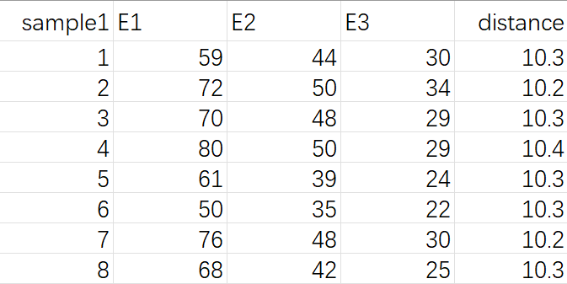
Table 1
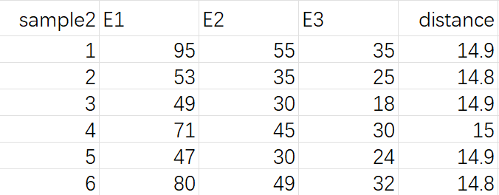
Table 2
Calculation
The equation for the change in amplitude of an attenuated plane wave can be expressed as:
$A=A_{0}e^{-αZ}$ (1)
A0 is the amplitude of the propagating wave at some location.​
A is the reduced amplitude after the wave has travelled a distance z from that initial location.​
α is the attenuation coefficient of the wave travelling in the z-direction.​
Z is the distance the wave has traveled through the medium.
Where, in equation (1), it is necessary to convert the unit of α from nepers/length to the unit dB/length.
According to the conversion factor equation
$1N_{p}=\frac{20}{ln10}dB$ (2)
The attenuation coefficient equation obtained by bringing Eq. (2) into Eq. (1) is given by:
$α=-\frac{20}{2x}\log_{10}{\frac{E_{0}}{E_{1}}}$ (3)
α is the attenuation coefficient of the wave travelling in the z-direction.
x is the thickness of the specimen.
E₀, E₁ are the sound pressure amplitudes of two adjacent bottom echoes of the specimen, respectively.
Take the measurement point 8 in the small iron block as an example, the measurement thickness is 10.3mm, and the measured amplitude values are 68,42 and 25. The measured amplitude values and thickness are brought into the formula (3), i.e., E0=42, E1=68, Z=2*10.3 and the attenuation coefficient α=0.332843db/mm and α2=0.241152db/mm are calculated. The average value of attenuation coefficient αmean=0.283312Db/mm for measurement point 1 and so on. Measurement point 1 out of the attenuation coefficient average value of αmean = 0.283312db/mm. and so on, all the measurement points will be brought into the formula (3) through the calculation of all the values of α, the results are shown in the figure below:
mild steel
sample1 | E1 | E2 | E3 | distance | α1 | α2 | mean
1 | 59 | 44 | 30 | 10.3 | 0.335709 | 0.23019 | 0.277987
2 | 72 | 50 | 34 | 10.2 | 0.306296 | 0.20172 | 0.248568
3 | 70 | 48 | 29 | 10.3 | 0.304666 | 0.211008 | 0.253549
4 | 80 | 50 | 29 | 10.4 | 0.29248 | 0.203407 | 0.24391
5 | 61 | 39 | 24 | 10.3 | 0.3539 | 0.259702 | 0.303164
6 | 50 | 35 | 22 | 10.3 | 0.383549 | 0.289382 | 0.333155
7 | 76 | 48 | 30 | 10.2 | 0.307734 | 0.210125 | 0.254288
8 | 68 | 42 | 25 | 10.3 | 0.332843 | 0.241152 | 0.283312
Table 3
brake disc
sample2 | E1 | E2 | E3 | distance | α1 | α2 | mean
1 | 95 | 55 | 35 | 14.9 | 0.28074 | 0.213307 | 0.244711
2 | 53 | 35 | 25 | 14.8 | 0.399411 | 0.33436 | 0.365441
3 | 49 | 30 | 18 | 14.9 | 0.418424 | 0.391062 | 0.404512
4 | 71 | 45 | 30 | 15 | 0.328249 | 0.261354 | 0.292898
5 | 47 | 30 | 24 | 14.9 | 0.46007 | 0.391062 | 0.424165
6 | 80 | 49 | 32 | 14.8 | 0.307173 | 0.238829 | 0.270854
Table 4
Based on the distribution characteristics of the ultrasonic attenuation coefficients calculated from the different measurement data of the two materials, the probability box plots of the attenuation coefficients were further plotted, thus removing the points with large errors for the subsequent data processing as follows^{【2】}

Figure 1

Figure 2
By comparing the results of the mild steel measurements in Table 1, and the box plot of the ultrasonic attenuation coefficient for mild steel (Fig. 1), no additional exclusions were needed for the measurements of the ultrasonic attenuation coefficient for mild steel, so the average of all the measurements was taken, i.e., α = 0.18482 db/mm
By comparing the results of the brake disc measurements in Table 1, and the box plot of the ultrasonic attenuation coefficient for brake discs (Fig. 2), the results of the ultrasonic attenuation coefficient for brake discs were compared. There is no need to do additional exclusion for the measurement results of the ultrasonic attenuation coefficient of brake disc, so the average value of all measurement points is taken, i.e. α = 0.12647db/mm.

Error analysis
In this experiment of ultrasonic bad piece coefficient, the experimental error may also cause a variety of effects on the experiment, by learning and understanding these errors, it will be able to better take relevant precautions in order to avoid the experimental error on the final experimental data image, so that the accuracy, reliability and consistency of the measurement data is higher. Also make the experiment more convincing, the following summary is a few aspects of the error:
Instruments and equipment may cause measurement errors, the probe and the media will be added between the coupling agent, the coupling agent with different thickness may lead to an increase in ultrasonic reflections, so that the measurement accuracy is reduced. So choose a better quality density more average coupling agent; at the same time to avoid the equipment of the probe used for a long time caused by aging, malfunction and other phenomena, which will also reduce the transmission efficiency of ultrasonic waves, so even if the correction and replacement of problematic equipment components, at the same time, the new and old equipment components for experimental comparison, in time to prevent the generation of such errors.
Operation error is the process that is most likely to produce errors in the experiment, due to the force of each operator, the operation method is different, the probe measurement position is different, will have an impact on the measurement data. At the same time, more than one person at the same time to complete an experiment, each person's error accumulated together will obviously affect the accuracy of the experiment. Therefore, the operator should be familiar with the experimental steps, the operation of the essentials, and at the same time timely communication, in order to prevent the generation of measurement errors.
Unevenness of the sample material itself (e.g. magazines, air bubbles and cracks, etc.) can also cause errors in the measurement results. Due to the unevenness of the sample material, it may cause the attenuation rate of the ultrasonic wave in different places is not consistent, so that the measured data produce a large error, before the measurement should ensure that the material material is uniform; at the same time each time the measurement of the material's temperature, humidity should be kept as consistent as possible, the temperature and humidity of the ultrasonic wave propagation characteristics and attenuation characteristics have a great impact.

Conclusion
In this experiment, we measured the ultrasonic attenuation coefficient of mild steel α = 0.18482db/mm, and the ultrasonic attenuation coefficient of brake disk α = 0.12647db/mm, although the measured values are in accordance with the distribution of the box-plot, but there is a large error in the measured values of the 3rd group of the attenuation coefficient of brake disk as well as the 8th group of the attenuation coefficient of mild steel, which are before and after the measurement of the two groups. I think the main reason for this phenomenon is that there is a poor contact between the probe and the medium, the operator's negligence, or there is a gap between the probe and the sample contact, did not press to make it fit, the coupling gel in the two materials between the thickness is not consistent, resulting in the measurement of the data deviation. However other data that can be used to calculate the attenuation coefficient, but for the accuracy of this experiment, it is necessary to carry out several experiments, from the analysis we can see that there are some differences in the results of different measurement groups, which reflects the performance in terms of measurement accuracy and consistency. Through these analyses, we can better understand and optimize the measurement process to improve the overall measurement accuracy and consistency.

Reference
[1]Mksen, T.M., Boudraa, B., Drai, R., Boudraa, M.: Automatic crack detection and characterization during ultrasonic inspection. J. Nondestruct. Eval. 29, 169–174 (2010)
[2]https://support.minitab.com/en-us/minitab/21/help-and-how-to/graphs/boxplot/interpret-the-results/key-results/

Guidance specific to this assessment
Abstract
The main objective of this article is to analyze experimental data from ultrasonic thickness measurements. We assessed the stability and accuracy of the operation by different operators by performing linear regression analysis, calculating means and standard deviations, and evaluating the overall consistency of the measurements.

Introduction:
This paper evaluates the effectiveness of new ultrasonic thickness measurement methods in terms of operator measurement accuracy. Ultrasonic thickness measurement is an important inspection tool in industrial production. This is especially true for through-wall thickness measurements of major components such as pipelines and pressure vessels. However, its measurement accuracy is affected by the characteristics of the instrument itself, but also with the operator's technical level and measurement methods. Inaccurate measurements can result in underestimation of the error potential, thus causing huge errors with the original data. At present, a lot of research work has been carried out at home and abroad, but there is a lack of systematic and in-depth research on the impact of human factors on measurement accuracy and how to improve the consistency and reliability of measurement results through program optimization. In order to ensure the accuracy and reliability of the test results, further research is needed to study the operator's test accuracy and the effectiveness of the test method.

Measurements and Graphs of Raw measurement

Defect | true size | Op1 | Op2 | Op3 | Op4 | Op5 | Op6 | Op7 | Op8 | Op9 | Op10
A | 0.25 | 1.00 | 0.00 | 0.50 | 0.50 | 0.50 | 0.00 | 1.00 | 0.30 | 0.50 | 0.80
B | 0.27 | 1.00 | 0.00 | 1.00 | 0.73 | 1.20 | 0.50 | 1.00 | 1.20 | 0.50 | 0.80
C | 0.28 | 1.00 | 0.00 | 0.50 | 0.76 | 1.00 | 1.20 | 1.00 | 0.70 | 0.50 | 1.30
D | 0.40 | 1.20 | 1.00 | 1.00 | 0.91 | 0.50 | 1.00 | 1.00 | 0.80 | 0.60 | 1.50
E | 0.40 | 1.40 | 1.00 | 1.10 | 0.98 | 1.20 | 1.00 | 1.00 | 0.90 | 0.20 | 1.60
F | 0.50 | 1.10 | 1.00 | 0.80 | 0.79 | 0.90 | 1.00 | 1.20 | 0.50 | 0.00 | 1.00
G | 0.52 | 0.90 | 1.50 | 1.00 | 1.01 | 1.50 | 1.10 | 1.00 | 0.70 | 1.00 | 0.90
H | 0.55 | 0.50 | 0.90 | 1.20 | 0.96 | 1.20 | 0.80 | 1.00 | 0.40 | 1.30 | 1.60
I | 0.70 | 2.00 | 1.60 | 1.20 | 1.35 | 1.50 | 0.90 | 1.00 | 1.00 | 1.60 | 2.20
J | 0.98 | 1.90 | 2.00 | 1.60 | 1.31 | 1.00 | 0.80 | 1.00 | 1.40 | 0.50 | 1.80
K | 1.12 | 1.00 | 1.80 | 1.80 | 1.37 | 0.50 | 1.00 | 1.50 | 1.30 | 1.80 | 2.00
L | 1.15 | 2.20 | 1.00 | 1.50 | 1.56 | 1.80 | 1.30 | 1.50 | 1.20 | 1.80 | 2.00
M | 1.10 | 2.00 | 1.60 | 1.50 | 1.60 | 2.00 | 1.40 | 2.00 | 1.60 | 0.50 | 2.20
N | 1.30 | 2.20 | 2.00 | 2.00 | 1.73 | 2.10 | 0.90 | 1.50 | 1.70 | 1.70 | 2.00
O | 1.60 | 2.00 | 2.00 | 1.50 | 1.56 | 0.80 | 0.90 | 2.00 | 1.50 | 1.20 | 2.00
P | 1.80 | 2.40 | 2.00 | 3.20 | 2.14 | 2.00 | 1.40 | 2.50 | 1.10 | 2.20 | 2.50
Q | 2.10 | 3.50 | 2.50 | 3.00 | 2.49 | 1.80 | 2.30 | 2.00 | 2.60 | 2.00 | 3.20
R | 2.70 | 2.80 | 2.50 | 3.50 | 2.97 | 3.00 | 3.20 | 3.50 | 2.20 | 2.50 | 3.50
S | 4.90 | 5.70 | 4.50 | 4.40 | 4.87 | 4.50 | 4.50 | 5.50 | 5.50 | 4.20 | 5.40
T | 6.00 | 7.00 | 6.50 | 5.50 | 6.17 | 5.50 | 6.20 | 6.50 | 6.00 | 5.30 | 6.70
U | 7.50 | 8.00 | 7.20 | 6.50 | 6.99 | 6.00 | 6.25 | 8.00 | 6.50 | 6.50 | 6.90
Table 1

Data Analysis
By evaluating the performance of the new ultrasonic thickness measurement procedure, a portion of the through-wall thickness measurements were made, and 10 surveyors, using the same equipment and procedure, each obtained 21 defect measurements:
Assessing operator stability
1、The relationship between each operator's measurements and the actual defect size was evaluated by linear regression analysis, and the following is a linear regression plot of each operator's measurements:
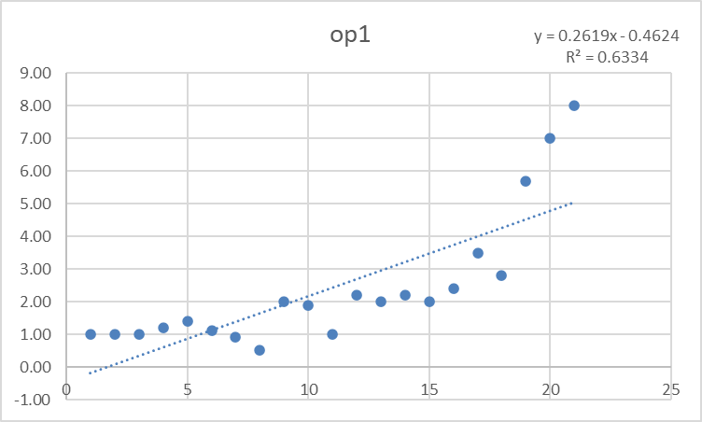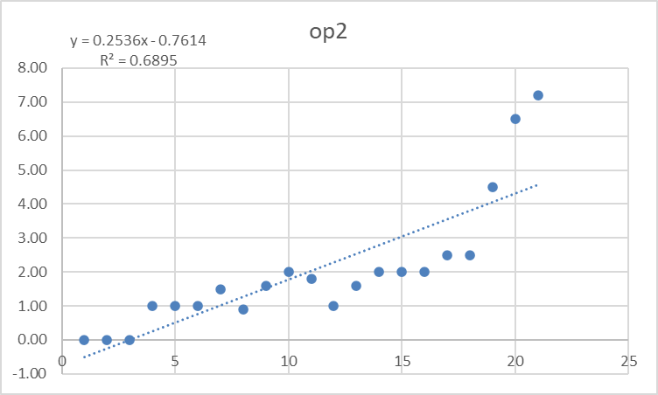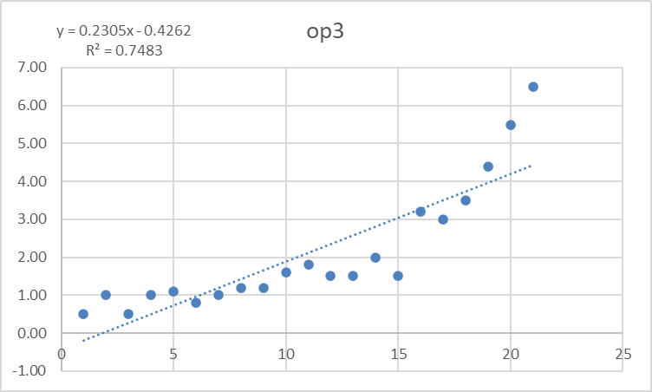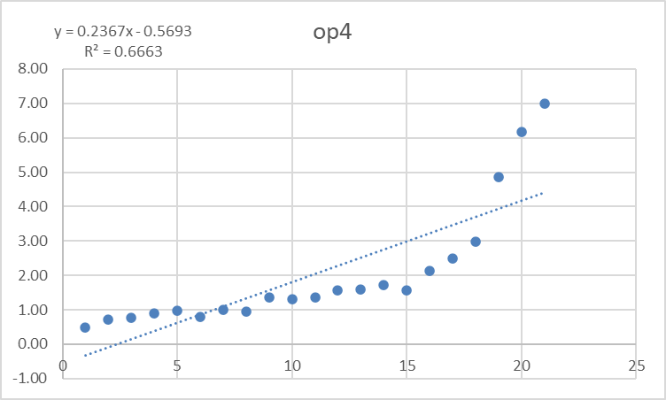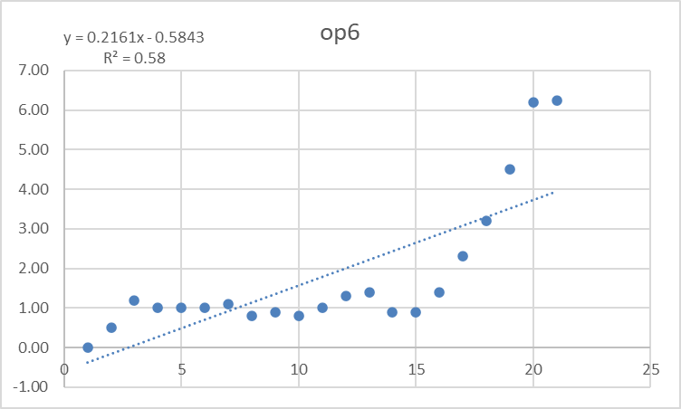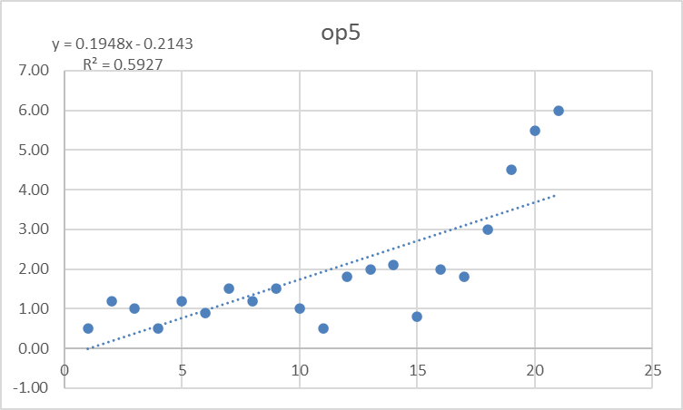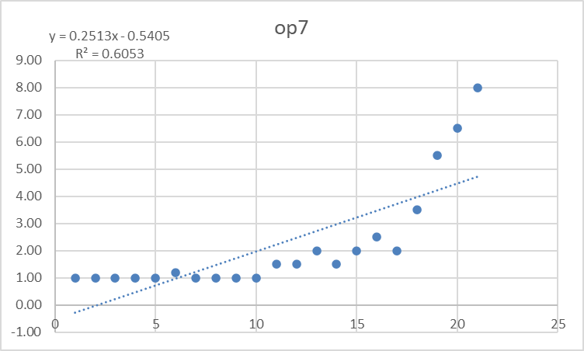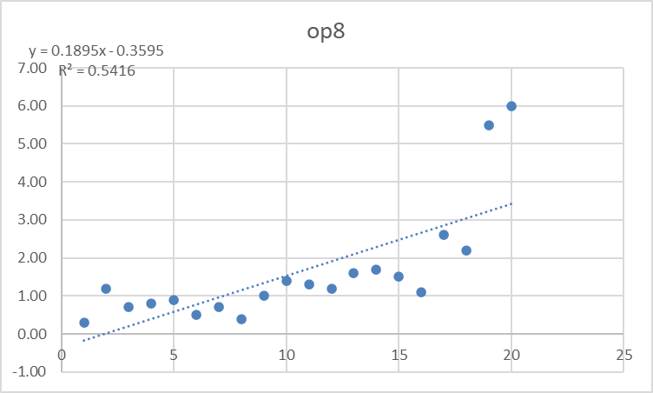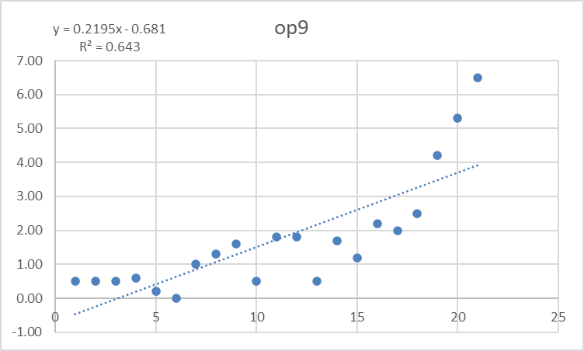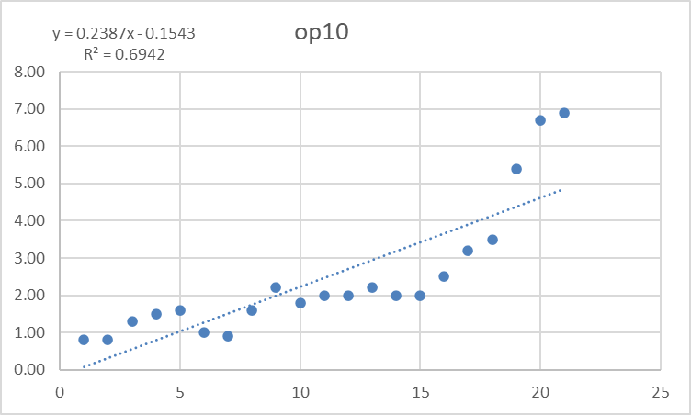
Figure 1
The scatter plot allows us to find the relationship between the measurements and the true size of some operators. The closer the points are to the red line, the higher the agreement between the measurements and the true dimensions. Through the regression line, we find that the red line indicates the best fit line, whose slope and intercept reflect the trend and accuracy of the operator's measurements. By analyzing the variations in slopes, we discover that the majority of operators have slopes that are lower than the optimal value of 1, indicating that the operators are not sensitive enough to respond to changes in dimensions that take place throughout the measuring procedure. Since op1 and op7 are nearer the optimum slope, their measurements yield more precise results when compared. Comparing the intercept differences reveals that most operators, particularly Op1 and Op10, have intercepts that are larger than the ideal value of 0, indicating the possibility of systematic bias in the measurements taken by various operators. Op6 and Op8, on the other hand, appear to have more consistent readings due to their smaller intercepts.
These variations could result from variations in each operator's operating techniques, measuring background, equipment familiarity, and measurement process execution. The measurement processes must be optimized, and operators must get frequent training and instruction in the necessary experimental skills in order to increase the precision and consistency of each operator's measurements.
2、Analyze each operator's accuracy and consistency by calculating and comparing the mean and standard deviation of their measurements.
We may examine each operator's measurement mean and standard deviation to see how well they perform in terms of measuring consistency and dependability. The standard deviation quantifies how much the measurements deviate from the mean, whereas the mean (average) represents the central tendency of an operator's measurements. In order to demonstrate a high level of consistency and dependability, the measures' mean should ideally be rather near to the real size and the standard deviation should be as little as feasible.
操作员 | 测量值均值 (mm) | 测量值标准偏差 (mm)
Op1 | 2.42 | 2.04
Op2 | 2.03 | 1.90
Op3 | 2.11 | 1.65
Op4 | 2.03 | 1.80
Op5 | 1.93 | 1.57
Op6 | 1.79 | 1.76
Op7 | 2.22 | 2.00
Op8 | 1.86 | 1.83
Op9 | 1.73 | 1.70
Op10 | 2.47 | 1.78
Table 2
We may infer from the analysis of the mean values that most operators' measurements have mean values that deviate somewhat from their actual sizes. Of these, Op8's mean value is more closely aligned with the actual size, suggesting that Op8 operators have a greater measuring accuracy. We may observe using standard deviation analysis that the standard deviation indicates how much the measurements fluctuate. Measurements with smaller standard deviations (like Op3 and Op5) are considered to be more consistent, whereas measurements with bigger standard deviations (like Op1, Op7, and Op10) are seen to be less consistent and more variable.
Through standard deviation analysis, we can see that the standard deviation reflects the degree of fluctuation in the measurements. Smaller standard deviations (e.g., Op3 and Op5) indicate that the measurements are more consistent; larger standard deviations (e.g., Op1, Op7, and Op10) indicate that the measurements are more variable and less consistent. Regarding the consistency and dependability of the measurements, there are pronounced variations throughout the operators. Op1, Op7, and Op10 exhibit lower levels of stability and dependability than do certain operators, such as Op3 and Op5. The operator's proficiency, knowledge with the instrument, and skill level can be ascribed to this discrepancy. In order to improve overall test accuracy, tester training should be enhanced and the testing process should be optimized to reduce inter-tester bias.
3. By calculating and analyzing the measurement error (the difference between the measured value and the true value) of each operator, we can understand the accuracy of their measurements and possible deviations. The following are the results of the statistical analysis of each operator's measurement error and its distribution
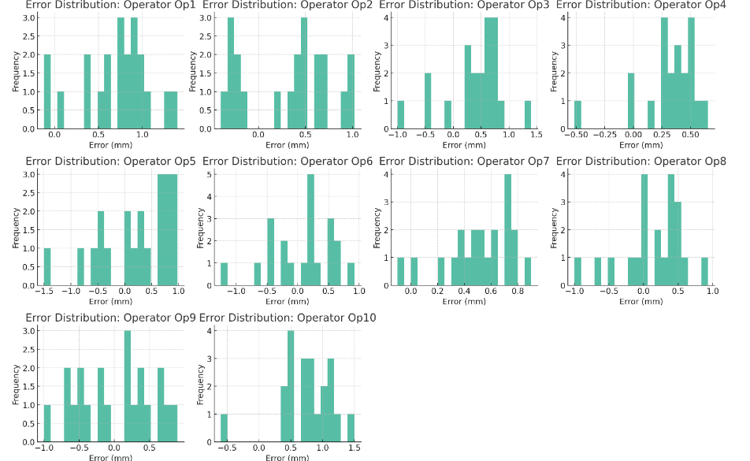
Figure 2
The error distribution plot for each operator shows the distribution of the difference between their measured and true values. The histogram shows the frequency distribution of the errors and can help identify the presence of systematic bias or random errors.
By looking at the operators (e.g., Op1, Op7, and Op10), they show a large average error, which may indicate the presence of systematic bias in the operators. Most of the operators showed large fluctuations in the error distribution, indicating the presence of random errors in addition to systematic bias. Of course smaller standard deviations indicate better consistency of measurements, with better consistency of measurements for op4, while larger standard deviations, indicating poorer consistency, were found for Op5, Op6, and Op9. These findings indicate that although the instruments and methods can achieve satisfactory test results in general, there are different degrees of deviations in actual operation, which can affect the accuracy and consistency of the test. Therefore, strengthening the testers' experimental skills, optimizing the measurement process, and periodically calibrating the instruments can help reduce such errors and improve the overall measurement accuracy.

Analyze the overall performance of equipment and procedures
Comprehensive evaluation of data from all operators to analyze the overall accuracy and consistency of the equipment and procedures Based on the previous analysis, the overall average measurement was 2.06 mm with an overall standard deviation of 1.80 mm. this indicates that there is a degree of consistency across all operators, even though the overall measurements deviate from the true dimensions. Combining the measurements from each operator and performing a linear regression analysis helps us to understand how the equipment and program are performing overall. Ideally, the overall slope should be close to 1 and the overall intercept should be close to 0. The mean of the overall error is 0.34 mm and the standard deviation is 0.45 mm. This indicates that the mean error is relatively small across all operators' measurements, but the fluctuations in the error are large, reflecting a large degree of variability between operators. Although the test results deviate slightly from the actual test results, overall they reflect the effectiveness of the equipment and program. The overall standard deviation is large, indicating that there are differences in measurement consistency between operators. This may be due to differences in operator skills, experience, and the way they perform the program. Although the equipment and procedures show some accuracy and consistency overall, there is still room for improvement.

Conclusion
There was a significant positive correlation between the measurements and the true dimensions for most technicians, indicating that their measurements were relatively accurate. Although individual technicians had large measurement errors, overall the equipment and program demonstrated good measurement performance in this study.

