Assignment
L5 – Computer Forensics (ACCD5000)
Jon Morgan (2218940)
2024
Contents
Introduction 2
Task 1: Research and report (500 word limit) 2
Task 3: Investigate and Report 2
Task 1 – Research and Report 3
Digital Forensics vs. Computer Forensics: Understanding the Distinctions 3
Task 3 – Investigate and Report 5
Summary of Case 5
Statement of Ethical Duty 5
Forensic Investigation 6
Tools 6
Evidence Acquisition and Preservation – FTK Imager 4.3.1.1 [3] 6
Evidence Preservation and Identification – HashMyFiles 2.44 [5] 6
Evidence Examination and Analysis – Autopsy 4.21 [7] 6
Continuity Record of Evidence Handling 6
Evidence 7
Analysis: Exhibits A – F 10
Analysis: Exhibits G – L 14
Analysis: Exhibits M – O 16
Analysis: Exhibits P – T 19
Analysis: Exhibits U – W 21
Analysis: Exhibits X – AA 24
Analysis: Exhibits BB – EE 26
Analysis: Exhibit FF 27
Summary of Analyses 28
APPENDICES 29
1. Exhibits E & F – EXIF metadata 29
2. Using FTK Imager – Securing the evidence 30
3. Using Autopsy – Scanning for evidence 31
4. Decrypting files 34
5. Software-based Write Blocker 36
References 37

Introduction
This document is the written portion of my submission for the assignment as given in L5 - Computer Forensics (ACCD5000). This document aims to convey the appropriate response to the relevant following tasks, as given:

Task 1: Research and report (500 word limit)
Do research on digital forensics addressing the following:
- Digital Forensics / Computer Forensics: Explore and comprehend the distinctions between the terms and concepts of computer forensics and digital forensics. You are expected to conduct thorough research on the definitions and historical evolution of both "computer forensics" and "digital forensics".
- Compare the fundamental concepts underlying computer forensics and digital forensics.
- Investigate the scope and applications of computer forensics and digital forensics in real-world scenarios.
- Analyze and present examples of cases where each discipline is particularly relevant.
Refer and in-text cite (IEEE style) academic credible literatures, textbooks recently published, Industry reports/ whitepapers, Job portals, news articles et al.

Task 3: Investigate and Report
You will be provided with digital evidence (Week 6 – 11/03/2024). Follow appropriate measures to secure the acquired evidence, analyse the data forensically investigating its content. This evidence is given to you based on a cyberbullying investigation.
Document the steps taken from the beginning (starting from collecting the evidence), analysis and findings and present it clearly specifying the findings of your analysis/ investigation. Your presentation must include the process of collecting the digital evidence, its Analysis and Findings with reasonable justification.
Recommendation: (Not limited to) Chain of Custody, Investigation Methodology, Tools used, Screenshots with Timestamps, Real-Time Demonstration, Professional Digital Forensics Report, Contingency Plans.
Word Limit: 2000 words (Equivalent)

Task 1 – Research and Report

Digital Forensics vs. Computer Forensics: Understanding the Distinctions

Digital forensics and computer forensics are terms often used interchangeably, yet they carry nuanced differences in their historical evolution, scope, and application in real-world scenarios.

Computer forensics emerged in the late 1970s and early 1980s, primarily focusing on the investigation of computer systems and data relating to criminal activities, initially often involving the recovery and examination of data and activities from physical storage media like hard drives and floppy disks. Later, as networks and the internet became more commonplace there was the natural emergence of network forensics too.

Digital forensics, a broader term likely coined during the 1990’s [1], evolved later to encompass investigations into a wider range of digital devices and data sources beyond traditional computers, including but not limited to – mobile phones, tablets, IoT devices, cloud services, and social media platforms. Digital forensics, as a ‘forensic science’ rooted in a scientific approach to the collection and preservation of evidence, draws on concepts from computer science, and the justice system to address the complexities of digital investigations and for supporting prosecutions.

Digital forensics can be thought of as the overall ‘umbrella term’, with computer forensics being a specific branch or skill within, not unlike mobile device forensics. Both, as forensic approaches, must share common concepts and scientific methodologies, aiming for the systematic preservation, collection, analysis, and presentation of digital evidence to support legal proceedings, using specialized tools and techniques to ensure the integrity and admissibility of evidence.

Computer forensics primarily deals with the investigation of traditional computing devices – PC’s and laptops – and the data stored on their physical and logical devices, including file systems and metadata, RAM (in cases of powered-up devices), logs and caches, including any traces of network activities. It focuses on recovering and analysing digital evidence of any such activities and is particularly relevant in cases such as hacking, identity theft, and financial fraud, helping investigators reconstruct activity timelines and to potentially identify (or rule out) perpetrators. An example of the real-life application of computer forensics can be seen on page 6 of [2], the “Maryland, 1996” boxout.

Digital forensics, on the other hand, extends beyond traditional computers to encompass a wider array of digital devices and data sources, including but not limited to - mobile devices, IOT sensor devices, CCTV, GPS systems, cloud services, and social media platforms. Digital forensics requires expertise in diverse areas such as mobile device forensics, network forensics, and social media forensics, and is applied in investigations ranging from corporate/governmental data breaches or insider threats, to cyberbullying and online harassment. It requires investigators to examine digital evidence from multiple sources, with the applicable tools and skills for each. An example of the real-life application of broader digital forensics can be seen on page 29 of [2], the “Action Fraud, 2000” boxout.

Task 3 – Investigate and Report

Summary of Case

An academic exercise in the collection, examination, and analysis of ‘evidence’ files placed onto my 16Gb USB storage device by Dr Nitheesh Kaliyamurthy. The ‘Data Acquisition Tools’ folder existed prior to the delivery of the evidence files therefore is outside the scope of investigation. This delivery method of the evidence files ruled out using certain digital forensic techniques, such as recovering deleted files, analysing filesystem partitions or timestamps, or ‘file carving’ from slack space.
The context given for the investigation is one of an allegation of Cyber-bullying. The author is tasked with identifying corroborative evidence that might be supportive of the allegation.

Prepare
Gather
Examine
Analyse
Report

Statement of Ethical Duty

I understand my duty to uphold integrity, objectivity, and professionalism in all my investigations, to respect individuals privacy rights, ensuring adherence to applicable laws, and assuring accuracy and impartiality in analysing digital evidence.

Forensic Investigation

All examination and analysis of the evidence provided for this academic investigation were performed by the author.

Tools

The following forensic tools have been used by the author pursuant to this academic investigation and report creation:

Evidence Acquisition and Preservation – FTK Imager 4.3.1.1 [3]
Industry recognised forensic software that allows the complete bit-by-bit capture of source media, such as a USB storage device. Used in conjunction with a software-based USB write-blocker to prevent writes to the source media, preserving evidential integrity and admissibility. The resulting output is a file or collection of files, containing the data in a compressed manner, with file extension starting “.E01” [4], with the numeral increasing with each additional ‘file segment’.

Evidence Preservation and Identification – HashMyFiles 2.44 [5]
Utility that allows calculation of various hashes of one or more files, useful for file verification, identification and error detection [6].

Evidence Examination and Analysis – Autopsy 4.21 [7]
Industry recognised open-source forensic software platform that allows the cataloguing, indexing and analysis of data sources including ‘image files’ within the construct of a ‘case’ and stored in a database. Provides many configurable analysis ‘modules’ to perform and record multiple types of data/file analysis and can be extended with additional modules if needed/available.

Continuity Record of Evidence Handling

USB Storage Device and data within
Investigator: Jon Morgan
Client: Dr Nitheesh Kaliyamurthy
Date/Time of seizure: 11/03/2024 at 17:00hrs
Location of Seizure: UWTSD, Room 205, Swansea Campus

Description of Evidence
Item# | Quantity | Item Description [Model, Serial#, Condition, Identifying Features etc]
1A | 1 | USB Storage device (Pen drive) – SanDisk Cruzer Switch, black/red  Serial #: BL161225486B  Model #: SDCZ52-016G  Capacity: 16 Gigabytes

Chain of Evidence Custody
Item# | Date/Time | Released By | Received by | Comments
1A | 11/03/2024  at 17:00 | Dr Nitheesh Kaliyamurthy | Jon Morgan | Dr Nitheesh Kaliyamurthy copied a pre-defined collection of ‘evidence’ files to the USB Storage Device – after this point the storage device was considered evidence and was treated as such.  The device has not been used since, excepting a single time during ‘Image Acquisition’ with the FTK Imager software as described in the ‘Tools’ section above and below with the subsequent evidence produced.  It has been stored in a (pretend) Faraday Bag since the time of original seizure.
1B | 11/03/2024  At 17:37 | Jon Morgan | Jon Morgan | Binary Image of USB Storage device 1A – created using FTK Imager in room 205 at UWTSD Swansea Campus.  Image Files:  Case2218940-FLASH.E01  Case2218940-FLASH.E02  Case2218940-FLASH.E03  Case2218940-FLASH.E04  Zero bad blocks encountered during copy process.  SHA1 Hash of image:  08f0c7d5dc6b5f3fbf5e2997c29efe6eb0a458cb  Binary Image files copied for backup contingency and off-site analysis – see evidence item 1C for details.
1C | 11/03/2024  At 21:01 | Jon Morgan | Classmates | Copy of 1B Binary Image files, uploaded to my personal student OneDrive storage area for private distribution to classmates. Also stands as a valid backup for contingency in the case of accidental data loss or corruption of the original image 1B.  Image Files:  Case1-FLASH.E01  Case1-FLASH.E02  Case1-FLASH.E03  Case1-FLASH.E04  Including a supporting ‘README’ file created by FTK Imager – “README_Case1-FLASH.E01.txt”  SHA1 Hash of image:  08f0c7d5dc6b5f3fbf5e2997c29efe6eb0a458cb  Sharing URL: Click

Evidence

Exhibit A
Filename | encrypt_file.cpp
Filepath | Logical_drive\
SHA1 Hash Value | 4e3d4f4b8aa74d85b2e6c16aa71219a2bb50e374

The above file contains C++ source code for a simple encryption/decryption program utilizing static substitution tables. After checking the source code, this file was compiled into an executable program – this program was then instrumental in accessing other evidence files, described later.

Exhibit B
Filename | Police Report.rar
Filepath | Logical_drive\
SHA1 Hash Value | ebbefcdf723f6c0aa2157e82a37e21b0eb1e1b46

The above file is a compressed RAR archive utilizing encryption. The password to decrypt and unpack it was found using a keyword search in Autopsy for the term ‘password’, revealing a file named “Readme.txt” containing the text “Password for file’s” and two potential password values, the second of which (“Qk;87R]_w3dmBGcb[#TX=4”) was the correct password. This resulted in the unpacking of two files within – see Exhibit’s C and D.

Exhibit C
Filename | E_PoliceReport-CS-01
Filepath | Logical_drive\
SHA1 Hash Value | 7816d714054adaf098a5761b997a67aafa272b10

The above file, recovered from Exhibit B, contains generic binary code and has no file extension or distinctive MIME Type. However, processing this file through the compiled program from Exhibit A to ‘decrypt’ it resulted in a valid PNG image file:
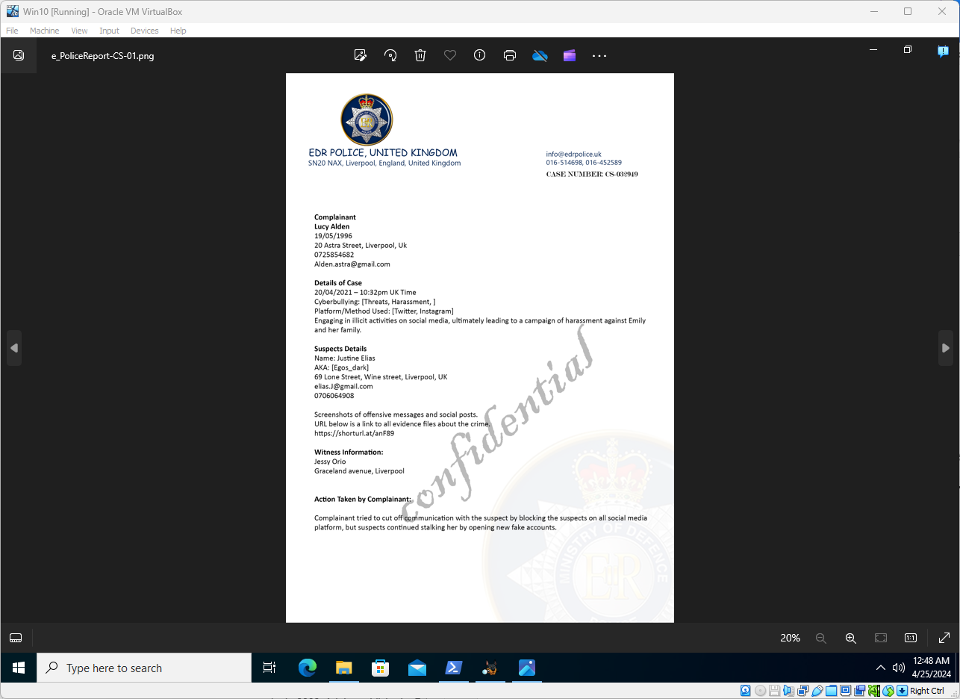

Exhibit D
Filename | E_PoliceReport-CS-02
Filepath | Logical_drive\
SHA1 Hash Value | f299dbffa7239b3a3cd8c8777a2fbbcb9e2b083c

The above file, recovered from Exhibit B, contains generic binary code and has no file extension or distinctive MIME Type. However, processing this file through the compiled program from Exhibit A to ‘decrypt’ it resulted in a valid PNG image file:

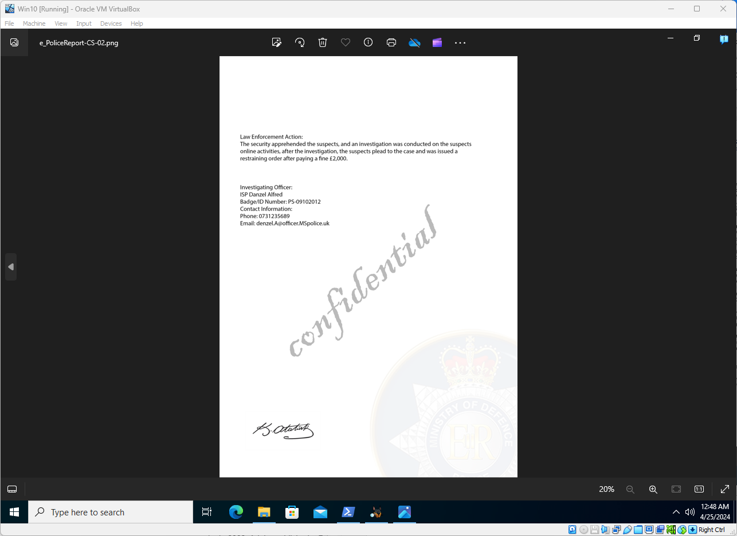

Exhibit E
Filename | e_IMG_0010
Filepath | Logical_drive\
SHA1 Hash Value | 68ddb562a801946d88ae9f1e31e7812918a427ec

The above file contains generic binary code and has no file extension or distinctive MIME Type. However, processing this file through the compiled program from Exhibit A to ‘decrypt’ it resulted in a valid JPG image file:
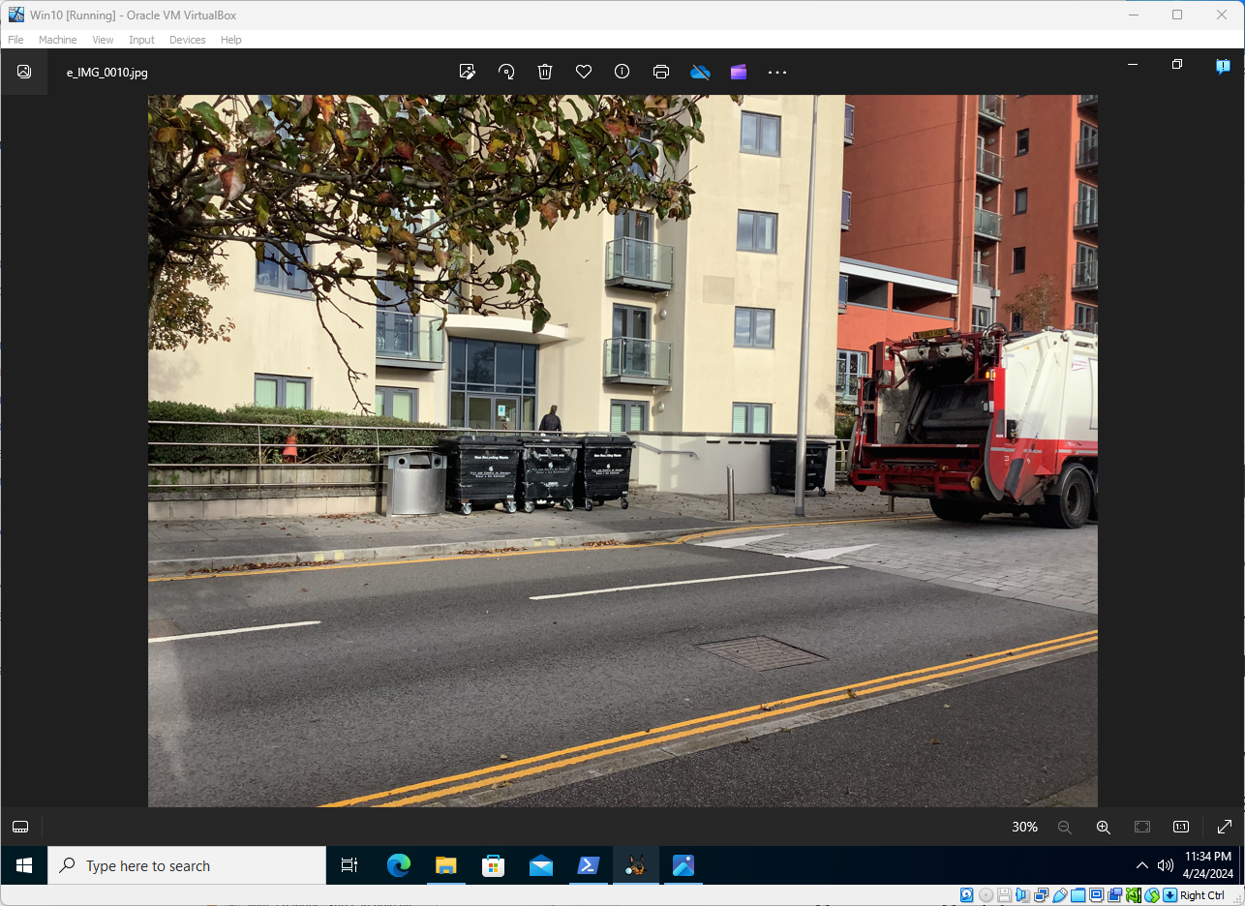

Exhibit F
Filename | e_IMG_0013
Filepath | Logical_drive\
SHA1 Hash Value | 9ea464b0ae29a62ec0a26d0fb0fad1aea9762a7b

The above file contains generic binary code and has no file extension or distinctive MIME Type. However, processing this file through the compiled program from Exhibit A to ‘decrypt’ it resulted in a valid JPG image file:
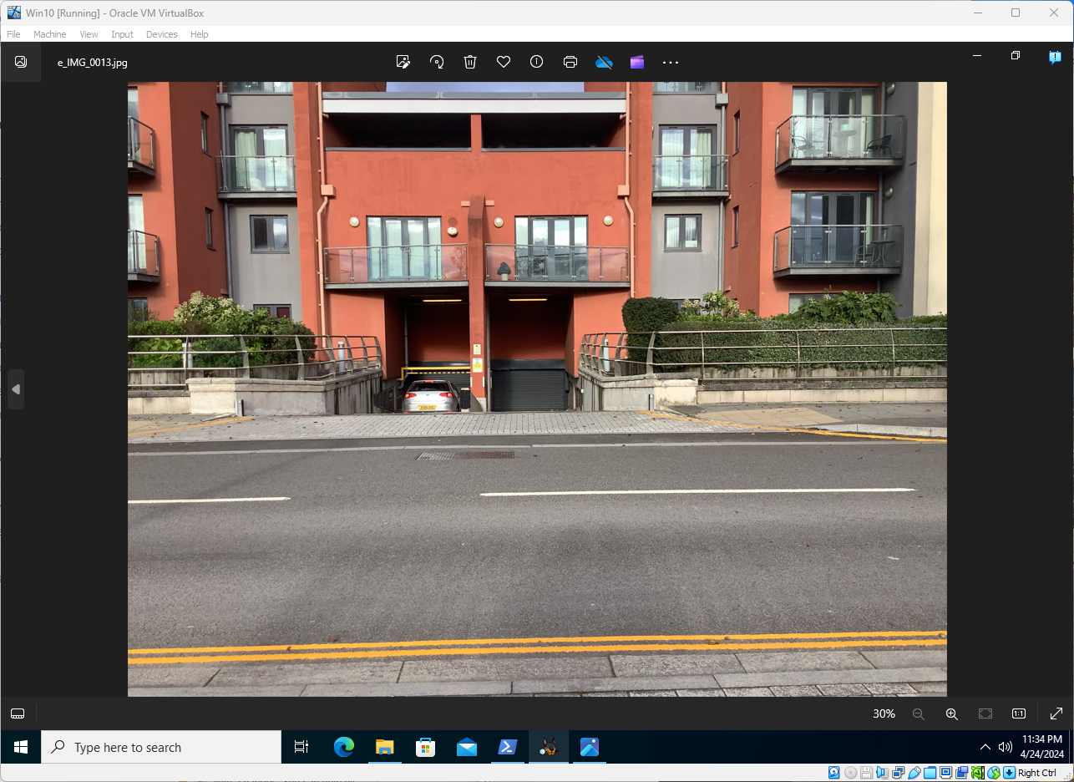

Analysis: Exhibits A – F
The key information to take away from this group of exhibits is from the images recovered from the “Police Report.rar” file. The following data confirms the investigation and prosecution of charges by Police against an individual named “Justine Elias” (see below). The images in exhibits E and F do not appear to be obviously or immediately relevant to the investigation, but they could nonetheless be places known to the Complainant, ‘Victim’ or ‘Suspect’ – that information is not known at this time. They also both have EXIF metadata attached, detail when and where they were taken (See Appendix).

- Complainant
  - Lucy Alden (Guardian to ‘Emily’?)
  - 19/05/1996
  - 20 Astra Street, Liverpool
  - 0725854682
  - Alden.astra@gmail.com
- Allegation
  - 20/04/2021 – 10:32pm UK time
  - Cyber-bullying – threats, harassment
  - Platform/method – Twitter, Instagram
  - Narrative – “Engaging in illicit activities on social media, leading to a campaign of harassment against ‘Emily’ and her family
- Complainant Action
  - Complainant tried to cut off all contact with the suspect by blocking them on all social media platforms, but suspect continued to harass by opening new fake accounts
- Suspect
  - Justine Elias / Egos_dark
  - 69 Lone Street, Wine Street, Liverpool
  - Elias.j@gmail.com
  - 0706064908
- Evidence
  - URL of ‘evidence files’ – hxxps://shorturl.at/anF89 (DO NOT OPEN)
- Witness
  - Jessy Orio
  - Graceland Avenue, Liverpool
- Police Action
  - Apprehended suspect, and an investigation was conducted on the suspects online activities. After investigation the suspect plead guilty to the charges and was issued a restraining order and ordered to pay a fine of £2,000.
- Investigator
  - ISP Danzel Alfred
  - Badge/ID Number – PS-09102012
  - 0731235689
  - denzel.a@officer.mspolice.uk
  - Case No. – CS-032949

Exhibit G
Filename | IMG_0101.jpg
Filepath | Logical_drive\
SHA1 Hash Value | 73972611fb713e30d72a977a4884212c4bf4600a

The above file is a screenshot from an iOS-based mobile device’s Twitter (now known as ‘X’) application, showing the start of an unsolicited conversation from someone identifying themselves as “Seer Musta”. There is no EXIF metadata attached.
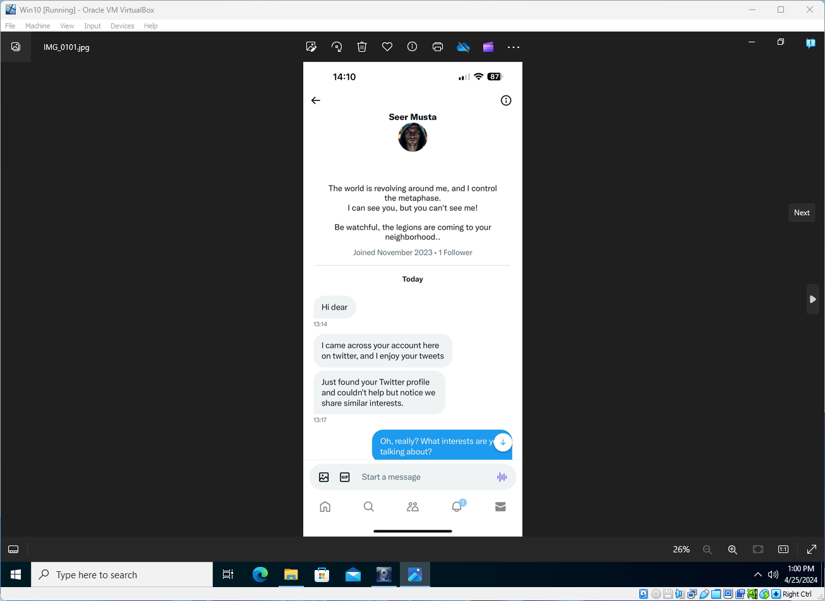

Exhibit H
Filename | IMG_0102.jpg
Filepath | Logical_drive\
SHA1 Hash Value | fbc9da05b6fc0a0eba3df50c1a638b9bb0f76c60

Continuation of the conversation with Seer Musta from Exhibit G. There is no EXIF metadata attached.
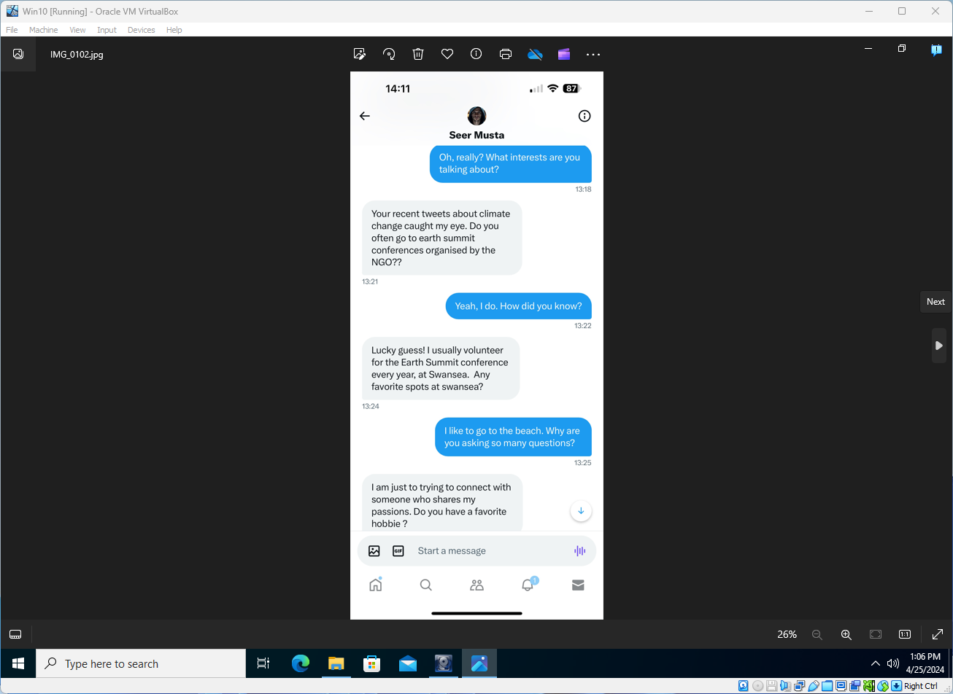

Exhibit I
Filename | IMG_0103.jpg
Filepath | Logical_drive\
SHA1 Hash Value | bf425a42a2ea66bfe1e789052b9a6bc40072d2d9

Continuation of the conversation with Seer Musta from Exhibit H. There is no EXIF metadata attached.
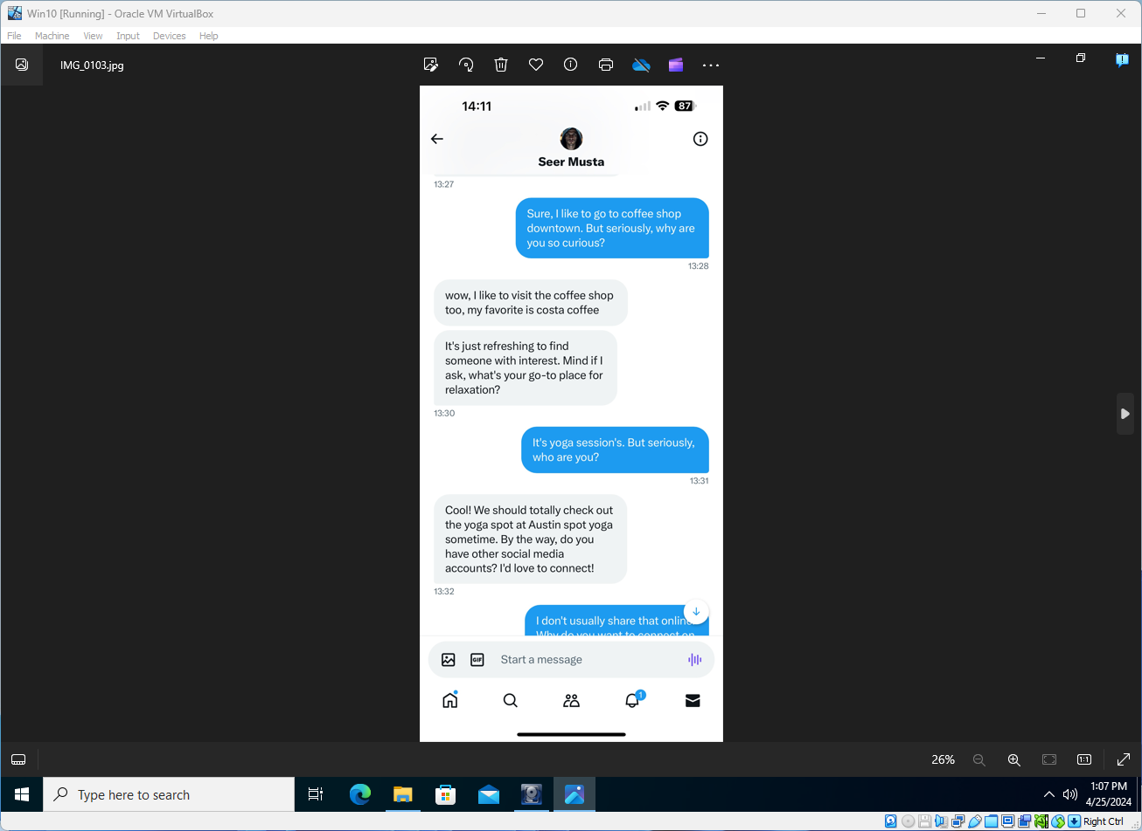

Exhibit J
Filename | IMG_0104.png
Filepath | Logical_drive\
SHA1 Hash Value | 488a3ee6fe2e475bfa46001f122d2b618d6a5294

Continuation of the conversation with Seer Musta from Exhibit I. There is no EXIF metadata attached.
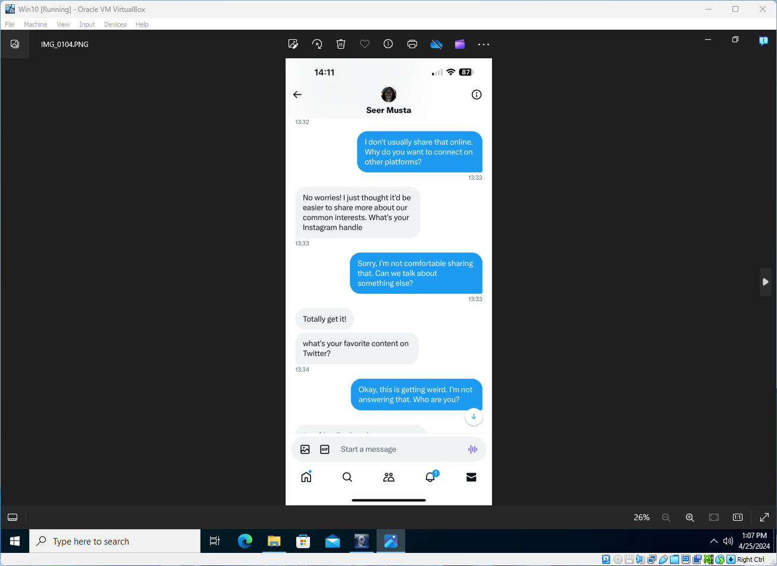

Exhibit K
Filename | IMG_0105.png
Filepath | Logical_drive\
SHA1 Hash Value | 03af43fec92ea364577cc316c1ce02c4b8479738

Continuation of the conversation with Seer Musta from Exhibit J. There is no EXIF metadata attached.
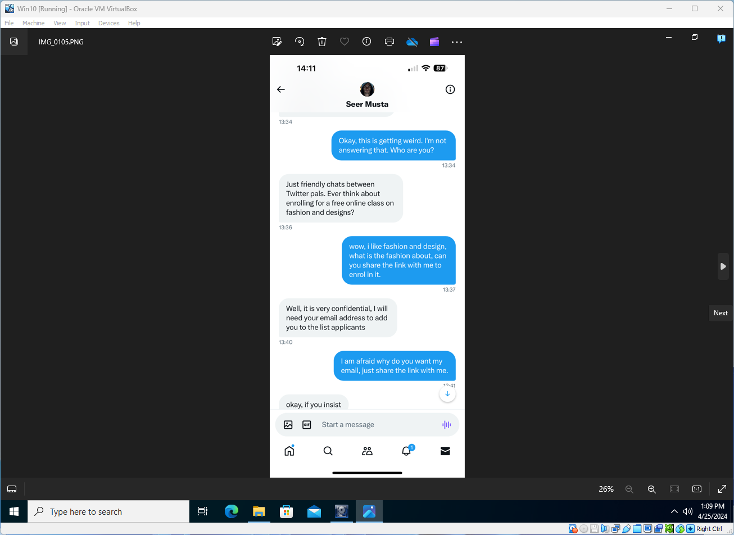

Exhibit L
Filename | IMG_0106.png
Filepath | Logical_drive\
SHA1 Hash Value | 77bf425b2885655684118e0b6e994ccf830f8d41

Continuation of the conversation with Seer Musta from Exhibit J. There is no EXIF metadata attached.
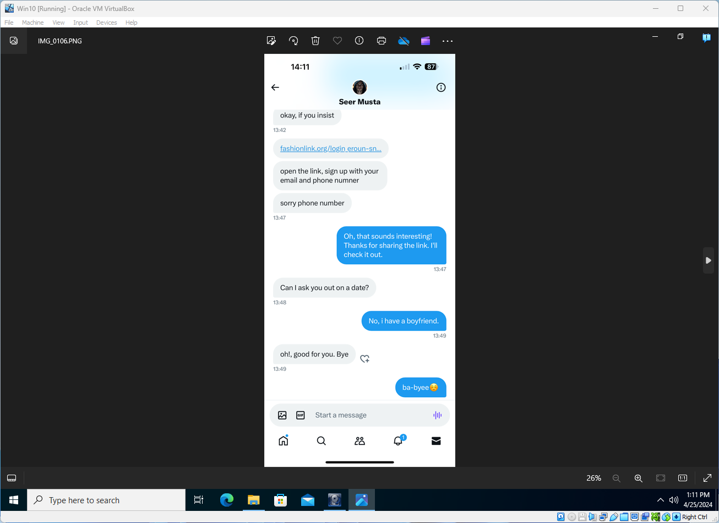

Analysis: Exhibits G – L
This group of exhibits shows several screenshots from an iOS-based mobile device’s Twitter (now known as ‘X’) application, showing an unsolicited conversation from someone identifying themselves as “Seer Musta”, who begins by continually pressing the target for information by asking questions repeatedly, with the target clearly showing some reluctance to engage them or reveal certain information such as their Instagram account name or their e-mail address. ‘Seer’ encourages the target to visit a URL to ‘sign up’ with their personal information, and also presses to meet for a ‘date’, which the target declines.

Exhibit M
Filename | IMG_0107.jpg
Filepath | Logical_drive\
SHA1 Hash Value | 2edca5e140dface6cac6e1c08d6a7bc09c921454

The above file is a screenshot from an iOS-based mobile device that appears to be the Facebook Messenger application, showing the start of an unsolicited conversation from someone identifying themselves as “Lee Saint”, listed as a known “Friend” on Facebook. There is no EXIF metadata attached.
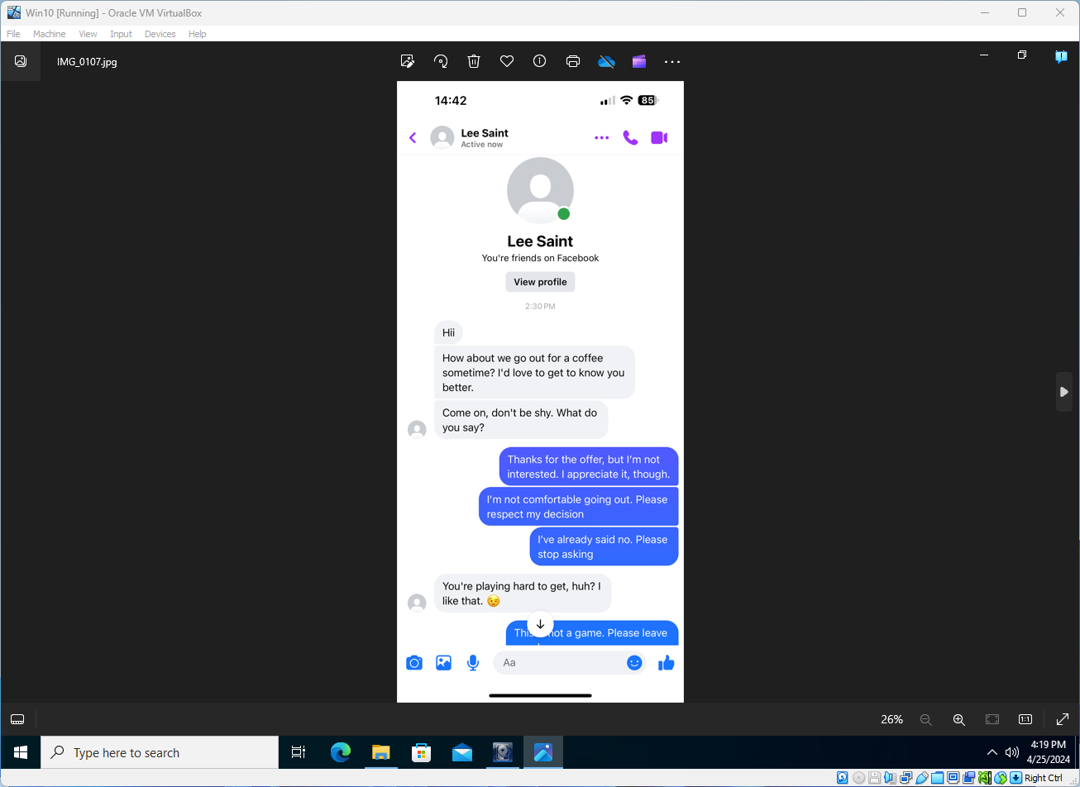

Exhibit N
Filename | IMG_0108.png
Filepath | Logical_drive\
SHA1 Hash Value | d91ed742454f33ba092290fdb2d19d0dc1536b0d

Continuation of the conversation with Lee Saint from Exhibit M. There is no EXIF metadata attached.
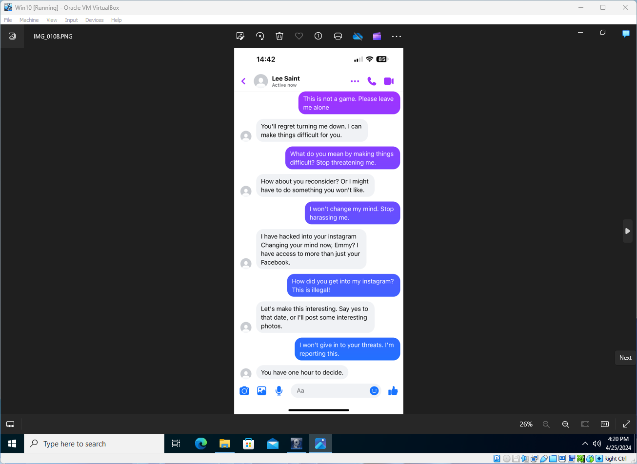

Exhibit O
Filename | IMG_0109.png
Filepath | Logical_drive\
SHA1 Hash Value | 7d20954fb54083eb06af82525522494d88049b89

Continuation of the conversation with Lee Saint from Exhibit N. There is no EXIF metadata attached.
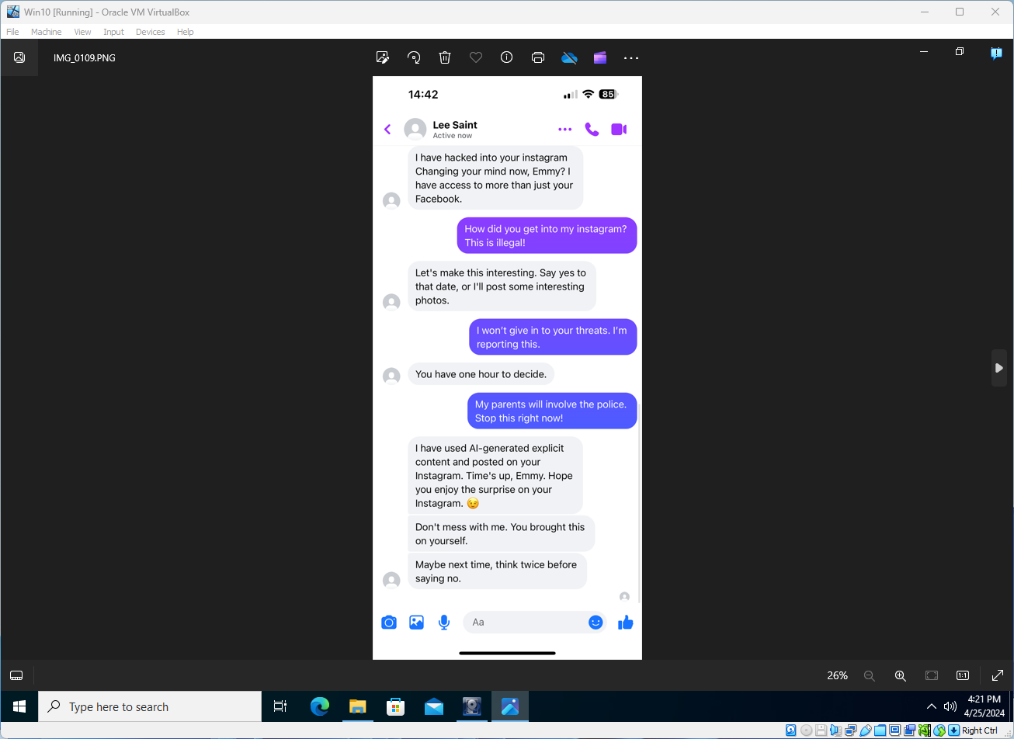

Analysis: Exhibits M – O
This group of exhibits shows several screenshots from an iOS-based mobile device that appear to be of the Facebook Messenger application, showing the start of an unsolicited conversation from someone identifying themselves as “Lee Saint”, listed as a known “Friend” on Facebook. ‘Lee’ launches straight into romantic or personal inquiries trying to pressure the target into meeting for a ‘date’ which the target rebuffs. ‘Lee’ then claims to have hacked the targets Instagram account and threatens to post ‘interesting’ photos as the target on Instagram, giving a one hour ultimatum to agree to a date before doing so. The target refuses – ‘Lee’ then claims to have posted ‘AI generated sexually explicit’ images to the target’s Instagram account.

Exhibit P
Filename | IMG_0110.png
Filepath | Logical_drive\
SHA1 Hash Value | 8850b9be6d7966609788457a4372bf8427823543

The above file is a screenshot from an iOS-based mobile device that appears to be from the Facebook Messenger application, showing the start of an unsolicited conversation from someone identifying themselves as “Fred William”, listed as a known “Friend” on Facebook. There is no EXIF metadata attached.
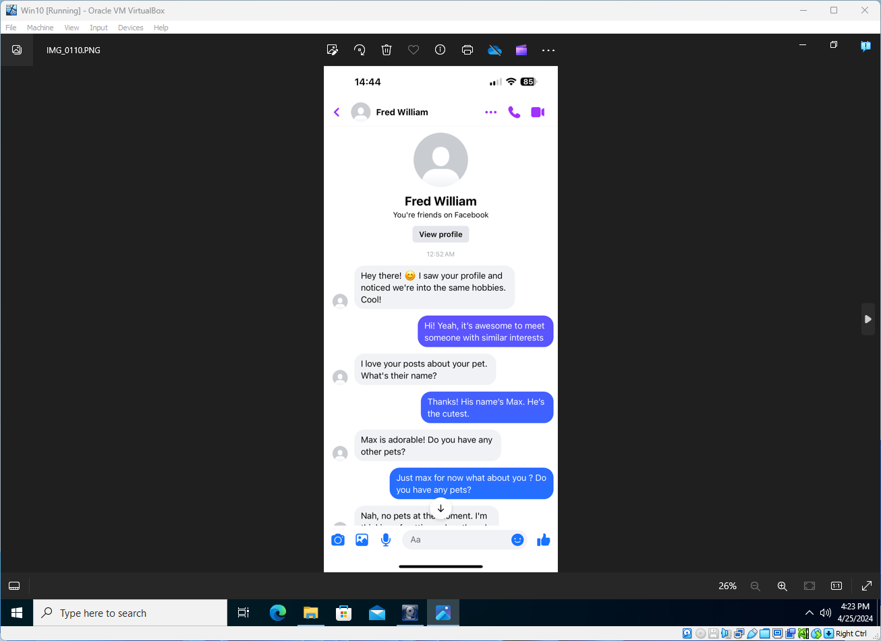

Exhibit Q
Filename | IMG_0111.png
Filepath | Logical_drive\
SHA1 Hash Value | 34d1ba2917c0848f9d757d19b0ca67ebb6b45b41

Continuation of the conversation with Fred William from Exhibit P. There is no EXIF metadata attached.
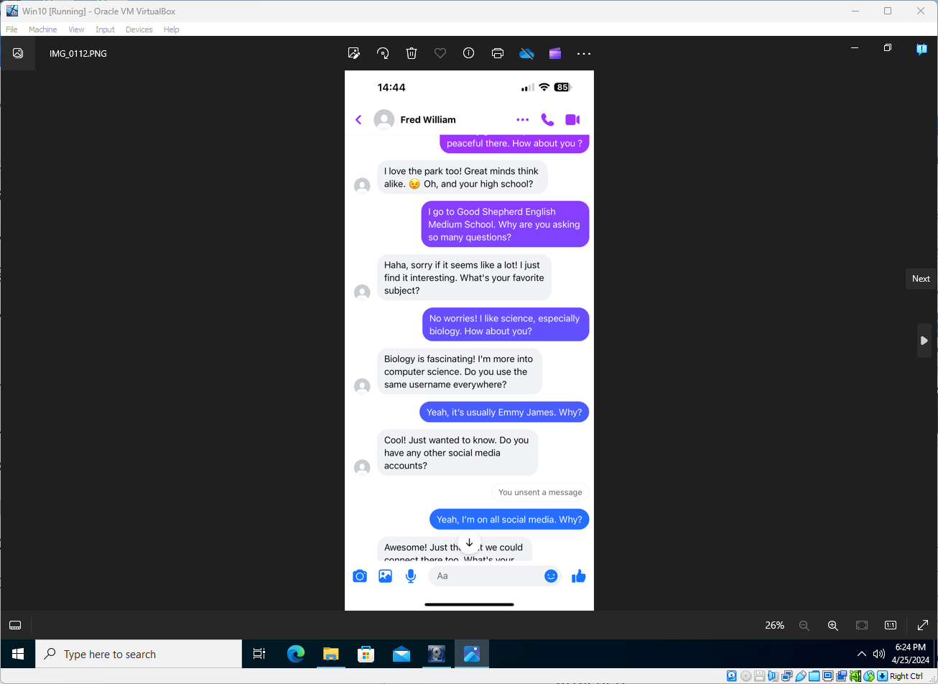

Exhibit R
Filename | IMG_0112.png
Filepath | Logical_drive\
SHA1 Hash Value | f948c368cfeb41ca2428e28e95f6bd1727454629

Continuation of the conversation with Fred William from Exhibit Q. There is no EXIF metadata attached.
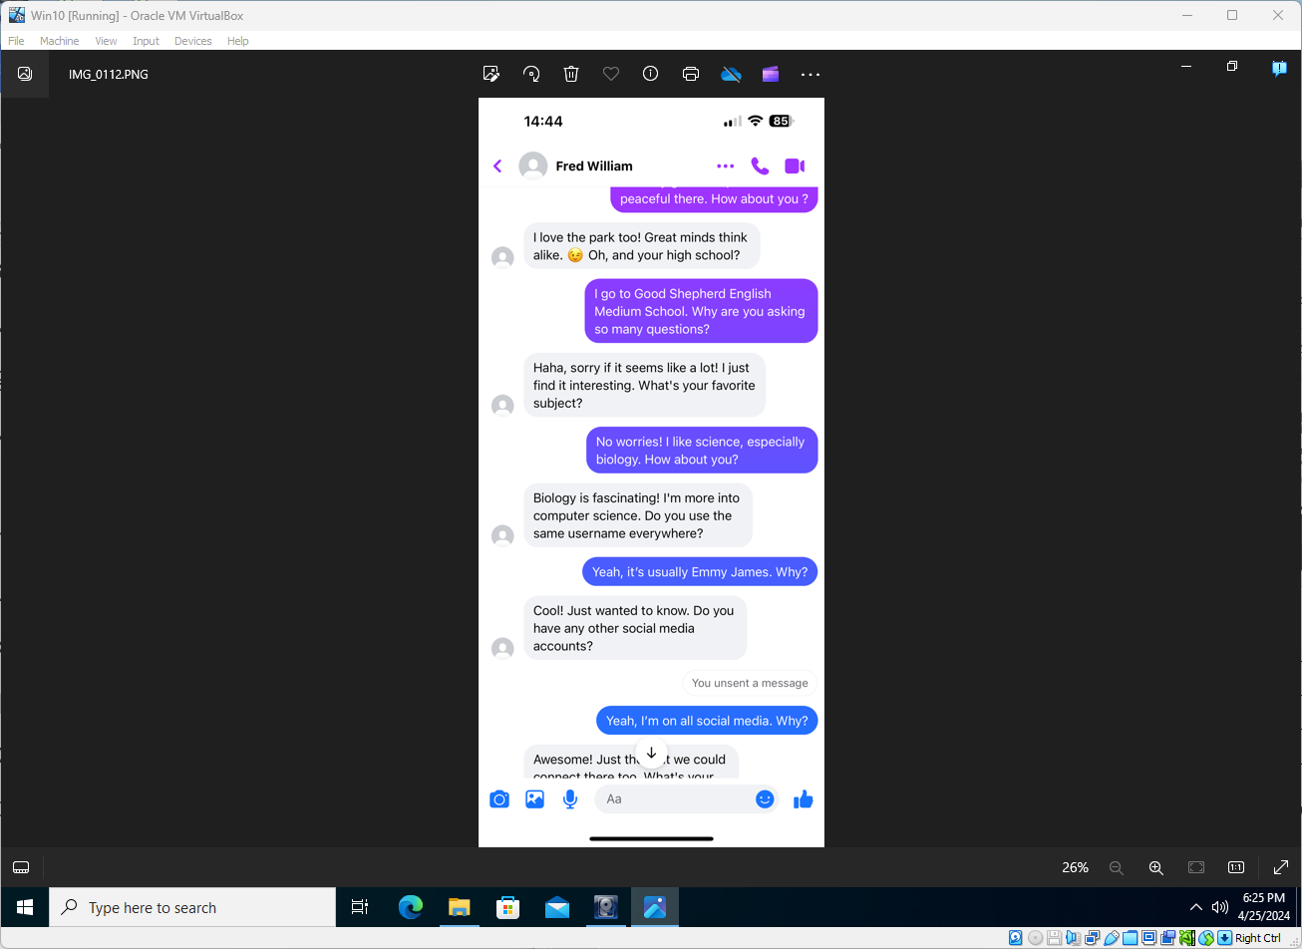

Exhibit S
Filename | IMG_0113.png
Filepath | Logical_drive\
SHA1 Hash Value | 70670ebb9d326304d8dd94e262dc155f8752c324

Continuation of the conversation with Fred William from Exhibit R. There is no EXIF metadata attached.
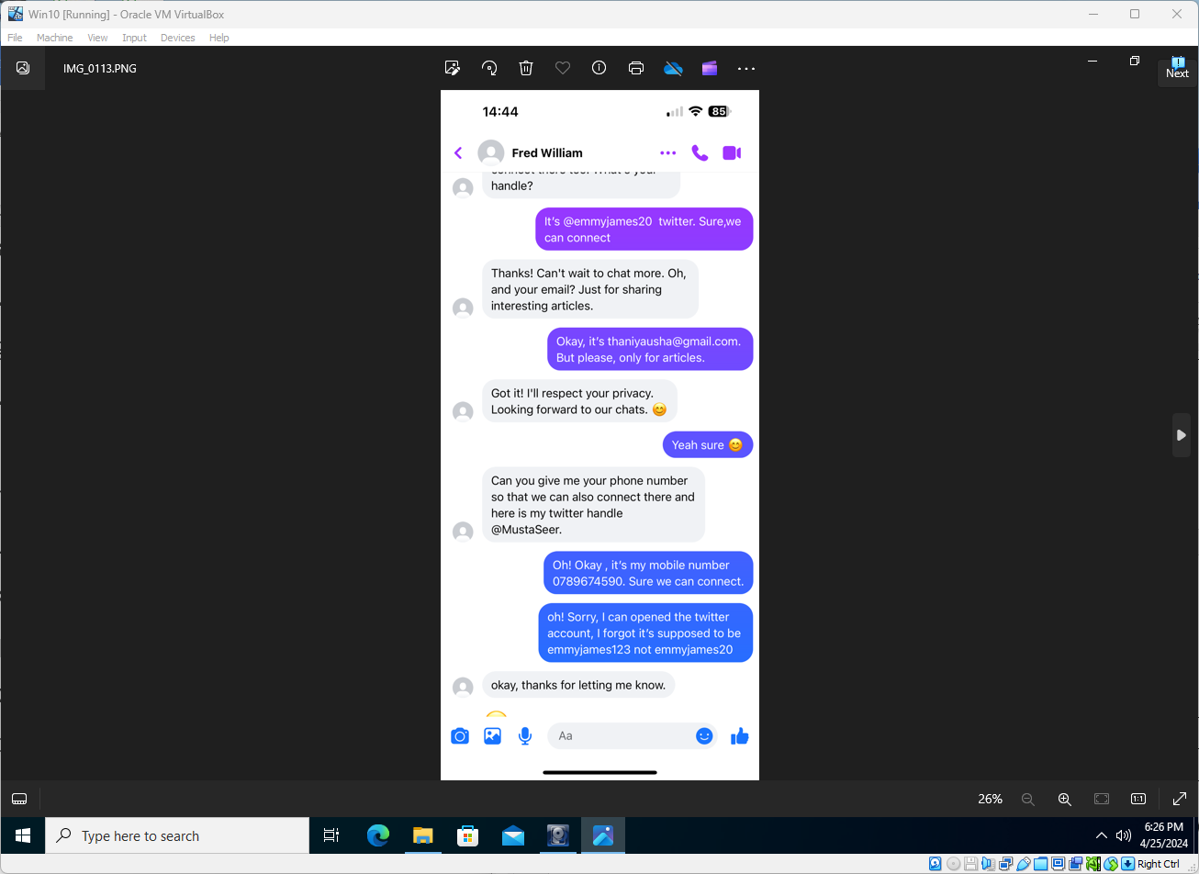

Exhibit T
Filename | IMG_0114.png
Filepath | Logical_drive\
SHA1 Hash Value | 07f7caa3ce817f52a35a792292e57e29a210c119

Continuation of the conversation with Fred William from Exhibit S. There is no EXIF metadata attached.
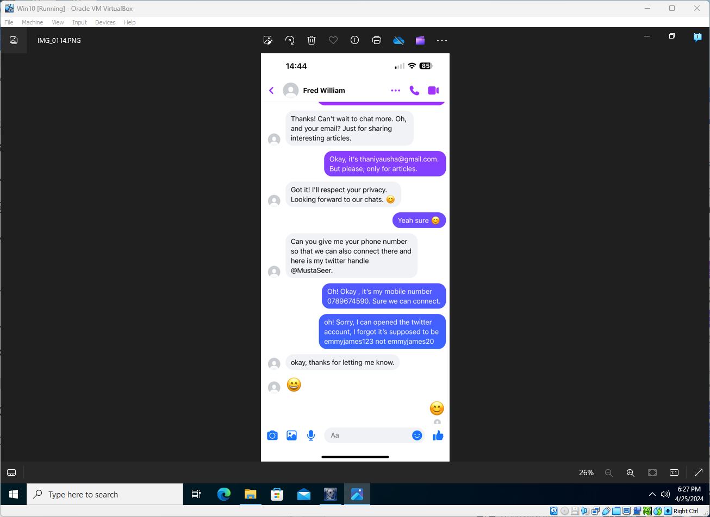

Analysis: Exhibits P – T
This group of exhibits shows several screenshots from an iOS-based mobile device that appear to be of the Facebook Messenger application, showing the start of an unsolicited conversation from someone identifying themselves as “Fred William”, listed as a known “Friend” on Facebook. ‘Fred’ launches straight into asking lots of questions of the target, asking for information commonly used as ‘Secret Question and Answer’ type information (Pet’s name, favourite colour, high school etc) used in some online identity schemes/platforms as an extra layer of identification to secure accounts against illicit password resets. Fred also asks for identifying information such as usernames and e-mail addresses, which the target divulges – all this information could be used in attempted online account intrusions or takeovers. ‘Fred’ also reveals a Twitter handle to contact him by – “@MustaSeer”, likely a link to exhibits G – L.

Exhibit U
Filename | IMG_0115.png
Filepath | Logical_drive\
SHA1 Hash Value | 8f115a66b280cd2793345d32efd2007afd6ec477

The above file is a screenshot from an iOS-based mobile device that appears to be from the Facebook Messenger application, showing the start of an unsolicited conversation from someone identifying themselves as “Justine Elias”, listed as a known “Friend” on Facebook. There is no EXIF metadata attached.
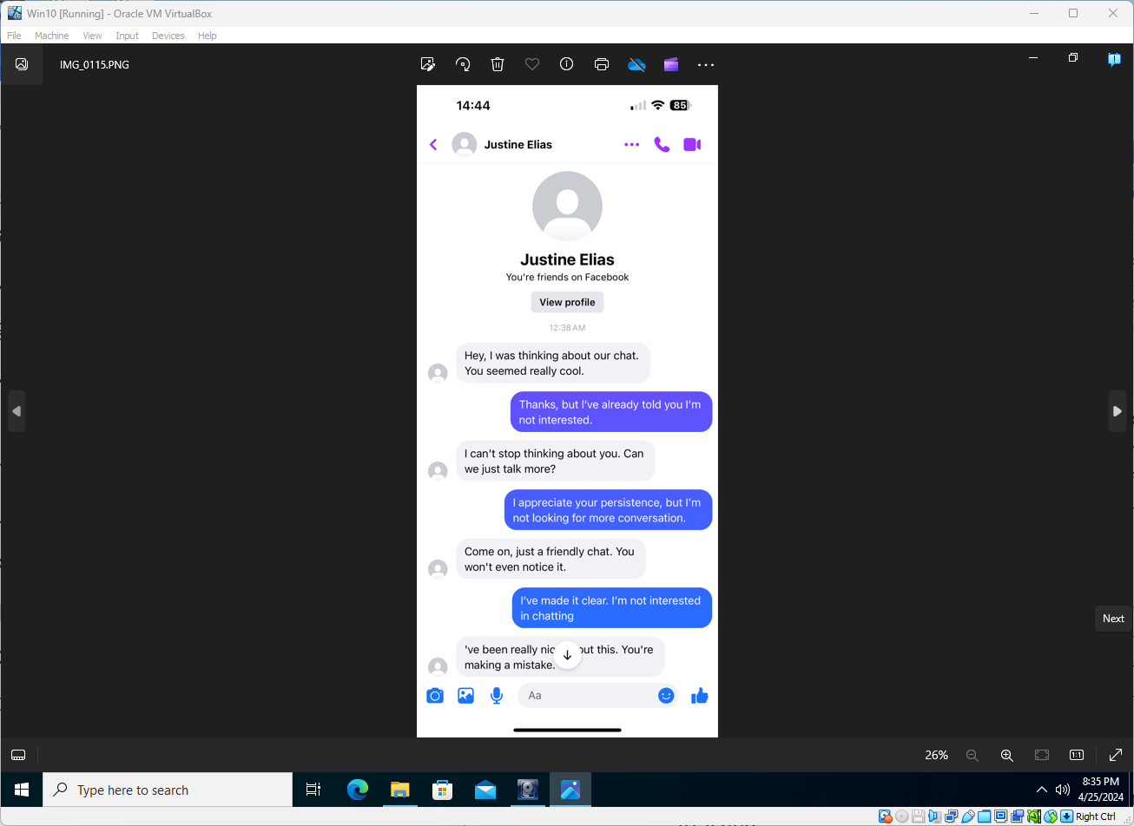

Exhibit V
Filename | IMG_0116.png
Filepath | Logical_drive\
SHA1 Hash Value | 460dc37bc41151912c72ac53452d597896a88fe3

Continuation of the conversation with Justine Elias from Exhibit U. There is no EXIF metadata attached.
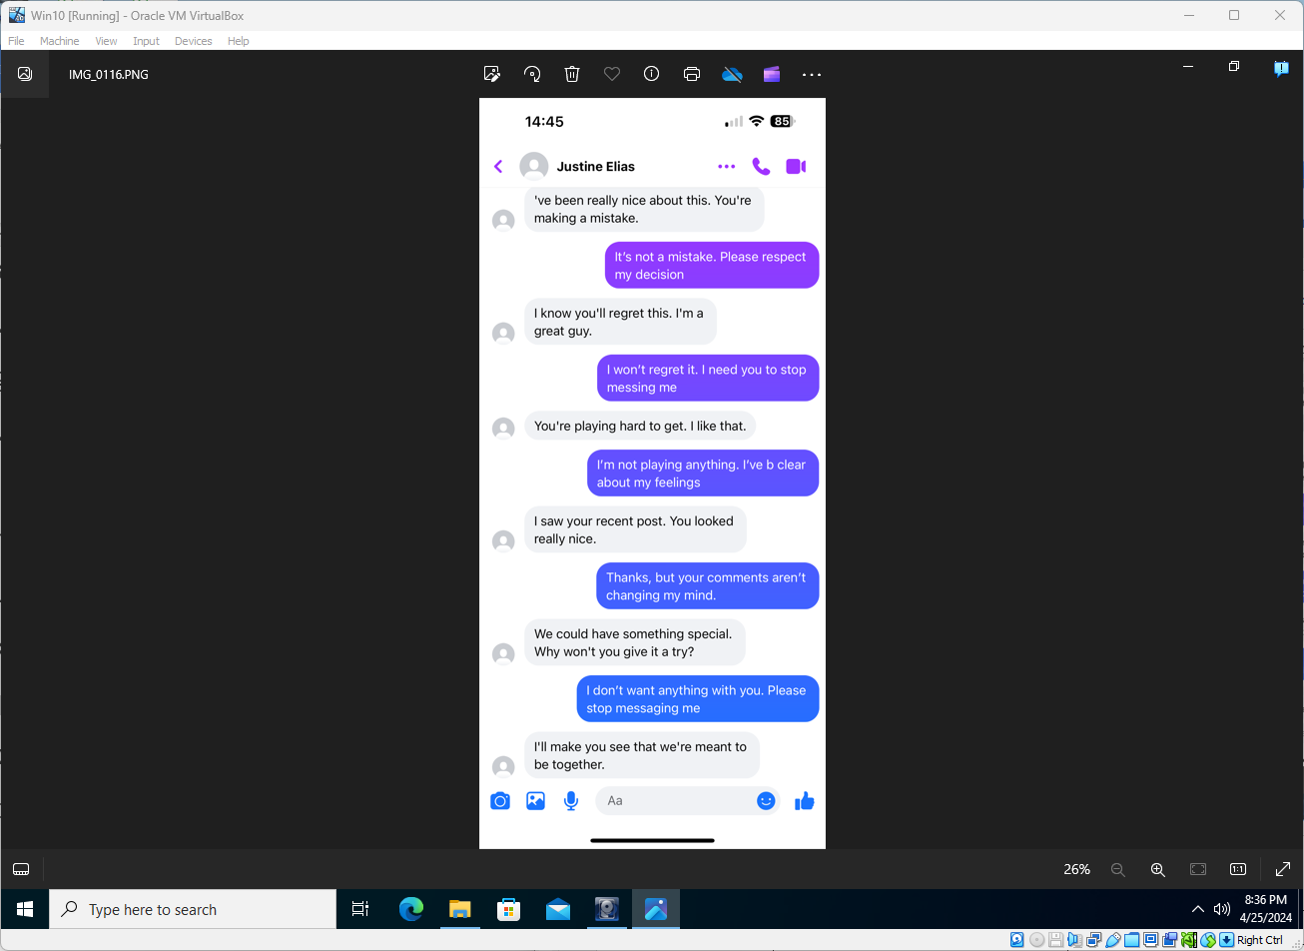

Exhibit W
Filename | IMG_0117.png
Filepath | Logical_drive\
SHA1 Hash Value | 40e77faf6ba5db321d341a7879866ca87ce93d17

Continuation of the conversation with Justine Elias from Exhibit V. There is no EXIF metadata attached.
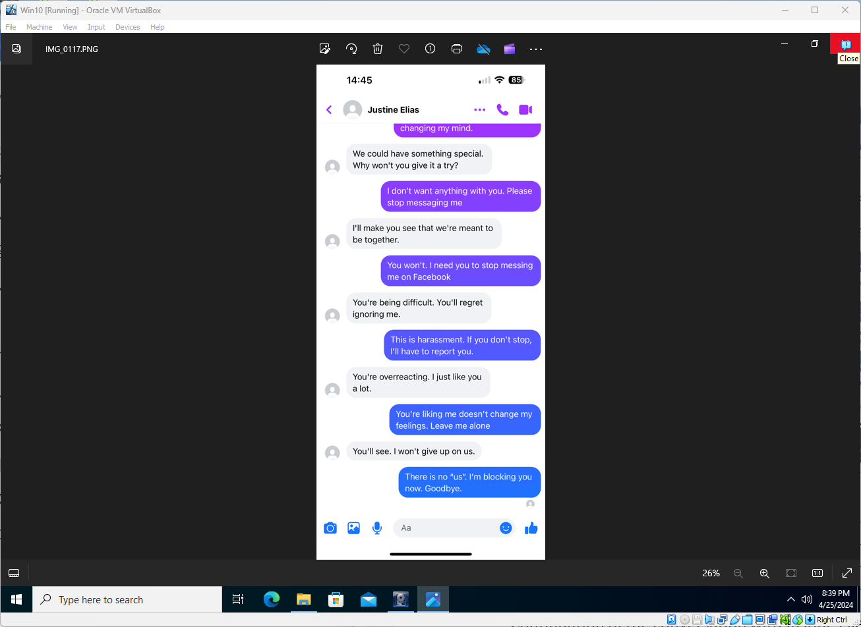

Analysis: Exhibits U – W
This group of exhibits shows several screenshots from an iOS-based mobile device that appear to be of the Facebook Messenger application, showing the start of an unsolicited conversation from someone identifying themselves as “Justine Elias”, listed as a known “Friend” on Facebook. ‘Justine’ launches into ‘heavy/over familiarity’ with the target, demanding to become close friends and to have a ‘chat’, which the target repeatedly refuses. ‘Justine’ continues pushing to be close friends and won’t take no for an answer, becoming apparently more frustrated and hostile the longer they are refused. The conversation ends with ‘Justine’ affirming that the target “will regret ignore them” and that they “won’t give up on us”. The target ends stating they will ‘block’ ‘Justines’ messages (within Facebook Messenger). Justine Elias is also the name of the person who pleads guilty to the charges brought by Police in the investigation detailed from the exhibit group A- F.

Exhibit X
Filename | IMG_0118.png
Filepath | Logical_drive\
SHA1 Hash Value | 14483e2a36ea9033ee948c42396a50a106787eca

The above file is a screenshot from an iOS-based mobile device that appears to be from the WhatsApp application, showing the start of an unsolicited conversation from someone identifying themselves only as “Zhen”. There is no EXIF metadata attached.
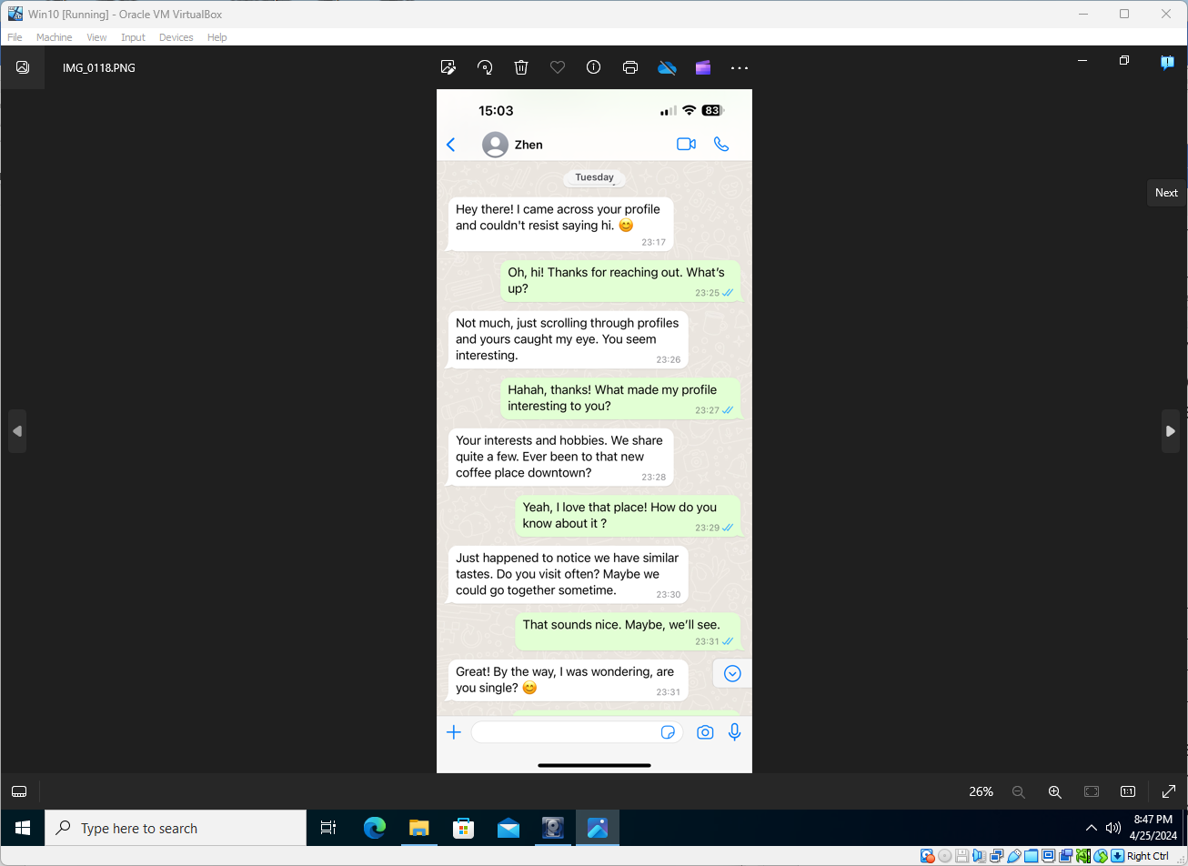

Exhibit Y
Filename | IMG_0119.png
Filepath | Logical_drive\
SHA1 Hash Value | d0bda4347cde98c1a03fb3e5c34a2a96024f9f33

Continuation of the conversation with Zhen from Exhibit X. There is no EXIF metadata attached.
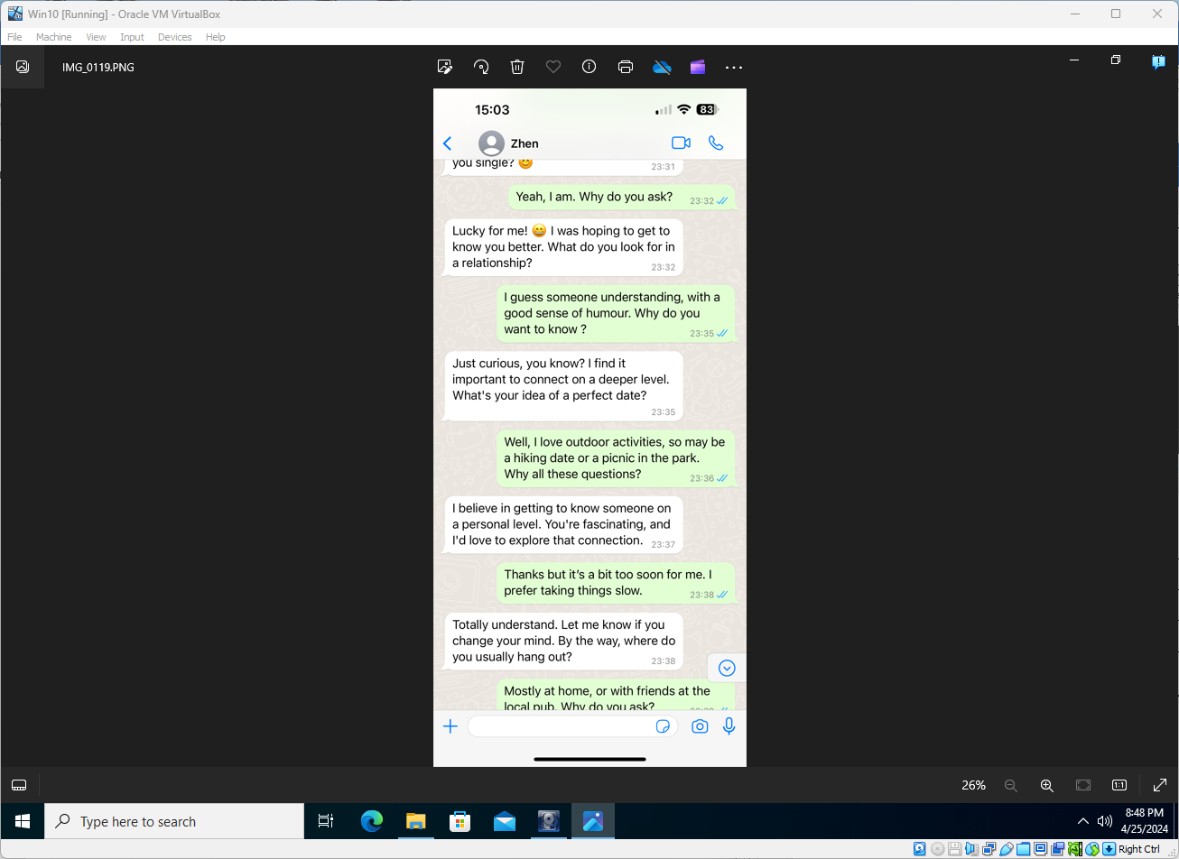

Exhibit Z
Filename | IMG_0120.png
Filepath | Logical_drive\
SHA1 Hash Value | bbcf1cb4fc4d0fe727c712c27a013c38961e6115

Continuation of the conversation with Zhen from Exhibit Y. There is no EXIF metadata attached.
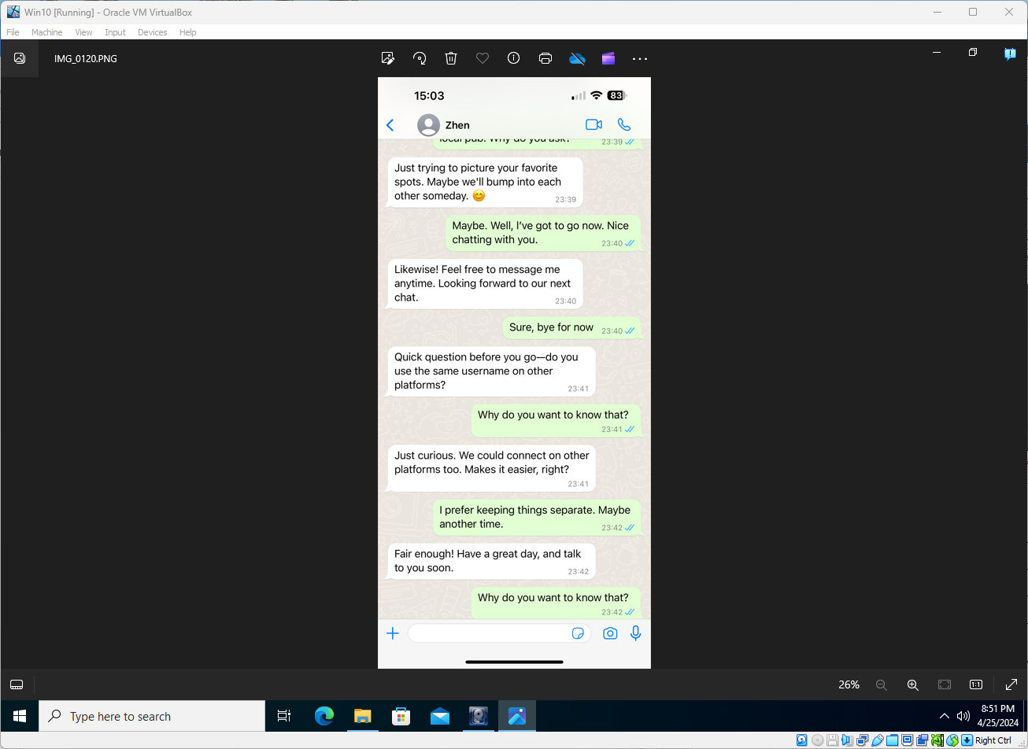

Exhibit AA
Filename | IMG_0121.png
Filepath | Logical_drive\
SHA1 Hash Value | 538c6c7023d628cb31d43761cb7596ab438ed770

Continuation of the conversation with Zhen from Exhibit Z. There is no EXIF metadata attached.
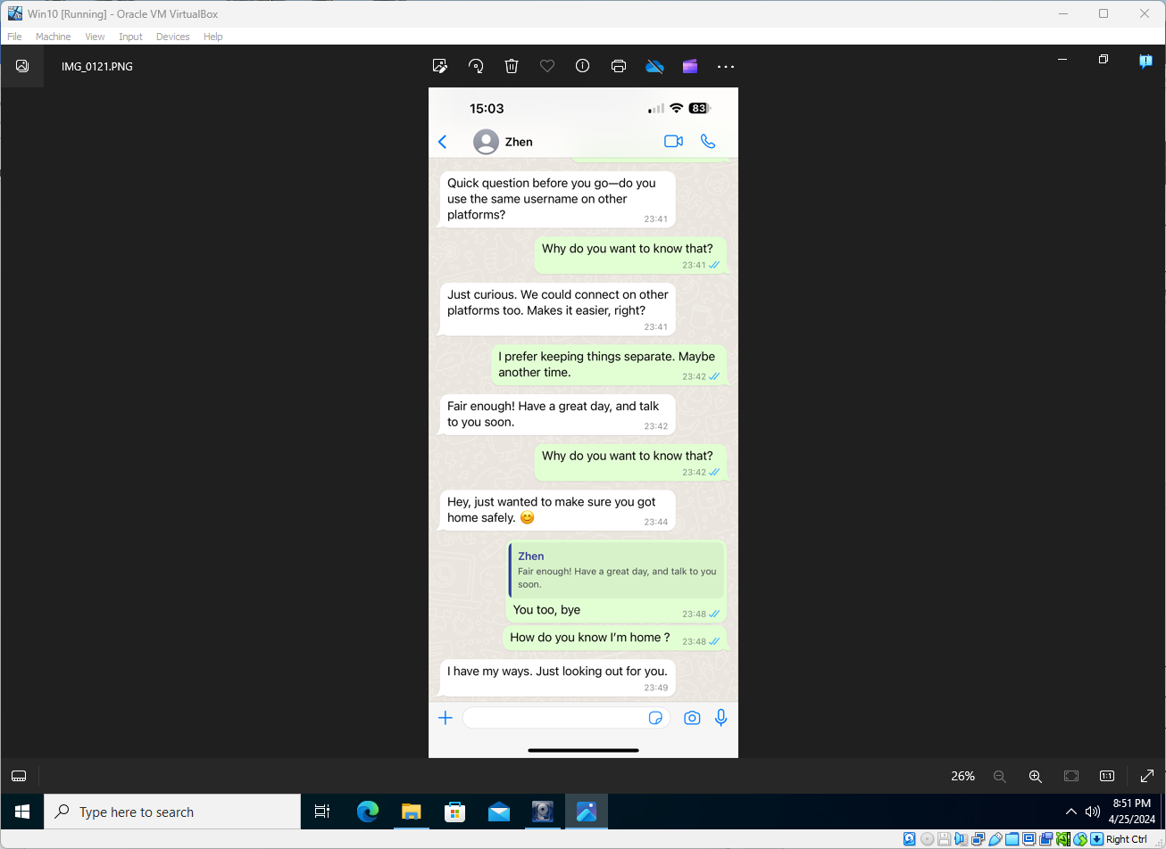

Analysis: Exhibits X – AA
This group of exhibits shows several screenshots from an iOS-based mobile device that appear to be of the WhatsApp application, showing the start of an unsolicited conversation from someone identifying themselves only as “Zhen”. ‘Zhen’ claims to have randomly happened upon the target’s ‘profile’ - I don’t believe there’s any way to ‘browse’ profiles in WhatsApp. You need someone’s contact information (typically a mobile phone number) which you submit to WhatsApp for it to match to users it is able to. ‘Zhen’ talks about a familiar (to the target) local coffee retailer and then starts asking about the targets relationship status, indicating they’d like to become more familiar to the target. ‘Zhen’ then begins to ask many questions of the target, including about their usernames on other (social) platforms, which the target rebuffs. ‘Zhen’ also inquires about the target arriving home safely, and when the target asks how they know they were at home, ‘Zhen’ implies that they’re intimately aware of the target’s whereabouts – “I have my ways. Just looking out for you.”

Exhibit BB
Filename | Screenshot_20231124-133925_WhatsApp.jpg
Filepath | Logical_drive\
SHA1 Hash Value | 07f83720ccc65f0ffc6726782dab241b995fdf12

The above file is a screenshot from an Android-based mobile device that appears to be from the WhatsApp application, showing the start of an unsolicited conversation from someone identifying themselves only “Justine Elias” – same name as exhibits U – W. There is no significant EXIF metadata attached.
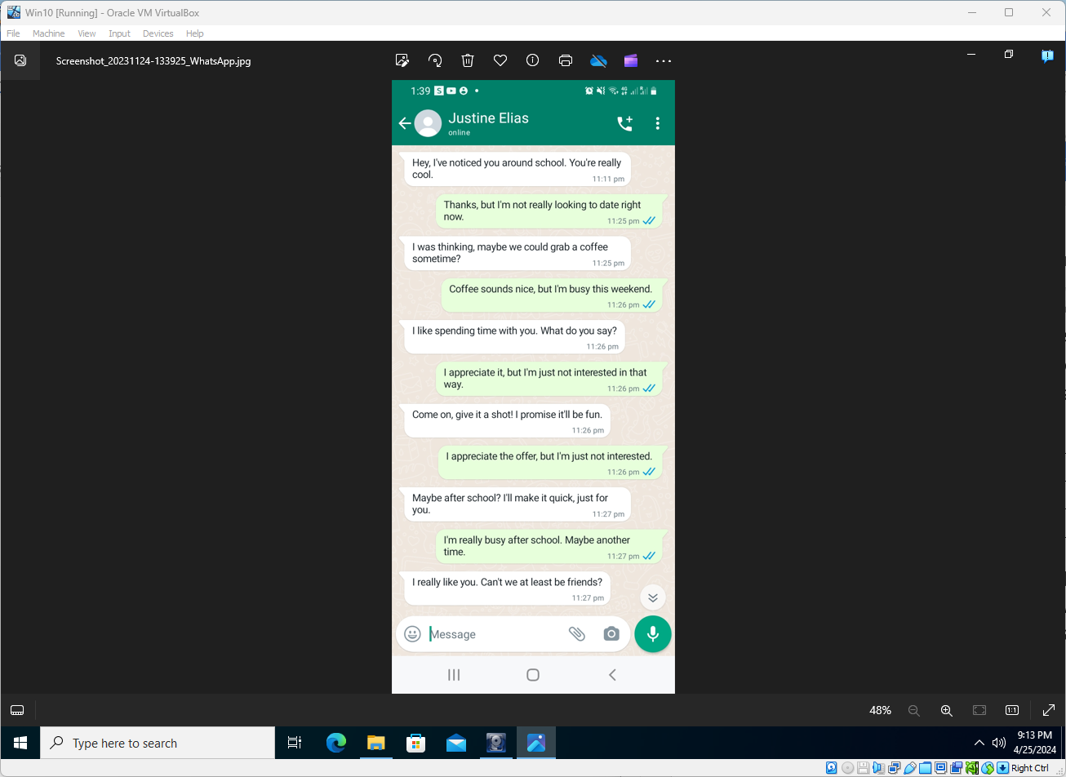

Exhibit CC
Filename | Screenshot_20231124-133938_WhatsApp.jpg
Filepath | Logical_drive\
SHA1 Hash Value | c5405443ca6a90a455268cab8b634c6798771a89

Continuation of the conversation with Justine Elias from Exhibit BB. There is no significant EXIF metadata attached.
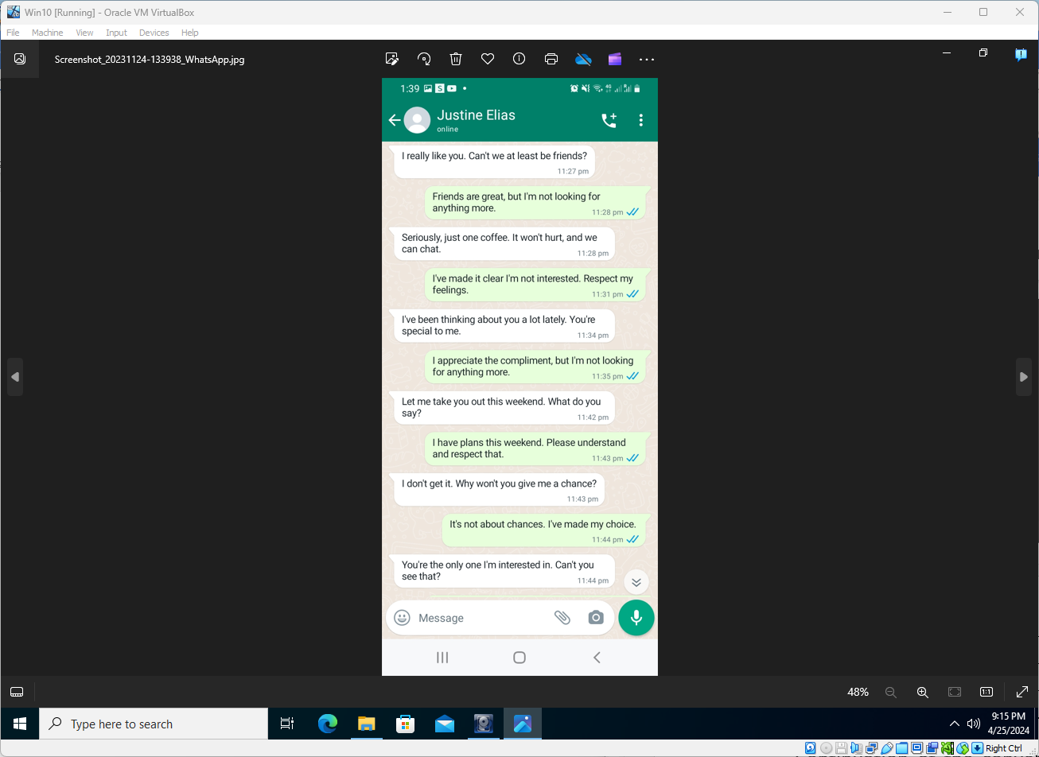

Exhibit DD
Filename | Screenshot_20231124-134017_WhatsApp.jpg
Filepath | Logical_drive\
SHA1 Hash Value | 3b625aa034a47b38713bc170def9624ac2a85832

Continuation of the conversation with Justine Elias from Exhibit CC. There is no significant EXIF metadata attached.
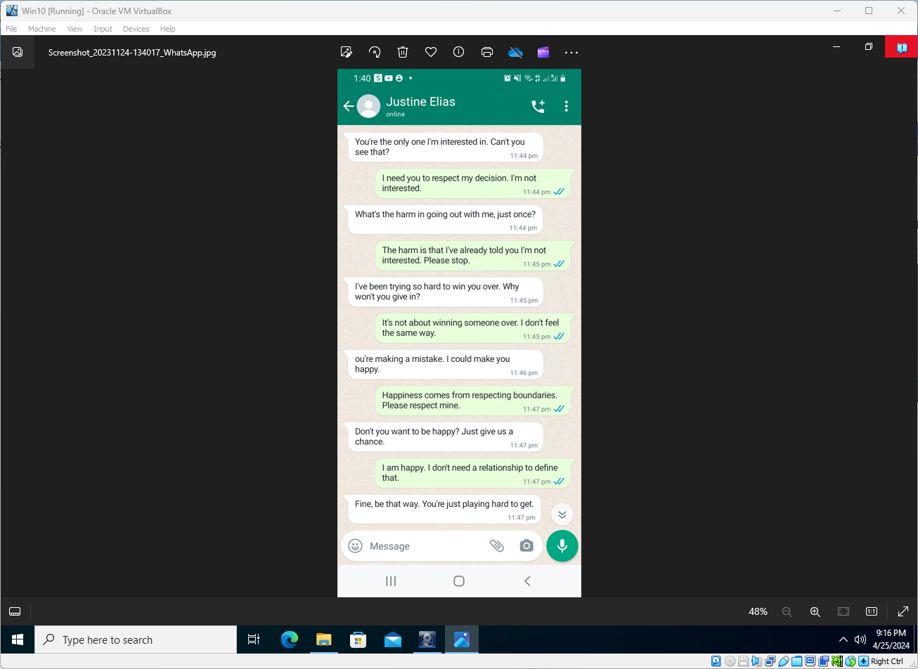

Exhibit EE
Filename | Screenshot_20231124-134028_WhatsApp.jpg
Filepath | Logical_drive\
SHA1 Hash Value | 899a1c90e9d3b97cbec0efb3d000cafff43b05db

Continuation of the conversation with Justine Elias from Exhibit DD. There is no significant EXIF metadata attached.
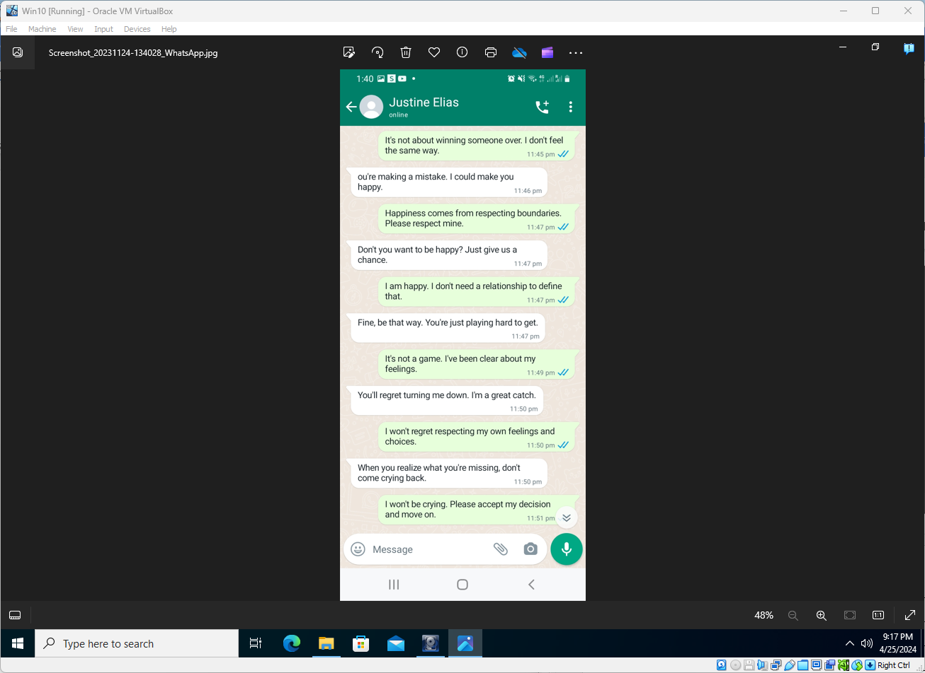

Analysis: Exhibits BB – EE
This group of exhibits shows several screenshots from an Android-based mobile device that appear to be of the WhatsApp application, showing the start of an unsolicited conversation from someone identifying themselves as “Justine Elias” – same name as exhibits U – W. ‘Justine’ launches straight into asking the target to meet up, which is refused several times. ‘Justine’ appears to become frustrated with the targets refusal of their requests to meet – “[y]ou’re making a mistake. I could make you happy.”, “Fine, be that way. You’re just playing hard to get.” and “You’ll regret turning me down.”

Exhibit FF
Filename | Screenshot_20231124-145712_WhatsApp.jpg
Filepath | Logical_drive\
SHA1 Hash Value | 1cb0a236e3ef1768d8c6e9a68076d01d2e6a42da

The above file is a screenshot from an Android-based mobile device that appears to be from the WhatsApp application, showing the start of an unsolicited conversation from someone identifying themselves “MustaSeer from Facebook” – same name as exhibits G – L. There is no significant EXIF metadata attached.
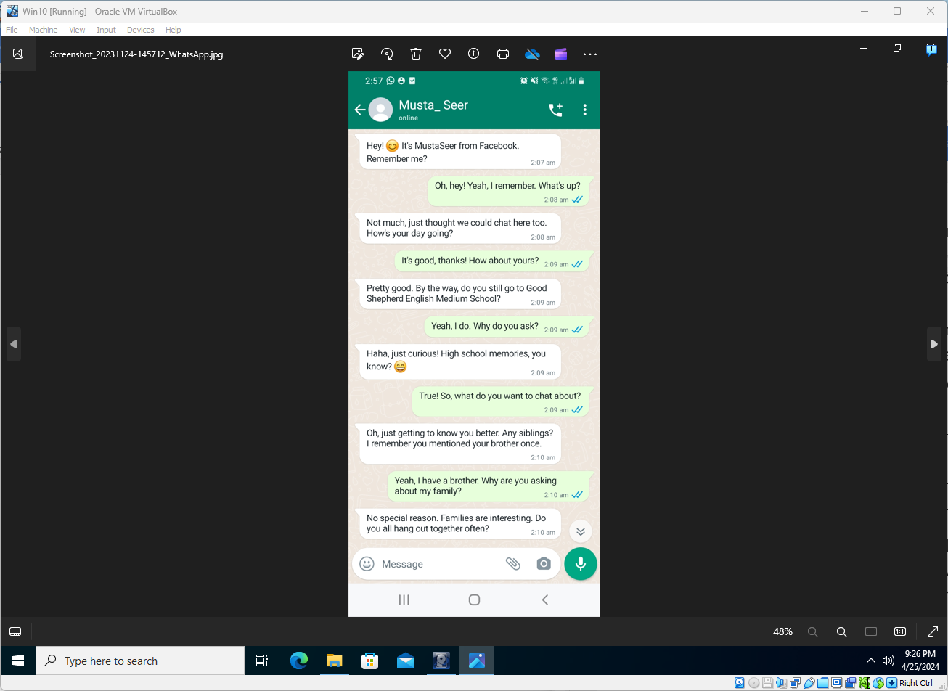

Analysis: Exhibit FF
This exhibit shows someone has knowledge of the targets contact information across more than one communication/social platform and has prior knowledge from a previous conversation.

Summary of Analyses

It is this report author’s opinion based on the analyses performed and documented herein above, that there are both evident observed patterns of behaviour strongly suggesting instances of harassment or cyber-stalking, and clear specific signs of threatening conduct. Also, there is clear documentation of a prior police investigation and prosecution of this case in 2021, resulting in a legal restraining order and a monetary fine.

APPENDICES

Exhibits E & F – EXIF metadata
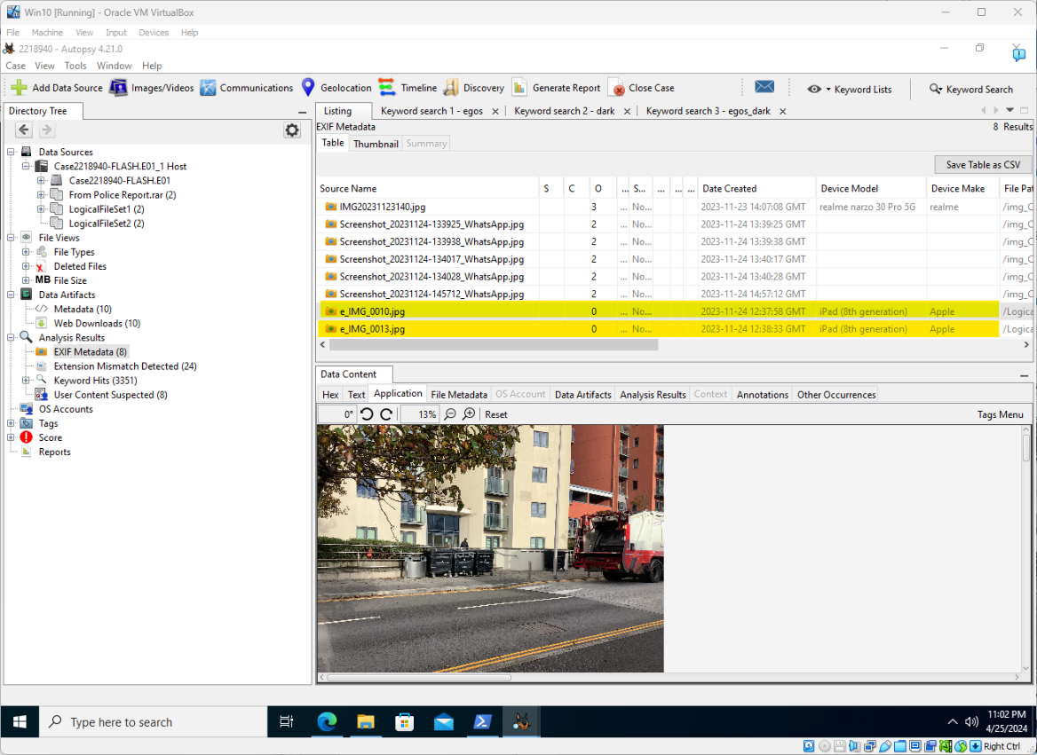
Appendix 1-1 – Autopsy revealing the Date and Time of photograph capture, and device info.
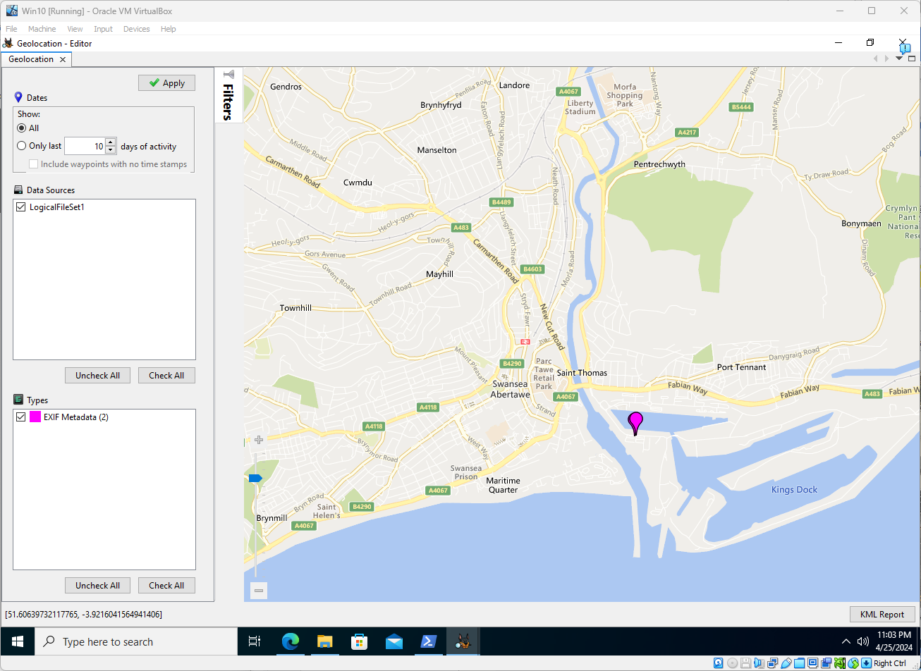
Appendix 1-2 – The Geolocation feature of Autopsy reading the EXIF GPS co-ordinates in the photographs.

Using FTK Imager – Securing the evidence
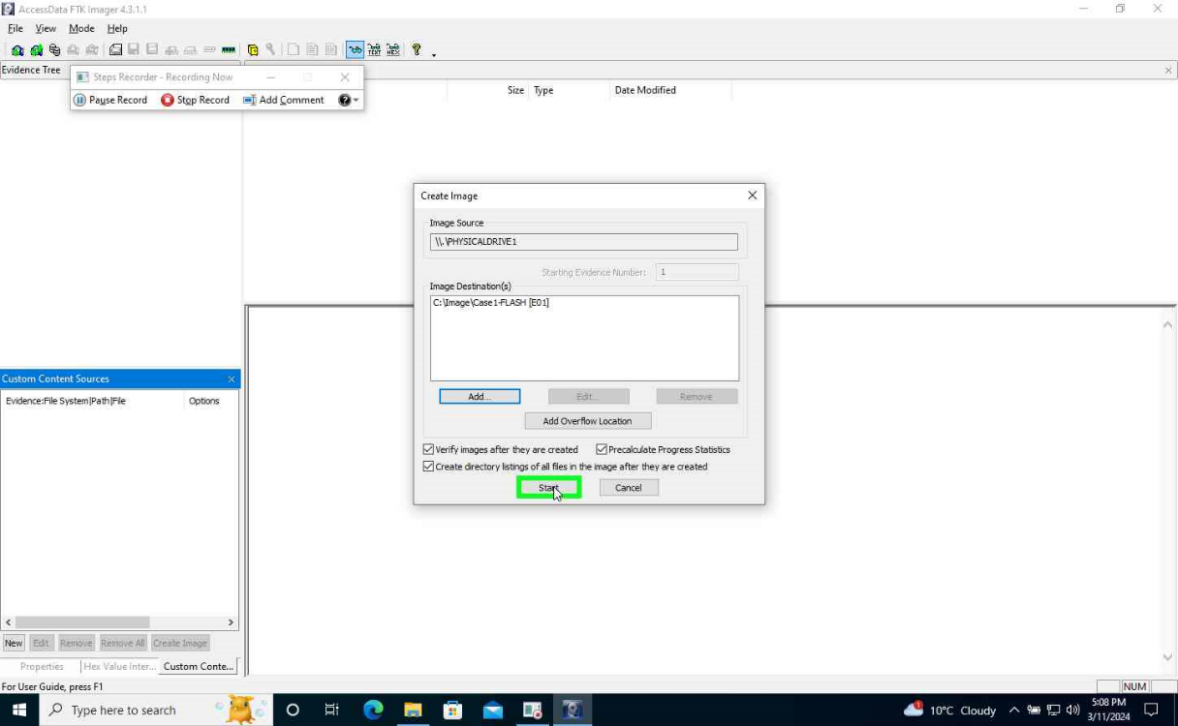
Appendix 2-1 – FTK Imager beginning binary image capture of source media.
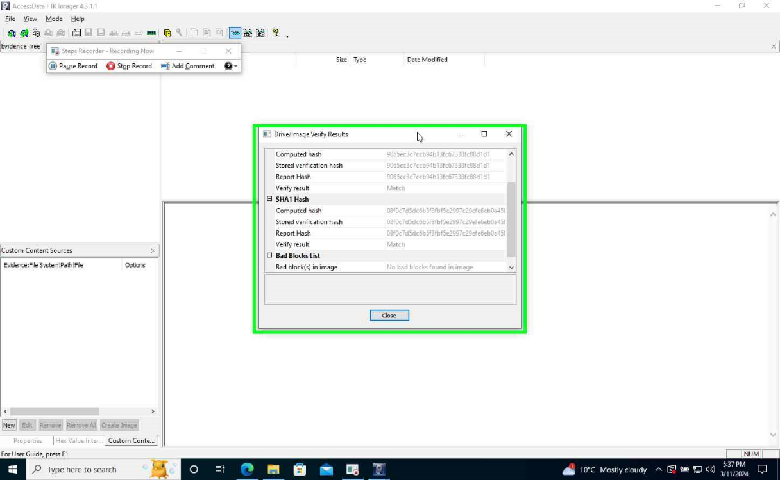
Appendix 2-2 – FTK Imager’s verification summary of successful binary image capture.

Using Autopsy – Scanning for evidence
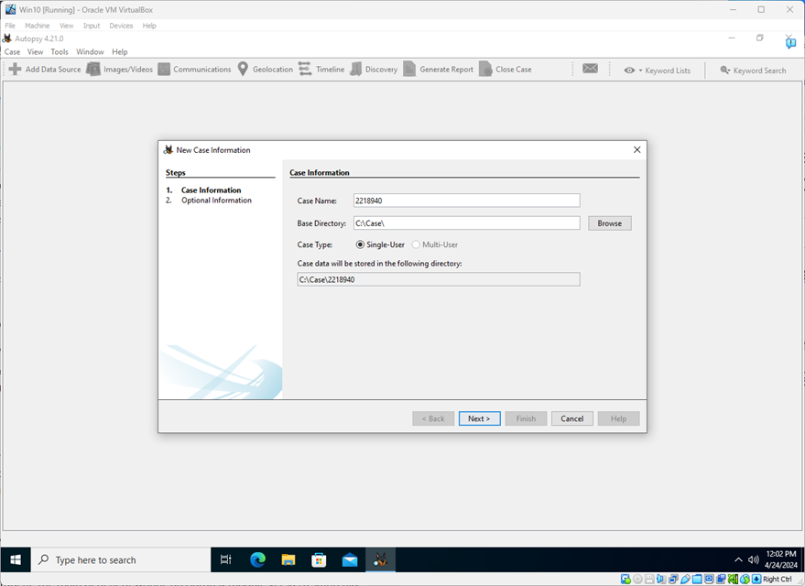
Appendix 3-1 – Creating a new 'Case' instance in Autopsy.
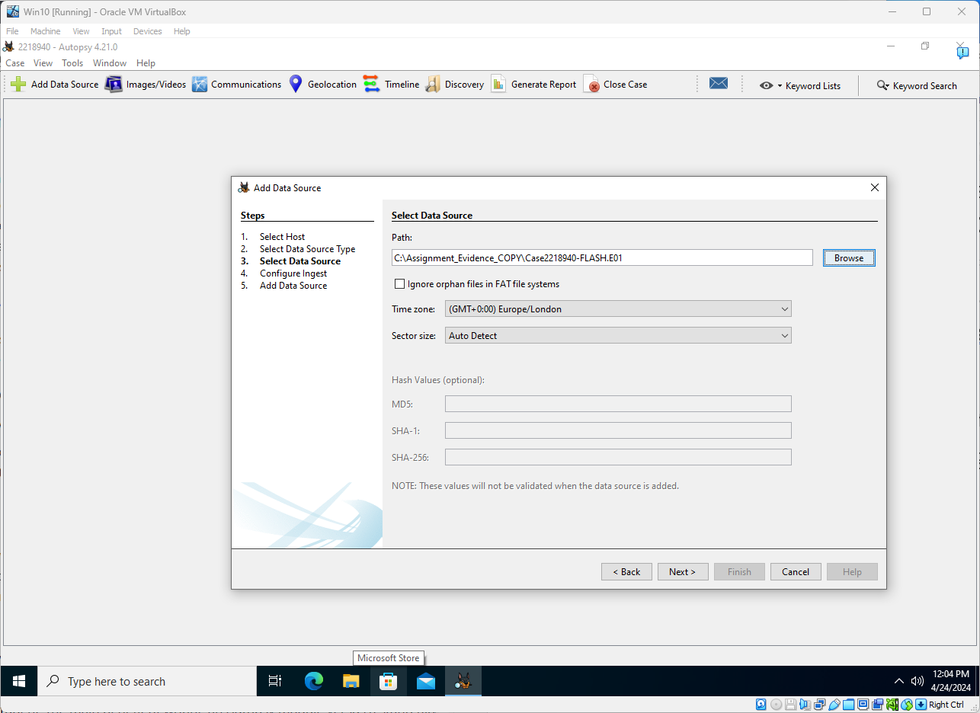
Appendix 3-2 – Adding a data source to the case.
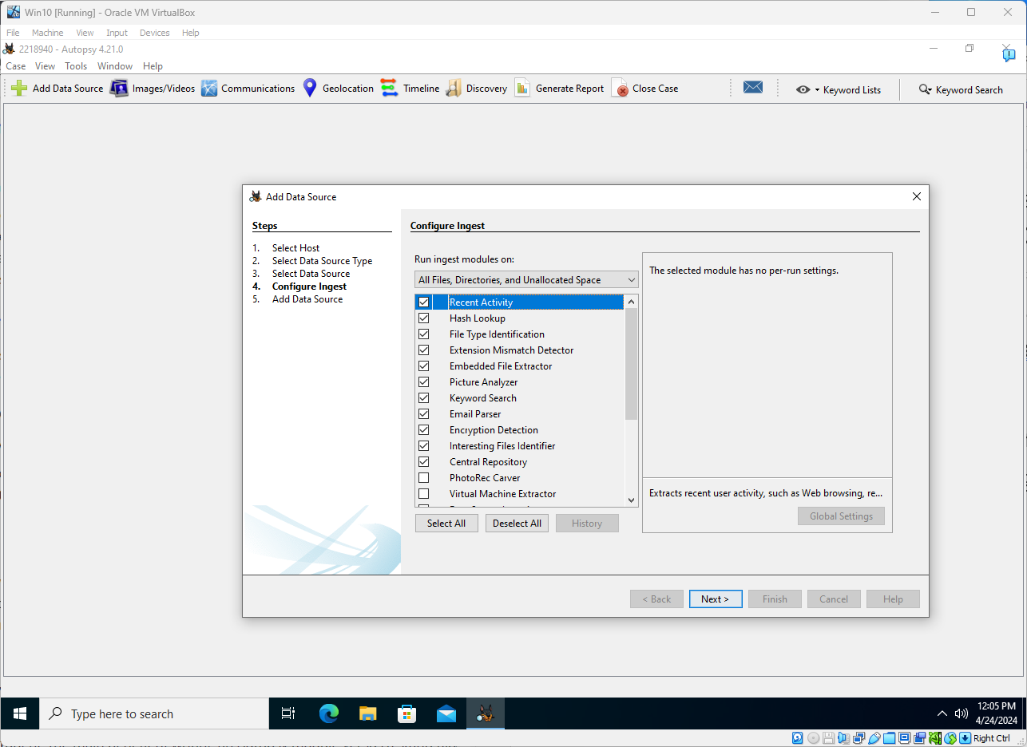
Appendix 3-3 – Configuring the analysis modules to scan the data source and save results into the case database.
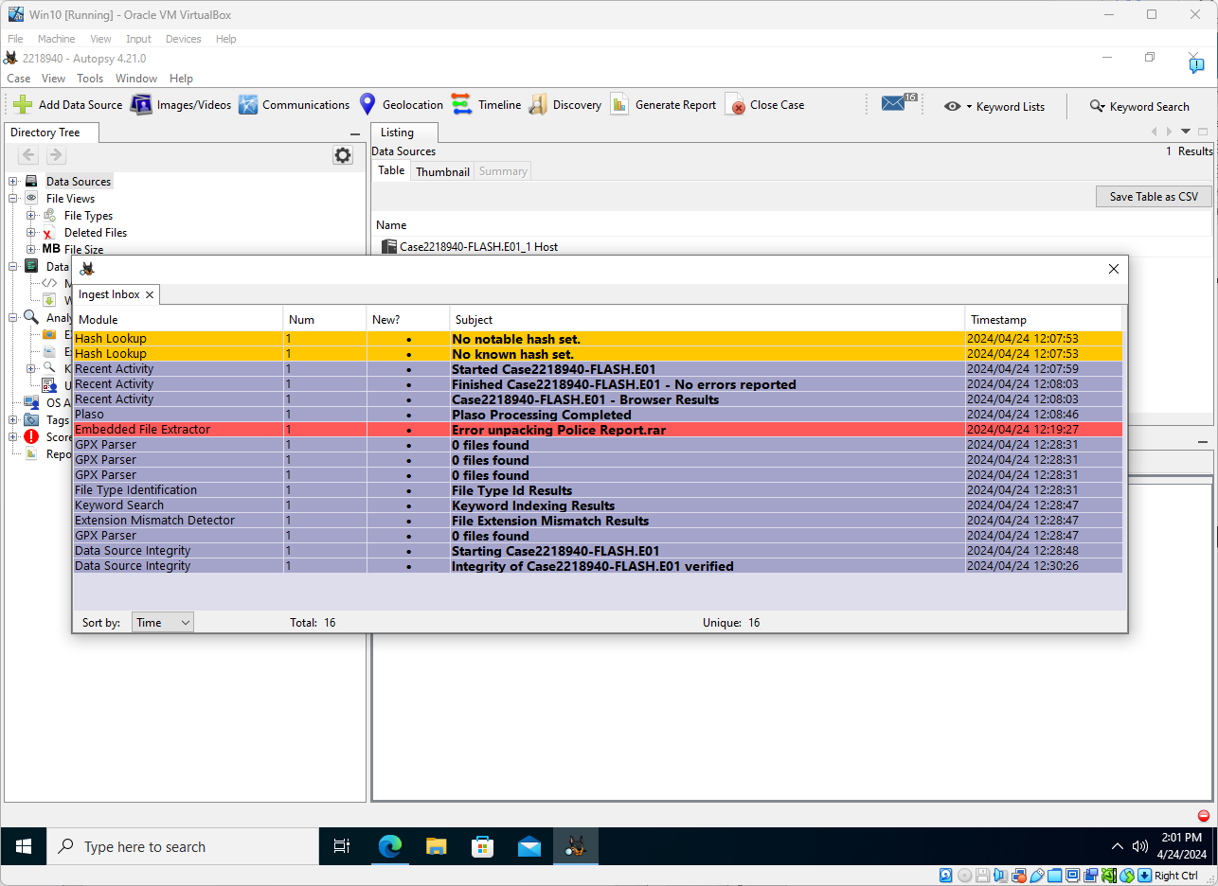
Appendix 3-4 – Reviewing the data source scan/ingestion process results for issues.
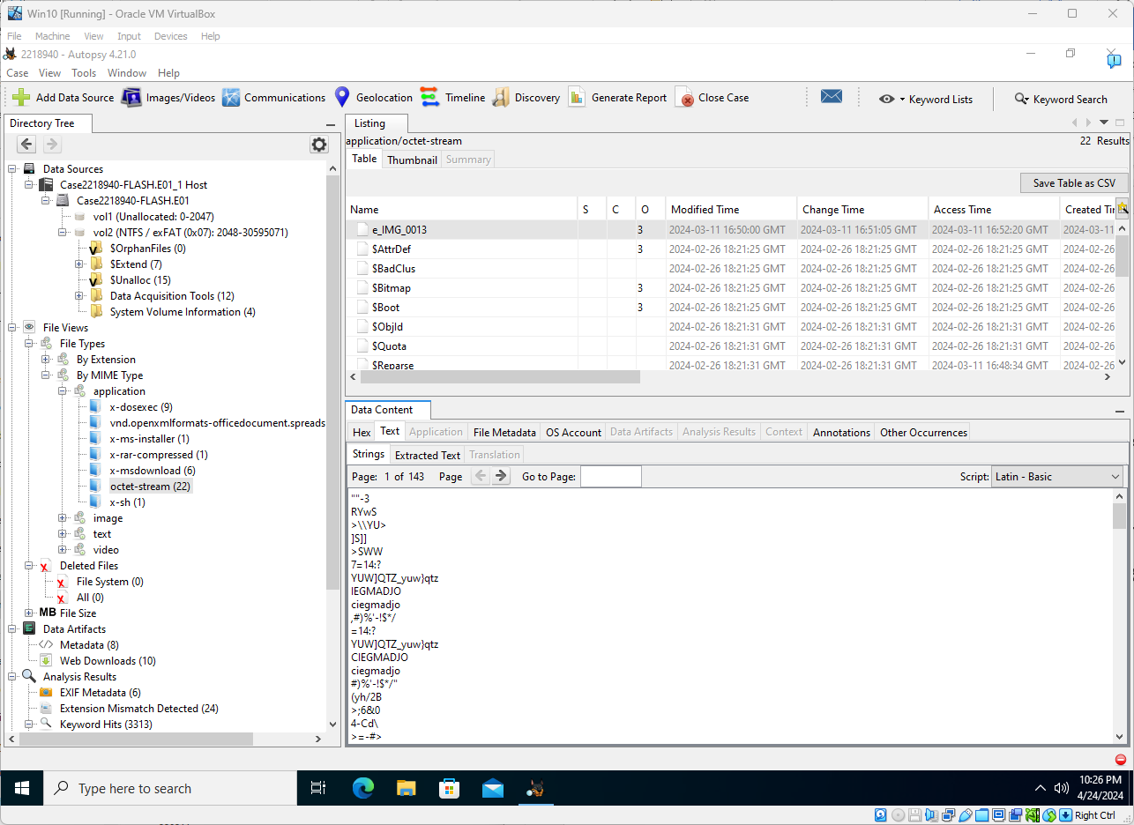
Appendix 3-5 – Reviewing the ‘File type – By MIME Type’ view in Autopsy, showing a binary file with legible strings.
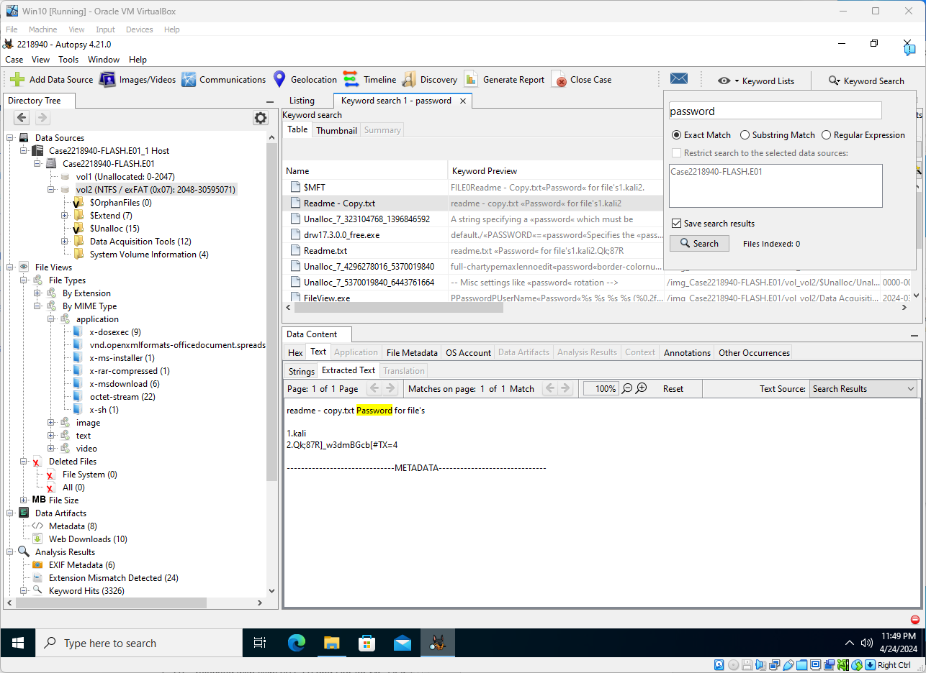
Appendix 3-6 – Autopsy running a keyword search against it’s index for the term 'password' and the results.

Decrypting files
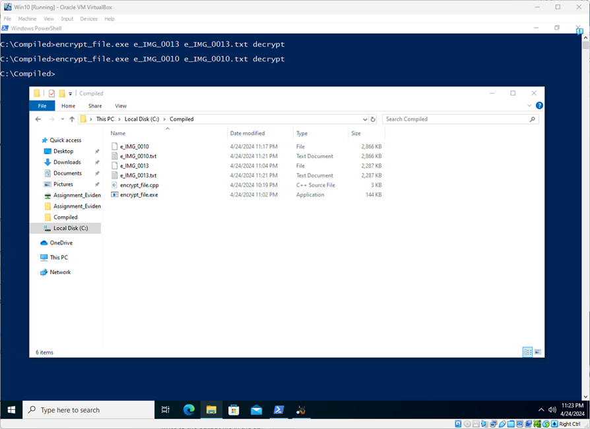
Appendix 4-1 – The usage of the compiled program to decrypt the files into new .txt files for inspection.
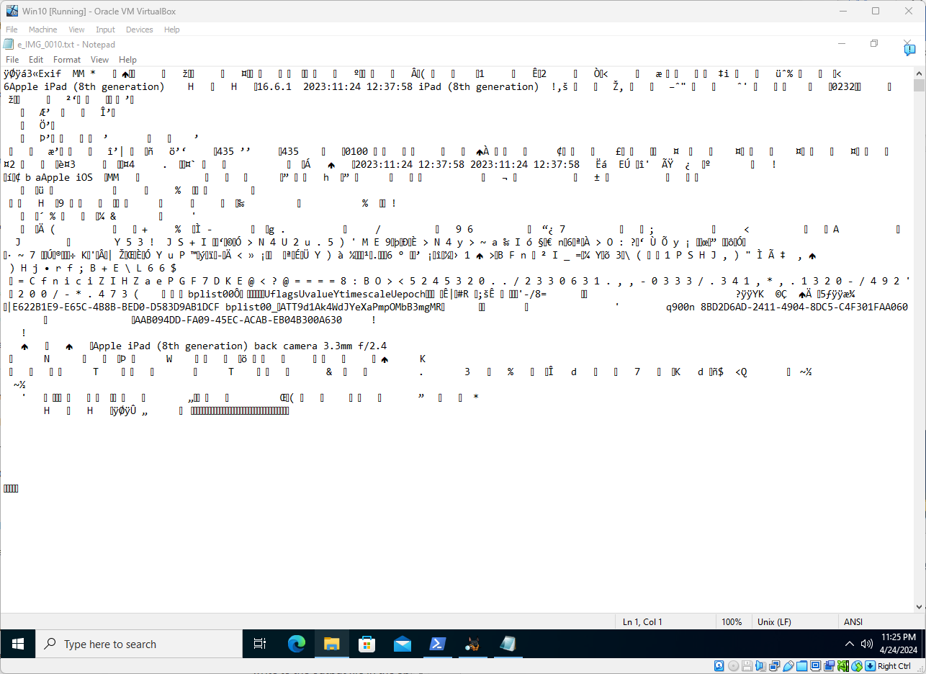
Appendix 4-2 – Text editor revealing now readable strings and keywords, notably the 'EXIF' header at the top.
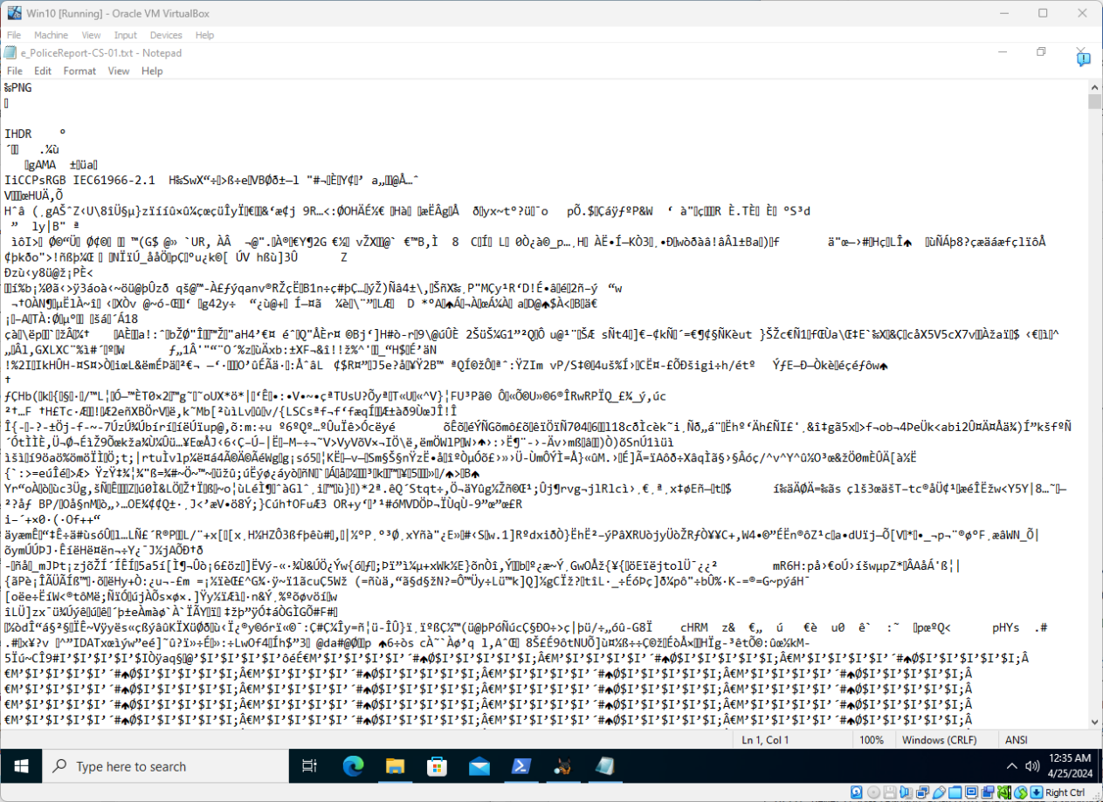
Appendix 4-3 – Same view of now readable strings in “e_PoliceReport-CS-01.txt”, notably the 'PNG' header at the top.

Software-based Write Blocker
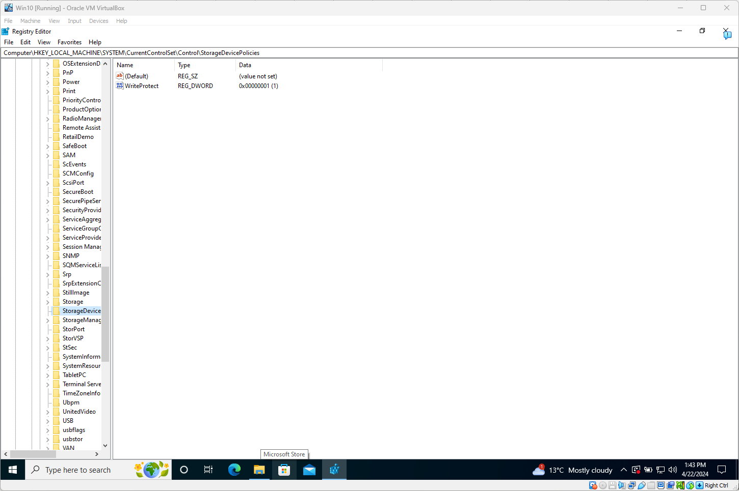
Appendix 5-1 - View of VM’s Windows Registry showing how it’s configured to enable USB Write Protect Policy.

References
[1] "What is Digital Forensics | Phases of Digital Forensics | EC-Council", Cybersecurity Exchange, https://www.eccouncil.org/cybersecurity-exchange/computer-forensics/what-is-digital-forensics/ (accessed Apr 22, 2024).
[2] E. Casey, Digital evidence and computer crime forensic science, computers and the internet, 3rd Ed. Burlington, MA: Academic Press, 2011.
[3] "FTK Imager." Exterro.com. https://www.exterro.com/digital-forensics-software/ftk-imager (accessed 22/04/).
[4] J. Metz. "EWF Specification." Github.com. https://github.com/libyal/libewf/blob/main/documentation/Expert%20Witness%20Compression%20Format%20(EWF).asciidoc (accessed 22/04/).
[5] N. Sofer. "HashMyFiles: Calculate MD5/SHA1/CRC32 hash of files." NirSoft. https://www.nirsoft.net/utils/hash_my_files.html (accessed Apr 26,).
[6] C. Team, "What Is Hashing, and How Does It Work?", Codecademy Blog, https://www.codecademy.com/resources/blog/what-is-hashing/ (accessed Apr 22, 2024).
[7] "Autopsy | Digital Forensics." Autopsy. https://www.autopsy.com/ (accessed Apr 22,).

