University of Wales Trinity Saint David
School of Engineering
Motion Simulation and FEA
CAD and FEA – M6X02210
Stephen Hutchings - P148299
18th January 2019
Abstract

A motion study and FEA analysis was carried out on a wishbone and suspension linkage whilst the components were moving over bumps in the road. In order to complete this study, the geometry of a wishbone and suspension linkage was measured on a Formula Ford, then this model was created using a bottom up method on Solidworks 2018 as was the simulated road. The purpose of the motion study was to assess the loads on suspension mounting points, and to evaluate the forces acting on the components whilst in motion. Following this, the loads from the motion study were transferred to FEA analysis to determine the stress acting on the parts. Results showed linear displacement increased as the wheel travelled over the bumps in the road. The FEA analysis demonstrated that loads caused stress and strain on the arms of the wishbone, also displacement occurred where the wishbone joined to the chassis. In order to improve the design the wishbone material was changed to alloy and a support bar was added between the two wishbone arms. The collaboration of motion study and FEA analysis allowed improvements without creating a prototype of the wishbone.

Contents page

1.0 Introduction …………………..Page 3
1.1 Aim……………………………..Page 3
2.0 Research………….…………..Page 3
3.0 Methodology……………........Page 5
4.0 Results and Discussion….….Page 6
4.1 Motion Analysis…………..….Page 6
4.2 FEA Analysis………….……..Page 9
4.2.1 Stress……………….…..…Page 9
4.2.2 Strain………………………Page 10
4.2.3 Displacement………….….Page 10
4.3 Improvements……………....Page 11
5.0 Conclusion…………….……Page 15
6.0 Reference list ………….…..Page 16
7.0 Appendices…………….…..Page 17
7.1 Photographs of model..…..Page 17
7.2 Drawings of model….….…Page 18

- Introduction
The advancement of computer-aided technology have extensively improved the engineering industry (Dwivedi, 2013). Prior to the use of FEA (finite element analysis), structural performance would have been tested using prototypes (Thomas, 2016); this suggests that this process would have been costly and not efficient. The development of FEA has permitted the evaluation of designs prior to the implementation (King, 2018), meaning that engineers are able to determine any strengths or deformities in the structure of the model before it is manufactured. In addition to testing the structural properties of models, there has been greater demand to establish the kinematics and dynamics of a product before it is produced, motion simulation provides a solution to this. (Solidworks, 2008). Therefore, this suggests that the motion and stress acting on model can be analysed using computer aided engineering methods. Furthermore, Chang (2018, pg4) deems that “motion simulation enables sizing of actuators and motors, the understanding of gear drives and dampeners and power consumption to be determined”. Thus, permitting behaviour analysis on moving parts. Also, research by Colsoul et al (2012) has demonstrated that the integration of both motion simulation and FEA in software such as CAD reduces time for engineers who would otherwise spend time transferring data between the two platforms. During this report, a literature review will be carried out on motion simulation, FEA techniques and models. A wishbone and suspension linkage will be assembled using CAD and a motion study and FEA analysis of these parts will be performed. Following this, any improvements to the parts will be made, this model will then be compared with the original model.

  - Aim: The aim of this report is conduct a motion simulation study and FEA analysis on a Wishbone/Swingarm and suspension linkage.

- Research

FEA has become a common design tool used in engineering industry as it potentially enhances performance and cost (Bi, 2017). Thus, implying that FEA boosts product efficiency, also it allows any issues with the product to be addressed before the product is produced. This suggests that FEA is able to solve problems with design and manufacturing before production. FEA techniques relate to the analysis of several aspects, which include structure, loads, temperature fields and displacement (Khannukar et al, 2015), suggesting that the stress can be accurately calculated using this type of software. In a study conducted by Thomas (2017) it was found that there were several applications that apply to the durability and design optimisation of the product, these include fracture testing, pressure testing, vibration and loading and stress assessment. The study also revealed that the when stress is applied to the component, FEA will predict any fractures, buckles or deformities. Therefore, this method could prevent potential component failure and make the product safer by analysing the failure of the component during different loads. However, the research demonstrated that FEA does not always expose the influence that material properties have on stress, it also discovered that invalid results could be produced even if a complete model was generated. Thus, hand calculations could improve the reliability of the testing. Gokhale (2008) deems that FEA can be a complicated procedure as all parts of the design need to be meshed in order to provide geometrical calculations; if the design does not mesh properly this can become a difficult issue to resolve. However, Koutromanous (2018) suggests that the meshing process improves accuracy and therefore is likely to provide precise results.
It is also important to recognise that using FEA alone will not provide the engineer with an insight of forces acting on the component whilst in motion. This reason being that FEA only measures static load (Um, 2018), implying that additional methods are needed to analyse the components properties of motion and the forces acting on the components whilst moving. Motion simulation can be used to analyse how design components move, according to Solidworks (2018, pg1) it allows “velocities, accelerations, joint reactions and power requirements” to be found, with regard to this report, motion simulation would allow the loads on the suspension mounting points to be measured during the simulation of road conditions. Steffen (2014) supports this and stated that motion simulation provides an insight to the operation and behaviour of mechanisms. As motion study allows for moving parts to be analysed, this allows the design’s movement to be studied prior to prototyping, therefore providing a better understanding of reaction forces and mechanism movement. In addition, Chang (2018) suggests that motion studies are fairly straight forward to create as it only requires the engineer to input the motor speed, tracing points and the motion results. Therefore, suggesting that motion simulation is time efficient and cost effective.
However, it is proposed that in order to fully analyse design problems and durability motion simulation and FEA should be used in collaboration as both analyse different fields of design; FEA provides analysis of structures, stresses, deformations and model simulation analyses body motions and mechanisms (Dietz et al, 2016). The loads calculated in motion simulation can then be transferred back to FEA simulation to determine the stresses present whilst in motion (King, 2018), thus, a clarification how gravity and acceleration affects the durability of components is provided and this allows the engineer to modify the design before it is manufactured.

3.0 Methodology
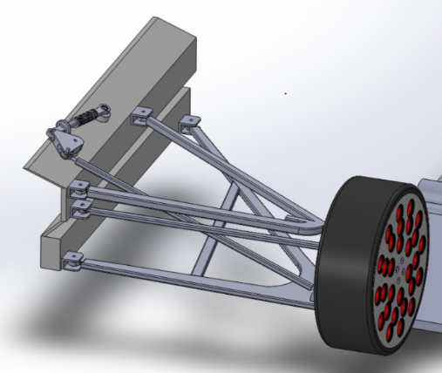
Firstly, in order to complete a motion study and FEA analysis of the wishbone and suspension linkage a model needed to be created using Solidworks. The modelling methodology used to create the components was a bottom up approach; where all components are individually made and then pulled together (Shih, 2018). The individual parts made were a subframe, wishbone mount brackets, upper wishbone, lower wish bone, suspension control arm, steering control arm, a wheel hub, top hub mount, a wheel, tyre, spring, rocker arm spring, and disc (See figure 1 for completed assembly). All of these were measured from a Formula Ford (see appendix 1 for photographs of the Formula Ford model and appendix 2 for sketches of the parts). The advantage of using a bottom up methodology is that individual components can be re-designed without changing the whole design (Planchard, 2017), meaning that improvements can be made to individual parts without changing the whole design. However, Reyes, (2018) states that using a bottom up method can create complexities when all parts are pulled together, signifying that issues may occur in the design process if parts do not fit together correctly. This is an aspect that will be kept in mind during the study. After each part had been assembled equations were added using the equations dialog box. The equations feature helps to control the dimensions of the design (Lombard, 2011); therefore, the original design is more likely to be adhered to.
Figure 1: Complete CAD assembly
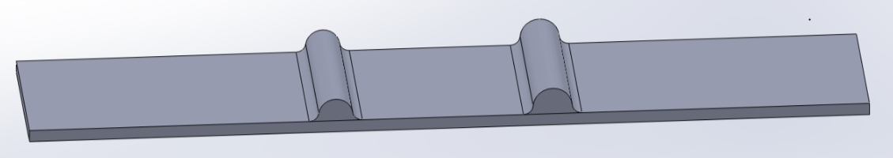
To simulate the linkage movement over road surfaces a motion study was completed, prior to this a road was created using Solidworks in order for the bumps to be simulated (see figure 2 for road assembly), the road was mated and parallel to the frame, the material selected for the road was dry steel and dry rubber for the tyre. The objective of the motion study was to assess the loads on the suspension mounting points. The type of motion study used was motion analysis, according to Catalin(2018) this type of analysis is used for analysing the effects of, friction, springs and inertial forces. In order for the motion analysis to work effectively materials were assigned to parts and all mates were accurate for degree of freedom definition, the material assigned to parts was steel. Before a motion study was conducted any redundant mates needed to be removed from the parts, the reason for this was because redundant mates produce inaccurate calculations (Chang, 2018). This was done manually; however, as there were a large number of redundancies, this was quite lengthy process. According to Shih (2018) this could have been done using ‘automatic redundant handling’ in Solidworks and the redundant mates would have been replaced with bushings, nevertheless, this did not work on this occasion.
Figure 2: Road assembly CAD
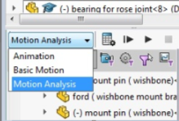
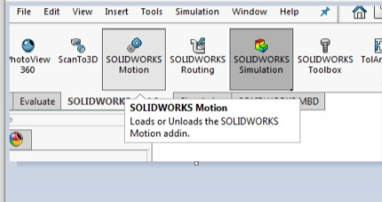
The ‘motion add in’ was loaded up whilst the assembly of the wishbone and suspension linkage was opened (see figure 3 for diagram of motion add in and figure 4 for motion analysis selection). A linear motor was selected for the road in order for the road to travel in one direction; this was applied at a constant speed of 450mm/s. Following this a rotary motor was selected at a constant speed of 50rpm in a forward motion, this was to enable the wheel to turn. A solid body contact was chosen, the purpose of this was to inform the software that the point of contact between road and tyre. Gravity was added into the simulation so that all components had a downward motion (Chang, 2018). Damper forces between the plunger and can on the suspension arm were added to measure linear displacement, the force applied between these two components was 5.00N/MM/s. Linear spring forces were applied following this. Measurements applied were 18nm, the length of spring was 70mm and width of 40mm. All actuators applied simulated real world conditions (Shih, 2018). Once everything had been applied the calculation of the motion study took place in order to calculate loads, this was done over 4 seconds. The graph created for motion analysis was a linear displacement, this will be analysed in the results section.
Figure 4: Motion analyssi
Figure 3: Motion add in
Following the motion study the loads calculated in the simulation were transferred into FEA simulation in order to detect any stress acting on the components and safety factors. This was done by selecting import motion loads then right clicking and opening the lower wishbone as a part. After this, the material was selected for the part and the analysis was set to run, this was completed for the original component and the improvement modifications part of the test. The main limitation of the study was that loads such as the overall weight of the vehicle was assumed during test, according to Chang (2018) load assumptions could provide inaccurate test results.

- Results

4.1 Motion analysis
Onwublolu (2014, pg 194) States that “linear displacement is the movement in a certain direction across a single axis”, in the case of this study, the wheel moving across the bumps in the road. Linear displacement was analysed during the motion study, this related to the spring movement whilst travelling over bumps. This was done using graphs in the motion study and by exporting the data to excel via an csv file. During this analysis linear displacement was measured against time. From graphs of plot two (See figure 5 for Solidworks graph and figure 6 for excel graph) it can be seen that linear displacement is greater when the wheel is travelling over the bumps in the road.
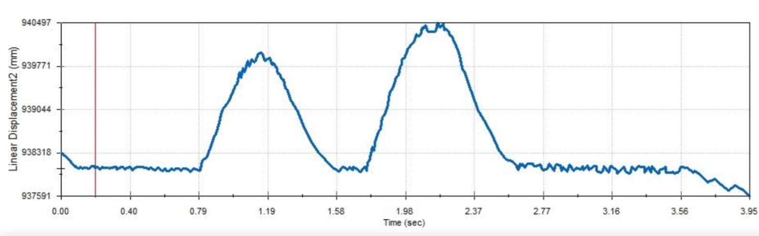
Figure 5: Motion study: Linear displacement (Solidworks)

Figure 5: Motion study: Linear displacement (Excel)
It can also be seen that there is a number of fluctuation lines present in the graph, the movement of the rose joints causes this (Shih, 2018). In order to eliminate fluctuations, mounting brackets were added into the design (see figure 7 for before changes were made and figure 8 for the insertion of mounting brackets).

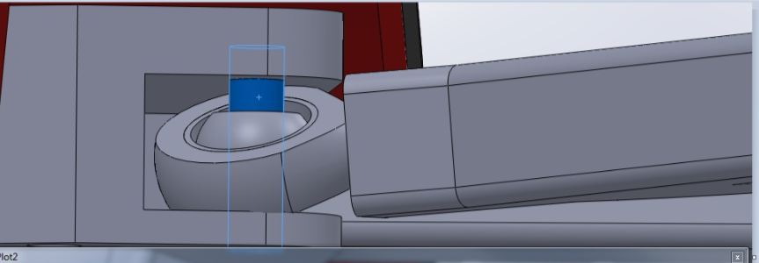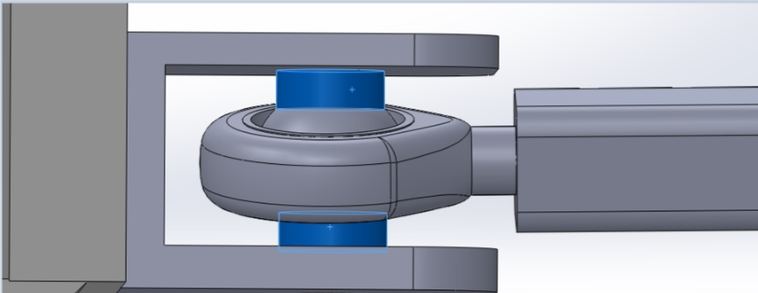
Figure 7: CAD: before brackets Figure 8: CAD: brackets inserted
The graph for plot 3 (See figure 9 for Solidworks graph and figure 10 for excel graph) demonstrates that this resulted in the motion becoming smoother.
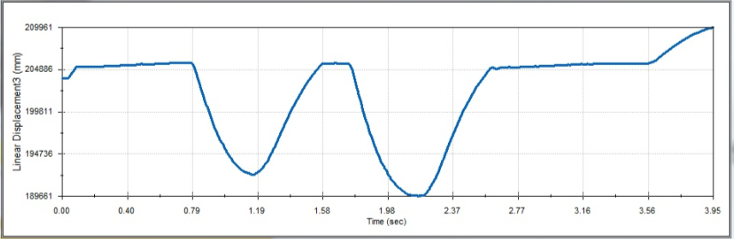
Figure 9: Motion study: Linear displacement, after the fitting of mounting brackets (Solidworks)

Figure10: Motion study: Linear displacement, after the fitting of mounting brackets (Excel)

4.2 FEA Analysis
As mentioned in the methodology section, loads from the motion study were transferred to FEA analysis in order to analyse the design and make improvements to the components. Stress, strain and displacement was analysed using FEA. Using this type of analysis will simulate the effects that certain forces has on the component. The lower component analysed during this part of the test was the lower wishbone, for the first part of FEA analysis the material dry steel was selected.
4.2.1 Stress
According to Patil et al (2013, pg43) “the maximum load is transferred from the upper to the lower arm which is possibility of failing and bending of the lower wishbone.” Therefore, it is important to concentrate on the stress acting on the lower wishbone arm during FEA analysis as stress occurs from loads being placed on the component. From figure 11 it can be seen that majority of stress appears down the arms of the wishbone, this could be a result of the bending forces applied during the simulation.
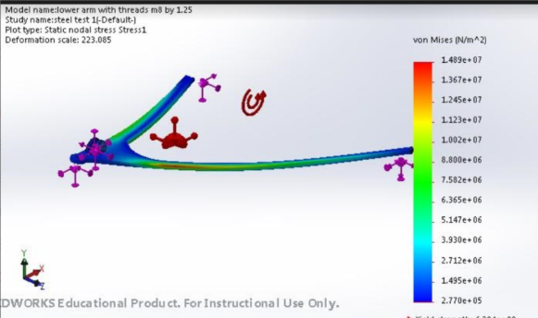
Figure 11: FEA analysis on lower wishbone: stress (steel)
The colours green and red signify that most of the stress is being applied to this area, King, (2018) explains that this stress is due to the load causing pressure on the material. However, as only a small part of the area is red, this suggests that the design of this component is still feasible as the component will not fracture, in addition the area only displays red when the component bend is at maximum. Also, it is important to note that the stress applied could be over exaggerated because a full movement is generated (MacDonald, 2007). As this would not occur in real life driving conditions, this suggests that the component is more reliable than displayed in FEA analysis.
4.2.2 Strain
Strain also relates to the potential material failure of a component caused by application of loads (Chang, 2018), therefore stress and strain are closely related. Strain is associated with the change in length of the component when the load is applied and the changes in nodes illustrate this (Akin, 2010) From figure 12 it can be seen that strain also occurs down the arms of the lower wishbone, this area is highlighted in green and red. This image suggests that the greatest change in size of material happens in this area of the wishbone. It appears that the tension caused by the material bending causes the strain to increase, as the red area is only apparent when maximum bending force is applied.

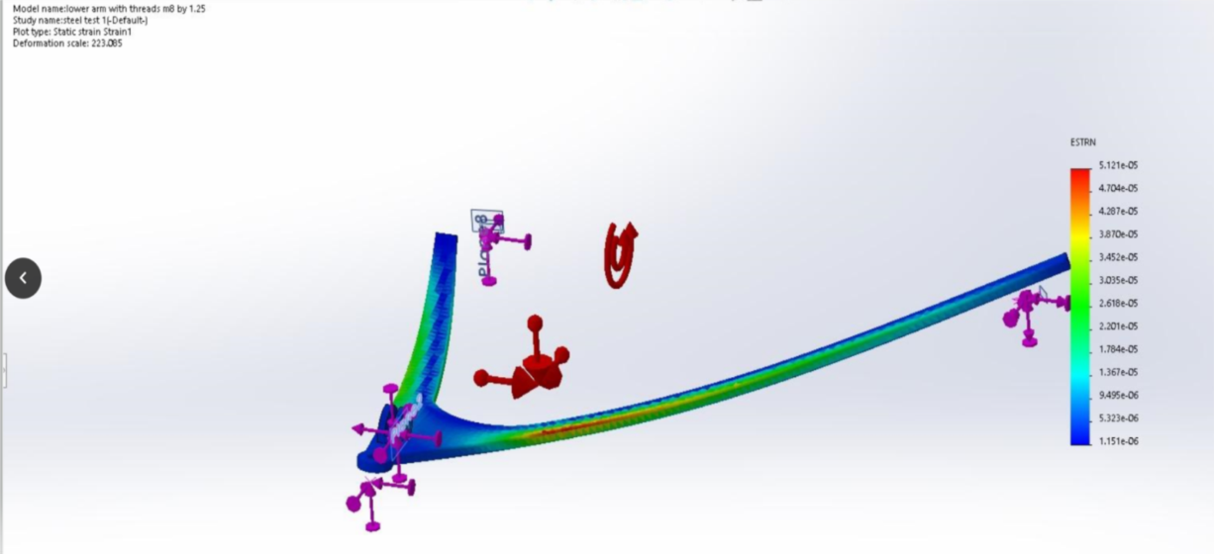
Figure 12: FEA analysis on lower wishbone: strain (steel)

4.2.3 Displacement
From figure 13 it can be seen that the maximum amount of displacement occurs at the rear end of the wishbone as the area is shaded in red. This signifies that movement whilst travelling over the bumps in the road has caused deformation in this area of the wishbone (Planchard, 2017). As this part of the component is attached to the chassis of the vehicle, the weight of the chassis may add loads to the component and therefore cause more displacement in this area. According to Shih (2018, pg 189) “displacements always depend on the material properties”, thus, a change in component materials would reduce the displacement in this area.
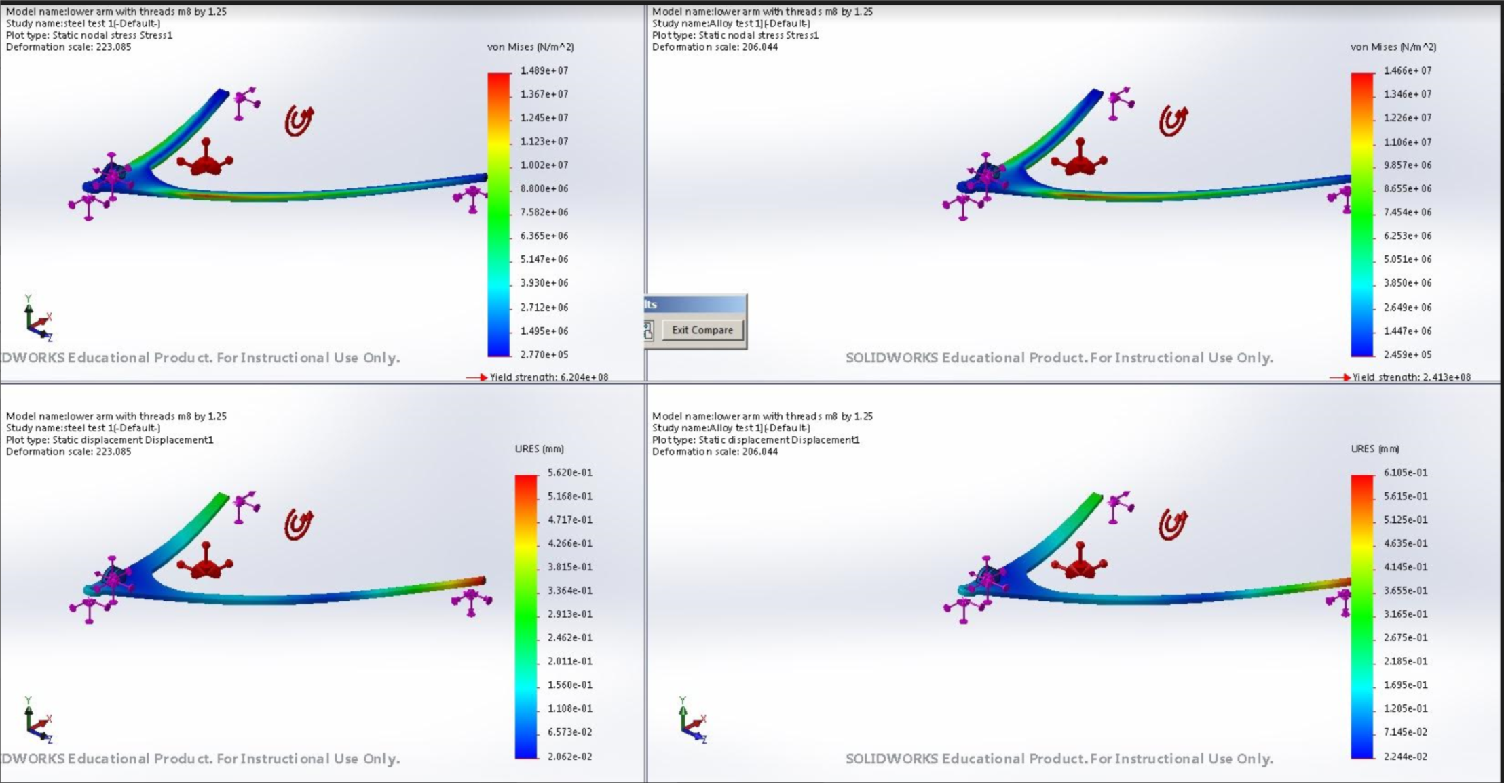
Figure 13: FEA analysis on lower wishbone: displacement (steel)

4.3 Improvements
One improvement that could be made is replacing the steel material on the wishbone with aluminium as this reduces the weight of the components and therefore likely to reduce the stresses and strains of the loads (Patil, 2013). In a study carried out by Deshwal et al (2016) on a double wishbone suspension system, greater differences were found between the use of aluminium and steel for components. It was discovered that the deflection of the aluminium wishbone was greater and the same static requirements were achieved for both materials. Therefore, the same FEA analysis was conducted on a lower wishbone made from aluminium. Figures 14, 15 and 16 show that the stress, strain and displacement forces are exactly the same on both the steel and aluminium wishbone meaning that changing the material from steel to aluminium will not reduce the stresses and strains of the load on this occasion.
Figure 14: FEA analysis on lower wishbone: stress (alloy)

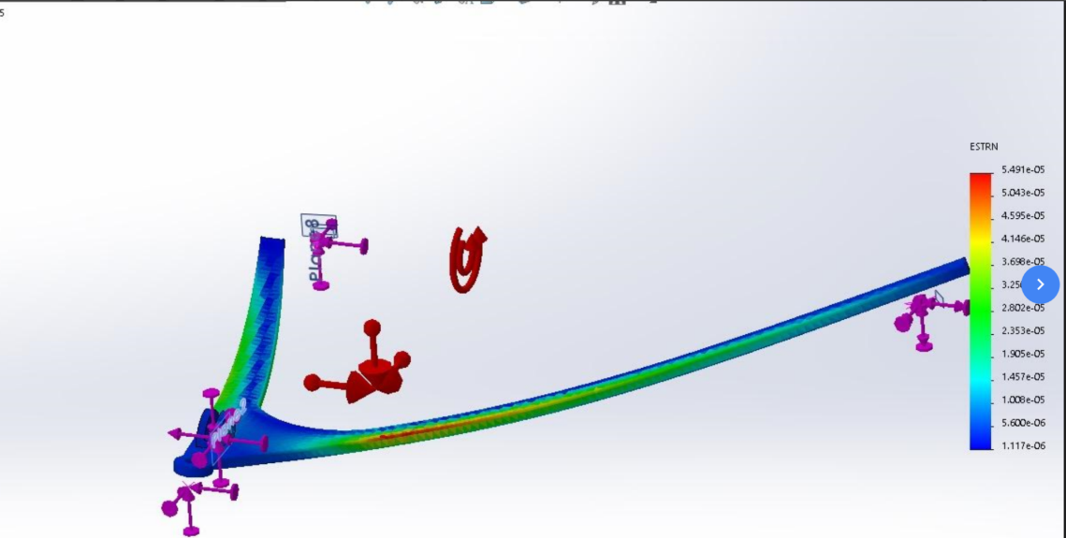
Figure 15: FEA analysis on lower wishbone: strain (alloy)

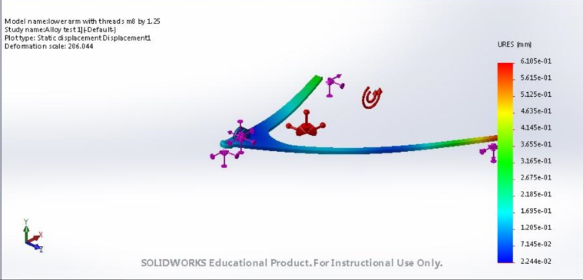
Figure 16: FEA analysis on lower wishbone: displacement (alloy)

Another way that improvements could be made to the wishbone is by adding a bar across the middle of the wishbone in order to provide support for the wishbone arms. In a study conducted by Vivekanandan et al (2014) different types of wishbone designs were analysed using FEA and it was revealed that including a support bar improved the overall strength of the design and reduced stresses of loads. As a result of this, a supporting bar was added to the original model on Solidworks, a motion study and FEA analysis was also completed to analyse the stress, strains and displacements. From figure 17 it can be seen that the stresses on the wishbone arms have been eliminated, as have the strains (see figure 18), suggesting that the structure of the design has improved from this modification. However, this improvement has made no change to the displacement (see figure 19), the reason for this is because the support bar added will have no effect on the red area of displacement as this is caused by the connection between the wishbone and the chassis and not by the weakness in the wishbone arm. Another was that displacements could be eliminated is by changing the material to carbon fibre polymer which has a high strength to weight ratio and high elasticity (Elmarakabi, 2013). Thus, the strength and elasticity of this material would mean that the component would not be affected so much by gravity loads whilst in motion.

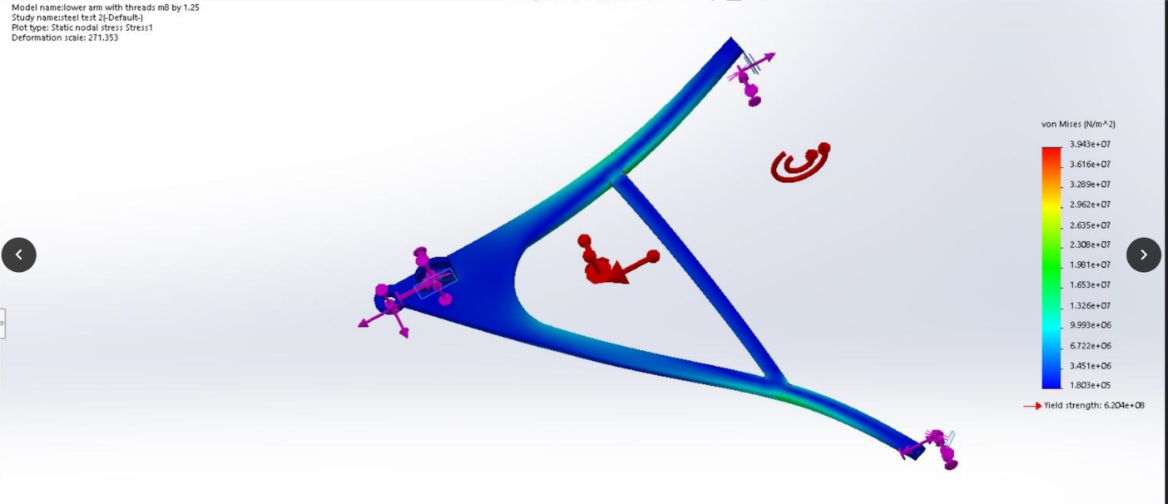
Figure 17: FEA analysis on lower wishbone: stress (added support bar)

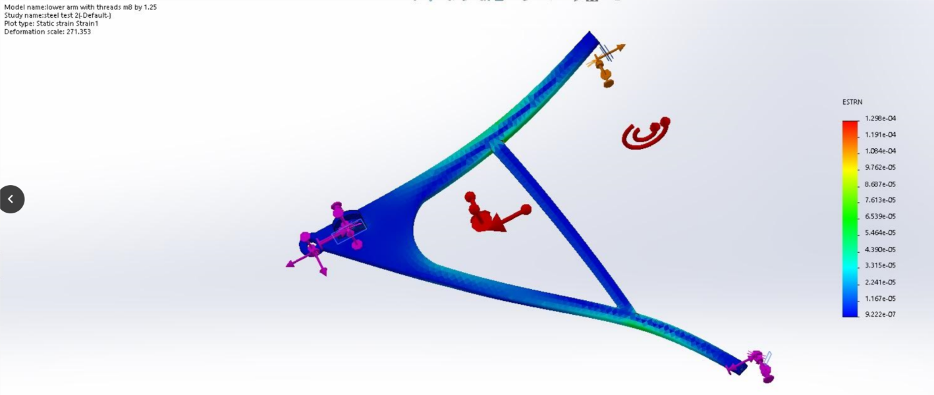
Figure 18: FEA analysis on lower wishbone: strain (added support bar)
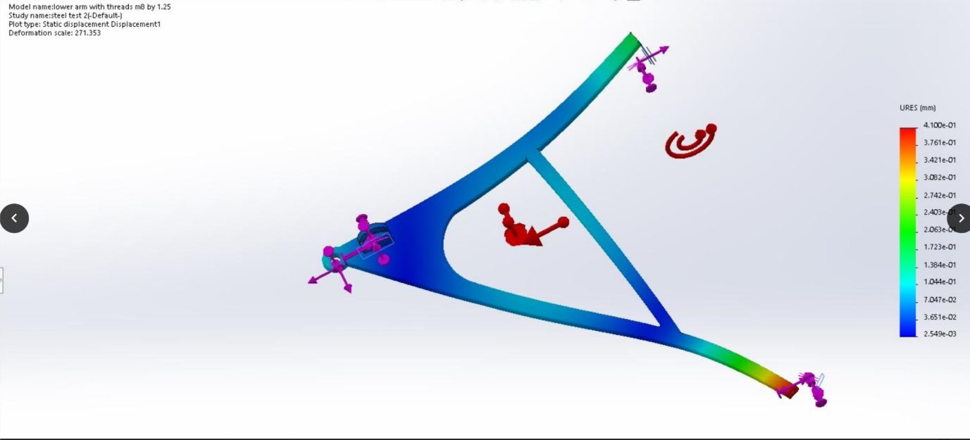
Figure 19: FEA analysis on lower wishbone: displacement (added support bar)

5.0 Conclusion
The motion analysis and FEA analysis function in Solidworks can provide assistance with problem solving and overall improve designs. During the experimental/design process in this study it was found that using this type of software can be complicated and invalid results can occur if particular processes are not completed properly. Nevertheless, it was established that using motion study in collaboration with FEA was an effective way to analyse the effects of motion on certain components. The results demonstrated that maximum stress and strain was located in the arms of the wishbones and this was a result of loads travelling from the upper wishbone and being placed on the component. The displacement was caused by the motion loads as the part travelled over the road. Nevertheless, the lower wishbone designed for this study was feasible because there was a limited amount of stresses, strains and displacement acting on the model. Stresses and strains may have been exaggerated in FEA as components would not have had such a great bending degree in real life conditions. In addition, it is important to remember that assumptions had been made for loads such as the weight of the vehicle and therefore true representations of real world conditions may not have been included in the study. On the other hand, analysis allowed improvements to be made to the existing component, these included changing the material and adding a supporting arm to the design. Design modifications tested enhanced the overall strength of the design.

Link to Solidworks files on One Drive:
https://uowtsd-my.sharepoint.com/personal/shutchings_148299_student_uwtsd_ac_uk/Documents/Forms/All.aspx?slrid=eb81b79e%2D7066%2D8000%2Da2e3%2D0a0ce6681cc2&RootFolder=%2Fpersonal%2Fshutchings%5F148299%5Fstudent%5Fuwtsd%5Fac%5Fuk%2FDocuments%2FCAD%20files&FolderCTID=0x0120004E9EEA78D0E5E54DBFA2A744568B0074

6.0 Reference list
Akin, J. (201) FEA analysis concepts: Via Solidworks. London: World Scientific.
Bi, Z. (2017) Finite Element Analysis Applications. London: Academic Press
Catalin, I. (2018) Animation in Motion Studies in Solidworks. Journal of Fiability and Durability. Vol 1. PP228-231
Chang, K. (2018) Motion Simulation and Mechanism Design with Solidworks 2018. Mission: SDC Publications
Colsoul, F., Voss, B. and Wissart, T. (2012) “Motion in FEA”: An Innovative Approach for More Physical and More Accurate Vehicle Dynamics Simulation," SAE Technical Paper
Deshwalm H., Jangid, R., Mehra, K., Singh, Y. and Yadar, N. (2016) FEA analysis and geometric optimisation of double wishbone pushrod actuation suspension system. International Journal of Mechanical Engineering. Vol 3(5), PP16-22
Dietz, S., Hippman, G. and Schupp, G. (2016) Interaction of Vehicles and Flexible Tracks by Co-Simulation of Multibody Vehicle Systems and Finite Element Track Models. International Journal of Vehicle Mechanics and Mobility. Vol 3(2), pp372-384
Dwivedi, A. (2013). Role of Computer and Automation in Design and Manufacturing for Mechanical and Textile Industries: CAD/CAM. International Journal of Innovative Technology and Exploring Engineering Vol 3 (3), PP 174-181.
Gokhale, N. (2017) Practical Finite Element Analysis. India: Finite to Infinite
King, S. (2018) Finite Element Analysis with SOLIDWORKS Simulation. Boston: Cengage Learning.
Khannukar, K., Kallannavar,V. and Manjunath,N. (2015) Dynamic anaylisis of chassis using FEA. International Journal of Engineering and Technology. Vol 2 (9), pp 2165-2170
Koutromanos, I. (2018) Fundamentals of Finite Element Analysis. West Sussex: Wiley and Sons
Lombard, M. (2012) Solidworks 2011 Parts and assembly bible. New Jersey: Wiley and Sons
Macdonald, B. (2007) Practical stress analysis with finite elements. Ireland: Glasnevin Publishing
Onwublou, A. (2014) Applied Mechanics with Solidworks. London: Imperial College Press
Patil, A., Todkar,A., Mithari, R. and Patil, V. (2013) Experimental & Finite Element Analysis of Left Side Lower Wishbone Arm of Independent Suspension System. Journal of Mechanical and Civil Engineering. Vol 7(2), PP43-48
Planchard, D. (2017) Solidworks 2017 tutorial. Mission: SDC Publications
Shih, R. (2018) Solidworks 2019 and Engineering Graphics. Mission: SDC Publications
Solidworks (2018) Understanding Motion Simulation. (online) available from: https://www.solidworks.com/sw/images/content/Training/SIM_Motion_UnderstandingMotion_WP_ENG.pdf [last accessed 14/01/2019]
Steffen, J. (2014) Analysis of Machine Elements using Solidworks Simulation 2014. Mission: SDC Publications
Thomas, D. (2016). Using Finite Element Analysis to Assess and Prevent the Failure of Safety Critical Structures. Journal of Failure Analysis and Prevention. Vol 17. PP 10-17
Vivekanandan, N., Gunkai, A., Acharya, C. and Gilbert, S. (2014) design, analysis and simulation of double wishbone suspension system. International Journal of Mechanical Engineering. Vol 2(6) PP1-12
Um, D. (2018) Solid Modelling and Applications. Switzerland: Springer

7.0 Appendices
7.1 Appendix 1: Photographs of Formula Ford Components
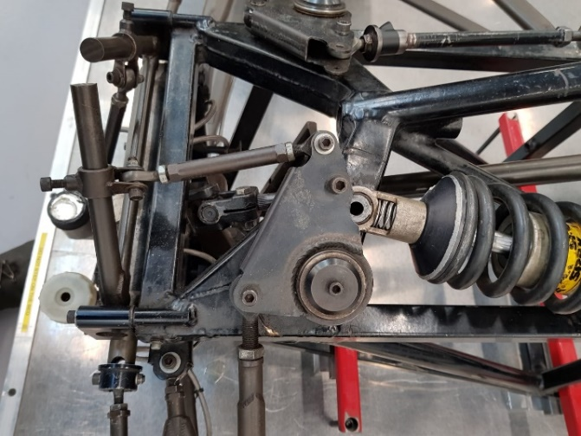
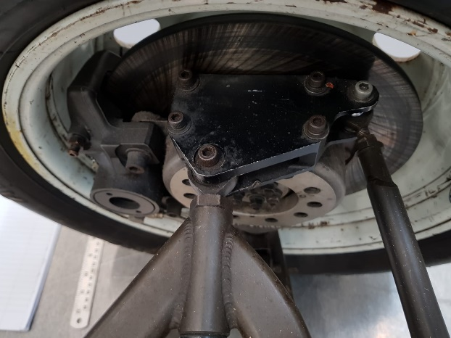
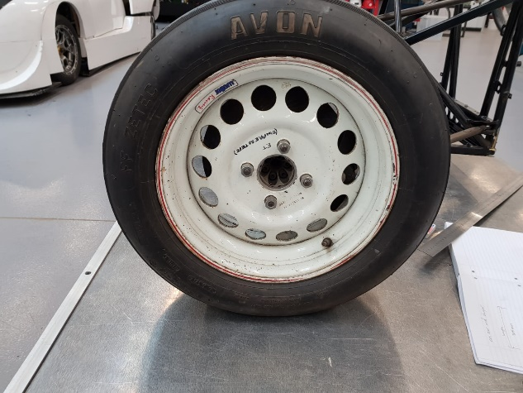
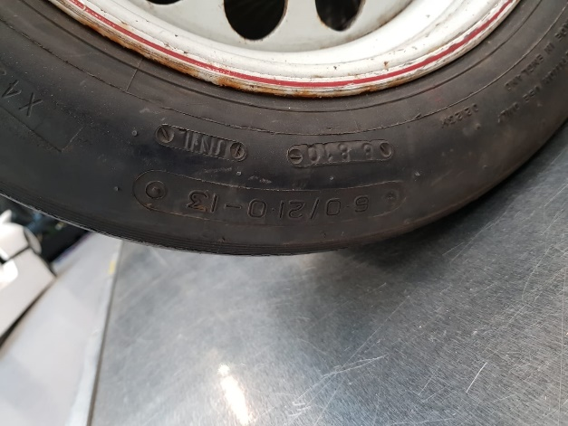
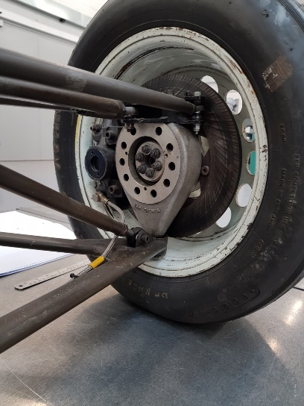
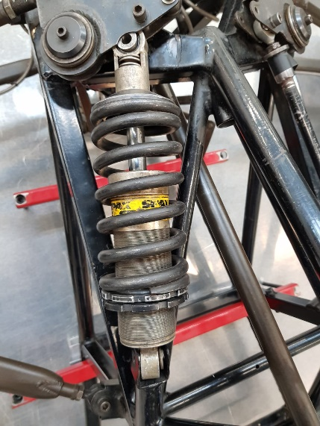
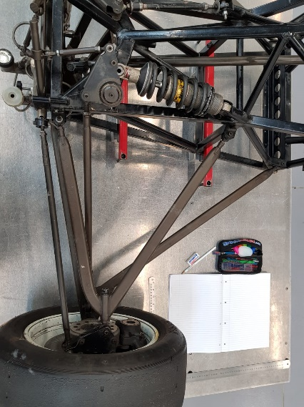

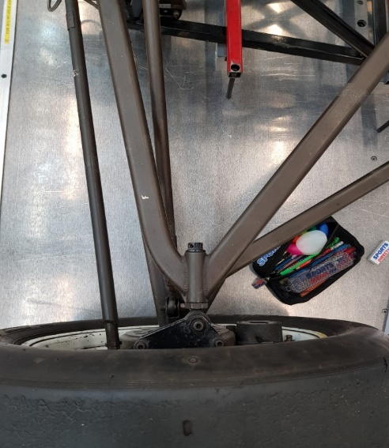
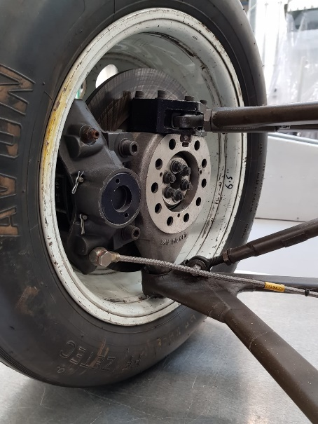

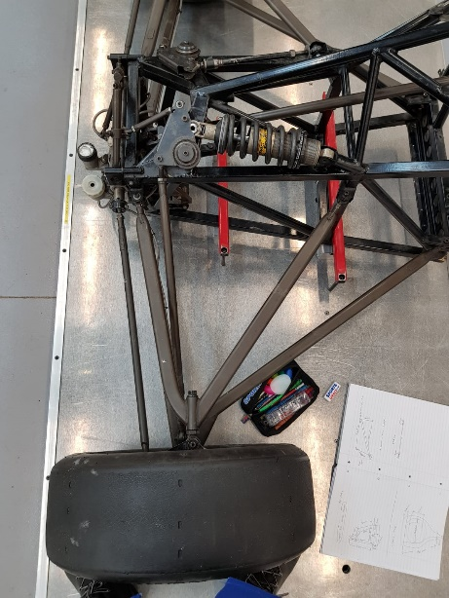

7.2 Drawings of model components

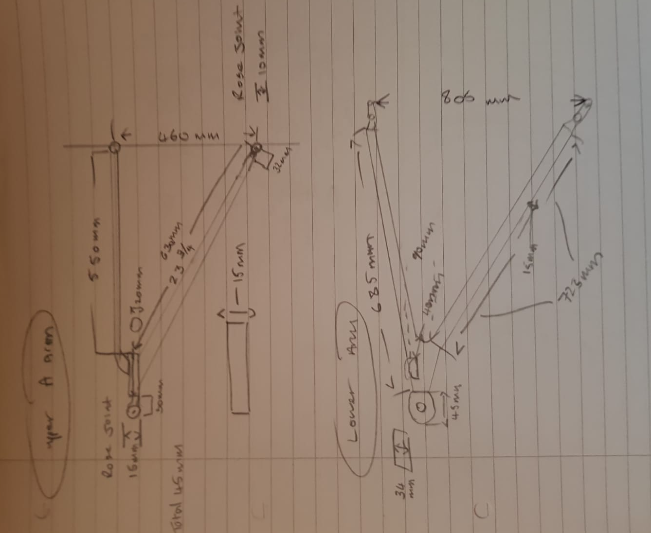
Drawing 1: Upper A arm and lower arm

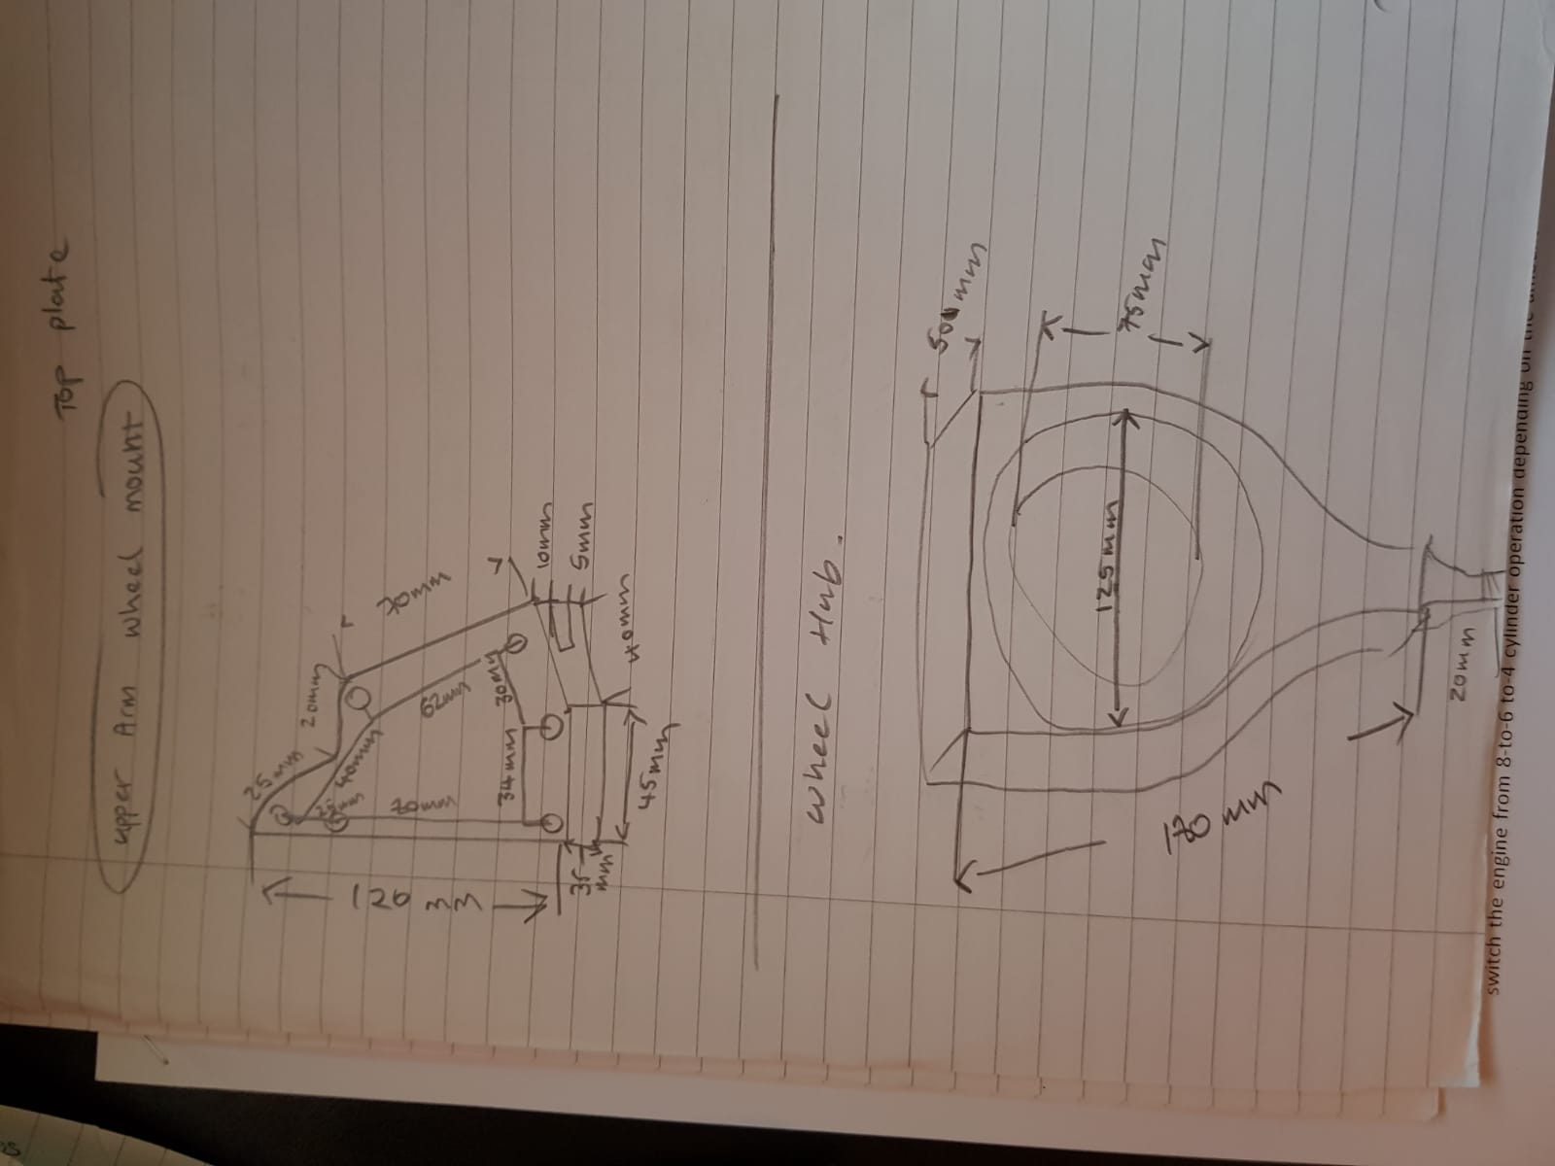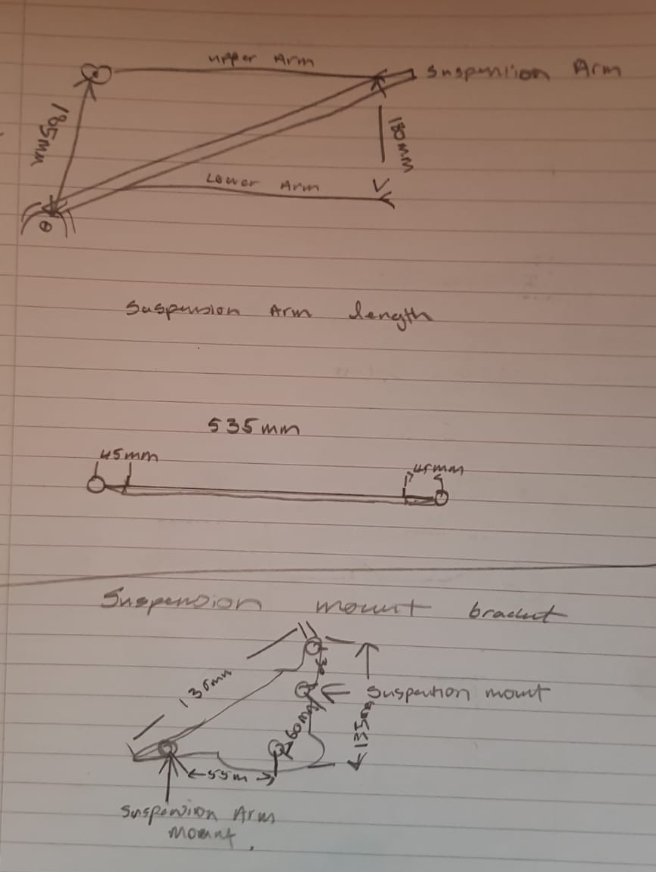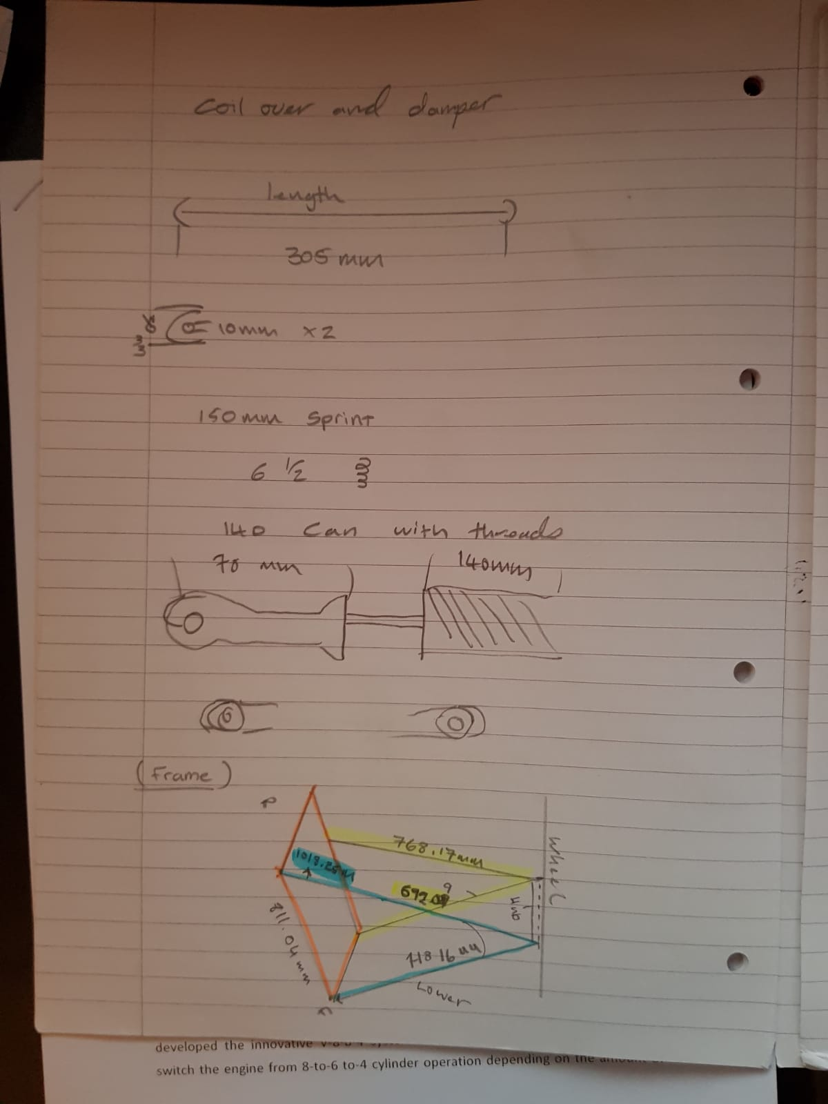
Drawing 2: Upper arm wheel mount and wheel hub
Drawing 3: Suspension arm length and mount bracket
Drawing 4: Coil over and damper

