HPAH7014 - Object Analysis
Potnia Pomos (The Lady of Pomos)
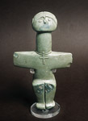
This object is arguably the single best-known, most ‘iconic’ archaeological object from Cyprus, referred to as ‘She’ rather than ‘it’ in this essay. When Cyprus joined the European Union, adopting the Euro in 2008, new coins for 1-euro and 2-euros denominations were issued, showing Her on their obverse: Her image may thus be described as ubiquitous.
Potnia Pomos

She is depicted on the cover of at least two academic works, including Steel’s Cyprus before history and a collection edited by Mina et.al. Replicas are exhibited in various regional museums and cultural centres: countless smaller versions, often made as jewellery, of varying accuracy, are for sale in every souvenir shop. The village of Pomos even has Her statue on its ‘welcome’. She is believed to be located currently in the Chalcolithic gallery of the Cyprus Museum in Lefkosia. Assignment to that period, c. 3000 BCE, is undoubted: Düring argues for “emergence of complex societies” in Cyprus from about five hundred years earlier. Peltenburg describes the Chalcolithic as the “zenith of picrolite use”, including the development of specific ‘exchange networks’ and that higher concentrations of picrolite are associated with ‘wealthier’ burials of the period.
The name Potnia Pomos is used in this essay, but is not standard. She was originally known as ‘Lady of Yialia’, designated as such by Vagnetti, and later by Steel: but has been retitled at some point in the last two decades or so as ‘Idol of Pomos’. Her precise provenance is a little blurred: the report states that She was found by a villager of Pomos, but at a site near Yialia, which, rather surprisingly, has never been excavated. This writer considers the term ‘idol’ no less offensive than the use of ‘n-words’ etc. with respect to darker-skinned human beings. Use of this word should be abandoned by archaeology: its ‘definitions’ are entirely misleading. The word Potnia is from the oldest-known stratum of Greek, meaning Mistress / Goddess, / Lady, used in the form Potnia Theron (Mistress of the Beasts) for Artemis and others, also of Demeter. Although giving Her proper respect, it is, of course, anachronistic, in that although the word is known from Mycenaean / Linear-B, Greek was not spoken on Cyprus prior to the (postulated) Achaean immigration around 1200 BCE.
She has been created from a pale green, homogeneous picrolite, most plausibly from a large pebble found in the Karyotis or Kouris rivers that descend from the peaks of the Troodos massif. Peltenburg suggests the material itself “valued” but not necessarily “ideologically charged”. Picrolite is a specific form of serpentine found only in Cyprus, a metamorphic rock that is soft enough (Mohs 3-4) to be worked easily. The surface is smooth and shining, inviting tactile response: tools with the finest of blades and points would be required for the precise carving. Further phenomenological comment is difficult without access to the actual object - understanding would also be aided by the experience of actually working with the stone. It appears that a ‘factory’ existed at Souskiou Laona (close to Palaeapaphos), certainly producing many similar figurines, but it is not known whether the Lady was carved there. Peltenburg argues against specialist carvers: this writer prefers to speculate that the sculptor thought of Potnia Pomos being released from the stone in much the same way (and with no less expertise) that Michaelangelo related to his sculptures.
A very large number of figurines have been found in Cyprus, produced over a period of 2000 years or more, but often fragmentary, from varying contexts or without recorded provenance. They are without doubt ‘”uniquely evocative”, but this has often resulted in a priori assumption that all have the same universal cultural meaning. Interpretation has been heavily skewed towards modern ideas of ‘art’ in which they are ‘primitive’. Most appear female, almost invariably dubbed ‘fertility figurines’, a notion this writer considers specious. A variation of this idea is that all the figures are ‘Goddesses’ (directly, or representations of a unitary being). An ‘older generation’ of archaeologists, such as Jaqueline Karageorghis, seem to use these terms without restraint: although perhaps no longer fashionable, they continue to be found everywhere. It is suggested that the very notions of ‘fertility’ and ‘fertility cult’ derive from the incomprehension of Abrahamic religions with respect to others, added to a ‘Victorian’ desire to euphemise religious rites that involve sexual intercourse. This misunderstanding is compounded by Hobbesian notions of ancient life as “nasty, brutish, and short”, abandoned by anthropology since the 1960’s. Human beings do not in general seem to have a problem with fertility. Although pre-modern levels of child mortality would require more births per woman than currently in order to maintain population levels, communities also had to ensure that population did not expand beyond available resources. It may reasonably be argued that most individual women, then as now, had more concern for avoiding pregnancy. An excess of births was a problem, as demonstrated by the continuing practice of the ‘exposure’ of infants up to Classical times - something even done by royalty, as in the Oedipus story.
Actually giving birth was a very different matter, usually fairly traumatic, often lethal. This writer finds it impossible to recognise Potnia Pomos as in ‘birthing posture’. Some Cypriot figurines do show an emerging child, but She does not: her knees are close together, not at all appropriate for birthing. Indeed only the widening of the hips (and absence of a penis) would indicate Her as female at all: no breasts are indicated, nor pubic area. Her belly is quite flat, wholly unlike that of pregnancy. It is easy to speculate that some of the many Cypriot figurines were meant to be clenched in the fist by women during labour - effectively therefore making them representations of an assisting ‘Midwife Goddess’, the desire for divine support from such a being entirely understandable. However, at about 15cm tall, Potnia Pomos is one of the largest of the figurines known from Cyprus, rather too large to be so used - the more common figurines at 5-6 cm would be more appropriate. It may also be noted that animals also generally have little problem in producing offspring.
Abandoning the tired tropes of ‘fertility’, Düring has recently proposed a rather different interpretation of Potnia Pomos as a dancer. This writer thinks however that she is mistaken. We certainly cannot assume any correspondence between ‘traditional (folk) dance’ as known in the present day and whatever was surely done five thousand years ago. On the other hand, ancient images of dancers, as illustrated below, from up to 2500 years ago, appear indistinguishable from the modern tradition. The Lady’s posture may be described in balletic terminology as ‘demi-plié’, feet in sixth position - it might well be considered to indicate stasis, or imminent emergence from such, rather than any sort of movement. To the best of this writer’s knowledge, such a position occurs nowhere in the modern repertoire of Greek traditional dance.
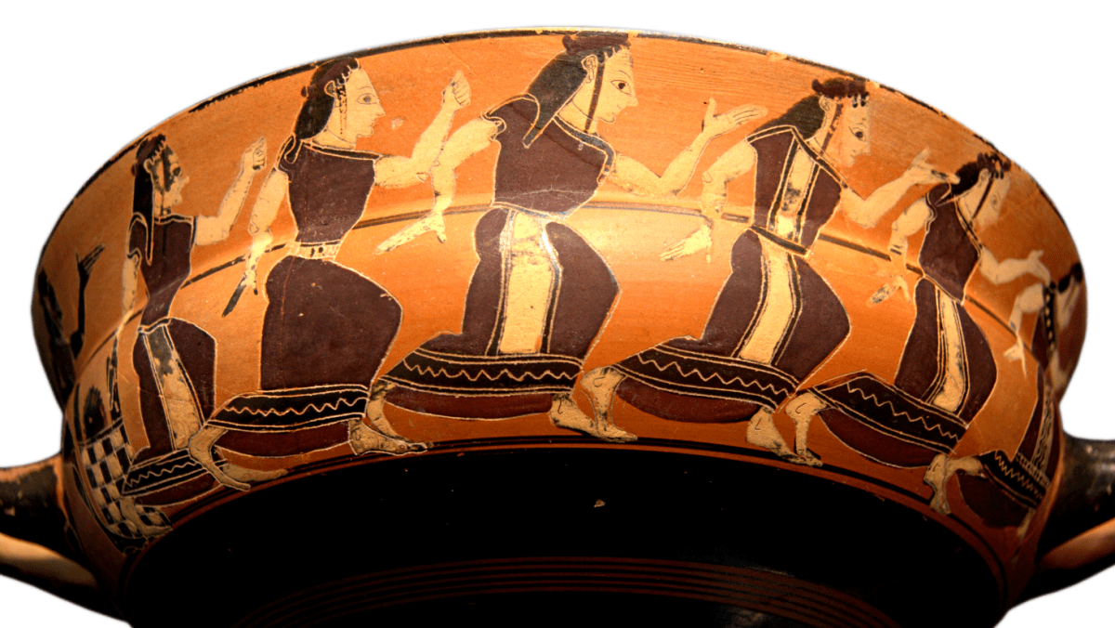
Attic Black-Figure Kylix, ca. 560 BCE by the ‘C Painter’ depicting the Subjugation of Thetis. This view shows the dancing Nereids.

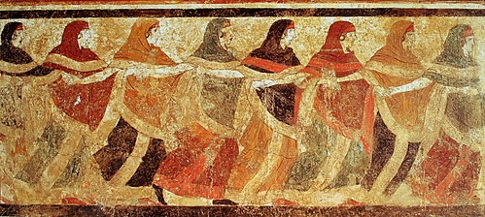
Additionally, Her arms are held out in ‘shoulder-hold’ or T-position, which is not traditionally adopted in women’s dance, but rather belongs to "men’s dances” such as Hasapiko.

Image from ‘Tomb of the Dancers’: Peucetian tomb in Ruvo di Puglia, Italy.

The Lady wears a necklace that holds a further exact image of herself, although suggestion of an infinite regression - known in modern art as the Droste effect - is not detectable. As such it is in no way representative of a prospective infant. This a feature that seems under-analysed: as far as this writer has been able to determine, it is unique. It is ubiquitous in present-day ‘Western’ culture for women to wear necklaces with pendant jewellery, but entirely unheard-of to wear an image of oneself. A plausible interpretation is that as such Potnia Pomos represents something similar to the concept popular in mysticism of correspondence between ‘macrocosm’ and ‘microcosm’, sometimes expressed as “as above, so below”. If so, this specific figurine may indeed be taken as representing a ‘Goddess’ of cosmic import, plausibly deriving from a very specific spiritual vision.
The popularity of Potnia Pomos unavoidably raises the question of ‘meaning’: abandonment of ‘fertility’ and caution re ‘Mother Goddess’ leaves a serious lacuna that is not obviated by the tourist industry’s appropriation. In addition to the comment above, this essay proposes an ‘explanation’ that does not seem articulated previously. It is based on the work of Felicitas Goodman at the Cuyamungue Institute in New Mexico, continued by Belinda Gore: their discoveries seem to have been largely ignored within anthropology, entirely so as far as archaeology is concerned. Engaged in modern ‘shamanic workshops’, in which trance was induced by sonic driving (usually with gourd rattle and sometimes by drum), it was found that the posture adopted by the participants had a significant effect on the nature of the ‘altered state’ experience. This was not random: “these postures in a predictable way shaped not merely the somatic perceptions, but even more importantly the contents of the visionary experience”. Well-known postures of relevance include the ‘Sami Shaman’ (prone, drum resting laid on the back). Variations in trance relate to destination (lower-world, upper-world, or this / ‘middle’ world) and purpose (divination, healing, etc). The less obvious postures include various asymmetries of limbs, head positions and even tongue protrusion. The postures do not necessarily match those traditionally considered ‘religious’, such as the raised-arm ‘invocation position’ shown by Mycenaean psi-figurines and still used widely or the ‘hands forward-facing’ position seen often in Egyptian devotion.
Goodman and Gore examined a variety of traditional artefacts that had no ‘explanation’ as to ‘meaning’ of the posture depicted, researching whether these artefacts encoded valuable information without a need for oral transmission. At first mostly from the American continents, the scope spread world-wide: the ‘Bear’ healing posture, for example, found extensively. Closer to Cyprus, the Cycladic figurine shown below was related to the function of the psychopomp - quite independently, Gimbutas noted the association of these figurines with burials. Other postures from Greek tradition are described as related to initiatory experience. The relation of Aegean figurines in general to shamanic postures remains to be fully explored.
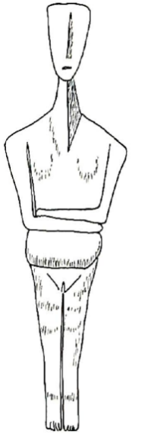
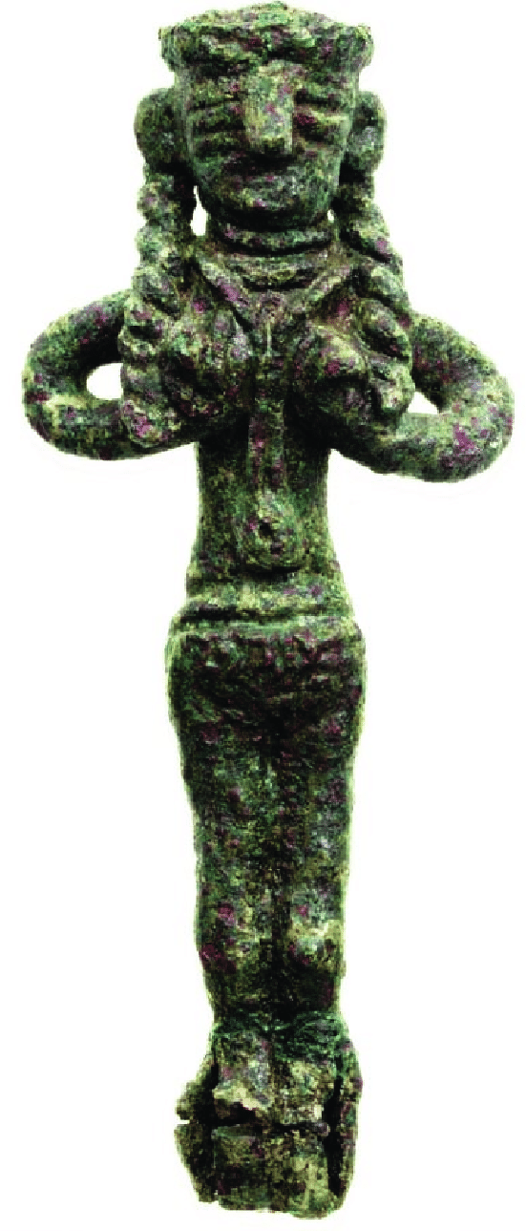
Cycladic ‘burial’ / ‘psychopomp’ figurine, marble,
approximately contemporary with Potnia Pomos.

‘Teratsoudhia’ figurine, bronze,
Cyprus, Mid-Late Bronze Age,
1000+ years later than Potnia Pomos
Although not catalogued by Goodman or Gore, the Cypriot Teratsoudhia figurine, above, for example, rather than necessarily being ‘erotic’ or ‘fecund’, seems close to the ‘Singing Shaman’ posture. For the present, the alternative explanation proposed as ‘meaning’ (or a primary component thereof) applies only for Potnia Pomos and perhaps other cruciform demi-plié figurines. The proposal here has the advantage that it is testable, hence permitting either confirmation or falsification, unlike the purely intellectual approaches that are customary.
It is suggested then that Potnia Pomos depicts a specific meditation / trance position. It would certainly be physically stressful to maintain it for more than a brief time: the physiological response to the posture would play its part in the precise experience of a devotee. That Her head is tipped backward from ‘natural’ position has been generally noticed: this writer can speak from personal experience that to do this can precipitate trance induction. The extended neck plausibly indicates an aspect of the trance experience, a ‘separation’ of head from body. A practice of directed gaze is also plausibly significant: although Goodman’s trancework requires the eyes closed, open-eyed trance is also widespread in the world.
In one sense then, Potnia Pomos could be considered non-personal, a ‘teaching aid’, or a medium for knowledge transmission and ‘cultural memory’. However, no single mode of usage or explanation should be considered sufficient. Simultaneously, the figurine represents the individual devotee expressing worship by engaging in trance practice. It is not possible to give a view more precisely as to what kind of experience is induced by the posture: there is no correlation between how the posture might be understood in everyday ‘normal consciousness’ and what derives from the altered state. It can therefore be but speculation that the Potnia Pomos posture more specifically (that is, including the wearing of the self-reflexive pendant) typically involves a form of identification with and ‘channelling’ or ‘possession’ by a female deity, and indicated as such via Her necklace. Potnia Pomos may then be interpreted as both Goddess and devotee.

Works Cited

Alphas, E. (2019). Woman in labour. In R. B. Halbertsma, & D. Pilides (Eds.), Cyprus: A Dynamic Island (pp. 72–72). Leiden: Sidestone Press.
Bailey, D. (2014). Touch and the cheirotic apprehension of prehistoric figurines. In P. Dent (Ed.), Sculpture and touch (pp. 27–44). Aldershot: Gower Publishing Co. Ltd.
Budin, S. L. (2000). The origins of Aphrodite
Ciaccia, O. (2022). Seeking Sekhmet: The veneration of Sekhmet Statues in contemporary museums. The Pomegranate (Corbett, Or.), 23(1-2)10.1558/pome.18653
Collard, D. (2011). Altered states of consciousness and ritual in late bronze age Cyprus
Dikaios, P. (1934). Two Neolithic Steatite Idols. Report of the Department of Antiquities, Cyprus, 16, , 10.
Düring, B. S. (2023). Reconsidering cruciform figurines of Chalcolithic Cyprus. In Düring B.S. & Akkermans P.M.M.G. (Ed.), Style and society in the prehistory of West Asia: Essays in honour of Olivier P. Niewenhuyse. (pp. 149–156). Sidestone Press: Leiden.
Gimbutas, M., & Dexter, M. R. (1999). The living goddesses. Berkeley: University of California Press.
Goodman, F. D. (1990a). A Trance Dance with Masks: Research and Performance at the Cuyamungue Institute. TDR : Drama Review, 34(1), 102–114. 10.2307/1146010
Goodman, F. D. (1990b). Where the Spirits Ride the Wind: Trance Journeys and Other Ecstatic Experiences. Bloomington: Indiana University Press.
Goodman, F. D. (1999). Ritual Body Postures, Channeling, and the Ecstatic Body Trance. Anthropology of Consciousness, 10(1), 54–59. 10.1525/ac.1999.10.1.54
Gore, B. (1995). Ecstatic Body Postures. Santa Fe: Bear & Co.
Goring, E. (2019). Figurines and figurative pendants. In E. J. Peltenburg, D. Bolger & L. Crewe (Eds.), Figurine makers of prehistoric Cyprus : settlement and cemeteries at Souskiou (pp. 207–222). Oxford ;: Oxbow Books.
Grant, J. (1956). Far Memory. London: Arthur Barker.
Halbertsma, R. B., & Pilides, D. (Eds.). (2019). Cyprus: A Dynamic Island. Leiden: Sidestone Press.
Holden, R. &. V., Mary. (1976). Greek Folk Dance. Newark, NJ: Folkraft.
Karageorghis, J. (2005). Kypris : the Aphrodite of Cyprus : ancient sources and archaeological evidence. Nicosia: A.G. Leventis Foundation.
Kassianidou, V. (2013). Mining landscapes of Prehistoric Cyprus. Metalla, 20(2), 36–45.
Kieburg, A. (2008). Aphrodite, Hephaistos and Ares: Some thoughts on the origins of the mythical connection of the three gods in the metallurgy of Late Bronze Age Cyprus. In &. McCarthy, & Andrew P. (Eds.), Island Dialogues: Cyprus in the Mediterranean Network (pp. 210–231). Edinburgh: University of Edinburgh.
Knox, D. (2012). Making Sense of Figurines in Bronze Age Cyprus: A Comprehensive Analysis of Cypriot Ceramic Figurative Material from EC I - LC IIIA (c.2300BC - c.1100BC)
Lewis-Williams, J. (2010). Conceiving God : the cognitive origin and evolution of religion. London: Thames & Hudson.
Maier, F. G., Karageorghis, V., & Leventis Foundation., A. G. (1984). Paphos : history and archaeology. Nicosia: A.G. Leventis Foundation.
Mina, M., Triantaphyllou, S., & Papadatos, G. (2016). An archaeology of prehistoric bodies and embodied identities in the eastern Mediterranean. Oxford ;: Oxbow Books.
Murphy, C. (2015). (A) Choreographed Frenzy: A Sequence of Steps Towards Understanding Movement and Dance in Aegean Bronze Age Iconography. In S. Cappel, U. Günkel-Maschek & D. Panagiotopoulos (Eds.), Minoan archaeology : Perspectives for the 21st century : proceedings of the International Ph.D. and Post-Doc conference at Heidelberg, 23-27 March 2011 (pp. 311–318). Louvain-la-Neuve: Presses Universitaires de Louvain.
Peltenburg, E. J., Bolger, D., & Crewe, L. (Eds.). (2019). Figurine makers of prehistoric Cyprus: settlement and cemeteries at Souskiou. Oxford ;: Oxbow Books.
Peltenburg, E. (1991). Local Exchange in Prehistoric Cyprus: An Initial Assessment of Picrolite. Bulletin of the American Schools of Oriental Research, 282(282), 107–126. 10.2307/1357265
Peltenburg, E. (2019). Picrolite procurement, manufacture and use. In E. J. Peltenburg, D. Bolger & L. Crewe (Eds.), Figurine makers of prehistoric Cyprus : settlement and cemeteries at Souskiou (pp. 233–248). Oxford ;: Oxbow Books.
Sauneron, S. (1962). Les fêtes religieuses d'Esna aux derniers siècles du paganisme
Steel, L. (2002). Cyprus before history : from the earliest settlers to the end of the Bronze Age. London: Duckworth.
Ucko, P. J. (1962). The Interpretation of Prehistoric Anthropomorphic Figurines. The Journal of the Royal Anthropological Institute of Great Britain and Ireland, 92(1), 38–54. 10.2307/2844320
Vagnetti, L. (1991). Stone Sculpture in Chalcolithic Cyprus. In J. &. P. Walsh Athasanios (Ed.), Chalcolithic Cyprus (pp. 139–151). Malibu, CA: Americal Schools of Oriental Research.
Walsh, J., & and Papageorghiou, A. (Eds.). (1991). Chalcolithic Cyprus. Malibu, CA: Americal Schools of Oriental Research.
Xenophontos, C. (1991). Picrolite, Its Nature, Provenance, and Possible Distribution Patterns in the Chalcolithic Period of Cyprus. Bulletin of the American Schools of Oriental Research, 282(282), 127–138. 10.2307/1357266.

Image from https://archive.ph/20120911235408/http://www.premierdmc.com.cy/IdolPomos.htm
Steel, 2005.
Mina et. al., 2016. The cover of Peltenburg et.al., 2019, shows a number of similar cruciform figurines from Souskiou, but not Potnia Pomos.
This writer is pleased to own such a copy, even the damage reproduced, 7cm high, in a white material - perhaps steatite (soapstone), often confused with picrolite (and with a fridge magnet attached to Her back!) She seems to serve devotional purposes just as well as might the original. Other reproductions are widely available, often in metals such as brass, bronze and gold. Almost all of the internet sites found under ‘Idol of Pomos’ are attempting to sell such.
https://pomos.org.cy/en/what-to-see/culture/#toggle-id-2. Photographs from the Pomos museum (https://www.polis.org.cy/en/pomos-museum) do not, however, seem to include Her.
However, a search of their web pages for ‘Idol of Pomos’ returns the bizarre message: “The keywords you have used are excluded from the acceptable search terms”, nor did a search in Greek produce better results. Searches simply for ‘Pomos’ and ‘Yialia’ were similarly useless. ‘Gialia’ produces only the monastery excavation. Wikipedia: https://en.wikipedia.org/wiki/Idol_of_Pomos, has what looks like a photograph of the museum exhibit.
Düring, 2019, p. 37, arguing against Cyprus as backwater prior to the Bronze Age (at around 2400 BCE). She also argues (p. 38) for “exchange networks stretching beyond the island” but these do not seem to have included picrolite.
Peltenburg, 1991, pp. 113-115. He terms the increase in number of picrolites at this period as ‘dramatic’. There seems to be rather few anthropomorphic figurines prior to this.
Peltenburg, 1991, pp. 117-118.
Vagnetti, 1991, p. 141.
Steel, 2005, p. 102, & pl. 13.
Internet search for ‘Lady of Yialia’ mostly references Panagia Chrysogialiotissa as noted above. It is not known whether the renaming was an archaeological preference or due to pressure from the Cypriot Orthodox Church (perhaps wanting the Yialia title for their own ‘Lady’) as Potnia Pomos became popular. The Yialia attribution is still used as late as Knox’ thesis of 2012.
Dikaios, 1934. He confuses Her material with steatite (soapstone), which actually is a softer rock of different chemical composition. Xenophontos, 1991, provides the detailed geological analysis, the term ‘picrolite’ now adopted generally. Pomos is a small village on the coast north of Paphos. Gialia (Yialia) is in the nearby forest, close to a medieval Georgian monastery, abandoned after the Ottoman takeover of 1571. The monastery is now ruined but covered to protect the archaeological site, excavation having been done by a joint Cypriot-Georgian team. The monastery was dedicated to Panagia Chrysogialiotissa (the Golden Virgin Mary of Gialia) with also a minor church dedicated to St. George. (retrieved by Wayback machine: http://www.cyprus.gov.cy/MOI/pio/pio.nsf/All/AE9E2250A22AC7F0C225723B00600EB4 ?OpenDocument, linked from Wikipedia https://en.wikipedia.org/wiki/Gialia_Monastery November 10th 2025). Whether such dedications are parallel to, or a ‘survival’ of the ancient celebration of Aphrodite and the spear-wielding ‘Ingot God’ can only be conjecture. At Pomos, the local church is dedicated to Panagia Chrysopateritissa (most plausibly derived from ‘golden staff’, alternatively ‘golden priests’). Due south, on the edge of the Troodos foothills about halfway to Paphos is the Chrysoroyiatissa (golden pomegranate) monastery. A theme of ‘gold’ seems significant - it is of course a standard epithet of Aphrodite.
‘Definitions’ refer to the worship of “false gods” and of a physical object as a deity. In actuality, Pagans / Polytheists do not worship ‘objects’. Rather, in the case of a statue for example, they may well consider the deity wholly present in the physical object, but unconstrained by its physicality (so can be wholly present in multiple statues). See for example, Ciaccia, 2022, pp. 42, 49, passim. In Egypt, after the initial ‘opening of the mouth’, exposure of the divine statue to the rays of the sun was a part of ensuring the continued presence of the deity, a rite known as ‘union with the disk’.(Sauneron, 1962, pp. 125-126, French edition - English translation in progress by this writer).
There is no knowledge of what the Lady was called in ancient Cyprus. The Eteocypriot script, although similar to Linear-A, remains almost entirely undeciphered.
Actual picrolite sources are near the top of the Troodos. (Kassaniadou, 2013, p. 38) It appears that the stone was also quarried, as slabs, from outcrops (Peltenburg, 2019, p. 236). The Troodos is source for many other minerals: Kassaniadou, 2013, p. 36, quotes ‘Psuedo-Aristotle’ as to the presence of gold and silver. Massive copper deposits (up to 40m in thickness) are present in the ‘pillow lavas’ on the massif margins (Kassaniadou, 2013, p. 37).
Peltenburg, 2019, p. 234. His argument is based on the use of picrolite for “small functional items”, that is, as tools. The stone nonetheless is very soft for tool usage: if only used in the context of making something of greater sanctity his argument would seem to fail. He also, p. 233-234, suggests the alternate proviso that “ascription of tools to the mundane world is misconceived”.
It is unclear whether copper implements or microliths (flint or obsidian) were used (it is conceivable that a modern microscopic comparative analysis might determine such questions) .
This writer entirely endorses the perspective of Bailey, 2014, that the ‘cheirotic approach’, actually handling the object, provides a deeper insight than can be afforded from the visual (and second-hand representations such as photographs). Further though, this writer would like to record access to Potnia Pomos (and other similar items) by a competent psychometrist. (Psychometry is the idea of ‘reading back’ events thought to have been ‘recorded’ in a physical object.) Certainly the account by Grant, 1956, pp. 211-212, suggests this worthwhile: she relates her ‘reading’ from a Mesopotamian cylinder seal, saying that these were worn on a large sharp pin, potentially a weapon, rather than a string. Initial castigation by ‘scientific’ archaeologists had to be reversed when a text was soon after found precisely describing an attack with such.
Peltenburg et.al., 2019, as a whole, discusses this site: about 800 picrolites, in states from unworked to finished, almost half only as ‘debitage’, have been found at there. Peltenburg, 2019, p. 239, fig.13-15 illustrates some 16 cruciform figurines. Peltenburg, 2019, p. 233, describes some items certainly as ‘tools’ rather than all being figurines or otherwise decorative, but also, p. 233-234, suggests the alternate proviso that “ascription of tools to the mundane world is misconceived”.
Peltenburg, 1991, p. 116. He also claims a cruciform figure easily replicated in less than an hour, a time that seems rather short for the institution of the Souskiou ‘factory’ to have been required.
Goring, 1991, p. 153.
Knox, 2012, p. 21.
Ucko, 1962, p. 39, argues that “jumping from Bronze Age European figurines to Palaeolithic Venuses and back again to neolithic material is unscientific”. This criticism might be considered invalid if a ‘Mother Goddess’ belief complex dated sufficiently far back in prehistory, perhaps even from before modern humans’ diaspora from Africa. The idea that ‘science’ must always separate cultures rather than look for connection must be considered epistemologically questionable.
Knox, 2012, pp. 22-29, discusses the biases of interpretation as ‘art’. ‘Primitiveness’ is axiomatic in the teleology of the 19th century ‘social-evolution’ paradigm, in which modern (that is, Western European) existence and religion are no longer so designated.
Cyprus has a number of ‘plank figurines’, mostly designated as ‘female’ even when not showing any appropriate anatomical details. Knox, 2012, p. 31, criticises this assumption by multiple authors.
Karageorghis, 2005, has no less than 51 index references to ‘fertility’, as such or associated with ‘cult’ or ‘deity’ without the slightest critical examination of the term.
This writer previously noted uncritical usage by Kieburg (2008).
The term ‘fertility cult’ is first attested in the OED at 1904.The notion is well summarised (though objectionably to this writer) by the Holman Bible Dictionary. “Fertility cults attribute the fertility of the cropland and herds to the sexual relations of the divine couple. Sacral sexual intercourse by priests and priestesses or by cult prostitutes was an act of worship intended to emulate the gods and share in their powers of procreation or else an act of imitative magic by which the gods were compelled to preserve the earth's fertility”. https://www.studylight.org/dictionaries/eng/hbd/f/fertility-cult.html accessed November 10th, 2025.
Hobbes’ notion was expressed in his Leviathan (1651). Sahlin’s Stone Age Economics is the best-known rebuttal of that view.
Ucko’s general scepticism with regard to Cretan figurines concludes (1962, p. 48) with a statement that (for Crete) there is in fact “no evidence for the existence of any deity connected with fertility”.
Knox, 2012, p 37, cites Schafer to this effect from his study of figurines in Texas.
The tragedy results from the loss of Oedipus’ parental contact due to exposure (from which he was rescued). Ucko, 1968, p. 39, makes much the same point, questioning the desirability of numerous children in hunter-gatherer (Palaeolithic) society, though still tending to accept the opposite for the Neolithic.
Goring, 1991, pp. 156-157, with reference to a group of terracotta figures.
Karageorghis, 2005, p. 11, fig. 6-8, for example, illustrates three cruciform figurines, very similar to Potnia Pomos, knees together and flat-bellied, nonetheless stating definitively that they represent a woman giving birth.
As known later in the Goddess Eileithyia (Εἰλείθυια), considered entirely distinct from, say, Aphrodite, Herself by no means a ‘Fertility Goddess’, whatever that term properly means. Budin, 2000, p. 20, describes Aphrodite as “above all, a goddess of sexuality and love”.
One notes that birthing women can express considerable hostility to ‘fertility’! That Potnia Pomos has no mouth is discussed below - at this point it may simply be noted that birthing women are rarely silent…
Larger than any of those found at Souskiou (Goring, 2019, p. 210).
The rather different issue of crops producing good harvests depends as much on ‘Weather Gods’, often conceived as male, than on ‘Mother Earth’.
During, 2023, p. 153-154 & photograph fig 9.2.
Murphy, 2015, discusses the difficulty of interpreting dance movement from static / two-dimensional representations - dance in general ‘parsimoniously discussed’ (p. 312). Certainly, with Potnia Pomos it is difficult to see ‘”quick rhythmic movement” characteristic of dance moves’ (phrase cited by Murphy, 2015, p. 311. after Evans re Cretan figures).
Holden & Vouras, 1976, describe around 150 Greek dances. The only dances, to my knowledge, in the current European Folk Dance repertoire that use a demi-plié are Passo Torau, from Sardinia and El Ginat Egoz (originally created for couples rather than the communal lines and circles) by Yemeni-Jewish choreographer Sara Levi-Tannai, 1944.
Source: https://commons.wikimedia.org/wiki/File: Peleus_Nereides_Staatliche_Antikensammlungen_8966_n1_resized_glare_reduced_white_bg.png
In modern times, these gendered conventions no longer apply. Female professional dancers may well wear trousers and dance Hasapiko alongside men and in village festivals younger women often do adopt shoulder-hold for some dances. Düring’s unavoidably modern photograph shows the women’s hands joined in the lower ‘V’ position. Ucko, 1968, p. 51, fig. 5, has an African female figurine in T-position, but in no way suggesting dance.
Source: https://en.wikipedia.org/wiki/Tomb_of_the_Dancers
Actually from a cocoa powder advertisement by the Droste brand from 1904.
Alphas, 2020, p. 73, endorses the ‘birthing’ interpretation and the pendant as a child.
The figures in Karageorghis’ illustration (noted above) do not have the reflexive representation. Alphas, 2020, p. 73, claims that “a number of terracotta Chalcolithic female figurines…wear figurine pendants around their necks”. However, she does not provide any evidence for this claim. Vagnetti, 1991, has ample illustrations, but only one (p. 148, fig, 11, made of limestone) has any hint of necklace, and it does not have a self-image. Certainly, it appears that some of the figurines were meant to be worn as necklace pendants, by a human being, but this is rather different from reflexivity in the figurine itself: these items generally seem to have a simple hole replacing head features. Similarly, none of the plates in Peltenburg et.al., 2019, seem to have the feature: the picrolite figurines seem mostly well-preserved, so deterioration over time is not acceptable as an explanation for the absence.
There is a substantial of psychological analysis of modern practice of wearing necklaces and pendants, although ‘explanations’ seem mostly somewhat trivial. Such items are worn much less frequently by males, partly due to male fashion for neckties that cover the area below the neck. A major use is as a statement of religious identity by Christians, in which it seems that the dedicated (monks and nuns, etc) and the senior clergy (bishops etc.) have pendants significantly larger than crosses worn by the general public. Pagans and Polytheists also widely use necklace pendants, as a sign of identity together with rather deeper significance.
This concept is of great age: the earliest-known version is from the Hermetic Emerald Tablet, traditionally attributed to Hermes Trismegistus.
Ucko’s suggestion, 1962, pp. 44-47, of figurines as children’s toys might surely apply to some figurines, but does not seem credible for Potnia Pomos. Goring’s (2019) exemplary archaeological typology of the Souskiou figurines does not give any assistance in this quest.
See Goodman, 1990b; Gore, 1995.
Although Lewis-Williams proposes Altered States of Consciousness as the experiential basis of religion, for example, 2010, p. 149 “Religious experience emerges from the human body”, he nonetheless (for example, 2010, p. 290, “no such things as supernatural realms”) considers all to be delusion. It is not surprising that rationalist archaeologists have not been interested in varieties of ‘delusion’. (Collard, 2011, p. 25, also makes this point, mentioning Goodman’s similar comment , 1986, p. 84.) Whereas in anthropology the importance of the ‘emic’ perspective is no longer doubted, in archaeology, the relevant community is long dead: nonetheless, they certainly had an ‘emic’ view of their own, very plausibly quite different from modern ‘scientific’ interpretations.
Goodman, 1990a, p. 103.
Goodman, 1990b, pp. 76-78. See also Morris & Peatfield, 2004, p. 38.
Nor, of course, the ‘feudal submission’ posture usual in Christian prayer.
Goodman, 1990b, p. 107, gives a map of locations where the Bear Spirit posture is identifiable in archaeology, and in the present day.
Gimbutas, 1999, pp. 22-23. All of the images noted by Gimbutas here have similar arm positions, described by her as ‘stiff nudes’, “stiff as the bare bone that symbolizes death”. Gimbutas herself, like other archaeologists, seems to think only in terms of ‘symbolism’ and ‘belief’, and rarely, if ever, makes any mention of spiritual experience or practice. Goodman’s discussion, 1990b, pp. 155-159, notes “every [Cycladic] grave…of that particular period…contains a characteristic figurine exhibiting this posture”. Bolger, et.al, 2019, p. 329, discuss the substantial number of picrolites found in the Souskiou tombs. Maier & Karageorghis, 1984, p. 34, suggest smaller picrolite figurines as “substitute for a companion to the dead”.
Gore, 1995, pp. 224-230.
That project must remain somewhat beyond the scope of this essay.
Source: Goodman, 1990b , p. 159.
Source: https://www.researchgate.net/figure/Bronze-figurine-of-the-Astarte-on-the-Ingot-type-from-Teratsoudhia-Tomb-104-Chamber-K_fig7_31885207
Gore, 1995, pp. 272-277. A broken, presumably male, figure in Ucko (1962, p. 49, figure 1.10) can also be so interpreted. Similarly, the male figurine from Petsophas, Crete (Morris & Peatfield, 2004, p. 46).
It must also be plausible that the arms-extended ‘cruciform’ posture is significant in itself, without the demi-plié
Amateur folk dancers rarely maintain a shoulder-hold dance for than about five minutes, whereas the trance experiences studied by Goodman & Gore require a posture held for about fifteen minutes, and without ‘micro-adjustments’ that are possible to mobile dancers to relieve tension. On the other hand, it is suggested that today’s trained professional dancers (or mime-artistes etc) would be able to maintain such a position.
Goodman, 1999, discusses some changes in brain chemistry occurring during trance.
It is also noticeable that although eyes and nose are in prominent relief, no mouth is shown, perhaps indicating a state outside normal conversational communication. The depiction of eyes and nose is perhaps canonical, portrayed similarly in the ‘Lady of Lemba’, but some other figurines (for example, a large (39.5cm) limestone, thought to be from Souskiou (Maier, p. 35, fig 16) do show a mouth.
Forms of ‘scrying’ (gazing into tealeaves, crystal-ball, bowl. etc) are all open-eyed trance.
Ucko, 1962, p. 46, suggests such use, but seems to focus on knowledge of pregnancy, which might be doubted as problematic in the relevant cultures (unlike that of his own day).
A plausible alternative to the reflexive pendant might be to hold one of the figurines that depict the posture.
It should be noted that although ‘channelling’ experience typically involves contact with some transpersonal entity, this is by no means always a ‘god/dess’. The well-known works by Jane Roberts relate to an entity she called ‘Seth’, apparently unrelated to the Egyptian deity.
As generated from RefWorks, style APA 6th .

