

Principles and practices of Data security, Governance and Compliance

By

Ayush Kumar

Lecturer: Munyaradzi N Murira

Report submitted as part of the requirements for the award of MSc Cyber Security and Digital Forensics

January 2024

Table of Contents
Abstract 1
1. Introduction 2
2. Security Frameworks and Models: 3
a. Information Technology Infrastructure Library (ITIL): 3
b. International Organization for Standardization (ISO) 27000 Series: 3
c. Utilizing Diagrams and Figures: 4
Diagram 1: ITIL Implementation in NG's Wireless Network 4
Diagram 2: ISO 27001 Application in NG's Information Security Management System 5
d. NIST Cybersecurity Framework: 5
e. COBIT (Control Objectives for Information and Related Technologies): 6
f. CIS Critical Security Controls (CIS Controls): 7
g. Zero Trust Security Model: 7
h. PCI DSS (Payment Card Industry Data Security Standard): 8
i. CMMI (Capability Maturity Model Integration): 8
j. ISO 22301 (Business Continuity Management): 9
3. Designing a Comprehensive Approach: Fortifying NatureGarden's Information Security, Governance, and Compliance 10
3.1 Information System Security: 10
a. Governance Structure: 10
b. Dynamic Security Policies: 11
c. Risk Management: 12
3.2 Human Factors and Training: 13
a. Training Program Components: 13
3.3 Technology Integration and Innovation: 14
a. Key Technological Integrations: 14
3.4 Regulatory Compliance and Legal Oversight: 15
3.5 Collaboration and Information Sharing: 16
3.6 Continuous Improvement: 17
3.7 Conclusion: 17
4. Comprehensive Critique, Analysis, and Discussion 18
a. Constant Evolution of Regulations and Standards: 18
b. Adaptability and Preparedness: 19
c. Global Standards and Reputation: 19
d. Risk Management and Contingency Planning: 20
e. Continuous Improvement: 21
f. Human Factors and Training: 21
g. Technology Integration and Innovation: 22
h. Regulatory Compliance and Legal Oversight: 23
i. Collaboration and Information Sharing: 24
6. Conclusion: Safeguarding the Future with a Comprehensive Information Security Strategy 25
7. References 26

List of Figures
Figure 1 ITIL [1] 4
Figure 2: The process to implement ISO 27001 [3] 5
Figure 3: Key Difference between NIST and ISO 27001 [2] 6
Figure 4: COBIT 2019 Objective Mapping [4] 6
Figure 5: Controls in CIS [5] 7
Figure 6: The PCI DSS Framework [7] 8
Figure 7: Business Continuity Strategy Approach [8] 9
Figure 8: Visualizing the Information Security Governance Board [10] 10
Figure 9: Illustrating the Risk Assessment Matrix [16] 12

List of Tables
Table 1 : CMMI Maturity Model [1] 9
Table 2: Information Security Governance Board Responsibilities [11] 11
Table 3: Key Components of Comprehensive Security Policies [13] [14] 11
Table 4: Risk Assessment tools with an underlying risk assessment model extracted from primary studies [16] 13

Abstract

NatureGarden (NG), a renowned global brand in the health and wellness sector, grapples with the challenges of an expansive wireless network and the increasing demand for personal device usage. This paper presents a tailored approach to address NG's specific needs in information system security, governance, and compliance.
The Information Security Governance Board stands at the core of the strategy, providing oversight and aligning security initiatives with NG's strategic goals. Illustrated through an organizational chart, this governance structure enhances transparency across the organization.
Dynamic security policies, outlined in a comprehensive table, address key aspects like data protection and incident response. A risk assessment matrix serves as a practical tool for agile risk management.
The critique underscores the importance of evolving regulations and standards in NG's security posture. The integration of new or updated regulations is crucial for legal compliance and positioning NG as a proactive entity in the dynamic cybersecurity landscape.
Human factors play a pivotal role, with the Security Awareness Program ensuring continuous training and fostering a security-conscious culture.
Technology integration, legal oversight, and collaboration further fortify NG's position. Advanced technologies, legal audits, and collaborative efforts contribute to a more robust global information ecosystem.
In conclusion, this comprehensive approach positions NG as a leader not only in healthy living products but also in information security practices. As NG navigates the future, this paper serves as a guide, emphasizing knowledge, adaptability, and an unwavering commitment to excellence in information security.

1. Introduction

NatureGarden (NG) stands as a global powerhouse, renowned for its premier products dedicated to promoting a healthy lifestyle. Operating on a worldwide scale, NG leverages cloud services to deliver cutting-edge IT solutions to its extensive staff and diverse clientele. The company's technological landscape is emblematic of the modern era, with a staggering 95% of its network functioning wirelessly. This underscores NG's commitment to staying at the forefront of technological advancements. Additionally, the company boasts a significant online and social media presence, strategically wielded as a potent tool for promoting its products and maintaining brand prominence.
Despite these successes, NG is currently grappling with a pivotal challenge. Faced with the demands of a sizable workforce and a customer base spanning the globe, there is an escalating need to authorize the use of personal devices for accessing the company's network and resources. This strategic shift has thrust into the spotlight the critical imperatives of information system security, governance, and compliance for NG. The protection of personal staff and client data, coupled with the safeguarding of intellectual properties valued in the billions, now occupies a central position in the company's concerns. Despite the acknowledged significance of information security within NG, the absence of an established policy has led to a state of operational disarray [1] [2].
In response to these urgent challenges, this paper embarks on a comprehensive exploration of diverse security frameworks and models. The overarching goal is to craft a bespoke approach meticulously tailored to align seamlessly with NG's distinctive needs. Such an approach aims not only to fortify the company's information systems but also to ensure robust compliance with evolving standards. As we delve into this exploration, our intent is to provide NG with a roadmap towards effective information system security, governance, and compliance. The envisioned outcome is a strategic framework that not only addresses current concerns but also positions NG to thrive in an ever-evolving technological landscape.

2. Security Frameworks and Models:

In the dynamic landscape of information security, NatureGarden (NG) stands at a crossroads, requiring a strategic approach to fortify its systems against evolving threats. The exploration of various security frameworks and models unveils potential pathways for NG to navigate this intricate terrain.

a. Information Technology Infrastructure Library (ITIL):

At the forefront of IT service management, ITIL emerges as a robust framework that aligns IT services with overarching business objectives. For NG, where 95% of the network operates wirelessly, implementing ITIL can provide the structure needed to effectively manage IT services. The emphasis on incident management, access control, and service continuity within ITIL resonates well with NG's concerns, offering a comprehensive and holistic approach to information system security.

In the context of NG's expansive global presence and reliance on cloud services, ITIL's systematic approach becomes instrumental in ensuring the seamless integration of IT services into the broader business strategy. Visual representations, such as diagrams and figures, will be employed to illustrate the specific application of ITIL principles within NG’s network architecture [1].

b. International Organization for Standardization (ISO) 27000 Series:

The ISO 27000 series, encompassing standards like ISO 27001 and ISO 27002, provides globally recognized benchmarks for information security management systems (ISMS). Adherence to these standards can establish a robust information security framework for NG. By aligning with international protocols, NG not only enhances its global reputation but also provides clients with assurance regarding its commitment to secure practices.

ISO 27001 outlines the requirements for establishing, implementing, maintaining, and continually improving an ISMS. This includes a risk management process tailored to the organization's needs, ensuring that NG can systematically identify, assess, and mitigate risks to its information security [2].
Visual aids, such as diagrams and figures, will be incorporated to elucidate how ISO 27001 principles can be integrated into NG’s existing security infrastructure. These visuals will serve as a guide for understanding the practical application of ISO standards within the company's unique context.

c. Utilizing Diagrams and Figures:
Visual aids play a pivotal role in enhancing the comprehension of complex frameworks. In the subsequent approach section, diagrams and figures will be strategically integrated to illustrate the application of ITIL and ISO standards within NG's information security architecture.

Diagram 1: ITIL Implementation in NG's Wireless Network

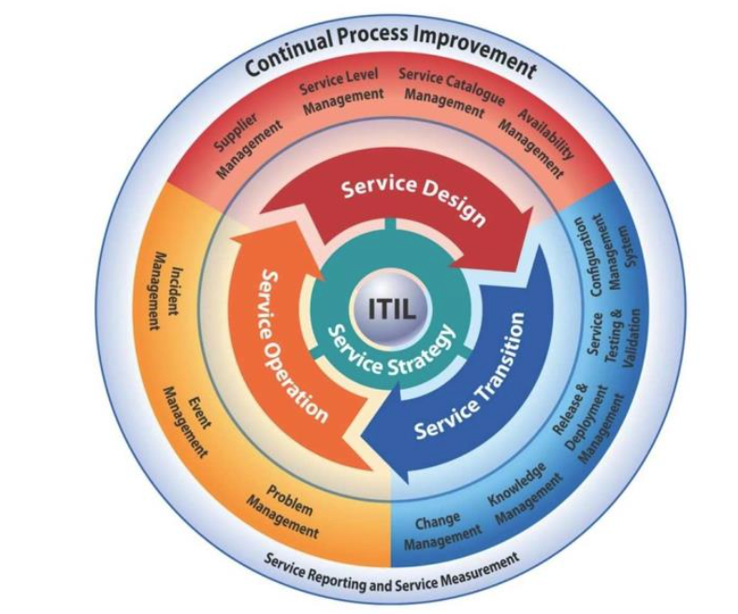
Figure 1 ITIL [1]

Diagram 2: ISO 27001 Application in NG's Information Security Management System

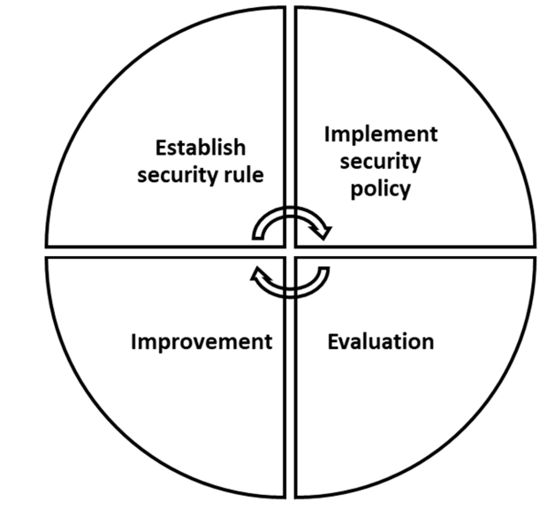
Figure 2: The process to implement ISO 27001 [3]

- Numerous widely recognized security frameworks and models are available for organizations to adopt, enhancing their information security posture. Here are several additional examples:

d. NIST Cybersecurity Framework:

The NIST Cybersecurity Framework, created by the National Institute of Standards and Technology (NIST), offers a voluntary set of standards, guidelines, and best practices for effectively managing cybersecurity risks. Widely utilized in the United States, this framework presents a comprehensive approach to cybersecurity, providing organizations with a structured methodology to enhance their security posture [2].

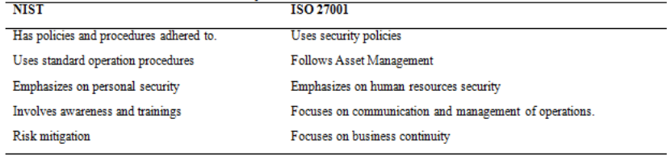
Figure 3: Key Difference between NIST and ISO 27001 [2]

e. COBIT (Control Objectives for Information and Related Technologies):

Originally developed by ISACA, COBIT is a governance and management framework designed to align information technology (IT) with business objectives. Focusing on ensuring compliance and implementing robust risk management practices, COBIT assists organizations in optimizing their IT processes and achieving strategic alignment with broader business goals [4].
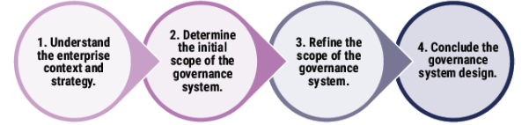

Figure 4: COBIT 2019 Objective Mapping [4]

f. CIS Critical Security Controls (CIS Controls):

Developed by the Centre for Internet Security (CIS), the Critical Security Controls offer a set of best practices designed to help organizations prioritize and implement crucial cybersecurity measures. Serving as a roadmap for enhancing cybersecurity posture and resilience, these controls provide practical guidance for organizations aiming to bolster their security defences.
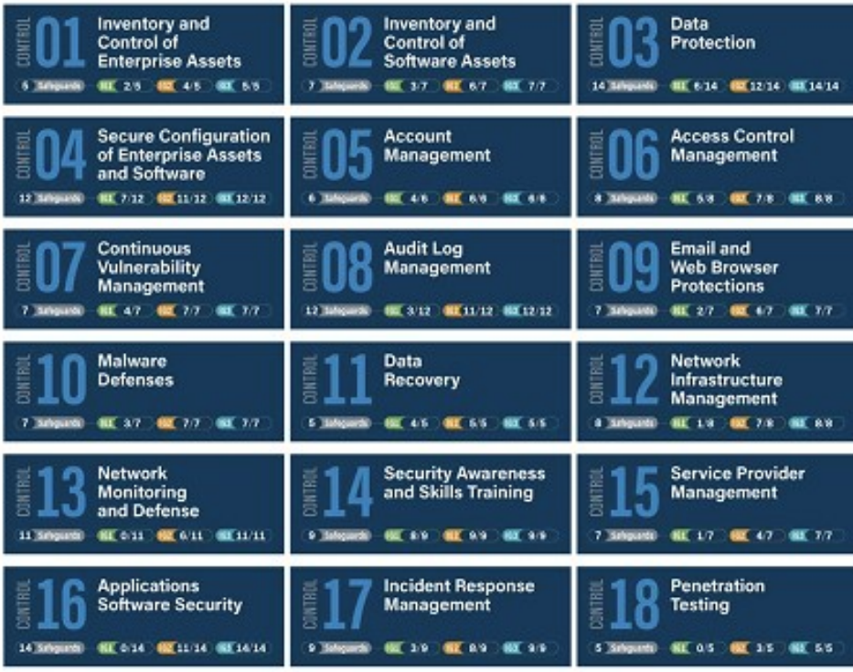
Figure 5: Controls in CIS [5]

g. Zero Trust Security Model:

In contrast to traditional security models relying on perimeter defences, the Zero Trust model assumes potential threats both inside and outside the network. This model mandates continuous verification of user identity and device health before granting access to resources, emphasizing a more proactive and dynamic approach to cybersecurity [6].

h. PCI DSS (Payment Card Industry Data Security Standard):

Created by the Payment Card Industry Security Standards Council, PCI DSS establishes a set of security standards to ensure that companies handling credit card information maintain a secure environment. This standard plays a critical role in safeguarding sensitive financial data and maintaining trust in payment transactions.
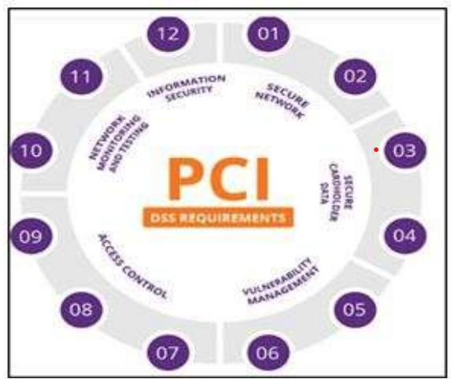
Figure 6: The PCI DSS Framework [7]

i. CMMI (Capability Maturity Model Integration):

Initially designed for software development, CMMI has evolved to encompass various aspects of organizational maturity, including cybersecurity. This framework provides a structured approach to improving processes and performance, aiding organizations in achieving higher levels of maturity across different domains.

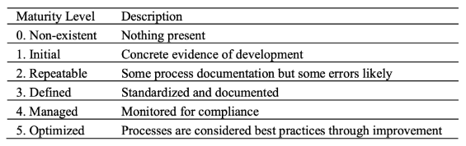
Table 1 : CMMI Maturity Model [1]

j. ISO 22301 (Business Continuity Management):

While not exclusively focused on information security, ISO 22301 addresses business continuity management. Ensuring that organizations can sustain operations during and after disruptions, this standard incorporates considerations for information security resilience, contributing to a holistic approach to organizational continuity planning.
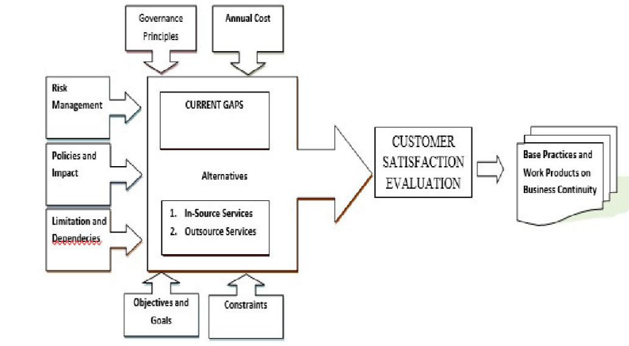
Figure 7: Business Continuity Strategy Approach [8]

3. Designing a Comprehensive Approach: Fortifying NatureGarden's Information Security, Governance, and Compliance

In response to the mounting challenges faced by NatureGarden (NG) in ensuring the security of its wireless-based network and accommodating personal device usage, a meticulously crafted approach is introduced. This strategy addresses the core aspects of information system security, governance, and compliance, aligning specifically with NG's distinctive needs and fostering a robust security framework.

3.1 Information System Security:

a. Governance Structure:
The Information Security Governance Board is positioned as the linchpin for NG's governance structure. This body, comprised of key stakeholders and experts, will provide strategic direction, oversee policy adherence, and ensure that information security aligns seamlessly with NG's overall business objectives. Roles and responsibilities will be meticulously defined, establishing a robust framework for governance [9].

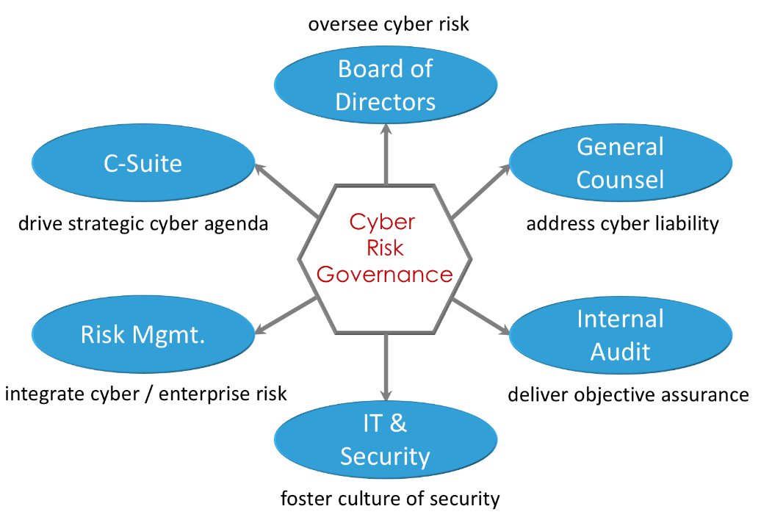
Figure 8: Visualizing the Information Security Governance Board [10]

Position | Responsibilities
Chief Information Security Officer (CISO) | Formulate and communicate security policies, provide strategic direction, and ensure compliance.
IT Security Manager | Implement security policies, conduct regular risk assessments, and oversee incident response.
Compliance Officer | Monitor regulatory changes, ensure NG's adherence, and coordinate legal aspects of security.
Table 2: Information Security Governance Board Responsibilities [11]

This detailed breakdown ensures a clear understanding of each role, fostering accountability and a coordinated approach to security governance.

b. Dynamic Security Policies:

Comprehensive security policies are crafted to address the nuanced challenges posed by personal device usage. The policies encompass data protection guidelines, access control frameworks, and incident response procedures. Aligning with international standards such as ISO 27001, these policies ensure that NG's information assets are shielded against evolving threats. A visual aid in the form of a table outlining key components of these policies will enhance accessibility and understanding across the organization [12].

Policy Aspect | Description
Data Protection | Guidelines for safeguarding sensitive data
Access Control | Framework for regulating user access
Incident Response | Procedures for effectively handling incidents
Table 3: Key Components of Comprehensive Security Policies [13] [14]

c. Risk Management:

Implementing a robust risk management framework involves regular risk assessments. A visual representation, like a risk assessment matrix, will be employed to prioritize potential threats and guide resource allocation for effective risk mitigation.
A robust risk management framework involves continuous risk assessments. The Risk Assessment Matrix visually prioritizes potential threats, guiding resource allocation for effective mitigation. Regular workshops and training sessions ensure that the risk-aware culture permeates the organization. This proactive approach enables NG to identify and address emerging risks promptly [12] [15].

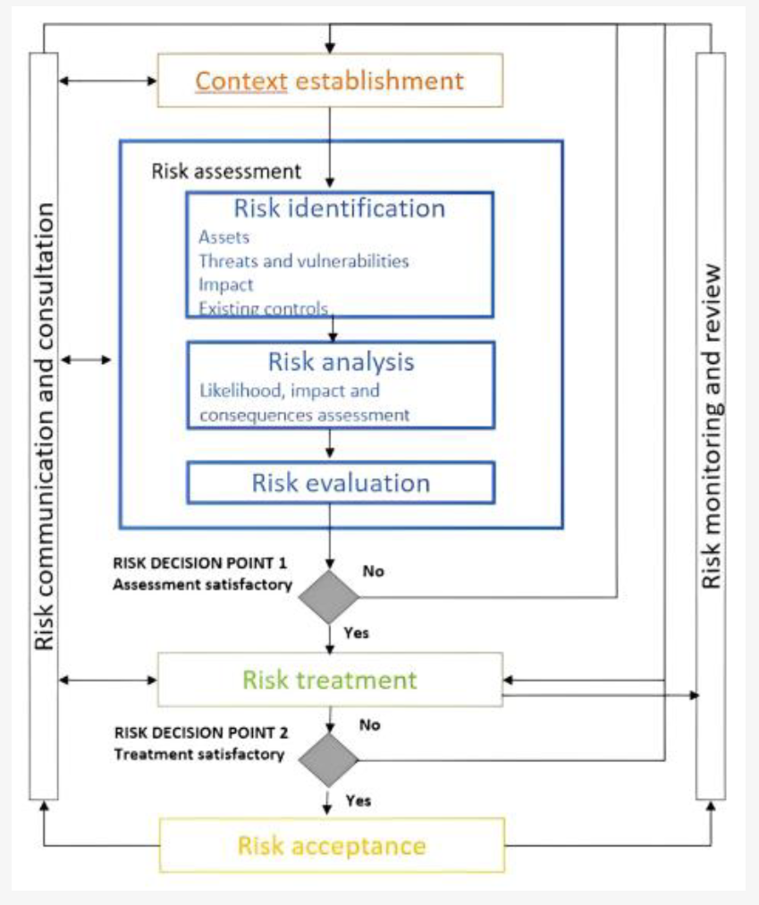
Figure 9: Illustrating the Risk Assessment Matrix [16]
Tool Name | Base Model | Type of Tool
MST risk analysis | ISO/IEC 27005, NIST 800-30, Octave | Quantitative
Teng Algorithm | ISO/IEC 27005 | Quantitative
R. Riesco model | ISO/IEC 27000 series | Quantitative
Mobile Risk Calculator | NIST 800-30, RISK watch, CORA | Quantitative
Nessus | NIST 800-30, HIPAA, PCI | Qualitative
CYRVM | NIST 800-30 | Quantitative
Cybersecurity evaluation tool CSET | NIST CSF, ISO/IEC 27001 | Qualitative
AWWA | NIST CSF | Qualitative
CSAT | NIST CSF | Qualitative
Table 4: Risk Assessment tools with an underlying risk assessment model extracted from primary studies [16]

3.2 Human Factors and Training:
An often-underestimated aspect of information security is the role of human factors. Employees play a crucial role in maintaining the integrity of NG's security framework. Therefore, a comprehensive training program is integrated into the approach. This program not only ensures that employees are well-versed in the latest security protocols but also cultivates a security-conscious culture within the organization.

a. Training Program Components:

Security Awareness Workshops:
Regular workshops are conducted to educate employees about the latest cybersecurity threats and best practices [17].

Simulated Phishing Exercises:
Simulated phishing exercises are employed to test employees' ability to recognize and respond to phishing attempts, a common entry point for cyber threats [18].
Role-specific Training Modules:
Tailored training modules are designed for different roles within the organization, ensuring that each employee receives relevant and targeted information.

This human-centric approach recognizes that technology alone cannot guarantee security. By investing in employee training, NG ensures that its workforce becomes an active line of defence against potential threats [17].

3.3 Technology Integration and Innovation:

The proposed approach integrates cutting-edge technologies to enhance NG's security posture. This includes the implementation of advanced threat detection systems, artificial intelligence-driven security analytics, and regular penetration testing. By staying at the forefront of technological innovation, NG not only detects and responds to threats more effectively but also positions itself as a technological leader in the industry [19].

a. Key Technological Integrations:

Advanced Threat Detection:
NG implements state-of-the-art threat detection systems capable of identifying and neutralizing emerging threats in real-time [20].

AI-driven Security Analytics:
Artificial intelligence is leveraged to analyse vast amounts of security data, providing insights into potential vulnerabilities, and enabling proactive threat mitigation [21].

Regular Penetration Testing:
NG conducts regular penetration testing to identify weaknesses in its systems, allowing for prompt remediation before malicious actors can exploit them.
The integration of these technologies reflects NG's commitment to not only meet current security standards but also anticipate and prepare for future threats [20].

3.4 Regulatory Compliance and Legal Oversight:

The legal and regulatory landscape surrounding information security is complex and ever-changing. NG's approach includes a dedicated legal oversight component to ensure that the company not only complies with existing regulations but also anticipates and prepares for future legal requirements [22].

Key Legal Oversight Measures:

Regular Legal Audits:
NG conducts regular legal audits to assess its compliance with existing regulations and identify areas that may require attention [23].

Legal Consultation for Emerging Threats:
In collaboration with legal experts, NG stays informed about emerging legal requirements related to information security, ensuring proactive compliance.

Incident Response Planning with Legal Considerations:
NG's incident response plan is crafted with legal considerations, ensuring that the company responds to security incidents in a manner that complies with legal requirements.
This legal oversight component is integral in providing NG with a comprehensive understanding of its legal responsibilities, reducing legal risks, and ensuring a proactive stance toward legal compliance [24].

3.5 Collaboration and Information Sharing:

Information security is a collective effort that extends beyond organizational boundaries. NG's approach emphasizes collaboration with industry peers, cybersecurity agencies, and law enforcement to collectively strengthen the overall security posture [25].

Key Collaboration Initiatives:

Industry Information Sharing Forums:
NG actively participates in industry forums where companies share information about emerging threats, vulnerabilities, and best practices.

Partnerships with Cybersecurity Agencies:
Collaborative partnerships with cybersecurity agencies provide NG with access to threat intelligence and proactive security recommendations [26].

Joint Training and Exercises:
NG collaborates with other organizations for joint cybersecurity training and simulated exercises to enhance collective preparedness.
By fostering collaboration and information sharing, NG contributes to the creation of a more resilient and secure global information ecosystem [27].

3.6 Continuous Improvement:

The approach is anchored in the principles of continuous improvement. Regular reviews and updates to governance structures, security policies, and risk management practices are integral. The dynamic nature of the cybersecurity landscape necessitates agility and adaptability. NG commits to staying abreast of emerging threats, technological advancements, and evolving industry standards, ensuring that its information security practices remain at the forefront.

3.7 Conclusion:

This meticulously designed approach, grounded in comprehensive research into security frameworks, positions NG to navigate the intricate landscape of information security with adaptability and resilience. The strategic use of visual aids, including tables and diagrams, enhances accessibility, providing a comprehensive and dynamic strategy for NG's information security, governance, and compliance needs.

4. Comprehensive Critique, Analysis, and Discussion

The challenges faced by NatureGarden (NG) in ensuring the security of its extensive wireless-based network and adapting to the demand for personal device usage necessitate a deep-dive critique, analysis, and discussion. The proposed approach is examined through various lenses, considering information system security, governance, compliance, human factors, training, technology integration, legal oversight, and collaboration.

a. Constant Evolution of Regulations and Standards:
Critique:
Strengths:
Emphasizes the significance of staying abreast of evolving regulations in the dynamic field of information security.
Acknowledges the importance of legal compliance and risk mitigation for NG's global standing.

Opportunities for Enhancement:
The critique could benefit from specific examples illustrating how the absence of a robust policy framework has exposed vulnerabilities.
Providing concrete instances would strengthen the analysis and underline the urgency of implementing comprehensive policies.

Analysis:
The critique appropriately underscores the necessity of an established policy framework while advocating for specific examples to fortify the argument. Illustrating instances where the lack of a policy led to vulnerabilities would provide a more tangible perspective on the urgency of implementation [28].

b. Adaptability and Preparedness:
Critique:
Strengths:
Recognizes the ever-changing nature of cybersecurity and the imperative for continuous updates to security policies.
Highlights NG's commitment to adaptability and preparedness in response to emerging threats.

Opportunities for Enhancement:
The analysis could gain depth by providing specific instances of NG successfully adapting to emerging threats.
A deeper exploration of how NG aligns with current industry trends would further support the assertion of preparedness.

Analysis:
The analysis effectively communicates the importance of adaptability and preparedness while suggesting opportunities for improvement. Specific examples of NG's successful adaptation and a deeper exploration of industry trend alignment would enhance the overall analysis [29].

c. Global Standards and Reputation:
Critique:
Strengths:
Recognizes the strategic importance of aligning with ISO 27000 series standards for global recognition.
Highlights the positive impact on NG's reputation and assurance to international clients.

Opportunities for Enhancement:
Adding specific instances where ISO compliance directly influenced NG's operations or client relationships would provide concrete support.
Exploring potential challenges or drawbacks in adhering to global standards could offer a more balanced perspective.

Analysis:
The analysis effectively emphasizes the strategic significance of adhering to global standards while suggesting opportunities for enhancement. Adding specific instances and exploring potential challenges would further enrich the analysis [30].

d. Risk Management and Contingency Planning:
Critique:
Strengths:
Recognizes the importance of a proactive risk management approach and the utility of a risk assessment matrix.
Emphasizes the continuous updates to contingency plans for business continuity.

Opportunities for Enhancement:
Including specific instances where the risk assessment matrix proved beneficial would enhance the critique.
Exploring potential challenges or limitations in the continuous updating of contingency plans would provide a more comprehensive view.

Analysis:
The analysis effectively highlights the importance of proactive risk management and continuous contingency planning while suggesting opportunities for improvement. Incorporating specific instances and exploring potential challenges would strengthen the overall analysis [31].

e. Continuous Improvement:
Critique:
Strengths:
Recognizes the importance of continuous improvement in the cybersecurity landscape.
Highlights NG's proactive stance in regularly reviewing and updating governance structures and security policies.

Opportunities for Enhancement:
Providing specific examples of improvements resulting from the iterative approach would add practical context.
Exploring potential challenges or limitations in the continuous improvement process could provide a more balanced perspective.

Analysis:
The analysis effectively emphasizes the importance of continuous improvement while suggesting opportunities for enhancement. Incorporating specific instances and exploring potential challenges would contribute to a more thorough and nuanced analysis [32].

f. Human Factors and Training:
Critique:
Strengths:
The Monthly Security Awareness Talks and Annual Security Drills show a dedication to continuous education and practical preparedness.
Role-specific Training Modules recognize the importance of tailoring training to individual job functions.

Opportunities for Improvement:
Enhancing the effectiveness of the program could involve incorporating interactive elements and real-world scenarios into training sessions.
Implementation of regular evaluation and feedback mechanisms is essential to gauge the impact of the training on employees' behaviour.

Analysis:
NG's emphasis on the human element is vital, acknowledging that employees are often the first line of defence. The diverse training components address different learning styles, contributing to a well-rounded security culture [33].

g. Technology Integration and Innovation:
Critique:
Strengths:
Adoption of a Threat Intelligence Platform and AI-driven Security Analytics reflects a commitment to staying ahead of evolving threats.
Regular Penetration Testing showcases a proactive approach to identifying and addressing vulnerabilities.

Opportunities for Improvement:
Continuous monitoring and adaptation are essential to keep pace with the rapidly evolving cybersecurity landscape.
Regular updates on the efficacy of implemented technologies and their impact on security posture should be provided.
Analysis:
NG's technological integrations align with industry best practices, demonstrating a forward-looking approach to cybersecurity. The emphasis on regular Penetration Testing is commendable for maintaining a robust security infrastructure [34].

h. Regulatory Compliance and Legal Oversight:
Critique:
Strengths:

Regular Legal Audits and legal consultations for threats demonstrate a commitment to staying compliant with evolving regulations.
Integration of legal considerations into incident response planning reflects a proactive approach.

Opportunities for Improvement:
Continuous monitoring of legal landscapes is crucial; mechanisms for real-time updates on legal requirements should be considered.
Communication of legal compliance measures to employees may enhance awareness.

Analysis:
NG's legal oversight measures contribute to proactive compliance and risk mitigation. Regular legal audits align with the dynamic nature of legal requirements, ensuring the company's responsiveness [35].

i. Collaboration and Information Sharing:
Critique:
Strengths:
Participation in industry forums, partnerships with cybersecurity agencies, and joint training initiatives showcase a commitment to collective security.
Actively engaging with law enforcement adds an extra layer of preparedness.

Opportunities for Improvement:
Transparency in sharing best practices and lessons learned from collaborative efforts can further benefit the broader community.
Regular assessments of the effectiveness of collaboration initiatives should be conducted.

Analysis:
NG's collaborative approach is commendable for creating a more resilient information ecosystem. The emphasis on sharing information, leveraging partnerships, and engaging in joint exercises contributes to a holistic security strategy [36].

6. Conclusion: Safeguarding the Future with a Comprehensive Information Security Strategy

NatureGarden (NG) is a global leader in health and wellness, facing challenges in a wireless and cloud-centric business environment. To address this, NG has developed a comprehensive information security strategy, emphasizing governance, compliance, and adaptability.
Key components of the approach include the creation of an Information Security Governance Board to centrally guide security initiatives in line with strategic goals. This structure promotes transparency and accountability throughout the organization. A detailed table outlines comprehensive security policies covering data protection, access control, and incident response.
The implementation includes a risk assessment matrix for agile risk management and resource allocation. The strategy recognizes the importance of staying updated on evolving regulations and standards to ensure legal compliance and proactive cybersecurity measures.
Human factors play a crucial role, with a Security Awareness Program emphasizing continuous training for the workforce as the first line of defence. NG invests in employee development to foster a security-conscious culture.
Additionally, technology integration, legal oversight, and collaboration contribute to a robust global information ecosystem. NG's use of advanced technologies, legal compliance measures, and collaborative efforts strengthen its security posture.
In conclusion, NG's comprehensive approach goes beyond information security, providing transferable skills for navigating complexities and fostering a culture of security. NG not only secures its operations but sets a benchmark for excellence in the industry, positioning itself as a leader in both healthy living products and information security practices. This strategy serves as a launchpad into a future fortified by knowledge, adaptability, and an unwavering commitment to excellence.

7. References

[1] | *. N. D. Y. A. T. A. D. R. H. S. I. C. S. N. R. H. Kharisma Putri Sholekha1, “Optimizing IT Service Strategies: A Performance Assessment through ITIL V3 in PT XYZ IT Operations Division,” International Journal of Informatics and Information Systems, vol. 6, pp. 169-180, 2023.
[2] | M. Alshar'e, “CYBER SECURITY FRAMEWORK SELECTION: COMPARISION OF NIST AND ISO27001,” Applied Computing Journal, vol. 3(1), pp. 245-255, 9 February 2023.
[3] | E. C. a. M. K. Fotis Kitsios *, “The ISO/IEC 27001 Information Security Management Standard:,” How to Extract Value from Data in the IT Sector, 27 March 2023.
[4] | M. I. F. Ruddy Kusuma Jaya1, “IT Project Management Control and The Control Objectives for IT and Related Technology COBIT2019 Framework,” Indonesian Journal of Computer Science, vol. 12, no. 5, pp. 2549-7286, 2023.
[5] | M. S. Ivan Bashofi, “Cybersecurity Maturity Assessment Design Using NISTCSF, CIS CONTROLS v8 and ISO/IEC 27002,” in IEEE International Conference on Cybernetics and Computational Intelligence (CyberneticsCom), Depok, 2022.
[6] | M. K. Y. M. Y. T. a. Y. K. T. Sasada, “Factor Analysis of Learning Motivation Difference on Cybersecurity Training with Zero Trust Architecture”.
[7] | M. D. Bajpai, “An study of Cyber Secusity Frameworks as Guidelines for Organisations,” International Journal of Aquatic Science, vol. 13, no. 01, 2022.
[8] | M. H. H. a. Derisma, “A Literature Review on Business Continuity Based on ISO 22301, Six Sigma and Customer Satisfaction Evaluation,” in 2018 International Conference on Information Technology Systems and Innovation (ICITSI), Bandung, 2019.
[9] | R. J. A. A. K. a. R. K. Biswas, “ A good-governance framework for urban management,” Journal of Urban Management, vol. 8, no. 2, pp. 225-236, 2019.
[10] | L. L. J. E. N. P. T. a. C. F. Yang, “Towards big data governance in cybersecurity,” Data-Enabled Discovery and Applications, pp. 1-12, 3 Dec 2019.
[11] | H. M. Melaku, “A Dynamic and Adaptive Cybersecurity Governance Framework,” Journal of Cybersecurity and Privacy, pp. 327-350, 2023.
[12] | E. M. Dunn Cavelty and A. Wenger, Cyber security politics : socio-technological transformations and political fragmentation, 1 ed., New York, NY: Routledge, 2022.
[13] | Y. D. C. D. S. M. N. N. &. F. T. Carlisle Adams, “Strengthening Enforcement in a Comprehensive Architecture for Privacy Enforcement at Internet Websites,” Frontiers in Computer Science (Lausanne), vol. 2, 2020.
[14] | E. D. Z. S. L. a. C. L. Y. He, “Agile incident response (AIR): Improving the incident response process in healthcare,” International journal of information management, vol. 62, p. 102435, 2022.
[15] | A. Q. a. P. Akhtar, “Risk matrix driven supply chain risk management: Adapting risk matrix based tools to modelling interdependent risks and risk appetite,” Computers & industrial engineering, vol. 139, pp. 105351-, 2020.
[16] | J. M. T. S. F. G. Isaac Daniel Sánchez-García, “Cybersecurity Risk Assessment: A Systematic Mapping Review, Proposal, and Validation,” Novel Approaches and Technologies for Software Engineering and IT Management, vol. 1, 28 December 2022.
[17] | W. J. Triplett, “Addressing Human Factors in Cybersecurity Leadership,” Journal of cybersecurity and privac, vol. 2, pp. 573-586, 2022.
[18] | H. H. W.-S. L. F. A. J. a. R. M. W. Yeoh, “Simulated Phishing Attack and Embedded Training Campaign,” The Journal of computer information systems, vol. 62, pp. 802-821, 2022.
[19] | Y. Chen, “Integration and technology innovation in technology-sourcing M&As-A comparative study on overseas and domestic M&As of Chinese enterprises,” Asian journal of technology innovation, vol. 30, pp. 715-737, 2022.
[20] | D. K. G. S. D. K. a. N. K. G. Sargsyan, Security Technologies and Methods for Advanced Cyber Threat Intelligence, Detection and Mitigation, Now Publishers, 2022.
[21] | G. L. A. N. K. Q. W. K. M. H. a. H. E. F. A. Khan, “AI-Driven Counter-Terrorism: Enhancing Global Security Through Advanced Predictive Analytics,” IEEE access, vol. 11, pp. 135864-135879, 2023.
[22] | J. P. a. C. J. G. Eddy, “Assessing and complying with regulatory oversight on utility performance,” Journal of business continuity & emergency planning, vol. 17, pp. 157-169, 2023.
[23] | S. C. X. L. N. N. a. A. R. V. Bateren, “Improving human rights in mental health takes more than just changing the law: An audit of medical assessments in regional community patients in Queensland,” Australasian psychiatry : bulletin of the Royal Australian and New Zealand College of Psychiatrists, vol. 30, pp. 195-199, 2022.
[24] | N. S. a. P. Kulkarni, “Cyber incident response and planning: a flexible approach,” Computer fraud & security, vol. 1, pp. 14-19, 2021.
[25] | A. G. T. A. P. a. G. B. B. J. R. Gil-Garcia, “Characterizing the importance of clarity of roles and responsibilities in government inter-organizational collaboration and information sharing initiatives,” Government information quarterly, vol. 36, pp. 101393-, 2019.
[26] | R. Hadley, “Cybersecurity for Public-Private Partnerships,” Living in a Dangerous World,” Security, vol. 56, pp. 38-41, 2019.
[27] | T. P. T. B. R. M. a. R. D. K. Ryselis, “Multiple Kinect based system to monitor and analyze key performance indicators of physical training,” Human-centric computing and information sciences, vol. 10, 2020.
[28] | Y. B. H. Z. W. &. Z. S. Xu, “Which financial earmarking policy is more effective in promoting FinTech innovation and regulation?,” Industrial Management + Data Systems, p. 2181, 2021.
[29] | L. X. D. Z. T. X. a. P. L. C. Chen, “A new model for describing the urban resilience considering adaptability, resistance and recovery,” Safety science, pp. 104756-, 2020.
[30] | A. B. A. M. P. a. E. K. O. Oriola, “A collaborative approach for national cybersecurity incident management,” Information and computer security, vol. 29, pp. 457-484, 2021.
[31] | J. J. M. H. a. J. H. M. Niemimaa, “Business continuity of business models: Evaluating the resilience of business models for contingencies,” International journal of information management, vol. 49, pp. 208-216, 2019.
[32] | A. A. Meteab, “Effect of Continuous Improvement of Information Technology Applications on E-Costumer Behavior in Social Media,” Webology, vol. 17, pp. 19-29, 2020.
[33] | M. A. P. a. A. A. E. K. Tzafilkou, “Teachers’ trainers’ intention and motivation to transfer ICT training,” The role of ICT individual factors, gender, and ICT self-efficacy,” Education and information technologies, vol. 26, pp. 5563-5589, 2021.
[34] | K. R. Jespersen, “Crowdsourcing design decisions for optimal integration into the company innovation system,” Decision Support Systems, vol. 115, pp. 52-63, 2018.
[35] | E. R. D. a. M. L. J. K. H. Campbell, “Sleepless over Cybersecurity: Legal Duties and Best Practices for Investment Company Directors,” The Investment Lawyer, vol. 28, pp. 18-30, 2021.
[36] | Q. T. S. H. Y.-C. C. a. C.-M. C. J. M.-T. Wu, “A Privacy Frequent Itemsets Mining Framework for Collaboration in IoT Using Federated Learning,” ACM transactions on sensor networks, vol. 19, pp. 1-15, 2023.

