Fault Tree Analysis

William Critchley

L5 - Systems Engineering (ACDB5021)

Wales Institute for Science and Art
University of Wales Trinity Saint David



Contents

Contents 2
Figures 3
Fault Tree Analysis 4
Calculations 5
Probabilities 5
AND & OR Gates 6
Example 6
Example – Impaired 7
Discussion 8
Conclusion 9
References 10

Figures
Figure 1: Basic Fault tree for loading a firearms magazine 4
Figure 2: Example Fault tree 6

Fault Tree Analysis
Fault tree analysis is an quantitative analytical method that focuses on the likelihood of an undesired event occurring. The technique uses a combination of logic gates and events; these are then laid out in an often graphical representation. The logic gates such and AND and OR allow for events to both impact the tree above them or not depending on what events are occurring. [1]
Fault trees were initially established in the 1960’s at the Bell Telephone Labs, working on the launch control systems on Minuteman ICBM’s. [2]
Each event on a fault tree is given a chance of occurring from 0 to 1, where 0 is impossible and 1 is certain. Each event will be matched with related events to make an event further up the tree occur, for example loading a firearms magazine could be broken down into the following basic tree
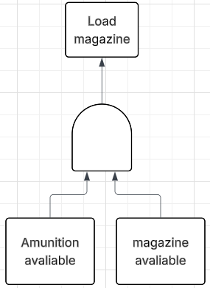
Figure 1: Basic Fault tree for loading a firearms magazine
The two main types of gates being used in this analysis are:
- AND Gates – where are the previous events must occur in order for the subsequent one to
- OR Gates – where either of a number of prerequisite potential events can occur for the subsequent event to occur
Conducting a fault tree analysis allows for the understanding of key impacting factors that will negatively affect the system if their capability is reduced, for example the tolerance for a propellant grain size, if the likelihood of an output being within spec drops it will impact wastage, slow down production and potential impact the performance of the system it is them used in.

Calculations

Probabilities
Given there are two states being taken into consideration for this analysis the probabilities for each are displayed below with adjustments made for impairments due to tiredness accounted for.
Event | Probability (Standard) | Probability (Impaired)
Tea availability | 0.98 | 0.98
Coffee availability | 0.98 | 0.98
Chance of leaky Kettle | 0.001 | 0.001
Chance of water supply failure | 0.01 | 0.01
Kettle reliability | 0.99 | 0.99
Plug in operation reliability | 0.89 | 0.6675
Switch on reliability | 0.89 | 0.6675
Mains supply failure chance | 0.01 | 0.01
Cup availability | 1 | 0.9
Cup reliability | 0.99 | 0.99
Milk availability | 0.95 | 0.95
Milk freshness | 0.95 | 0.95
Sugar availability | 0.88 | 0.88
Sweetener Availability | 0.99 | 0.99

The factors affected by the impairment are.
- Plugging in the kettle - 75% of original capability
- Turning on the kettle - 75% of original capability
- Selecting a cup – 90% of original capability
Applying these reductions to the initial capability gives the following reductions.
- Plugging in the kettle – 0.89*0.75 = 0.6675
- Turning on the kettle - 0.89*0.75 = 0.6675
- Selecting a cup – 1*0.9 = 0.9
When calculating the probabilities of the different event occurring AND and OR gates are calculated differently, this can be summed up as follows,

AND & OR Gates
The probability of the event after an AND gate occurring can be calculated by thanking the probability of each prerequisite event and multiplying them together to calculate the probability of the subsequent event occurring.
The method of calculating the probability of an OR gate is taking 1- the probability of each event happening and then multiplying these results together and taking this value away from 1.

e.g. when 3 events, A – P(0.2) B – P(0.4) C – P(0.5), cause a sequential event X .
For an AND gate the calculation would be
$P\left(x\right)=P\left(A\right)*P\left(B\right)*P(C)$ [3]
For an OR gate the calculation would be
$P\left(x\right)=1-(\left(1-P\left(A\right)\right)*\left(1-P\left(B\right)\right)*\left(1-P\left(C\right)\right))$[3]

Example
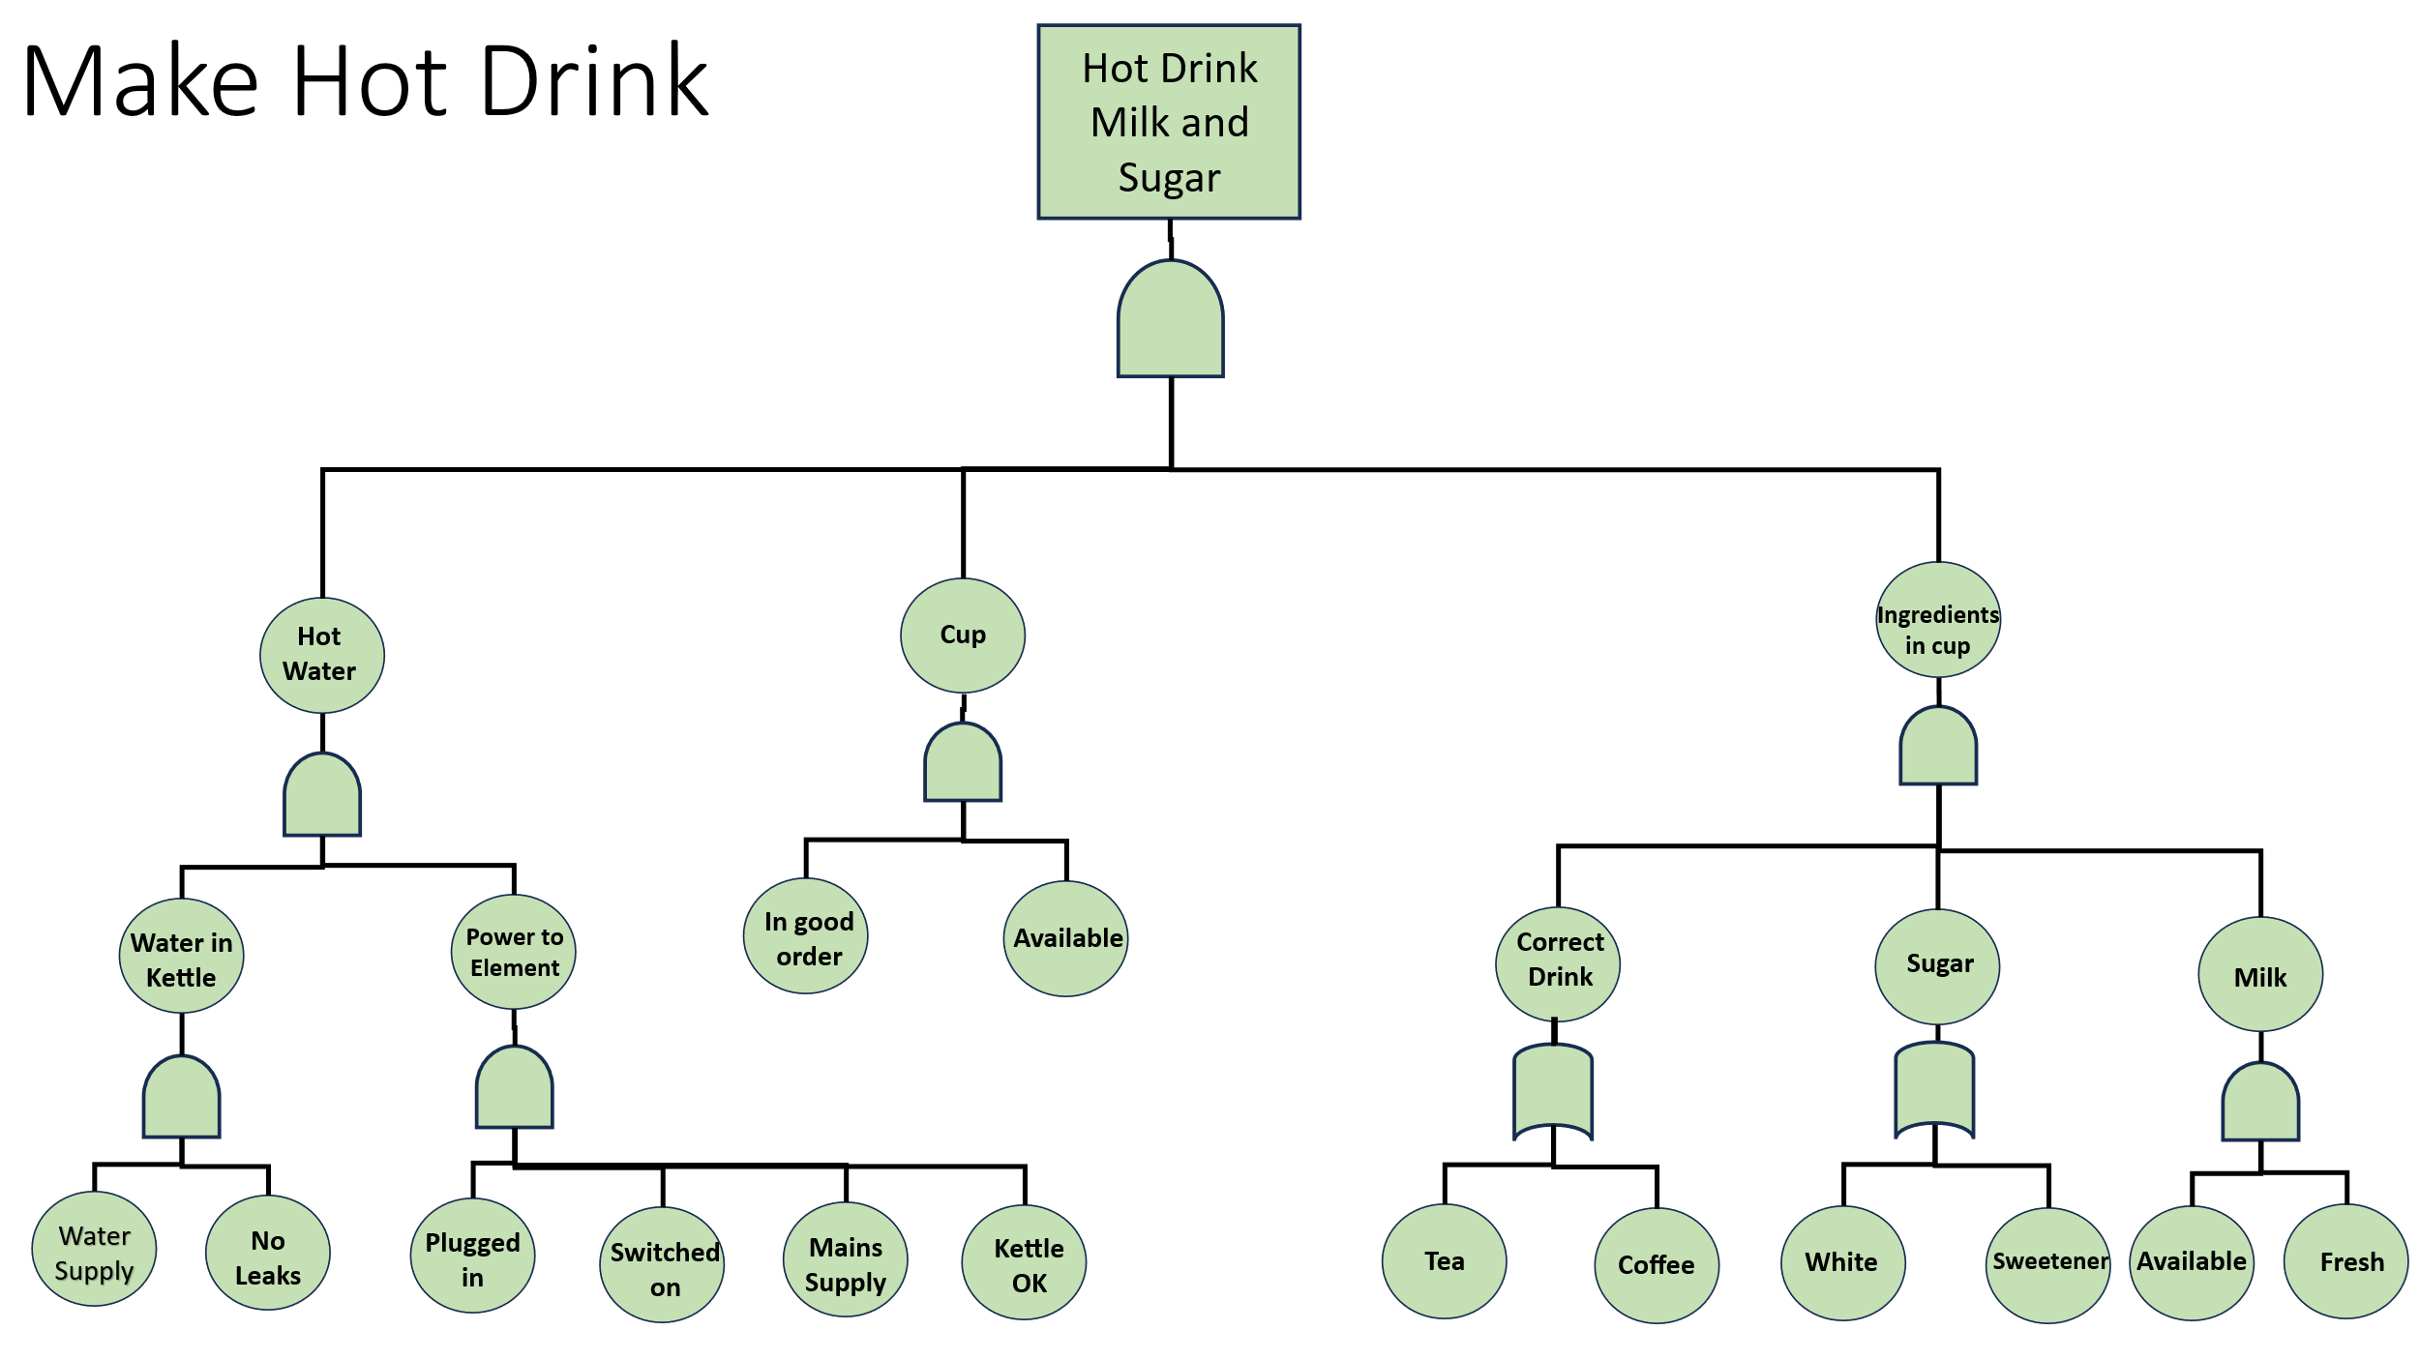
Figure 2: Example Fault tree

Starting from left to right:
- Water in kettle = 0.99*0.999 = 0.98901
- Power to element = 0.89*0.89*0.99*0.99 = 0.77633721
- Hot Water = 0.98901*0.77633721 = 0.7678052640621
- Cup = 1*0.99 = 0.99
- Correct Drink = 1-((1-0.98)*(1-0.98)) = 0.9996
- Sugar = 1-((1-0.88)*(1-0.99)) = 0.9988
- Milk = 0.95*0.95 = 0.9025
- Ingredients in cup = 0.9996*0.9988*0.9025 = 0.9010564332
- Hot drink = 0.7678052640621*0.99*0.9010564332= 0.6849175139
A 68.492% chance of making the drink correctly when under normal circumstances

Example – Impaired
Starting from left to right:
- Water in kettle = 0.99*0.999 = 0.98901
- Power to element = 0. 6675*0.6675*0.99*0.99 = 0.436689680625
- Hot Water = 0.98901* 0.436689680625 = 0.43189046103
- Cup = 0.9*0.99 = 0.891
- Correct Drink = 1-((1-0.98)*(1-0.98)) = 0.9996
- Sugar = 1-((1-0.88)*(1-0.99)) = 0.9988
- Milk = 0.95*0.95 = 0.9025
- Ingredients in cup = 0.9996*0.9988*0.9025 = 0.9010564332
- Hot drink = 0.43189046103*0.891*0.9010564332= 0.3467394914
A 34.674% chance of making the drink correctly when under Impaired circumstances.

Discussion
The Calculations section shows how even a small change in the probability of an event going wrong can have a significant impact on the results of an activity. The creating of a hot drink saw almost a 50% decrease in potential effective completion meaning the person conducting the action is almost twice as likely to successfully make a hot drink when not tired when compared to being tired. This provides insight into how the factors affecting the operator can heavily impact the outcome as in the scenario none of the hard factors related to the creation of the hot drink changed. Milk access remained the same, sugar access remained the same, the actual ability to get water into the kettle was not degraded these factors while significant in the overview of the system still fall down when met with poor results for the calculation of the final outcome.

Conclusion
This exercise allowed students to gain a practical understanding of how fault trees work and their application to a real-world problem, the inclusion of a undesirable factor negatively impacting results showed how these factors need to be controlled to maintain a level of assurance over the final output.
This toolset will provide helpful when thinking about system in the workplace allowing for more critical features to be recognised and the ensuring of their function prioritised.

References
[1] Ministry of Defence, “Fault Tree Analysis”, ASEMS, [Online] Available: https://www.asems.mod.uk/printpdf/toolkit/fault-tree-analysis
[2] Prof J. Andrews Dr S. Lunt, “An Introduction to Fault Tree Analysis”, University of Nottingham, [Online], Available: https://www.nottingham.ac.uk/research/groups/resilience-engineering/documents/nxgen/outputs/an-introduction-to-fault-tree-analysis.pdf
[3] W. E. Vesely, F. F. Goldberg, N. H. Roberts, D. F. Haasl, “Fault Tree Handbook”, U.S. Nuclear Regulatory Commission, January 1981, [Online] Available: https://www.nrc.gov/docs/ML1007/ML100780465.pdf

