
Master of Business Administration
International Business pathway


Contemporary employability skills
Assessment 1: Individual report. Weight: 50%

Module name: Financial Management
Module code: LCMB7002

Lecturer name: Dr Shengfeng Mei

Student name: Md Ismail Hossan
Student ID: 2521543

Word count: 5405

Submission date: 23.4.2026

AI use acknowledgement
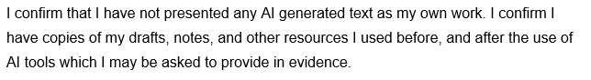

Executive Summary
The report analyses the financial viability and competitive standing of Hyundai Motor Company in the five years span; FY2020 to FY2024. The analysis indicates that revenue, profitability and shareholder returns are growing vigourously, with a transition toward premium vehicles and electric mobility. The financial ratios show that the profitability is enhanced, and that leverage is steady, and the liquidity is also sufficient, although the long-term assets are extremely high. The management of working capital is effective, with good relationships with suppliers and effective receivables management, but the growing EV operations necessitate stricter inventory management. Strategic financial restructuring in the form of selective divestments, equity financing, and joint ventures to sustain future growth without compromising financial risk is also proposed in the report. Findings of the investment appraisal indicate that Project C is the most appropriate choice, since it excels in all the financial metrics. Within the constraints of capital, a blend of Projects B and C is advisable in terms of optimal risk and in terms of good returns. Altogether, Hyundai is financially competent and in a good position to grow over long term in the dynamic global automotive industry.
Table of Contents
Executive Summary 3
1. Introduction 1
2. Financial Health Check: 5-Year Ratio Analysis (FY2020–FY2024) 2
2.1 Overview of Financial Performance 2
2.2 Profitability Ratios 3
2.3 Liquidity and Efficiency Ratios 5
2.4 Gearing Ratios 6
2.5 Investment Ratios, Cash Flow Analysis, Strengths and Threats 7
2.6 Cash Flow Analysis, Strengths and Threats 8
3. Working Capital Management Analysis 10
3.1 Cash Operating Cycle 10
3.2 Working Capital Reforms to Improve Liquidity 10
3.3 Short term vs Long term Financing 11
4. Strategic Financial Restructuring Plan 12
4.1 Recommended Financial Restructuring Options 12
4.2 Impact on Shareholder Value and Capital Structure 13
4.3 International and Ethical Considerations 13
5. Investment Appraisal and Capital Budgeting 14
5.1 Overview of Projects and Assumptions 15
5.2 Payback Period (PBP) 15
5.3 Accounting Rate of Return (ARR) 16
5.4 Net Present Value (NPV) 17
5.5 Profitability Index (PI) and IRR 17
5.6 Project Recommendation 18
5.7 Capital Rationing Decision 19
6. Conclusion 19
References 21
Appendices 24
Appendix A: Ratio Tables 24
Appendix B: Investment Appraisal Calculations 25

List of Figures
Figure 1: Hyundai Motor Key Financial Highlights (FY2020–FY2024) 3
Figure 2: Hyundai Motor Profitability Ratios (FY2020–FY2024) 4
Figure 3: Hyundai Motor Liquidity and Efficiency Ratios (FY2020–FY2024) 6
Figure 4: Hyundai Motor Gearing Ratios (FY2020–FY2024) 7
Figure 5: Hyundai Motor Investment and Shareholder Return Ratios (FY2020–FY2024 8
Figure 6: Working Capital Reforms to Improve Liquidity 11

List of Tables
Table 1: Hyundai Motor Key Financial Highlights (FY2020–FY2024) 2
Table 2: Hyundai Motor Profitability Ratios (FY2020–FY2024) 4
Table 3: Hyundai Motor Liquidity and Efficiency Ratios (FY2020–FY2024) 5
Table 4: Hyundai Motor Gearing Ratios (FY2020–FY2024) 7
Table 5: Hyundai Motor Investment and Shareholder Return Ratios (FY2020–FY2024) 8
Table 6: Project Cash Flows (£ million) 15
Table 7: Payback Period Calculations 15
Table 8: ARR Calculations 16
Table 9: NPV Calculations at 10% Discount Rate 17
Table 10: PI and IRR Summary 17
Table 11: Investment Appraisal Summary 18
Table 12: Capital Rationing — Combined Portfolio Analysis 19

1. Introduction
Hyundai Motor Company is a large international car producer which has developed as a local South Korean company to become an essential participant of the modern mobility industry. Nowadays, it is not only about classic cars it is also about electric cars, clean energy solutions and modern technologies such as autonomous driving. As part of the Hyundai Motor Group, the company has strengthened its global position and continues to compete with leading automotive brands worldwide. Its transition to electric cars and models that are more luxurious indicates the changing nature of the industry, as there is growing need of new and more technologically advanced and environmentally friendly transport options. Companies such as the International Energy Agency point out the fast increase in global uptake of electric cars, and market trends in other countries such as the UK, as detailed in the Society of Motor Manufacturers and Traders, demonstrate how policies and consumer preferences are defining the future of the industry. This report assumes the role of a Chief Financial Officer to analyse the financial performance of Hyundai within the past five years based on their published annual reports. The report will discuss the general financial health of the company using important ratios, discuss the effectiveness of the management in working capital and cash flow and recommend where applicable. It will also present financial strategies to facilitate future growth and appraise potential investment projects based on standard financial appraisal techniques to facilitate sound decision making.

2. Financial Health Check: 5-Year Ratio Analysis (FY2020–FY2024)

2.1 Overview of Financial Performance
The Hyundai motor composition has depicted a marked and steady enhancement in its financial performance in the last five years. After the setbacks caused by the global pandemic, the company proceeded with an upward trajectory toward recovery due to the increase in demand and the transition towards more premium vehicles, as well as an upsurge in the emphasis on electric mobility. Instead of simply depending on the sales volume, Hyundai has been adding value to the product mix, which has boosted its general profitability. Meanwhile, this upward trend has been supported by improvements in cost control, and operational efficiency.
The firm has seen a remarkable growth in its earnings over this time not only in terms of increased revenues but also better margins. The most recent year has seen slight softening, primarily because of the greater investment in electrification, and some weakening of the global demand, but in general profitability is much more robust than it has been in prior years. This indicates that Hyundai has been able to invest in the main business and is ready to encounter changes in the industry in the future.
Financial position Hyundai has increased its total assets substantially, in part through its ongoing investment in new technologies, production plants and international expansion initiatives including its manufacturing plant in the United States. Equity levels of shareholders have also been growing steadily aided by retained earnings and steady returns on investors. All these points suggest that Hyundai is not facing down at all but is aggressively in the process of positioning towards long term expansion within the changing car industry (Putri et al., 2023).
Table 1: Hyundai Motor Key Financial Highlights (FY2020–FY2024)
Metric | FY2020 | FY2021 | FY2022 | FY2023 | FY2024
Sales Revenue (KRW bn) | 103,998 | 117,611 | 142,528 | 162,664 | 175,231
Operating Income (KRW bn) | 2,395 | 6,679 | 9,820 | 15,127 | 14,240
Net Income (KRW bn) | 1,925 | 5,693 | 7,984 | 12,272 | 13,230
Total Assets (KRW bn) | 209,344 | 233,946 | 255,742 | 282,463 | 339,798
Shareholders' Equity (KRW bn) | 69,481 | 74,986 | 82,349 | 92,497 | 109,103
Source: Hyundai Motor Company Integrated Report (2024a); Excel Appendix A.
Figure 1: Hyundai Motor Key Financial Highlights (FY2020–FY2024)
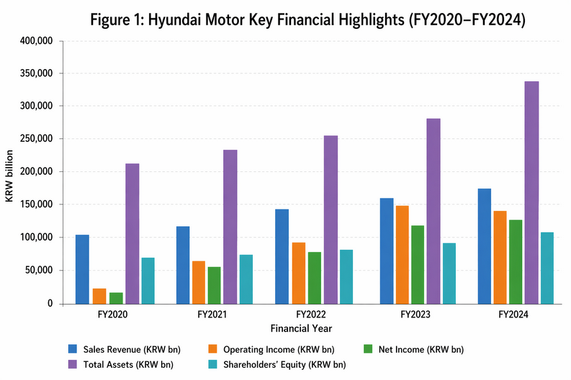

2.2 Profitability Ratios
The profitability profile of Hyundai Motor indicates that over the five-year period, profitability was near the upward trend which is explained by the compounding effect of the favourable exchange rates, the premium product mix with the enrichment of the product mixture by Genesis and SUV models and the rising cost efficiency ( Hyundai Motor Company, 2024b). The operating profit margin had dropped as low as 2.3% in FY2020 to 9.3% in FY2023, before stabilizing at 8.1% in FY2024, which can be explained by the increased electrification-related spending and 1.8% decrease in vehicle volumes worldwide. The net profit margin followed the same pattern with this figure increasing to 7.55 per cent in FY2024 compared to the previous year, FY2020, where the figure stood at 1.85 per cent. Such numbers are favourable compared to the industry average operating margin of about 67 in the automotive industry and all show Hyundai as no longer a volume-oriented and margin-sensitive operator but a more prestigious manufacturer (Sabrina, 2025).
The Return on Equity (ROE) is most didactic. This improvement is a sign of good net income growth of 7.8 percent on year-on-year basis, as well as, effective capital deployment. Return on Assets (ROA) also increased twofold to 6.0% during the time indicating that the huge growth in asset base has been proportional to earnings growth (Hyundai Motor Company, 2024a). There was an increase in the EBITDA between FY2020 and FY2024, KRW 6,580 billion EBITDA to KRW 18,527 billion, although the FY2024 EBITDA margin of 14.64% is significantly greater than in past years, which could indicate the management of depreciation and operational leverage. Nevertheless, the modest FY2023–FY2024 operating margins softening is worth keeping an eye on since the increasingly high R&D, currently at KRW 4,586 billion in FY2024, and capital intensity in EV infrastructure might squeeze the operating margins further within the short term (Kang et al., 2023).
Table 2: Hyundai Motor Profitability Ratios (FY2020–FY2024)
Ratio | FY2020 | FY2021 | FY2022 | FY2023 | FY2024
Operating Profit Margin | 2.30% | 5.68% | 6.89% | 9.30% | 8.13%
Net Profit Margin | 1.85% | 4.84% | 5.60% | 7.54% | 7.55%
Return on Equity (ROE) | 10.0% | 10.2% | 11.5% | 9.0% | 15.8%
Return on Assets (ROA) | 3.8% | 3.9% | 4.4% | 3.5% | 6.0%
EBITDA (KRW bn) | 6,580 | 11,235 | 14,868 | 20,074 | 18,527
EBITDA Margin | 10.72% | 11.30% | 12.76% | 10.52% | 14.64%
Source: Hyundai Motor Company Integrated Report (2024a); Excel Appendix A.
Figure 2: Hyundai Motor Profitability Ratios (FY2020–FY2024)
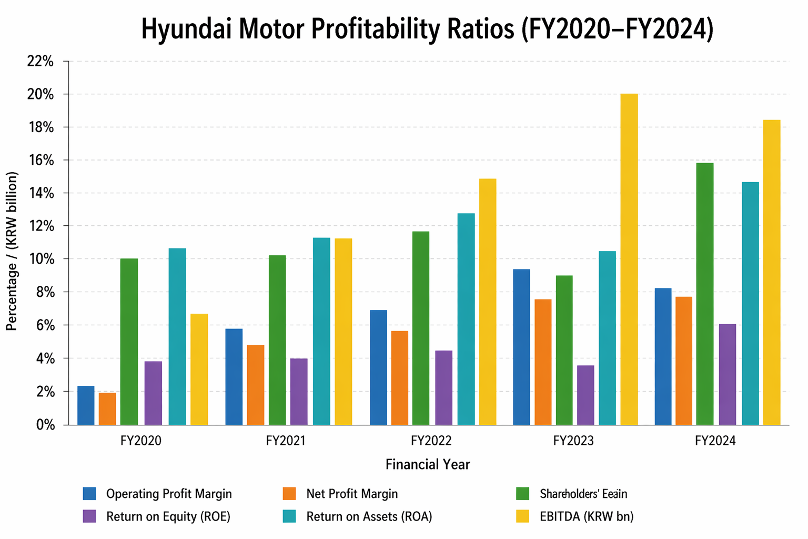

2.3 Liquidity and Efficiency Ratios
The liquidity position of Hyundai Motor is defined by rather small liquid asset ratios considering the total assets. The liquid assets as a percentage of the total assets also five-year trend were more or less the same with a high point in FY2022 at 10.4 percent and a low point in FY2024 at 8.1 percent (Hyundai Motor Company, 2024a). This implies that, although, the company has sufficient short-term coverage, a higher proportion of the increased asset base is held in long-term productive assets in line with its capital-intensive EV expansion programme. The key measure of liquid assets (in absolute terms) however increased by KRW 17,082billion to KRW 27,488billion indicating that the absolute liquidity has increased but not the ratio.
Efficiency wise, the turnover of assets decreased somewhat between 0.50 in FY2020 and 0.52 in FY2024 with 0.576 in between Year 2022 and 2023. This simple efficiency indicator indicates how difficult it is to achieve approximate comparable revenue growth over an expanded base of assets due to pre-operating manufacturing of EVs investments - a trend that is observable in the context of working capital management in high capitalised automotive sectors (Lind et al., 2012). The ratio of CapEx to sales was high during the formula, and it stayed between 4.0 percent and 6.1 percent; this confirms the report of Hyundai Motor Company, which planned KRW 8.6 trillion in capital spending in 2025 alone (Hyundai Motor Company, 2024a). The ratio of R&D investment and sales was 2.3 to 2.98 an indication of continued but controlled investment in next generation vehicle platforms.
Table 3: Hyundai Motor Liquidity and Efficiency Ratios (FY2020–FY2024)
Ratio | FY2020 | FY2021 | FY2022 | FY2023 | FY2024
Liquid Assets / Total Assets | 8.16% | 8.44% | 10.42% | 9.38% | 8.09%
Asset Turnover (times) | 0.497 | 0.503 | 0.557 | 0.576 | 0.516
CapEx to Sales | 6.14% | 4.98% | 4.02% | 5.95% | 5.92%
R&D to Sales | 2.98% | 2.63% | 2.34% | 2.44% | 2.62%
Source: Hyundai Motor Company Integrated Report (2024a); Excel Appendix A.

Figure 3: Hyundai Motor Liquidity and Efficiency Ratios (FY2020–FY2024)
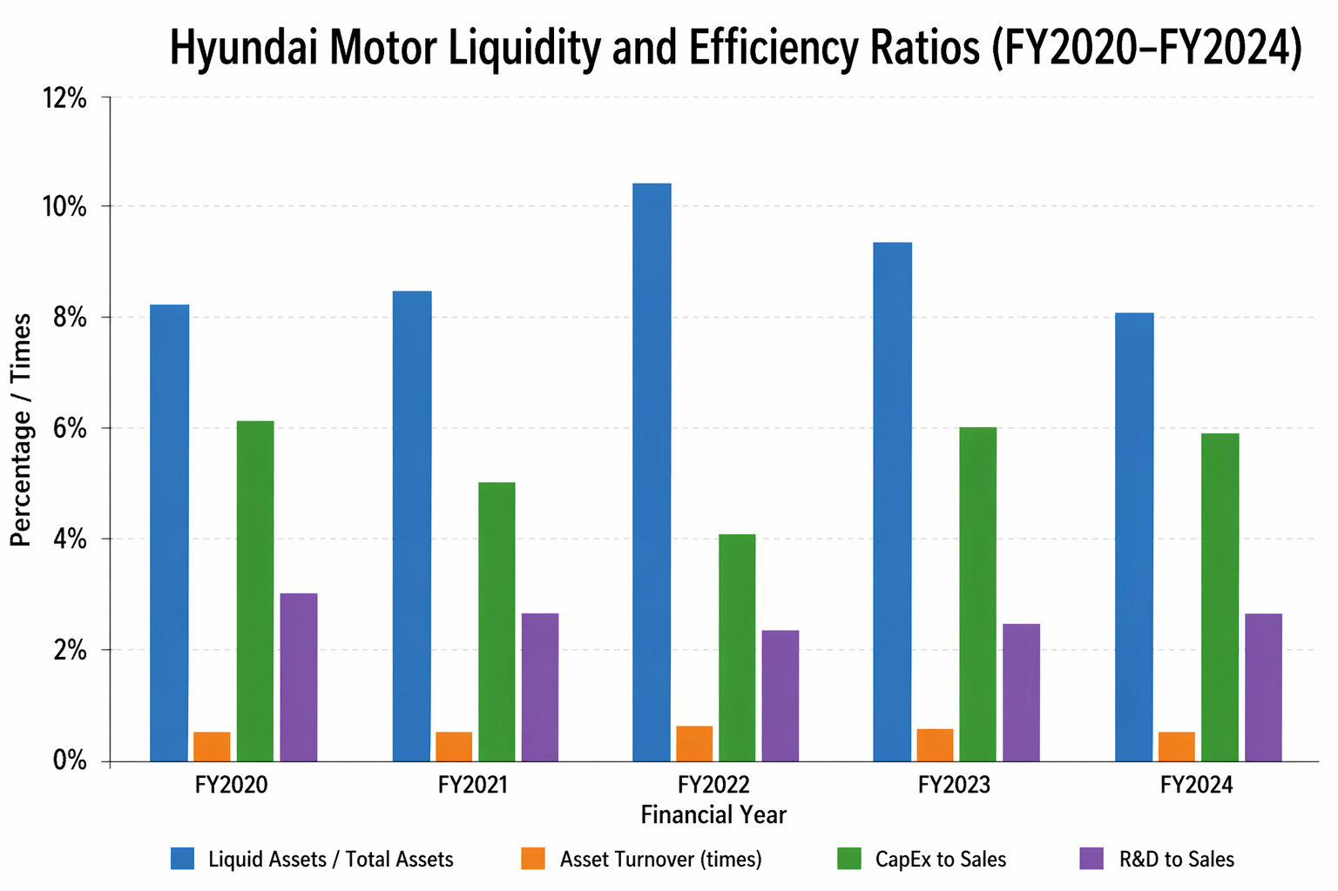

2.4 Gearing Ratios
The gearing of Hyundai Motor is relatively stable and moderately leveraged across the FY 2020 to FY 2024. Debt ratio showed a steady range of between 0.618 and 0.624, which means that about 61-62% of total asset is financed by liabilities. Such a gearing is not particularly extraordinary in a large automaker company with a capital-intensive production process and a large financial services company (Hyundai Capital) that entails a considerable amount of borrowing (Chen et al., 2023). The debt-to-equity (D/E) ratio was also range-bound at between 1.58 and 1.66; FY2022 being the least aggressive at 1.58. An equity ratio of about 32–33 in the process who is sure that a constant percentage of financing is given by equity is assertive that the global norms of the automotive industry are fairly governed (Kim, 2025).
The equity ratio is kept at approximately 32 supported by the solid growth of the net income and the increase of shareholders equity with KRW 69,481billion in FY2020 to KRW 109,103 billion in FY2024 (Hyundai Motor Company, 2024a). Such strength in the equity base indicates the ability by Hyundai to finance a large part of its growth internal to the capital markets rather than depending on the debt capital markets as the overall level of investment grows. The slightly increasing D/E ratio between FY2022 and FY2024 (1.58 to 1.63) is however indicative of a slight rise in leverage that the CFO must closely watch due to the growing global interest rates and the massive future investment obligations being undertaken after the Hyundai Way plan (Hyundai Motor Company, 2024a).
Table 4: Hyundai Motor Gearing Ratios (FY2020–FY2024)
Ratio | FY2020 | FY2021 | FY2022 | FY2023 | FY2024
Equity Ratio (Equity/Assets) | 33.2% | 32.1% | 32.2% | 32.7% | 32.1%
Debt Ratio (Liabilities/Assets) | 61.8% | 62.4% | 61.2% | 61.9% | 62.0%
Debt-to-Equity (D/E) | 1.618 | 1.660 | 1.579 | 1.622 | 1.633
Source: Hyundai Motor Company Integrated Report (2024a); Excel Appendix A.
Figure 4: Hyundai Motor Gearing Ratios (FY2020–FY2024)
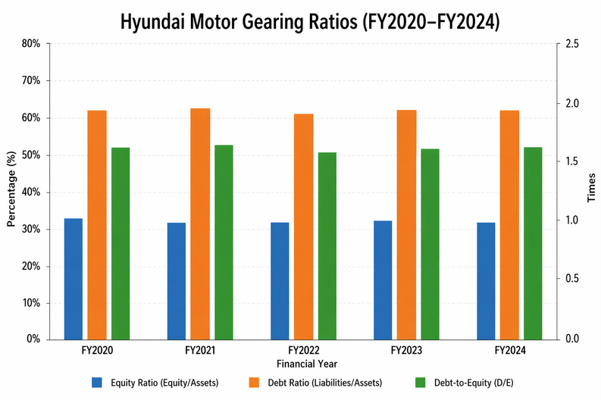

2.5 Investment Ratios, Cash Flow Analysis, Strengths and Threats
The investment and shareholder return profile of Hyundai Motor shows a significant trend over the five years. The dividends per share increased drastically, and KRW 5,454 in FY2020, to KRW 47,615 in FY2024, and total shareholder returns (dividends and buybacks) increased, but KRW 1,197 billion to KRW 4,145 billion (Hyundai Motor Company, 2024a). There was also a degree of volatility in the payout ratio, with an immediate decrease in the ratio, 20.4% in FY2024, to an increase of 33.4% in FY2023, representing Hyundai's pragmatic position of tuning distributions to the capital requirements instead of pursuing a conservative policy. This aligns with the targeted shareholder return of more than 35% which is to be implemented between 2025 and 2027 according to the company (Hyundai Motor Company, 2024a). Capital expenditure increased significantly, reaching KRW 6,389 billion in FY 2020, and KRW 10,367 billion in FY 2024, which supports the fact that manufacturing investment is truly undergoing intensification.
Table 5: Hyundai Motor Investment and Shareholder Return Ratios (FY2020–FY2024)
Metric | FY2020 | FY2021 | FY2022 | FY2023 | FY2024
Dividends per Share (KRW) | 5,454 | 18,979 | 28,521 | 45,703 | 47,615
Payout Ratio | 30.2% | 29.8% | 25.3% | 33.4% | 20.4%
CapEx (KRW bn) | 6,389 | 5,861 | 5,734 | 9,671 | 10,367
Total Shareholder Return (KRW bn) | 1,197 | 1,492 | 1,548 | 2,499 | 4,145
Source: Hyundai Motor Company Integrated Report (2024a); Excel Appendix A.
Figure 5: Hyundai Motor Investment and Shareholder Return Ratios (FY2020–FY2024
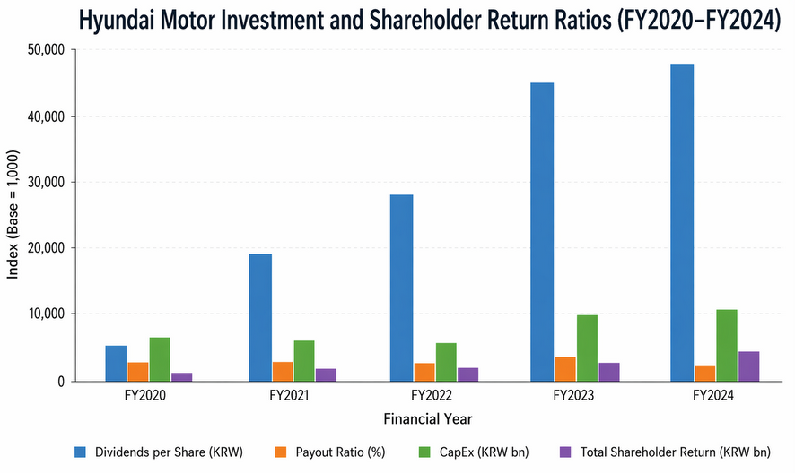

2.6 Cash Flow Analysis, Strengths and Threats
Hyundai's key financial strengths include consistent revenue growth, recovering and now premium-level profitability margins, a stable equity ratio, and escalating shareholder returns (Kang et al., 2023). This is supported by the success of its IONIQ range, high price elasticity in the premium Genesis segment and advantages of an international diversified manufacturing network. Its major threats are the fact that its FY2024 operating income is going to decrease by a slight margin (1.8% on-Year) due to the decreasing vehicle sales globally, the increasing rivalry force because of the increasing sales of Chinese EVs, and the currency risk because of its high percentage of revenues in USD and EUR and costs in KRW-denomination (IEA, 2024). The UK market is an opportunity, as well as a regulatory risk, and BEV registrations hit a high level of 381,970 units in 2024 but fell short of a necessary 22% ZEV target indicating that the conditions of demand incentives are not yet stable (SMMT, 2025).

3. Working Capital Management Analysis
Working capital management is a safe management of the short run assets of a company as well as short run liabilities so as to maintain the business operations, maintain sufficient liquidity and the effective utilisation of money at the workplace (Kang, 2023). Proper management of the working capital will directly determine the profitability of a firm, its exposure to risk and its ability to meet both operating needs as well as strategic investments without having to resort to the expensive external funding (Demiraj et al., 2022). Capital-intensive global company like Hyundai Motor found it especially telling to optimise on what it stores or recalls as well as payables in relation to its supply chain due to the magnitude of its chain and its geographic distribution.

3.1 Cash Operating Cycle
The trend of the cash operating cycle in Hyundai Motor depicts an effective and gradually enhancing trend. The firm has augmented its liquid assets, which is an improved financial flexibility and a buffer against financial crises. The post-pandemic asset utilisation also increased such as Hyundai could generate higher revenue with its assets. This however, was not much improved as more production facilities were introduced before realisation of full returns. The dealers mainly sell the vehicles on behalf of the company, a factor that accelerates it to receive payments as opposed to the direct model of sale. This helps to achieve that the receivables cycle is shorter. Simultaneously, Hyundai has high bargaining power on the side of suppliers because of its global size. This enables the company to postpone payments and exploit supplier credit as a cheap source of finance. Lind et al. say that this is typical of large automotive companies. In general, Hyundai is well-positioned in working capital but should adjust to the emerging models of EV sales (Jo et al., 2023).

3.2 Working Capital Reforms to Improve Liquidity
The reforms that will enhance the liquidity situation at Hyundai Motor Company must also be analyzed against other competitors to entail the strategic relevance. Hyundai has a less efficient cash cycle of 28 day compared to BYD Company Limited (18 days) and Toyota Motor Corporation (23 days) and weak compared to Volkswagen (37 days) as can be seen in the cash cycle structure. First, increasing supply chain financing will help Hyundai approach BYD in terms of longer payables (65 days) with greater success, enhancing liquidity and securing suppliers (Hyundai Motor Company, 2024b). Second, Hyundai should improve inventory control, which is longer than Toyota and BYD, and holding costs and risk of obsolescence in the rapidly changing EV market; it can solve it with the just-in-time and sophisticated forecast technique. Third, receivables management has to be reinforced, with Hyundai, 45 days being larger than Toyota, as early payment incentives should be offered (Hieu and Trang, 2022). All these reforms enhance efficiency in converting cash and long-term financial stability for Hyundai.
Figure 6: Working Capital Reforms to Improve Liquidity
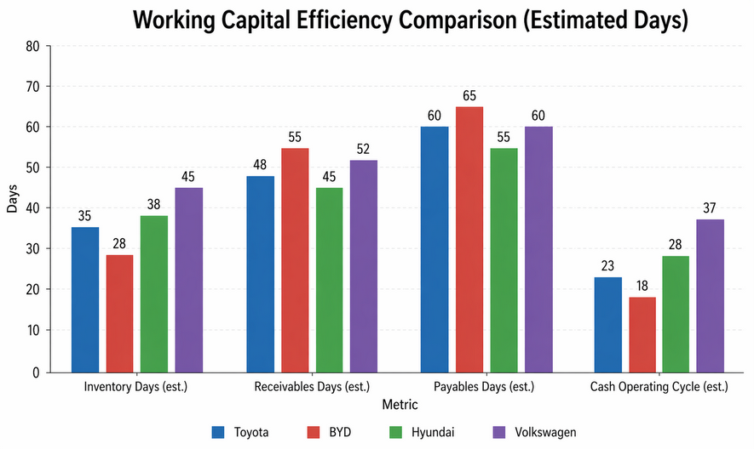

3.3 Short term vs Long term Financing
Hyundai Motor is financed by short term and long-term sources. Trade credit and commercial paper are short term sources of finances, they are flexible and cheap to start with. These sources, however, are riskier in case interest rates are higher or refinancing is a hard task. Long term financing incorporates bonds and loans, which present more stability and planning future investments. Another advantageous aspect to Hyundai is the high internal capital with its financial service facility and steady influx of cash. This enables the company to finance a big portion of its investments in house (Hyundai Motor Company, 2024a). Nonetheless expansion plans in the future under its long-term strategy will necessitate it to seek external financing. Green bonds and other long-term instruments are particularly helpful because they coincide with the sustainability principles. Demiraj et al. (2022) hold that a balanced form of financing lowers risks and enhances financial capabilities. Thus, Hyundai ought to keep a combination of the two forms of financing.

4. Strategic Financial Restructuring Plan
Strategic financial restructuring refers to the systematic reorganisation of the capital structure, asset portfolio and financial activities of a firm to become more effective in long-term value creation and competitive positioning as well as financial risk management (Pike et al., 2019). In the case of Hyundai Motor, the urgency is not that of distress-based restructuring but rather of targeted capital reallocation that is on the one hand a shift of financial and organisational resources out of its mature, lower-return activities into the high-growth EV, hydrogen, and software-defined vehicle categories upon which automotive competitiveness will be based through the 2030s.

4.1 Recommended Financial Restructuring Options
A selective divestiture programme in the non-core business units is the first suggested restructuring step. The conglomerate model of Hyundai Motor involves interest in operations other than the production of vehicles as it has interests in steel, logistics, and construction-oriented business through the main Hyundai Group ecosystem (Ryu and Do, 2023). These assets are stable cash flow generators, but they are consuming management resources and capital that might better earn higher returns when used in EV technology, battery research and development, or autonomous driving. An aggressive disposition of non-core holding would free up capital, streamline the strategy and may optimise the value of its stocks in the market by alleviating conglomerate discount (Hyundai Motor Company, 2024a).
The second step entails equity injection by strategically placing new shares to anchor investors who share the long-term vision of Hyundai in long term mobility (Hieu and Trang, 2022). The share buyback programme of up to KRW 4 trillion that the firm is undertaking between 2025 and 2027 show confidence in the intrinsic value, but selective buyback equity to sovereign wealth funds or financial institutions can finance transformational acquisitions, including battery technology company or software platforms, without large debts being raised. This practice is aligned with the trends found with major automotive producers around the world that are on the road to EVs (IEA, 2024). Third, Hyundai has to seek formal strategic alliances and joint venture in battery cell production. Instead of completely vertical integration of battery production, which is a capital-intensive solution that would greatly amplify leverage, joint development with existing battery manufacturers, as Hyundai has already started with LG Energy Solution and SK Innovation, decentralises capital risk and still access and has a security of their technology and supply chains (Hyundai Motor Company, 2024b).

4.2 Impact on Shareholder Value and Capital Structure
The suggested restructuring steps would have a net positive impact on the shareholder value and the capital structure of Hyundai. The hidden value hidden by selective divestitures would be unlocked, creating non-operating cash proceeds that can be used to finance EV investment or returned to shareholders as enhanced buybacks and special dividends that directly increases earnings per share and improves ROE. This would further support the upward trend of ROE which has already increased, as it stands at 9.0 percent in FY2023 and at 15.8 percent in FY 2024, by allowing capital to get focused in the areas of business that have returned high returns (Ryu and Do, 2023).
The level of capital at risk on the balance sheet is lower because of joint venture approach to battery production without necessarily compromising the strategic value of supply security. Hyundai keeps its equity ratio and D/E factors healthy, which further vertical integration would diminish, and maintains its financial flexibility to seize future opportunities through its lean and partner-based strategy to battery manufacturing (Pike, Neale and Akbar, 2019). The revamped capital structure, where a slightly lower leverage ratio would be attained with assistance of the equity injection and divestiture proceeds would sustain the investment-grade credit rating of Hyundai and allow them to proceed with investment in the KRW 120.5 trillion investment programme with favourable financing (Hyundai Motor Company, 2024a). Businesswise, a leaner and more focused company would have the advantages of a better agility in decision-making, a faster response to thinness in gathering resources to the new market offerings, a greater accountability of management to performance metrics specific to EVs.

4.3 International and Ethical Considerations
The growing global presence of Hyundai Motor comes along with a complicated array of international and ethical factors that should be incorporated into the restructuring plan (Zeng et al., 2022). One of the main financial risks is currency risk: because revenue is determined mostly in USD, EUR, and other popular currencies as well as the cost base is still mainly KRW-based at present, exchange rate volatility is a significant earnings risk. Periodic strengthening of the KRW with regard to major trading currencies can erase the value of foreign revenues that is translated, which was realised during times of global risk aversion. Hyundai must keep a strong natural hedging policy of aligning USD and EUR income with USD and EUR components of costs wherever possible, such as through increased local production in the United States (HMGMA) and Europe, and offset with derivative hedging of remaining exposures (Hyundai Motor Company, 2024b).
Risk of regulatory and other barriers to trade is rising, especially in the UK and European Union where ZEV mandates and carbon-reduction regulations are setting out certain prerequisites of compliance to manufacturers. The ZEV requirement of the UK with its mandate of 22% EV market share by 2024 puts a direct financial strain on any manufacturer including Hyundai, especially as consumers persistently drive lower than mandated EV sales and manufacturers are incurring large discounting costs to reach the end goal (SMMT, 2025). Tariff exposure would be minimised by local manufacturing in the UK and Europe is a strategy that Hyundai is undertaking through its CKD assembly collaborations and longer-term Hyundai Way investments, would fit better with regulatory inclinations. The supply chain sustainability, especially sourcing of lithium, cobalt and nickel used in the manufacturing of batteries, is coming into question as it is scrutinised by institutional investors and fundamentally by the regulators under the EU Directive on the Corporate Sustainability Reporting and similar UK frameworks. The Hyundai Way plan also expressly promises responsible battery sourcing and ESG disclosure enhancement (Hyundai Motor Company, 2024a), yet CFO needs to make sure that those promises should be backed with budget and with a working plan of operation instead of being not more than an aspiration.

5. Investment Appraisal and Capital Budgeting
The roots of investment appraisal and capital budgeting involve the process through which a CFO decides to distribute scarce financial resources to projects yielding the greatest shareholder values and that are consistent with strategic goals (Pike et al., 2019). In the case of Hyundai Motor, which has invested KRW 120.5 trillion by 2033, strict project review is no financial due process but rather an important governance mechanism that establishes the speed and course of competitive change in the company.

5.1 Overview of Projects and Assumptions
Three investment projects A, B, and C are considered each having an initial investment of £50 million project life of five years and straight-line depreciation to zero, which means that the annual depreciation charge is 10 million pounds. A discount rate of 10 per cent is a weighted average cost of capital, which will suit a global investment-grade automotive manufacturer that invests in EV-related capital projects. Historical cash inflows of the three projects are vastly different among them, resulting in a meaningful trade-off between early liquidity, accounting profitability, and risk-adjusted value creation. Depreciation on an annual basis equals the amount of the depreciation of the asset per annum divided by five years which amounts to 10 million. Average investment is £25 million.
Table 6: Project Cash Flows (£ million)
Project | Init. Inv. | Yr 1 | Yr 2 | Yr 3 | Yr 4 | Yr 5 | Total CF
Project A | £50m | £10m | £12m | £14m | £10m | £8m | £54m
Project B | £50m | £11m | £11m | £11m | £11m | £11m | £55m
Project C | £50m | £5m | £10m | £20m | £25m | £5m | £65m
Source: Assessment Brief LCMB7002, UWTSD (2026).

5.2 Payback Period (PBP)
The payback period indicates how swiftly an investment is repaid and can be used to gauge liquidity risk (SMMT, 2025). Project A takes approximately four and a half years to pay back its investment whereas Project B takes a little more at 4.55 years to make it. The most risk-averse and quickest option is project C, which will pay off in approximately 3.6 years. A reduced payback enables faster payback and this can be critical in regard to the current EV investments by Hyundai (Hyundai Motor Company, 2024a). Nonetheless, the approach does not recognise the time value of money and cash flows in the future hence must be supplemented with other appraisal methods (Pike et al., 2019).

Table 7: Payback Period Calculations
Project | Yr 1 Cum. | Yr 2 Cum. | Yr 3 Cum. | Yr 4 Cum. | Yr 5 Cum. | Payback Period
Project A | £10m | £22m | £36m | £46m | £54m | 4.50 years
Project B | £11m | £22m | £33m | £44m | £55m | 4.55 years
Project C | £5m | £15m | £35m | £60m | £65m | 3.60 years
Source: Excel Appendix B.

5.3 Accounting Rate of Return (ARR)
Accounting rate of Return calculates on the percentage of average accounting profit of average investment and is an easy to work with profitability factor based on reported financial data. ARR = (Annual cash flow less annual depreciation)/ Average investment.
Table 8: ARR Calculations
Project | Total CF | Avg. Annual CF | Annual Dep. | Avg. Profit | Avg. Investment | ARR
Project A | £54m | £10.80m | £10m | £0.80m | £25m | 3.20%
Project B | £55m | £11.00m | £10m | £1.00m | £25m | 4.00%
Project C | £65m | £13.00m | £10m | £3.00m | £25m | 12.00%
Source: Excel Appendix B.
Project C has a definitively higher ARR than Project A (3.20%) and Project B (4.00%), which means that in terms of accounting profitability C leads to the largest average annual rate of return per unit of invested capital. The size of the difference is staggering and makes Project C the best choice of investment. ARR has a weakness of not discounting future profits to current values and risks being manipulated by accounting policies, especially when it comes to depreciation techniques (Demiraj et al., 2022). However, given the publicly-traded nature of Hyundai and continuing earnings-per-share goals and accounting profitability being central investor-reporting measures, ARR is a beneficial supplement to DCF-based techniques (Park, 2025).

5.4 Net Present Value (NPV)
Net Present Value assesses whether a project is value creating or not, taking into account the cost of capital. It adjusts the future cash flows to present value applying a required rate of return (Pike et al., 2019). In this scenario, none of the three projects have a positive NPV at a discount rate of 10% indicating that they fail to break even after a period of five years. This does not however imply that they should be eliminated on the spot. The returns are likely to be less fast in the EV sector because of the large upfront costs and stagnant development in the early years (IEA, 2024). Project C is the most financially appealing, with the least negative NPV. This implies it has an enhanced long-term value compared to Projects A and B. At a 10% discount rate, the discount factors are: Year 1 = 0.9091; Year 2 = 0.8264; Year 3 = 0.7513; Year 4 = 0.6830; Year 5 = 0.6209.
Table 9: NPV Calculations at 10% Discount Rate
Project | PV Yr1 | PV Yr2 | PV Yr3 | PV Yr4 | PV Yr5 | Σ PV | NPV
Project A | £9.09m | £9.92m | £10.52m | £6.83m | £4.97m | £41.32m | −£8.68m
Project B | £10.00m | £9.09m | £8.26m | £7.51m | £6.83m | £41.70m | −£8.30m
Project C | £4.55m | £8.26m | £15.03m | £17.08m | £3.10m | £48.02m | −£1.98m
Source: Excel Appendix B.

5.5 Profitability Index (PI) and IRR
Profitability Index is a value created per unit of invested and IRR is the anticipated rate of return of a project. The tools are useful in making comparisons between projects given small amounts of capital. The PI of Project C is the highest and, therefore, it creates the highest value per pound invested. It additionally boasts the greatest IRR, which is more akin to the demanded rate of returns (IEA, 2024). This means that there was increased likelihood to be made profitable in the long run. By comparison, PI and IRR of Projects A and B are much smaller hence not attractive options. Their returns are much lower than the requisite rate, which augments financial risk. Hence, PI and IRR evidently endorse Project C because it is the optimal investment option (Pike et al., 2019).
Table 10: PI and IRR Summary
Project | Σ PV | Init. Inv. | PI | IRR (interpolated) | Rank
Project A | £41.32m | £50m | 0.827 | ~2.87% | 3rd
Project B | £41.70m | £50m | 0.834 | ~3.20% | 2nd
Project C | £48.02m | £50m | 0.960 | ~8.66% | 1st
Source: Excel Appendix B.

5.6 Project Recommendation
Project C is the most suitable investment choice that Hyundai has basing on all evaluation techniques. It scores well in all financial indicators, such as payback period, ARR, NPV, PI and IRR. Such consistency eliminates the element of making erroneous decisions. Project C also aligned with the strategy of Hyundai because it is not an exception considering the overall tendency of EV investments with the increased return in the later years (Hyundai Motor Company, 2024b). These kinds of projects are time consuming yet are capable of providing significant long-term returns. On the contrary, projects A and B are performing poorly and have low returns. The negative NPV however indicates that the five-year analysis time could be inadequate. The timeline would be extended and may help to have a better perspective of the long-term value (Pike et al., 2019).
Table 11: Investment Appraisal Summary
Method | Project A | Rank | Project B | Rank | Project C | Rank
Payback Period | 4.50 yrs | 3rd | 4.55 yrs | 2nd | 3.60 yrs | 1st
ARR | 3.20% | 3rd | 4.00% | 2nd | 12.00% | 1st
NPV | −£8.68m | 3rd | −£8.30m | 2nd | −£1.98m | 1st
PI | 0.827 | 3rd | 0.834 | 2nd | 0.960 | 1st
IRR | ~2.87% | 3rd | ~3.20% | 2nd | ~8.66% | 1st
Source: Excel Appendix B.

5.7 Capital Rationing Decision
Companies have limited capital and there is need to select the optimal mix of projects. Here, Hyundai is able to invest in just two projects because of the budget constraints. The best option when the Profitability Index is the central way of measurement is the combination of Projects B and C (Lind et al., 2012). This portfolio has a value efficiency where it offers maximum value and minimum financial loss as compared with other alternatives. Project C gives high returns in the long term and Project B gives consistent and stable cash flows. Such balance minimises the general financial risk and enhances the stability of cash flows (Hyundai Motor Company, 2024a). Projects A are poor and must not be used. As such, Projects B and C can be chosen with financial benefits as well as strategic benefits to Hyundai in its future development.
Table 12: Capital Rationing — Combined Portfolio Analysis
Portfolio | Total Investment | Combined NPV | Average PI | Recommendation
Project A + B | £100m | −£16.98m | 0.831 | Reject
Project A + C | £100m | −£10.65m | 0.893 | 2nd
Project B + C | £100m | −£10.28m | 0.897 | Preferred
Source: Excel Appendix B.

6. Conclusion
The financial performance of Hyundai Motor between FY2020 and FY2024 indicates a positive and decisive change. The firm did experience a great deal of increase in revenues, profit, and equity returns representing increased efficiency and strategic orientation. It has its leverage position stable, which shows that the financial management is balanced regardless of heavy investments. The performance on working capital is also high as the company has been effective in managing its receivables and gaining supplier credit advantages. Nevertheless, the growing EV growth and internationalisation demand management of inventory and receivables. The partnerships strategy, selective divestments strategy, and the equity financing account by the company allow a viable method of financing future investments without expanding the financial risk. Moreover, the global risks like currency fluctuations, regulation and ESG should be incorporated in the financial planning. Investment wise, Project C is the most applicable because it does well in all the assessment procedures. Over a tight budget, it is optimal to pick a combination of Projects B and C since they offer the most acceptable compromise between predictable cash flow and growth over a long term to support the overall strategic goals of Hyundai.

References
Chen, Y. et al. (2023) Economic Contribution Study of Hyundai Motor America’s US Operations. Center for Automotive Research.
Demiraj, R., Dsouza, S. and Abiad, M. (2022) ‘Working capital management impact on profitability: pre-pandemic and pandemic evidence from the European automotive industry’, Risks, 10(12), p. 236. Available at: https://www.mdpi.com/2227-9091/10/12/236 (Accessed: 22 April 2026).
Hieu, L.Q. and Trang, T.D. (2022) ‘Analysis of marketing strategy and successful leadership in a case of Hyundai Motor Company’, Mediterranean Journal of Basic and Applied Sciences (MJBAS), 6, pp. 36–47.
Hyundai Motor Company (2023) Hyundai Motor Announces 2023 Q4 Business Results. Seoul: Hyundai Motor Company. Available at: https://www.hyundai.com/worldwide/en/newsroom/detail/hyundai-motor-announces-2023-q4-business-results-0000000405 (Accessed: 22 April 2026).
Hyundai Motor Company (2024a) Hyundai Motor Company Integrated Report 2024. Seoul: Hyundai Motor Company. Available at: https://www.annualreports.com/Company/hyundai-motor-company (Accessed: 22 April 2026).
Hyundai Motor Company (2024b) Hyundai Motor Announces 2024 Annual and Q4 Business Results. Seoul: Hyundai Motor Company. Available at: https://www.hyundai.com/worldwide/en/newsroom/detail/hyundai-motor-announces-2024-annual-and-q4-business-results-0000000897 (Accessed: 22 April 2026).
IEA (2024) Global EV Outlook 2024. Paris: International Energy Agency. Available at: https://www.iea.org/reports/global-ev-outlook-2024 (Accessed: 22 April 2026).
Jo, H.J., Jeong, J.H. and Kim, C. (2023) ‘An overview of Hyundai Motor’s production system’, in Agile Against Lean: An Inquiry into the Production System of Hyundai Motor, pp. 65–116.
Kang, K.P. et al. (2023) ‘Application of deep metric learning in the verification process of wheel design similarity: Hyundai motor company case’, AI Magazine, 44(4), pp. 406–417.
Kang, K.P. et al. (2023) ‘Developing the wheel image similarity application with deep metric learning: Hyundai motor company case’, in Proceedings of the AAAI Conference on Artificial Intelligence, 37(13), pp. 15512–15518.
Kang, M. (2023) ‘The formalization of informal workers at Hyundai Motor Company’, Politics & Society, 51(1), pp. 108–134.
Kim, H. (2025) ‘The rise of two South Korean multinationals: how Samsung Electronics and Hyundai Motor built a competitive advantage by closing the capabilities gap’, in Routledge Handbook of Korean Business and Management. London: Routledge, pp. 224–247.
Lind, L., Pirttilä, M., Viskari, S., Schupp, F. and Kärri, T. (2012) ‘Working capital management in the automotive industry: financial value chain analysis’, Journal of Purchasing and Supply Management, 18(2), pp. 92–100. Available at: https://www.sciencedirect.com/science/article/abs/pii/S1478409212000222 (Accessed: 22 April 2026).
Park, K.S. (2025) ‘The corporate governance and practices of Korean companies’, in Routledge Handbook of Korean Business and Management. London: Routledge, pp. 71–88.
Pike, R., Neale, B. and Akbar, S. (2019) Corporate Finance and Investment: Decisions and Strategies. 9th edn. Harlow: Pearson Education. Available at: https://www.pearson.com/en-gb/subject-catalog/p/Pike-Corporate-Finance-and-Investment-Decisions-and-Strategies-9th-Edition/P200000005235/9781292208572 (Accessed: 22 April 2026).
Putri, S.F. et al. (2023) ‘Marketing communication strategy of Hyundai Motor Indonesia electric vehicle’, SIBATIK Journal: Jurnal Ilmiah Bidang Sosial, Ekonomi, Budaya, Teknologi, dan Pendidikan, 2(8), pp. 2469–2480.
Ryu, C. and Do, S. (2023) ‘A method for managing software assets in the automotive industry (focusing on the case of Hyundai Motor Company and parts makers)’, Applied Sciences, 13(7), p. 4174.
Sabrina, D. (2025) ‘Peran foreign direct investment dalam pembangunan industri nasional: Studi kasus Hyundai Motor Company’, Jurnal Ilmiah Nusantara, 2(3), pp. 790–801.
SMMT (2025) December 2024 New Car Registrations. London: Society of Motor Manufacturers and Traders. Available at: https://media.smmt.co.uk/december-2024-new-car-registrations/ (Accessed: 22 April 2026).
Zeng, H. et al. (2022) ‘Preparation of magnetic N-doped iron sludge based biochar and its potential for persulfate activation and tetracycline degradation’, Journal of Cleaner Production, 378, p. 134519.

Appendices

Appendix A: Ratio Tables
Table A1: Hyundai Motor Full Ratio Calculations (FY2020–FY2024)
Metric | FY2020 | FY2021 | FY2022 | FY2023 | FY2024
Sales Revenue (KRW bn) | 103,998 | 117,611 | 142,528 | 162,664 | 175,231
Operating Income (KRW bn) | 2,395 | 6,679 | 9,820 | 15,127 | 14,240
Net Income (KRW bn) | 1,925 | 5,693 | 7,984 | 12,272 | 13,230
Total Assets (KRW bn) | 209,344 | 233,946 | 255,742 | 282,463 | 339,798
Shareholders' Equity (KRW bn) | 69,481 | 74,986 | 82,349 | 92,497 | 109,103
Liquid Assets (KRW bn) | 17,082 | 19,745 | 26,639 | 26,507 | 27,488
CapEx (KRW bn) | 6,389 | 5,861 | 5,734 | 9,671 | 10,367
R&D (KRW bn) | 3,097 | 3,098 | 3,337 | 3,969 | 4,586
Operating Profit Margin | 2.30% | 5.68% | 6.89% | 9.30% | 8.13%
Net Profit Margin | 1.85% | 4.84% | 5.60% | 7.54% | 7.55%
ROE | 10.0% | 10.2% | 11.5% | 9.0% | 15.8%
ROA | 3.8% | 3.9% | 4.4% | 3.5% | 6.0%
Asset Turnover | 0.497 | 0.503 | 0.557 | 0.576 | 0.516
Debt Ratio | 61.8% | 62.4% | 61.2% | 61.9% | 62.0%
D/E Ratio | 1.618 | 1.660 | 1.579 | 1.622 | 1.633
Equity Ratio | 33.2% | 32.1% | 32.2% | 32.7% | 32.1%
Payout Ratio | 30.2% | 29.8% | 25.3% | 33.4% | 20.4%
Source: Hyundai Motor Company Integrated Report (2024a); Excel Appendix A.

Appendix B: Investment Appraisal Calculations
ASSUMPTIONS
Item | Value
Initial Investment (all projects) | £50m
Project Life | 5 years
Discount Rate | 10%
Annual Depreciation (£50m ÷ 5) | £10m
Average Investment [(£50m + £0) ÷ 2] | £25m
Scrap Value | £nil
Source: Assessment Brief LCMB7002
SECTION 1: PROJECT CASH FLOWS (£m)
Project | Init. Inv. | Yr 1 | Yr 2 | Yr 3 | Yr 4 | Yr 5 | Total CF | Annual Dep.
Project A | £50m | £10m | £12m | £14m | £10m | £8m | £54m | £10m
Project B | £50m | £11m | £11m | £11m | £11m | £11m | £55m | £10m
Project C | £50m | £5m | £10m | £20m | £25m | £5m | £65m | £10m
Source: Assessment Brief LCMB7002
SECTION 2: PAYBACK PERIOD — CUMULATIVE CASH FLOW (£m)
Project | Init. Inv. | Cum. Yr 1 | Cum. Yr 2 | Cum. Yr 3 | Cum. Yr 4 | Cum. Yr 5 | Recovered? | PBP (yrs)
Project A | £50m | £10m | £22m | £36m | £46m | £54m | Yes | 4.50
Project B | £50m | £11m | £22m | £33m | £44m | £55m | Yes | 4.55
Project C | £50m | £5m | £15m | £35m | £60m | £65m | Yes | 3.60

Working Notes — Payback Period:
Project A: £46m recovered by end of Year 4. Remaining = £50m − £46m = £4m. Year 5 inflow = £8m. Fraction = 4 ÷ 8 = 0.50. PBP = 4 + 0.50 = 4.50 years.
Project B: £44m recovered by end of Year 4. Remaining = £50m − £44m = £6m. Year 5 inflow = £11m. Fraction = 6 ÷ 11 = 0.545. PBP = 4 + 0.545 ≈ 4.55 years.
Project C: £35m recovered by end of Year 3. Remaining = £50m − £35m = £15m. Year 4 inflow = £25m. Fraction = 15 ÷ 25 = 0.60. PBP = 3 + 0.60 = 3.60 years.
SECTION 3: ACCOUNTING RATE OF RETURN (ARR)
Formula: ARR = Average Annual Accounting Profit ÷ Average Investment × 100
Average Annual Accounting Profit = (Average Annual Cash Flow − Annual Depreciation)
Step / Item | Project A | Project B | Project C
Total Cash Inflows (£m) | £54m | £55m | £65m
Average Annual CF (£m) [Total ÷ 5] | £10.80m | £11.00m | £13.00m
Annual Depreciation (£m) | £10.00m | £10.00m | £10.00m
Avg. Accounting Profit (£m) [ACF − Dep.] | £0.80m | £1.00m | £3.00m
Average Investment (£m) [(£50m + £0) ÷ 2] | £25m | £25m | £25m
ARR [Avg. Profit ÷ Avg. Investment] | 3.20% | 4.00% | 12.00%
Working Notes — ARR:
Project A: £0.80m ÷ £25m = 0.032 = 3.20%
Project B: £1.00m ÷ £25m = 0.040 = 4.00%
Project C: £3.00m ÷ £25m = 0.120 = 12.00%

SECTION 4: NET PRESENT VALUE (NPV) — DISCOUNT FACTORS
Formula: DF = 1 ÷ (1 + 0.10)^t
Year | Discount Factor (10%)
Year 1 | 0.9091
Year 2 | 0.8264
Year 3 | 0.7513
Year 4 | 0.6830
Year 5 | 0.6209
NPV — Discounted Cash Flows (£m)
Project | Init. Inv. |  | PV Yr 1 | PV Yr 2 | PV Yr 3 | PV Yr 4 | PV Yr 5 | Σ PV | NPV
Project A | £50m | £9.09m |  | £9.92m | £10.52m | £6.83m | £4.97m | £41.33m | −£8.67m
Project B | £50m | £10.00m |  | £9.09m | £8.26m | £7.51m | £6.83m | £41.69m | −£8.31m
Project C | £50m | £4.55m |  | £8.26m | £15.03m | £17.08m | £3.10m | £48.02m | −£1.98m
Working Notes — NPV:
Project A: (£10m × 0.9091) + (£12m × 0.8264) + (£14m × 0.7513) + (£10m × 0.6830) + (£8m × 0.6209) − £50m = £9.09m + £9.92m + £10.52m + £6.83m + £4.97m − £50m = £41.33m − £50m = −£8.67m
Project B: (£11m × 0.9091) + (£11m × 0.8264) + (£11m × 0.7513) + (£11m × 0.6830) + (£11m × 0.6209) − £50m = £10.00m + £9.09m + £8.26m + £7.51m + £6.83m − £50m = £41.69m − £50m = −£8.31m
Project C: (£5m × 0.9091) + (£10m × 0.8264) + (£20m × 0.7513) + (£25m × 0.6830) + (£5m × 0.6209) − £50m = £4.55m + £8.26m + £15.03m + £17.08m + £3.10m − £50m = £48.02m − £50m = −£1.98m

SECTION 5: INTERNAL RATE OF RETURN (IRR) — INTERPOLATION
Formula: IRR = r_low + [NPV_low ÷ (NPV_low − NPV_high)] × (r_high − r_low)
Item | Project A | Project B | Project C
Lower Rate (r_low) | 1% | 1% | 5%
NPV at r_low (£m) | +£3.94m | +£4.70m | +£5.40m
Higher Rate (r_high) | 5% | 5% | 10%
NPV at r_high (£m) | −£4.51m | −£3.85m | −£1.98m
IRR (interpolated) | ~2.87% | ~3.20% | ~8.66%
Working Notes — IRR:
Project A: 1% + [3.94 ÷ (3.94 + 4.51)] × (5 − 1) = 1% + [3.94 ÷ 8.45] × 4 = 1% + 1.865% ≈ 2.87%
Project B: 1% + [4.70 ÷ (4.70 + 3.85)] × (5 − 1) = 1% + [4.70 ÷ 8.55] × 4 = 1% + 2.199% ≈ 3.20%
Project C: 5% + [5.40 ÷ (5.40 + 1.98)] × (10 − 5) = 5% + [5.40 ÷ 7.38] × 5 = 5% + 3.659% ≈ 8.66%
SECTION 6: PROFITABILITY INDEX (PI)
Formula: PI = Σ PV of Cash Flows ÷ Initial Investment
Item | Project A | Project B | Project C
Σ PV — Sum of Discounted CFs (£m) | £41.33m | £41.69m | £48.02m
Initial Investment (£m) | £50m | £50m | £50m
NPV (£m) | −£8.67m | −£8.31m | −£1.98m
PI [Σ PV ÷ Init. Inv.] | 0.827 | 0.834 | 0.960
Working Notes — PI:
Project A: £41.33m ÷ £50m = 0.827
Project B: £41.69m ÷ £50m = 0.834
Project C: £48.02m ÷ £50m = 0.960
SECTION 7: APPRAISAL SUMMARY
Method | Project A | Rank | Project B | Rank | Project C | Rank | Best
Payback Period (yrs) | 4.50 | 2nd | 4.55 | 3rd | 3.60 | 1st | C
ARR (%) | 3.20% | 3rd | 4.00% | 2nd | 12.00% | 1st | C
NPV at 10% (£m) | −£8.67m | 3rd | −£8.31m | 2nd | −£1.98m | 1st | C
PI | 0.827 | 3rd | 0.834 | 2nd | 0.960 | 1st | C
IRR (%) | ~2.87% | 3rd | ~3.20% | 2nd | ~8.66% | 1st | C
Recommendation: Project C is the preferred single investment, ranking first across all five appraisal methods.
SECTION 8: CAPITAL RATIONING — BUDGET = £100m (Indivisible Projects @ £50m each)
Select by highest average PI. All three two-project combinations evaluated below.
Combination | Total Cost | Project 1 NPV | Project 2 NPV | Combined NPV | Average PI | Verdict
B + C ✓ RECOMMENDED | £100m | −£8.31m | −£1.98m | −£10.29m | 0.897 | Best
A + C | £100m | −£8.67m | −£1.98m | −£10.65m | 0.893 | 2nd
A + B | £100m | −£8.67m | −£8.31m | −£16.98m | 0.831 | Worst

