Marketing Essentials
Component 2: Marketing Plan

Introduction 3
The Marketing Mix 3
The Micro Marketing Environment 4
The Macro Marketing Environment 5
Creating Customer Value and Engagement 6
Effective Use of Digital Marketing 7
Conclusion 8
References 9

Introduction
The primary objective and purpose of this essay happen to be focused on the development of a detailed marketing plan for the London Marriot Hotel County Hall which happens to be a part of the larger international hotel chain brand Marriot Group of Hotels. From a geographical point of view, this Hotel happens to be situated in the city of London which happens to be the capital city of the United Kingdom and also an apparently popular tourist destination.
The plan would begin by developing a planned marketing mix followed by an analysis of their macro and micro marketing environment using tools such as the SWOT and PESTLE analysis tool, and it would conclude by discussing and developing an efficient customer value and engagement plan complimented by the use of digital marketing. The key objective of these marketing plan elements would be to attract new customers after the pandemic lockdown using the best available resources and technology.

The Marketing Mix
The current marketing mix of the London Marriot Hotel County Hall has been discussed below:
1. Product - The London Marriot Hotel County Hall is a world-class hotel located in the heart of the city. The hotel offers a wide range of services and amenities to its guests, including restaurants, bars, a fitness centre, a spa, and a business centre. The hotel also offers a variety of room types to suit the needs of its guests, including standard rooms, suites, and executive rooms (HotelMarriott, 2022). However to attract more customers, the hotel their customers with complimentary additional security arrangements like sanitisers, masks and even instant covid test facilities to attract new customers by building trust and ensuring their safety (Mehta and Kumar, 2021).
2. Price - The London Marriot Hotel County Hall offers a variety of pricing options to its guests. However by adopting a balanced pricing strategy offering both affordable and premium-priced services depending on the needs of their customers they can attract more customers.
3. Place - The London Marriot Hotel County Hall is located in the heart of the city, making it easily accessible to its guests. The hotel is located near a variety of attractions, including the London Eye, Big Ben, and Westminster Abbey. The hotel is also located near a variety of transportation options, including the London Underground and the London bus system.
4. Promotion - The London Marriot Hotel County Hall would promote its services and amenities to its guests through a variety of channels, including its website, social media channels, and print and online advertising. Further emphasis would be given to the elevated safety arrangements done by the hotel in the marketing content to rebuild trust and a sense of safety among customers (Davahli and Karwowski, 2020).

The Micro Marketing Environment
In this section of the report, it would be crucial to discuss and identify the key micro-environmental factors which can have an impact on the business of the London Marriot Hotel County Hall. One of the key strengths of their business happens to be the fact that they are a part of the global brand with high recognition among customers and partners. This strength combined with other such strengths such as the ability to attract high-profile customers and tourists with a diverse portfolio of services positions them efficiently to capitalise by further enhancing their amenities in the safety and hygiene department and winning the trust of their target audience (Shin and Kang, 2020).
One of their key weakness happens to be the high level of dependency on business and international travellers and mostly catering to the needs of these high-profile customers with premium pricing. They can address this weakness by adopting a more flexible approach towards their pricing strategy and incorporating affordably priced services and attracting a wider range of customers in the post-pandemic era (Awan and Shamim, 2020).
One of the key opportunities for the business of Hotel Marriot London happens to be the rise in domestic travel as international travel restrictions ease and also an increase in business travel as companies resume operations. They can effectively tap into this opportunity and make marketing content and special discounts for domestic tourists and visitors. This will allow them to boost and enhance their consumer base for the current business environment as well as build a loyal customer base for the future as well.
Lastly, when it comes to key threats it was found that one of the key threats to the business happens to be the stringent government regulations related to travel and hospitality and the continued decline in international travel caused mostly due to the effects of the pandemic and the fear of getting infected. Hotel Marriot London can efficiently address this threat by making preparations and arrangements according to the need of the hour, which happens to be a maximum focus on the safety of the customers by offering them a truly and diligently safe environment to live and have fun in with evidence and trust of the brand which Hotel Marriott is (Lai and Wong, 2020).

The Macro Marketing Environment
The macro-environmental factors that can have an impact on the London Marriot Hotel County Hall after the pandemic are the following:
1. Economic conditions: The pandemic has resulted in a sharp economic downturn, with businesses across a range of sectors closing their doors. This has had a direct impact on the hotel industry, with occupancy rates plummeting (Hao and Xiao, 2020). The London Marriot Hotel County Hall will need to carefully consider its pricing strategy in order to attract guests during this difficult period.
2. Social trends: The pandemic has also led to a change in social trends, with people now preferring to stay at home rather than travel. This is likely to have a negative impact on the London Marriot Hotel County Hall, as people are less likely to book rooms for vacations or business trips.
3. Political environment: The UK's decision to leave the European Union has created a great deal of uncertainty, both in the economic and political spheres. This is likely to have an indirect impact on the London Marriot Hotel County Hall, as it may deter some international travellers from visiting the UK.
4. Technological environment: The hotel industry has been slow to adopt new technologies, but the pandemic has highlighted the need for hotels to invest in digital tools and platforms (Kim and Han, 2022). The London Marriot Hotel County Hall will need to invest in its online presence and booking systems in order to stay competitive.

Creating Customer Value and Engagement
When it comes to creating customer value and engagement, there happens to be a variety of options and methods which can be considered and implemented by the London Marriot Hotel County Hall in the post-pandemic era. Some of the key ways to create value for their customer are as follows:
- Enhancing the customer experience - London Hotel Marriot can focus on enhancing the customer experience by providing more personalized services and creating more unique and memorable experiences (Neirotti and Ragueseo, 2016).
- Offering more value-added services - London Hotel Marriot can offer more value-added services such as concierge services, airport transfers, and most importantly provide enhanced cleaning and safety protocols to give customers peace of mind when staying at the hotel.
- Enhancing the hotel amenities - London Hotel Marriot can enhance the hotel amenities and services by providing more luxurious, comfortable and most importantly safe and hygienic accommodations (Chen and Chen, 2021).
Further, when it comes to boosting visitor engagement, there is no easy answer for how London Hotel Marriot can create visitor engagement in a post-pandemic era. However, some things that the hotel can do to try and engage visitors in a post-pandemic era include:
- Developing new and innovative marketing campaigns that focus on the hotel's unique selling points and what sets it apart from other hotels in the area.
- Focusing on creating a more personalised and unique experience for each visitor by really getting to know them and their needs.
- Making use of social media platforms to connect with potential and past guests, as well as to share content that showcases the hotel in a positive light (Verissimo and Menezes, 2015).
- Making sure that the hotel's website is up-to-date and user-friendly, as this is often one of the first places that potential guests will look when considering a hotel.

Effective Use of Digital Marketing
There are a number of ways that London Hotel Marriot can create and use digital marketing in its marketing activities in a post-pandemic world. Some of these include:
1. Creating a strong online presence: In a post-pandemic world, it is more important than ever for businesses to have a strong online presence. This means having a website that is optimised for search engines and is easy to navigate, as well as active social media accounts (Hsieh and Nguyen, 2020).
2. Producing high-quality content: High-quality content is key to attracting and retaining customers in a post-pandemic world. London Hotel Marriot should focus on creating content that is informative, engaging, and visually appealing and most importantly focused on spreading awareness about covid and also cleverly demonstrating how safe London Marriot Hotel County Hall happens to be in the post-pandemic era (Bharwani and Mathews, 2021).
3. Focusing on customer service and safety: In a post-pandemic world, customers will be even more focused on finding businesses that offer excellent customer service and safety. London Hotel Marriot should make sure that its customer service is responsive and helpful in order to stand out from the competition (Jiang, 2020).
4. Offering discounts and promotions: In a post-pandemic world customers are affected economically, thus they would be looking for businesses that offer great value for their money. London Hotel Marriot should consider offering discounts and promotions and including these in digital marketing campaigns and content in order to attract and retain customers (Singh and Nicely, 2022).
Conclusively, the London Marriot Hotel County Hall would want to include a message of hope in their digital marketing after the pandemic, such as "we're looking forward to welcoming you back." As well as a focus on the importance of safety and cleanliness, with messages such as "we're committed to keeping you safe."

Conclusion
Based on the findings of this brief it can be conclusively stated that the overall business environment for London Marriot Hotel County Hall happens to be quite competitive with a fairly large amount of competitors present in the market. However, in the post-pandemic era, lies a great opportunity for the business of London Marriot Hotel County Hall to continue to be profitable and attract new customers by adapting to the situation and capitalising on their strengths and tapping on the opportunities in a clever and efficient manner as expressed and recommended in this report.

References
Awan, M.I., Shamim, A. and Ahn, J., 2020. Implementing ‘cleanliness is half of faith’in re-designing tourists, experiences and salvaging the hotel industry in Malaysia during COVID-19 pandemic. Journal of Islamic Marketing.
Bharwani, S. and Mathews, D., 2021. Post-pandemic pressures to pivot: tech transformations in luxury hotels. Worldwide Hospitality and Tourism Themes.
Chen, Y.A. and Chen, C.L., 2021. Case study of sustainable service design in the hospitality industry. Chinese Management Studies.
Davahli, M.R., Karwowski, W., Sonmez, S. and Apostolopoulos, Y., 2020. The hospitality industry in the face of the COVID-19 pandemic: Current topics and research methods. International Journal of Environmental Research and Public Health, 17(20), p.7366.
Hao, F., Xiao, Q. and Chon, K., 2020. COVID-19 and China’s hotel industry: Impacts, a disaster management framework, and post-pandemic agenda. International journal of hospitality management, 90, p.102636.
Hsieh, H.C., Nguyen, X.H., Wang, T.C. and Lee, J.Y., 2020. Prediction of knowledge management for success of franchise hospitality in a post-pandemic economy. Sustainability, 12(20), p.8755.
Jiang, X., 2020. Digital economy in the post-pandemic era. Journal of Chinese Economic and Business Studies, 18(4), pp.333-339.
Kim, J.J. and Han, H., 2022. Saving the hotel industry: Strategic response to the COVID-19 pandemic, hotel selection analysis, and customer retention. International Journal of Hospitality Management, 102, p.103163.
Lai, I.K.W. and Wong, J.W.C., 2020. Comparing crisis management practices in the hotel industry between initial and pandemic stages of COVID-19. International Journal of Contemporary Hospitality Management.
MarriotHotel 2022. Welcome to London Marriot Hotel County Hall County Hall, 5 Star Hotel near London Eye | London Marriot Hotel County Hall County Hall. Available at: https://www.marriott.com/en-us/hotels/lonch-london-marriott-hotel-county-hall/overview/ (Accessed: October 30, 2022).
Mehta, M.P., Kumar, G. and Ramkumar, M., 2021. Customer expectations in the hotel industry during the COVID-19 pandemic: a global perspective using sentiment analysis. Tourism Recreation Research, pp.1-18.
Neirotti, P., Raguseo, E. and Paolucci, E., 2016. Are customers’ reviews creating value in the hospitality industry? Exploring the moderating effects of market positioning. International Journal of Information Management, 36(6), pp.1133-1143.
Shin, H. and Kang, J., 2020. Reducing perceived health risk to attract hotel customers in the COVID-19 pandemic era: Focused on technology innovation for social distancing and cleanliness. International Journal of Hospitality Management, 91, p.102664.
Singh, S., Nicely, A., Day, J. and Cai, L.A., 2022. Marketing messages for post-pandemic destination recovery-A Delphi study. Journal of Destination Marketing & Management, 23, p.100676.
Veríssimo, M. and Menezes, N., 2015. Social media as a tool to enhance customer experience in hospitality industry. Portuguese Journal of Marketing/Revista Portuguesa de Marketing, (34).

Appendix
Component 1: Presentation
Slide 1:

Slide 2:
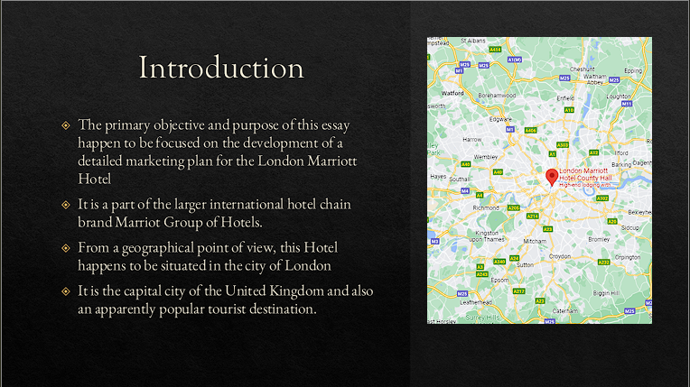

Slide 3:
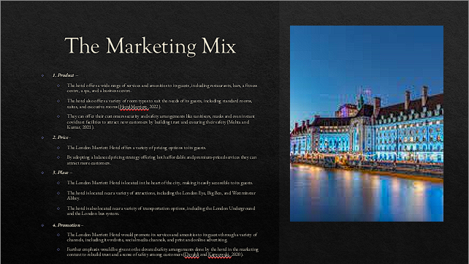
Slide 4:
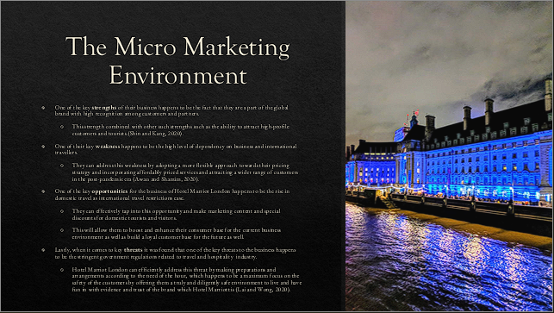

Slide 5:
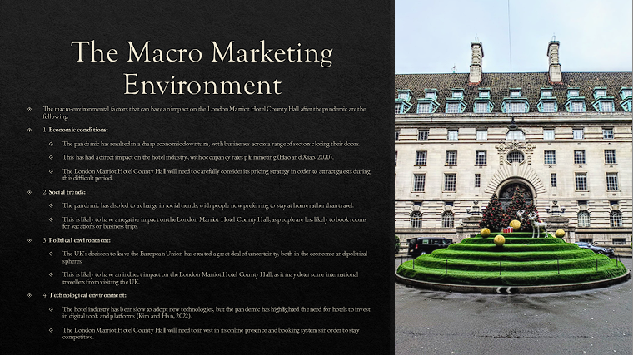
Slide 6:
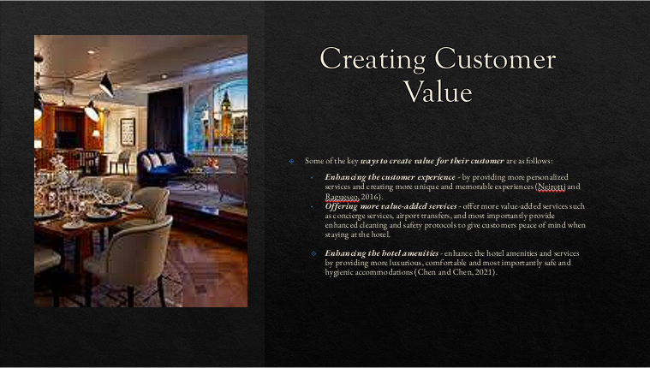

Slide 7:
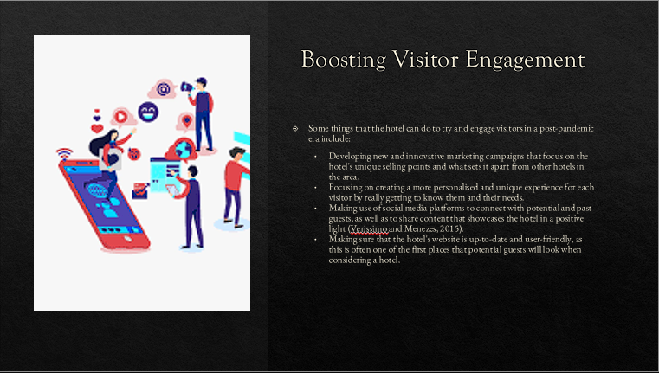
Slide 8:
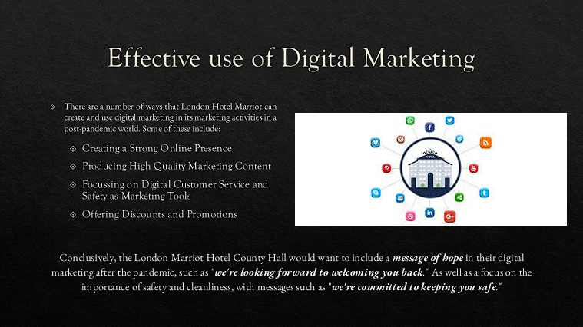

Slide 9:
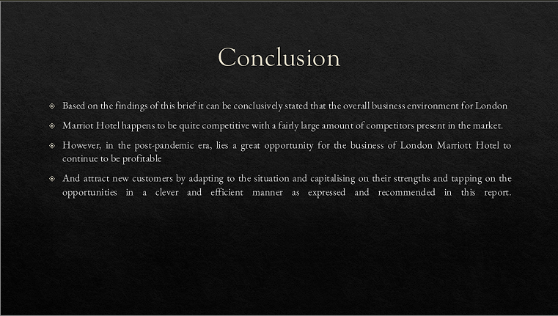
Slide 10:


