University of Wales Trinity Saint David

Wales Institute of Science & Art



Quality Improvement Plan Using Basic Quality Tools
Quality & Business Improvement (ACMA4038)

Lloyd Thomas
25753
11/03/2026

Contents
1 Introduction 3
1.2 Improvement target 3
1.3 Scope and boundaries 3
1.4 Investment 3
2. Problem Statement and Baseline Performance 4
2.1 “Current state” symptoms (before vs after) 4
2.2 Data sources and collection method 6
3 Methodology and improvement approach 7
3.1 Continuous improvement frame 7
3.2 Quality tools selected 7
4 Root cause analysis of the key issues 8
4.1 Defined problem 8
4.2 Process mapping 9
4.3 Cause identification 10
4.4 Cause validation 10
5. Pareto Analysis 12
6. Improvement opportunities and options 13
6.1 Identified opportunities 13
7. 7. Prioritised improvement plan 14
7.1 Prioritisation method 14
7.2 Improvement plan table 15
8. Monitoring, control and KPIs 17
7.1 KPIs aligned to your improvement target 17
7.2 Measurement plan 17
7.3 “Sustain” actions 17
9. Discussion 18
8.1 Compare your approach to recognised quality improvement practice 18
8.2 What the £5m investment enabled 18
8.3 Limitations 18
10. Conclusion 19
11. References (Harvard) 20

List of Figures

Figure 1 – Shows the old Bridgeport machine used before the Improvement 4
Figure 2 - Shows the old Doosan machine used before the improvement 4
Figure 3 - Shows new MAZAK I-700 5
Figure 4 – Shows new MAZAK VTC-800 6
Figure 5 - Shows Process map 9
Figure 6 - shows Fishbone analysis 10

List of Tables
Table 1 - shows process map 10
Table 2 – Show Pareto Analysis 13
Table 3 – Shows Priority assessment 14
Table 4 – Shows prioritisation method 15

Introduction
Safran Group is the “7th biggest aerospace company in the world by revenue, where the adjusted revenue in 2024 was €27,317 million” (Safran 2025). Seats play a massive contribution to that revenue, with South Wales holding a “1,000-strong” (Butler, 2025) army of employees working for Safran Seats GB.
Within Safran Seats GB, every part is produced in-house, cutting out any need for external manufacturers. That is causing the machine Shop to be vital in its pursuit of becoming the biggest Manufacturer of Aeroplanes in the World.

1.2 Improvement target
Safran’s main goal was to maximise machining capability and efficiency to align with wider company goals to “Ramp Up”. The issue management had was the outdated machines that were too slow and often had issues with breaking down.
The secondary issue Safran had was the carbon footprint. Being an aerospace company the pressure of lowering global imitations is higher than ever before. Safran is a French-based company but operates in 30 different countries across the world, so they must meet the EU and global agenda of decarbonisation. This doesn’t just include the plane being in the air, but also the way it’s manufactured.

1.3 Scope and boundaries
To reach these goals, Safran took a deep inspection into their CNC department. Just bringing in the newest machines would not be good enough to reach their goals, so they used analysis methods such as kaizen and looked at every aspect, such as tooling and programming.

1.4 Investment
5 million pounds was invested into their machine shop, with £1.6m of support from the Welsh Government’s Economy Futures Fund (Zenoot | Manufacturing news, industry insights and case studies, 2024). The Welsh Government, being eager to help the company situated in Cwmbrân, gave a massive opportunity for improvement.

2. Problem Statement and Baseline Performance

2.1 “Current state” symptoms (before vs after)
At the beginning of 2023, on average Safran’s machines were 23 years old. They had 42 different machine types, meaning too much complexity and parts needing multiple setups just to get finished. That made it nearly impossible to meet customer lead times and be ahead of competitors.
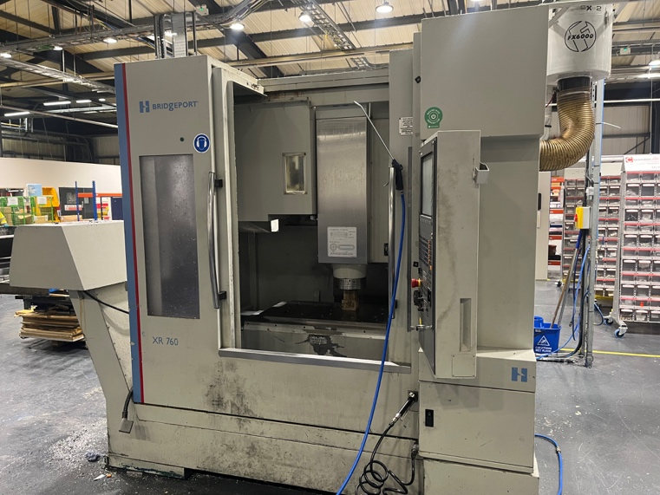
Figure 1 – Shows the old Bridgeport machine used before the Improvement
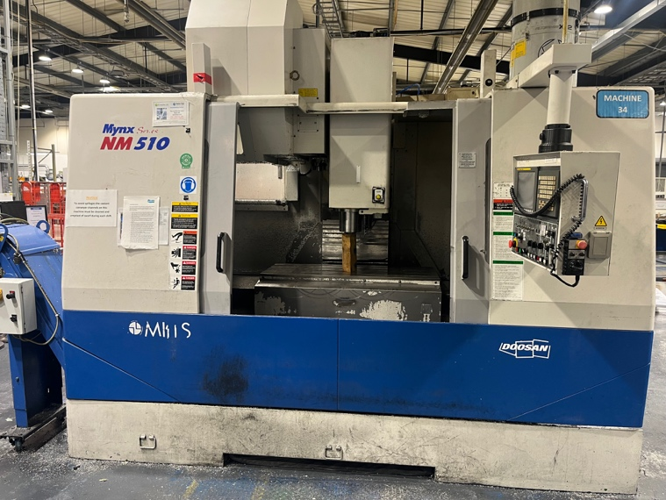
Figure 2 - Shows the old Doosan machine used before the improvement
One of the biggest issues with these machines is the speed at which the work can be produced, for example, the DOOSAN machine, as shown above, Jones Machinery (n.d.) states that the MYNX 500 has a maximum spindle speed of 8,000 rpm, whereas the MAZAK VTC-800 has a maximum spindle speed of 18,000 rpm (Mazak, n.d.).
Another issue that Safran faced around the timings of parts being produced was the amount of time it takes to set a job up. Within Safran, the workflow is very Erratic and Inconsistent meaning tools are being constantly made up and taken apart, which was found to take up the majority of an operator’s day. Very often, an operator would make up ten different tools just to make one part, just for them, then strip them all down.
Slow machinery and material shortages in 2024 led to JAL A350 interior supply chain issues (Alkema, 2023).
In 2022, with these old machines, the average time from data sent out to part produced was 11.5 hours, whereas in 2024, the average time was 5.4 hours, resulting in a 51% reduction. This number has had such a reduction because on average, each job had to go through three different types of machines, whereas now there are 5-axis machines, so most jobs are done on just one machine.
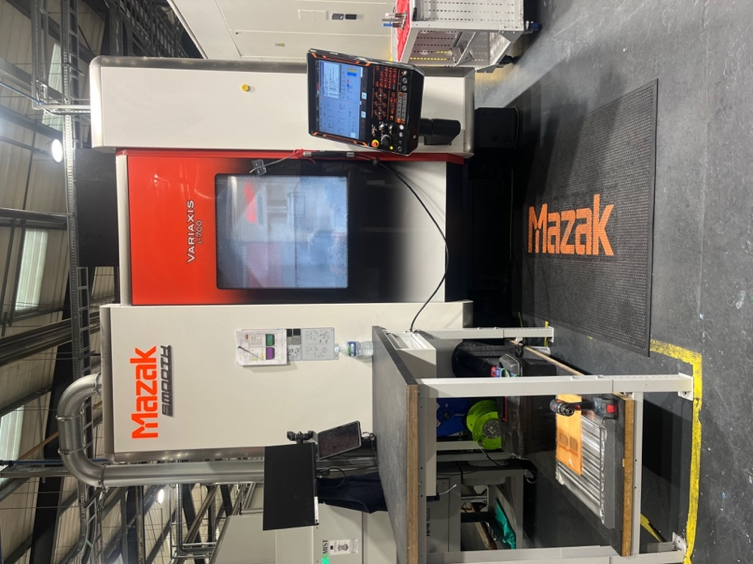
Figure 3 - Shows new MAZAK I-700
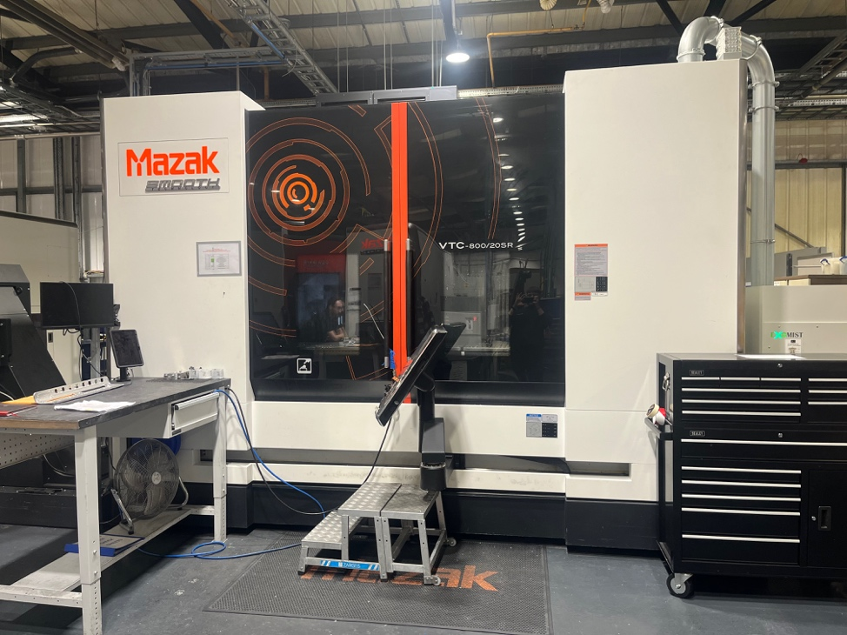
Figure 4 – Shows new MAZAK VTC-800

2.2 Data sources and collection method
The evidence found supporting the information used was mainly found within Safran Seats GB; management, like Nick Godard (Manufacturing 4.0 Lead), had information all around this new investment. With the investment from the Welsh Government and from Safran Group, this information had to be provided as part of the agreement with both parties.

Methodology and improvement approach

3.1 Continuous improvement frame
Safran employed a DMAIC-lite method to organise the improvement process, starting from identifying the machine shop performance gap, measuring baseline OEE and downtime, analysing key loss drivers with Pareto and root cause analysis, and implementing specific actions tied to the £5m investment. The final ‘Control’ phase guarantees that the improvements are maintained through established KPIs, standardised procedures, and ongoing performance evaluations.

3.2 Quality tools selected
When looking to improve their production, Safran used a few different methods of RCA it identifies why they had problems with the old system, why there could be issues with the new system, and their potential risks/ downfalls.
Fishbone analysis is one RCA method that was used; “this method assists in analyzing the root cause of a quality-related problem” (Kumah et al., 2024). A key bonus to the fishbone analysis is that it looks at multiple fronts, keeping the ideas fresh and forcing the manager who is conducting the analysis to stop any biases.
Another method of RCA that can be used would be the 5 Why’s. “The Five Whys technique is a simple but powerful way to troubleshoot problems by exploring cause-and-effect relationships” (Serrat, 2017). On the other hand, a downfall would be it can potentially open up for bias. Many managers, when conducting 5 whys analysis, put extended blame on the operator instead of looking for different angles.

Root cause analysis of the key issues

4.1 Defined problem
In 2022, the machine shop achieved an average OEE of 43%, which is below the target of 85%. The largest losses are occurring in Availability, as machines are breaking down on average every two days and taking an average of two weeks to be repaired. The objective is to increase OEE to 85% within three years by reducing unplanned downtime and average changeover time, while maintaining quality performance.

Process mapping

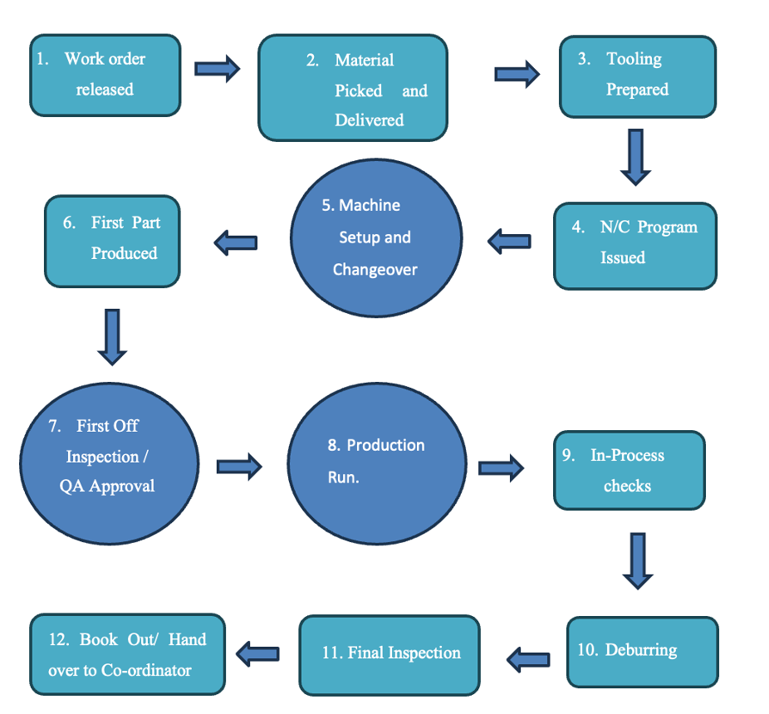
Figure 5 - Shows Process map

Process mapping is an ideal way to plan the path, by laying out the guidelines and tracking where each operation will go step by step, it leaves each operator involved in every role a clear road map of what’s to be done. Meanwhile, the planning department can plan while knowing how long each step will take.

4.3 Cause identification
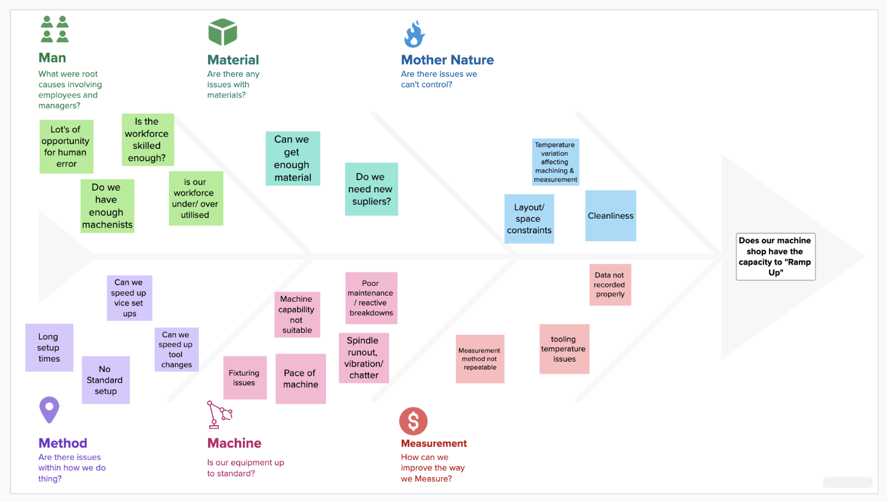
Figure 6 - shows Fishbone analysis

4.4 Cause validation
Problem statement - The setup time is too long.
- Why?
There is no generic setup, meaning each production order needs to be completely stripped back and started again from scratch.
- Why?
Tools have to be of different lengths for each job, with the header stating how long that tool needs to be for that job.
- Why?
Job packs state exactly what is needed for one job only.
- Why?
There is no standardised tooling
- Why?
The machines have no capability for standardised tooling and tracking.
From the improvements found from the 5 whys analysis and other methods Safran increased their time from ‘data being released to part produced form 11.5 hours to 5.4 hours which is a 51% increase (Godard 2024).

5. Pareto Analysis
Table 2 – Show Pareto Analysis
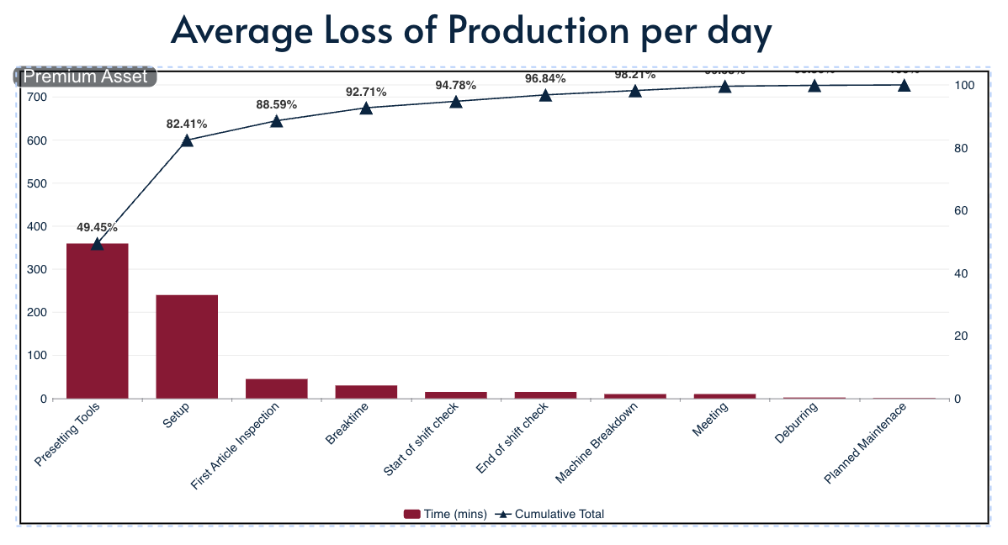
Pareto analysis is a basic quality tool used in manufacturing to identify the vital few issues within a workforce. Isolating and focusing on the issues that keep appearing enables the management to keep the machines running for longer.
Pareto analysis uses a 20-80 rule, which states that the 20% of causes creates 80% of the impact. This rule helps spend time, money and resources on the true main contributors of downtime.
Although Pareto analysis is effective, one major downside is that it does not identify why these issues are occurring, only that they are occurring. This is why sometimes analysis, such as fishbone or 5 whys, can be favoured
From this analysis, it has been shown that just over 80% of their production issues are caused by 20% of issues. The identified areas for improvement are the presetting tools and the setup time.

Improvement opportunities and options

6.1 Identified opportunities
- The first opportunity for improvement was the setup times being too slow and inconsistent. To improve this, Safran enrolled standardised setups and tooling, resulting in 95% of jobs being extremely similar to the last.
- The second opportunity for improvement was the tool availability and tool-setting delays. By standardising tools of every kind, the operators only had to pick the tools off the shelves instead of making each tool by hand, dramatically cutting down the tooling time.
- Another opportunity for Improvement was setting up activities done “on machine” instead of “off machine”. If all setup work is done while the last job is running, there is barely a need for any downtime for setting the next job.
Table 3 – Shows Priority assessment
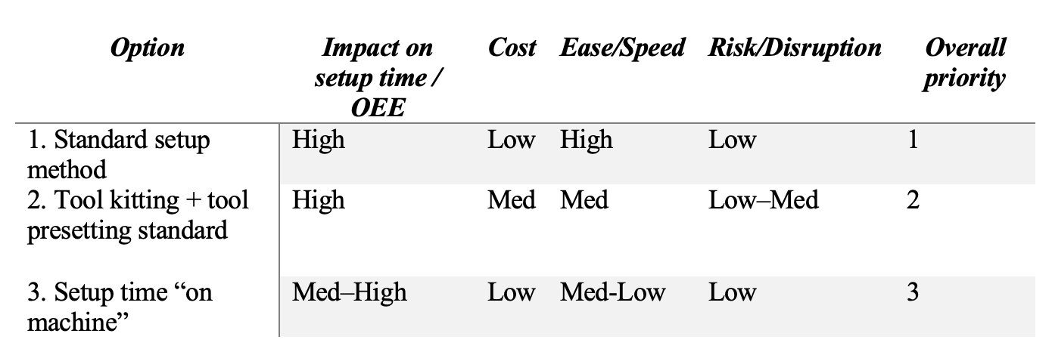

7. Prioritised improvement plan

7.1 Prioritisation method
Table 4 – Shows prioritisation method
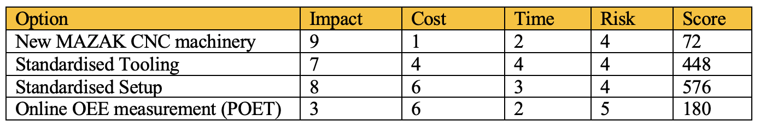

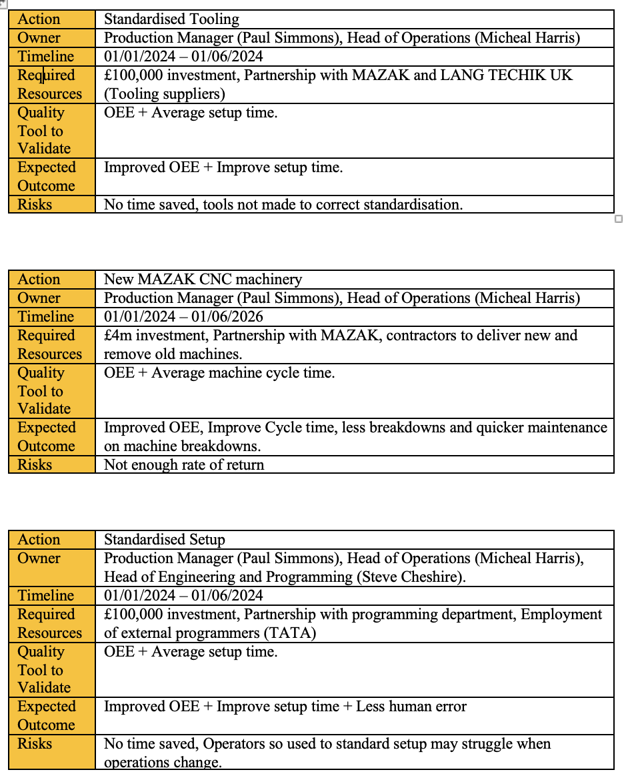
Improvement plan table

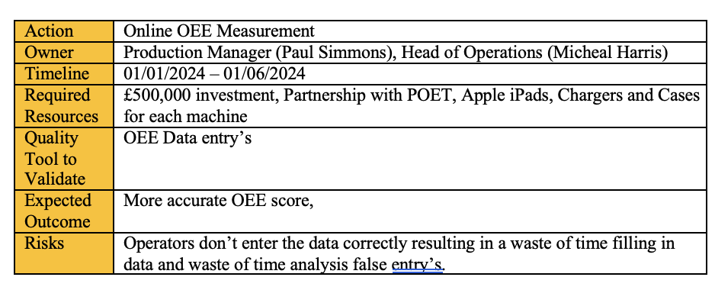
Table 5 – Shows improvement plan

Monitoring, control and KPIs

7.1 KPIs aligned to your improvement target
It’s well known within the industry that 85% OEE is the target for world-class performance. In 2022, Safran was running at 43%, whereas at the back end of 2024, they were at 83% OEE, with this major improvement, they have improved by 39% within two years.

7.2 Measurement plan
In 2026, the target for OEE is 85% efficiency, which is world-class performance. If the OEE goes below 78% in a day, then it triggers an inspection of why it’s lower. This data will be inspected by senior management, then escalated further if needed. All data is clearly displayed on a 5ft wide television at the base of the machine shop so all bystanders can see the daily performance of the machining workforce.

7.3 “Sustain” actions
To sustain the highly skilled environment within Safran Seats’ machine shop, they partnered up with the University of Wales Trinity St David to upskill employees. When this improvement project started, there were only 8 skilled ‘setters’. Now, in 2026, there are 31 skilled ‘setters’ and 8 currently in training (Godard 2024). Actions such as upskilling staff in a declining industry are vital to sustaining excellence.

Discussion

8.1 Compare your approach to recognised quality improvement practice
Safran used many different tools for improvement that are all accepted in quality improvement practices globally. Such as Kaizen, which “originated in Japan and was introduced as a philosophy of continuous improvement” (Gupta and Jain, 2014).

8.2 What the £5m investment enabled
£5 million investment can unlock serious issues in a company, and that’s exactly the case with Safran. With a 39% increase in OEE (Godard 2024), the financial benefit has come and is here to stay. With the new machinery, Safran went from 44 machines to 22 machines while improving its on-demand production by 15% (Godard 2024).

8.3 Limitations
The baseline of data wasn’t up to industry standard, resulting in lots of improvement aren’t be put into the correct statistics, like the carbon footprint. There isn’t an official amount of C02 used by the factory, but they can accurately estimate it with the decrease in the amount of machining time and amount of paper used.
Time window was also a limitation when the Welsh Government invested in the company; they expected to see results of where that money is going, resulting in some areas being rushed into production.

Conclusion

To conclude, Safran Seats GB aimed to “ramp up”; this was only possible by improving the machine shop. The key area for improvement was the reduction of the amount of time taken to setup the machinery.

From doing different types of analysis like the Pareto and RCA, Safran could clearly see that the biggest amount of time lost was in the setup process, and presetting tools.

The investment enabled many changes in the Safran Seats machine shop, such as 12 new MAZAK machines that come with standardised tooling and tracking. With this, they were able to preset tools in advance to maximise efficiency within the setup process.

Safran measures its OEE through POET, which is entered by the operator of each machine. The aim for OEE is a ‘world-class’ standard, which is 85%.
To sustain these improvements, Safran chose to train employees to the needed industry requirements and standardise setups, resulting in a lack of opportunity for human error.

References (Harvard)

Butler, B. (2025) ‘1,000-strong aircraft seats maker “well-placed” despite challenging year’, Insider Media Ltd., [online]. Available at: https://www.insidermedia.com/news/wales/1000-strong-aircraft-seats-maker-well-placed-despite-challenging-year (Accessed: 6 March 2026).
Godard, N. (2024) Manufacturing 4.0 lead, studies done to present to the Welsh Government’s Economy Futures Fund.
Gupta, S. and Jain, S.K. (2014) ‘The 5S and kaizen concept for overall improvement of the organisation: a case study’, International Journal of Lean Enterprise Research, 1(1), pp. 22–40. Available at: Inderscience Online.
Jones Machinery (n.d.) Used Doosan/Daewoo MYNX 500 Vertical Machining Center with Fanuc 21-M Control – Specifications [PDF]. Available at: https://www.jonesmachinery.com/media/site/used-machines/1239-daewoo-mynx-500.pdf (Accessed: 27 February 2026).
Kumah, A., Nwogu, C.N., Issah, A.-R., Obot, E., Kanamitie, D.T., Sifa, J.S. and Aidoo, L.A. (2024) ‘Cause-and-Effect (Fishbone) Diagram: A Tool for Generating and Organizing Quality Improvement Ideas’, Global Journal on Quality and Safety in Healthcare, 7(2), pp. 85–87. doi: 10.36401/JQSH-23-42.
Lowrey, A. (2026) Studies done within Safran Seats GB.
Mazak (n.d.) 5-axis machining centres VTC-800. Available at: Mazak UK website (Accessed: 6 March 2026).
Safran (2025) Safran reports its full-year 2024 results. Press release, 14 February. Available at: Safran Group website.
Walton, J. (2023) ‘JAL A350 interiors supply chain issues raise spectre of delays in 2024’, Runway Girl Network, 19 December. Available at: https://runwaygirlnetwork.com/2023/12/safran-seats-jal-a350-1000-delays-2024/ (Accessed: 27 February 2026).
Zenoot (2024) ‘Safran Seats to make investments at two Welsh sites’, Zenoot, [online]. Available at: https://zenoot.com/2024/02/22/safran-seats-to-make-investments-at-two-welsh-sites/ (Accessed: 18 February 2026).
www.oee.com (n.d.) ‘World-Class OEE: Set Targets To Drive Improvement’, OEE.com, [online]. Available at: https://www.oee.com/world-class-oee/

