

Programme Name : Master of Business Administration
Module Name : International Business Concepts
Module Code: LCMB7034
Assignment Title: Report- Tesla
Lecturer’s Name : Hoang Dang Nguyen
Student Name : Trupil Rajeshbhai Kumbhani
Student ID : 2431306
Term 2
Submission Date: 15th December 2025

Table of Contents
1. Introduction 3
2. Benefits and challenges of international operations 4
2.a. Tesla as a multinational company 4
2.b. Structure of Global Value Chain 5
2.c. Modes of entering an international market 7
2.d. Advantages of International Operations 8
3. The OLI Factors influence Tesla's Market Entry into India 9
3.a. Ownership Advantages 10
3.b. Location Advantages 10
3.c. Advantages of internalisation 12
3.d. Connecting OLI factors to the choice of market entry mode for the selected emerging economy 13
3.e. Examples from the company’s international strategy 13
3.f. Discussing which factor is dominant and why 13
3.g. Superior competitive capabilities in ownership 14
4. Critical evaluation of how cultural differences between the home country of Tesla and the chosen emerging economy 14
4.a. Cultural differences between the home country of Tesla and the chosen emerging economy 14
4.b. Ways through which it can impact on the company’s market entry strategy 15
4.c. Ways through which it can impact on its potential for success in that market 16
5. Discussing and recommending three major adjustments Tesla may need to consider in their Standard Operating Procedures (SOPs) to ensure success in India 16
6. Conclusion 20
References 21
Appendices 23
Appendix 1: Porter’s value chain 23
Appendix 2: Hofstede cultural comparison USA and India 24

1. Introduction
This report critically discusses Tesla's international operations and analyses the strategic factors that affect its potential market penetration in India using the OLI framework.
About the company
Tesla, Inc. is one of the most prominent American multinational companies that deal with electric vehicles (EVs), battery energy storage, and renewable energy solutions (Tesla, 2025). Tesla is based in Austin, Texas, and operates in more than 30 countries across North America, Europe and the Middle East, and Asia-Pacific, and was founded in 2003. The mission of the company is to work towards making the world a place where it switches to sustainable energy by using innovation, technology, and large-scale electrification. Tesla's internationalisation has enabled the firm to achieve a leading 17.6% market share in the global battery electric vehicle market in 2024. The Supercharger network was introduced on September 24, 2012, as Tesla entered production, with six stations in California. As of September 2025, Tesla operates a network of about 7,700 Supercharger stations with over 73,000 connectors worldwide. The current report examines the advantages and limitations of Tesla's international expansion and critically reviews the Ownership-Location-Internalisation (OLI) variables that bear on Tesla's potential entry into the Indian market.
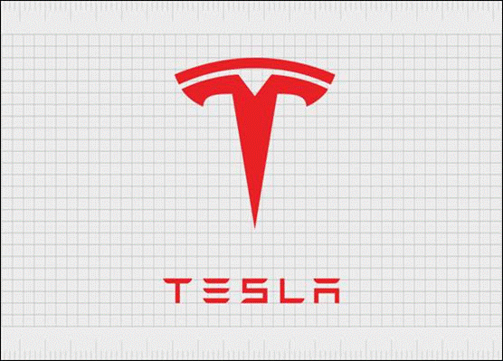
Figure 1: Tesla Logo
(Source: Tesla, 2025)

2. Benefits and challenges of international operations

2.a. Tesla as a multinational company
Tesla is a multinational corporation (MNC) because it has a wide range of networks in terms of production, sales, and services throughout the world. As of 2024, Tesla was operating in over 40 countries, with its large-scale manufacturing facilities in the United States, China, Germany and Mexico. Tesla is highly vertically integrated and develops many components in-house, such as batteries, motors, and software. Its Gigafactory concept represents international integration, i.e., the manufacture of vehicles, battery packs and energy systems across different continents to cater to local and international markets. The organisational structure, capital mobility and Tesla's ability to influence supply chains and policy development are the factors that make the company a transnational one. Worldwide, Tesla has already achieved significant market share in terms of profit (Statista, 2022). Tesla's approach to vertical integration such as owning as many aspects of production as possible, from raw materials to final assembly is a stark contrast to the traditional automotive industry model of outsourcing key components and relying heavily on global supply chains (Emmer, 2024).
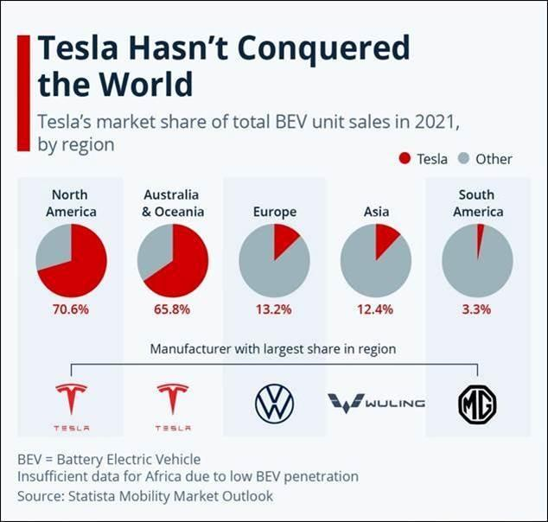
Figure 2: Worldwide Revenue
(Source: Statista, 2022)

2.b. Structure of Global Value Chain
The global value chain can be described as an innovative chain of Tesla that is marked with high levels of research and development, verticalization of manufacturing, global sourcing, and a digital-first sales model.

Research and Development (R&D): Tesla spends heavily on R&D, focusing on the design of electric powertrains, self-driving systems and artificial intelligence. The company has research centres in California, Texas, and Berlin, with a worldwide data network that continuously enhances its Full Self-Driving (FSD) systems using real-world driving data from millions of vehicles. Tesla spent over $3.8 billion on R&D in 2024, which helped it develop high-performance batteries and vehicle software. Tesla uses over-the-air updates to deliver new features or fix problems in vehicles. This is enabled by tight integration between a few powerful onboard computers, unlike the way automakers previously handled technology, which involved purchasing off-the-shelf electronic components for each subsystem that typically could not interface at the software level.

Sourcing and Supply Chain: Tesla sources materials such as lithium, nickel, aluminium and cobalt from various countries, including Australia, Indonesia and Canada. It enables it to localise the supply chain in order to reduce geopolitical risks as well as transportation costs (Rasshyvalov et al., 2024). In the case of Gigafactory Shanghai, it partners with regional component suppliers in China to ensure battery cell supply is not interrupted. In contrast, the U.S. facilities procure their partners in North America.
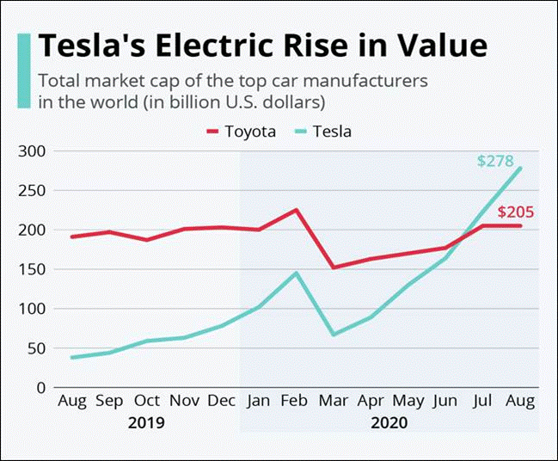
Figure 3: Electric Rise Value
(Source: Statista, 2025A)

Tesla's Gigafactories are the core of its production network. The most important ones are Fremont (California), Giga Nevada, battery packs, Giga Texas, Cybertruck and Model Y, Giga Berlin, Europe-focused production, Giga Shanghai, Asian market, and the recently announced Giga Mexico, Latin America. These factories jointly manufactured 1.77 million vehicles in 2024, the highest annual production for Tesla. The Gigafactory model is based on economies of scale, automation and AI-mediated manufacturing to lower unit costs without undermining product quality.

Sales and Distribution: Tesla employs a direct-to-consumer strategy through its website and company-owned stores, bypassing traditional dealership channels (Asuncion et al., 2023). Tesla's strategy is to service its vehicles first through remote diagnosis and repair. If it is not possible to resolve a problem remotely, a mobile technician is dispatched, or customers are referred to a local Tesla-owned service centre. As of October 2024, the company operates 1,306 retail stores, galleries, service centres, delivery centres and body shop locations globally.

Funding and Insurance Department: Tesla offers its vehicle financing, leasing, and insurance packages in-house in various countries such as the U.S., Europe, and Asia. These services lower the ownership bills and increase brand loyalty. By 2024, Tesla Insurance will operate in 12 U.S. states, powered by real-time driver data and hopes to expand to Europe and Asia.
(Refer to Appendix 1)

2.c. Modes of entering an international market

Tesla uses various international market entry modes tailored to the host country's settings.
Wholly Owned Subsidiaries: This is Tesla's predominant entry mode into foreign markets (Wu and Wang, 2021). The first wholly foreign-owned automotive plant to be established in China after the liberalisation of regulations was Gigafactory Shanghai, which opened in 2019. The plant enabled Tesla to keep all the production, technology, and profits under its control and would lead to further ones in Germany and Mexico.

Joint Ventures and Partnerships: Tesla has strategic partnerships mainly due to the need to collaborate with technology and local compliance. In the power division, it has collaborated with Panasonic to supply battery cells, with CATL in China to supply lithium-ion batteries, and with various utility companies to supply the Megapack energy project under construction. Although these are not official equity joint ventures, such alliances do offer access to regional knowledge and optimisation of resources.

Exporting and Distribution: Tesla ships vehicles in its key manufacturing locations to the markets that lack local manufacturing (Paakko, 2024). As an example, Giga Shanghai cars are shipped to Australia, Japan, and some regions of Europe, whereas Giga Berlin serves the EU region. Asia or Europe can be used to compensate for the declining demand in North America. Exporting is still an effective entry mode in small or developing markets where full-scale production has not yet been established.

Future Prospects in India: The entry mode Tesla plans to use in India will be similar to the one in Shanghai: at first, it will import but will subsequently assemble vehicles and eventually start manufacturing in India. In 2025, negotiations with the Indian government have focused on reduced import duties and policy support for EV infrastructure. The Gujarat or Maharashtra proposed plant would meet the domestic demand and the export options to Southeast Asia and Africa.
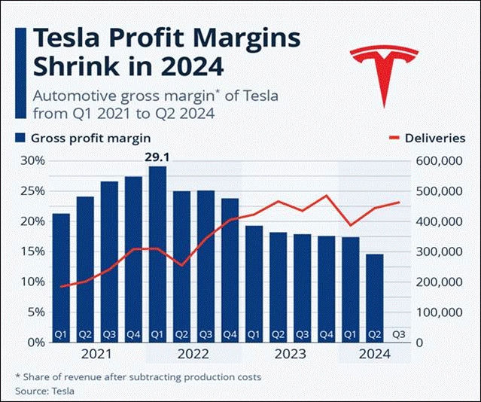
Figure 4: Revenue Margins
(Source: Statista, 2024)

2.d. Advantages of International Operations

Diversification of the Market around the World: The presence in different parts of the world helps Tesla to avoid economic and political risks. Asia or Europe can be used to compensate for the declining demand in North America. An example is the growth of Gigafactory Shanghai, which enabled Tesla to maintain consistent production despite supply chain issues in the U.S.

Economies of Scale: The global manufacturing system enables Tesla to reduce its costs by manufacturing in large volumes, having standardised components, and sharing research and development. The Gigafactory system focuses on centralising battery and component manufacturing, reducing costs, and improving worldwide distribution efficiency.

Emerging Market Demand: Emerging markets like India, Indonesia, and Brazil are home to an increasing number of middle-income citizens, urbanisation and government incentives for electric mobility. Entering these markets will enable Tesla to be the first mover in markets with EV penetration under 2%.

Technology Transfer: In contrast to more advanced countries, the US exhibits a low rate of innovation alongside higher technology transfer rates. As compared to developed nations, the US has a low rate of innovation and a higher rate of technology transfer.

Supply Chain Constraints: Tesla's reliance on key raw materials, such as lithium and cobalt, exposes it to geopolitical risks and price fluctuations. Supply disturbances, such as those encountered during the COVID-19 pandemic and conflicts that disrupt metal supply chains, can have a significant impact on production.
Adaptation to Culture and the Market: Consumer behaviour is diverse in different regions. Although such a minimalist design suits Western consumers, other markets, such as India, might require lower prices and greater accessibility to after-sales services.

Competition and Market Saturation: In developed markets, Tesla faces growing threats from well-known car manufacturers switching to EVs (e.g., Volkswagen, BYD, Hyundai). Competition and the invention of new cameras demand continuing technological and efficiency spending.

Human Resource and Management dilemma: Managing a workforce spread across geographies requires cultural sensitivity, effective communication, and adherence to Tesla's high-performance culture. Some countries, such as Germany, have a high rate of unionisation, whereas Tesla has not practised unionisation in the U.S., as it has always been a non-union company.

Ecological and moral Issues: The fast growth of Tesla is also accompanied by environmental and social issues, including the controversy of land use in Germany and the ethics of resource sourcing in Africa. To continue with its sustainability narrative, it must be highly compliant in the global sphere and report openly.

3. The OLI Factors influence Tesla's Market Entry into India
The Ownership, Location, and Internalisation (OLI) model, proposed by John Dunning, explains why companies use foreign direct investment (FDI) rather than exporting or licensing. In the case of Tesla, this framework would provide the strategic basis for investment decisions and entry modes into India.
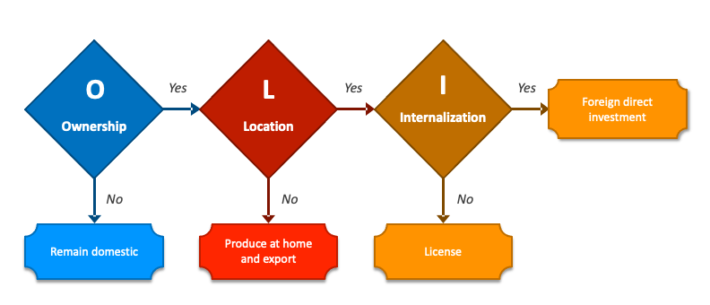
Figure 5: OLI framework
(Source: Batschauer da Cruz et al., 2022)

3.a. Ownership Advantages

Ownership advantages are firm-specific assets that confer a competitive advantage in international markets.
Technological Innovation: Tesla's most significant competitive strengths lie in its proprietary battery design and powertrain efficiency technologies, as well as its software integration. The company's patents in autonomous driving (FSD) and energy management systems are difficult to imitate, as it has in-house R&D capabilities that ensure technological leadership. Competitors do not have specific entry barriers due to their AI-controlled vehicle control and data-driven production optimisation.

Vertical Integration: Tesla is a vertically integrated company, which means that it handles the design, production, software, distribution and charging infrastructure, which makes the company cost-effective and ensures a high quality of the offered products.

Monetary Resources and International Specialisation: Tesla has sufficient financial resources to launch large-scale operations and absorb initial market-entry risks, with total assets of $122 billion and equity of $72.9 billion in 2024. The success it has had in investing heavily in China and Germany will augment its ability to duplicate such models in India.

3.b. Location Advantages

India offers Tesla an attractive location opportunity, with market potential, policy support and cost-effective production.
Market Potential: India, the world's third-largest automobile market, is experiencing rapid growth in demand for electric cars, driven by urbanisation, rising incomes and increasing environmental awareness. India seeks to attain a 30% share of electric vehicles, in the total vehicles sold, by 2030. Sale of EVs in India went up from 50,000 in 2016 to 2.08 million in 2024 as against global EV sales having risen from 918,000 in 2016 to 18.78 million in 2024 (NITI Aayog, 2025). India offers Tesla a huge untapped customer base of more than 1.4 billion with growing infrastructure.
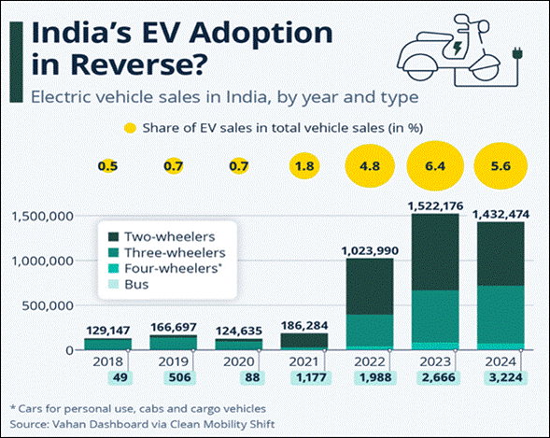
Figure 6: EV Adoption
(Source: Statista, 2025B)

The FAME-II scheme and production-linked incentive (PLI) programs in India stimulate the production of EVs and batteries, as well as the localisation of these industries. The tax incentives, concessions in import duties, and possible land subsidies would be available to Tesla as long as it establishes a manufacturing facility in India, and as long as it achieves localisation levels. According to the latest policy deliberations in 2025, there is an ample regulatory approach to entice Tesla to invest.

Geographic strategic location: India's proximity to major emerging markets in Southeast Asia and Africa enhances its potential as an export hub. Having a manufacturing base in India would make logistics and tariffs cheaper than for exports to China. Additionally, the area offers access to ports, which facilitates distribution.

Labour and Cost Advantages: India provides a great source of inexpensive, technically competent, and highly skilled labour force. Labour costs are also much lower than in developed economies, enabling competitive manufacturing. The production system of Tesla, which is based on automation, would also maximise productivity and decrease the cost of operation.
The increasing battery ecosystem in India and lithium agreements with other nations, such as Australia and Argentina, are in line with Tesla's demands in the supply chain. The possibility of localising component sourcing would improve sustainability and reduce foreign exchange risks.

3.c. Advantages of internalisation

The benefits of internalisation explain why companies find it beneficial to own and exercise control over their operations rather than enter into contracts with external suppliers.
Proprietary Technology Control: The Tesla Company relies a great deal on protecting its intellectual property, especially in battery chemistry, autonomous driving software, and AI systems. By internalising operations in India, it is possible to exercise total control over technology use, ensuring it cannot be imitated or leaked to local competitors.

Quality Assurance/ Brand Integrity: Control over the production and distribution of Tesla vehicles enables the company to maintain product quality and brand consistency. The risk of brand dilution or service inconsistency due to outsourcing or franchising in India is possible. Therefore, a wholly owned subsidiary model aligns with Tesla's brand and operational philosophy.

Effective Knowledge Communication: Through internalisation of its operations, Tesla will be able to easily transfer the knowledge, training, and process innovation across its current Gigafactories. The lessons that were learned in Shanghai and Berlin can be deployed in India, in terms of automation, localisation of supply chains, and upskilling of the workforce.

Customer Relationship Management: Tesla's digital ecosystem, including its mobile app, software updates available in its cars, and its direct sales model, requires a centralised data management system. Internalisation enables real-time data collection, which can be used to make predictions and optimise after-sales.

3.d. Connecting OLI factors to the choice of market entry mode for the selected emerging economy

The use of the OLI framework implies that a wholly owned subsidiary by means of foreign direct investment is the most suitable entry mode of Tesla into India, with a gradual strategy:
Phase 1: Testing Importation and Market Control (Short-term): First, Tesla can bring in only some vehicle models (e.g., Model 3 and Model Y) to test consumer reaction and build brand equity. This would reduce risks as negotiations with policymakers proceed on favourable terms.

Phase 2: (Medium Term): Creating a semi-knocked-down (SKD) or fully-knocked-down (CKD) assembly facility allows a degree of cost reduction through localisation. The move is in line with the vision of Make in India of India, as well as minimising the effects of tariffs.

Phase 3: Complete Manufacturing and Research and Development (Long Term): As soon as the sales volumes are justified by the investment, Tesla will be able to create a Gigafactory in the country and produce vehicles and battery packs. Having an R&D centre on site will help adapt products to Indian road and climatic conditions and complement the local innovation ecosystem.

3.e. Examples from the company’s international strategy
The international strategy of Tesla is based on full ownership, vertical integration and technology transfer across markets. For example, Gigafactory is established in Sanghai mentioned that Tesla’s preference for retaining control over manufacturing, software and intellectual property. On the other hand, Gigafactory in Berlin showed that Tesla to localise production in Europe while reducing logistics costs and tariff exposure. Thus, the examples has shown that Tesla prioritises maintaining internal control, exporting its proprietary technology and replicating its vertically integrated business model through different global markets.

3.f. Discussing which factor is dominant and why
The ownership advantages are the dominant factor driving Tesla’s international expansion. Tesla’s battery manufacturing technology, autonomous driving software as well as real-time vehicle data are effective to provide a competitive edge to avoid imitation. Location advantages are prioritised such as China’s scale or Europe’s regulatory incentives, but they seem to be less focused to innovation, quality and cost structures. At the same time, the Internalisation advantages reinforce the dominance, as outsourcing or licensing can undermine its technological leadership across the market.

3.g. Superior competitive capabilities in ownership
In the world, Tesla is a symbol of innovation, quality, and sustainability. This brand name facilitates high pricing and brand loyalty. In India, as EV brands are not yet established, Tesla would be a more aspirational, technologically advanced brand, attracting early adopters and green consumers. The company’s vertical integration across software, manufacturing, sales and charging infrastructure provides cost efficiencies and consistent product performance globally. Additionally, it is seen that the company’s global data driven advantages have strengthened its AI models and enhances safety. It is a strong brand associated with innovation and sustainability. Hence, it is mentioned that these abilities can enable Tesla to manage their international process while retaining tight control over its most valuable intellectual assets.

4. Critical evaluation of how cultural differences between the home country of Tesla and the chosen emerging economy
Hofstede’s Cultural Dimensions Theory is a framework used to understand the differences in culture across countries and the ways that business is done across different cultures. In other words, the framework is used to distinguish between different national cultures, the dimensions of culture, their impact on etiquette and to facilitate communication in areas ranging from business to diplomacy.

4.a. Cultural differences between the home country of Tesla and the chosen emerging economy
In order to compare the cultural differences between India and the USA, Hofstede’s cultural dimension model is considered. In terms of power distance, it is seen that India scores higher, which denotes that a hierarchical society is present where authority is respected and decision-making is centralised. Without understanding the cultural aspects of the penetrating country, it can be critical for a company to set its business strategies (Hassan and Craft, 2012). From this point of view, it is stated that Tesla, which follows a flatter organisational structure, may need to adapt its management style in India by emphasising formal leadership roles and respecting hierarchical protocols in government and corporate interactions (Refer to Appendix 2).
In India, employees expect to be directed clearly as to their functions and what is expected of them. On the other hand, in the USA, both managers and employees expect to be consulted and information is shared frequently. At the same time, communication is informal, direct and participative (Theculturefactor, 2025). It is noted that US culture values independence, while Indian culture leans toward collectivism (Refer to Appendix 2). In this regard, Tesla's marketing strategy in India is based on community benefits, family values and national progress, such as reducing pollution or boosting technological pride.
Additionally, it is mentioned that both countries have a strong grasp of success and the concerned company can achieve this shared ambition by positioning its vehicles as aspirational products in India. It can also be helpful to reach mobile customers by developing cutting-edge technology. Apart from that, India's slightly higher score in Uncertainty Avoidance mentions a moderate preference for structure and predictability (Refer to Appendix 2). In this respect, the company can focus on maintaining a stable base for communication about its technology, safety standards, and service infrastructure to build trust among Indian consumers. The cultural orientations of the USA and India appear effective for the company to enhance its future planning process. The company benefits more from managing its business in the USA, as the country's culture is more indulgent, favouring leisure and gratification (Hassan and Craft, 2012). In terms of indulgence, India receives a low score of 26 in this dimension, meaning that it is a culture of Restraint. Societies with a low score in this dimension have a tendency to cynicism and pessimism. As a result of this, the company can focus on environmental impact as well as managing business values for money. Thus, in short, it can be evident that the success of business in India is based on cultural management and focusing on the country's culture to maintain trust and relevance in this emerging market.

4.b. Ways through which it can impact on the company’s market entry strategy
Based on the above analysis, it is clear that India’s culture is similar to the USA to a certain extent, but there are also some differences. For example, power distance is much higher in India. Hence, it is true that business collaboration is not necessary when entering the country. At the same time, the individualism score is lower than in the USA, so Tesla can follow employee-focused strategies. It can support cultural needs in India while enhancing productivity. In terms of entering a new country, it is needed to understand the strategies through which the ways to approach the customers become easier (Asuncion et al.2023). Hence, Tesla can emphasise grasping the benefits of a motivated business environment. Additionally, effective global brand positioning should take into account both cultural and behavioural aspects of micro-segmentation, meaning that Tesla's strategy in India should strike a balance between global brand consistency and local cultural adjustments. Therefore, it is mentioned that the cultural dimensions of India may impact on Tesla’s market entry strategy by encouraging it to introduce collective business approaches.

4.c. Ways through which it can impact on its potential for success in that market
The analysis shows that the USA culture clashes with Indian's as there is a huge gap in power distance. It is true that success depends on respecting governmental and corporate hierarchy, likely requiring strategic joint ventures or local partnerships to navigate regulation, bureaucracy and distribution channels. Thus, without the adoption of the strategy, Tesla may face barriers to gaining proper market access. The high Collectivism score dictates that marketing should shift from appealing to individual status (a US focus) to stressing collective welfare. For evidence, the national technological pride, pollution reduction for the community and family safety are the main. Internally, success is based on an HR policy that emphasises team achievements and group harmony rather than purely individual competition, boosting local employee retention and productivity (Rasshyvalov et al.2024). Additionally, it is mentioned that the company needs to prioritise establishing a stable, visible as well as localised service infrastructure and strong safety standards. As a result, these aspects can help Tesla build consumer trust through predictable communication about technology and safety and a reliable, expanding charging network to mitigate uncertainty around EV adoption.

5. Discussing and recommending three major adjustments Tesla may need to consider in their Standard Operating Procedures (SOPs) to ensure success in India
The possibility of Tesla entering the Indian market would require the company to make adjustments to its current Standard Operating Procedures (SOPs) to adjust to the local business environment, cultural forces and consumer preferences in the country. The OLI analysis has determined that although Tesla has significant ownership capabilities in terms of proprietary technology and brand equity and that India has substantial location advantages such as market potential and low cost, effective internalisation needs special attention to operational change.

Ranking Organisational Structure and Decision-Making Protocols
The existing organisational culture at Tesla in the United States is low power distance (score of 40), in which hierarchy is mainly established for convenience, with decision-making participative and decentralised (Theculturefactor, 2025). Communication is informal and direct, where the managers depend significantly on the individual employees and teams regarding expertise and information exchange often occurs among organisational levels. Nevertheless, the much higher power distance score recorded in India at 77 indicates that Tesla must fundamentally reorganise its management and communication SOPs to align with local cultural expectations and business practices (Theculturefactor, 2025).
Indian business culture is typified by a strong emphasis on hierarchy and a top-down organisational framework, in which employees rely on supervisors for guidance and an unequal distribution of power is considered a natural phenomenon. So, Tesla would need to modify its flat organisational structure by adding more hierarchical levels, with defined relationships and official communication guidelines. The collaborative and consensus-based decision-making processes in the Tesla American operations would have to be adjusted to directive leadership styles where managers are instructive and employees demand the definition of functions and expectations. Tesla needs to encourage regional management systems with defined authority ranges and formal approval mechanisms, which is contrary to the usual Silicon Valley model of granting low-tier workers considerable autonomy.
The communication SOPs should introduce formal communication channels with documented hierarchies, where feedback mechanisms are not top-down directive communication but can still generate insights into operations. Hassan and Craft (2012) highlight the importance of firms in the globalising markets to note that the micro-segmentation bases, such as cultural and behavioural factors, play a crucial role in strategic positioning decision-making. Thus, the organisation's SOPs should align with localised management practices while preserving the company's innovative culture.

Pricing Strategy and Localisation of Products
The price policy of Tesla is based on its positioning as a high-end, technology-oriented company with a focus on high-income consumers in developed markets, where the average car costs (Statista, 2024). This strategy, which has worked well in markets with high purchasing power and with well-developed EV infrastructure, needs a significant adjustment to the Indian market, where price sensitivity is the most important factor and the automotive market is distinctly different.
The Indian car market is dominated by car models and these advantages of location, which are found during OLI analysis, such as the cheaper sources of labour and government subsidies in the form of the FAME-II program and government incentives for the production of the product, should be affected through SOPs that require ambitious localisation goals. Tesla needs to create procurement SOPs with a minimum local content requirement with the first category being localisation at the CKD assembly stage and the second one being 70 to 80 percent localisation in complete manufacturing processes. As shown by Hassan and Craft (2012), companies that use micro-bases in their segmentation of the market based on the needs and preferences of their consumers and thus segment the market into micro-bases. The company ought to create special R&D guidelines to come up with India-specific variants, which may include smaller battery pack options (40-50 kWh) for the urban customers, who would prioritise affordability over range, unlike the American market, which may prefer 75-100 kWh options.
SOPs must also develop policies in selling strategies and allocate relationship managers, flexible loan plans such as extended terms of payments and collaborating with Indian financial institutions, and trade-in programs on traditional cars. Sloman et al. (2019) emphasise that market structures have a strong impact on pricing strategies and the pricing SOPs at Tesla must also include dynamic pricing rules that react to regional demand differences, government incentive systems and competitive positioning to the international players, as well as new Indian EV manufacturers with Tata Motors and Mahindra Electric.

Billing Infrastructure Development and After-Sales Service
The after-sales service model of Tesla in developed markets is based on remote diagnostics, over-the-air updates and mobile service units and the company-owned service centres are their second-best. Being technologically advanced, this model presupposes high-quality internet connectivity, high-level technological literacy of the customers and well-developed transport infrastructure, which may not be effective in the whole geographically and socioeconomically diverse country of India. The internalisation benefits that have been realised in the OLI framework indicate that Tesla should focus on quality management and brand status by remaining completely controlled by opening wholly-owned subsidiaries.
The expansive geographic physical area of India, where there exist wide urban-rural gaps in the quality of infrastructure and technological penetration requires a hybrid service model whereby SOPs are required to necessitate the development of regional service hubs in the tier-1 cities (Mumbai, Delhi, Bangalore, Chennai, Hyderabad) and satellite service centres in the tier-2 cities and they should be accessible within reasonable geographic scope (Tesla, 2025). The training and certification SOPs of Indian service personnel should be thorough as it should not only cover the technical aspects but also include the customer service ethics in line with Indian cultural anticipations. The culture of high-power distance indicates that customers anticipate the service interaction with good communication protocols that are formal. The multilingual support, clear pricing framework and long service hours to accommodate the Indian work patterns should be included in the service SOPs.
As for the EV charging network, Tesla must actively lead the establishment of infrastructure as opposed to relying on third-party networks (Paakko, 2024). SOPs are required to ensure that charging infrastructure planning is integrated with the stage of market entry, with a major focus on the installation of Supercharger stations on major highways and destination charging stations in urban areas, residential complexes, and business facilities. John et al. (2003) also noted that the proper operation of any international business should be accompanied by thorough knowledge of the host country’s infrastructural constraints and the initiative to overcome them. Moreover, Tesla is effective with SOPs of mobile charging service and battery swapping feasibility studies since Indian consumers who are used to fast refuelling at petrol stations everywhere can be resistant to the long periods of charging. These holistic after-sales and infrastructure SOPs will directly tackle the challenges that have been reported in the OLI analysis in terms of market adaptation and cultural factors so that Tesla can be positioned to succeed in the long term in the emerging Indian EV market.

6. Conclusion
Thus, it can be concluded that the report has critically identified the aspects that Tesla may face while entering and expanding its business in India. The analysis of the global value chain has been developed to shed light on the fact that Tesla offers its vehicle financing, leasing, and insurance packages in-house in various countries such as the U.S., Europe and Asia. Additionally, different entry modes are analysed and hence, it becomes easier to suggest which can be best suited for Tesla.
The presence in different parts of the world helps Tesla to avoid economic and political risks. Moreover, it is highlighted that if the concerned company is able to manage its business in India, finding a new market range will be easier. Another essential aspect is that in developed markets, Tesla is experiencing a growing threat from well-known car manufacturers switching to EVs. The use of the OLI framework implies that a wholly owned subsidiary by means of foreign direct investment is the most suitable entry mode of Tesla into India. The Ownership, Location, and Internalisation (OLI) model has been implemented to assess how the internal structure of Tesla can be beneficial to enter and establish a market base in India.

References
Asuncion, J., Murphy, M., Prutow, N., Siantar, M., Tyre-Vigil, J., and Awwad, M. (2023). Benefits and effects of Tesla’s direct-to-customer sales model. In Proceedings of the 6th European Conference on Industrial Engineering and Operations Management.
Batschauer da Cruz, C.B., ElieteFloriani, D., and Amal, M., (2022). The OLI Paradigm as a comprehensive model of FDI determinants: a sub-national approach. International Journal of Emerging Markets, 17(1), pp.145-176.
Emmer, M., (2024). Why Vertical Integration Is The Path To Strategic Advantage. Available at: https://www.forbes.com/councils/forbesbusinesscouncil/2024/01/29/why-vertical-integration-is-the-path-to-strategic-advantage/
Hassan, S.S. and Craft, S., (2012). Examining world market segmentation and brand positioning strategies. Journal of Consumer Marketing, 29(5), pp.344-356.https://www.emerald.com/insight/content/doi/10.1108/07363761211247460/full/html
Hassan, S.S. and Craft, S., (2012). Examining world market segmentation and brand positioning strategies. Journal of Consumer marketing, 29(5), pp.344-356. https://www.academia.edu/download/49167128/Linking_global_market_segmentation_decis20160927-25537-1y5po1r.pdf
John, J., Wild, K.L. and Han, J.C., (2003). International Business. PrenticeHall.https://studentebookhub.com/wp-content/uploads/2024/preview/9780137653355.pdf
NITI Aayog, (2025). UNLOCKING A $200 BILLION OPPORTUNITY : ELECTRIC VEHICLES IN INDIA. Available at: https://niti.gov.in/sites/default/files/2025-08/Electric-Vehicles-WEB-LOW-Report.pdf
Paakko, O., (2024). Supply chain complexities in developing electric autonomous vehicles: a comparative analysis of Tesla and Waymo.
Rasshyvalov, D., Portnov, Y., Sigaieva, T., Alboshchii, O. and Rozumnyi, O., (2024). Navigating geopolitical risks: Implications for global supply chain management. Multidisciplinary Reviews, 7.
Sloman, J., Garratt, D., Guest, J. and Jones, E., (2019). Economics for business. Pearson.https://research.aston.ac.uk/en/publications/economics-for-business
Statista, (2022). Infographic: Tesla Hasn’t Conquered the World. [Online] Statista Daily Data. Available at: https://www.statista.com/chart/28347/tesla-share-of-bev-unit-sales-by-region-mmo/?srsltid=AfmBOorXD4sfJg-0La0Rnt0lZuOFXs_KB2qorP2PmlKibdT0wqa4wWqB [Accessed 26 Oct. 2025].
Statista, (2024). Infographic: Tesla Profit Margins Shrink in 2024. [Online] Statista Daily Data. Available at: https://www.statista.com/chart/29774/tesla-gross-margin-and-deliveries/?srsltid=AfmBOopvGg0XNy4Jz3NLCSEa8cZNZCPXlPlIn8INSWsbqwU_nteTEwbD [Accessed 26 Oct. 2025].
Statista, (2025). Infographic: India’s EV Adoption in Reverse? [Online] Statista Daily Data. Available at: https://www.statista.com/chart/31486/electric-vehicle-sales-in-india-by-year-and-type/?srsltid=AfmBOopEmK8ZSIw5IqnD40aEVLNKrX3TMG2SiAOYOLMQtJaQ9djiLO8r [Accessed 26 Oct. 2025].
Statista, (2025). Welcome To Zscaler Directory Authentication. [Online] Available at: https://www.statista.com/chart/20606/tesla-market-valuation-record/?srsltid=AfmBOoqjtH1RiiSjAn6zwRtaumgEv9cAP24UcgkboisVNerqeSbhfROF [Accessed 26 Oct. 2025]
Tesla, (2025). Electric cars, solar panels & clean energy storage. [Online] Tesla.com. Available at: https://www.tesla.com/.[Accessed 26 Oct. 2025]
Theculturefactor (2025) Country comparison tool [online] Available at: https://www.theculturefactor.com/country-comparison-tool?countries=india%2Cunited+states[Accessed 26 Oct. 2025]
Wu, Y. and Wang, S., (2021). Sustainable market entry strategy under a supply chain environment. Sustainability, 13(6), p.3046.

Appendices

Appendix 1: Porter’s value chain
The Value Chain framework by Porter can be used to offer a systematic analysis of the Tesla operations that generate value and competitive advantage in the electric vehicle sector. The framework differentiates between primary activities, which are directly related to the production and delivery of the products and support activities that facilitate and optimise primary activities.

Primary Activities
Inbound Logistics
Tesla obtains the essential resources lithium, nickel, cobalt and aluminium from the global suppliers who are located in Australia, Indonesia and Canada. It has geopolitical risk reduction strategies and supply chain localisation strategies that ensure that it is minimally affected by geopolitical risks and that its transportation costs are minimised.

Operations
Tesla is based on its Gigafactories network comprising Fremont, Giga Nevada, Giga Texas, Giga Berlin, Giga Shanghai and the planned Giga Mexico. All of these plants yielded 1.77 million vehicles in 2024 with the benefit of economies of scale, automation and AI-mediated manufacturing that enabled unit costs to be brought down without compromising quality.

Outbound Logistics
Tesla uses direct-to-distribution to the manufacturing box and the delivery centre and customers without the traditional dealership intermediaries.

Marketing and Sales
The company-owned retail stores, online and digital marketing strategies are the direct-to-consumer model used by Tesla instead of traditional advertisement.

Service
The integrated service strategy incorporates Tesla Insurance schemes that are available in various markets that provide real driver data coverage. This model of service increases the satisfaction of customers with quality control and brand integrity.

Appendix 2: Hofstede cultural comparison USA and India
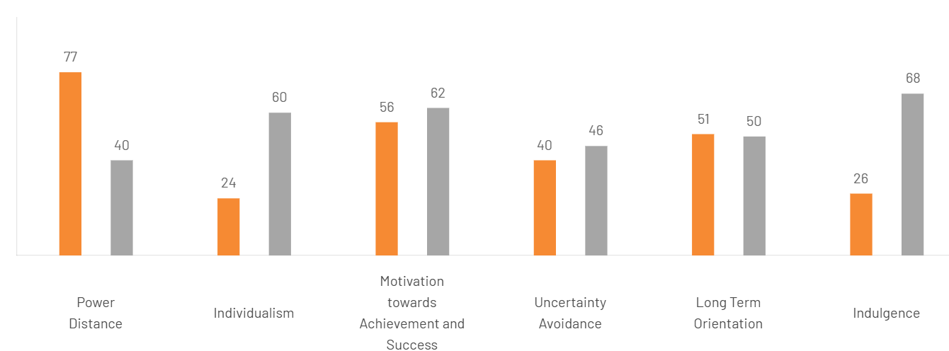
Figure 1: Hofstede cultural model
(Source: Theculturefactor, 2025)

Power Distance
India is much higher (77) than the United States (40), which shows that there is no fundamental similarity in the organisational hierarchy and authority relationships. High power distance in India indicates the satisfaction of the hierarchical system and top-down organisational forms of society. On the other hand, the United States with its lower score in power distance (40) noted the American ideal of liberty as manifested through the emphasis on equal treatment in all aspects of social and governmental existence.

Collectivism versus Individualism
The US is rated a very high individualism meaning personal success, rights of the individual and autonomy. The process of decision-making emphasises personal merit and objective standards and the promotion of professions is made based on personal achievements rather than belongingness. Although India is undergoing greater individualistic leanings in its urban regions, it is more collectivist in nature, whereby group cohesion, family ties and long term relationships are some of the factors, which affect business dealings. In the case of Tesla, such cultural differences require the performance management systems to adjust to the practices where performance metrics are based on both the team and the individual performance, there are the relationship-building guidelines that the company must establish in dealing with suppliers and partners.
Long term orientation
The cultural dimensions analysis demonstrates that there is a significant distance between the American and Indian business cultures that Tesla needs to address through adopting a comprehensive cross-cultural management strategy. As it is shown by Hassan and Craft (2012), effective global brand positioning should take into consideration both cultural and behavioural aspects of micro-segmentation, which means that Tesla strategy in India should strike the balance between global brand consistency and local cultural adjustments. In addition, the company must form cross-cultural management teams with American and Indian leaders and help exchange knowledge and cultural sensitivity on the implementation of operational practices.

