Curtis Stephens
1903184 University of Wales Trinity Saint David
ACCA5023 Network operating systems and services Worksheet two

Contents
1.0 Introduction 2
2.0 Pre-Requisite Tasks 2
2
3.0 Deploying Active Directory 4
4.0 Creating user accounts using Active Directory 7
5.0 Connecting workstations to the domain 10
6.0 Observational tasks 12
6.1 Domain Name System 12
6.1.1 Using DNS with Active Directory 13
6.2 Critical Roles 13
6.2.1 Group Policy Management 13
6.2.2 Routing and Remote Access Service (RRAS) 14
6.2 Levels of Access 14
6.3 AGDLP and AGUDLP 14
Bibliography 15

Introduction
In this part of the assignment, active directory will be deployed and used. It will be used to create user accounts for the network which will be used both for administrative purposes, as well as regular users of the network.
Prerequisite tasks will also need to be undertaken. These are:
- Renaming the system
- Ensuring firewall is turned off (It is as it was not turned on after completing worksheet one)
- Creating an administrator password, which enforces complexity requirements to keep the network safe
- Creating a domain and assigning computers to that domain
Later, there are also observational tasks that need to be undertaken. These revolve around DNS, Active Directory, levels of access and roles, and “Account, global, domain local, permission”, otherwise known as AGDLP, which is the way that Microsoft recommends for implementing role-based access controls,

Pre-Requisite Tasks

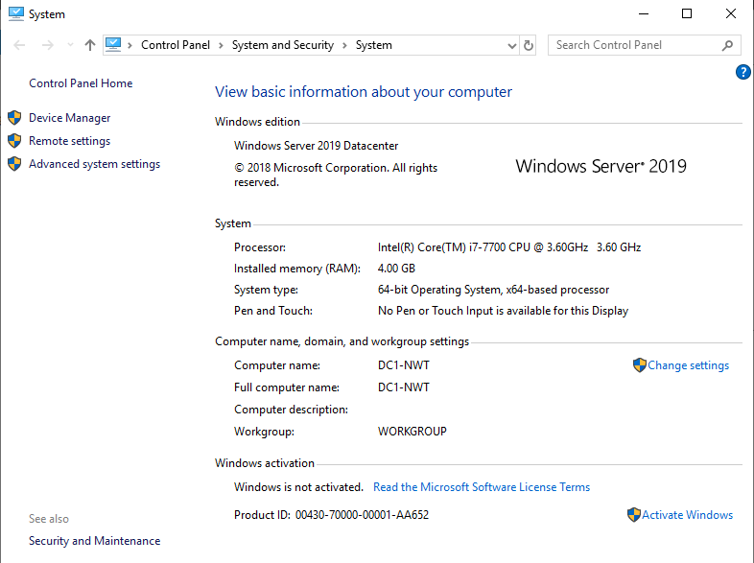

For the first pre-requisite task, the server needed to be renamed to DC1-NWT. As can be seen in the screenshot above, the server was successfully renamed.

Next, the firewall was disabled as shown below
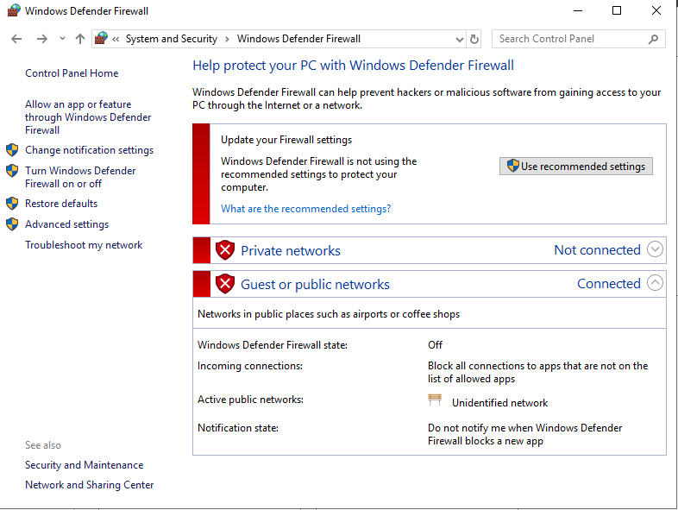
Finally, the below screenshot shows that the IP address is statically assigned, and that DNS is not set up.
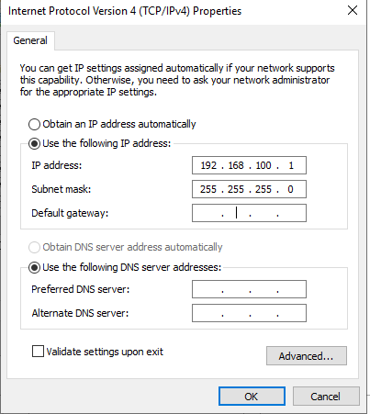

Deploying Active Directory
In this part of the worksheet, Active Directory has been deployed on the server, and the domain is also set up for the network. After doing this, the server will be assigned as a domain controller.
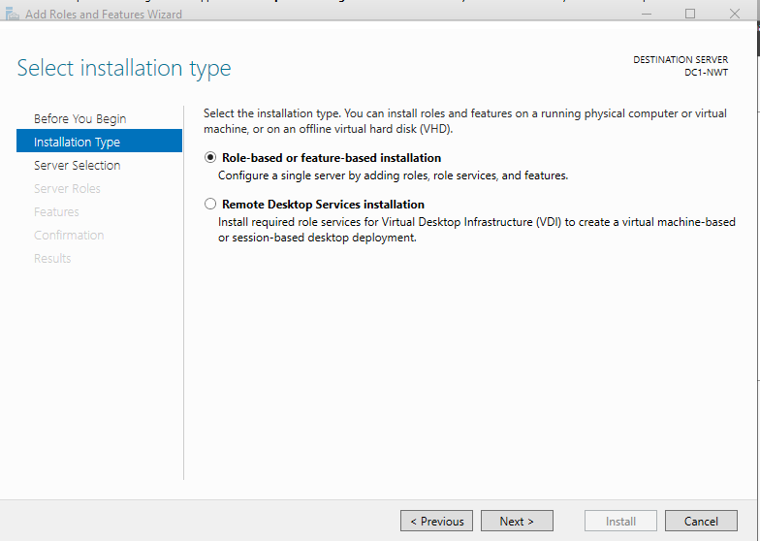
Active Directory has been deployed as a role-based installation. This type of installation is used when a network administrator requires a way to put users into groups, as will be done in this scenario. In this server, users will be placed into groups based on what their role is within the company. The higher up a user is, the more rights they will get within the network or on a workstation within the network.

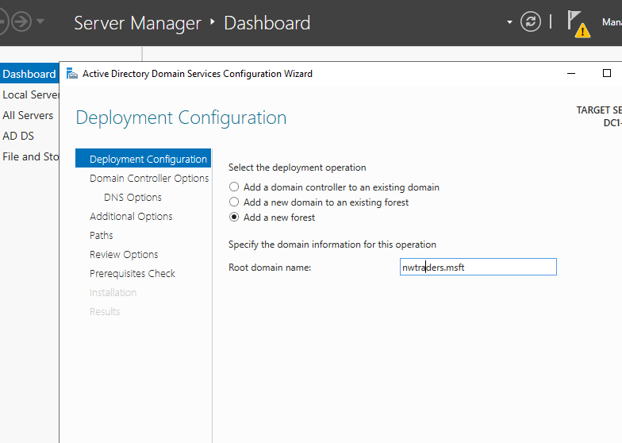
In this screenshot, the domain has been named nwtraders.msft, and a new forest created for the network and domain.
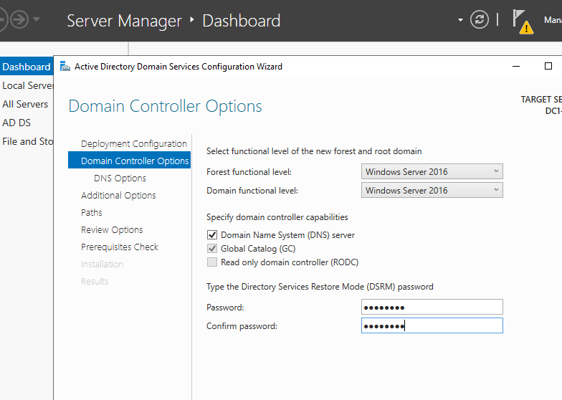
The password ‘N3tW0rk1’ was entered at this stage for the DSRM password.
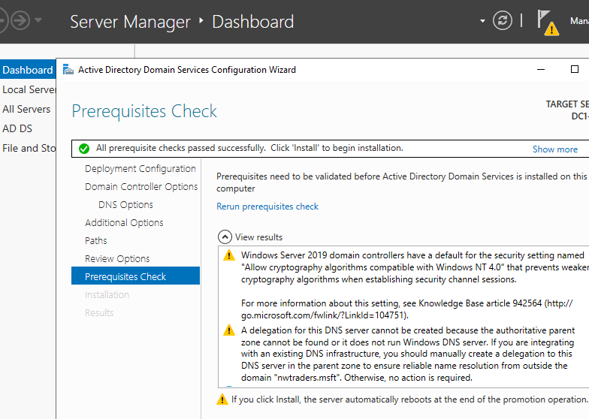
This screenshot shows that the prerequisite check was completed successfully, and installation of the chosen features can begin.
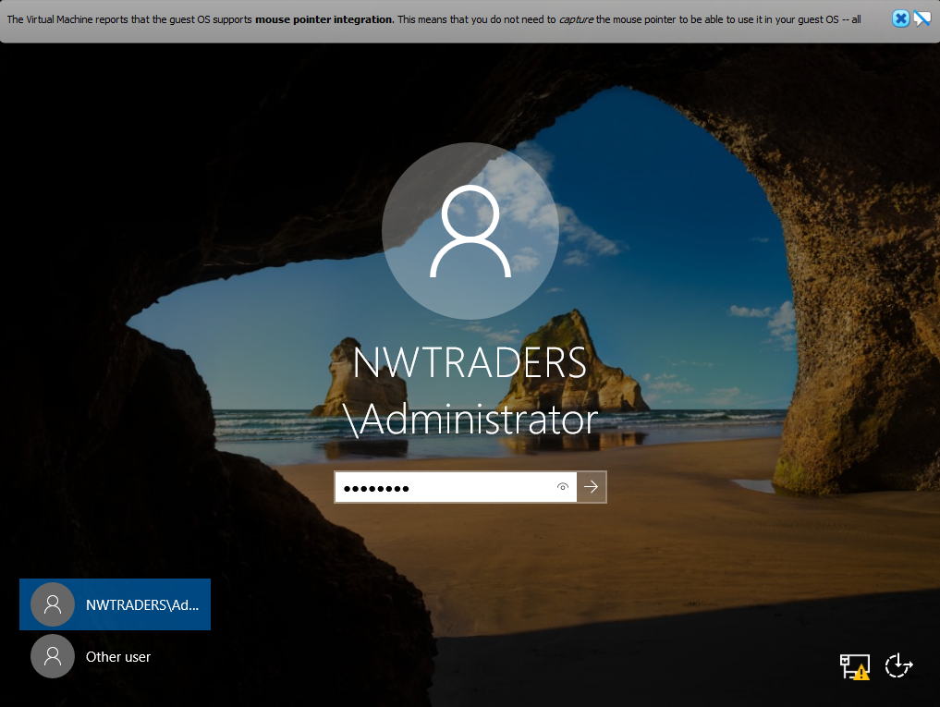
Above is the login screen, showing that the domain is working correctly on the server.

Creating user accounts using Active Directory
In this task, user accounts will be created for employees who access the network. As well as this, access times will be configured to restrict when users can gain access to the network and workstations.
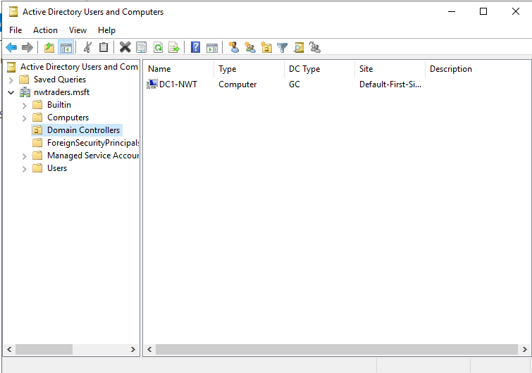
Firstly, this screenshot verifies that this server is assigned as the domain controller.
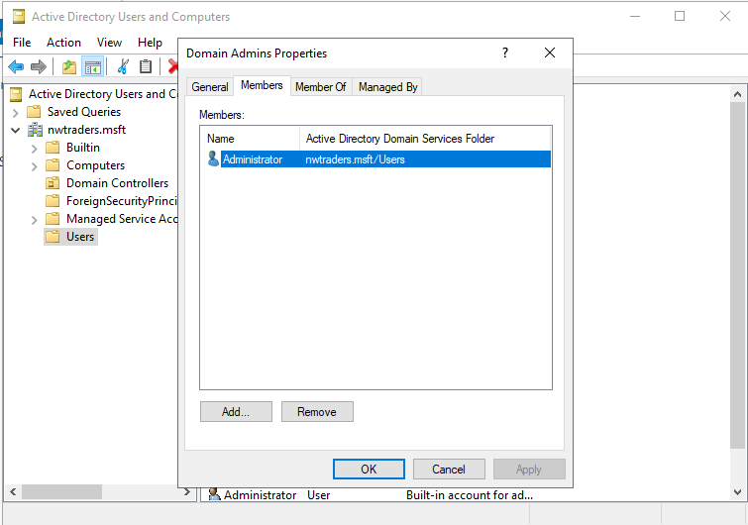
The admin account is a member of the admin group – however a failsafe account will be created in case something happens with the admin account, such as the account being hacked or password being lost or forgotten.
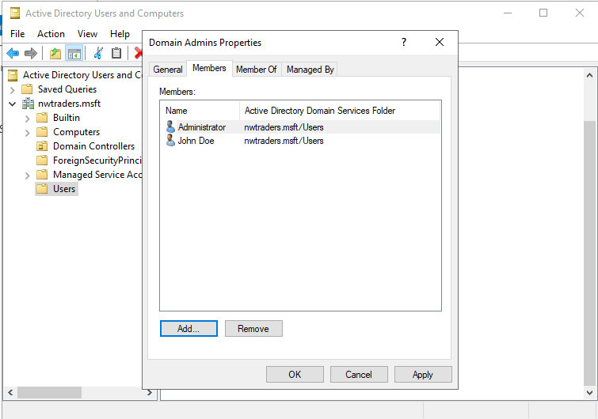
Pictured above are the two admin accounts – one is the main account, and one is a failsafe account.
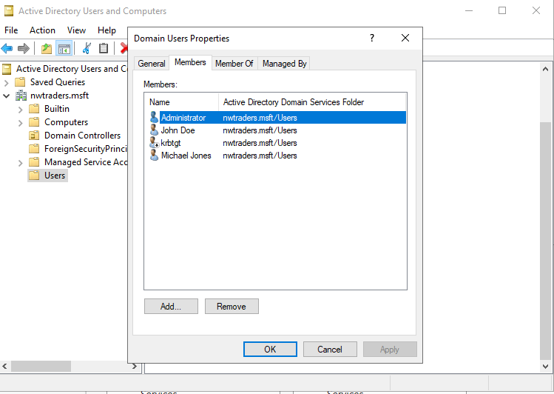
A non-admin account (Michael Jones) has also been created. This account will have limits as to when it can log in, as pictured below.
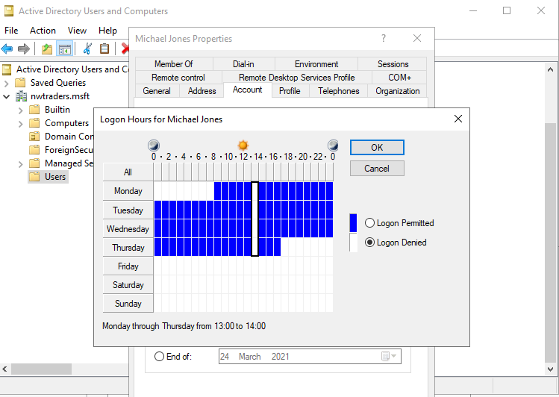
This account will only be able to log in on weekdays (Where the bars are blue). If the bars are white, then the account will not be able to log on.
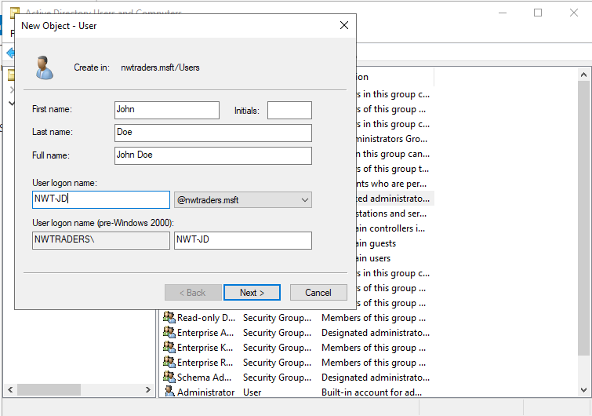

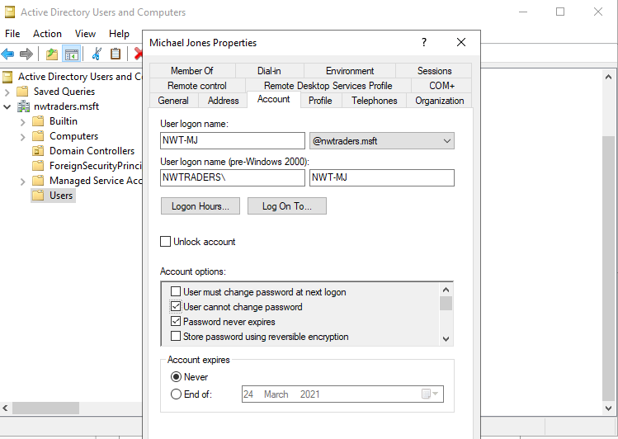
Above are screenshots of the two users’ login details, as well as the password settings for Michael Jones’ account.
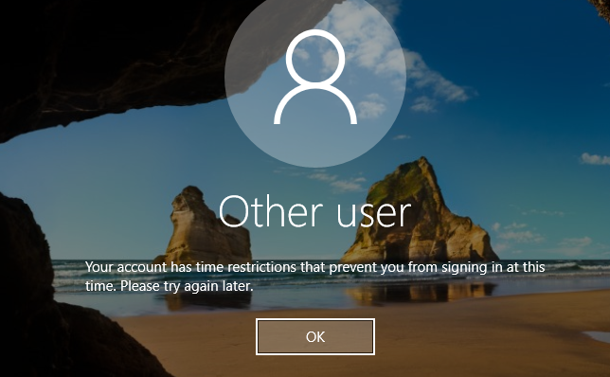
The above screenshot shows what happens when a login to the Michael Jones account was attempted outside of allowed hours.

Connecting workstations to the domain
Here, the workstation will be connected to the domain with the server.
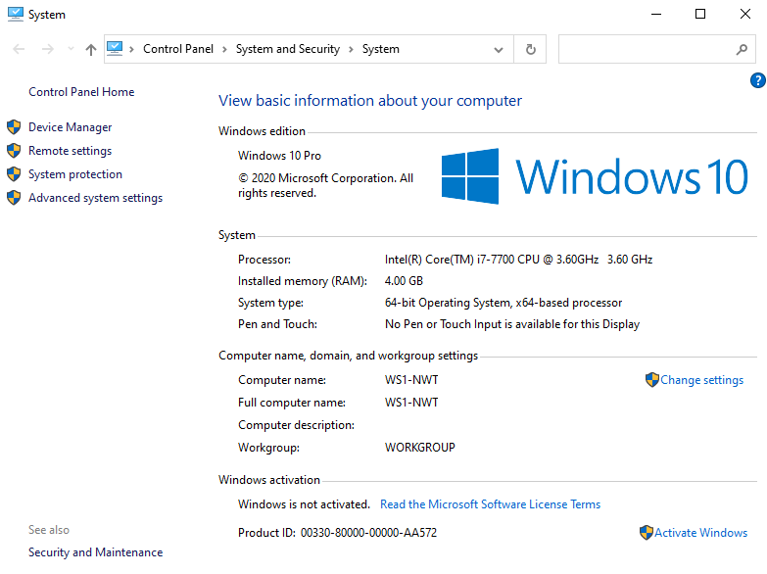
The workstation has been renamed to WS1-NWT to assist with connecting the PC to the domain, as well as identifying the workstation.
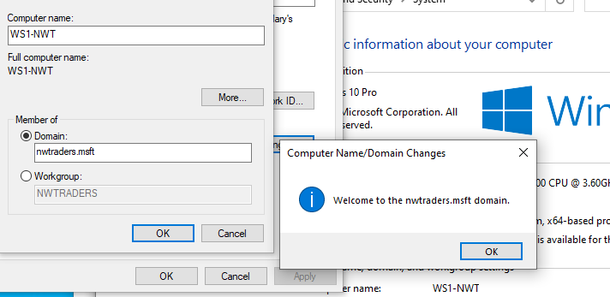
The above screenshot shows that the workstation has been successfully connected to the nwtraders.msft domain.
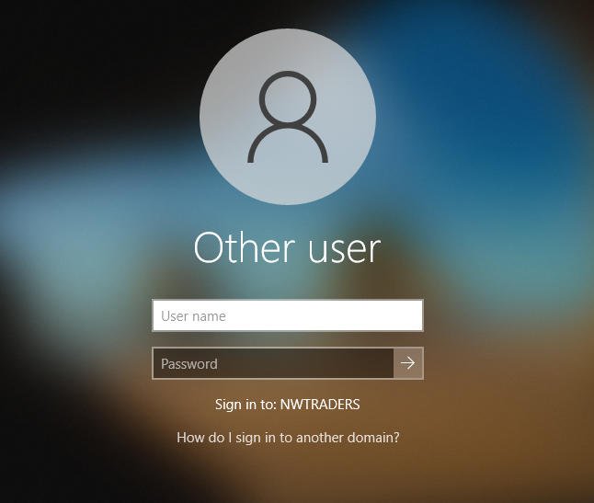
The login screen also shows the domain that the workstation is connected to.

Observational tasks

Domain Name System
A Domain Name System (or DNS for short) is a collection of databases used to translate host names into IP addresses.
For example, if a user needs to go to a website, instead of having to remember the IP address for every website, they can just type in the URL and then DNS works behind the scenes to find the IP address for that URL. The page is then displayed to the user.
How DNS works is quite simple – When a domain name is entered, it gets sent to a DNS server which searches for that domain name, and from that gets the IP address which it uses to make the connection to a webpage. (1)
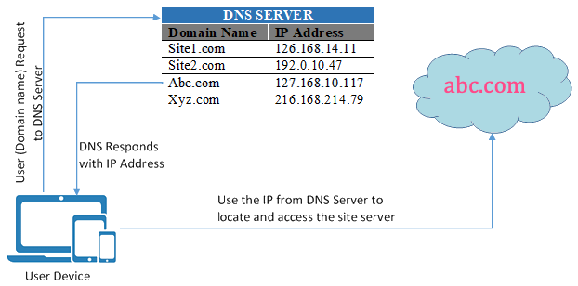 (2)
As can be seen in the above diagram, the user makes a request to the DNS server with a domain name. The server looks up the IP address for the server, and then the DNS responds with the IP address for the webpage they are trying to view. The IP address is then used to access the webpage.

6.1.1 Using DNS with Active Directory
Active Directory uses DNS to resolve names of domain controllers. This is done to make it possible for clients to locate them, and for the domain controllers that host the service to communicate with one another.
Using Active Directory Domain Services allows for easy integration of Active Directory namespace into existing DNS namespaces. Active Directory DNS zones save the network administrator from needing to set up secondary DNS zones, and then having to configure transfers. (3)

Critical Roles

6.2.1 Group Policy Management
When installing Active Directory, the user is also required to install Group Policy Management.
Group Policy Management essentially allows a network administrator to push policies to end-user devices, without having to apply them workstation by workstation. This means that less time is used updating policies, and that more time can be spent being devoted to the security of the network, if needed.
Through using Group Policy Management, administrators can do things such as: -
- Setting password complexity requirements to secure user accounts if they feel that there is a threat.
- Stopping users from using USB ports to avoid malware and viruses from getting into the network.
- Disabling users from downloading files from the internet, again to disable threats from being able to access the network.
- Stopping users from accessing files and folders or changing the contents of them depending on their position in the company.
These can be set per user or per group of users. This therefore allows different users to have different permissions on a user-by-user basis. (4)

6.2.2 Routing and Remote Access Service (RRAS)
This service is used to support either remote user or site-to-site connectivity. It does this by using a VPN or a dial-up connection.
RRAS allows VPN connections to be deployed, which allows an organisation to provide their users with remote access to the organisations network – This is being seen now more than ever during the COVID-19 pandemic, where this is being used for people to access an organisation’s files through either their own device, or a company-provided device when working from home.
RRAS is also an open platform for routing and networking and can be used as a software router. Routing services can be used by organisations using Local Area Network (LAN) connections, or Wide Area Networks (WAN). This can also be done over the internet using VPN connections. Routing is used for multiprotocol LAN to LAN, LAN to WAN, VPN and Network Address Translation routing services.

6.2 Levels of Access
It is important for a network to have different levels of access within the user groups, to allow for different permissions for different users. Most networks base their access on user roles and positions within a company, for example a lower-ranked member of staff may have less access on the network than a higher-ranked member of staff, mainly to ensure that they do not do anything wrong, such as deleting files, and downloading malicious files onto the workstation and the network.
This is the same concept higher up with administrators – some may have different experience, for example one may be more experienced in a field and may be in a different group which allows them to work in the area that they specialise in, and therefore does not allow another user to access something outside of the area that they are skilled in, in case something goes wrong.

AGDLP and AGUDLP
Accounts, Global, Domain Local, Permissions (AGDLP) and Account, Global, Universal, Domain Local, Permission (AGUDLP) is the way that Microsoft recommends implementing role-based access control. This is done using nested groups in an Active Directory domain – Users and computers are members of global groups, global groups are members of domain local groups, which describe permissions and user rights.
Using AGDLP enables Windows environments to be set up in a way which reduces account management related issues, as well as permission management issues.
Benefits of using AGDLP include:
- Being able to assign resource access to users who are in other domains.
- Being able to easily revoke user access to a resource by removing their account from the group which is able to access the resource.
- If permissions are set up correctly, an administrator will only need to add users to an appropriate group for the purpose required, and their permissions will be set up automatically with minimal work needed.
The AGDLP strategy is as follows:
A: Creating user accounts
G: Creating a global group, and adding to it the user accounts created in the previous step
DL: Creating a Domain Local group which contains the resource that users require access to and adding the global group as a member of the Domain Local group to enable them to access it.
P: Allocating permissions on the resource by using the domain local group that was made. (5)
AGUDLP is slightly different, as the U stands for Universal which is simply an extra group scope.
Universal groups can include accounts, Global groups, and other Universal groups that are in any domain in the forest which the Universal group is based in. This group can then have permissions allocated in any domain or forest, and the group scope can also be converted into a Domain Local group, or a Global group, as long as no other universal groups are members. (6)
In my opinion, this strategy would make management of a network a lot easier, as it allows a network manager to add permissions a lot easier and devote more time to other tasks – such as keeping the network secure, looking out for threats, and helping other users who require it.
This would also make management better as if there is an immediate internal threat to the network from a user – perhaps a disgruntled employee – the administrator can simply revoke their access to resources by removing them from groups.
Also, adding new users to a domain is made easier as the user would only need to be added to a group and their permissions will be automatically set up.

Bibliography
1. Fisher, Tim. What is DNS (Domain Name System)? Lifewire. [Online] 27 November 2019. [Cited: 9 March 2021.] https://www.lifewire.com/what-is-dns-domain-name-system-2625855.
2. What is DNS and How it Works? Webnots. [Online] 2 March 2019. [Cited: 9 March 2021.] https://www.webnots.com/what-is-dns-and-how-it-works/.
3. Microsoft. DNS and AD DS. Microsoft. [Online] 8 August 2018. [Cited: 9 March 2021.] https://docs.microsoft.com/en-us/windows-server/identity/ad-ds/plan/dns-and-ad-ds.
4. SolarWinds MSP. Group Policy Management Overview. SolarWinds MSP. [Online] 27 January 2020. [Cited: 10 March 2021.] https://www.solarwindsmsp.com/blog/group-policy-management.
5. AGDLP (Accounts, Global groups, Domain Local groups, Permissions). Ignited Soul. [Online] 18 January 2013. [Cited: 10 March 2021.] https://ignitedsoul.com/2013/01/18/agdlp-accounts-global-groups-domain-local-groups-permissions/.
6. Berger, Alex. All about AGDLP group scope for Active Directory - Account, Global, Domain Local, Permissions. Stealthbits. [Online] 21 October 2014. [Cited: 10 March 2021.] https://stealthbits.com/blog/all-about-agdlp-group-scope-for-active-directory-account-global-domain-local-permissions/.

