Programme: Certificate of Higher Education in Health and Social Care

Module code: LCHS4010 Psychology in Health and Social Care.

Student Name: Dikiula Ntedi Richard

Student ID:2133786

Introduction
Psychology plays a crucial role in health and social care by enhancing our understanding of physiological factors influencing human behaviour across the lifespan. Key theories, such as Erikson's psychosocial stages, emphasize the importance of developmental challenges individuals face from infancy to late adulthood (Erikson, 1950). Each stage impacts emotional and social well-being, influencing how clients engage with care services. Additionally, Havighurst's activity theory highlights the significance of ongoing development through age-appropriate activities, which can significantly affect physical and mental health (Havighurst, 1961). Understanding these theories aids health and social care professionals in tailoring interventions that address individual needs, fostering better outcomes (McLeod, 2018).

Main Body:
Using the Attachment Theory of Bowlby to Work with Jenny
A Lifespan Developmental Approach

Part A: Theories of Lifespan Development in Health and Social Care Practice

Annotated Bibliography
Understanding theories of lifespan development is essential for health and social care professionals because it helps explain how individuals’ psychological and social needs change across different stages of life. These theories guide practitioners in supporting wellbeing, promoting independence and delivering person-centred care. Two influential perspectives frequently applied in practice are Erikson’s psychosocial theory and Havighurst’s activity theory.
Erikson’s psychosocial theory proposes that individuals progress through eight developmental stages across the lifespan, each characterised by a psychosocial crisis that must be resolved to support healthy development (Erikson, 1963). In health and social care settings, this theory helps practitioners understand emotional and social challenges that service users may experience. For example, older adults in the stage of ego integrity versus despair may reflect on their life achievements. Professionals can support positive outcomes by encouraging reminiscence therapy and promoting social engagement, which may improve wellbeing and reduce feelings of isolation (Broderick and Blewitt, 2019). Similarly, adolescents experiencing the identity versus role confusion stage may require supportive environments that promote autonomy and self-expression, which is particularly relevant in youth mental health services (McLeod, 2018).

Diagram of: Bowlby’s attachment theory and Positive psychology approaches to ageing 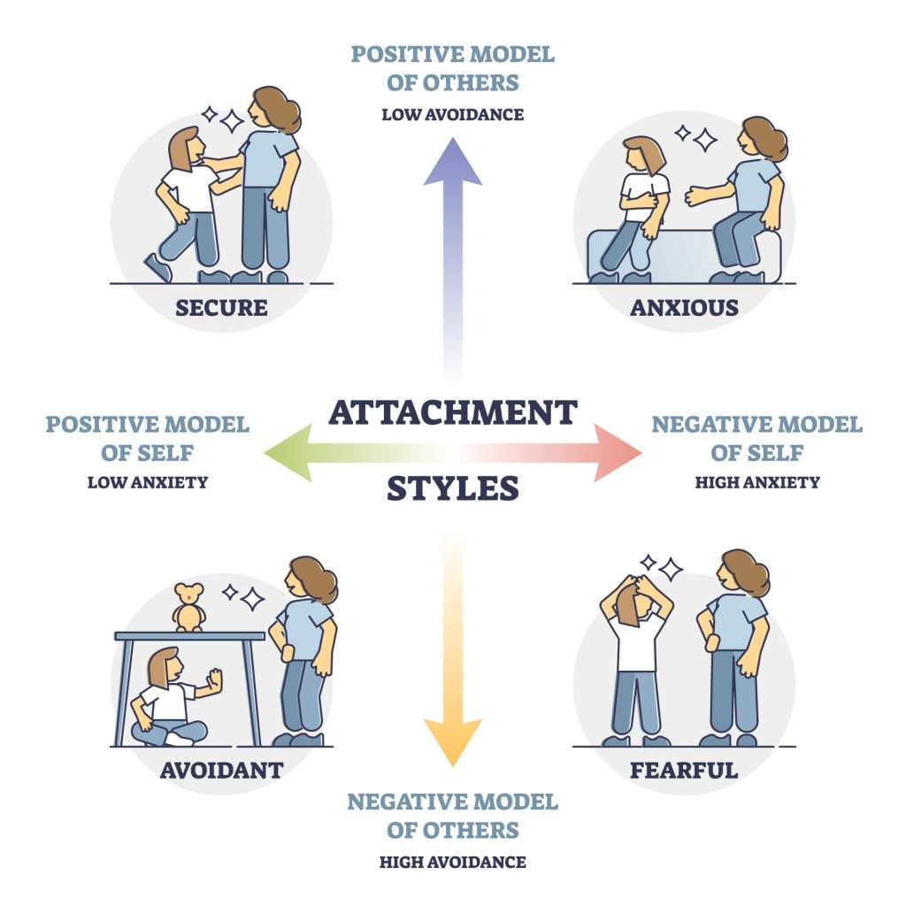
Havighurst’s activity theory focuses specifically on ageing and suggests that successful ageing occurs when older adults remain socially active and maintain roles similar to those they had earlier in life (Havighurst, 1961). This theory is widely applied in social care practice, where encouraging participation in community activities, volunteering or hobbies can enhance life satisfaction and mental wellbeing among older people (Berk, 2018). Maintaining social roles may also reduce the risk of loneliness, which is linked to poorer physical and psychological health outcomes (Victor, 2010).

Psychological factors such as identity, motivation, self-esteem and social relationships strongly influence behaviour throughout the lifespan. Understanding these factors allows practitioners to provide holistic care that considers emotional as well as physical needs (Mcleod, 2018). For example, individuals experiencing low self-esteem may struggle with treatment adherence, while those with strong social support networks often demonstrate better recovery outcomes (Berk, 2018). Applying lifespan development theories therefore helps professionals tailor interventions to each stage of life, improving communication, empathy and effectiveness in care delivery.
Overall, integrating psychosocial and ageing theories into practice allows health and social care professionals to better understand service users’ developmental needs. This knowledge supports person-centred care and promotes psychological wellbeing across the lifespan.

Examine the social and biological determinants of human behaviour in relation to the context of health and social care and working with children and young people
Human behaviour is shaped by both biological and social determinants, which are particularly important in health and social care settings involving children and young people. Biological determinants refer to genetic, neurological and physiological factors that influence behaviour and development. For example, brain maturation, hormonal changes and inherited traits can affect emotional regulation, risk-taking and cognitive functioning during childhood and adolescence (Shonkoff & Phillips, 2000). Neurodevelopmental conditions such as attention deficit hyperactivity disorder (ADHD) or autism spectrum disorder also demonstrate how biological factors can influence behaviour, learning and social interaction (Thapar et al., 2017). These biological influences highlight the importance of early identification and supportive interventions within health and social care services.
However, biological factors alone do not determine behaviour. Social determinants—including family environment, socioeconomic status, education, culture and peer relationships—also play a critical role in shaping behaviour and wellbeing. The social determinants of health framework suggests that children’s health outcomes are strongly influenced by the conditions in which they grow, live and learn (Marmot, 2015). For instance, children living in poverty may experience increased stress, limited access to healthcare and fewer educational opportunities, which can negatively affect both behavioural development and long-term health (World Health Organization, 2010). Similarly, parenting style and attachment relationships can significantly influence emotional development and behavioural regulation (Bowlby, 1988).
In health and social care practice, understanding the interaction between biological and social determinants is essential when working with children and young people. Bronfenbrenner’s ecological systems theory emphasises that a child’s development is influenced by multiple environmental systems, including family, school and wider societal structures (Bronfenbrenner, 1979). This perspective encourages practitioners to adopt a holistic approach that considers both internal biological processes and external social contexts. For example, behavioural difficulties in a child may be linked to neurological factors, family stress or a combination of both.
Recognising these interconnected determinants enables professionals to provide more effective support and early intervention. Health and social care practitioners must therefore assess biological needs alongside social circumstances, ensuring that services promote healthy development, safeguard wellbeing and address inequalities affecting children and young people (Department of Health and Social Care, 2022). Understanding these determinants ultimately supports more person-centred and preventative approaches to care.

Part B: Short Report: Applying Psychosocial Theory to Improve Psychological Wellbeing in Residential Care

Psychological wellbeing is an essential component of quality care for older adults living in residential settings. One useful framework for understanding emotional needs in later life is Erik Erikson’s theory of psychosocial development. Erikson proposed that the final life stage is characterised by the conflict between integrity and despair, where individuals reflect on their lives and evaluate whether they feel a sense of fulfilment or regret (Erikson, 1950). Applying this theory in residential care can support practitioners to promote dignity, life satisfaction and emotional wellbeing among older residents.
According to Erikson, achieving ego integrity occurs when individuals feel their lives have meaning and value, while despair may arise when people experience regret, loss or feelings of failure (Erikson, 1950; Knight, 2017). Older adults in residential care may be particularly vulnerable to despair due to factors such as reduced independence, health problems and separation from familiar environments (Berk, 2018). Therefore, care professionals can use Erikson’s theory to guide interventions that support positive life reflection and emotional adjustment.
One practical strategy is the use of life review and reminiscence activities, which encourage residents to discuss past experiences, achievements and meaningful relationships. Research shows that reminiscence therapy can increase life satisfaction and reduce depressive symptoms in older adults (Westerhof et al., 2010; Woods et al., 2018). Structured group discussions, memory books or storytelling sessions can help residents construct a coherent narrative of their lives and strengthen their sense of identity (Bohlmeijer et al., 2007).
Another application is promoting person-centred care, where staff acknowledge residents’ individual histories, values and preferences. Understanding a person’s life story allows staff to tailor activities and communication in ways that reinforce dignity and personal identity (Kitwood, 1997; Nolan et al., 2004). This approach can also foster stronger relationships between staff and residents, which contributes to emotional security and wellbeing.
Opportunities for continued contribution and social engagement are also important. Erikson emphasised the importance of feeling that one’s life has purpose (Erikson, 1950). Encouraging residents to participate in community roles within the care home—such as mentoring others, assisting with activities, or sharing skills—can help maintain a sense of usefulness and belonging (Berk, 2018).

Psychosocial Theory and Supporting Older Adults

Erik Erikson developed Psychosocial Theory, which explains human development across eight life stages. The final stage, ego integrity versus despair, is particularly relevant to older adulthood, as individuals reflect on their life experiences and develop a sense of fulfilment or regret (Erikson, 1963). In health and social care settings, this theory helps professionals understand the emotional, social and psychological needs of older adults and guides supportive practices that promote dignity, reflection and wellbeing (Knight, 2017).
One challenge professionals may face when applying psychosocial theory is time and workload pressures in health and social care environments. Staff working in hospitals, care homes or community services often focus on physical health needs and routine care tasks, leaving limited time to support the deeper psychological and reflective processes that psychosocial theory emphasises (Berk, 2018). For example, encouraging life review, discussing personal achievements or addressing feelings of regret requires meaningful communication and relationship building, which may be difficult in busy care settings (Corey, 2016). As a result, the emotional and developmental needs of older adults may be overlooked.
A useful strategy to overcome this challenge is integrating structured life-review or reminiscence activities into routine care. Reminiscence therapy, which involves discussing past experiences, achievements and meaningful life events, can support older adults in developing a sense of integrity and acceptance of their lives (Westerhof & Bohlmeijer, 2014). Health and social care professionals can incorporate these conversations during regular interactions, group activities or care planning sessions. Training staff in communication skills and person-centred approaches can also help them recognise opportunities to support psychosocial wellbeing alongside physical care (Brooker, 2007). This approach allows professionals to apply psychosocial theory practically without significantly increasing workload.
Critically, psychosocial theory remains highly relevant in supporting older adults because it highlights the importance of identity, reflection and emotional wellbeing in later life. Understanding the stage of ego integrity versus despair helps professionals recognise why older adults may wish to discuss their life experiences or express concerns about regrets and meaning (Erikson, 1963). Supporting these needs can improve self-esteem, mental health and overall wellbeing (Berk, 2018). However, the theory has limitations because it assumes that development occurs in fixed stages and may not fully account for cultural differences or the diverse life experiences of older people (Knight, 2017). Despite these criticisms, psychosocial theory remains a valuable framework for promoting holistic, person-centred care that considers both the psychological and social needs of ageing individuals.

Conclusion
In Erikson’s psychosocial theory provides a valuable framework for supporting psychological wellbeing in residential care. By incorporating reminiscence work, person-centred care and opportunities for meaningful participation, health and social care professionals can help older adults achieve a sense of integrity and improved emotional wellbeing.

References
- Erikson, E. H. (1950). Childhood and Society. W. W. Norton & Company.
- Havighurst, R. J. (1961). Developmental Tasks and Education. Longman.
- McLeod, S. (2018). Erik Erikson: Psychosocial Stages of Development. Retrieved from [Simply Psychology](https://www.simplypsychology.org/Erik-Erikson.html).
ReplyForward
Berk, L.E., 2018. Development through the lifespan. 7th ed. Boston: Pearson.
Broderick, P.C. and Blewitt, P., 2019. The life span: Human development for helping professionals. 5th ed. Boston: Pearson.
Erikson, E.H., 1963. Childhood and society. 2nd ed. New York: W.W. Norton.
Havighurst, R.J., 1961. Successful aging. The Gerontologist, 1(1), pp.8–13.
McLeod, S., 2018. Erik Erikson’s stages of psychosocial development. Simply Psychology. Available at: https://www.simplypsychology.org/Erik-Erikson.html (Accessed: 11 March 2026).
Victor, C.R., 2010. Loneliness in care homes: A neglected area of research? Aging Health, 6(6), pp.637–646.
Berk, L.E., 2018. Psychosocial development in adulthood. In: Development through the lifespan. Boston: Pearson.
Broderick, P.C. and Blewitt, P., 2019. Social and emotional development across the lifespan. In: The life span: Human development for helping professionals. Boston: Pearson.
Bowlby, J. (1988). A secure base: Parent-child attachment and healthy human development. Basic Books.
Bronfenbrenner, U. (1979). The ecology of human development: Experiments by nature and design. Harvard University Press.
Department of Health and Social Care. (2022). Health and social care integration: Policy overview. UK Government.
Marmot, M. (2015). The health gap: The challenge of an unequal world. Bloomsbury.
Shonkoff, J. P., & Phillips, D. A. (2000). From neurons to neighborhoods: The science of early childhood development. National Academy Press.
Berk, L. (2018) Development Through the Lifespan. 7th ed. Boston: Pearson.
Bohlmeijer, E., Roemer, M., Cuijpers, P. and Smit, F. (2007) ‘The effects of reminiscence on psychological well-being in older adults’, Aging & Mental Health, 11(3), pp. 291–300.
Erikson, E. (1950) Childhood and Society. New York: Norton.
Kitwood, T. (1997) Dementia Reconsidered: The Person Comes First. Buckingham: Open University Press.

PRESENTATION HANDOUT
Psychology in Health and Social Care
Using the Attachment Theory of Bowlby to Work with Jenny
A Lifespan Developmental Approach

Module: LCHS4010
Level: Level 4 | Assessment 1
Institution: University of Wales Trinity Saint David
Date: March 2026
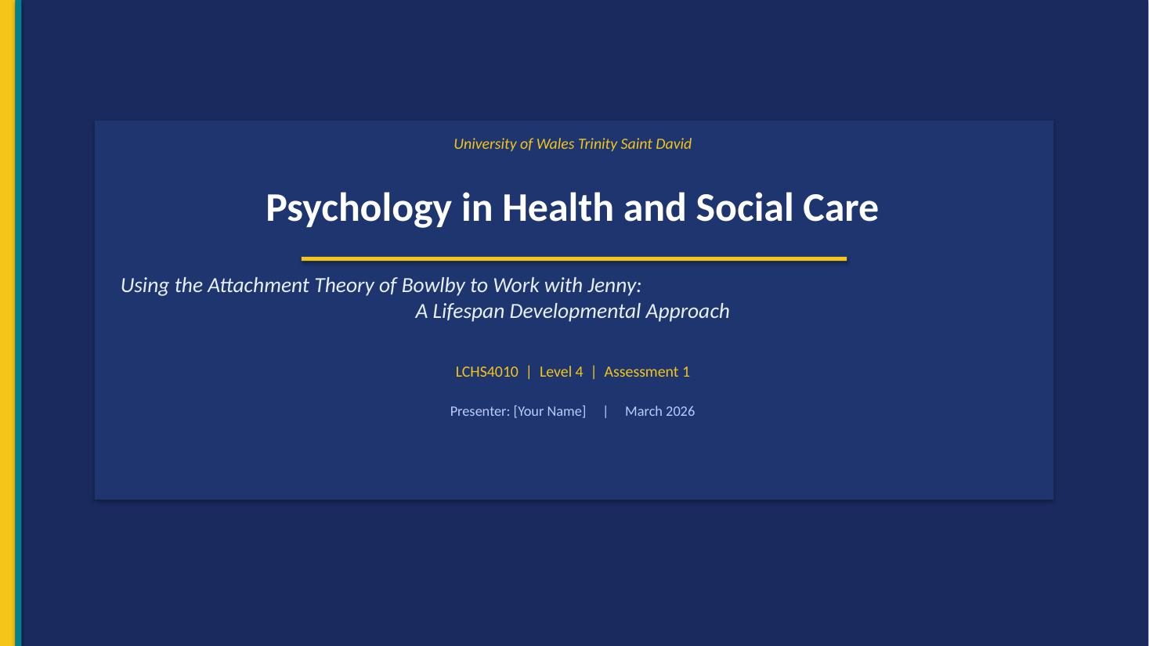

Speaker Notes:
Good morning/afternoon. My name is Richard and today, I am going to deliver a 10-minute individual presentation on module LCHS4010. I will use the Attachment Theory developed by Bowlby to the example of Jenny, a young carer of 16 years. I will discuss how it has influenced her growth throughout history and today, outline the evidence-based support plan, and discuss the usefulness and limitations of the theory in health and social care critically.

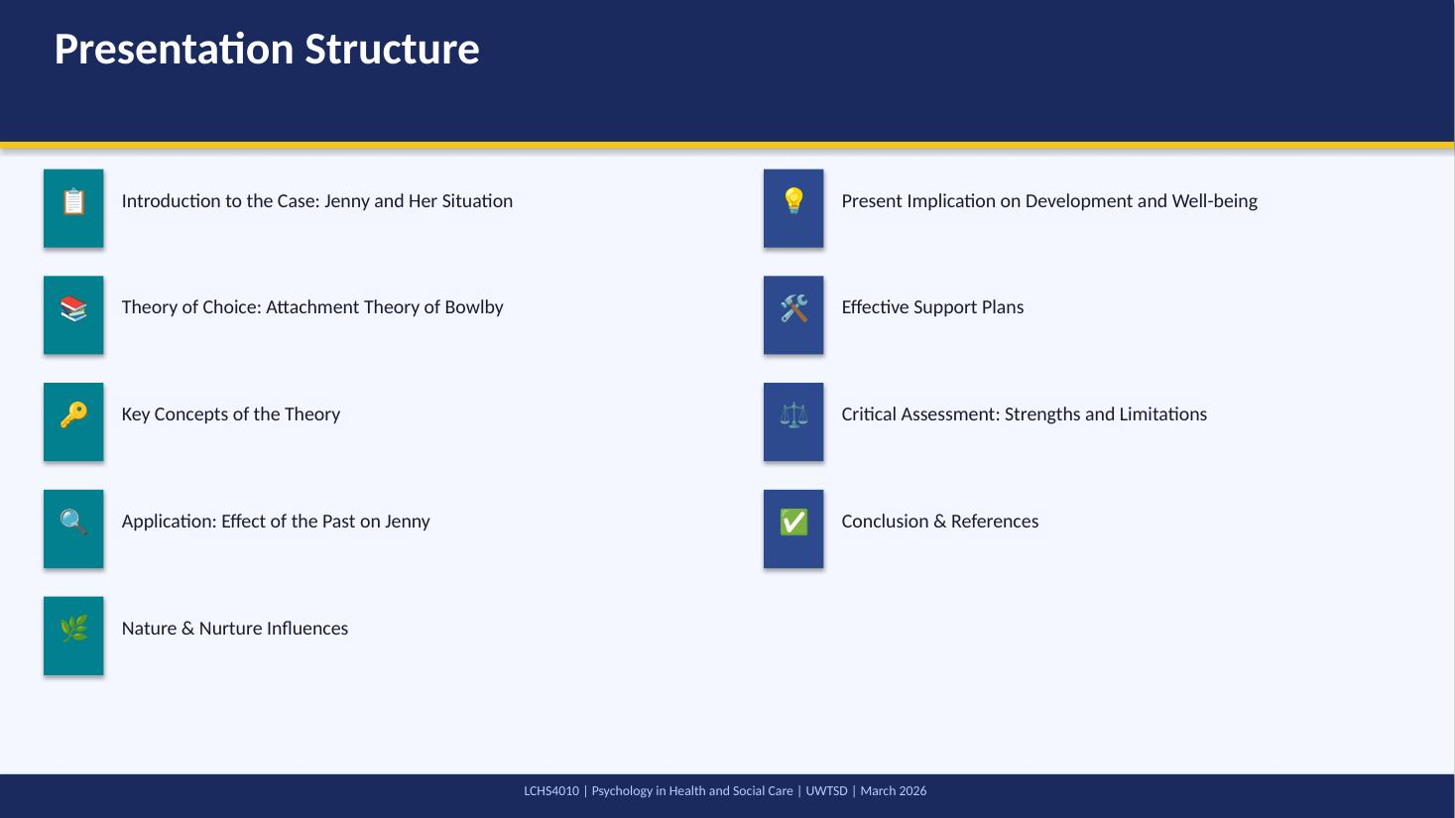
Speaker Notes:
This slide explains my presentation outline. I will first put the context of the situation Jenny is in, and then introduce and discuss the Attachment Theory proposed by Bowlby. I will use the same theory to examine the past and the present contribution toward the development of Jenny. I will then put forward evidence-based interventions and then critically assess the applicability of the theory. The presentation is based entirely on the academic literature with the use of Harvard referencing.

SLIDE 3 — Case Overview: Who is Jenny?
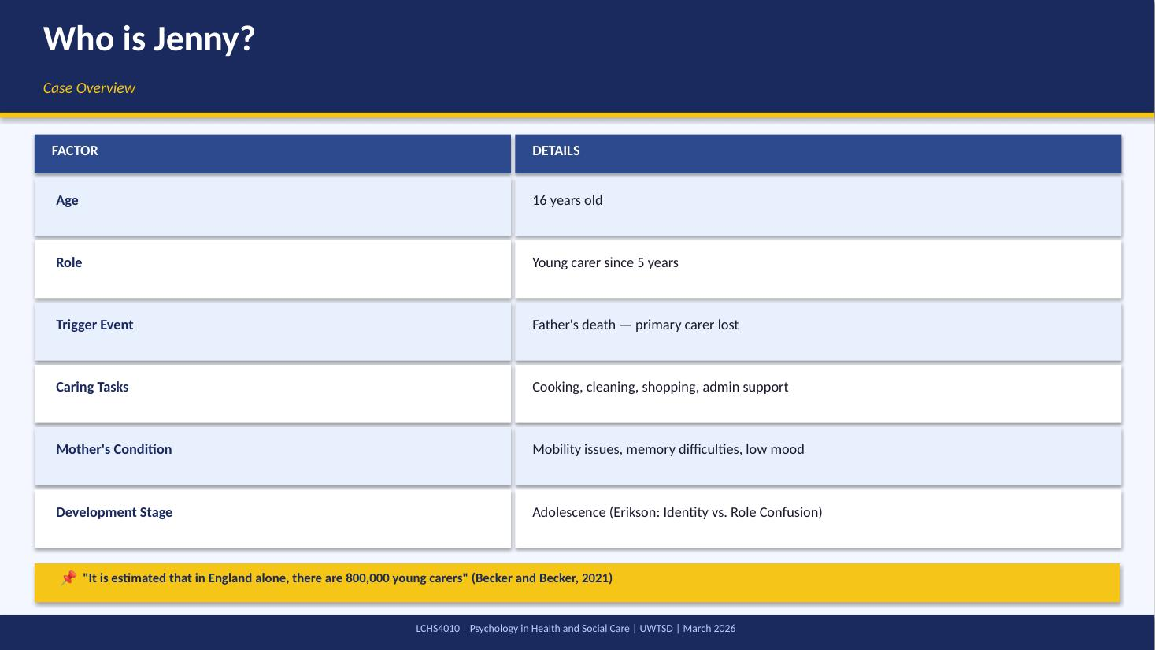
Speaker Notes:
Jenny is 16 and has been the main carer to her mother in the last five years since the death of her father. Her mother has physical and cognitive health problems. Jenny has been endowed with the role of a caring adult at a critical period of adolescent development. This puts her own psychological, social and education development at high risk. Becker and Becker (2021) emphasize that young carers are at a disproportionate risk of poor mental health and educational disturbance relative to other children.

SLIDE 4 — Why Bowlby's Attachment Theory?
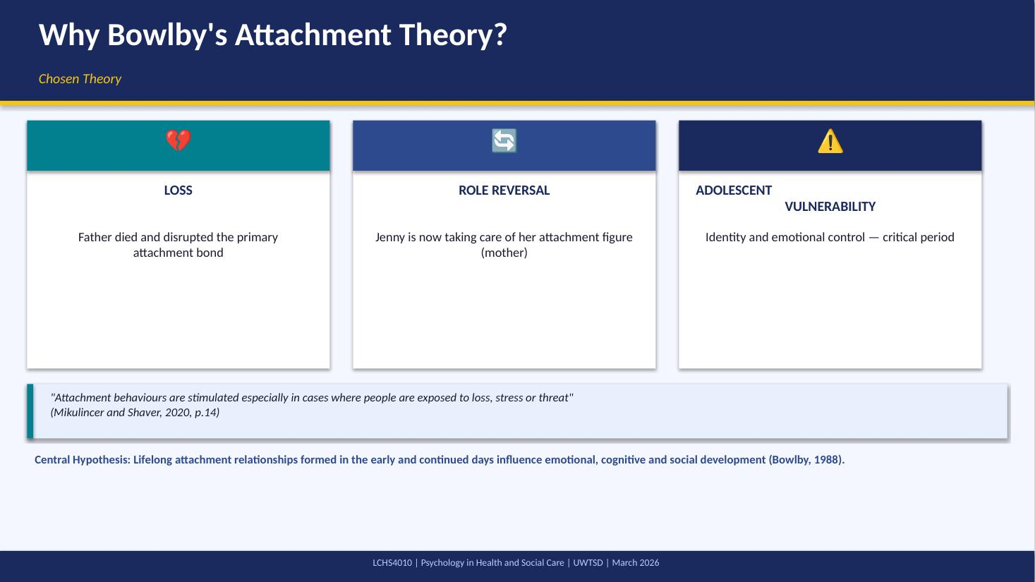
Speaker Notes:
I chose the Attachment Theory developed by Bowlby since it addresses directly the central dimensions of the experience of Jenny, which are bereavement, lack of secure attachment, and role reversal. Bowlby (1988) hypothesized that the attachment relationships between the early childhood stage and the lifespan affect behaviour and regulation of emotional life. Mikulincer and Shaver (2020) confirm that stress and loss are the main triggers of attachment activation, which is why the theory is especially relevant to the current situation of Jenny and her life at the age.

SLIDE 5 — Core Concepts of the Theory
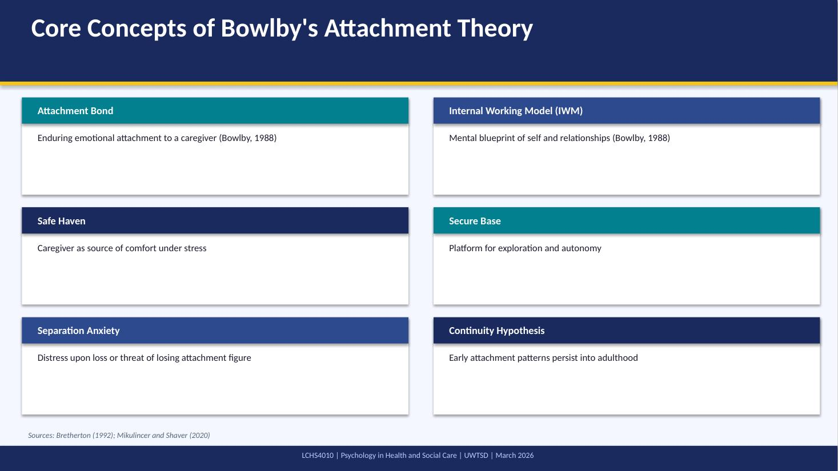
Speaker Notes:
Bowlby (1988) singled out the attachment bond as an essential biological and psychological necessity. One of the major concepts is the Internal Working Model, the cognitive pattern by which people mentate relationships and manage emotions. Insecure attachment styles may be a result of a disrupted IWM due to loss or irregular caregiving. Bretherton (1992) observed that the IWM has been influencing relationship patterns in life. The role reversal with her mother and the loss of her father will have greatly affected her IWM and secure base in the case of Jenny.

SLIDE 6 — The Past 5 Years: Attachment Disruption
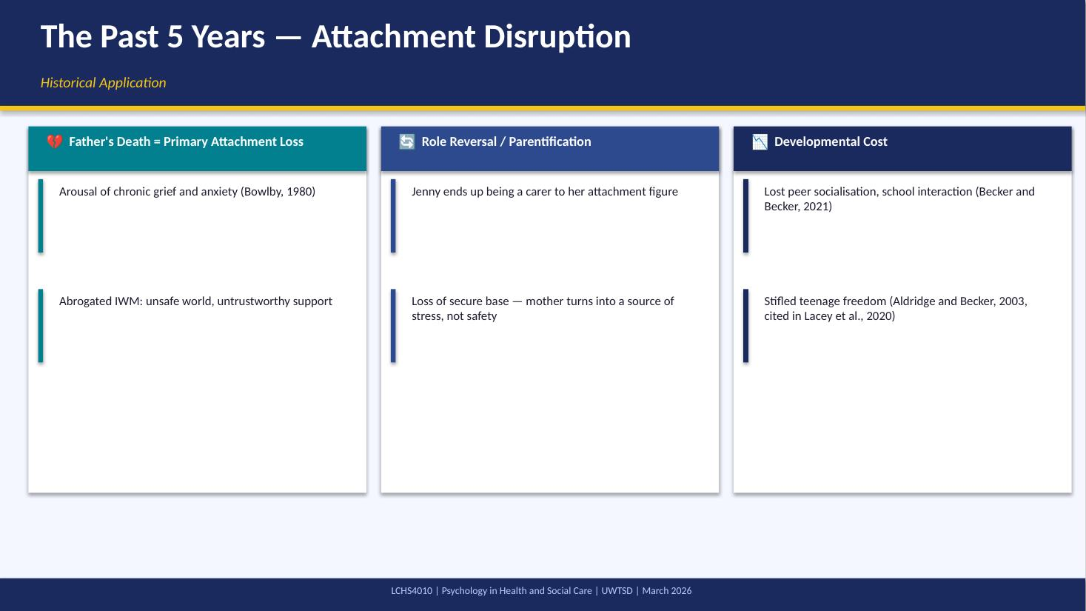
Speaker Notes:
During the last five years Jenny has undergone two disruptions of attachment. First, loss of her father who was her main attachment figure caused grief, anxiety and destabilised Internal Working Model. Second, the resultant role reversal leaves Jenny in a nurturing role to her mother thereby eliminating the mutual emotional safety net which a mother-child attachment would offer. Lacey et al. (2020) concluded that parental loss and role reversal in young carers also show much higher levels of anxiety, depression and social isolation compared to other groups.

SLIDE 7 — Nature & Nurture in Jenny's Development
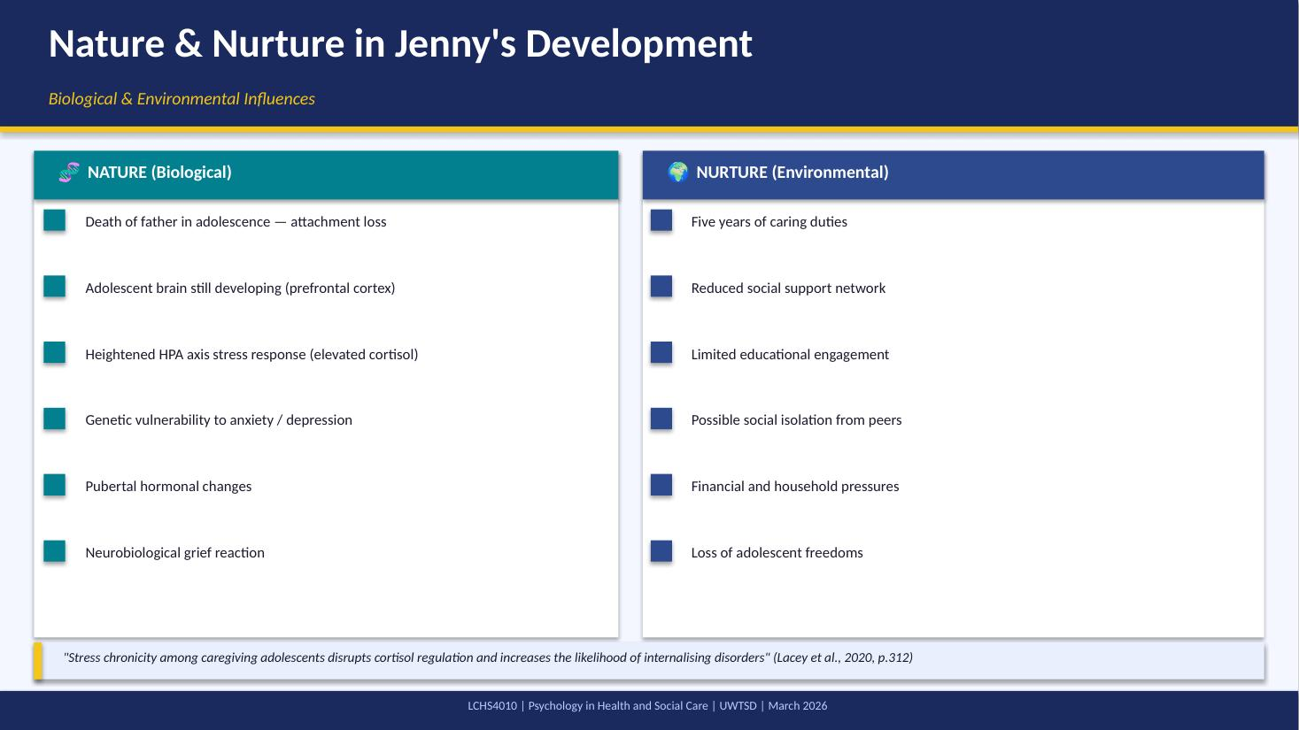
Speaker Notes:
Nature-nurture concept is critical to the overall development of Jenny. The adolescent brain of Jenny is still developing critically especially in aspects that control emotional controls and judgment. The sustained stress due to caregiving can increase cortisol levels, and Lacey et al. (2020) attribute this to the risk of developing internalising disorders in young carers. These biological weaknesses are compounded by her father loss, five years of caregiving and less peer interaction. Bowlby himself recognized that attachment patterns are influenced by biological and environmental factors in their interaction.

SLIDE 8 — Impact Across Developmental Domains
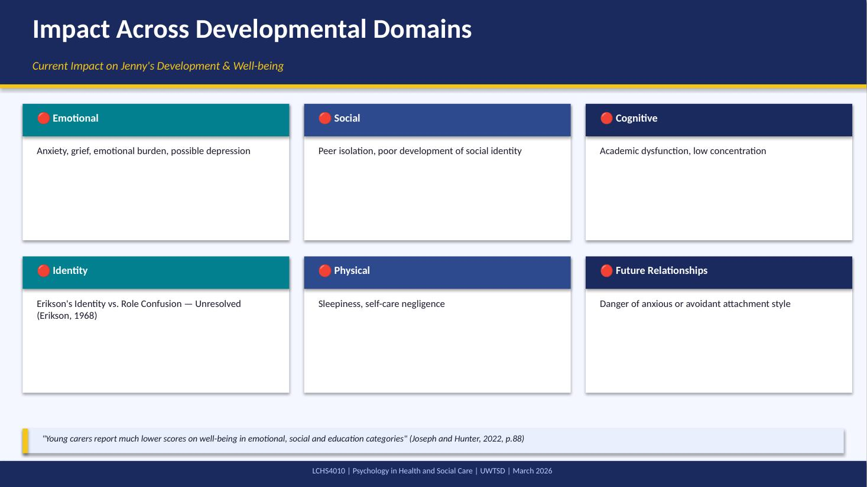
Speaker Notes:
Based on the framework proposed by Bowlby, Jenny was a caring and disrupted attachment as a result of five years of caregiving, which has multi-domain developmental effects. On the emotional plane, she is subject to chronic stress and unresolved grief. Having less peer contact prevents the identity development that became essential during adolescence, as discovered by Erikson (1968). Joseph and Hunter (2022) establish that the young carers always rate lower in all the well-being domains than their non-caring counterparts.

SLIDE 9 — Evidence-Based Support Plan for Jenny
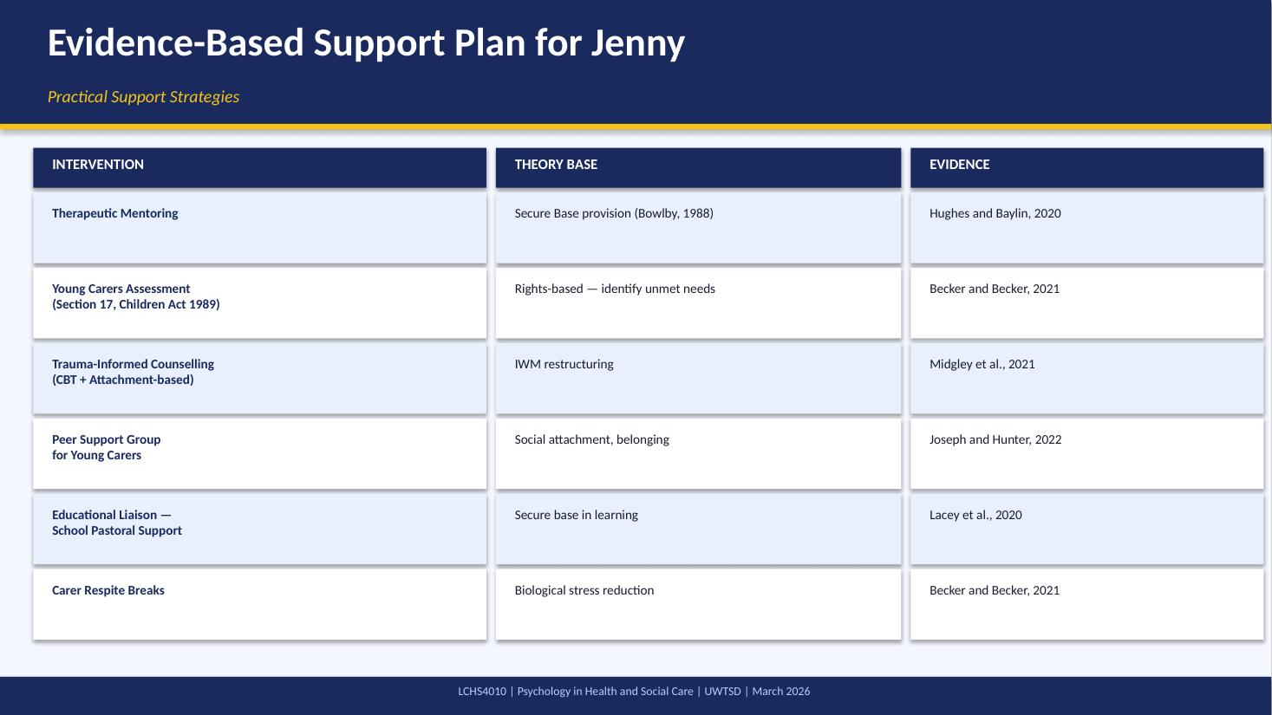
Speaker Notes:
As the theory of Bowlby suggests, the most effective way of assisting Jenny is to reinstate a feeling of secure base and reconstructing a healthy Internal Working Model. A therapeutic mentor is able to offer a stable and secure attachment figure. Hughes and Baylin (2020) suggest that adolescents with disrupted attachment histories should be treated using dyadic developmental psychotherapy. Midgley et al. (2021) established that attachment-based therapies have been shown to be especially useful in alleviating anxiety and depression in adolescents with a history of caregiving.

SLIDE 10 — Strengths of Attachment Theory
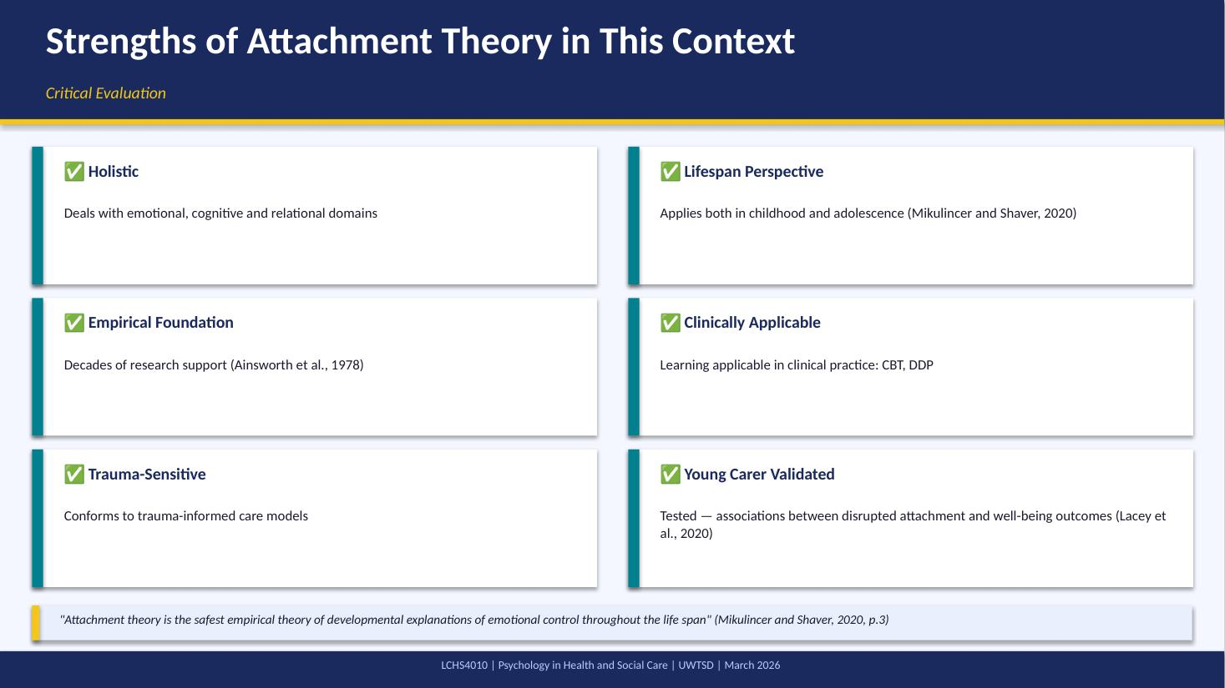
Speaker Notes:
The Attachment Theory proposed by Bowlby has strong points in the given context of health and social care. Its lifespan applicability renders it the best during adolescence like in the case of Jenny where the disruption at an early age has a developmental effect on her. Mikulincer and Shaver (2020) have defined it as the most empirically sound model of emotional regulation in the lifespan. The practical applicability of the theory is directly manifested in its implementation into such clinical models as Dyadic Developmental Psychotherapy and Attachment-Based CBT.

SLIDE 11 — Limitations to Consider
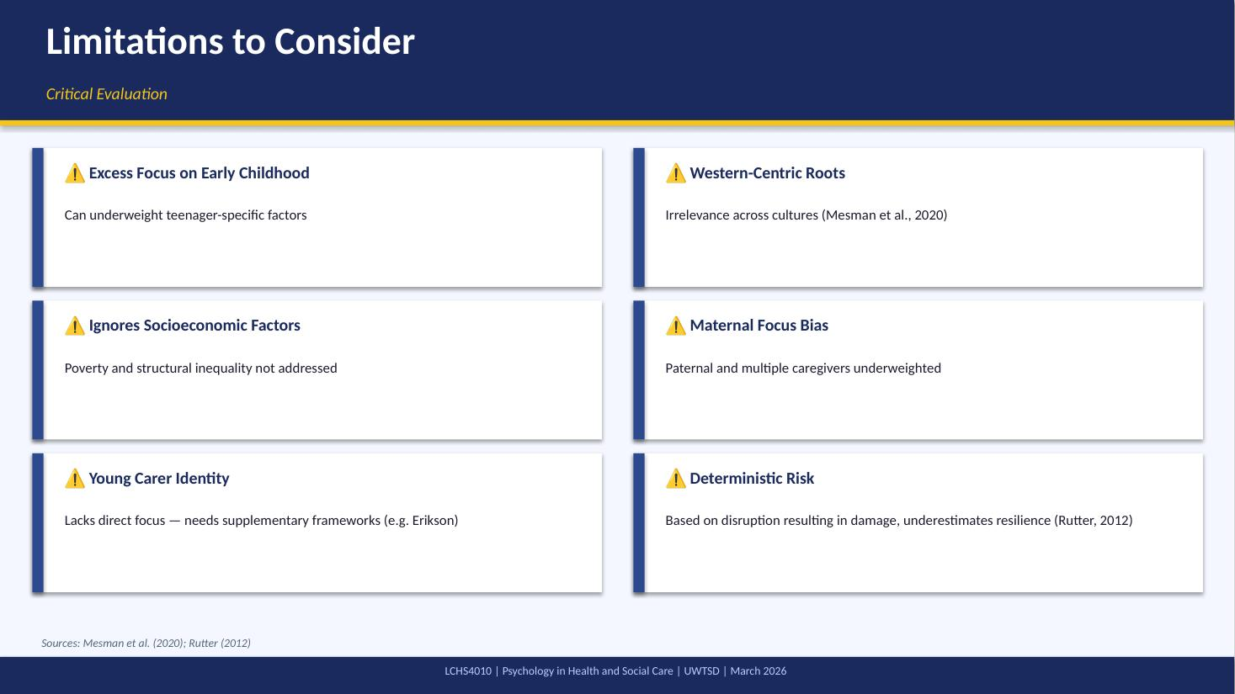
Speaker Notes:
Though it has its merits, the theory by Bowlby has certain weaknesses when used in the case of Jenny. Mesman et al. (2020) question the cross-cultural validity of the attachment classification. The initial maternal orientation of the theory can also restrain its effective application in various families. Significantly, Rutter (2012) notes that impaired attachment is not necessarily a doom-or-gloom scenario, however, resilience factors need to be taken into account when developing a support plan. The systemic socioeconomic influences central to many young carers experiences are not addressed.

SLIDE 12 — Conclusion & Summary
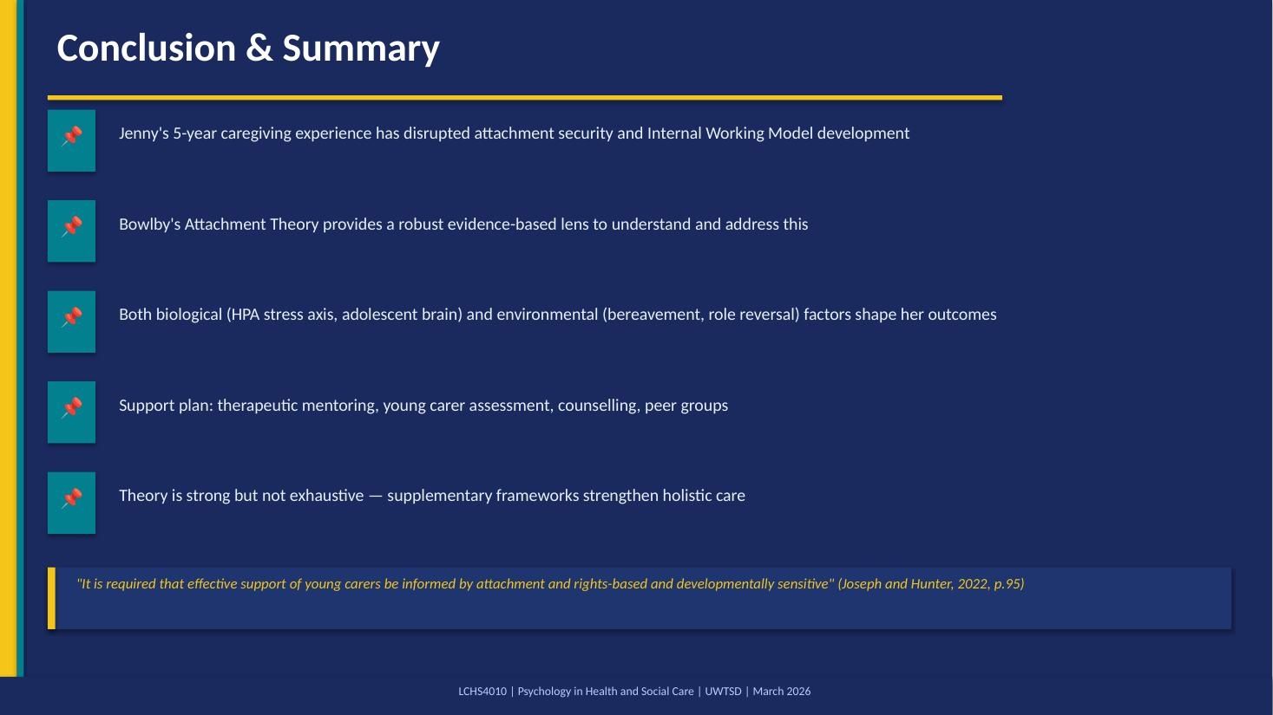
Speaker Notes:
To sum up, the Attachment Theory offered by Bowlby presents an effective and clinically significant theory of how the experiences of Jenny had an influence on her development. The death of her father and five years of role reversed care has shaken her secure base and Internal Working Model at a critical stage of development. The developmental path of Jenny can be redirected positively with the right attachment-informed interventions such as therapeutic mentoring, peer support, formal assessment and counselling.

SLIDE 13 — References
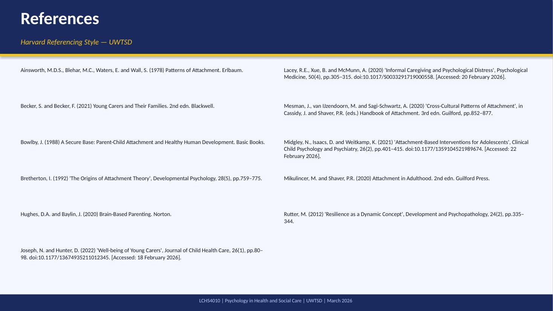
Speaker Notes:
These are the full references used throughout the presentation. All sources follow UWTSD Harvard referencing style. The reference list includes a minimum of six credible academic sources, comprising seminal texts, peer-reviewed journal articles, and edited academic volumes. Web-accessed sources include access dates between 18 and 22 February 2026. I am happy to take any questions at this point.

