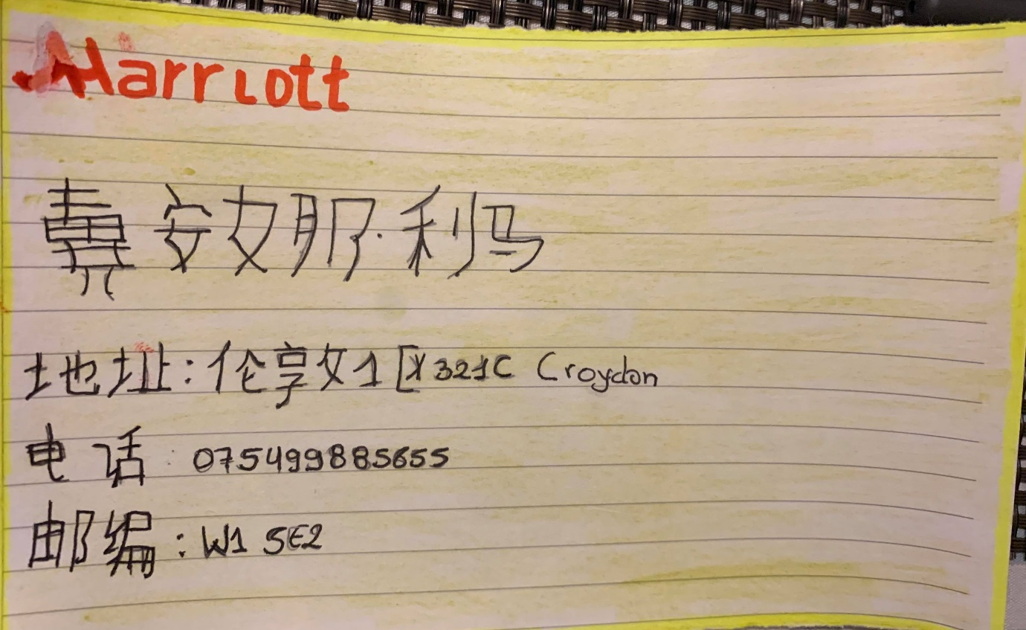
“UNIVERSITY OF WALES TRINITY SAINT DAVID”
- NAME: Diana Lima Morocho
- STUDENT ID: 1815043
- LECTURE: Ms. Jim Pi
- DATE: 2019-12-20

