
Please note that this exercise is intended to provide students with experience of using the SolidWorks part and assembly modelling applications. The work undertaken is not intended to contribute towards the module grade.

TASK DESCRIPTION

Using the SolidWorks Computer Aided Engineering software, you are required to construct an assembly of the following parts:

- Crankshaft
- Gudgeon Pin
- Connecting Rod (Con Rod)
- Piston

The Crankshaft, Gudgeon Pin and Piston geometry have already been modelled and should be downloaded from Moodle as separate part files. You are required to position and constrain each of the components within the assembly (using assembly ‘mates’) in order that the inter-part assembly geometry is correct.

You are required to build the Connecting Rod geometry around the other parts, paying due regard to their position, dimensions and form. The distance between centres of the Connecting Rod ends should be 200mm. You are free to establish appropriate dimensions for the remaining undefined Connecting Rod geometry. It is therefore expected that each student will produce a unique model.

You are to begin and finish your modelling activity in a single 1hr 50min session.

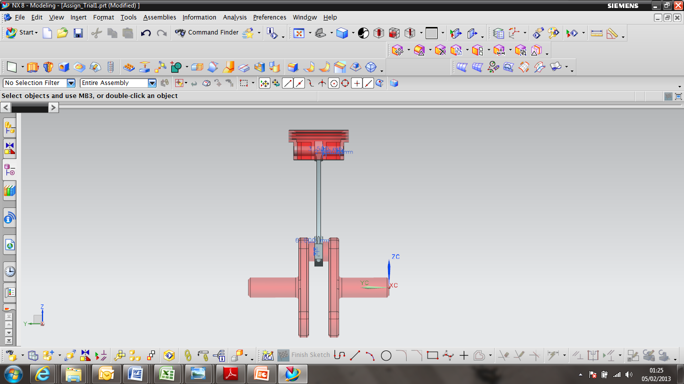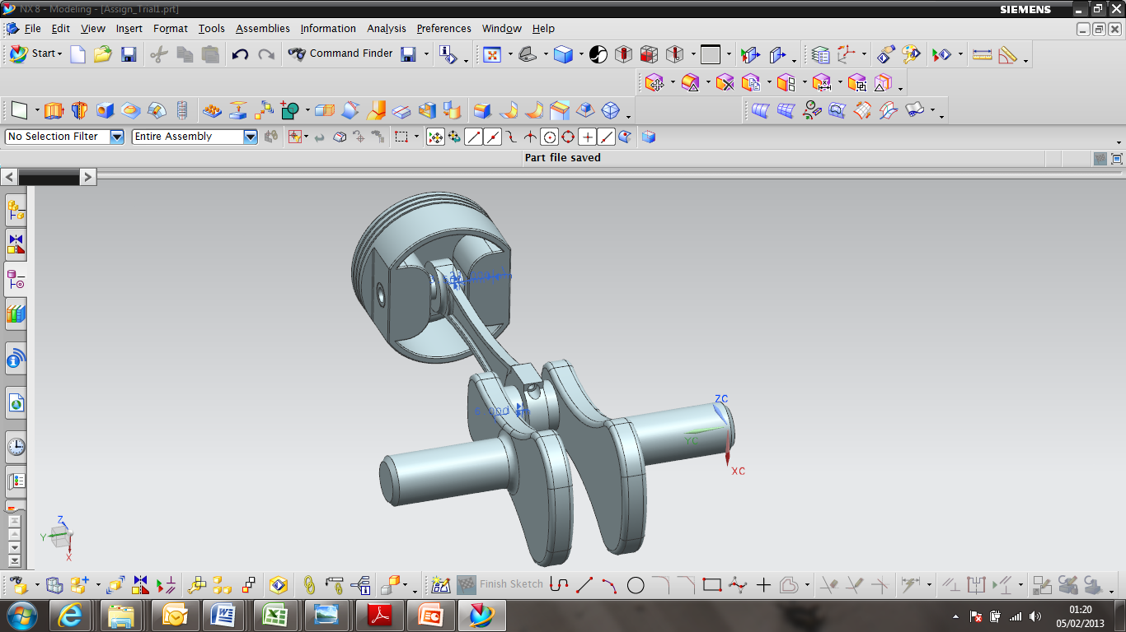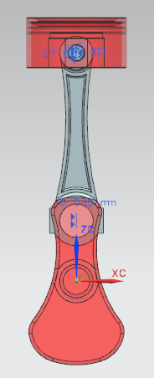

The Suggested Assembly Configuration

The exact geometry of the piston, crank shaft and gudgeon pin parts in the model files may differ slightly from that shown in the images on this briefing sheet
GUIDANCE FOR Students IN THE COMPLETION OF TASKS

You should aim to address the following points when completing this exercise:

- Create correct Part Geometry
- Use a range of appropriate tools when modelling
- Manage and organise the part structure
- Create a suitable assembly structure

