How applying a Gaussian filter to a mipmapped image texture affects its quality and building time
Name: Sam Mounter
Student Number: P144579
Course: BSc Computer Games Development
Faculty: School of Applied Computing
Module Title: High Performance Computing for Games and Visualisation
Module Lecturers: Andrew Baker, Gordon Dickers
Submission Date: April 2018

Abstract
Mipmapping is a technique commonly used in computer graphics where the width and height of an image texture are recursively halved until a sample consisting of a single texture element has been produced. These samples are then stored in a pyramid structure, and when the texture is rendered into a scene, the sample with the appropriate level of detail is loaded. Most implementations of the mipmap structure utilise box filtering to scale down the textures; this involves finding the average colour of a 2 x 2 grid of pixels and applying that to one pixel in the new sample. This comes with some drawbacks, notably the potential introduction of aliasing effects to the samples. The report aims to investigate image blurring methods that can be applied to the texture before downsizing. A review is conducted of some alternative filtering methods that can be applied to the mipmap structure, which is then used to draw up an algorithm testing the application of combined Gaussian and box filtering against simply the latter. The visual results and the host/device runtimes of these techniques are measured using three images of varying complexity, with conclusions drawn regarding the impact of image detail and the blurring methods utilised on the time taken to produce the mipmap samples, as well as their visual quality.
Table of Contents
Introduction 3
Review 5
Algorithm Description 7
Parallelisation 8
Results and Evaluation 10
Visual Results 10
Host Time (CPU) 12
Device Time (GPU) 13
Conclusions and Future Work 13
Bibliography 14
Appendices 15

Figure 1: A visual representation of mipmap sampling [2] 4
Figure 2: Frequency response of the box filter (yellow) versus ideal response (burgundy) [3] 5
Figure 3: Gaussian bell curve [4] 5
Figure 4: Mitchell-Netravali curve [5] 6
Figure 5: The Lanczos filter [7] 7
Figure 6: The images used to test the program 7
Figure 7: CUDA architecture memory hierarchy [8] 9
Figure 8: Circle (Fig. 6a) with only box filtering (left) and Gaussian filtering (right) applied 10
Figure 9: Rainbow (Fig. 6c) with only box filtering (left) and Gaussian filtering (right) applied 11
Figure 10: Lena (Fig. 6b) with only box filtering (left) and Gaussian filtering (right) applied 11
Figure 11: Closeup of Lena (Fig. 9) with only box filtering (left) and Gaussian filtering (right) 12

Table 1: Average host execution time for each image 12
Table 2: Average device execution time for each image 13

Introduction
Mipmapping is a technique proposed by Williams in 1983 [1] which continuously filters bitmap textures down from their original resolution to a single texture element (“texel”) and stores the samples in a pyramid parametric, as pictured in Figure 1. This is a technique commonly used in 3D rendering to avoid aliasing effects caused by the minification of textures from their stored resolution to their projected onscreen resolution. The latter resolution is found and used to determine which of the texture samples stored in the mipmap will be used for rendering.
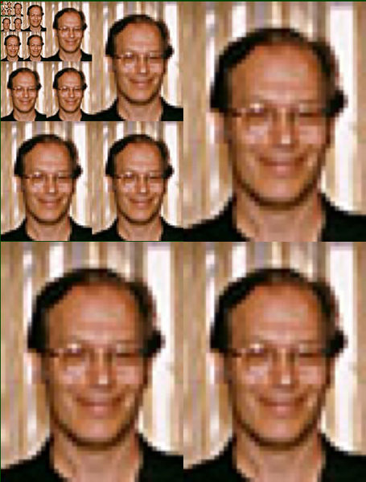
Figure 1: A visual representation of mipmap sampling [2]
Many graphics APIs, such as OpenGL, have pre-defined mipmap generation functionality, so the technique is largely taken for granted. Most implementations of the mipmap filter use box filtering to scale down the textures, which is a basic filtering technique whereby the colour value of each pixel in a down-sample is the average of those of a corresponding grid of pixels (2x2 on this case) in the larger texture, each of which has equal weighting. The main problem with using this type of filter is illustrated in Figure 2; it removes some of the lower frequencies required to maintain image sharpness but retains a lot of the higher frequencies that should be removed to maintain smooth edges. [3] It might be worth investigating an alternative sampling method that can be applied to a mipmapping algorithm.
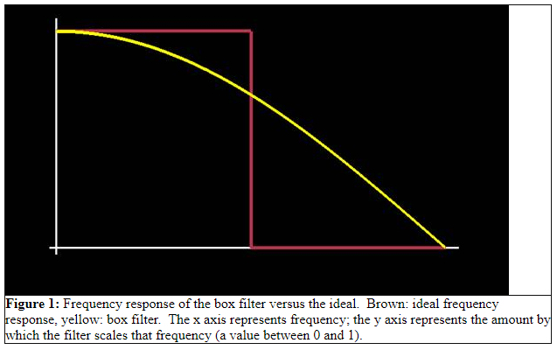
Figure 2: Frequency response of the box filter (yellow) versus ideal response (burgundy) [3]

Review
An alternative filter that can be applied to mipmap sampling is based upon the Gaussian curve, pictured in Figure 3. A kernel is built that can contain a square number of pixels, with the colour of the pixels closest to the centre having a larger weighting on the new pixel colour than those further away. The standard deviation determines how much weighting the central pixels have, and the weighting values in the entire kernel must all add up to 1. This might reduce the impact of aliasing on the down-sampled image but a strict approximation of the filter will have to be set, as it would be too computationally expensive to calculate in real-time.
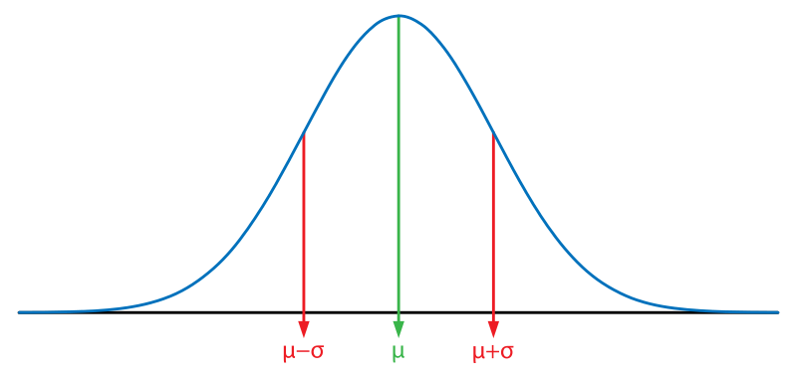
Figure 3: Gaussian bell curve [4]
Mitchell and Netravali [5] propose the use of a bicubic reconstruction filter to resolve aliasing effects introduced by the sampling of 2D images in computer graphics, pictured in Figure 4. A typical symmetrical cubic filter is shown to be defined using eight parameters; this can be reduced to two by ensuring that the filter remains smooth, and that a flat signal is returned if all of the samples have a constant value (i.e. solid colour). When applied to pixel weighting, any pixel located right in the centre of the curve will have a near-full value. This will decrease along with distance from the centre, with any pixels that are more than one pixel-distance away having a negative weighting value. A suitable compromise between anisotropy, blurring and “ringing” can be reached, given the right parameters have been selected, but the author is concerned about the unpredictable side-effects of using negative weighting values.
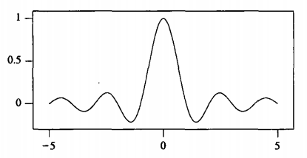
Figure 4: Mitchell-Netravali curve [5]
The Lanczos filter is proposed by Duchon. [6] It is named after the Hungarian mathematician Cornelius Lanczos because it aims to filter out the frequency of the carrier wave by convolving a rectangular representation of it with the desired function (in other words, plotting the amount of overlap between the carrier wave and the final function at all possible points). This essentially consists of a cardinal sine (sinc) function that has been windowed by a set carrier value to achieve a gradual decrease, which can be seen in Figure 5. When applied to pixel weighting, any pixel located in the centre of the kernel will have full weighting on the new colour, with the weighting value at any given distance calculated using sinc(x)*sinc(x/a), where x is the distance from the centre and a is the window value. The graph cuts off at distances that exceed the window value. This results in fewer ringing artefacts when compared with conventional sinc filters, but this also utilises negative weighting values, so the author is unsure of how useful it might actually be.
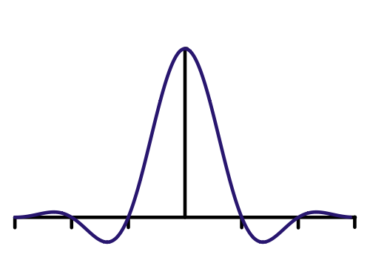
Figure 5: The Lanczos filter [7]

Algorithm Description
The main purpose of this program is to load a 512 x 512 bitmap (.bmp) image from file and recursively produce samples that are a quarter as large as the previous sample until the image consists of one pixel. These down-samples are stored in an image buffer, which is drawn onscreen after the mipmapping process has finished. Two different versions of the algorithm can be executed; one where only box filtering is applied, and another where the images are blurred with a Gaussian filter prior to down-sampling. The time taken to create the mipmap and the quality of the images produced is compared. Three different .bmp files of varying complexity is assessed, which are pictured in Figure 6.
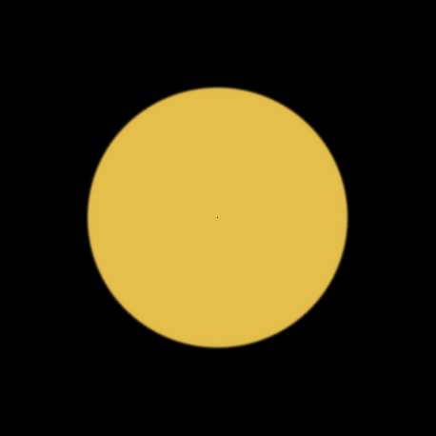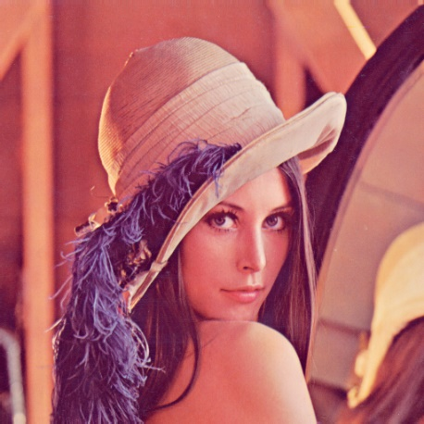
Figure 6: The images used to test the program
The .bmp file needs to be 24-bit to be used in the program. If the image is successfully loaded from file, a specialised input buffer is created to store the image in, and an empty output buffer of a size a quarter of that of the input is initialised. Equivalent buffers are then allocated on the GPU device, and the CPU host transfers the contents of its input buffer to the device. If a Gaussian blur is wanted, it is performed at this point. The device then performs the box filtering operation as it is described in the review, storing the resulting pixels in the output buffer. This is copied back to the host and drawn onscreen in a designated region of the frame buffer. After the mipmapping operation has finished, the frame buffer is displayed onscreen. The full code implementation can be seen in the Appendices of this report.

Parallelisation
CUDA is a parallel computing API developed by NVIDIA that allows developers to implement computing solutions on a system’s graphics processing unit (GPU). [8] CUDA functions are called as extensions to C and are executed in parallel on the GPU across a defined number of threads and blocks. CUDA is used for many fields of research aside from computer graphics, such as video encoding and medical imagery.
The CUDA architecture, pictured in Figure 7, is utilised for the Gaussian blur and the box filtering operations during implementation because they consist of a single function performed multiple times across different areas of the texture. A single kernel called by CUDA during runtime is referred to as a ‘grid’, of which there may be multiple. Each grid is divided up into a large number of blocks, which in turn are divided up into a maximum of 1024 threads. Each block operates independently of the others, sharing only global memory with the rest of the device and the host.
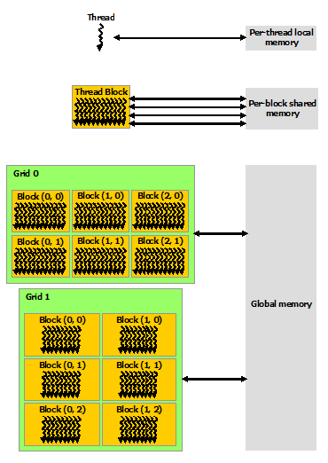
Figure 7: CUDA architecture memory hierarchy [8]
One of the key challenges of this project is how to effectively utilise this structure for the project implementation. If one thread were to be allocated for each pixel, multiple blocks would be required for larger textures, and if one pixel is being used by threads in different blocks, their operations would have to be synchronised to avoid overwriting.
The size of the input and output buffers depends on the intended size of the output image. The length of the output buffer is equal to the area of the output image multiplied by three (to accommodate the RGB-components of the image), with the input buffer being four times as large as that (i.e. the size of the input image). The contents of the host input buffer are copied to the device before the image filtering operations, with the output copied to the host afterwards.
For the Gaussian blur operation, one block is created if the size of the input texture is smaller than 1024, with the number of threads per block allocated equal to this size. Otherwise, the number of threads is maximised to 1024, and the number of blocks is set to the input texture size divided by 1024. Each thread represents a pixel, with a filter mask initialised to contain the weighting values to be applied to that pixel and its immediate neighbours. If the central pixel is not located at the image boundary, then its colour values are stored in a kernel alongside those of its neighbours. The filter mask is then applied to the kernel, and the average RGB components are found by adding up all of the filtered colour values. After all of the threads in the block have found a colour for their pixel (this is synchronised with __syncthreads()), the new colour is applied to the central pixel of the kernel in the input buffer.
The process used to find the number of blocks and threads for box filtering is similar to that for the Gaussian blur, except that the pixel resolution of the output image is used rather than the input. Each thread in this solution represents a pixel in the output texture, which is the average colour of a 2 x 2 block of pixels in the input buffer. The index of the top right pixel in this block is found using the index and row number of the thread and is used to find the indices of the other pixels in the block. An average colour value for the output pixel is calculated from the pixels in the input block. A __syncthreads() function is used to ensure each thread in the block has reached the same point, after which the new colour values are applied to the output buffer.

Results and Evaluation
The two versions of the algorithm described above have been applied to the images in Figure 6, with the visual results and execution times compared.

Visual Results
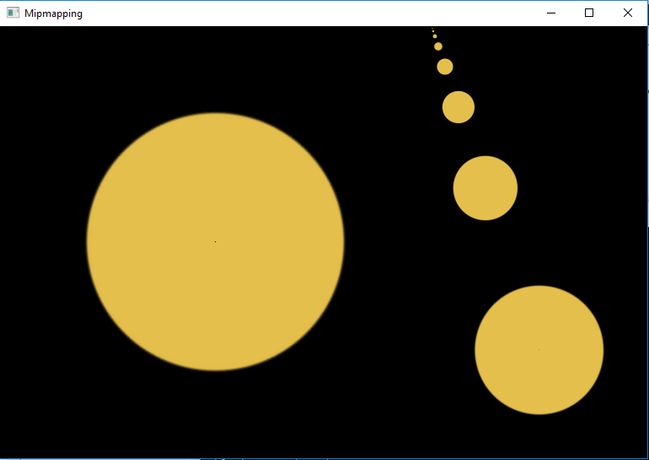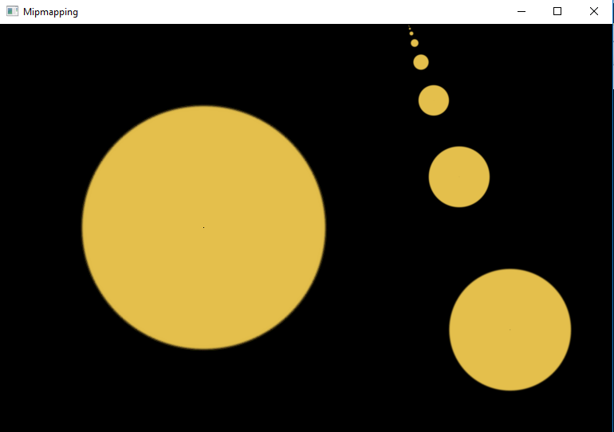
Figure 8: Circle (Fig. 6a) with only box filtering (left) and Gaussian filtering (right) applied
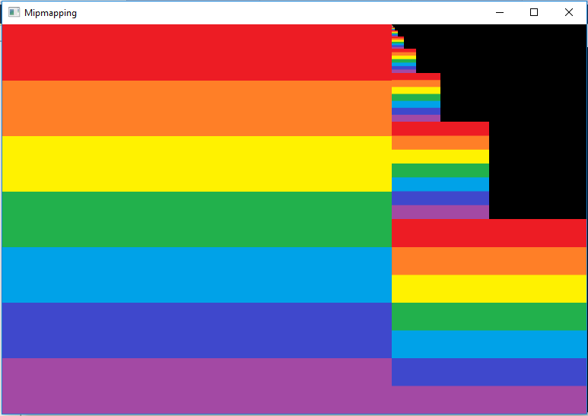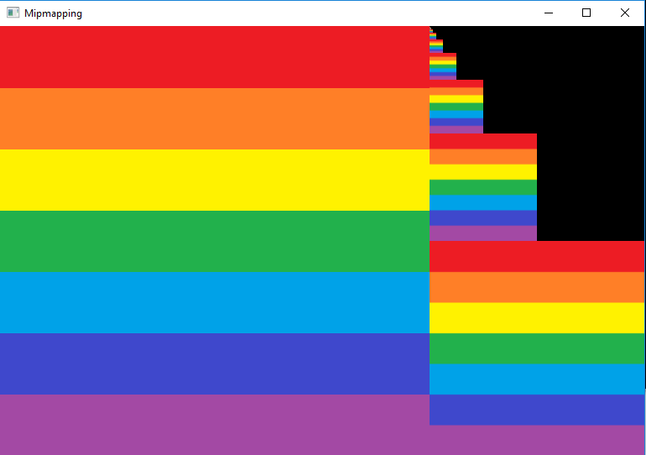
Figure 9: Rainbow (Fig. 6c) with only box filtering (left) and Gaussian filtering (right) applied
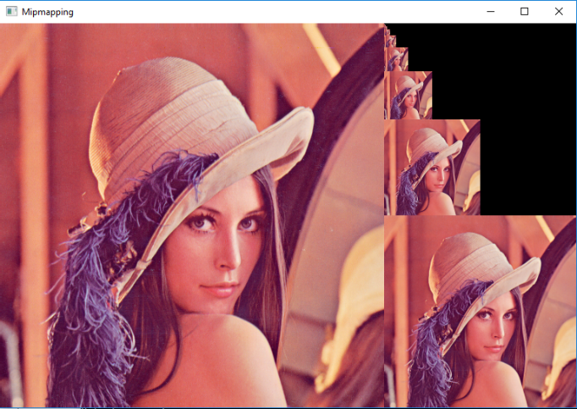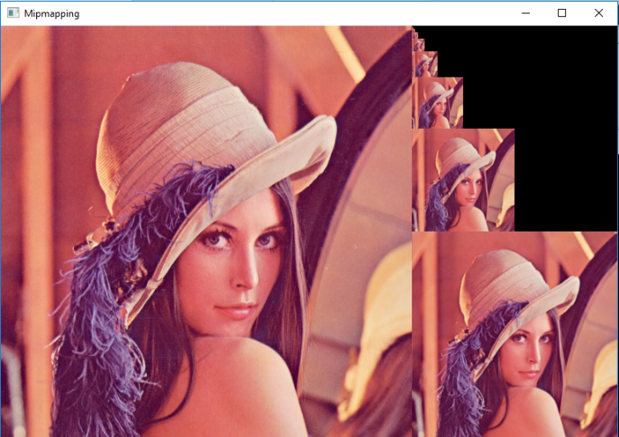
Figure 10: Lena (Fig. 6b) with only box filtering (left) and Gaussian filtering (right) applied
The above three figures show the two versions of the mipmap algorithm applied to a plain image of a circle (Figure 8), a rainbow tile (Figure 9) and a commonly-used test photograph of Lena Soderberg (Figure 10) respectively. A close-up examination of the down-sampled images shows that the samples with the Gaussian blur applied to them undergo feathering (see Figure 11). However, it is only particularly noticeable in Figure 10, where a detailed image is being tested. The differences in Figure 8 and Figure 9 are too subtle to be worth commenting on.
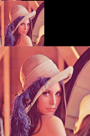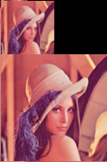
Figure 11: Closeup of Lena (Fig. 9) with only box filtering (left) and Gaussian filtering (right)

Host Time (CPU)
Table 1 shows the average host execution time for each image in Figure 6, with and without the Gaussian blur applied. There appears to be negligible difference in host runtime between the images, even after the blur has been utilised. The fluctuations that are there do not follow a pattern and can be attributed to random system variance during execution.
Image Used | Filters Used | Average Host Runtime (milliseconds)
Circle (Fig. 4a) | Box only | 621.4
Circle (Fig. 4a) | Box + Gaussian | 619.4
Rainbow (Fig. 4c) | Box only | 629.9
Rainbow (Fig. 4c) | Box + Gaussian | 612.9
Lena (Fig. 4b) | Box only | 559.3
Lena (Fig. 4b) | Box + Gaussian | 626.4
Table 1: Average host execution time for each image

Device Time (GPU)
Table 2 shows the average device execution time for each image in Figure 6, broken down across both functions. When a Gaussian blur is applied to the image, the mipmap structure takes several times longer to generate than without it. Like with the host, the complexity of the image has no impact on the device runtime, with any differences also explainable by random system variance.
Image Used | Filters Used | Average blur Runtime (microseconds) | Average filterKernel Runtime (microseconds)
Circle (Fig. 4a) | Box only | N/A | 166.5
Circle (Fig. 4a) | Box + Gaussian | 1202.9 | 187.5
Rainbow (Fig. 4c) | Box only | N/A | 183.5
Rainbow (Fig. 4c) | Box + Gaussian | 1185.9 | 166.4
Lena (Fig. 4b) | Box only | N/A | 177.1
Lena (Fig. 4b) | Box + Gaussian | 1216.3 | 171.3
Table 2: Average device execution time for each image

Conclusions and Future Work
Based upon the visual results conducted in the previous section, the effects of applying a Gaussian filter to blur a bitmap texture prior to down-sampling is only noticeable for detailed images such as the Lena photograph, and even then, only upon close examination. There is a miniscule loss in quality with the blur applied, but the author does not consider this to be an issue as the textures are designed to be viewed at a distance anyway.
There is virtually no difference in average CPU host execution time regardless of the image that has been loaded. Both of the filtering functions are performed on the GPU device, so neither of those would have an impact on the host runtime. The inclusion of the Gaussian blur adds another 1200 microseconds to the generation of the structure, but neither this nor the box filtering time varies according to the complexity of the image being processed.
From these combined results, the author concludes that the application of a blurring function to a mipmap structure makes no discernible difference to the generation runtime nor the visual quality of the produced samples, but rather adds an unnecessary amount of computational time to produce results similar to those achieved using only the box filter. The complexity of the processed image does not have an impact on the generation time either, so that does not factor into the conclusion. Future research into mipmapping would most likely involve different aspects of the technique aside from image filtering, or even an investigation of alternative methods of down-sampling image textures.

Bibliography

[1] | L. Williams, “Pyramidal parametrics,” ACM SIGGRAPH Computer Graphics, vol. 17, no. 3, pp. 1-11, 1983.
[2] | Amberesque, “File:Lance Williams.jpg,” 17 November 2004. [Online]. Available: https://upload.wikimedia.org/wikipedia/commons/3/36/Lance_Williams.jpg. [Accessed 13 April 2018].
[3] | J. Blow, “Mipmapping, Part 1,” The Inner Product, 13 January 2004. [Online]. Available: http://number-none.com/product/Mipmapping,%20Part%201/index.html. [Accessed 13 April 2018].
[4] | Fleshgrinder, “File:Gaussian distribution.svg,” 19 June 2009. [Online]. Available: https://upload.wikimedia.org/wikipedia/commons/thumb/c/c8/Gaussian_distribution.svg/800px-Gaussian_distribution.svg.png. [Accessed 13 April 2018].
[5] | D. P. Mitchell and A. N. Netravali, “Reconstruction Filters in Computer Graphics,” ACM SIGGRAPH Computer Graphics, vol. 22, no. 4, pp. 221-228, 1988.
[6] | C. E. Duchon, “Lanczos Filtering in One and Two Dimensions,” Journal of Applied Meteorology, vol. 18, no. 8, pp. 1016-1022, 1979.
[7] | V. Marie, “File:Lanczos Filter.svg,” 18 April 2008. [Online]. Available: https://commons.wikimedia.org/wiki/File:Lanczos_Filter.svg. [Accessed 18 April 2018].
[8] | NVIDIA Corporation, “CUDA C Programming Guide v9.1.85,” 5 March 2018. [Online]. Available: https://docs.nvidia.com/cuda/cuda-c-programming-guide/index.html. [Accessed 16 April 2018].
[9] | T. Akenine-Möller, E. Haines and N. Hoffman, Real-time rendering, Wellesley, Mass.: Peters, 2008.
[10] | D. Pape, “DMS 423 - Class 15,” University at Buffalo, 6 March 2009. [Online]. Available: http://resumbrae.com/ub/dms423_f08/15/. [Accessed 13 April 2018].

Appendices
#define BITMAP_ID 0x4D42

#include "cuda_runtime.h"
#include "device_launch_parameters.h"

#include <stdio.h>
#include <math.h>
#include <Windows.h>
#include "freeglut.h"

cudaError_t mipmapping(float* in, float* out, int size);
BITMAPINFOHEADER imageInfoHeader;
unsigned char* imageBuffer;
float colourBuffer[1179648] = { 0.0 };
float* outBuffer;
float* inBuffer;
unsigned char *LoadBitmapFile(char *filename, BITMAPINFOHEADER *bitmapInfoHeader);
void drawToFrame(int y, int size);
void render(void);

__global__ void blur(float* in, int n, int length)
{
int index = threadIdx.x + blockIdx.x * n;
float filterMask[9] = { 0.0 };
float pixelsSample[27] = { 0.0 };

//how much each neighbouring value will contribute to the new pixel
filterMask[0] = 0.0625f;
filterMask[1] = 0.125f;
filterMask[2] = 0.0625f;
filterMask[3] = 0.125f;
filterMask[4] = 0.25f;
filterMask[5] = 0.125f;
filterMask[6] = 0.0625f;
filterMask[7] = 0.125f;
filterMask[8] = 0.0625f;

if (index > length && index < (length * length) - length - 1)
{
//collect neighbouring pixel values
pixelsSample[0] = in[(index - length - 1) * 3]; //r
pixelsSample[1] = in[(index - length - 1) * 3 + 1]; //g
pixelsSample[2] = in[(index - length - 1) * 3 + 2]; //b

pixelsSample[3] = in[(index - length) * 3]; //r
pixelsSample[4] = in[(index - length) * 3 + 1]; //g
pixelsSample[5] = in[(index - length) * 3 + 2];

pixelsSample[6] = in[(index - length + 1) * 3]; //r
pixelsSample[7] = in[(index - length + 1) * 3 + 1]; //g
pixelsSample[8] = in[(index - length + 1) * 3 + 2]; //b

pixelsSample[9] = in[(index - 1) * 3]; //r
pixelsSample[10] = in[(index - 1) * 3 + 1]; //g
pixelsSample[11] = in[(index - 1) * 3 + 2]; //b

pixelsSample[12] = in[(index) * 3]; //r
pixelsSample[13] = in[(index) * 3 + 1]; //g
pixelsSample[14] = in[(index) * 3 + 2]; //b

pixelsSample[15] = in[(index + 1) * 3]; //r
pixelsSample[16] = in[(index + 1) * 3 + 1]; //g
pixelsSample[17] = in[(index + 1) * 3 + 2]; //b

pixelsSample[18] = in[(index + length - 1) * 3]; //r
pixelsSample[19] = in[(index + length - 1) * 3 + 1]; //g
pixelsSample[20] = in[(index + length - 1) * 3 + 2]; //b

pixelsSample[21] = in[(index + length) * 3]; //r
pixelsSample[22] = in[(index + length) * 3 + 1]; //g
pixelsSample[23] = in[(index + length) * 3 + 2]; //b

pixelsSample[24] = in[(index + length + 1) * 3]; //r
pixelsSample[25] = in[(index + length + 1) * 3 + 1]; //g
pixelsSample[26] = in[(index + length + 1) * 3 + 2]; //b

//apply the filter mask
pixelsSample[0] *= filterMask[0]; //r
pixelsSample[1] *= filterMask[0]; //g
pixelsSample[2] *= filterMask[0]; //b

pixelsSample[3] *= filterMask[1]; //r
pixelsSample[4] *= filterMask[1]; //g
pixelsSample[5] *= filterMask[1]; //b

pixelsSample[6] *= filterMask[2]; //r
pixelsSample[7] *= filterMask[2]; //g
pixelsSample[8] *= filterMask[2]; //b

pixelsSample[9] *= filterMask[3]; //r
pixelsSample[10] *= filterMask[3]; //g
pixelsSample[11] *= filterMask[3]; //b

pixelsSample[12] *= filterMask[4]; //r
pixelsSample[13] *= filterMask[4]; //g
pixelsSample[14] *= filterMask[4]; //b

pixelsSample[15] *= filterMask[5]; //r
pixelsSample[16] *= filterMask[5]; //g
pixelsSample[17] *= filterMask[5]; //b

pixelsSample[18] *= filterMask[6]; //r
pixelsSample[19] *= filterMask[6]; //g
pixelsSample[20] *= filterMask[6]; //b

pixelsSample[21] *= filterMask[7]; //r
pixelsSample[22] *= filterMask[7]; //g
pixelsSample[23] *= filterMask[7]; //b

pixelsSample[24] *= filterMask[8]; //r
pixelsSample[25] *= filterMask[8]; //g
pixelsSample[26] *= filterMask[8]; //b

//add them all up
float rAvg = 0.0f, gAvg = 0.0f, bAvg = 0.0f;
for (int i = 0; i < 27; i += 3)
{
rAvg += pixelsSample[i];
gAvg += pixelsSample[i + 1];
bAvg += pixelsSample[i + 2];
}
__syncthreads();

in[(index) * 3] = rAvg;
in[(index) * 3 + 1] = gAvg;
in[(index) * 3 + 2] = bAvg;
}
}

__global__ void filterKernel(float* in, float* out, int n, int length)
{
int index = threadIdx.x + blockIdx.x * n;

float floorVal = floor((float)index / (float)length);
int topQuarter = ((int)floorVal * length * 4) + ((index - (int)floorVal * length) * 2);
float rAvg = ((in[topQuarter * 3]) + (in[(topQuarter + 1) * 3]) +
(in[(topQuarter + length * 2) * 3]) + (in[(topQuarter + length * 2 + 1) * 3])) / 4.0f;
float gAvg = ((in[(topQuarter * 3) + 1]) + (in[((topQuarter + 1) * 3) + 1]) +
(in[((topQuarter + length * 2) * 3) + 1]) + (in[((topQuarter + length * 2 + 1) * 3) + 1])) / 4.0f;
float bAvg = ((in[(topQuarter * 3) + 2]) + (in[((topQuarter + 1) * 3) + 2]) +
(in[((topQuarter + length * 2) * 3) + 2]) + (in[((topQuarter + length * 2 + 1) * 3) + 2])) / 4.0f;
__syncthreads();

out[index * 3] = rAvg; //r component of new pixel
out[index * 3 + 1] = gAvg; //g component of new pixel
out[index * 3 + 2] = bAvg; //b component of new pixel

// printf("Colour value for pixel %d - %f, %f, %f\n", index, out[index * 3], out[index * 3 + 1], out[index * 3 + 2]);
}

int main(int argc, char** argv)
{
// glutInit(&argc, argv);
// glutInitDisplayMode(GLUT_DOUBLE | GLUT_RGB);
// glutInitWindowPosition(100, 100);
// glutInitWindowSize(768, 512);
// glutCreateWindow("Mipmapping");

imageBuffer = LoadBitmapFile("lena.bmp", &imageInfoHeader);
if (imageBuffer == NULL)
{
printf("File failed to load\n");
return 1;
}

int currentLength = 512, drawY = 0;
cudaError_t cudaStatus;
while (currentLength > 1)
{
inBuffer = (float*)malloc((currentLength * currentLength * 3) * sizeof(float)); //new incoming image
memcpy(inBuffer, outBuffer, (currentLength * currentLength * 3) * sizeof(float)); //copy old output into new input
free(outBuffer); //goodbye, old output

currentLength /= 2;
outBuffer = (float*)malloc((currentLength * currentLength * 3) * sizeof(float)); //new outgoing image
cudaStatus = mipmapping(inBuffer, outBuffer, currentLength); //mipmapping
if (cudaStatus != cudaSuccess)
{
fprintf(stderr, "mipmapping failed!");
return 1;
}

drawToFrame(drawY, currentLength);
drawY += currentLength;
free(inBuffer); //goodbye, old input
}
free(outBuffer);

//cudaDeviceReset must be called before exiting in order for profiling and
//tracing tools such as Nsight and Visual Profiler to show complete traces.
cudaStatus = cudaDeviceReset();
if (cudaStatus != cudaSuccess)
{
fprintf(stderr, "cudaDeviceReset failed!");
return 1;
}

//downsampling is performed here
// glutDisplayFunc(render);
// glutMainLoop();

free(imageBuffer);
return 0;
}

cudaError_t mipmapping(float* in, float* out, int size)
{
float *dev_in = 0;
float *dev_out = 0;
cudaError_t cudaStatus;

//setup the GPU on which we want to operate
cudaStatus = cudaSetDevice(0);
if (cudaStatus != cudaSuccess)
{
fprintf(stderr, "cudaSetDevice failed! Do you have a CUDA-capable GPU installed?");
goto Error;
}

//allocate memory on the GPU buffers
cudaStatus = cudaMalloc((void**)&dev_in, (size * size * 12) * sizeof(float)); //in buffer
if (cudaStatus != cudaSuccess)
{
fprintf(stderr, "cudaMalloc failed!");
goto Error;
}
// printf("Input size: %d\n", (size * size * 12));

cudaStatus = cudaMalloc((void**)&dev_out, (size * size * 3) * sizeof(float)); //out buffer
if (cudaStatus != cudaSuccess)
{
fprintf(stderr, "cudaMalloc failed!");
goto Error;
}
// printf("Output size: %d\n", (size * size * 3));

//copy input buffer onto GPU memory
cudaStatus = cudaMemcpy(dev_in, in, (size * size * 12) * sizeof(float), cudaMemcpyHostToDevice);
if (cudaStatus != cudaSuccess)
{
fprintf(stderr, "cudaMemcpy failed!");
goto Error;
}

//launch kernel with specified number of blocks and threads
int numBlocks, numThreads;
if ((size * size * 4) <= 1024) //can you fit the entire input image onto one block?
{
numBlocks = 1;
numThreads = (size * size * 4);
}
else //you can't?
{
numBlocks = (size * size * 4) / 1024;
numThreads = 1024;
}

// printf("%d blocks, %d threads\n", numBlocks, numThreads);
blur <<<numBlocks, numThreads >>> (dev_in, numThreads, (size * 2));

if ((size * size * 4) <= 1024) //can you fit the entire input image onto one block?
{
numBlocks = 1;
numThreads = (size * size);
}
else //you can't?
{
numBlocks = (size * size) / 1024;
numThreads = 1024;
}

// printf("%d blocks, %d threads\n", numBlocks, numThreads);
filterKernel <<<numBlocks, numThreads>>>(dev_in, dev_out, numThreads, size);

//check for kernel launching errors
cudaStatus = cudaGetLastError();
if (cudaStatus != cudaSuccess)
{
fprintf(stderr, "Kernel launch failed: %s\n", cudaGetErrorString(cudaStatus));
goto Error;
}

//cudaDeviceSynchronize waits for the kernel to finish, and returns
//any errors encountered during the launch.
cudaStatus = cudaDeviceSynchronize();
if (cudaStatus != cudaSuccess)
{
fprintf(stderr, "cudaDeviceSynchronize returned error code %d after launching Kernel!\n", cudaStatus);
goto Error;
}

//copy output buffer to host memory
cudaStatus = cudaMemcpy(out, dev_out, (size * size * 3) * sizeof(float), cudaMemcpyDeviceToHost);
if (cudaStatus != cudaSuccess)
{
fprintf(stderr, "cudaMemcpy failed!");
goto Error;
}

Error:
cudaFree(dev_in);
cudaFree(dev_out);

return cudaStatus;
}

unsigned char *LoadBitmapFile(char *filename, BITMAPINFOHEADER *bitmapInfoHeader)
{
FILE *filePtr; // the file pointer
BITMAPFILEHEADER bitmapFileHeader; // bitmap file header
unsigned char *bitmapImage; // bitmap image data
int imageIdx = 0; // image index counter

// open filename in "read binary" mode
filePtr = fopen(filename, "rb");
if (filePtr == NULL)
return NULL;

// read the bitmap file header
fread(&bitmapFileHeader, sizeof(BITMAPFILEHEADER), 1, filePtr);

// verify that this is a bitmap by checking for the universal bitmap id
if (bitmapFileHeader.bfType != BITMAP_ID)
{
fclose(filePtr);
return NULL;
}

// read the bitmap information header
fread(bitmapInfoHeader, sizeof(BITMAPINFOHEADER), 1, filePtr);

// move file pointer to beginning of bitmap data
fseek(filePtr, bitmapFileHeader.bfOffBits, SEEK_SET);

// allocate enough memory for the bitmap image data
int imageSize = bitmapFileHeader.bfSize - bitmapFileHeader.bfOffBits;
bitmapImage = (unsigned char*)malloc(imageSize);

// verify memory allocation
if (!bitmapImage)
{
free(bitmapImage);
fclose(filePtr);
return NULL;
}

// read in the bitmap image data
fread(bitmapImage, 1, imageSize, filePtr);

// make sure bitmap image data was read
if (bitmapImage == NULL)
{
fclose(filePtr);
return NULL;
}

// add the colours to the colour buffer
outBuffer = (float*)malloc((512 * 512 * 3) * sizeof(float));
int n, m;
for (int i = 0; i < imageSize; i += 3)
{
//this will go into the mipmapping process
outBuffer[i] = (float)bitmapImage[i + 2] / (float)255.0f;
outBuffer[i + 1] = (float)bitmapImage[i + 1] / (float)255.0f;
outBuffer[i + 2] = (float)bitmapImage[i] / (float)255.0f;

n = floor(i / 1536); //row number
m = n * 2304 + (i % 1536); //pixel number relative to row
//this will be rendered onscreen
colourBuffer[m] = (float)bitmapImage[i + 2] / (float)255.0f;
colourBuffer[m + 1] = (float)bitmapImage[i + 1] / (float)255.0f;
colourBuffer[m + 2] = (float)bitmapImage[i] / (float)255.0f;
}

// close the file and return the bitmap image data
fclose(filePtr);
return bitmapImage;
}

void drawToFrame(int y, int size)
{
int imageSize = size * size * 3;
int startPoint = y * 2304 + 1536; //starting point of new texture
int endPoint = (y + size - 1) * 2304 + (1536 + size * 3);

// printf("Start - %d, End - %d\n", startPoint, endPoint);

int count = startPoint, row = 0, m;
while (count < endPoint)
{
for (int i = 0; i < (size * 3); i += 3)
{
m = count + i; //how many pixels in from the edge

colourBuffer[m] = outBuffer[row * (size * 3) + i];
colourBuffer[m + 1] = outBuffer[row * (size * 3) + i + 1];
colourBuffer[m + 2] = outBuffer[row * (size * 3) + i + 2];
}

count += 2304;
row++;
}
}

void render(void)
{
glClear(GL_COLOR_BUFFER_BIT | GL_DEPTH_BUFFER_BIT);
glDrawPixels(768, 512, GL_RGB, GL_FLOAT, colourBuffer);
glutSwapBuffers();
}

