
Database Implementation for AutoPark Management System Using Microsoft Access

Module: ACCA 4023
Name: Methuseli Ncube
Student Number: 2507567
Course Title: CertHE Computing Skills for workplace
Module Name: Introduction to Web and Database Concepts
Lecture: Dr Shah Room
Date: 07 JULY 2026

Table of Content
Introduction 1
Scenario Analysis and System Purpose 1
Implementation Alignments 2
Entities and Relationships 2
Data Structure Development 3
Normalisation Compliance 4
Sample Data Population 5
Query Development 6
Validation and Testing 8
Design Decisions and Reflection 10
Future Improvements 10
Conclusion 11
References 12
Appendix 13

List of Figures and Table
Figure 1 Booking table design showing vehicle, slot, entry time, exit time and booking status 6
Figure 2 Relationship diagram showing primary key and foreign key links between all tables 6
Figure 3 Vehicle table design showing vehicle registration details and customer foreign key 7
Figure 4 Customer table design showing customer identification and contact details 7
Figure 5 ParkingSite table populated with sample parking location records 8
Figure 6 Vehicle table populated with sample vehicle registration records 9
Figure 7 Query design for currently occupied parking slots 9
Figure 8 Query result showing currently occupied parking slots 10
Figure 9 Query design for vehicles parked at a selected parking site 10
Figure 10 Query design for revenue generated by each parking site 10
Figure 11 Query design for most frequently used parking site 11
Figure 12 AutoPark booking report generated using Microsoft Access Report Wizard 11
Figure 13 Booking table populated with sample parking transaction records 16
Figure 14 Query result showing vehicles parked at a selected parking site 16
Figure 15 Query design for currently occupied parking slots 17
Figure 16 Payment table populated with sample payment transaction records 17

Table 1 Validation and Testing Results for the AutoPark Management System 9

Introduction
The design and implementation of an AutoPark Management System database using Microsoft Access is presented here [1]. The idea of the system is to take the manual booking and record of parking away from the process and create a structured database to keep accurate records of parking information, vehicles, slots, customer information, and bookings & payments. The scenario illustrates how the organisation has multiple parking sites throughout the city, with the manual process leading to inaccuracies, loss of information, slow searching, and poor space utilisation. The database was therefore intended to aid in the control of operations, in maintaining an effective record system, and in guiding management decisions. The implementation's been built according to the relational database model, as the information in the scenario is related by clear business relationships. Vehicles can be owned by customers, and there are many possible bookings for a vehicle. A vehicle can be assigned to a parking site, and each completed booking may have a payment record. Microsoft Access worked well for this purpose because it allows for tables, keys, relationships, referential integrity, queries, and reports to be stored in one database file.
Scenario Analysis and System Purpose
AutoPark needs an integrated solution with which to track the complete parking procedure from vehicle entry to final payment. The existing manual method is not effective, as it relies on often-repeated writing, manual checking, and individual records [2]. This adds further risk for replicating customer information or for the status of the slot to be mistaken or data on payment to be lost. To solve these problems, the new database design puts each type of information in a different table and relates the information together using primary and foreign keys. The primary function of the system will be to enable the staff to locate the sites, availability/parking of the sites, presence of vehicles in the sites, and booking periods and payments at the sites. This also helps in management by providing useful query results, e.g., what is the revenue per parking site, what number of vehicles are parked at a given site, and what is the most used park site. The database is not just a repository; it is, above all an operational information system that helps to improve the control and monitoring of parking [3].
Implementation Alignments
The implementation directly correlates with Task 1, as the following elements are represented: scenario analysis, entity identification, ERD structure, development of the tables, relationship constraints, sample data, queries and testing evidence. The practical component is contained in the database file that is created in Access, and the explanations in this report are about the logic of the design. Data structure development is shown in the tables; ERD and cardinality are shown in the Relationships window, and the queries show how data can be used to extract and provide meaningful operational information [4]. This also explains what is meant by 'normalisation' and 'validation', both crucial elements of proving the database are built right. This is significant since a submission that includes a distinction level will not be just a series of screenshots; it will also contain the explanation of why each of the design choices was appropriate for the AutoPark scenario and how the implementation will address the business need.

Entities and Relationships
The following are the 6 main entities found: parking site, parking slot, customer, vehicle, booking, and payment. Location-level information stored in a parking site includes the park name, location, and level. Each individual space stored in a parking slot has associated with it the number of the slot, its type, and its status. Vehicle owner information (name, phone, and email are recorded by the customer). Vehicle stores: Registration number, vehicle type, and colour, and associates each vehicle with its owner. Records that are the vehicle that used a slot and when it was entered, exited, and booked. Payment records the itemised amount, how, and when it is paid for a booking. Most relationships are one to many [5]. The single parking site may contain multiple slots, and each of the slots is associated with a single site. One can own several vehicles; all the vehicles belong to one. There are numerous bookings for one vehicle over time, and a single booking relates to one vehicle. Each booking uses one slot at different times.
A slot can be used in many bookings. This simplified system will allow for one booking to be tied to one payment. These relationships enable the database to be traceable, i.e., a payment could be traced back to the booking, vehicle, customer, slot and site.
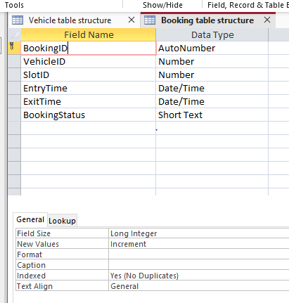
Figure 1: Booking table design showing vehicle, slot, entry time, exit time and booking status
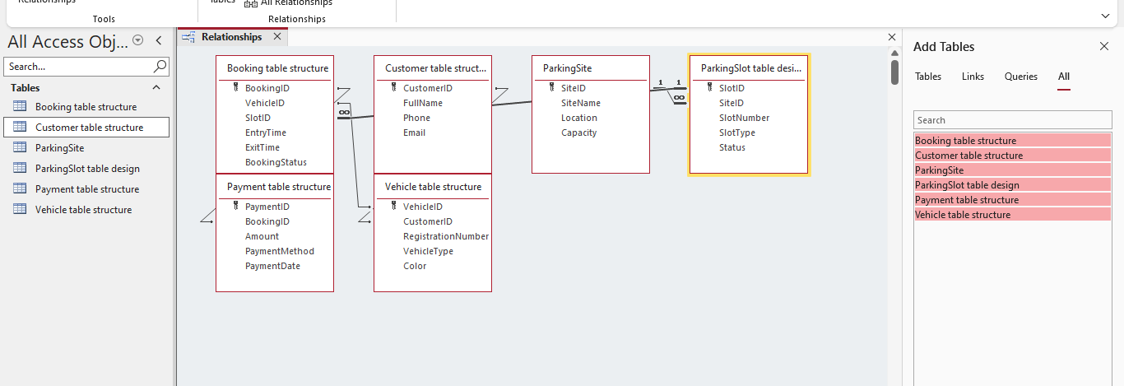
Figure 2 Relationship diagram showing primary key and foreign key links between all tables

Data Structure Development
The database was created using Microsoft Access, with the use of various tables and appropriate data types. Primary keys like SiteID, SlotID, CustomerID, VehicleID, BookingID and PaymentID were added using AutoNumber so that they are automatically generated. For foreign keys (SiteID in ParkingSlot, CustomerID in Vehicle, VehicleID and SlotID in Booking, and BookingID in Payment), 'Number' was used. Name, phone number, email, registration number, vehicle type, vehicle slot type and vehicle slot status were entered using short text. Entry time, exit time and payment date were further used on that date/time, the amount of payment was recorded using currency. The relationships were defined in the Relationships window, and enforced referential integrity was used [6]. This was an important control, as it prevents child records from being created without having valid parent records. For instance, once an existing vehicle is booked, if it is not registered in the system, the booking cannot be created, and if the customer doesn't exist, no vehicle can be associated with the booking. This enhances data integrity and increases the reliability of the database for use in operations.
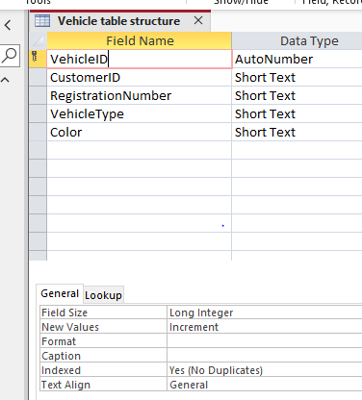
Figure 3 Vehicle table design showing vehicle registration details and customer foreign key
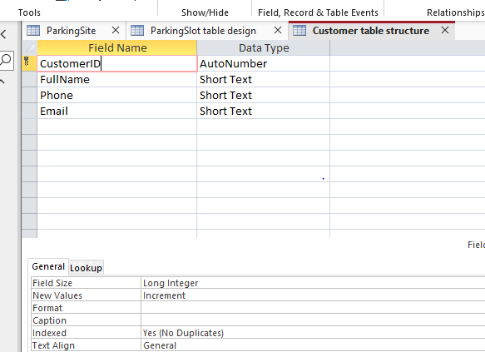
Figure 4: Customer table design showing customer identification and contact details

Normalisation Compliance
The database design is designed in third normal form to minimise redundancy and dependency issues. Every field contains only a single value, and every record is identified by the primary key. For instance, customer name and phone and email are in separate fields, as are vehicle registration and vehicle type. This simplifies the search, update and validation of records. The second normal form is considered because every non-key attribute is dependent on the primary key of its own table. The Vehicle table provides details about vehicles, the Customer table provides details about customers, and the Payment table provides details about payment transactions. Transitive dependency is the avoidance of which creates the third normal form. To some of the other examples given above, one notices that in this case, the name of the site is stored in ParkingSite instead of in Booking and so is accessible via ParkingSlot. The customer name is not present in the booking but can be accessed through the vehicle [7]. This design minimises duplication and maintains consistency if there is a change in data.

Sample Data Population
The structure of the tables was designed, and then sample data was loaded into each table to run the system using realistic records. City-based parking locations were added to the parking site. The individual slot numbers, slot types and slot statuses (available, reserved and occupied) were placed in parking slots. Customer records included real names, telephone numbers, etc., and vehicle records included registration numbers and types with the correct customer. The record of actual parking activity was included. To see vehicles that are actively parked, some bookings were active; some bookings were completed to see finished bookings. Payment details for the bookings made were then captured, such as amount paid, method and date. This sample data will be required since it is only when records are linked across all the related tables that queries can yield useful results. This also confirmed that referential integrity had been working as it should, as Access would not allow for the saving of related records if the customers, vehicles, slots and bookings were not valid.
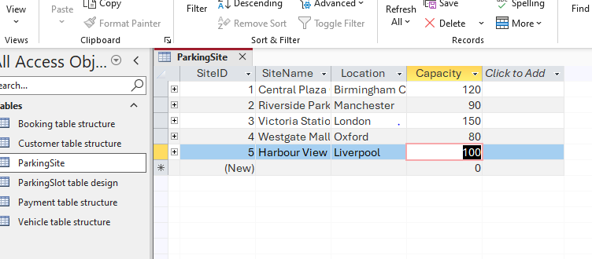
Figure 5 ParkingSite table populated with sample parking location records
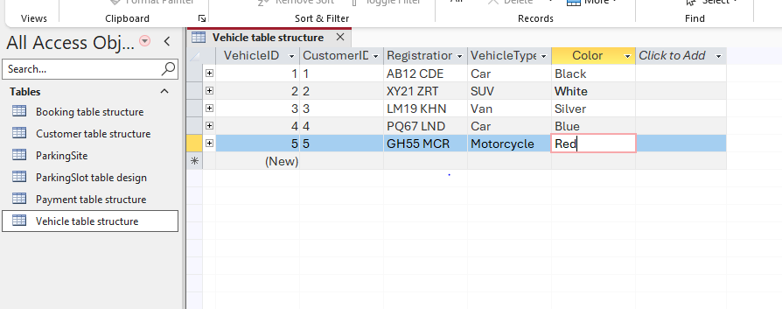
Figure 6: Vehicle table populated with sample vehicle registration records

Query Development
Some functional questions were developed to illustrate the use of the database. Occupied Slots will return records that have the slot status of occupied or booking status of active [8]. This enables staff to easily recognise spaces that are not available. The vehicles of a specific site query the vehicle, booking, ParkingSlot and ParkingSite. This shows information like the site name, slot number, registration number, the type of vehicle entering and if it has been booked or not. The parameter can be entered in 'Site Name' for the user to input when the query is run. The revenue by site query joins Payment, Booking, ParkingSlot and ParkingSite, and groups together records by site and adds up the sum of the payments. This helps management, as they know which sites are earning more. Vehicle details by slot number is another search that enables the staff to find out what is taking up a particular slot in the vehicle. The most-used parking site query returns a list of bookings at a site, sorted in descending order based on the number of bookings. The relational design can yield valuable information without redundant data being duplicated in these queries.
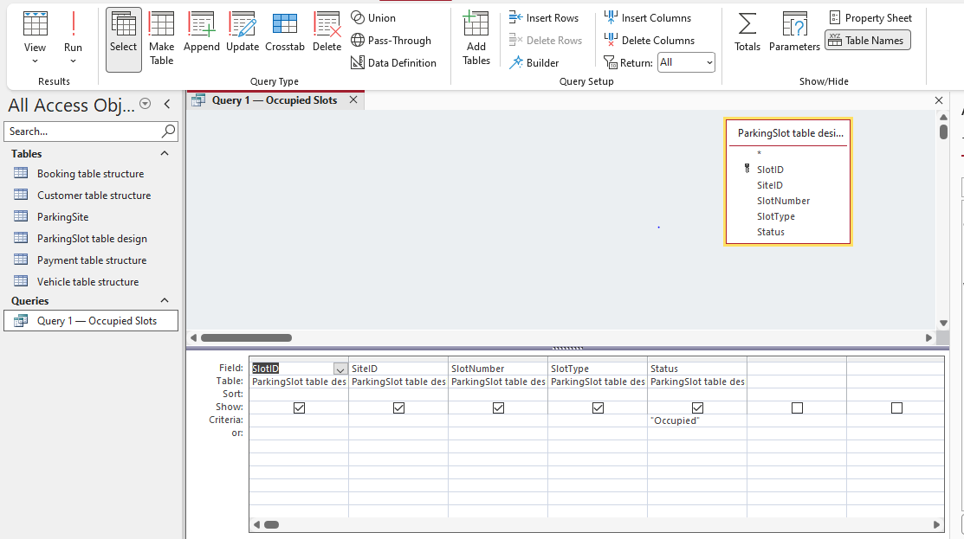
Figure 7 Query design for currently occupied parking slots
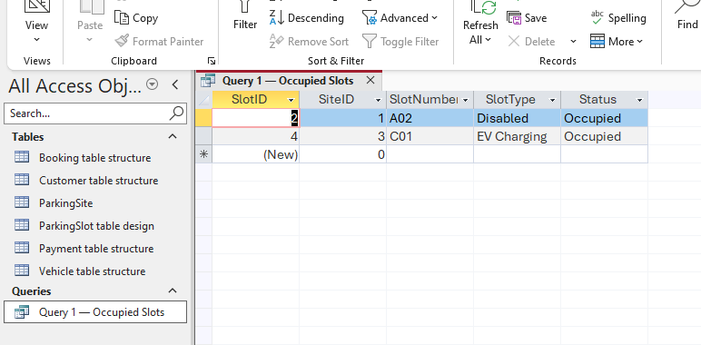
Figure 8 Query result showing currently occupied parking slots

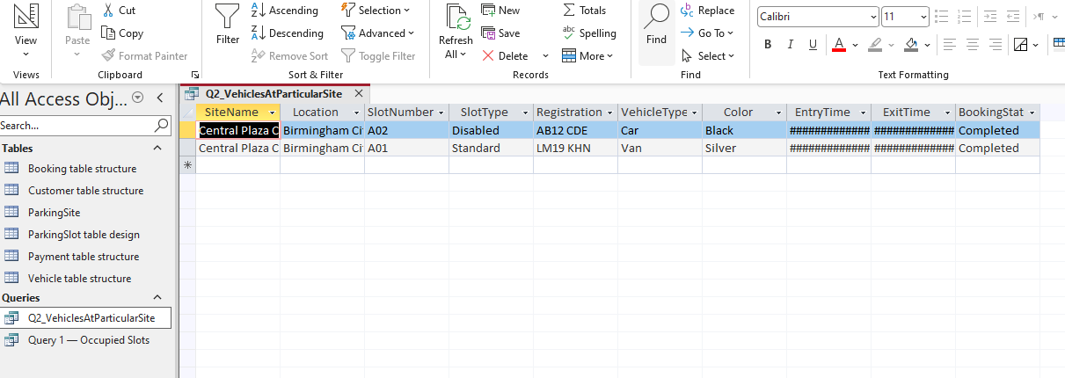
Figure 9 Query design for vehicles parked at a selected parking site

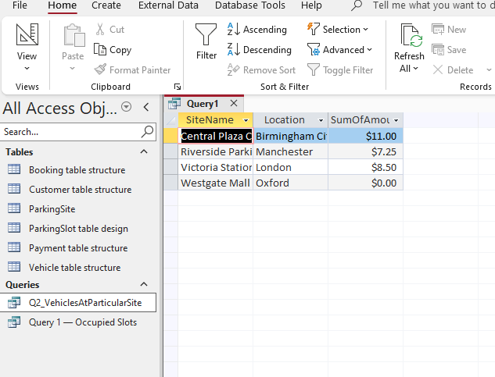
Figure 10 Query design for revenue generated by each parking site

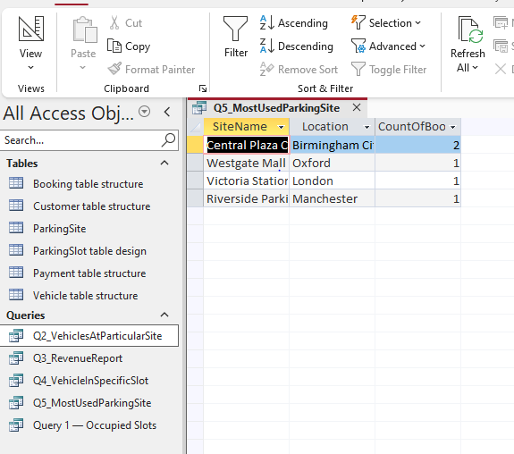
Figure 11: Query design for most frequently used parking site
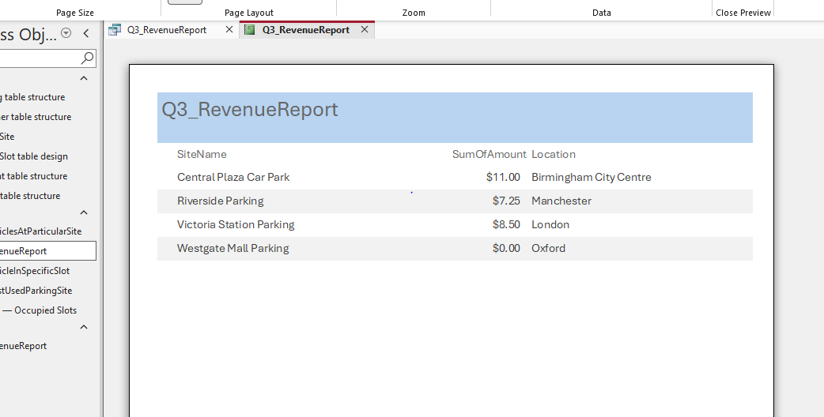
Figure 12 AutoPark booking report generated using Microsoft Access Report Wizard

Validation and Testing
Validation and testing were carried out to ensure that the implemented solution fulfilled the functional requirements [9]. The first test was to determine if records can be successfully placed in each table. The correct record of customer, vehicle, site and slot, booking and payment was kept. The second test looked to see if referential integrity caught invalid data. For instance, it should not be possible to book a vehicle that is not in the database or to book a slot for a vehicle that does not have one. This verified that they were in relation as desired. The third test was for the accuracy of the query. The "occupied slots" query only returned results that were relevant to the query, the "vehicles by site" query returned vehicles in the building selected in the query, and the "revenue" query sums the totals by location. The vehicle returned the proper information for the vehicle slot query, and the most used site returned the most popular site at the top of the list in the site query. The tests revealed the ability of the database to enter data, maintain relationships, and provide valuable operational results.
Table 1 Validation and Testing Results for the AutoPark Management System
Test Action | Expected Result | Actual Result | Status
Create all required tables in Microsoft Access. | All six tables should be created successfully. | ParkingSite, ParkingSlot, Customer, Vehicle, Booking and Payment tables were created. | Pass
Assign primary keys to each table. | Each table should have a unique primary key. | Primary keys were assigned correctly to all tables. | Pass
Create foreign key relationships between related tables. | Tables should link correctly through matching ID fields. | Relationships were created between sites, slots, customers, vehicles, bookings and payments. | Pass
Enable referential integrity. | Invalid records should not be accepted without related parent records. | Referential integrity was applied successfully. | Pass
Enter sample data into all tables. | The database should accept realistic sample records. | Sample data was entered successfully without errors. | Pass
Run occupied parking slots query. | The query should display only occupied slots. | Occupied slots were displayed correctly. | Pass
Run vehicles at selected site query. | The query should display vehicles parked at the selected parking site. | Vehicles linked to the selected site were shown correctly. | Pass
Run revenue by site query. | The query should calculate total revenue for each site. | Revenue totals were generated correctly. | Pass
Run vehicle by slot query. | The query should show vehicle details for a selected slot. | Correct vehicle and slot details were displayed. | Pass
Run the most-used parking site query. | The query should identify the site with the highest number of bookings. | The most frequently used parking site was displayed correctly. | Pass
Generate an access report. | The report should present booking or revenue information clearly. | The report was generated successfully. | Pass
Check database against assignment requirements. | The system should manage sites, slots, customers, vehicles, bookings and payments. | The database met the main functional requirements. | Pass

Design Decisions and Reflection
The major design issue was whether to opt for one flat table or a relational database structure. If there were many customers, then the names would be duplicated in many rows in a flat table, along with site name, vehicle information, etc., and payment details. This will make the updates hard to make and lead to more inconsistencies. Each major concept is presented in its own table, reflecting a more professional, database design-orientated presentation [10]. One of the major challenges was to maintain 'Booking' as the core transaction table. This is to reflect the business process. A booking is the event that uses a vehicle to use a parking slot. Payment was tied to Booking so that financial data is directly tied to parking. One of the issues during implementation was the ability to understand joins among multiple tables, particularly for the 'vehicles at a specific site' query. The vehicle is not directly connected to the site but by way of booking and parking slot. This demonstrated the need for a relationship design that is clearly understood before developing a query.
n fields where appropriate, like payment method, booking status and slot type. Secondly, automatic updates of the slot status could be added to the system. When a booking is made, Future Improvements
The current system fulfils assignment requirements, but there are several things that could be improved. User-friendly forms could be developed for the customers, vehicles, bookings and payments [11]. The forms would make the system easier for staff and minimise the chance of data being typed straight into tables. Other consistency improvements might be achieved with a dropdown menu; when made, the booking might fill the slot automatically, and once the vehicle is picked up, the payment is made and the slot is set to available. Third, dashboard reports can be included with data for revenue, occupancy rate, "unpaid bookings" and busiest locations. The validation could also be tightened to catch payment amounts of less than zero and registration numbers that are already registered with other customers before they can be registered again, as well as other exit times before entry times.

Conclusion
The AutoPark Management System database offers a structured approach to manage parking spaces, positioning, customers, vehicles, bookings and payments through a Microsoft Access database. The design incorporates primary key, foreign key and referential integrity, ensuring the connections between the records are appropriate and that no data is missing. This also adheres to normalisation principles, which means that there is no duplication and each table holds only information about one main subject. The queries that are created in the system illustrate the actual use of it. Staff can find slots that are occupied, check for vehicles on a specific site and find a vehicle in a set slot. Management can analyse revenue and determine the most popular parking lot. Testing showed the system works correctly as it allows for accurate data entry, keeps relationships and generates meaningful query results. The implementation is a straightforward and effective database solution that directly corresponds to the scenario in the assignment and the business requirements of AutoPark.

References
- Ulvi H, Arslan Selçuk S, Satoğlu G. Smart Parking Systems as Data-Oriented Architectural Spaces: A Conceptual Framework for Sustainable Urban Mobility. Sustainability. 2026 Mar 25;18(7):3229.
- Zhou X, Zafarani R. A survey of fake news: Fundamental theories, detection methods, and opportunities. ACM Computing Surveys (CSUR). 2020 Sep 28;53(5):1-40.
- Elfaki AO, Messoudi W, Bushnag A, Abuzneid S, Alhmiedat T. A smart real-time parking control and monitoring system. Sensors. 2023 Dec 10;23(24):9741.
- Davis WS, Yen DC, editors. The information system consultant's handbook: Systems analysis and design. CRC press; 2019 Apr 30.
- Tolbert LC. Beyond Piggly Wiggly: inventing the American self-service store. University of Georgia Press; 2023.
- Shen L, Su C, Zheng XV, Zhuang G. Between contracts and trust: Disentangling the safeguarding and coordinating effects over the relationship life cycle. Industrial Marketing Management. 2020 Jan 1;84:183-93.
- Dhakshinamoorthy J, Viswanathan VV, Annadurai Y, Dhivya VP. Parking Reservation and Smart Allocation using IoT. In2025 International Conference on Visual Analytics and Data Visualization (ICVADV) 2025 Mar 4 (pp. 427-434). IEEE.
- Coching JK, Billones RK, Brillantes AK, Yunus S, Pitogo VA, Senkerik R. Digital twinning mechanism and building information modeling for a smart parking management system. Smart Cities. 2025 Sep 9;8(5):146.
- Hasan HR, Salah K, Jayaraman R, Omar M, Yaqoob I, Pesic S, Taylor T, Boscovic D. A blockchain-based approach for the creation of digital twins. IEEE Access. 2020 Feb 18;8:34113-26.
- McKinley OG, Pandey S, Ottley A. Trustworthy by Design: The Viewer's Perspective on Trust in Data Visualization. InProceedings of the 2025 CHI Conference on Human Factors in Computing Systems 2025 Apr 26 (pp. 1-17).
- Lyons G, Hammond P, Mackay K. The importance of user perspective in the evolution of MaaS. Transportation Research Part A: Policy and Practice. 2019 Mar 1;121:22-36.

Appendix
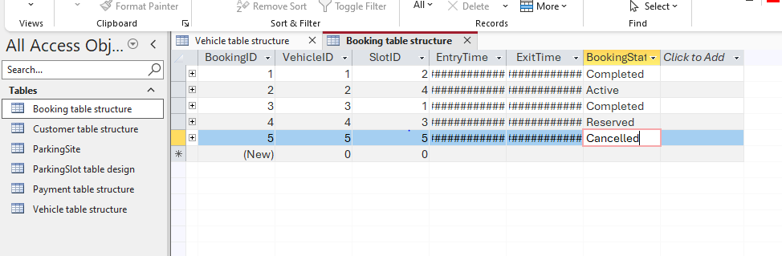
Figure 13 Booking table populated with sample parking transaction records
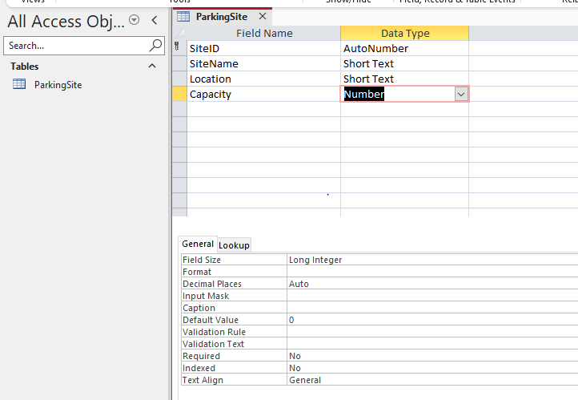
Figure 14 Query result showing vehicles parked at a selected parking site
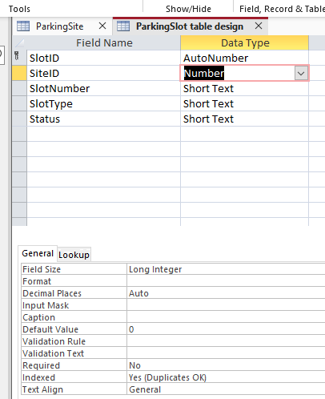
Figure 15 Query design for currently occupied parking slots
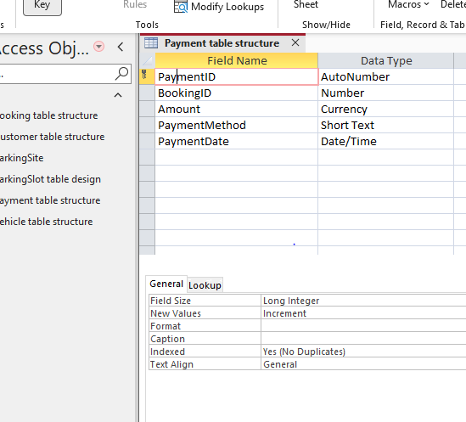
Figure 16 Payment table populated with sample payment transaction records

