University of Wales Trinity Saint David

Wales institute of Science and Arts


Project Summary and Reflection

Engineering Design (ACMA4008)

Jamie Woodberry

2007714

April/2022
The outcome of this challenge was positive, because our final design that we used performed at its best ability. It managed to shoot from 2-4 meters easily. When it came to the 5 metres it needed a little more power to reach 5 and 6. How we could’ve benefited from this was by making more time manufacturing the line launcher and by this we would’ve been able to trial it more and used various springs and from that we would’ve then known what the power of the spring and it would’ve been able to shoot 5 and 6 metres. Therefore, with the lack of time before trial day we had to use the spring that we assembled to it. If we managed to find a spring to shoot 6 metres, we then could’ve calculated the desired angles.

A problem that we faced on the day was the solenoid, this component was supposed to be our release mechanism and because we couldn’t get it to work, we needed to release it manually. This caused a bit of a problem when we needed to shoot the squash ball accurately and consistently. The reason why it caused a problem was because when we loaded the spring via our hands and released the spring to shoot, it wasn’t shooting the ball accurately and would cause drag as the pipe would slow it down as it wasn’t releasing smoothly. To overcome this problem, we should’ve made the inner pipe dimension greater as then it would’ve been flush, and it wouldn’t have moved around as much and would’ve shot accurately and not shot at a different force each time. As you can see from figure 3, we had to insert screws to keep the wood in place as it kept coming out when the ball was released, this also caused problems on the longer distances as it would shoot as fast as it was supposed to.

As a group I believe we all worked well as a team and done what needed to be done in the time that was set. We all split up the tasks in the manufacturing stage and we were therefore able to do several practice shots before trial day. This benefited us quite a lot as we knew when it came to trial day our device would’ve been able to shoot and without fail. As myself I believe that I worked well as an individual because I did what needed to be done and when it came to the manufacturing part I worked well.

If we had to repeat this this challenge again, I would use a similar design to what we had and make a couple of changes to the device. One change that would be made if the design had to be made again, would be how we assemble the line launcher together, this is because we could’ve been able to change the spring before trial day and it would’ve been able to shoot 2-6 metres. And by this we would’ve been able to hit the desired measurements asked.
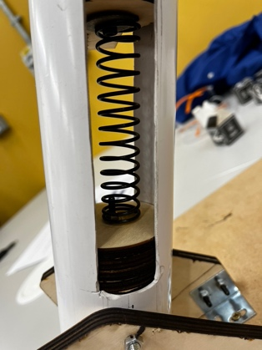
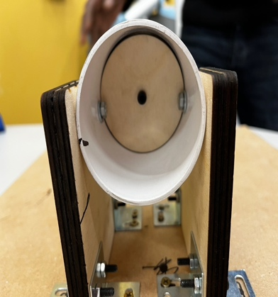
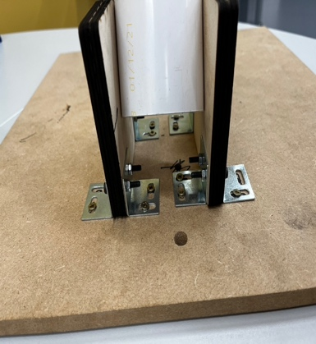
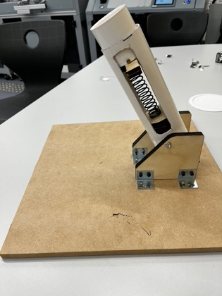
This was our final design of the of the line launcher.
Figure 4:
Figure 3:
Figure 2:
Figure 1:

