Effective Team working and Communication, (BMSW4002).
Manal El Mouden Karemes ID 2010778, group 3.
Diya Ganguly.

Cover list:
Introduction. ……………………………………………………………………………………page 1.
Models of communication.
- Shannon- Weaver Mathematical Model, 1949………………..……..page 1.
- Berol’s model ………………………………………………………………………..page 2 & 3.
- Schramm’s Model…………………………………………………………………..page 4.
Communication skills……………………………………………………………………... page 4 & 5.
Class case study
- Maria and Pedro Case study…………………………………………………..page 5.
- The professor and the village people case study…………….….…. page 6.
Examples of poor communication in the workplace.
- Example 1…………………………………………………………………………….…page 6.
- Example 2……………………………………………………………….………………page 6.
Suggestion for improving the communication…………….…………..………. page 7.
Conclusion………………………………………………………….…………….…….………. page 8
Reference…………………………………………….……………………….……….…………page 9.
Appendix…………………………………………………………………………………..……..page 10.

In this report I am going to be writing about Models of communications, I will be showing some communication barriers in the case studies and about my workplace and the suggestions to improve the communication.
Communication is the exchanging or share of information between two or more people, to have an effective communication we must follow some steps. The first step we need to have a sender, the person who formulates the message, the message could be in a variety of channels some examples are verbal, non-verbal, texting, media, e-mail etc. Once we have the message formulated with the right channel, we need a receiver, the person who will receive the message and who will have the opportunity to give a feedback which is the last step.
However, are some Models of Communication with different theories.

Communication Models

- The Shannon-Weaver Mathematical Model, 1949.
Shannon is a mathematic and Weaver is a scientist, both have created this Model of communication. This model was developed to improve the communication between de sender and the receiver, and it is based in 5 stages, information (source), transmitter (encoder), channel (which can be interrupted), receiver (decoder), destination.
The first stage is about the information, the person who forms the message and the start of the communication, then should be an encoder who transmits the message to make sure the other person understands, that could be a person, translator... Next stage is the channel which is the way that we transmit this message for example phone call, messages, letters, verbal, non-verbal... however the channel can be interrupted by ‘’noise’’ that could be a distraction, distance, physical environment, etc and that could change the message we want to transmit. The fourth stage is decoder (receiver) which is the person who receive the message and the last stage is the destination where the communication ends.

- Berlo’s model of communication
In 1960 David Berlo advanced Shannon Weaver’s model of communication (1949), he added factors that affects individual components in the communication. Berlo’s model of Communication consist in Sender-Message-Channel-Receiver (SMCR). Those factors will help to have an effective Communication.
Encodes.
decodes
receiver
source
message
Channel
-communication skills
-Attitudes
-knowledge
-social system
-Culture

-communication skills
-Attitudes
-knowledge
-social system
-Culture

- Content.
- Elements
- Treatments
- Structure.
- Code.
- Hearing.
- Seeing.
- Touching.
- Smelling.
- Tasting.

Source or sender is the person who wants to transmit the message to the receiver. The factors that I will briefly explain are related with the source and with the receiver as they are the same for both.
- A good communication skill is needed so we can pass the information to the other person. If our communication is not good, the receiver will not be able to understand the message and the communication will not be effective. Communication skills also include speaking, present, listening, write, etc.
- Attitude, that can change the meaning of what we want to communicate. The sender and the receiver must have the right attitude, so they do not misunderstand the message.
- Knowledge, it is important to be familiar with the message that we are sending, because it will have a different effect to receiver. It is going to make us to be more confident, and we will be able to explain it if necessary as we will know about what we are talking about.
- Social system, that can change the effect of the message to the receiver as it is about social factors like values, religion, laws, etc. It can also be affected by the place or situations.
- Culture, when we are communicating with someone that have a different culture, we must be careful as they might find things offensive when in our culture are accepted.

Message is the information that the sender wants to send to the receiver. The message can be in form of voice, text, or other media. The factors that we must think about when forming a message are.
- Content, it is all the message we want to transmit.
- Elements, that can be gestures, signs, language… the non-verbal things that we use when communicating.
- Treatment is the way that we transmit the message, and it affects the feedback of the receiver.
- Structure is the way that we arrange the message, the information we want to send can be affected if we arrange it in a wrong way. If that happen the receiver will not understand us properly.
- Code is the way in which we are sending the message, that can be text, video, language…

Channel is the source we use to send the message and can be in different ways such us telephone, letters, etc. But communication might be affected by the five senses of a human being and the channel will not be effective.
- Hearing: by listening we receive the message transmitted.
- Seeing: we also get information through seeing as it can be transmitted as a non-verbal message, for example gestures.
- Touching: that can be a source when using non-verbal communication, for example touching hands.
- Smelling: we collect information by smelling. For example, by smelling a perfume we get the information about it and decide if we want it or not.
- Tasting: we also collect information by tasting, as it gives us information that we can send as a message.

Receiver is the person that receives the message. Berlo’s model of communication believes that the receiver must be coordinated to the adobe factors so the communication can be effective. If the receiver and the sender are not similar, the message might not have the same effect. The factors that receiver must have are the same as the sender.
- Communication skills.
- Attitude.
- Knowledge.
- Social system.
- Culture.

- Schramm’s Model of Communication.
Wilbur Schramm has postulated this model of communication in 1954, he developed this model of communication because he thought that communication is a process of two people where the sender sends the message and the receiver the feedback. If the receiver does not send any feedback it is impossible to know if the communication was effective or not. The receiver has also the right to say what he thinks or if he agrees with the sender or not.

Encoder.
Decoder.
Message.

Interpreter.
Interpreter.
Decoder.
Encoder.

Message.

Note: All models of communication mentioned adobe complement each other!!

Communication skills.

Communication skills are a very useful skills that we use when given or receiving information. It allows you to have an effective communication and to understand and be understood by others in workplace, friends…
There are different types of communication skills which help to be a good communicator.
- Verbal communication skills which is the communication by spoken or written words, that can be when giving or receiving information, giving a presentation or report, phone cell conversation… Verbal communication is not all about spoken or written words, there are specific skills that are necessary to make communication effective, for example: eye contact, posture, sincerity, clarity…

- Non- verbal communication where we also can say body language, is the way we communicate without words. It includes facial expression, eye movements, gestures… there are some barriers when we are having a non-verbal communication:

- Status effects
- Semantic problems
- Perceptual distortions
- Cultural differences
- Physical distractions
- Poor choice of communication channels

- Active listening skills: it is very importation to pay attention to the person who is talking to us, that way we can understand what is that person saying and show them respect. There is a big difference between hearing and listening, hearing is when the person is talking but we get distracted by something else and we do not know what is that person saying while listening is paying full attention to that person, asking questions, etc.

- Giving and receiving feedback is a communication skill which allows us to see if that person is understanding us by asking them questions or opinions.

Case study 1 and 2.
- Case Study 1; Pedro and Maria.
This case study is about a couple that are having a conversation by phone, in this case the communication was not effective. Pedro was working in a building place where was a lot of noise, Suddenly Maria called asking him to bring chicken for dinner. Pedro did not receive the message effectively and he did not bought kitchen for dinner, the confusion happened because of the channel noise, the communication was by phone and miss communication between them. The Shannon-Weaver Model explains that the communication can be destroyed because of the channel noise, and that was the case. Maria could of avoid that miss understanding as she knows he is working in a building place by sending him a text message or wait until he finishes work.
Using Schramm’s Model, the communication between them could be effective, Maria could of ask Pedro if he did understand what she was saying and get feedback from him. That way the confusion could be avoided.

- Case study 2; Professor and the village people.
This case study is about a professor that lives not far to a little village, one day his house was in fire and he went down the village asking for help. Asking for help he was saying ‘the edifice is being consumed by a great conflagration!’, but no one from the village helped him. The village people could not help him because he was speaking in a formal way and they did not understand him. The problem was also that he did not had any knowledge about the type of communication they use in the village, he thought they can understand him as he is used to speak a higher level of English. The professor could not decode the message and the communication with the village people was not effective. The professor must have spoken using a simple language or signs, he could also ask for feedback to see if they understand him or not. Having knowledge about village people would of be easy for him to have an effective communication with them.
The model of communication which explains this problem is Berlo’s Model, message not effectively decoded because of the village knowledge.
To avoid the message the professor had to use Schramm’s Model of communication, that way he could of get feedback from the village people to know if they understand or not.

Poor communication in the workplace.
- The first example is about when I was working in a restaurant making notes of what each customer had, then the boss came and told me ‘table 3 two glasses of Wine’ I stopped making notes and I took the drinks to that table. The customer saw 2 glasses more than what they asked for when I gave them the bill, the customers were upset because they thought that the last drinks I gave were from the house and that we wanted to charge them more. This confusion was because when I was making notes my boss wanted to make sure that table 3 only had two drinks and I thought that he was asking me to give them two more drinks. The misunderstanding could be avoided by using Schramm’s Model of communication by asking me if I understood what he was saying and give him feedback.

- Second example is about the manager and the restaurant owner. The owner was asking the manager to call me for the weekend, but the manager thought that the boss was saying that he already called me, and the manager did not ask anything else. In the weekend I did not show up in my workplace because no one called me, then the boss called me very upset because they were busy. I explained the situation that I did not know as no one called me and he fired the manager because he thought that he did not want to call me. Because the manager’s first language was not English he did not understand and to avoid the confusion the boss had to consider Berlo’s Model of Communication as they do not have the same knowledge about English, he could also use Schramm’s Model of communication by asking feedback to the manager.

Suggestion for improving communication.

To improve the communication the best model to use is the Schramm’s model of communication as it includes feedback in the conversation so they can share information between each other, to agree or disagree or to make sure they are receiving the right message.
Other ways of improving are paying full attention when someone is talking to us by not just hearing them but listening, that way we can show respect and the sender will be more comfortable when speaking as the receiver will be showing that he has interest of what is he saying.
Make eye-contact when speaking to someone and avoid crossing hands or looking at the floor. Also motivate yourself to listen, avoid interrupting, have a creating and open mind, have an active engagement with the speaker… all those factors will improve our communication.

Conclusion:

In my opinion knowing about communication skills was a very helpful topic, I learnt about 3 models of communication and how they work to make the communication more effective with the person I am talking to. Learning about those Models also helped me to identify where an error can be made in a bad and non-effective communication. It is very important to understand and be understood by others as it will make everything easier.
When talking about communication we also include attitudes, behaviour, first impressions… when at work, interview, with friends, etc. This topic helped me to develop my communication skills and to understand why it is very important for our professional and personal life.

Reference list:
Businesstopia. 2021. Berlo's SMCR Model of Communication - Businesstopia. [online] Available at: <https://www.businesstopia.net/communication/berlo-model-communication#:~:text=In%201960%2C%20David%20Berlo%20postulated%20Berlo%E2%80%99s%20Sender-Message-Channel-Receiver%20%28SMCR%29,has%20mainly%2C%20four%20components%20to%20describe%20the%20> [Accessed 29 April 2021].

Qsstudy.com. 2021. Schramm's Model of communication - QS Study. [online] Available at: <https://qsstudy.com/business-studies/schramms-model-communication#:~:text=Schramm%E2%80%99s%20Model%20of%20Communication%20was%20postulated%20by%20Wilbur,carefully%20put%20into%20words%20and%20conveyed%20to%20others.> [Accessed 29 April 2021].

Au.indeed.com. 2021. [online] Available at: <https://au.indeed.com/career-advice/resumes-cover-letters/communication-skills> [Accessed 29 April 2021].

Oberlo.com. 2021. 20 Ways to Improve Your Communication Skills. [online] Available at: <https://www.oberlo.com/blog/communication-skills> [Accessed 30 April 2021].

Drew, C., 2021. [online] Helpfulprofessor.com. Available at: <https://helpfulprofessor.com/shannon-weaver-model/#:~:text=The%20Shannon%20and%20Weaver%20model%20is%20a%20linear,the%20process%20between%20sending%20and%20receiving%20the%20message.> [Accessed 30 April 2021].

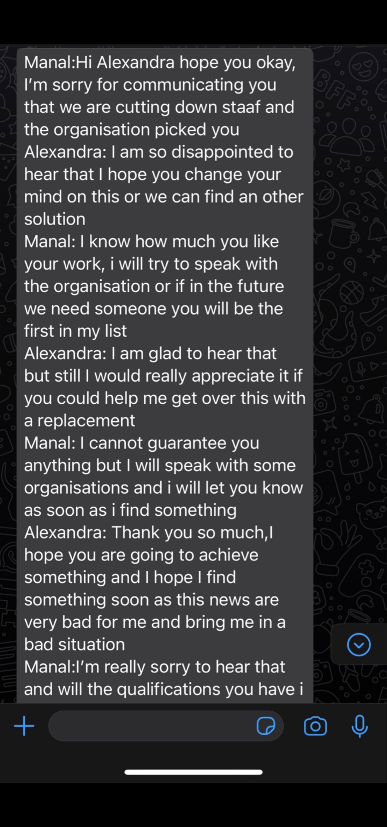
Effective communication, class practice.


